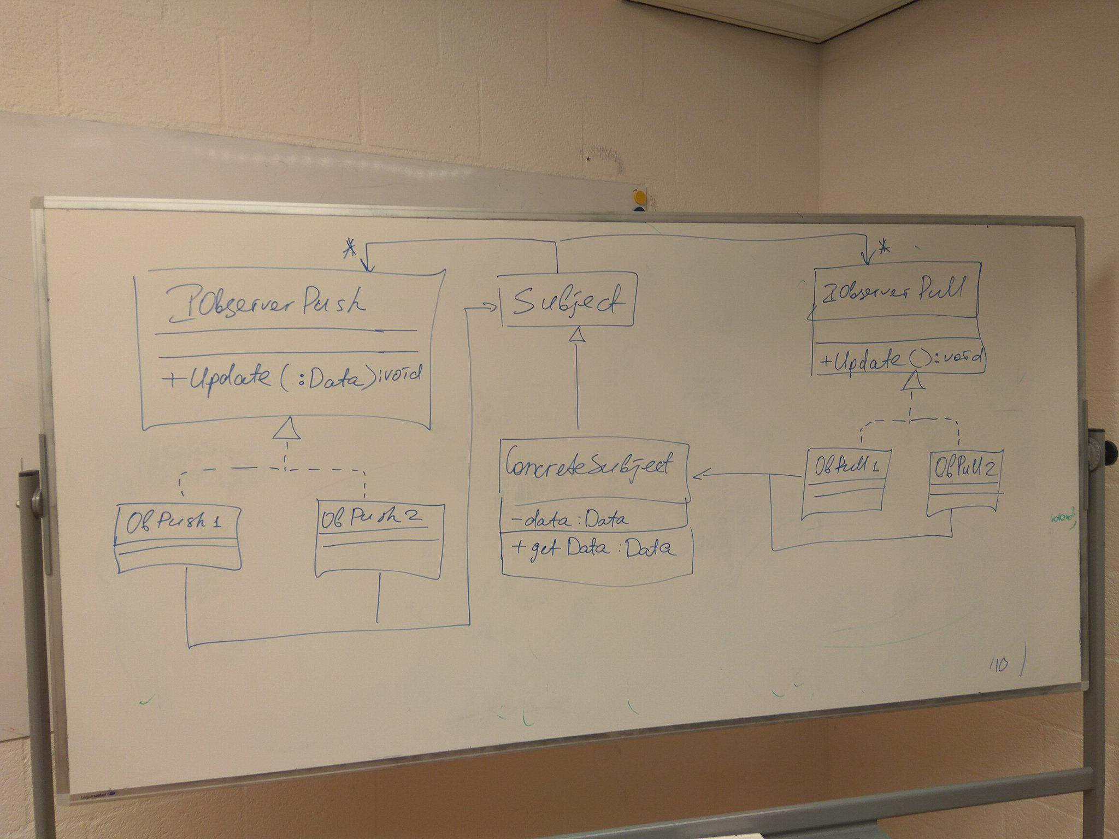

**Left Side is Push pattern –** Here, the subject pushes the data to the observer and asks it to update by calling method Update(:Data). As the data is passed as the parameter from subject to IObserverPush, all the Concrete observers know what to update and they **have** to the update.

**Right Side is Pull Pattern –** Here, the subject callsmethod update(), but doesn’t pass any data. Thus, the observers are only informed about the update. They can update themselves by calling the method GetData() whenever they wish to update.