**Abstract Factory Pattern**

MRUNAL PATIL – 3101851

EMIL KARAMIHOV - 2992884

**Application Description:** The application represents a game with some characters, weapons, etc. The GameFactory can create a character or a weapon. A character can jump or walk. Possible weapons for character are Sword and Axe. A weapon can be used for hitting or defending.

**Abstract Factory** is a creational design pattern that lets you produce families of related objects without specifying their concrete classes.

* Reusability
* Extensibility
* Maintainability

**Design Pattern Solution**

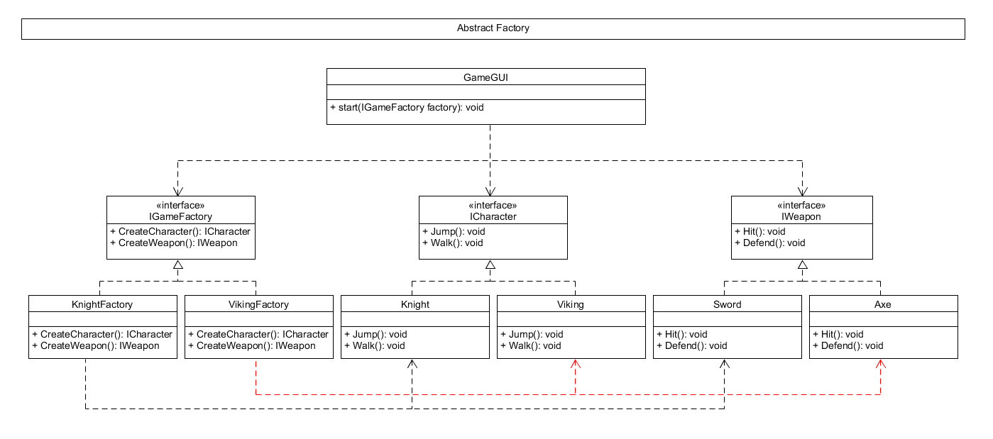

**Consequences**

* Positive consequences

1. Follows the Open/Closed Principle.
2. Allows building families of product objects and guarantees their compatibility.
3. Avoids tight coupling between concrete products and code that uses them.
4. Divides responsibilities between multiple classes.

* Negative consequences

1. Increases overall code complexity by creating multiple additional classes