SOT

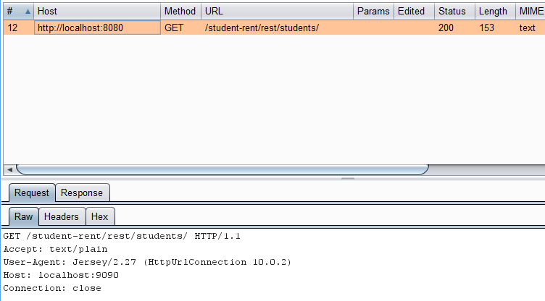

Client sends a GET request using the URL. Server sends Status 200 (OK) to indicate that the response has succeeded.

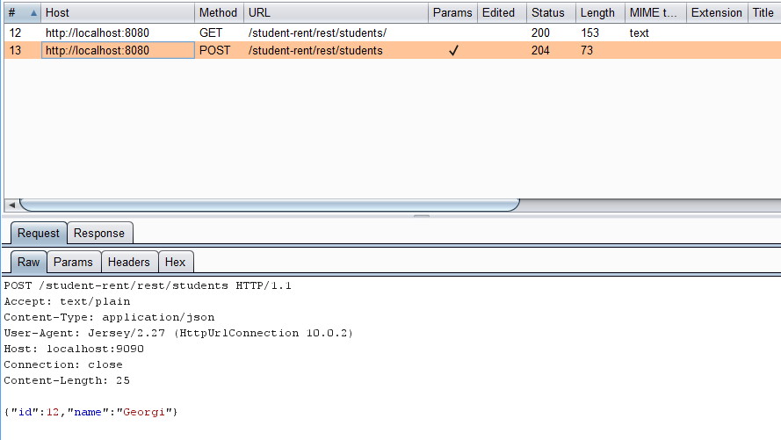

Client sends POST request using the URL. Server return 204 no content. The server has fulfilled the request but does not need to return an entity-body, since it is a POST (create) request. A parameter has been passed with the request. The parameter is of JSON type.

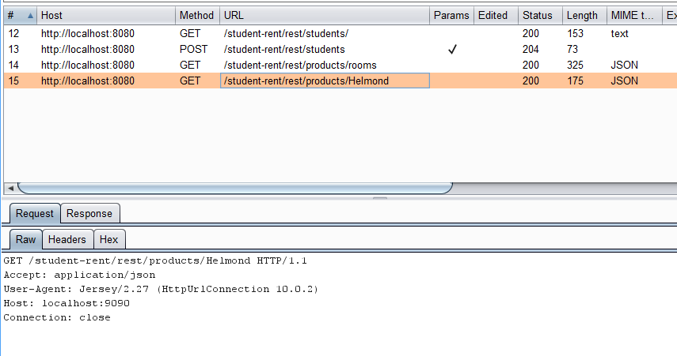

Client sends GET request using the URL. Server return 200 no content. The server has fulfilled the request and returns JSON. A parameter has been passed with the request. The parameter is of Path type.

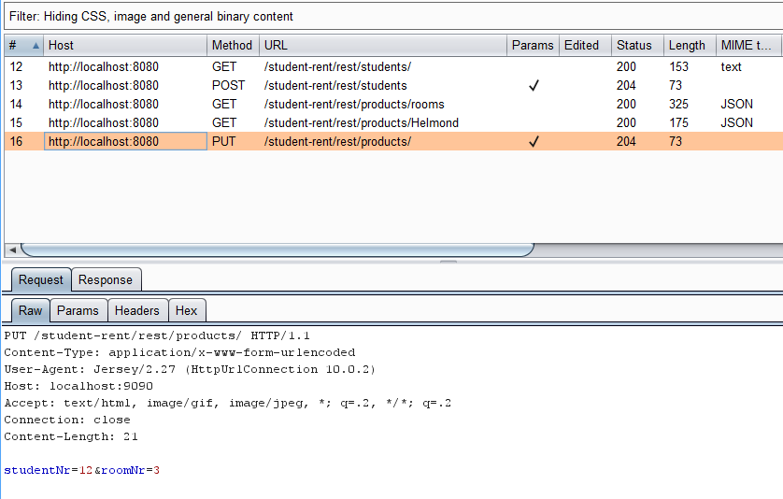

The request is of PUT type (update). Server return 204 no content. The server has fulfilled the request but does not need to return an entity-body. Form parameters are being used here.

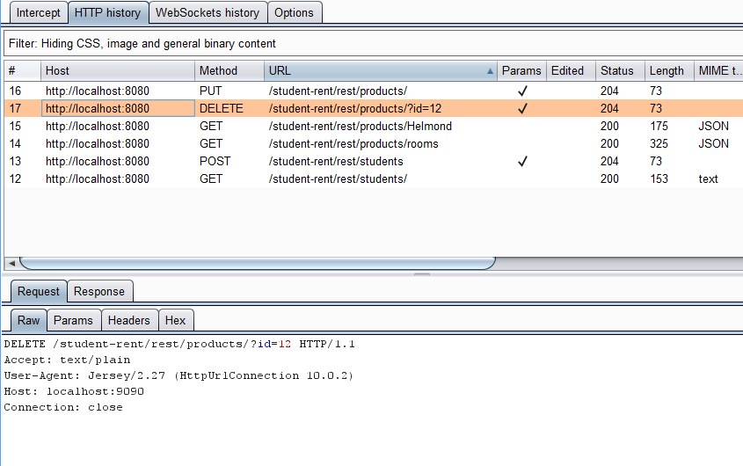

The request is of DELETE type (update). Server return 204 no content. The server has fulfilled the request but does not need to return an entity-body. Query parameter is being used as specified in the URL.

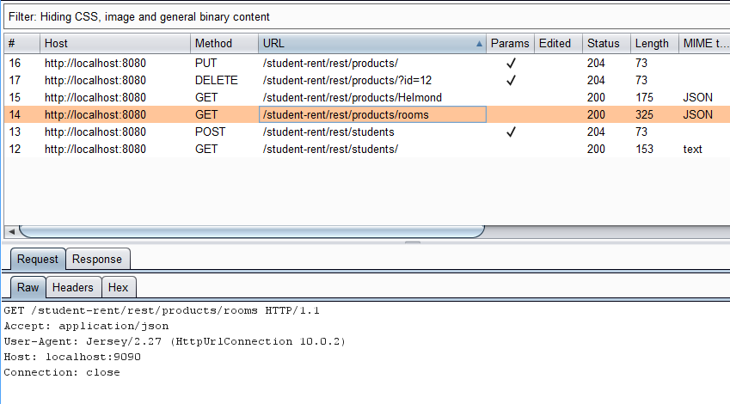

Finally, the request is of GET type. The service return status 200 (OK). Client receives Response of JSON type.