*Mid-term Review – 3T*

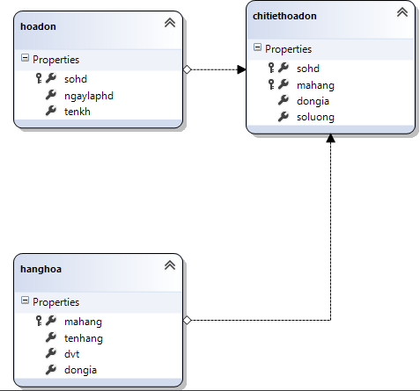

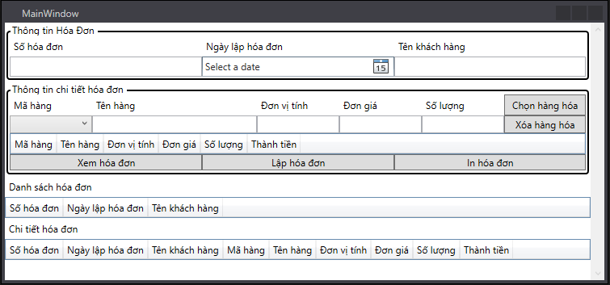

<ScrollViewer>

<StackPanel>

<GroupBox Header="Thông tin Hóa Đơn" BorderBrush="Black" BorderThickness="2">

<Grid>

<Grid.ColumnDefinitions>

<ColumnDefinition/>

<ColumnDefinition/>

<ColumnDefinition/>

</Grid.ColumnDefinitions>

<Grid.RowDefinitions>

<RowDefinition/>

<RowDefinition/>

</Grid.RowDefinitions>

<Label Grid.Row="0" Grid.Column="0" Content="Số hóa đơn"/>

<Label Grid.Row="0" Grid.Column="1" Content="Ngày lập hóa đơn"/>

<Label Grid.Row="0" Grid.Column="2" Content="Tên khách hàng"/>

<TextBox Grid.Row="1" Grid.Column="0" Name="txtSohd"/>

<DatePicker Grid.Row="1" Grid.Column="1" Name="dpNgaylaphd" />

<TextBox Grid.Row="1" Grid.Column="2" Name="txtTenkh"/>

</Grid>

</GroupBox>

<GroupBox Header="Thông tin chi tiết hóa đơn" BorderBrush="Black" BorderThickness="2">

<StackPanel>

<Grid>

<Grid.ColumnDefinitions>

<ColumnDefinition/>

<ColumnDefinition Width="2*"/>

<ColumnDefinition/>

<ColumnDefinition/>

<ColumnDefinition/>

<ColumnDefinition/>

</Grid.ColumnDefinitions>

<Grid.RowDefinitions>

<RowDefinition/>

<RowDefinition/>

</Grid.RowDefinitions>

<Label Grid.Row="0" Grid.Column="0" Content="Mã hàng"/>

<Label Grid.Row="0" Grid.Column="1" Content="Tên hàng"/>

<Label Grid.Row="0" Grid.Column="2" Content="Đơn vị tính"/>

<Label Grid.Row="0" Grid.Column="3" Content="Đơn giá"/>

<Label Grid.Row="0" Grid.Column="4" Content="Số lượng"/>

<ComboBox Grid.Row="1" Grid.Column="0" Name="cmbMahang" SelectedValuePath="mahang" DisplayMemberPath="mahang" SelectionChanged="cmbMahang_SelectionChanged"/>

<TextBox Grid.Row="1" Grid.Column="1" Name="txtTenhang"/>

<TextBox Grid.Row="1" Grid.Column="2" Name="txtDvt"/>

<TextBox Grid.Row="1" Grid.Column="3" Name="txtDongia"/>

<TextBox Grid.Row="1" Grid.Column="4" Name="txtSoluong"/>

<Button Grid.Row="0" Grid.Column="5" Content="Chọn hàng hóa" Name="btnChon" Click="btnChon_Click" />

<Button Grid.Row="1" Grid.Column="5" Content="Xóa hàng hóa" Name="btnXoa" Click="btnXoa_Click" />

</Grid>

<DataGrid Name="dgCTHD" AutoGenerateColumns="False">

<DataGrid.Columns>

<DataGridTextColumn Binding="{Binding mahang}" Header="Mã hàng"/>

<DataGridTextColumn Binding="{Binding tenhang}" Header="Tên hàng"/>

<DataGridTextColumn Binding="{Binding dvt}" Header="Đơn vị tính"/>

<DataGridTextColumn Binding="{Binding dongia}" Header="Đơn giá"/>

<DataGridTextColumn Binding="{Binding soluong}" Header="Số lượng"/>

<DataGridTextColumn Binding="{Binding thanhtien}" Header="Thành tiền"/>

</DataGrid.Columns>

</DataGrid>

<Grid>

<Grid.ColumnDefinitions>

<ColumnDefinition/>

<ColumnDefinition/>

<ColumnDefinition/>

</Grid.ColumnDefinitions>

<Grid.RowDefinitions>

<RowDefinition/>

</Grid.RowDefinitions>

<Button Grid.Row="0" Grid.Column="0" Content="Xem hóa đơn" Name="btnXem" Click="btnXem_Click"/>

<Button Grid.Row="0" Grid.Column="1" Content="Lập hóa đơn" Name="btnLap" Click="btnLap_Click" />

<Button Grid.Row="0" Grid.Column="2" Content="In hóa đơn" Name="btnIn"/>

</Grid>

</StackPanel>

</GroupBox>

<Label Content="Danh sách hóa đơn"/>

<DataGrid Name="dgDSHD" AutoGenerateColumns="False">

<DataGrid.Columns>

<DataGridTextColumn Binding="{Binding sohd}" Header="Số hóa đơn"/>

<DataGridTextColumn Binding="{Binding ngaylaphd}" Header="Ngày lập hóa đơn"/>

<DataGridTextColumn Binding="{Binding tenkh}" Header="Tên khách hàng"/>

</DataGrid.Columns>

</DataGrid>

<Label Content="Chi tiết hóa đơn"/>

<DataGrid Name="dgCTHD_view" AutoGenerateColumns="False">

<DataGrid.Columns>

<DataGridTextColumn Binding="{Binding sohd}" Header="Số hóa đơn"/>

<DataGridTextColumn Binding="{Binding ngaylaphd}" Header="Ngày lập hóa đơn"/>

<DataGridTextColumn Binding="{Binding tenkh}" Header="Tên khách hàng"/>

<DataGridTextColumn Binding="{Binding mahang}" Header="Mã hàng"/>

<DataGridTextColumn Binding="{Binding tenhang}" Header="Tên hàng"/>

<DataGridTextColumn Binding="{Binding dvt}" Header="Đơn vị tính"/>

<DataGridTextColumn Binding="{Binding dongia}" Header="Đơn giá"/>

<DataGridTextColumn Binding="{Binding soluong}" Header="Số lượng"/>

<DataGridTextColumn Binding="{Binding thanhtien}" Header="Thành tiền"/>

</DataGrid.Columns>

</DataGrid>

</StackPanel>

</ScrollViewer>

**Ctruycapdulieu.cs**

using System.Data.Linq;

namespace OnTap_GiuaKi

{

class CTruycapdulieu

{

private static CTruycapdulieu data=null;

private hoadonDataContext dc;

private CTruycapdulieu()

{

dc = new hoadonDataContext();

}

public static CTruycapdulieu khoitao()

{

if (data == null) data = new CTruycapdulieu();

return data;

}

public void capnhat()

{

dc.SubmitChanges();

}

public Table<hoadon> getDSHoadon()

{

return dc.hoadons;

}

public Table<chitiethoadon> getDSChitiethoadon()

{

return dc.chitiethoadons;

}

public Table<hanghoa> getDSHanghoa()

{

return dc.hanghoas;

}

}

}

**Cxulyhanghoa.cs**

using System;

using System.Collections.Generic;

using System.Linq;

using System.Text;

using System.Threading.Tasks;

using System.Data.Linq;

namespace OnTap_GiuaKi

{

class CXulyhanghoa

{

private CTruycapdulieu tc;

public Table<hanghoa> dtHanghoa;

public CXulyhanghoa()

{

tc = CTruycapdulieu.khoitao();

dtHanghoa = tc.getDSHanghoa();

}

public List<hanghoa> getDSHanghoa()

{

return dtHanghoa.ToList();

}

public void them(hanghoa a)

{

dtHanghoa.InsertOnSubmit(a);

tc.capnhat();

}

public hanghoa tim(string mahang)

{

foreach (hanghoa a in dtHanghoa.Where(x => x.mahang == mahang))

return a;

return null;

}

public void xoa(string mahang)

{

hanghoa a = tim(mahang);

if (a != null)

{

dtHanghoa.DeleteOnSubmit(a);

tc.capnhat();

}

}

//sửa hàng hóa a trong CSDL

public void sua(hanghoa a)

{

hanghoa x = tim(a.mahang);

if (x != null)

{

x.tenhang = a.tenhang;

x.dvt = a.dvt;

x.dongia = a.dongia;

tc.capnhat();

}

}

}

}

**Cxulyhoadon.cs**

using System;

using System.Collections.Generic;

using System.Linq;

using System.Text;

using System.Threading.Tasks;

using System.Data.Linq;

namespace OnTap_GiuaKi

{

class CXulyhoadon

{

private CTruycapdulieu tc;

public CXulyhoadon()

{

tc = CTruycapdulieu.khoitao();

}

public List<hoadon> getDSHoadon()

{

return tc.getDSHoadon().ToList();

}

public void them(hoadon a)

{

tc.getDSHoadon().InsertOnSubmit(a);

tc.capnhat();

}

}

}

**Cxulyhoadonview.cs**

using System;

using System.Collections.Generic;

using System.Linq;

using System.Text;

using System.Threading.Tasks;

namespace OnTap_GiuaKi

{

class CChitiethoadonview

{

public string sohd { get; set; }

public string ngaylaphd { get; set; }

public string tenkh { get; set; }

public string mahang { get; set; }

public string tenhang { get; set; }

public string dvt { get; set; }

public double dongia { get; set; }

public int soluong { get; set; }

public double thanhtien { get; set; }

public static List<CChitiethoadonview> getCChitiethoadon(hoadon hd)

{

return hd.chitiethoadons.Select(x => new CChitiethoadonview

{

sohd = x.sohd,

ngaylaphd = hd.ngaylaphd.Value.ToShortDateString(),

tenkh = hd.tenkh,

mahang = x.mahang,

tenhang = x.hanghoa.tenhang,

dvt = x.hanghoa.dvt,

dongia = x.dongia.Value,

soluong = x.soluong.Value,

thanhtien = x.soluong.Value * x.dongia.Value

}).ToList();

}

}

}

**MainWindow.xaml.cs**

using System;

using System.Collections.Generic;

using System.Linq;

using System.Text;

using System.Threading.Tasks;

using System.Windows;

using System.Windows.Controls;

using System.Windows.Data;

using System.Windows.Documents;

using System.Windows.Input;

using System.Windows.Media;

using System.Windows.Media.Imaging;

using System.Windows.Navigation;

using System.Windows.Shapes;

namespace OnTap_GiuaKi

{

/// <summary>

/// Interaction logic for MainWindow.xaml

/// </summary>

public partial class MainWindow : Window

{

private CXulyhanghoa xlhh;

private CXulyhoadon xlhd;

private hoadon hd;

public MainWindow()

{

InitializeComponent();

}

private void Window_Loaded(object sender, RoutedEventArgs e)

{

dpNgaylaphd.SelectedDate = DateTime.Now;

hd = new hoadon();

hd.sohd = "";

hd.ngaylaphd = DateTime.Now;

hd.tenkh = "";

xlhh = new CXulyhanghoa();

xlhd = new CXulyhoadon();

cmbMahang.ItemsSource = xlhh.getDSHanghoa();

dgDSHD.ItemsSource = xlhd.getDSHoadon();

}

private void cmbMahang_SelectionChanged(object sender, SelectionChangedEventArgs e)

{

hanghoa a = (hanghoa)cmbMahang.SelectedItem;

if (a == null) return;

txtTenhang.Text = a.tenhang;

txtDvt.Text = a.dvt;

txtDongia.Text = a.dongia.Value.ToString();

txtSoluong.Text = "1";

}

private void btnChon_Click(object sender, RoutedEventArgs e)

{

hanghoa hh = (hanghoa)cmbMahang.SelectedItem;

if (hh == null) return;

chitiethoadon a = new chitiethoadon();

a.hanghoa = hh;

a.dongia = double.Parse(txtDongia.Text);

a.soluong = int.Parse(txtSoluong.Text);

hd.chitiethoadons.Add(a);

dgCTHD.ItemsSource = CChitiethoadonview.getCChitiethoadon(hd);

}

private void btnLap_Click(object sender, RoutedEventArgs e)

{

if (hd.chitiethoadons.Count <= 0) return;

hd.sohd = txtSohd.Text;

hd.ngaylaphd = dpNgaylaphd.SelectedDate.Value;

hd.tenkh = txtTenkh.Text;

xlhd.them(hd);

dgDSHD.ItemsSource = xlhd.getDSHoadon();

hd = new hoadon();

hd.sohd = "";

hd.ngaylaphd = DateTime.Now;

hd.tenkh = "";

dgCTHD.ItemsSource = CChitiethoadonview.getCChitiethoadon(hd);

}

private void btnXem_Click(object sender, RoutedEventArgs e)

{

hoadon hd = (hoadon)dgDSHD.SelectedItem;

if(hd==null) return;

dgCTHD_view.ItemsSource = CChitiethoadonview.getCChitiethoadon(hd);

}

private void btnXoa_Click(object sender, RoutedEventArgs e)

{

}

}

}