Lab 02

Introduction to CSS3 &

Formatting using style sheets

1. **OBJECTIVES**

* Understanding and using difference type of selectors.
* Using internal and external style sheets.
* Using CSS properties and CSS3 properties.
* Using pseudo-class and pseudo-element.
* Using CSS3 transform and transition.
* Using CSS3 animation.

1. **STEP BY STEP EXERCISES**
   1. **The priority of selectors**

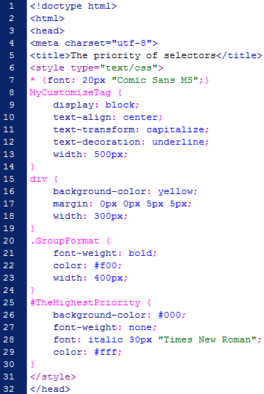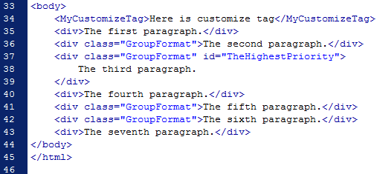

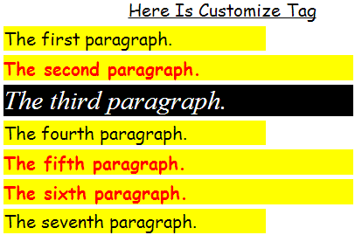

*Figure 2.1*

* 1. **Recognize odd and even element**

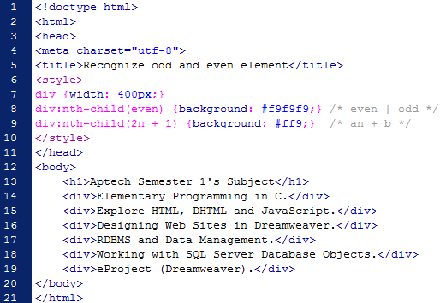

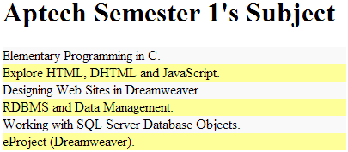

*Figure 2.2*

* 1. **Create product list with CSS3**



*Figure 2.3*

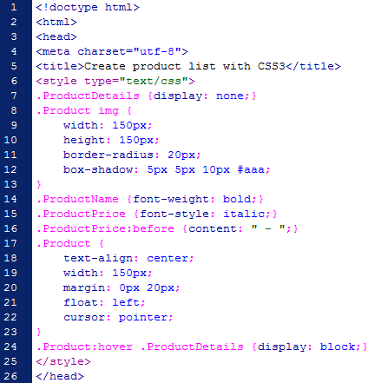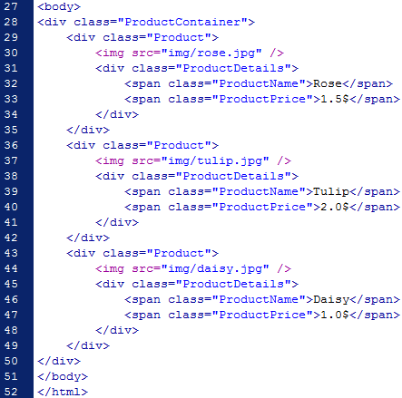

* 1. **The basic transform and transition**

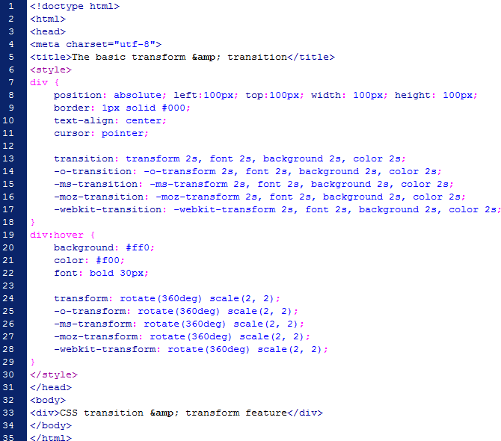

|  |  |  |
| --- | --- | --- |
|  |  |  |

*Figure 2.4*

* 1. **Using CSS3 transition to zoom in product image**

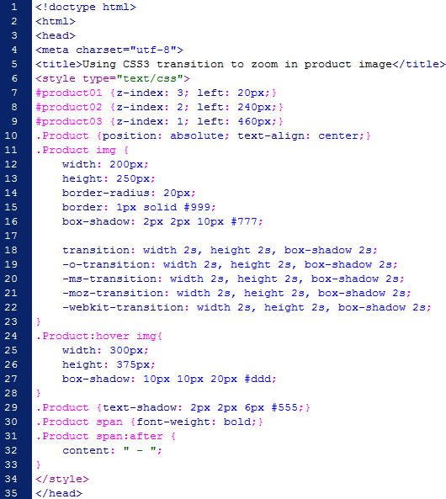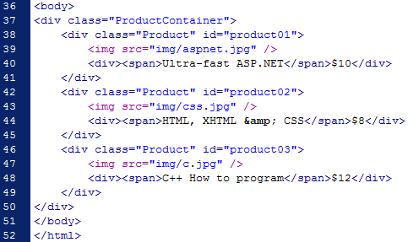

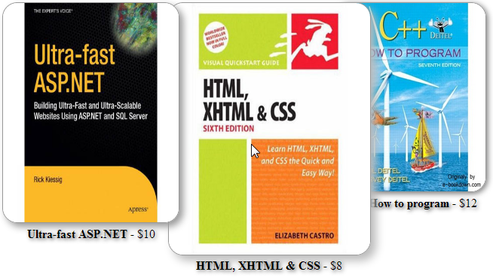

*Figure 2.5*