Lab 03

Displaying Graphics and CSS3 Animation&

Creating Navigational Aids and Division-Based Layout

1. **OBJECTIVES**

* Using CSS3 transform and transition.
* Create Navigation.
* Create slideshow and drop down menu.

1. **STEP BY STEP EXERCISES**
   1. **Create a menu as below**

Create LeftMenu.css file with the following code:

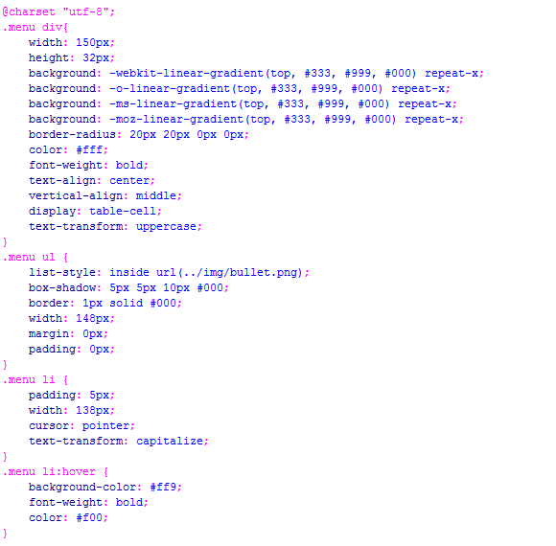

Create file .html to show such as Figure 3.1

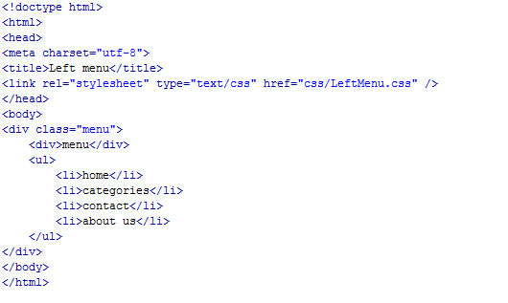

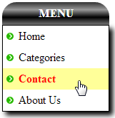

*Figure 3.1*

* 1. **Create drop down menu using CSS3 as below**

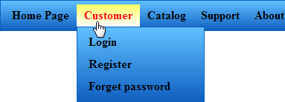

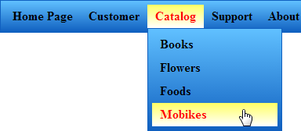



*Figure 3.2*

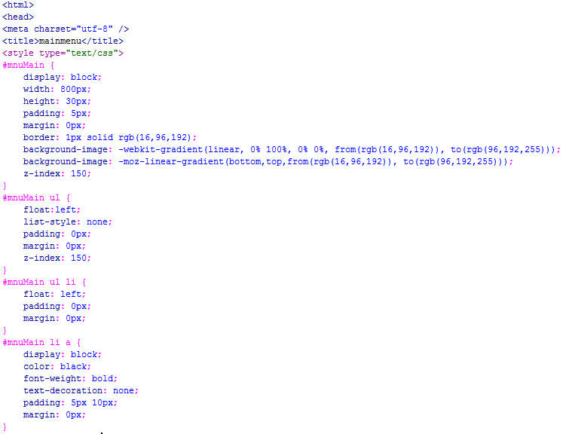

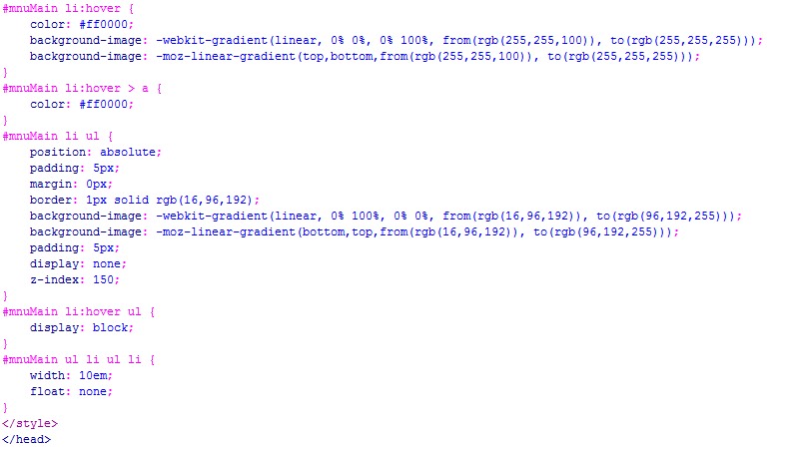

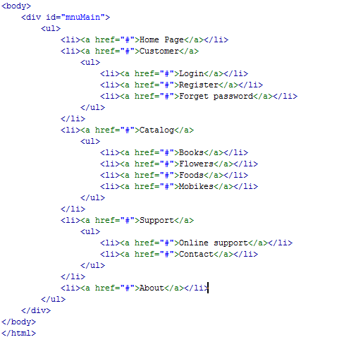

* 1. **Create scrolling product panel using CSS3 animation**

***Note:*** *The scrolling will be stopped when user move the pointer over the product panel.*

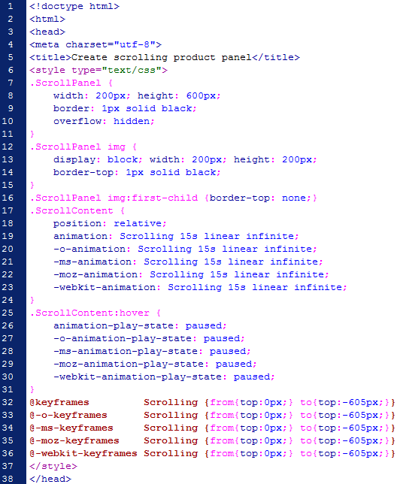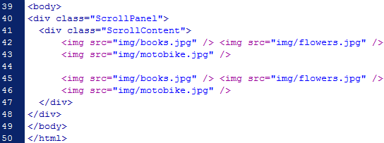



*Figure 3.3*

1. **EXTRA EXERCISES**
   1. **Using CSS3 animation to create a slideshow as below**

|  |  |  |
| --- | --- | --- |
|  |  |  |

*Figure 3.4*

Hint:

