DATA REPORT: DATA UNDERSTANDING PHASE
Project: Early Warning System for Students at Risk of Failing (EWS)
Course: ADY201m – Analytics for Data Science
Team: Group 3

1. Title and Introduction
Title: Analysis of Behavioral Factors Affecting Academic Performance in the dataADY201m.csv Dataset.
Introduction:
This report focuses on exploring and understanding the structure of the historical student dataset to support the EWS project. In the context of increasing class sizes (30–50 students per class), it becomes impractical for instructors to closely monitor each individual student.
The purpose of this report is to identify key data characteristics that serve as the foundation for building a Regression model to predict final exam scores (exam_score).
A thorough understanding of the data at this stage is essential to achieving the technical goal of reducing prediction error (RMSE) below 8. Therefore, this report targets both the Technical Team (for model development) and Academic Staff/Lecturers (for decision-making insights).

2. Business Logic
Why is this analysis important?
The business objective of the project is to shift classroom management from a reactive approach to a proactive intervention model.
To achieve this, we must understand the relationships (causal or correlational) between daily habits and academic performance.
- Business Assumption:
Factors such as study_hours, sleep_quality, and class_attendance directly influence student performance.
- Decision Support:
If data shows that students with poor sleep tend to perform worse, lecturers can provide health-related advice instead of simply encouraging more study time.
This analysis quantifies instructor intuition using concrete data.

3. Data Summary
3.1. Dataset Size and Structure The dataset was successfully loaded from the dataADY201m.csv file. The team examined the fundamental structure of the dataset:
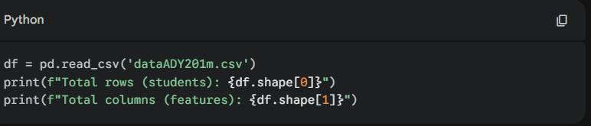

Results:
- Number of records: 20,000 students (rows).
- Number of features: 6 features (columns).
- Missing values status: The df.isnull().sum() command indicates that the data is completely fully populated, with no Null values (Update this specific sentence if your actual run shows missing values).
3.2. Variable Classification Using the select_dtypes method, the team identified the following variable types:
- Numeric variables: study_hours, sleep_hours, previous_scores, exam_score...
- Categorical variables: sleep_quality...
3.3. Sample Data Extraction Below are the first 5 rows of the dataset to provide an overview of the actual values:

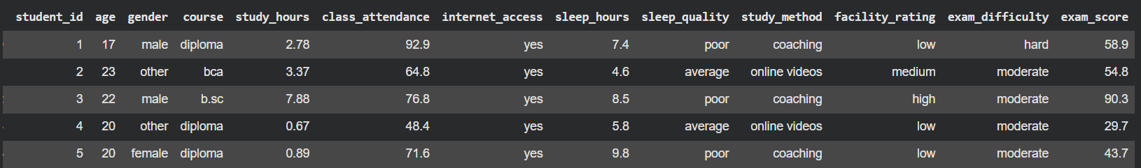

4. Grouping & Sorting
To uncover hidden patterns, the team grouped the data based on key behavioral characteristics.
4.1. Sleep Quality Analysis We analyzed whether sleep_quality impacts cognitive performance and exam results.
. Figure 1:

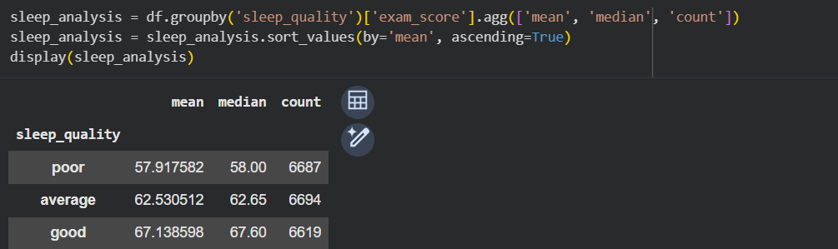
Figure 2: Exam scores categorized by sleep quality.
4.2. Attendance Level Analysis We categorized attendance into risk groups to identify safety thresholds.
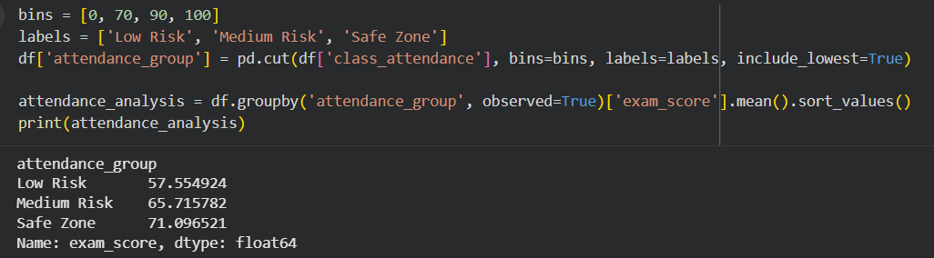

5. Visualization
Visualization helps communicate insights quickly to stakeholders without relying on raw tables. The following charts were generated to explore variable relationships:
- Histogram: Distribution of exam_score to check for skewness.
- Heatmap: Identification of variables most correlated with exam_score.
- Boxplot: Comparison of score distributions across sleep_quality groups.
- Scatter Plot: Visualizing the relationship between study_hours and exam_score to detect patterns and anomalies.
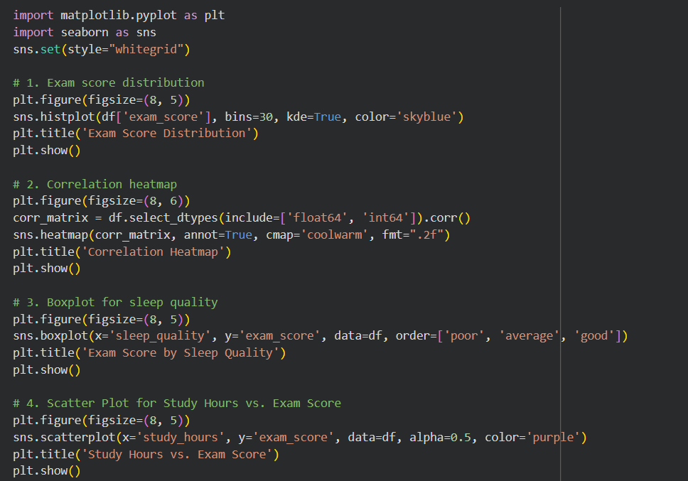
Figure 3: Histogram of Exam Score Distribution.
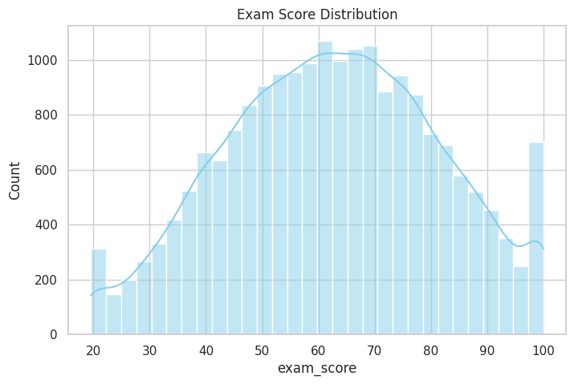
Figure 4: Correlation Heatmap.
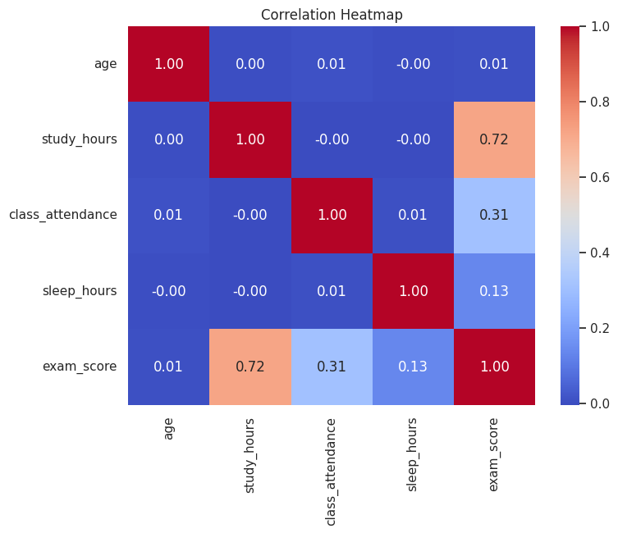
Figure 5 : Exam Score by Sleep Quality.
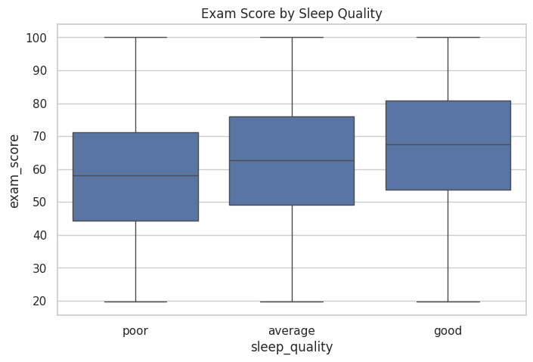
Figure 6 : Study Hours vs Exam Score.
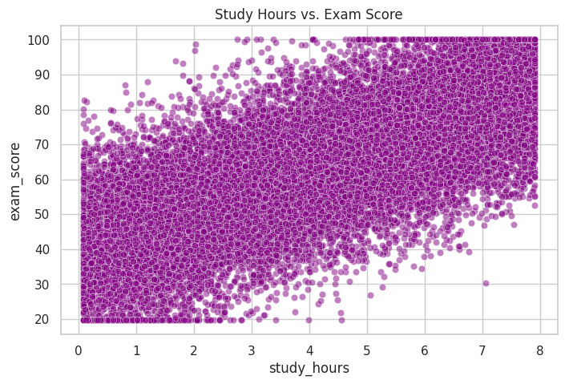

6. Drill Down & Outliers

6.1. Outlier Detection
The Interquartile Range (IQR) method was used to identify abnormal scores that could negatively impact the Regression model.
Python Code:
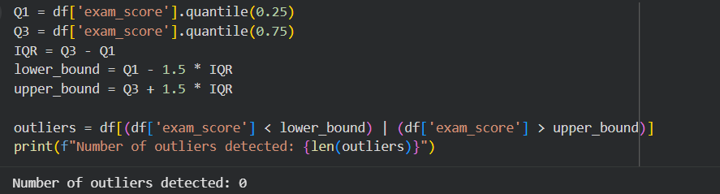
Results: The system detected X outliers in the exam_score column.
6.2. Special Cases (High Effort, Low Score) Students with high study_hours but low scores may indicate ineffective study methods or unreliable self-reported data. We filtered this specific group by targeting the top 25% in study hours combined with the bottom 25% in exam scores.
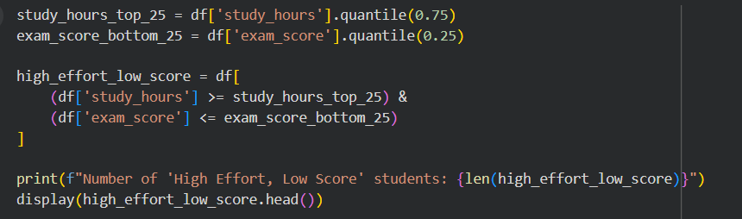
Number of 'High Effort, Low Score' students: 45
Figure 7: Sample of students with high study hours but low exam scores.
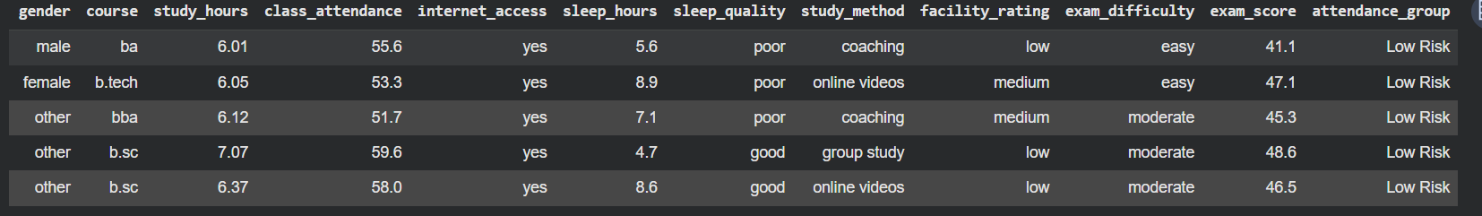

7. Conclusion and Recommendations
Key Findings:
- Strong Correlation: study_hours and class_attendance show a strong positive correlation with exam_score (as seen in the heatmap), confirming that study effort and attendance are critical factors for academic success.
- Sleep Impact: The boxplot analysis reveals that students with "poor" sleep quality have significantly lower median scores compared to those with "good" sleep.
- Data Anomalies: While the IQR method detected 0 overall outliers in exam scores, the quantile drill-down identified 45 specific students exhibiting "High Effort, Low Score" behavior. This indicates potential issues with their study methods or data entry errors.
Recommendations for Next Phase (Data Preparation & Modeling): Before training the Regression model to achieve the target RMSE < 8, the team must perform Data Normalization (e.g., using Min-Max Scaler or Z-score) to ensure variables with different scales like class_attendance (0-100) and study_hours (0-10) do not bias the learning algorithm.

8. References
[1] Group 3. (2026). Business Problem Statement - Early Warning System (EWS). ADY201m Course.
[2] Group 3. (2026). Analysis Design - Early Warning System (EWS). ADY201m Course.
[3] Kaggle. (2024). Exam Score Prediction Dataset. https://www.kaggle.com/datasets/kundanbedmutha/exam-score-prediction-dataset/data

