Mr. Meeseeks, a Search Engine

Have you ever had to find stuff on the internet, but only wanted to look through certain websites? Of course you have. Here’s one way to solve that problem, in Python 2.
Jokes...

Problem Description (from http://www.math.ucla.edu/~rombach/PIC16_project2.pdf):

Create a mini search engine. This engine uses a list of urls as its “internet”.
•Your engine needs to create a network based on links between the pages which will be in thesource code of any page)
•The engine understands the meaning of quotation marks.
•The engine does pagerank on the sub-network of the pages that contain the search term from the user, and then lists the first few, together with a small snippet of the text on the page. This should be a snippet that contains the highest concentration of the search term words.
•For starters, you may want to create some pages to form your own little internet as a test case.
•Your engine recognizes typos, and says “Did you mean...?” The suggestion it gives will be the word in its dictionary (for example: mieliestronk.com/corncob_lowercase.txt), that is closest to the search term.
Description of the SearchEngine class:

Let’s call an instance of the SearchEngine class SearchEngine_object
- SearchEngine initializes with a set of urls and a list of words as a “dictionary”.
- It then generates a network of links between the pages.
- It also cache the pages, both the source code and the text, so it doesn’t have to keep reading the page every time it wants to do something with the page.
  - The cached source codes are used for generating the network and for getting titles of each website.
  - The cached texts are used to query the SearchEngine and to get the snippets.
- When the user wants to find something in their mini-”internet”, he/she can query the SearchEngine instance.
  - The engine tries to catch misspelled words and asks the user if he/she wants to revise his/her query, while giving him/her a couple of likely options.
  - The engine prints out the results, ranked by the PageRank algorithm and grouped by relevancy. Each result consists of the url, the title, and a snippet of the page. The return value is a list of urls in the same order.
- The user can also:
  - Update the SearchEngine_object’s dictionary using the function update_dict(new_dict).
  - Refresh the SearchEngine_object’s cache by using the function refresh_cache(). This is useful when the pages in the “internet” changes.

Libraries Needed: urllib2, re, numpy
Pseudocode for each function:

function update_dict(new_dict)
Set the local dictionary to new_dict

function refresh_cache()
For each url in the “internet”
Read each page’s source code
Save it in a list, _cached_pages
Convert the page’s source code to readable text, using _strip_html()
Save it in another list, _clean_cached_pages
Generate the network

function_strip_html(txt)
Find each html tag in string txt using Regular Expression and delete it
Replace each whitespace in txt with a space (‘ ‘)

function _generate_network()
Initiate a numpy array of zeros, representing the number of links between pages
For each page in the “internet”
Get a list of urls in each page’s source code, again using RegEx
Change any relative url to its full url form
For each url in this new list
If the url is in our “internet”
Increment a connection in the right indices in our network
Return network

function query(input_query, num_results)
Split the input_query into quoted and unquoted components using the function _parse_search_query()
Checks for spelling error using function _find_closest()
If there is, asks if user wants to change their query
Get a list of ranked urls matching the query using the function _match_and_find_urls()
For each url in this list
Obtain and print the output (url, title, snippet(with _snippet()) for each url
Returns the list of ranked urls

function _parse_search_query(query)
Find the quoted component using RegEx
Find the unquoted component by removing quotation marks from query and split it by whitespace
Return lists of quoted and unquoted components

function _find_closest(misspelled)
Get a list of edit distances using helper function _dist()
Get the minimum edit distance
Return a list of words with the minimum edit distance

function _dist(word1, word2)
Initialize a matrix of edit distances from word1 to word2, each index (i,j) represent the minimum edit distance from word1[ : i ] to word2[ : j ]
For each row index matrix
For each column index in matrix
If row index == 0
matrix[row index, col index] = col
Else if col index == 0
matrix[row index, col index] = row
Else if last characters of word1 and word2 are the same
matrix[row index, col index] = matrix[row index-1, col index-1]
Else
Take the min of the above, left, and top left elements + 1
Return matrix[length of word1, length of word2]

function _match_and_rank_url(quoted, unquoted, num_results)
To get the ranks based on relevancy,
For each page in “internet”
Count number of number of unique matches for quoted and unquoted to get the ranks based on relevancy
If there are any matches, add the index of the page to a list of indices
Construct a subnetwork based on the set of indices using function _subnetwork()
Run PageRank on the subnetwork using function _pagerank()
Until we have at least n_results pages to return
Rank the pages based on PageRank and group the them by relevancy scores
Return only the top num_results pages

function _subnetwork(indices)
List comprehension for each element in indices twice, columns and rows

function _pagerank(N,p)
Cast the network N as a numpy array with float as the type of each element
Normalize N+p, where p is a small constant, call this N
Obtain eigenvectors and eigenvalues of N
Take absolute value of all eigenvalues
Find maximum eigenvalue, 1, and get its corresponding eigenvector, the scores
Return a list of corresponding ranks of the scores
function _normalize(net)
Divide each column in net by its own sum and return new network

function _snippet(index, quoted, unquoted)
Obtain the page from clean cache at index
If the page is too small
Split the page, by ‘\n’, into 2 lines and return it
#else
Use a moving window on the page and find the window that have the most matches
Split the window, by ‘\n’, into 3 lines and return it
Demo on an Artificially Constructed Network
Network: http://pic.ucla.edu/~dpnguyen/pic16/ (might be down temporarily)
Dictionary: http://mieliestronk.com/corncob_lowercase.txt

Code:
exec(open("./SearchEngine.py").read())
english_dict = urllib2.urlopen( 'http://mieliestronk.com/corncob_lowercase.txt').read().split()
# personal fake internet
urls = ''
for i in range(20):
urls += 'http://pic.ucla.edu/~dpnguyen/pic16/page%d.html ' %i

cool_engine = SearchEngine(urls,english_dict)

Network Visualization (20 nodes):
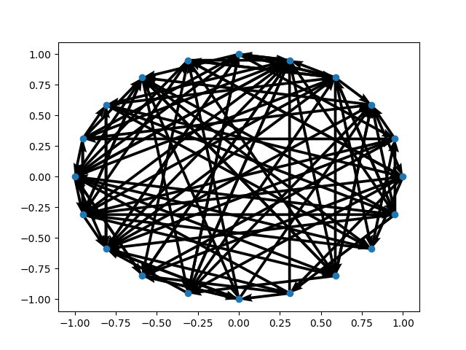

Sample Query Output for cool_engine.query('coffee "money" beans taes lef price', 5):

['clef', 'lea', 'leaf', 'led', 'lee', 'left', 'leg', 'let', 'ref']
It seems that you misspelled "lef". Some suggestions are displayed above?
Do you want to change your input for this word (y/n)>? y
To what? >? leaf
['tabs', 'tags', 'takes', 'tales', 'tames', 'tans', 'tapes', 'taps', 'tares', 'tars', 'taxes', 'tees', 'ties', 'toes', 'tues']
It seems that you misspelled "taes". Some suggestions are displayed above?
Do you want to change your input for this word (y/n)>? y
To what? >? bagteas
['bagels', 'baiters', 'bates', 'battens', 'batters']
It seems that you misspelled "bagteas". Some suggestions are displayed above?
Do you want to change your input for this word (y/n)>? n
http://pic.ucla.edu/~dpnguyen/pic16/page0.html
Wikipedia Finance
Economic history [show] v t e Finance is a field that deals with the study of investments. It
includes the dynamics of assets and liabilities over time under conditions of different degrees of uncertainty and risk.
Finance can also be defined as the science of money management. Finance aims to price
http://pic.ucla.edu/~dpnguyen/pic16/page10.html
Wikipedia Communist state
ne Transaction. p. 21. ISBN 978-0202362281. "Contrary to Western usage, these countries describe themselves as ‘Socialist’
(not ‘Communist’). The second stage (Marx’s ‘higher phase’), or ‘Communism’ is to be marked by an
age of plenty, distribution according to needs (not work), the absence of money
http://pic.ucla.edu/~dpnguyen/pic16/page5.html
Wikipedia Coffee
ins even though actual coffee beans are not added to it.[112][113] Instant coffee Main article: Instant coffee
Instant coffee A number of products are sold for the convenience of consumers who do not want
to prepare their own coffee or who do not have access to coffeemaking equipment. Instant coffee
http://pic.ucla.edu/~dpnguyen/pic16/page9.html
Wikipedia Privately held company
ot Corp., Deloitte Touche Tohmatsu (one of the members of the Big Four accounting firms), Hearst Corporation,
Cox Enterprises, S. C. Johnson, McWane, Carlson Companies, and Mars are among the largest privately held companies
in the United States. KPMG, the UK accounting firms Ernst & Young and Price
http://pic.ucla.edu/~dpnguyen/pic16/page12.html
Wikipedia Ethiopia
.[157][158] Coffee remains its most important export product, and with new trademark deals around the world
(including recent deals with Starbucks) the country plans to increase its revenue from coffee.[159] Most regard
Ethiopia's large water resources and potential as its "white oil" and its coffee

Return Value
['http://pic.ucla.edu/~dpnguyen/pic16/page0.html',
'http://pic.ucla.edu/~dpnguyen/pic16/page10.html',
'http://pic.ucla.edu/~dpnguyen/pic16/page5.html',
'http://pic.ucla.edu/~dpnguyen/pic16/page9.html',
'http://pic.ucla.edu/~dpnguyen/pic16/page12.html']

