HANOI UNIVERSITY OF SCIENCE AND TECHNOLOGY
School of Information and communications technology

Software Design Document
Version 1.3

AIMS Project
Subject: ITSS Software Development

Group 16
Nguyễn Huy Diễn – 20235910
Nguyễn Tiến Đạt – 20239715
Lê Hoàng Kiên – 20235958
Phạm Đức Phước – 20235988

Hanoi, June 2026
<All notations inside the angle bracket are not part of this document, for its purpose is for extra instruction. When using this document, please erase all these notations and/or replace them with corresponding content as instructed>
<This document, written by Prof. NGUYEN Thi Thu Trang, is used as a case study for student with related courses. Any modifications and/or utilization without the consent of the author is strictly forbidden>

Table of Contents

Table of Contents 4
1 Introduction 10
1.1 Objective 10
1.2 Scope 10
1.3 Glossary 11
1.4 References 11
2 Overall Description 12
2.1 General Overview 12
2.2 Assumptions/Constraints/Risks 16
2.2.1 Assumptions 16
2.2.2 Constraints 18
2.2.3 Risks 20
3 System Architecture and Architecture Design 23
3.1 Architectural Patterns 23
3.1.1 Layered Architecture (Macro-level) 23
3.1.2 Vertical Slice Architecture (for Payment subsystems & services) 24
3.1.3 Event-driven Decoupling 24
3.1.4 AOP-based cross-cutting concerns (Audit Logging) 24
3.1.5 Micro-level design patterns (summary) 25
3.2 Interaction Diagrams 26
3.2.1 Sequence Diagrams 26
3.2.2 Communication Diagrams 28
3.3 Analysis Class Diagrams 29
3.4 Unified Analysis Class Diagram 30
3.5 Security Software Architecture 30
3.5.1 Authentication (User Identity Validation) 30
3.5.2 Authorization (Functional Activity Access Control) 30
3.5.3 Encryption Protocol (Data Protection) 31
4 Detailed Design 32
4.1 User Interface Design 32
4.1.1 Screen Configuration Standardization 32
4.1.2 Screen Transition Diagrams 36
4.1.3 Screen Specifications 36
4.2 Data Modeling 76
4.2.1 Conceptual Data Modeling 76
4.2.2 Database Design 77
4.3 Non-Database Management System Files 88
4.4 Class Design 89
4.4.1 General Class Diagram 89
4.4.2 Class Diagrams 90
4.4.3 Class Design 98
Table 1. Attribute design 104
Table 2. Operation design 106
Table 1. Attribute design 107
Table 2. Operation design 107
Table 1. Attribute design 108
Table 2. Operation design 108
Table 1. Attribute design 109
Table 2. Operation design 109
Table 1. Attribute design 110
Table 2. Operation design 110
Table 1. Attribute design 111
Table 2. Operation design 111
Table 1. Attribute design 112
Table 2. Operation design 112
Table 1. Attribute design 113
Table 1. Attribute design 113
Table 2. Operation design 113
Table 1. Attribute design 115
Table 2. Operation design 115
Table 1. Attribute design 117
Table 2. Operation design 117
Table 1. Attribute design 118
Table 2. Operation design 118
Table 1. Attribute design 119
Table 2. Operation design 119
Table 1. Attribute design 120
Table 2. Operation design 120
Design for class “PayPalGatewayFacade” 5
4.4.4 Table 1. Attribute design 5
4.4.5 Table 2. Operation design 5
Design for classes “PayPalOrdersClient”, “PayPalPaymentsClient”, “PayPalAuthClient”, “PayPalAmountConverter” 7
4.4.6 Table 1. Attribute design 7
4.4.7 Table 2. Operation design 8
4.4.8 request : PayPalApiModel.CreateOrderRequest / RefundRequest — built by PayPalGatewayFacade, never by the AIMS core. 9
4.4.9 vndAmount : Long — e.g. 250 000 VND with the default rate (25 000) converts to “10.00”. 9
4.4.10 PayPalApiException (package-private) if PayPal returns a non-2xx HTTP response or an empty access token; caught and re-thrown as PaymentException by PayPalGatewayFacade only. 9
4.4.11 Each client targets exactly one PayPal API group (Orders / Payments / OAuth) instead of one monolithic client — preserves functional cohesion and SRP (see Cohesion & SRP table, item 1). 9
4.4.12 PayPalAmountConverter keeps the VND↔currency conversion a gateway-only concern; the AIMS core continues to think purely in VND. 9
4.4.13 Covered by the PayPalGatewayFacade subsystem sequence diagram above; no separate diagram needed. 9
5 Design Considerations 10
5.1 Goals and Guidelines 10
5.2 Architectural Strategies 13
5.3 Design and Program Evaluation 17
5.3.2 Coupling & Other SOLID 21
5.4 Design Patterns 23

List of Figures
Figure 1. AIMS Use Case Diagram 11
Figure 2. AIMS Purchase Process 12
Figure 3. AIMS Product Management Process 13
Figure 4. AIMS Administration Process 14
Figure 5. UC Place Order Sequence Diagram 25
Figure 6. UC Pay Order Sequence Diagram 26
Figure 7. UC Place Order Communication Diagram 27
Figure 8. UC Pay Order Communication Diagram 27
Figure 9. UC Place Order Analysis Class Diagram 28
Figure 10. UC Pay Order Analysis Class Diagram 28
Figure 11. Screen Transition Diagram for AIMS System 35
Figure 12. Entity-Relationship Diagram for AIMS System 75
Figure 13. Database Design for AIMS System 78

List of Tables
Table 1. Example of table design 10
Table 1. Example of attribute design 12
Table 1. Example of operation design 12
Table 4. Example of attribute design 14

Introduction

Objective
The purpose of this Software Design Document (SDD) is to describe the architectural design, detailed design, and implementation strategies of the AIMS (An Internet Media Store) system. This document presents the software structure, design decisions, data organization, class design, interaction mechanisms, and architectural patterns used to develop the system.
The SDD serves as a technical blueprint for the implementation and maintenance of the AIMS system. It provides detailed descriptions of the system architecture, database design, user interface design, security mechanisms, and software components to ensure that the software is developed consistently and systematically according to the requirements specified in the Software Requirements Specification (SRS).
In addition, this document explains the design considerations adopted to improve software quality attributes such as maintainability, extensibility, scalability, low coupling, and high cohesion. It also presents the application of SOLID principles and software design patterns to support future requirement changes, including the integration of new product types, payment gateways, shipping fee calculation strategies, and notification delivery methods.
The intended audiences of this document include:
- Developers and maintainers who implement, extend, and maintain the system;
- Testers and quality assurance personnel who validate the correctness of the implementation;
- Project supervisors and instructors who evaluate the software architecture and design quality;
- Future developers and stakeholders who need to understand the internal structure and design rationale of the system.
This document acts as a reference throughout the software development lifecycle and supports future system enhancement and refactoring activities.

Scope
The software product to be described in this document is called AIMS (An Internet Media Store), an e-commerce software that supports the buying and selling of physical media products. The system supports several types of physical media products including Books, Newspapers, CDs, and DVDs. Customers can browse for products, add products to a virtual shopping cart, and place orders for their purchases. Besides, the system also provides administrative features for users to manage products, orders, and users. In particular, the Product Manager can add, update, remove products, or manage stock, whereas the Administrator can manage user accounts and system roles.
The system aims to provide a convenient platform for purchasing media products while ensuring efficient product management and order processing. It also integrates payment services to support secure transaction processing.

Glossary
<Listing and explaining the terms appearing in the software’s profession and this document. Any assumption of the reader’s prior knowledge or experience on the subject is ill advised>

References
Centers for Medicare & Medicaid Services. (n.d.). System Design Document Template. Retrieved from Centers for Medicare & Medicaid Services: https://www.cms.gov/Research-Statistics-Data-and-Systems/CMS-Information-Technology/XLC/Downloads/SystemDesignDocument.docx

<Listing the referenced material used in this document, including the one related to the project>

Overall Description

General Overview
AIMS (An Internet Media Store) is a web-based e-commerce platform for the retail of physical media products – Books, Newspapers, CDs, and DVDs. The system supports two primary user-facing roles: the Customer, who browses, purchases, and tracks orders; and the Product Manager, who maintains the product catalog and processes orders. A third role, the Administrator, manages user accounts, roles, and system access. Two external payment service actors are also integrated: VietQR (QR-code-based bank transfer) and PayPal (credit card processing).
Software Architecture Overview
The system follows a client-server architecture with a clear separation between the frontend and backend tiers:
- Frontend: A single-page application built with React and TypeScript, responsible for rendering the user interface and communicating with the backend via RESTful HTTP APIs.
- Backend: A Java Spring Boot application organized into layered packages (controller → service → repository), handling all business logic, data persistence (PostgreSQL via Spring Data JPA), and integration with external payment gateways.
The backend is structured around the key domain entities: Product (with subtypes Book, CD, DVD, Newspaper), Order, OrderItem, Cart, and User. Design patterns, including Strategy, Registry, Factory, Builder, and AOP-based audit logging, are applied throughout the backend to enforce extensibility and separation of concerns, as detailed in Section 5.
Design Goals
The key design goals driving architectural decisions are:
- Extensibility: the system must accommodate new product types and new payment methods without requiring changes to existing components (Open/Closed Principle).
- Separation of concerns: controllers own only the HTTP boundary; all business logic resides in the service layer.
- Maintainability: high cohesion within classes and loose coupling between modules, with design patterns applied to eliminate switch/if-else chains over product type hierarchies.
- Auditability: all significant state changes (product creations, edits, deletions) are logged with actor identity and timestamp.
System Context – Use Case Diagram
The following Use Case Diagram, carried over from the SRS (with no structural changes), summarizes all system capabilities and the actors that interact with them.
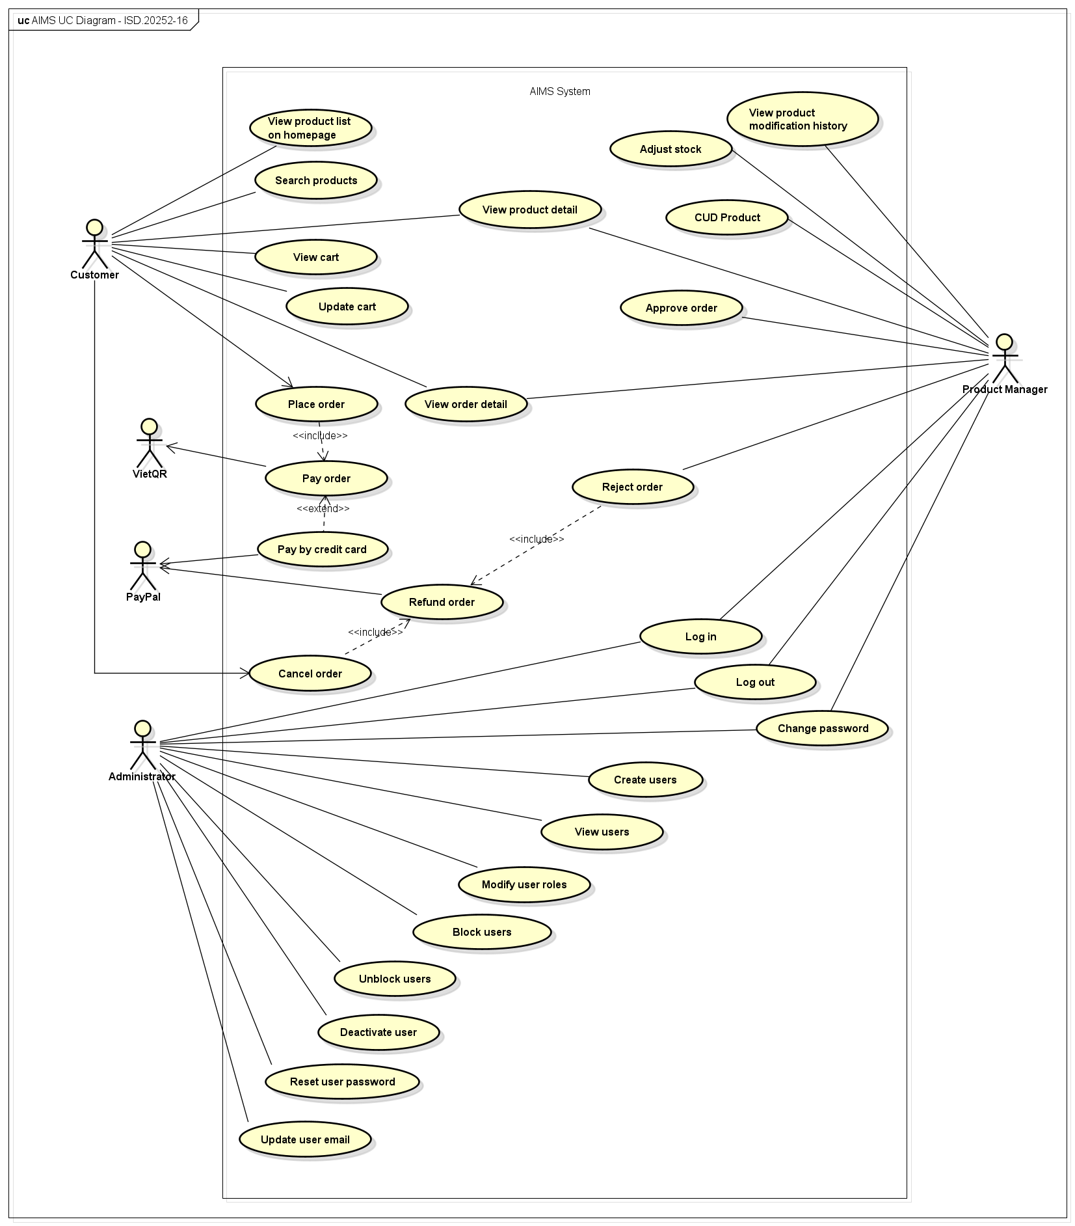
Figure 1. AIMS Use Case Diagram
The diagram identifies three human actors (Customer, Product Manager, Administrator) and two system actors (VietQR, PayPal), and maps them to the full set of use cases across the purchase, product management, and administration processes.
Business Process Activity Diagrams
The SRS identified three core business processes. These are reproduced below unchanged, as the implementation design does not alter the high-level process flows.
- Purchase Process
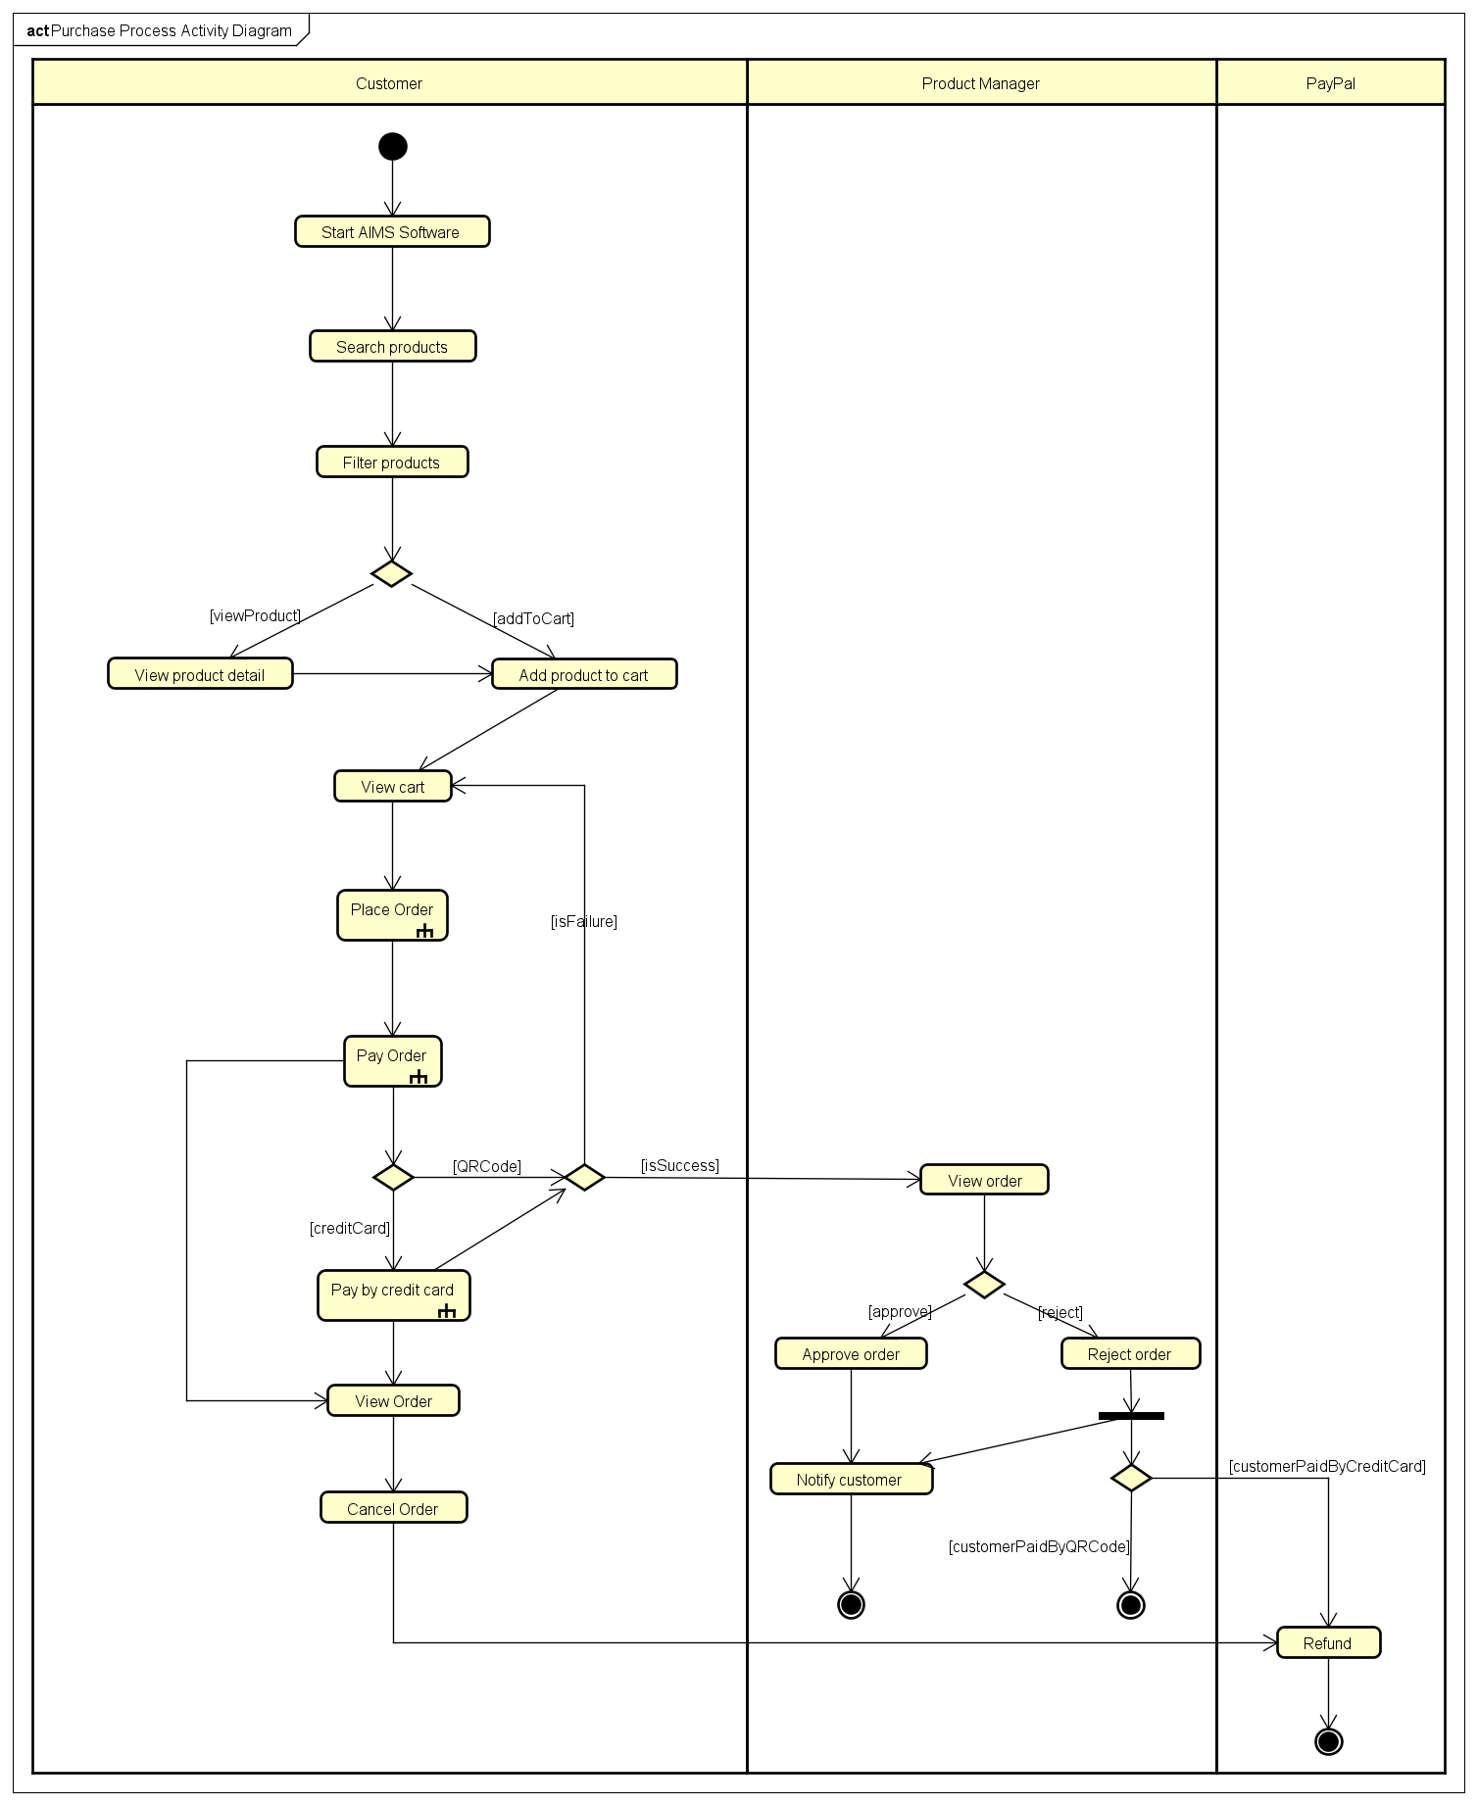
Figure 2. AIMS Purchase Process
The Purchase Process covers the end-to-end customer journey from product discovery through payment and order confirmation. After placing an order, the Product Manager reviews and either approves or rejects it; rejection via credit card triggers a PayPal refund.
- Product Management Process
The Product Management Process covers all catalog maintenance activities available to the Product Manager after login: searching, creating, updating, and deleting products, adjusting stock levels, and viewing product modification history.
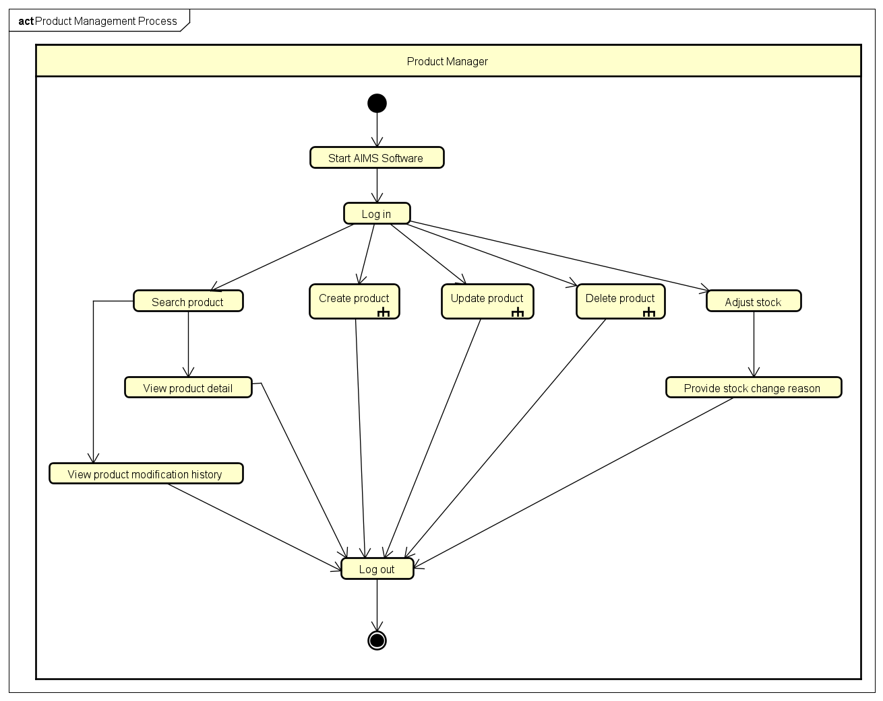
Figure 3. AIMS Product Management Process
- Administration Process
The Administration Process covers user account lifecycle management by the Administrator: creating users, viewing users, modifying user status (block, unblock, deactivate), managing user roles (assign, modify), and resetting passwords.
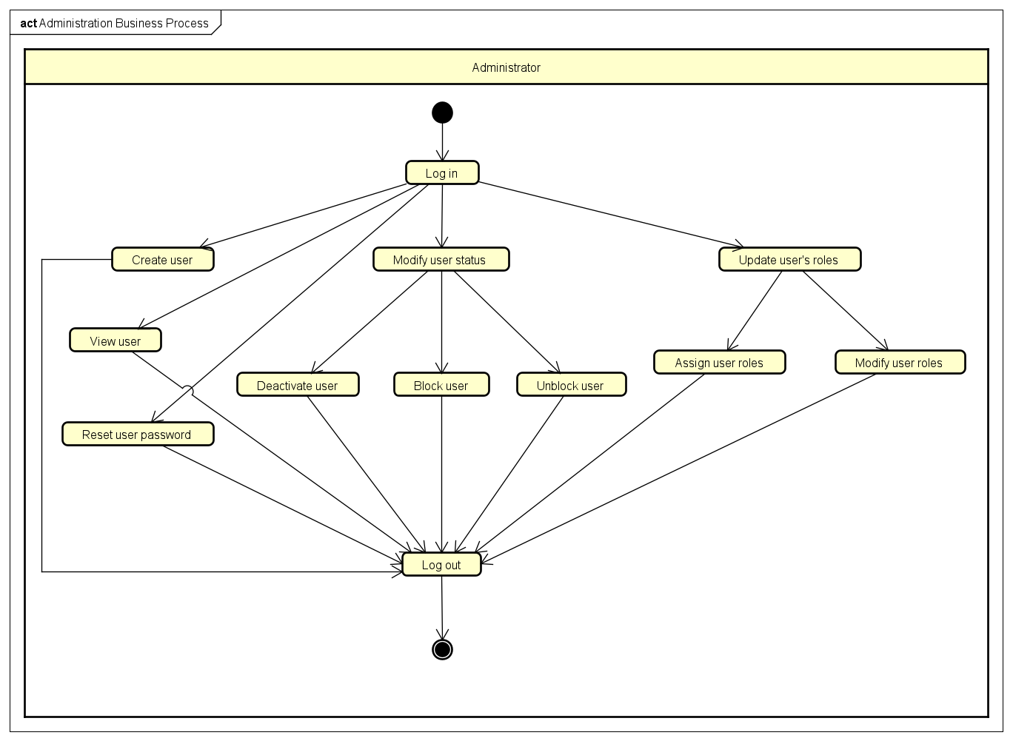
Figure 4. AIMS Administration Process
A note on diagram updates: Little structural changes have been made to the use case diagram or business process activity diagrams from the SRS, only some minor refinements have been made to better reflect the problem statement. The only refinements in the SDD arise at the detailed design level, specifically the addition of the Approve/Reject Order flow visible in the Purchase Process diagram, and the audit logging requirement that links Product Management back to the product modification history use case.

Assumptions/Constraints/Risks

Assumptions
The following assumptions have been made during the design of the AIMS system. These assumptions form the basis upon which design decisions were made; if any of them prove incorrect, some design decisions may need to be revisited.
- End-user environment
Customers are assumed to access the system through a modern web browser (Chrome, Firefox, Edge, Safari) on desktop or mobile devices. No native mobile application is required within the scope of this project.
Customers are assumed to have basic familiarity with e-commerce workflows: adding products to a cart, entering a delivery address, and completing a payment. No onboarding tutorial is in scope.
Product Managers and Administrators are assumed to be internal staff operating from a trusted network, on a desktop browser. They are not assumed to be technically skilled beyond what is required to operate a standard business web interface.
No login is required for customers. All customer-facing browsing, cart management, and order placement features are available to anonymous users.
- Related software and infrastructure
The system is assumed to be deployed on a server environment capable of supporting up to 1,000 concurrent users with a response time under 2 seconds under normal load and under 5 seconds during peak hours.
A PostgreSQL relational database is assumed to be available and is the sole persistent data store. No secondary caches, message brokers, or external data stores are assumed to be in scope for the initial version.
The VietQR and PayPal Sandbox APIs are assumed to be available and reachable from the backend server during development and demonstration. Their behavior is assumed to match the specifications provided in the official API documentation referenced in the Problem Statement.
Email delivery is assumed to be handled by an external SMTP service. The system generates and dispatches notification emails (order confirmation, approval/rejection, cancellation) but does not own the email infrastructure.
- Payment and refund behavior
VietQR payment is assumed to follow the sandbox callback model: a test callback API call simulates a successful bank transfer. No real fund movement occurs in the demonstration environment.
PayPal Sandbox is assumed to support the full order capture and refund API cycle. Automated refunds on order rejection or customer cancellation are only implemented for PayPal-paid orders. For VietQR-paid orders, no automated refund is triggered; the Product Manager is assumed to handle these manually outside the system.
- Product and business rules
The four product types in scope, Book, CD, DVD, and Newspaper, are assumed to have stable data schemas for the duration of this project. The architecture is designed to accommodate new types without modifying existing components, but no new types are required to be implemented.
All product prices are assumed to be stored and displayed in Vietnamese Dong (VND). A 10% VAT is always applied on top of the current price when presenting totals to the customer. Shipping fees are not subject to VAT.
Delivery addresses are assumed to be within Vietnam. The delivery fee calculation rules (Hanoi/HCMC vs. elsewhere, weight tiers) are assumed to remain fixed as specified in the Problem Statement.

Constraints
The following constraints impose fixed boundaries on the design and implementation of the AIMS system. Unlike assumptions, these are not open to interpretation but rather they are hard requirements, external mandates, or environmental facts that the design must work within.
- Hardware and software environment
The backend must be implemented in Java with Spring Boot. The frontend must be implemented in React with TypeScript. These technology choices are mandated by the course and can only be substituted with other technologies that support Object-Oriented Programming.
PostgreSQL is the required database management system. The data model and persistence layer must be designed accordingly, including reliance on JPA/Hibernate for ORM and Spring Data JPA for repository abstraction.
The system must run on a standard server environment accessible via the public internet or a local network during demonstration. No specialized hardware (GPU, dedicated load balancer, custom appliance) is assumed or required.
- Performance requirements
The system must support up to 1,000 concurrent users without significant performance degradation.
Response time must not exceed 2 seconds under normal conditions and 5 seconds during peak load. This constrains the design to avoid computationally expensive operations on the request thread; in particular, notification dispatch and audit logging must not block the primary transaction path.
The system must be capable of continuous operation for at least 300 consecutive hours without failure, and must recover to normal operation within 1 hour of any incident.
- Interoperability and interface/protocol requirements
Payment processing must integrate exclusively with VietQR (QR-code bank transfer) and PayPal Sandbox (credit card). Both integrations communicate over HTTPS REST APIs using the authentication and request formats defined in their respective official documentation. No other payment gateways are in scope.
The VietQR integration requires obtaining a short-lived access token (valid for 300 seconds) before each QR generation request. The system must handle token expiry correctly and re-request tokens as needed.
The frontend and backend communicate exclusively via RESTful HTTP APIs (JSON over HTTPS). No WebSocket, gRPC, or other communication protocol is in scope.
Order and transaction notification emails must be sent to the customer's provided email address. The system depends on an external SMTP provider for delivery; the internal design is constrained to producing well-formed email content and delegating dispatch.
- Security requirements
All user passwords must be securely hashed before storage. Plaintext passwords must never be persisted or accessible to any user, including Administrators. Administrators may trigger a password reset process but cannot retrieve or view a user's existing password.
Sensitive administrative actions, such as password resets and email updates, must be logged with the actor's user ID and timestamp, and the affected user must be automatically notified.
Product Managers and Administrators must authenticate via login before accessing any management features. Customer-facing features require no authentication.
- Data integrity and business rule constraints
Every product barcode must be globally unique across the entire database. The system must enforce this at both the application and database constraint levels.
The current price of any product must always remain between 30% and 150% of its original value. The system must reject any update that would violate this range.
Product Managers may not delete more than 20 products per day. Products with stock greater than zero cannot be hard-deleted; they must be deactivated instead. The system must enforce both rules and include the count of deactivated products in operation summaries.
Up to 10 products may be selected for deletion in a single operation.
Orders in the Pending Processing state are the only ones eligible for customer cancellation or Product Manager approval/rejection. State transition rules must be enforced by the system and cannot be bypassed via direct API calls.
Refunds are only automated for PayPal-paid orders. For VietQR-paid orders that are cancelled or rejected, the system must notify the Product Manager that a manual refund is required; no automated fund transfer is triggered.
- Data repository and distribution
All persistent data resides in a single PostgreSQL instance. No distributed database, replication topology, or read replica is in scope. This constrains horizontal scalability but is acceptable within the course project context.
Product audit history (creation, update, deletion events) must be permanently stored and queryable by Product Managers through the system interface. This is a retention requirement; audit records must not be purged on a rolling basis.
- Capacity constraints
Product Manager order review pages display 30 pending orders per page. This is a fixed display constraint defined in the Problem Statement.
The homepage displays 20 random products on initial load for customers. This is a fixed presentation constraint.
- Licensing and academic constraints
The PayPal and VietQR integrations are implemented against sandbox/test environments only and are for demonstration purposes. No real financial transactions occur. The system must not be deployed in a production context with live payment credentials within the scope of this course.
All design decisions must be defensible in terms of SOLID principles, coupling and cohesion levels, and design pattern application, as these are explicit course evaluation criteria. This constrains the design toward well-structured, documented patterns even in cases where a simpler implementation might suffice.

Risks
The following risks have been identified as having a meaningful probability of impact on the system design, implementation quality, or project delivery. Each entry describes the nature of the risk, its potential impact, and the mitigation strategy applied or planned.
Table 1. Risk Category & Mitigation Strategy
Risk Category | Description | Mitigation strategy
External API Dependencies (Payment Gateways) | The system depends on two third-party sandbox APIs (VietQR and PayPal) for payment processing. These services may be unavailable during development, testing, or the final demonstration due to network issues, sandbox downtime, or API changes.  → Core purchase flow cannot be demonstrated end-to-end. Order placement and payment confirmation are blocked. | Payment gateway integrations are isolated behind a gateway interface in the service layer. If a sandbox is unreachable, the team can substitute a local stub that simulates a successful response, without touching any other part of the system. Token expiry handling for VietQR (300-second lifetime) is explicitly implemented to reduce one common failure mode.
Data Concurrency & Inventory | The system is required to support up to 1,000 concurrent users. Under concurrent load, two customers may simultaneously attempt to purchase the last unit of a product, or a Product Manager may update a price concurrently with a customer placing an order.  → Overselling (orders accepted beyond available stock), or price inconsistency between the displayed invoice and the recorded order. | Stock availability is checked within a database transaction immediately before order confirmation. Spring's @Transactional combined with PostgreSQL's default row-level locking provides protection against the most common race conditions at the expected concurrency level. The invoice is generated and temporarily saved at the point the customer proceeds to payment, capturing the price at that moment. JPA @Version annotations are implemented on core entities. If a concurrent modification occurs, the transaction will fail safely, prompting the user to refresh their cart rather than processing an invalid financial transaction.
Database Performance | Inefficient database access patterns, excessive object loading, or unnecessary service dependencies may reduce system performance as the application grows.  → Impact: Under peak load of 1000 concurrent users, lazy-loading relational data could severely degrade response times beyond the 5-second maximum. | Query Optimization: The Data Access (Repository) layer utilizes JPA JOIN FETCH queries and carefully mapped boundaries for aggregate roots. Heavy, bulk read operations will bypass deep ORM entity mapping where necessary to preserve memory and connection pool limits.
Team coordination | The project is developed collaboratively within a limited academic schedule. Inconsistent coding styles, architectural misunderstandings, or merge conflicts may affect project quality and progress. | Establish coding conventions and architectural guidelines; Use version control and regular code reviews; Maintain consistent documentation and communication among team members.
VietQR refund gap | VietQR does not provide a refund API. When a VietQR-paid order is cancelled by the customer or rejected by the Product Manager, no automated refund can be issued.  → Customers who paid via VietQR receive no automated reimbursement. Without a clear process, this creates a poor customer experience and a potential dispute. | The system explicitly detects the payment method at the point of cancellation or rejection and, for VietQR orders, sends a notification to the Product Manager flagging that a manual refund is required. This is documented as a known limitation in both the Problem Statement and the SRS, and is an accepted constraint within the course scope rather than a design defect.

System Architecture and Architecture Design
The architectural design of AIMS followed an iterative, requirements-driven process. The starting point was the use case model and business process diagrams from the SRS, from which the major functional subsystems (product catalog, order lifecycle, payment processing, notification, and audit logging) were identified. For each subsystem, the team analyzed the volatility of requirements (e.g., new product types, new payment methods, new notification channels), identified the extension points that needed to be protected, and selected architectural patterns accordingly. The resulting architecture was then validated against SOLID principles and refactored where violations were found. The patterns applied, and the reasoning behind each, are described in Section 3.1 below. Detailed class-level design arising from these patterns is documented in Section 4.4.

Architectural Patterns
AIMS applies architectural patterns at two levels: the macro-level (overall system organization) and the micro-level (individual subsystem structure). The following patterns are in use.

Layered Architecture (Macro-level)
The system is organized into four horizontal layers, applied uniformly across both the frontend and the backend.
On the backend, the layers are:
- Presentation layer: Spring MVC REST controllers. Responsible solely for parsing HTTP requests, invoking the service layer, and serializing responses. No business logic resides here.
- Service layer: Spring @Service components. Owns all business rules, orchestration, and transaction management. This is where design patterns (Strategy, Template Method, Factory, Registry) are applied.
- Repository layer: Spring Data JPA repositories. Responsible for all database access. No query logic escapes this layer into the service layer.
- Domain layer: JPA entity classes, value objects, and enumerations representing the core business concepts (Product hierarchy, Order, Cart, User, etc.).
On the frontend, the layers are:
- Screen layer: React page components acting as thin orchestrators. They hold no business logic and delegate all data operations to the service layer.
- Component layer: Reusable UI components (ProductFormSection hierarchy, shared order components) with no direct API knowledge.
- Service layer: TypeScript service objects (ProductManagementService, OrderService, etc.) that own all HTTP communication with the backend.
Rationale: Layered architecture enforces a single direction of dependency (each layer depends only on the one below it), makes responsibilities unambiguous, and allows each layer to be tested or replaced independently. The constraint that controllers own only the HTTP boundary and all business logic lives in the service layer is a direct consequence of this pattern and is applied without exceptions throughout the codebase.

Vertical Slice Architecture (for Payment subsystems & services)
Within the payment subsystem, rather than forcing both payment methods into a single unified strategy interface, each payment method (VietQR, PayPal) is organised as a self-contained vertical slice under its own package (*.payment.vietqr, *.payment.paypal). Each slice owns its own controller endpoint, service logic, and gateway client.
A pair of shared contracts (IQRPaymentGateway and IRedirectPaymentGateway) are defined in the services.payment.contract package, representing the two structurally distinct interaction models (poll-based QR vs. redirect-and-capture). These interfaces are defined by the application layer and implemented by each slice, following the Dependency Inversion Principle.
Rationale: VietQR and PayPal differ structurally: VietQR generates a QR code and polls for a callback confirmation, while PayPal redirects the user to an external page and captures payment on return. Forcing a single interface over both flows would require one or both implementations to expose methods they do not use, a violation of the Interface Segregation Principle. Vertical slices provide package-level OCP (each new payment method is a new slice, not a modification of existing ones) and SRP (each slice is responsible for exactly one payment method). This trade-off is discussed further in Section 5.2.

Event-driven Decoupling
Post-state-transition side effects (notification emails and refund triggers) are decoupled from the order state transition itself via Spring application events (e.g. OrderSuccessEvent, OrderCancelledEvent). These events are published after the originating transaction commits, and handled by Transactional Event Listener methods.
Rationale: Without event-driven decoupling, the Service class would need to directly invoke the notification service and the refund service, accumulating dependencies and fan-out coupling. Events invert this relationship: the Service publishes a fact about what happened; downstream handlers react independently. This satisfies OCP at the service level, adding a new side effect (e.g., an SMS notification) requires only a new listener, not a modification to the service class.

AOP-based cross-cutting concerns (Audit Logging)
Audit logging for product and admin operations is implemented as an AOP advice triggered by custom annotations. The advice intercepts annotated service methods, captures the method arguments and return value, constructs an Audit Log record, and persists it, entirely outside the annotated method's own logic.
Rationale: Audit logging is a cross-cutting concern: it is required on every crucial product and admin operation but has nothing to do with the business logic of creating or updating a product. Weaving it in via AOP avoids polluting every service method with logging boilerplate, keeps the service methods focused on their primary responsibility (SRP), and allows the logging behavior to be modified or extended without touching business logic.

Micro-level design patterns (summary)
Beyond the structural patterns above, several classical GoF design patterns are applied within individual subsystems to eliminate type-switch dispatch and enforce extensibility at the class level. These include the Strategy and Registry pattern (delivery fee calculation, product type dispatch, notification channel routing, refund dispatch), the Template Method pattern (shared payment finalization sequence), the Builder pattern (Product entity construction and selective mutation), and the Factory pattern (polymorphic product mapping and notification message building). The full rationale and implementation details for each are covered in Section 5.4 Design Patterns.

Interaction Diagrams

Sequence Diagrams
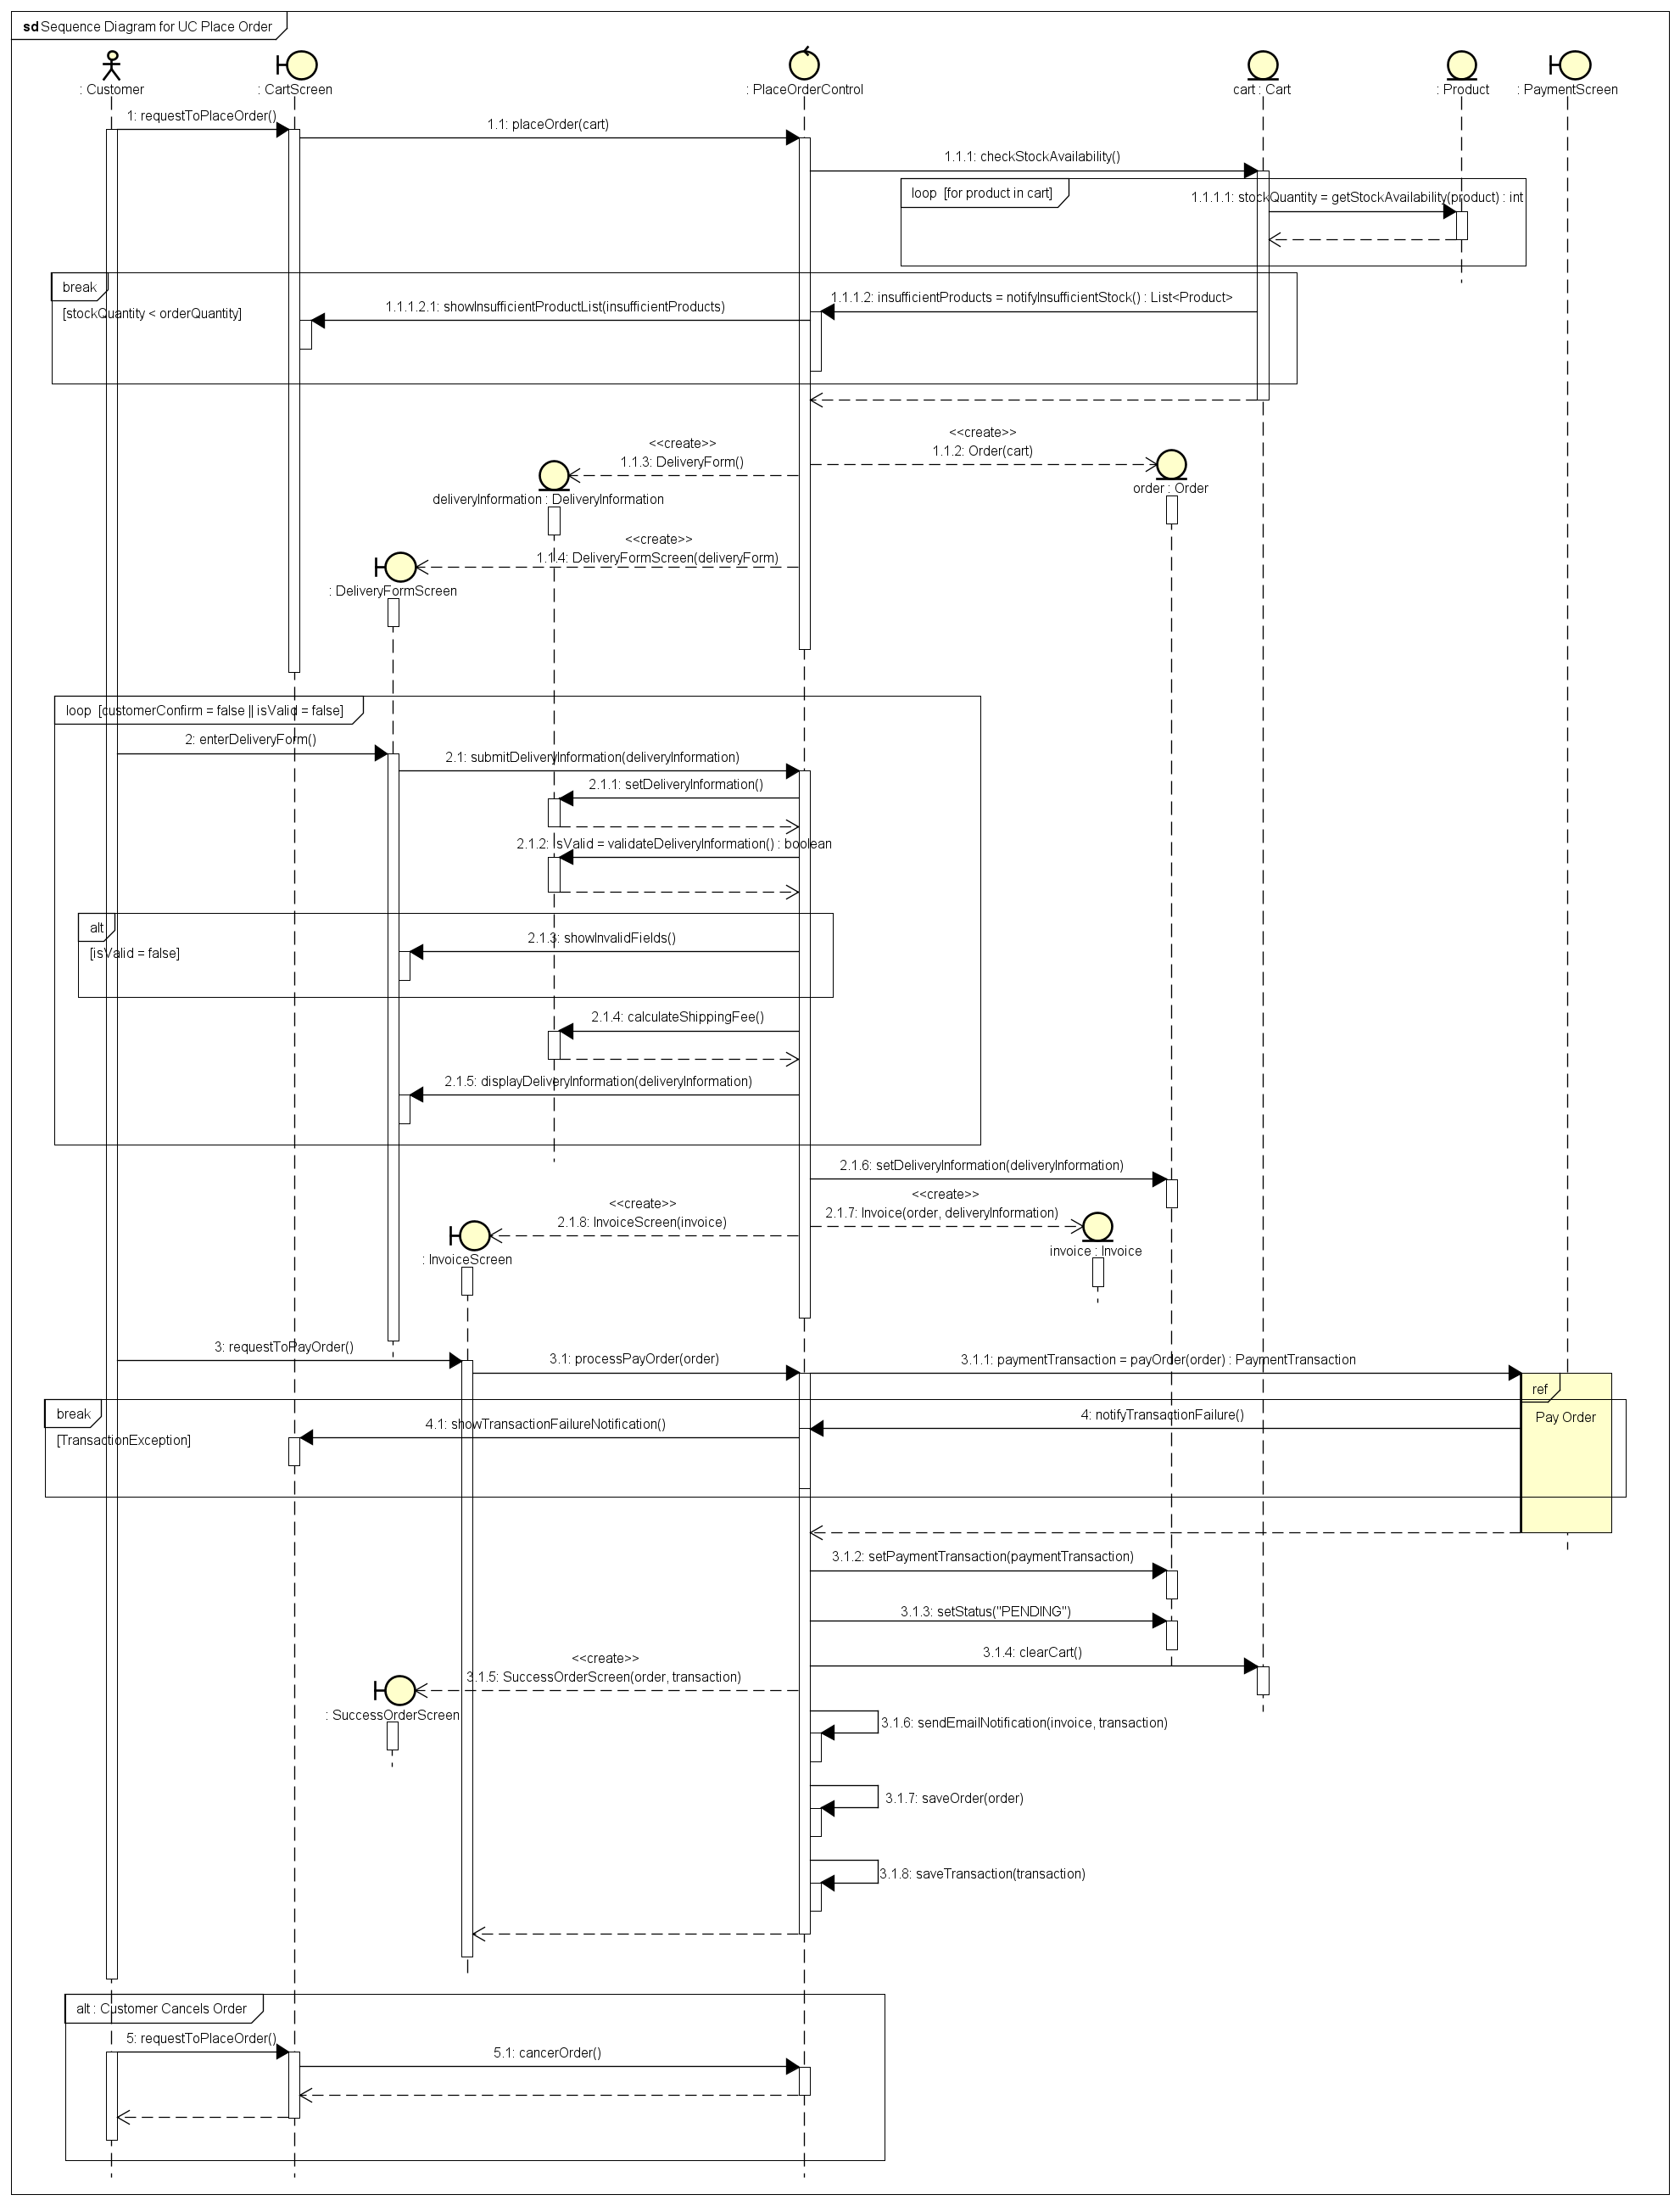
Figure 5. UC Place Order Sequence Diagram
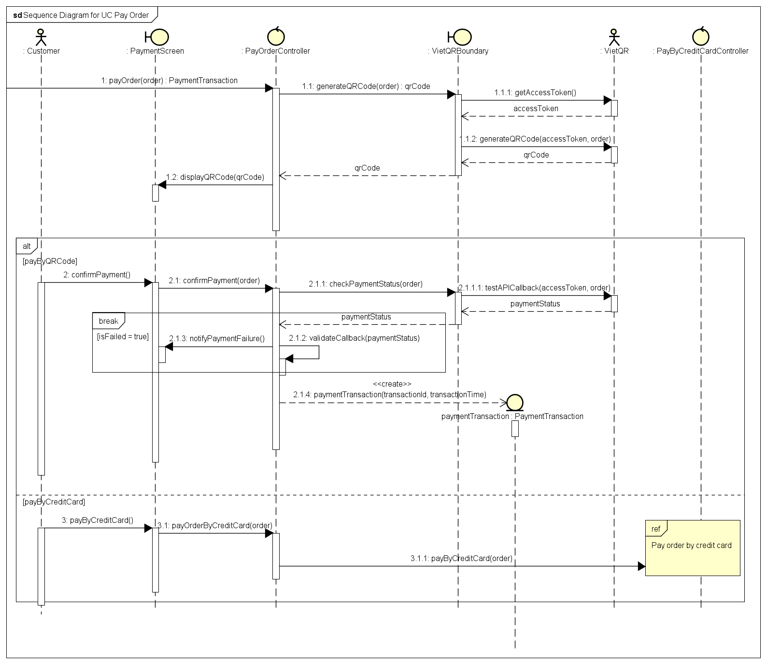
Figure 6. UC Pay Order Sequence Diagram

Communication Diagrams
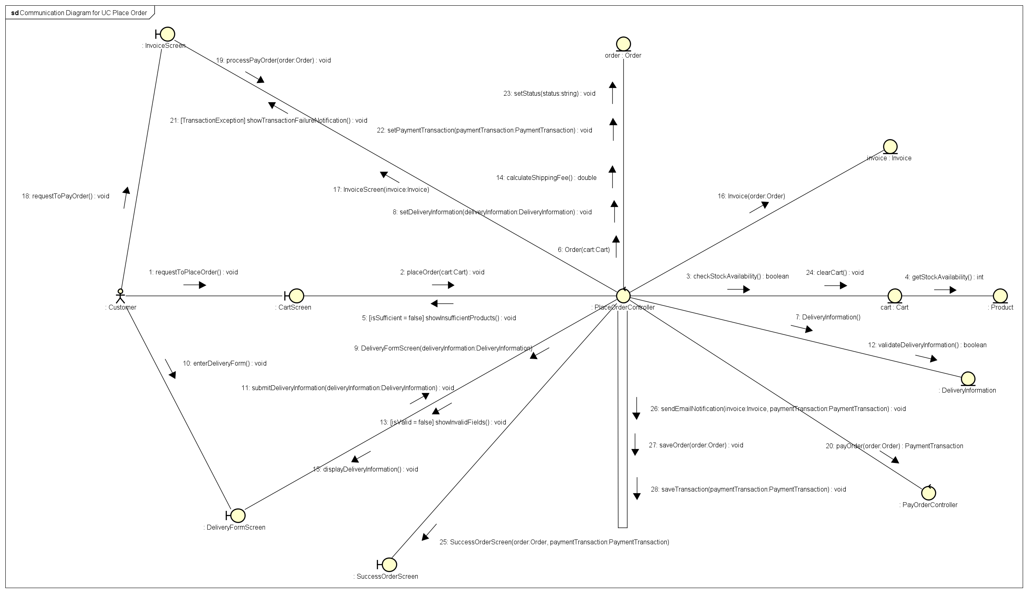
Figure 7. UC Place Order Communication Diagram
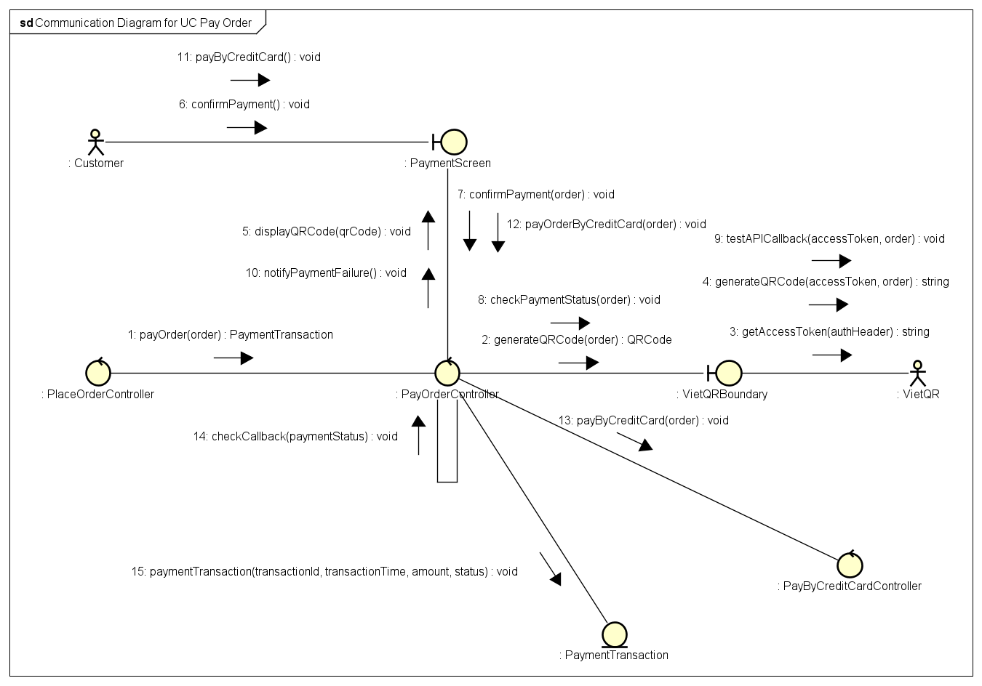
Figure 8. UC Pay Order Communication Diagram

Analysis Class Diagrams
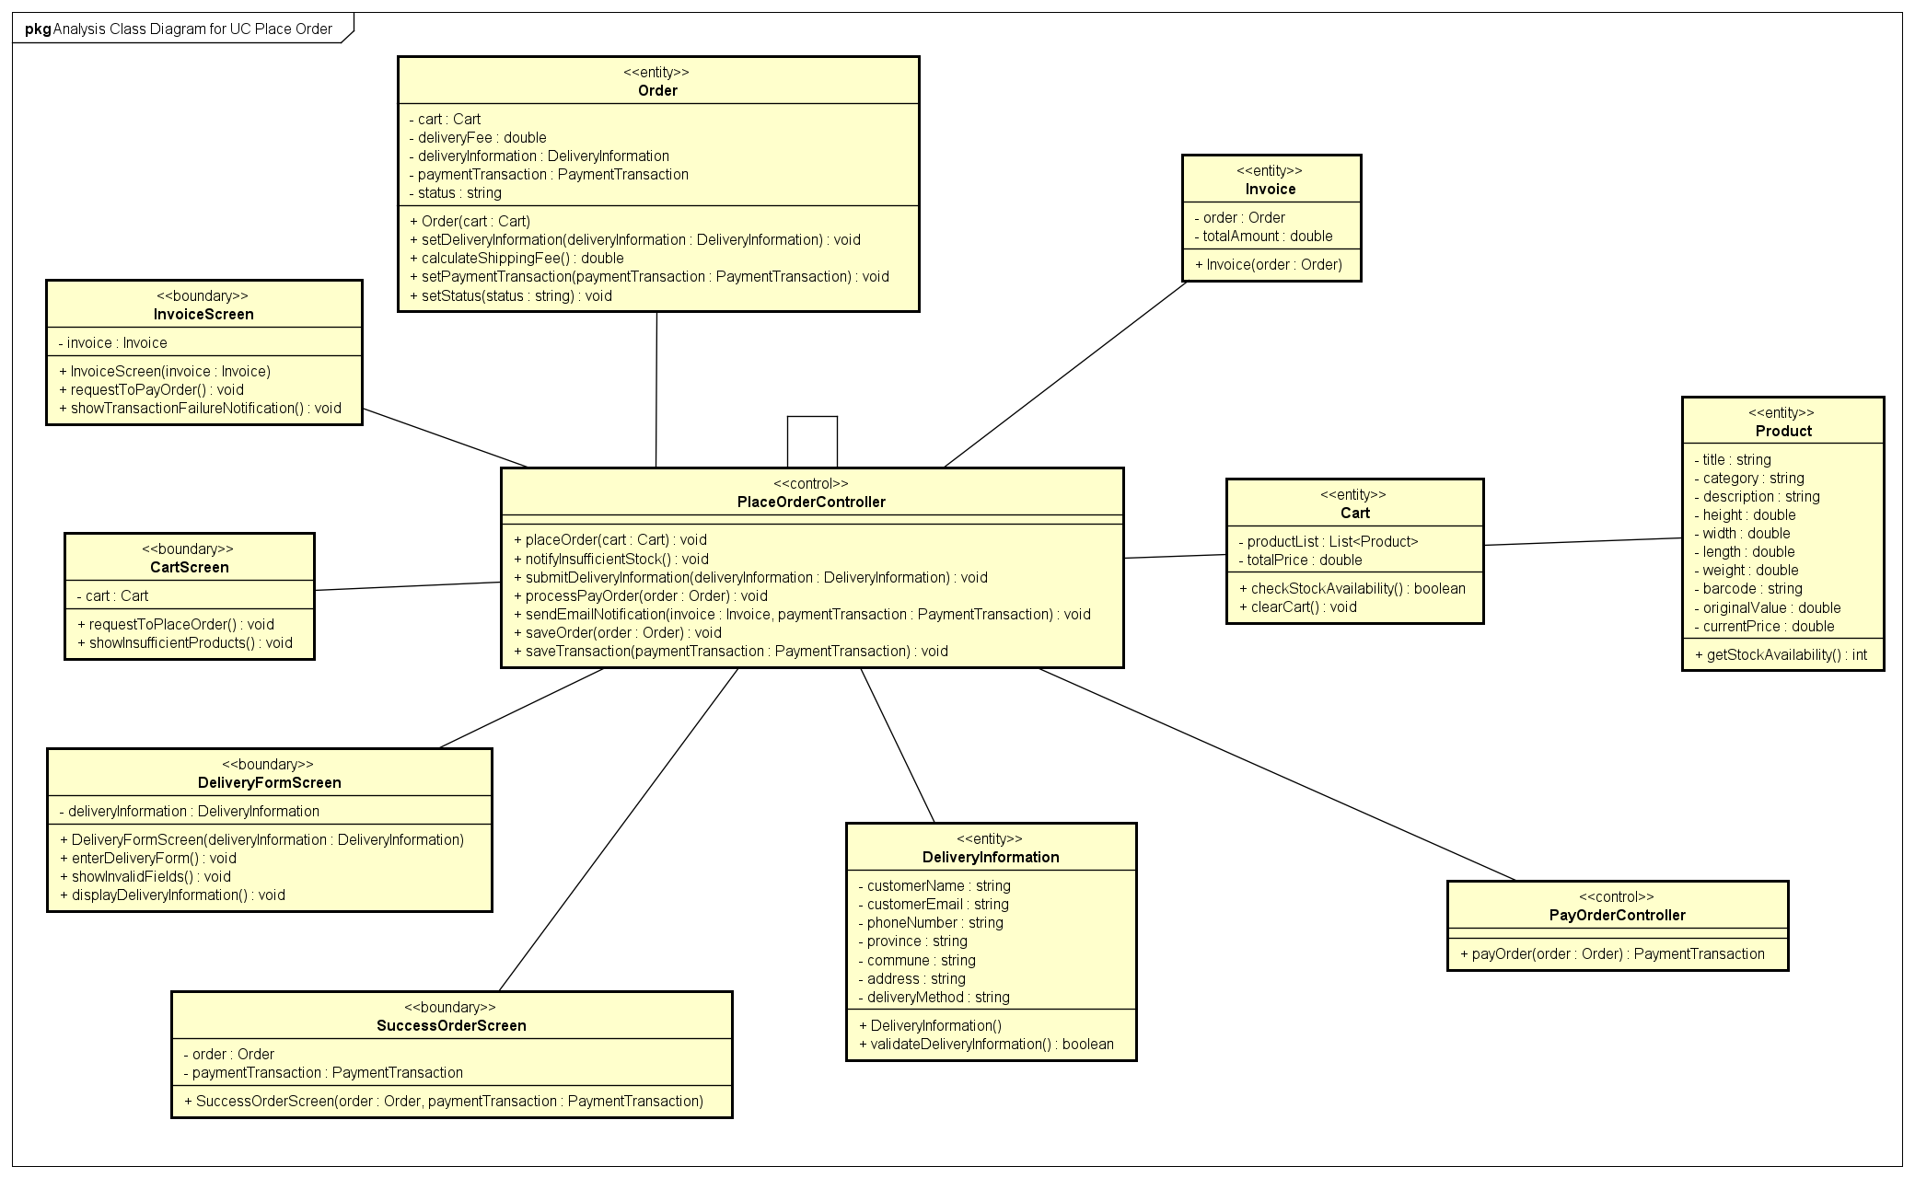
Figure 9. UC Place Order Analysis Class Diagram
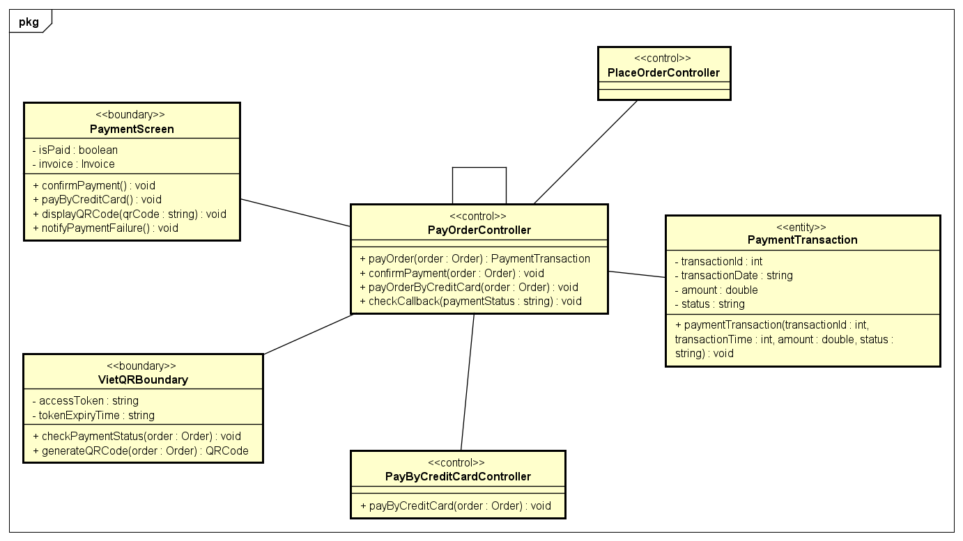
Figure 10. UC Pay Order Analysis Class Diagram

Unified Analysis Class Diagram

Security Software Architecture
The AIMS security architecture is designed to protect sensitive user data, enforce the Principle of Least Privilege, and ensure accountability for administrative actions. The system employs a stateless, token-based security model utilizing Spring Security and JSON Web Tokens (JWT) for the backend, integrated with a React frontend.

Authentication (User Identity Validation)
Authentication is handled via a stateless JWT mechanism to validate user identities before granting access to the AIMS portal (specifically for Administrators and Product Managers).
- Credential Verification: Users submit their credentials (email and password) to the login endpoint. Spring Security intercepts the request and verifies the credentials against the PostgreSQL database.
- Account Status Evaluation: Before issuing a token, the system evaluates the user's account status. Deactivated users are rejected immediately at the authentication level (DisabledException).
- Token Generation: Upon successful verification, the backend generates a signed JWT. The token payload contains the user's ID, email, assigned roles, and critical security flags (including the account status and password reset requirement).
- Client-Side Storage: The React frontend securely stores the JWT and attaches it as a Bearer token in the Authorization header for all subsequent API requests.

Authorization (Functional Activity Access Control)
Authorization in AIMS is enforced using strict Role-Based Access Control (RBAC) combined with a "Restricted JWT" pattern to handle edge cases without relying on continuous database queries.
- Filter-Level Enforcement: Every incoming request passes through a custom JwtAuthFilter. The filter decodes the JWT, validates its signature, and extracts the user's roles and claims to build the SecurityContext.
- Role-Based Routing: Endpoints are protected using Spring's method security. Only Admins can access admin related endpoints (specifically for user creation, blocking, role assignment), while Managers access product and order-related services.
- Restricted JWT Pattern for Edge Cases:
  - Blocked Accounts: If the JWT contains a flag showing that the account is blocked: the filter automatically rejects all business operations with an HTTP 403 Forbidden status, while still allowing the frontend to route the user to a specific "Blocked Notice" screen.
  - Password Enforcement: If the JWT contains must_change_password: true status, the system restricts access to all endpoints except /api/profile/password, forcing the user to secure their account before proceeding.

Encryption Protocol (Data Protection)
Encryption protocols are deployed to secure data both in transit and at rest, mitigating business risks associated with credential theft or interception.
- Data in Transit: All communications between the React frontend client and the Spring Boot backend server are encrypted, ensuring that JWTs, temporary passwords, and sensitive business data cannot be intercepted.
- Data at Rest (Passwords): Passwords are never stored in plain text. The system utilizes the BCrypt hashing algorithm (via Spring's BCryptPasswordEncoder) to hash user passwords before storing them in the PostgreSQL database. This protects user credentials even in the event of a database breach.

Detailed Design

User Interface Design

Screen Configuration Standardization
Table 2. General Layout Requirement
Category | Rules
Minimum screen size | At least 1366×768 pixels. Layouts must be able to automatically adapt to any screen sizes, resolutions, and aspect ratios.
Page titles | Place the main title at the top-center of every screen. Use only one main title per screen
Action buttons | Standard action buttons must be positioned in a consistent, recognizable location, typically at the bottom vertically and aligned to the center or right horizontally. Primary buttons (Upload, Save, Publish) go at the bottom-right or top-right. Secondary buttons (Cancel, Filter) sit next to them but look less prominent.
Menu Bar / Navigation | It is recommended to place global navigation at the top-right or in a left sidebar. Highlight the current page clearly.
Content area | Main content sits in the center. Side panels (filters, metadata) go on the left or right. Keep consistent spacing between sections.
Responsive behaviour | On smaller screens: stack columns vertically, shrink padding, and make buttons full-width. Never hide essential actions.
Table 3. Customer Flow Layout Requirement
Category | Rules
Header | A top-anchored, sticky navigation bar, allowing page content to scroll smoothly underneath. It houses the AIMS logo (left) and interactive actions like Theme Toggle, Login, and Cart (right)
Content area | Centered with a maximum width for maximum readability
Footer | Anchored to the bottom of the viewport, providing standard copyright and contact information.
Table 4. Manager / Admin Flow Layout Requirement
Category | Rules
Sidebar Navigation | A fixed left-hand sidebar serving as the primary navigation hub, housing the logo, navigational tabs, and the user profile/logout actions.
Header | A top header for the active viewport containing a mobile menu toggle, page title, and contextual actions.
Content area | Implements a grid system to cleanly separate complex data into easily digestible, independent modules.
Table 5. UI Kit
Category | Rules
Fonts & Typography | Use 2 cohesive font families consistently throughout the entire application.  - For Headings: Use Montserrat  - For UI / Body Text: Be Vietnam Pro  A clear hierarchy of text sizes must be defined, distinguishing between main titles, sub-titles, and standard paragraph text.
Color Palette | Use defined color roles instead of hardcoding colors for theme compatibility  - Primary color: Deep Violet / Indigo  - Backgrounds: Pearl White  - Status colors: Fractional opacity layers are used instead of harsh solid colors for Success, Destructive for Errors / Failures
Icons & Graphics | Use Lucide icon library universally  Images must maintain correct aspect ratio and quality
Spacing | Follow a steady rhythm: 4px, 8px, 12px, 16px, 24px, 32px for gaps and padding.  Use border radii and deep, soft shadows to create depth for shapes.
Table 6. Data formatting
Category | Rules | Examples
Numeric values | Use a comma separator every 3 digits. For decimal numbers, use dot separator to separate whole part and fractional part. There should only be exactly 2 digits after the dot separator. | 1,450,800.00  93,491.30  89.33  …
Currency | Follow Vietnamese standard currency format: a number adhering to numeric value rules (with no fractional part) followed by the currency symbol ₫. | 1,000,000₫  730,000₫  45,000₫
Date & Time | Use standardized pattern commonly used in Vietnam (Day of the week is optional)  - Date: [Day of the week] DD/MM/YYYY  - Time: HH:mm:SS (24-hour format)  Never show raw timestamp (YYYY-MM-DDTHH:mm:SSZ)  For recent timestamps of up to 1 week before now, show relative time. | 18/04/2026  17:45:49  15 minutes ago  4 hours ago  3 days ago
Text handling | Support all Unicode characters using UTF-8 format
Media Duration | Show CD and DVD duration as HHhMMm or MMmSSs | 143 minutes = 2h23m  231 seconds = 3m51s
Product dimensions | Each dimension: width, height, length must follow the above numeric value rule and formatted as width×height×length | 13.4×1.6×9.2
Table 7. Control rule
Category | Rules
Input validation | Check inputs in this order:  - Is the field empty?  - Is the format correct?  Only show errors after the user leaves the field or clicks submit. Messages must explain what's wrong and how to fix it.
Error handling | Show friendly, specific messages. Log technical details for developers, but never show raw errors to users. If a request fails, offer a Retry button.
Navigation & focus | When users press Tab, fields should follow a logical top-to-bottom, left-to-right order. Popups (like help screens) should block interaction with the main screen until closed.  Users are consistently provided with "Go Back" or "Cancel" buttons to safely return to the previous state without committing changes. No complex shortcuts are required
Secondary screens | Secondary interfaces, such as help or manual screens, should appear as popups to prevent interaction with the main screen until the popup is closed.
Loading states | Show a skeleton screen or spinner while data loads. Never leave a blank white space.
Empty states | When a list has no items, show: a helpful message + simple illustration + a button to take action.

Screen Transition Diagrams

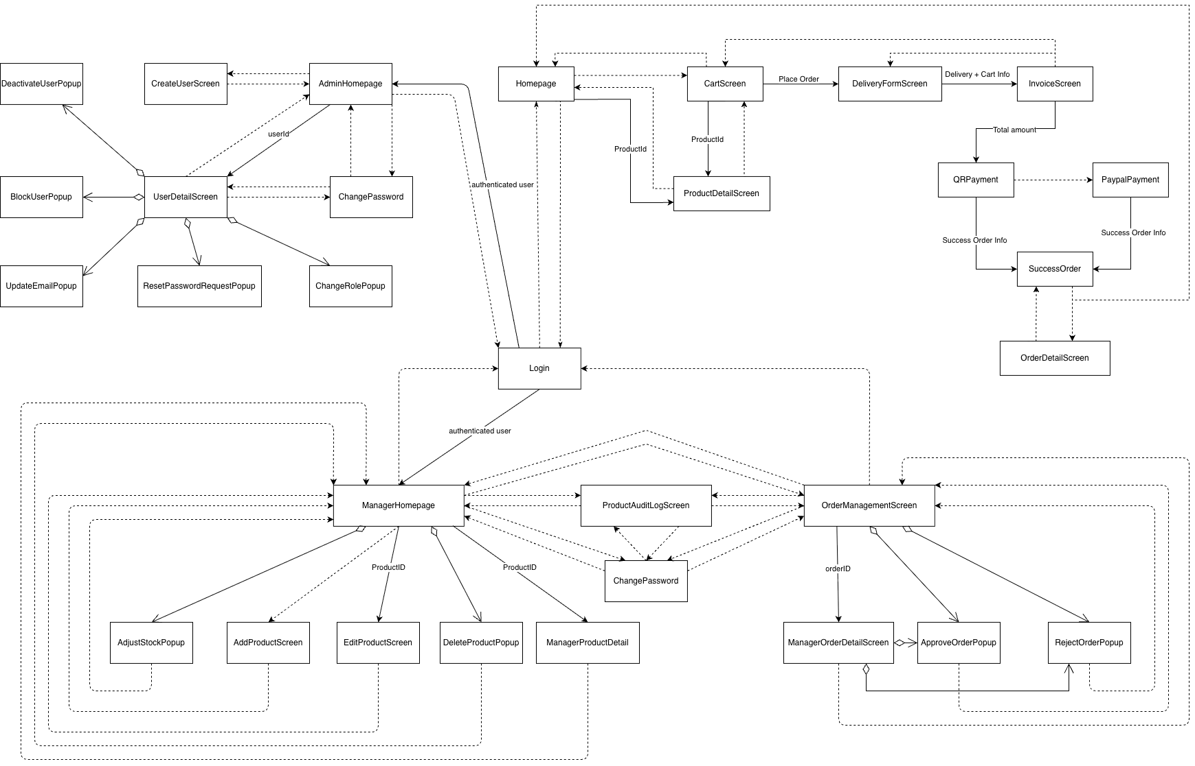
Figure 11. Screen Transition Diagram for AIMS System

Screen Specifications
Screen Specification for “Homepage”
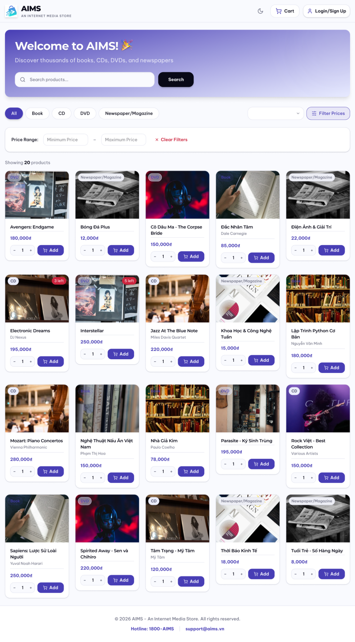
Date of creation | Approved by | Reviewed by | Person in charge
17/04/2026 | Lê Hoàng Kiên | Nguyễn Tiến Đạt | Nguyễn Huy Diễn

- Controls, Operations, and Functions
Control | Operation | Function
Area for displaying product list | Initial | Display product list
Product item card, showing product type, picture, title, author(s)/artist(s), and price | Initial/Click | Show product detail
[Each product item] Area for adjusting quantity | Click +/-  or  Input | Adjust the quantity of the product item to be added to cart
[Each product item] Add button with cart symbol | Click | Add the product with specified quantity to cart
Area with welcome message and search bar | Initial | Greets customer
Search bar & Search button | Input & Enter | Search items in store
Button area “All”, “Book”, … | Click | Filters items by product type
Dropdown selection box | Click & Select | Sort items by alphabet or by price
Filter price Box | Click | Show an area to filter by price
Price Range area | Input | Define price range to filter
Moon Symbol | Click | Toggle Light/Dark mode
Cart button with cart symbol | Click | Show cart
Login button | Click | Show login screen for product manager and admin.

- Field attributes
Item | Length | Type | Color | Remarks
Media title | 40 characters | Text | Black | Left-Justified
Author(s) / Artist(s) | 30 characters | Text | Gray | Left-Justified
Price | 8 digits + ₫ | Numeral | Purple / Indigo | Left-Justified
Screen Specification for “CartScreen”
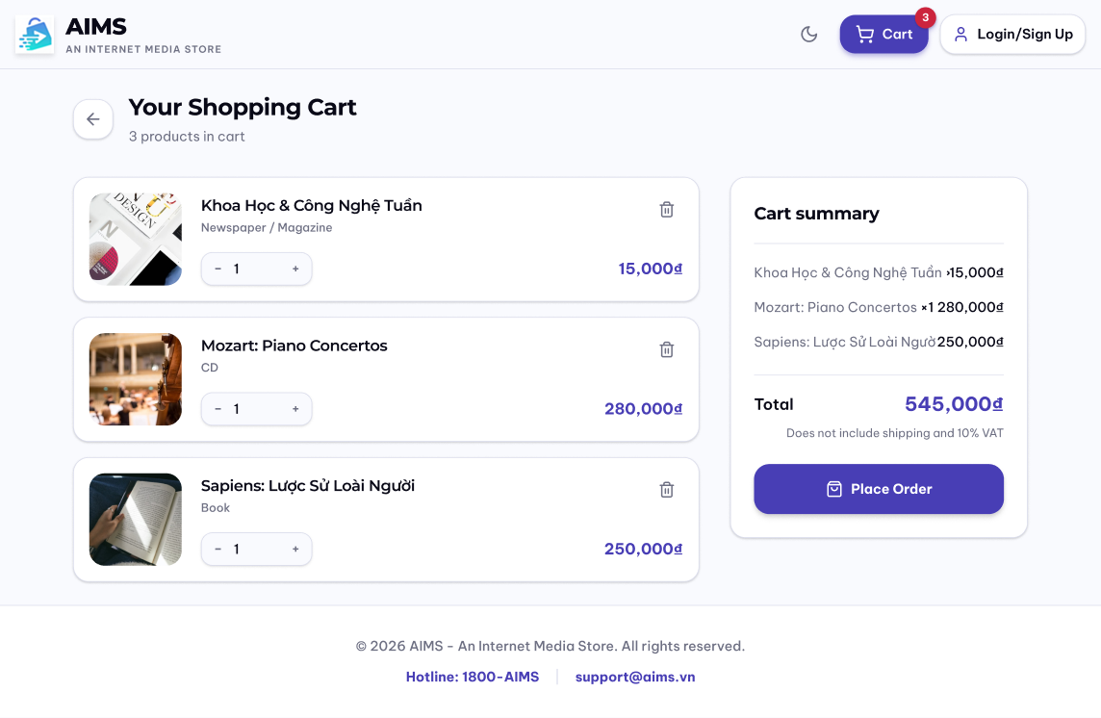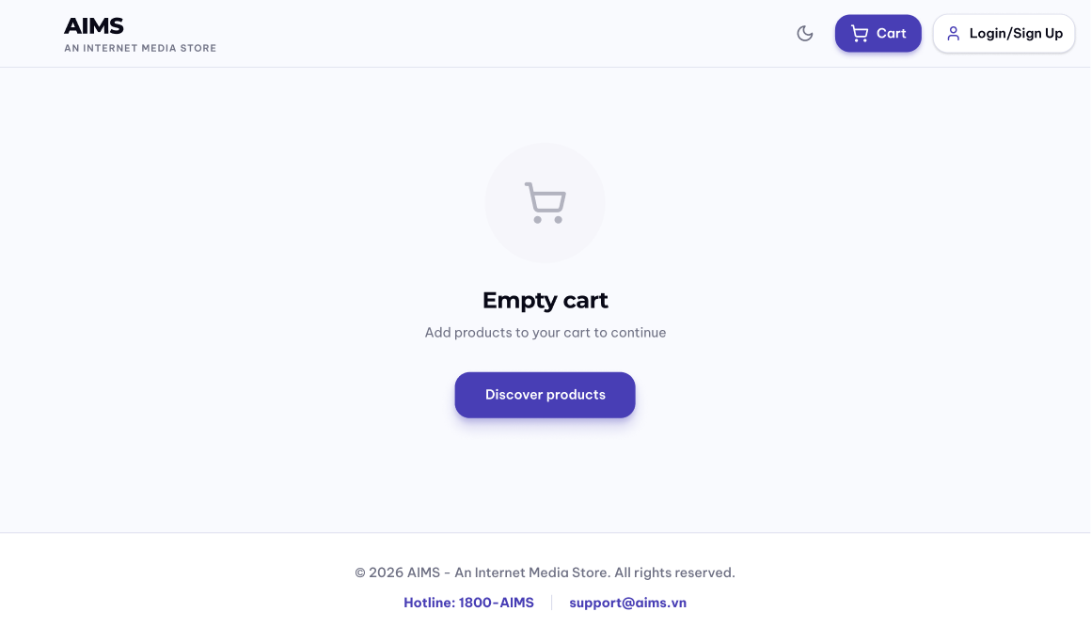
(cart screen when empty)
Date of creation | Approved by | Reviewed by | Person in charge
18/04/2026 | Nguyễn Tiến Đạt | Lê Hoàng Kiên | Nguyễn Huy Diễn

- Controls, Operations, and Functions
Control | Operation | Function
Area for displaying cart content | Initial | Display cart content
Area for displaying cart summary | Initial | Display cart summary
Place order | Click | Display / Transition to Delivery Form screen
Back button | Click | Back to Homepage
Shopping cart title with number of products summary | Initial | Show number of products in cart
[Each cart item] Area for adjusting quantity | Click +/-  or  Input | Adjust the quantity of the cart item
[Each cart item] Trashbin button | Click | Remove item from cart
[When cart is empty] Empty cart content area | Initial | Show notification that cart is empty
[When cart is empty] Discover products Button | Click | Back to Homepage

- Field attributes
Item | Length | Type | Color | Remarks
Media title | 40 characters | Text | Black | Left-Justified
Author(s) / Artist(s) | 30 characters | Text | Gray | Left-Justified
Price | 8 digits + ₫ | Numeral | Purple / Indigo | Right-Justified
Media title with multiplier | 30 characters + x[digits] | Text | Black | Left-Justified
Total | 10 digits + ₫ | Numeral | Purple / Indigo | Right-Justified
Screen Specification for “ProductDetailScreen”
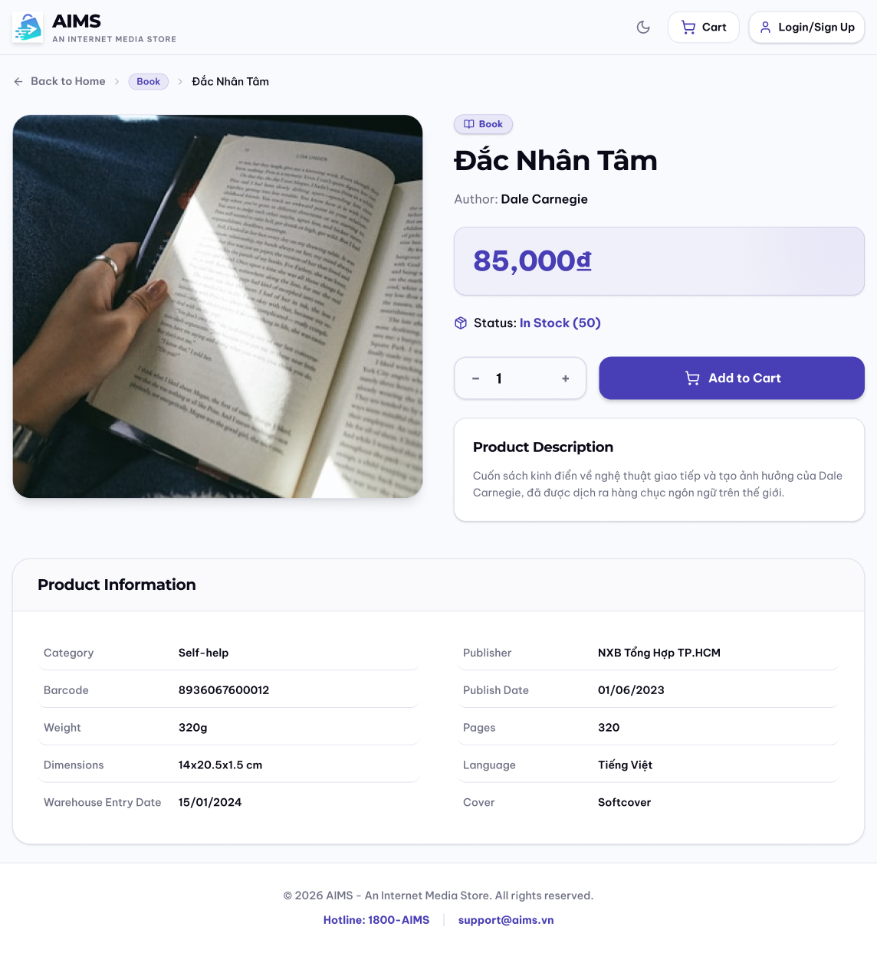
Date of creation | Approved by | Reviewed by | Person in charge
18/4/2026 | Nguyễn Tiến Đạt | Phạm Đức Phước | Lê Hoàng Kiên

- Controls, Operations, and Functions
Control | Operation | Function
Image (left) | Initial | Display representative image of the product
Area for navigation-like display with “Back to Home” button (top) | Initial  Click | Display the button to go back to Homepage. Show the type of product and title of product
Product summary area | Initial | Display general information of the product (type, title, author(s)/artist(s), price, description, stock status)
Area for adjusting quantity | Click +/-  or  Input | Adjust the quantity of the product item to be added to cart
Add button with cart symbol | Click | Add the product with specified quantity to cart
Product information area | Initial | Show more detailed information about the product

- Field attributes
Item | Length | Type | Color | Remarks
Title | 40 characters | Text | Black | Left-justified
Barcode | 13 characters | Text | Gray | Left-justified
Category | 30 characters | Text | Black | Left-justified
Price | 8 digits + ₫ | Numeral | Purple | Left-justified
Stock Quantity | 3 digits | Numeral | Purple | Left-justified
Weight | 5 digits | Numeral | Black | Left-justified
Dimensions | 3 digits x 3 digits x 3 digits | Numeral | Black | Left-justified
Warehouse Entry Date |  | Date | Black | Left-justified
Product Description | 1000 characters | Text | Black | Left-justified
Author | 30 characters | Text | Black | Left-justified
Publisher | 30 characters | Text | Black | Left-justified
Publication Date |  | Date | Black | Left-justified
Pages | 5 digits | Numeral | Black | Left-justified
Language | 10 characters | Text | Black | Left-justified
Genre | 20 characters | Text | Black | Left-justified
Cover Type | 10 characters | Text | Black | Left-justified
Artist/Band | 30 characters | Text | Black | Left-justified
Record Label | 30 characters | Text | Black | Left-justified
Release Date |  | Date | Black | Left-justified
Number of tracks | 2 digits | Numeral | Black | Left-justified
Studio | 30 characters | Text | Black | Left-justified
Director | 30 characters | Text | Black | Left-justified
Runtime | 4 digits | Numeral | Black | Left-justified
Disc Type | 15 characters | Text | Black | Left-justified
Main Topic | 30 characters | Text | Black | Left-justified
Screen Specification for “DeliveryFormScreen”
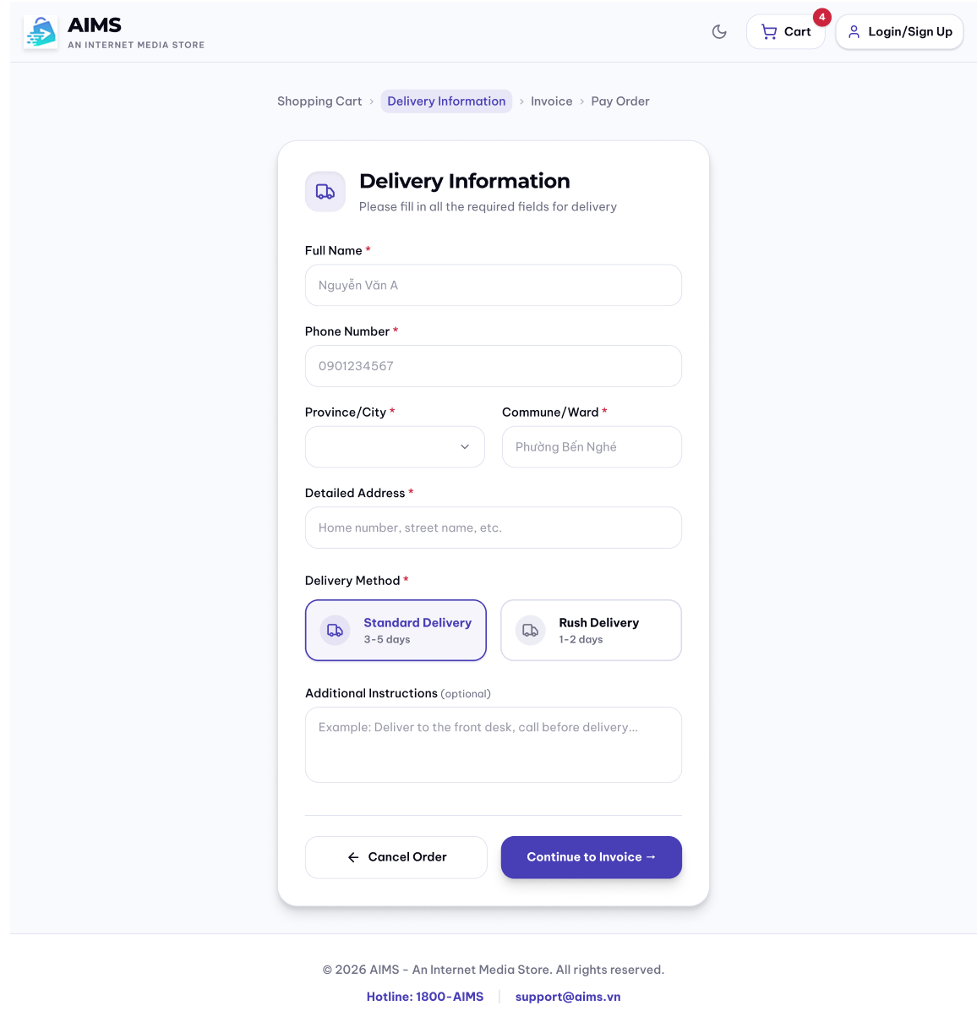
Date of creation | Approved by | Reviewed by | Person in charge
19/4/2026 | Phạm Đức Phước | Lê Hoàng Kiên | Nguyễn Huy Diễn

- Controls, Operations, and Functions
Control | Operation | Function
Area for navigation | Initial | Display steps in the Order Placement flow and highlight the current step
Area for inputting delivery information | Initial | Display area for inputting delivery information
Full name input textbox | Input | Box for inputting customer’s full name
Phone number input textbox | Input | Box for inputting customer’s phone number
Province / City dropdown selection box | Click & Input | Box for choosing customer’s province or city
Commune / Ward input textbox | Input | Box for inputting customer’s commune or ward
Detailed address input textbox | Input | Box for inputting customer’s detailed address
Delivery method selection area | Click & Select | Area for choosing delivery method
Additional instructions input textbox | Input | Box for inputting customer’s additional instructions
Screen Specification for “InvoiceScreen”
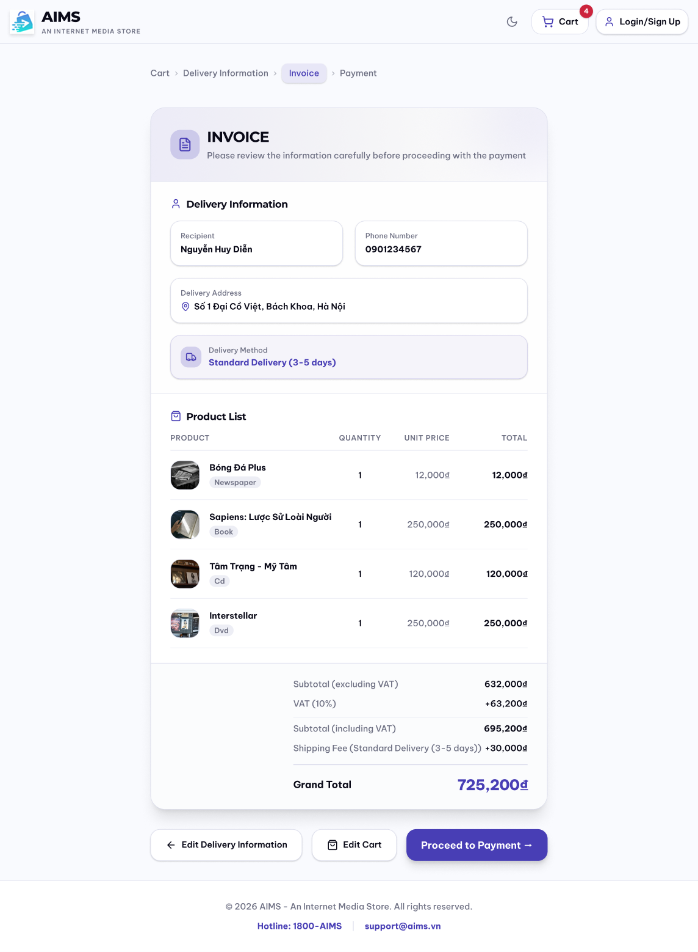
Date of creation | Approved by | Reviewed by | Person in charge
19/4/2026 | Phạm Đức Phước | Nguyễn Tiến Đạt | Nguyễn Huy Diễn

- Controls, Operations, and Functions
Control | Operation | Function
Area for navigation | Initial | Display steps in the Order Placement flow and highlight the current step
Invoice area | Initial | Display invoice information, including delivery information
Delivery information area | Initial | Show some general information about delivery form the customer has just submitted
Product list area | Initial | Show the product list the customer places
Price calculation area | Initial | Show subtotal, VAT, subtotal with VAT, shipping fee, and the grand total
Edit delivery information button | Click | Switch back to Delivery Form screen
View cart button | Click | Switch back to Cart Screen
Proceed to Payment button | Click | Switch to QR Payment Screen

- Field attributes
Item | Length | Type | Color | Remarks
Recipient | 50 characters | Text | Black | Left-justified
Phone number | 10 digits | Text | Black | Left-justified
Delivery address | 100 characters | Text | Black | Left-justified
Media title | 40 characters | Text | Black | Left-justified
Media type | 10 characters | Text | Gray | Left-justified
Quantity | 3 digits | Numeral | Black | Left-justified
Unit price | 8 digits + ₫ | Numeral | Gray | Right-justified
Total price | 8 digits + ₫ | Numeral | Black | Right-justified
Subtotal | 8 digits + ₫ | Numeral | Black | Right-justified
VAT | 8 digits + ₫ | Numeral | Black | Right-justified
Subtotal with VAT | 8 digits + ₫ | Numeral | Black | Right-justified
Shipping Fee | 8 digits + ₫ | Numeral | Black | Right-justified
Grand Total | 8 digits + ₫ | Numeral | Purple / Indigo | Right-justified
Screen Specification for “QRPaymentScreen”
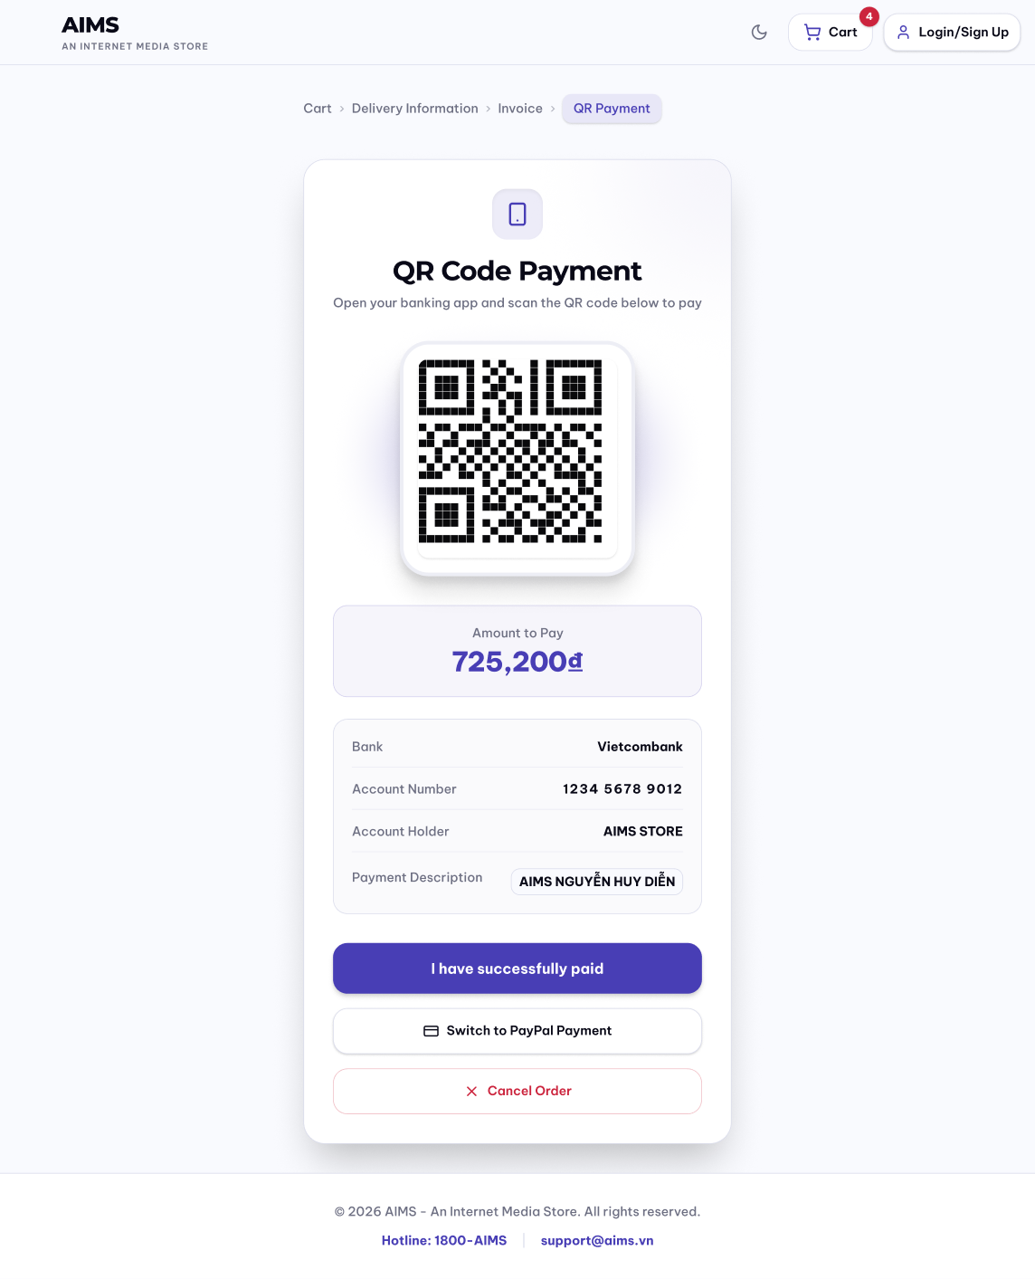
Date of creation | Approved by | Reviewed by | Person in charge
18/4/2026 | Nguyễn Huy Diễn | Phạm Đức Phước | Nguyễn Tiến Đạt

- Controls, Operations, and Functions

Control | Operation | Function
Area for displaying QR Code | Initial | Display the QR code generated from VietQR API based on order information (amount, bank account, payment content).
Area for displaying total amount | Initial | Display the total amount to be paid
Area for displaying bank information | Initial | Display the receiving bank name corresponding to the VietQR bankCode.
Area for displaying account number | Initial | Display the receiver’s bank account number used for payment.
Area for displaying account holder | Initial | Display the name of the account holder (merchant).
Area for displaying payment description | Initial | Display the payment content used for transaction identification (e.g., order ID or customer name).
Button I have successfully paid | Click | Trigger payment verification; call system to check payment status (via testcallback); if successful then navigate to success screen; otherwise show error.
Button Switch to PayPal Payment | Click | Redirect user to PayPal payment screen
Button Cancel Order | Click | Cancel order and redirect to previous screen (cart/home)

- Field attributes

Item | Length | Type | Color | Remarks
QR Code Image | N/A | Image | Default | Displays QR code generated from VietQR API
Payment Title | 30 characters | Text | Black | “QR Code Payment”; centered
Amount to Pay | 20 digits | Numeral | Blue | Displays total amount
Bank | 50 characters | Text | Black | Displays receiving bank name (from bankCode)
Account Number | 19 digits | Numeral | Black | Displays merchant bank account number
Account Holder | 50 characters | Text | Black | Uppercase, no accents (VietQR requirement)
Payment Description | 19 characters | Text | Gray | Transfer content; no special characters (VietQR constraint)
Button “I have successfully paid” | N/A | Button | Purple | Confirms payment completion; triggers verification
Button “Switch to PayPal Payment” | N/A | Button | Gray | Redirects to PayPal payment method
Button “Cancel Order” | N/A | Button | Red | Cancels order after confirmation
Screen Specification for “OrderDetailScreen”
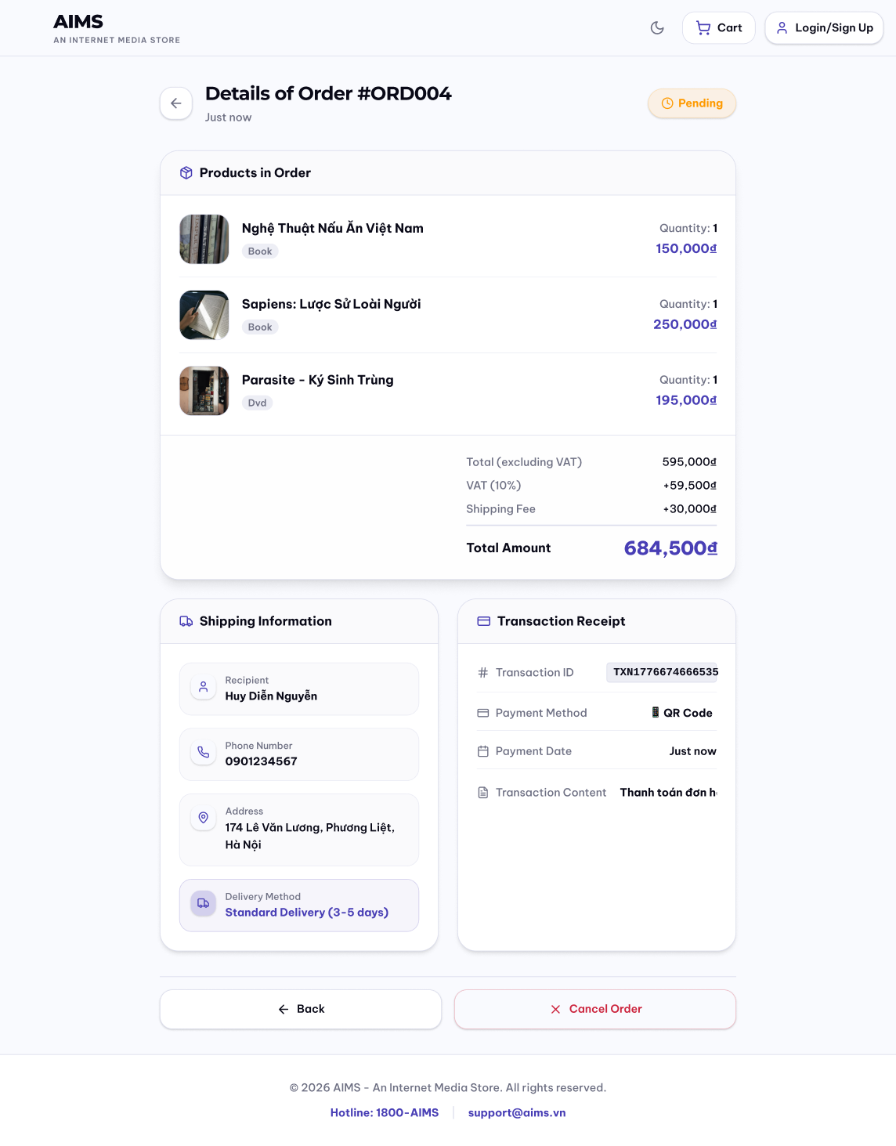
Date of creation | Approved by | Reviewed by | Person in charge
20/4/2026 | Nguyễn Tiến Đạt | Phạm Đức Phước | Lê Hoàng Kiên

- Controls, Operations, and Functions

Control | Operation | Function
Button to return to order success screen | Click “⟵” or “⟵ Back” | Return to SuccessOrderScreen
Cancel order button | Click | Confirm cancelling order
Area to display order information | Initial | Display order information

- Field attributes

Item | Length | Type | Color | Remarks
Product title | 40 characters | Text | Black | Left-justified
Product type | 12 characters | Text | Gray | Left-justified
Unit price | 8 digits + ₫ | Numeral | Purple | Right-Justified
Quantity | 3 digits | Numeral | Black | Right-Justified
Total Payment | 8 digits + ₫ | Numeral | Purple | Right-Justified
Recipient | 50 characters | Text | Black | Left-justified
Phone | 10 digits | Numeral | Black | Left-justified
Address | 100 characters | Text | Black | Left-justified
Delivery method | 50 characters | Text | Purple | Left-justified
Notes | 30 characters | Text | Black | Left-justified
Transaction code | 16 characters | Text | Black | Right-Justified
Method | 20 characters | Text + relevant method symbol | Black | Right-Justified
Payment time | 15 characters | Text | Black | Right-Justified
Transfer note | 30 characters | Text | Black | Right-Justified
Screen Specification for “SuccessOrderScreen”
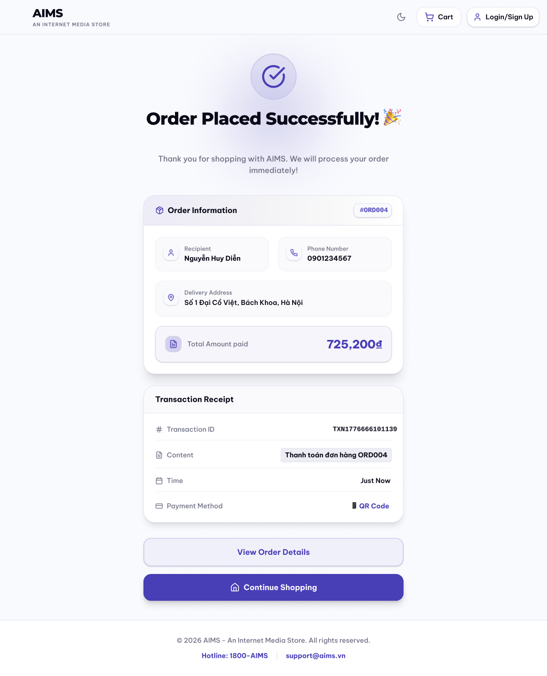
Date of creation | Approved by | Reviewed by | Person in charge
20/4/2026 | Phạm Đức Phước | Nguyễn Tiến Đạt | Nguyễn Huy Diễn

- Controls, Operations, and Functions
Control | Operation | Function
Success message area | Initial | Display order placement success message, along with an appreciation message
Order information area | Initial | Display general order information
Transaction receipt area | Initial | Display transaction information
View order details button | Click | Transition to Order Detail screen to show more detailed information
Continue shopping button | Click | Transition back to Homepage
- Field attributes
Item | Length | Type | Color | Remarks
Order ID |  | Text | Purple / Indigo | Left-justified
Recipient | 50 characters | Text | Black | Left-justified
Phone | 10 digits | Text | Black | Left-justified
Address | 100 characters | Text | Black | Left-justified
Total amount paid | 8 digits + ₫ | Numeral | Purple / Indigo | Right-justified
Transaction ID |  | Text | Black | Right-justified
Transaction Content | 100 characters | Text | Black | Right-justified
Transaction time |  | Text | Black | Right-justified
Payment method | 15 characters | Text | Purple / Indigo | Right-justified
Screen Specification for “Login”
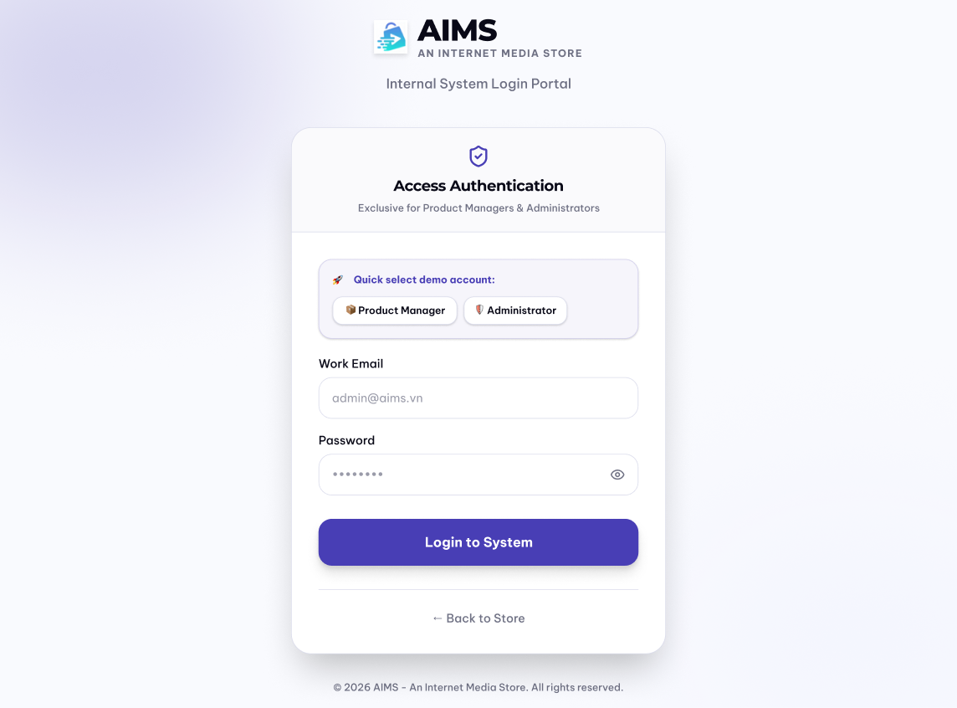
Date of creation | Approved by | Reviewed by | Person in charge
19/4/2026 | Nguyễn Tiến Đạt | Nguyễn Huy Diễn | Lê Hoàng Kiên

- Controls, Operations, and Functions

Control | Operation | Function
Area for filling email | Input | Fill in the email
Area for filling password | Input | Fill in the account password
Log in to System button | Click | Display the screen (manager/admin) based on the account role
Back to Store button | Click | Display home page
Screen Specification for “ManagerHomepage”
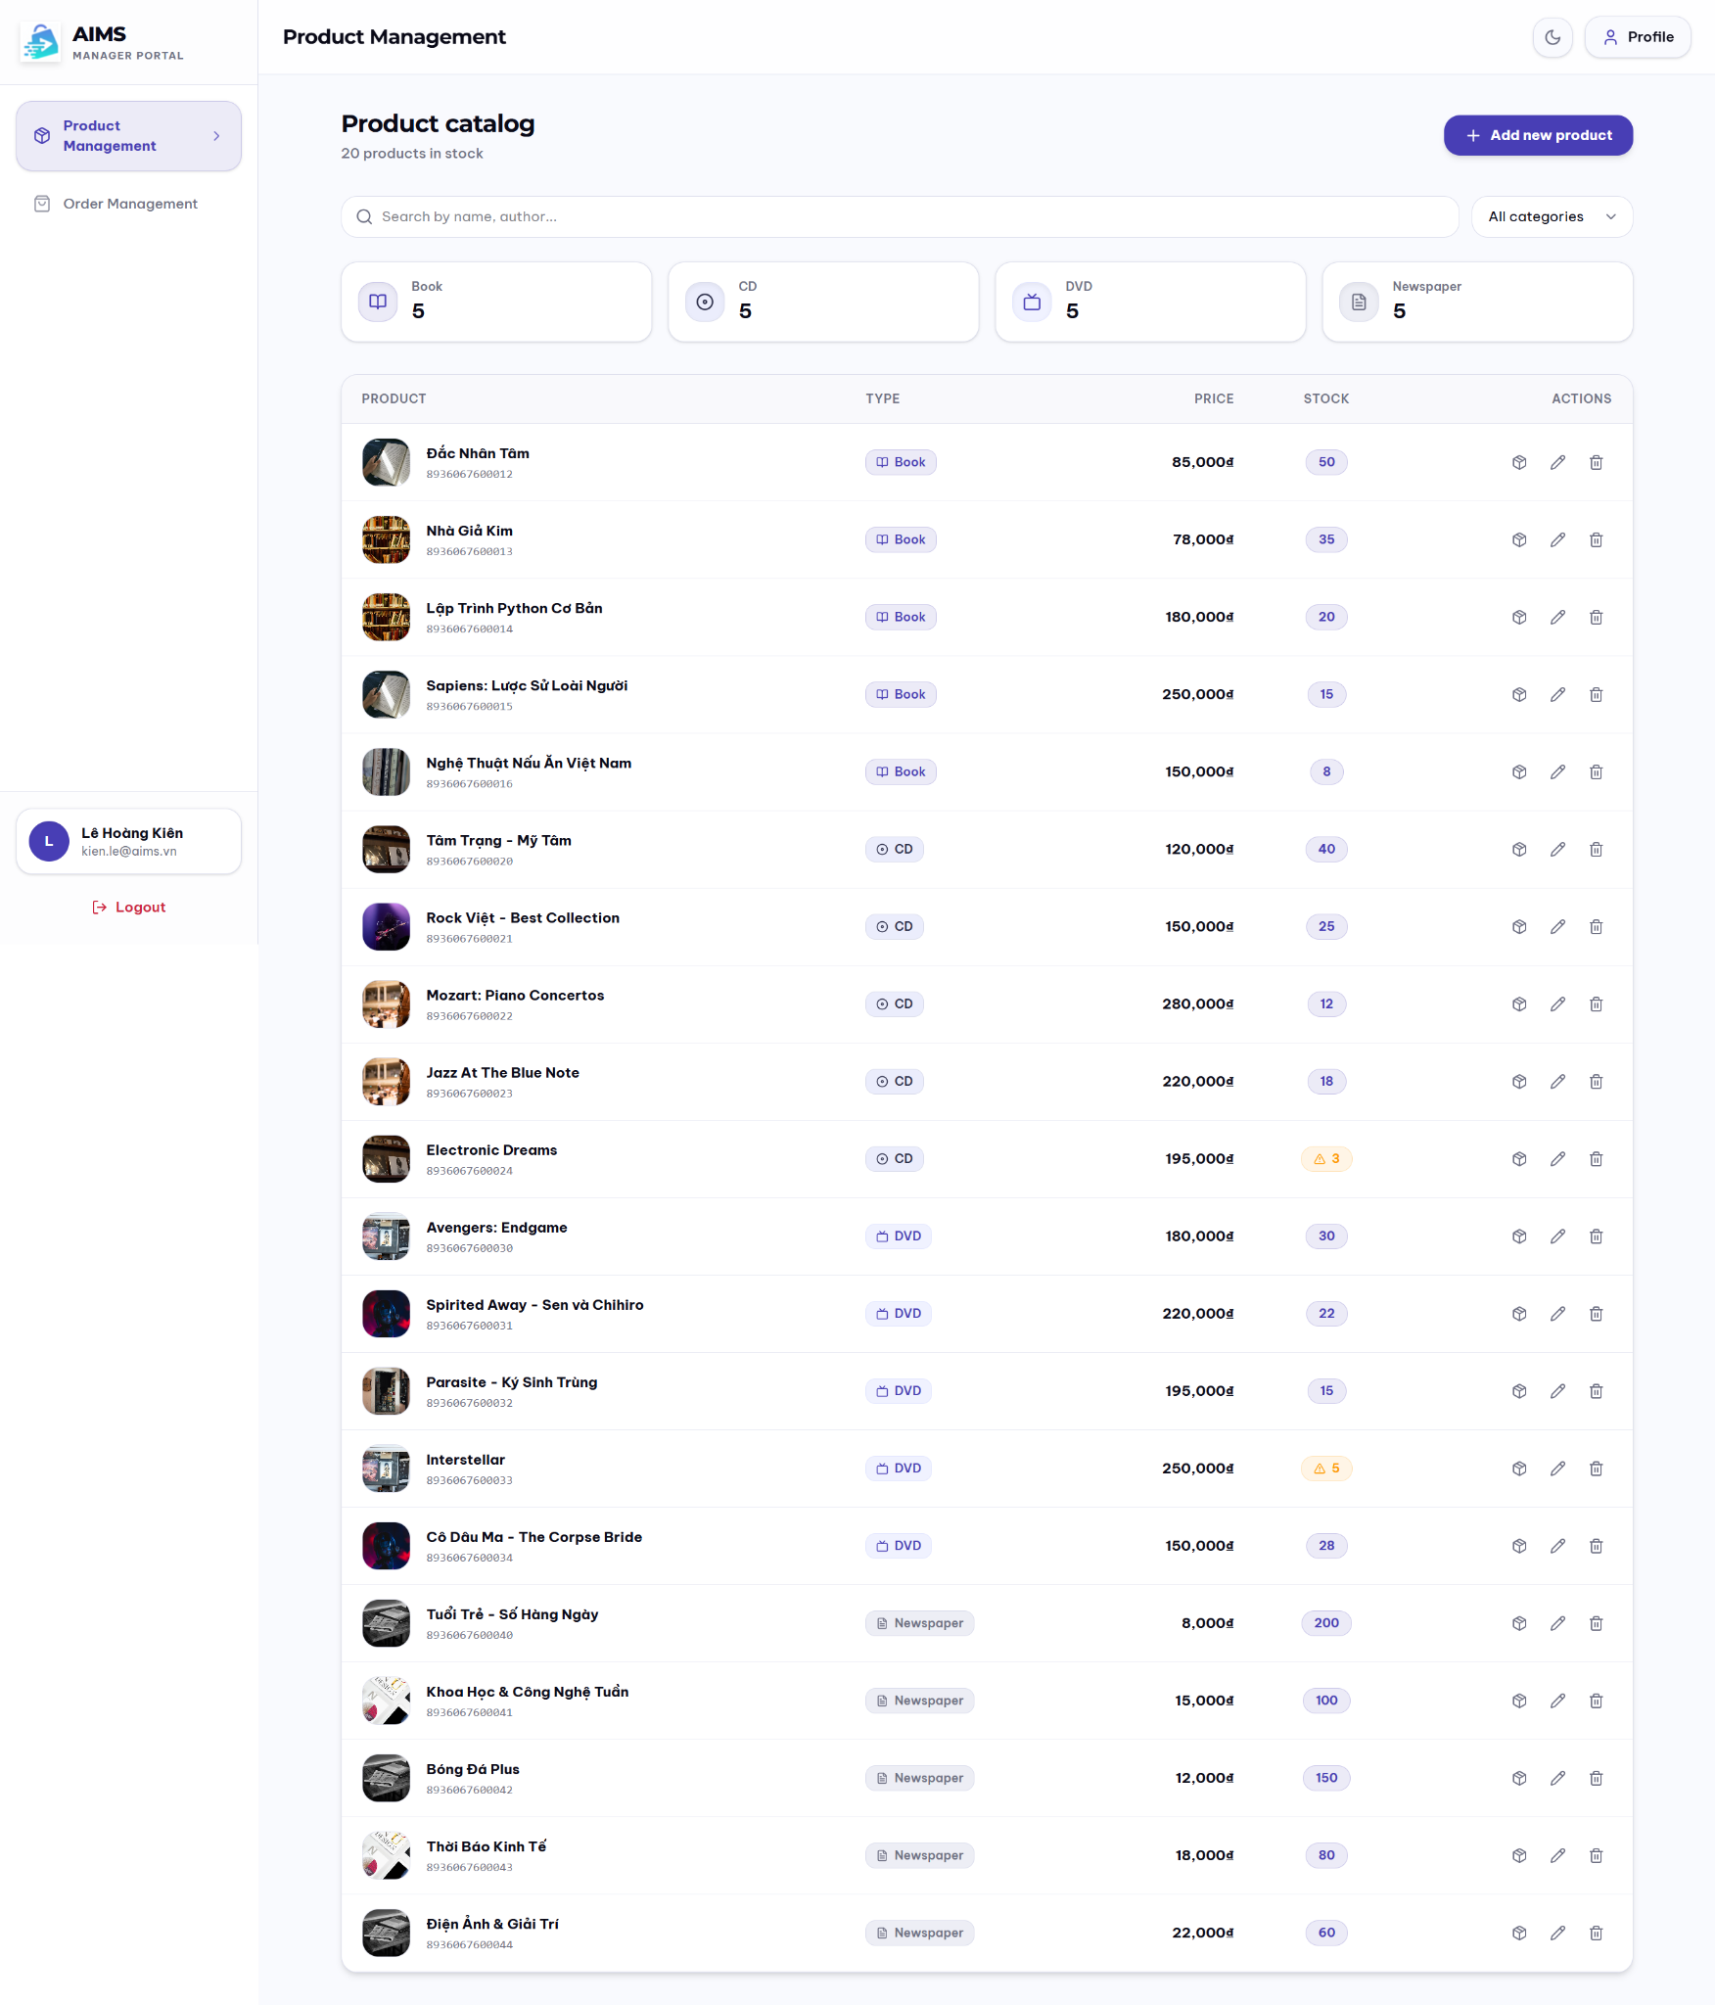
Date of creation | Approved by | Reviewed by | Person in charge
19/4/2026 | Nguyễn Huy Diễn | Phạm Đức Phước | Lê Hoàng Kiên

- Controls, Operations, and Functions

Control | Operation | Function
Profile button | Click | Displays UserProfile
Order Management button | Click | Displays OrderManagerScreen
Add new product button | Click | Displays AddProductScreen to add new product
Search product search bar | Input | Search product by name, author, …
Book/CD/DVD/Newspaper button | Click | Displays products of relevant product type
Area for displaying product | Initial/Click | Display the media with corresponding information / Click to display product details
Adjust stock button | Click | Displays AdjustStockPopup to adjust product stock level
Edit product button | Click | Displays EditProductScreen to edit product
Delete product button | Click | Displays DeleteProductPopup
Logout button | Click | Log out of the account, displays LoginSignup screen

- Field attributes

Item | Length | Type | Color | Remarks
Media title | 40 characters | Text | Black | Left-justified
Media type | 12 characters | Text | Black | Left-Justified
Price | 8 digits + ₫ | Numeral | Purple / Indigo | Left-Justified
Stock | 4 digits | Numeral | Purple / Yellow with warning sign
Screen Specification for “AddProductScreen”
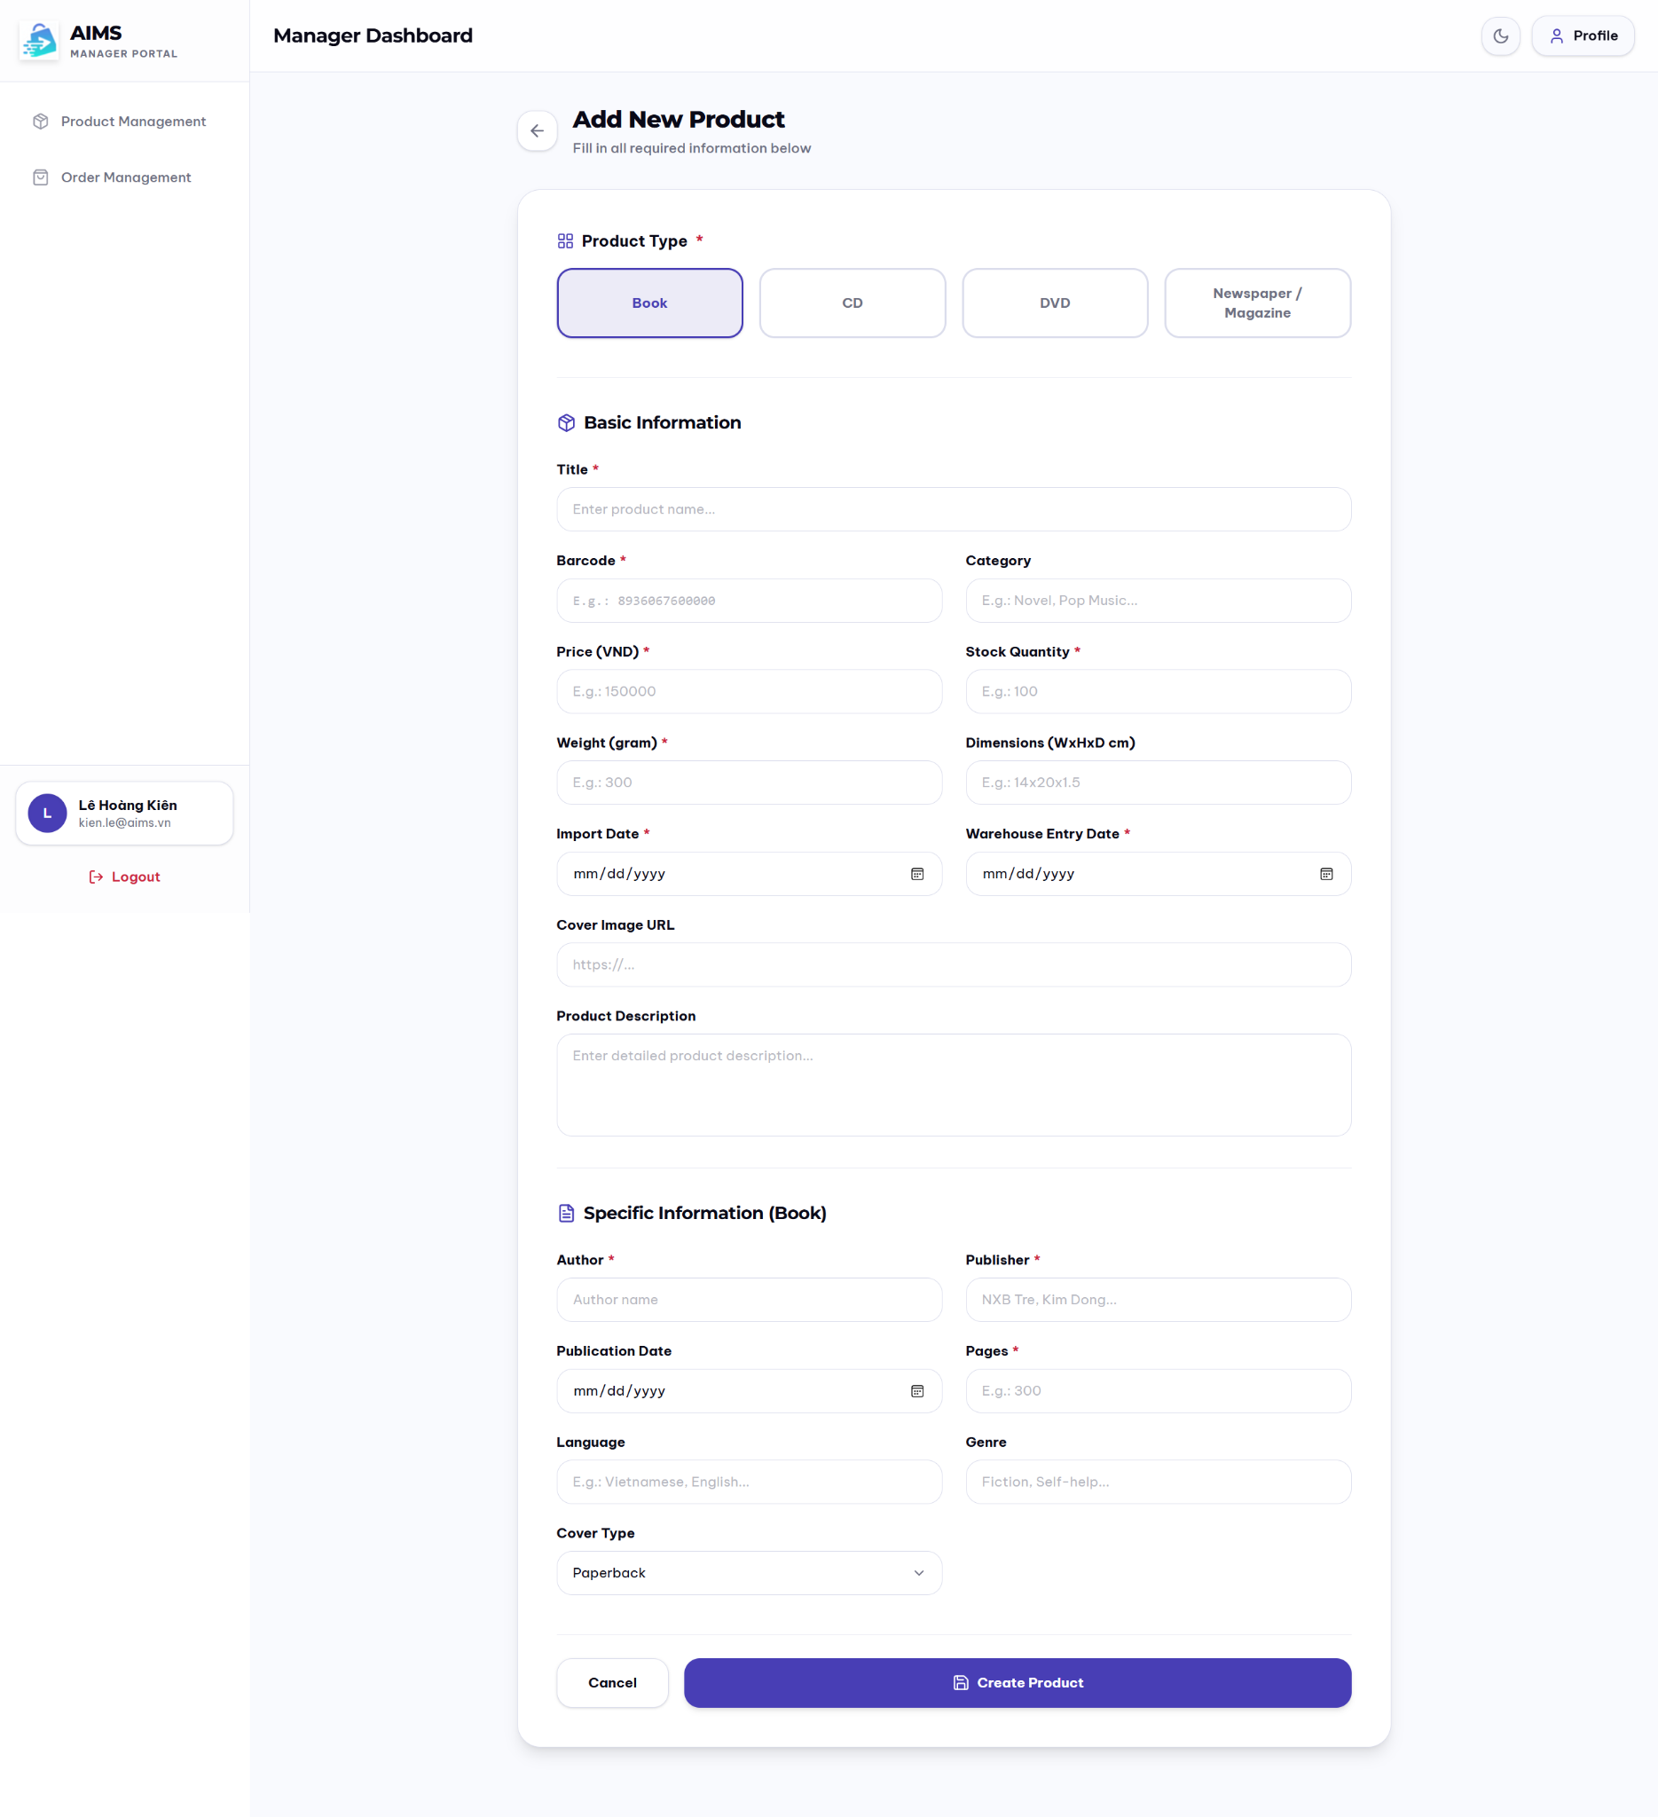
Date of creation | Approved by | Reviewed by | Person in charge
19/4/2026 | Phạm Đức Phước | Lê Hoàng Kiên | Nguyễn Huy Diễn

- Controls, Operations, and Functions

Control | Operation | Function
Book/CD/DVD/Newspaper/Magazine button | Click | Choose the product type
Area to fill in product basic and specific information | Input | Fill in product information
Product Management button | Click | Displays ManagerHomePage
Order Management button | Click | Displays OrderManagerScreen
Profile button | Click | Displays UserProfile
Logout button | Click | Log out of the account, displays LoginSignup screen
Cancel button | Click | Cancel adding new product
Create Product button | Click | Confirm creating product
Screen Specification for “EditProductScreen”
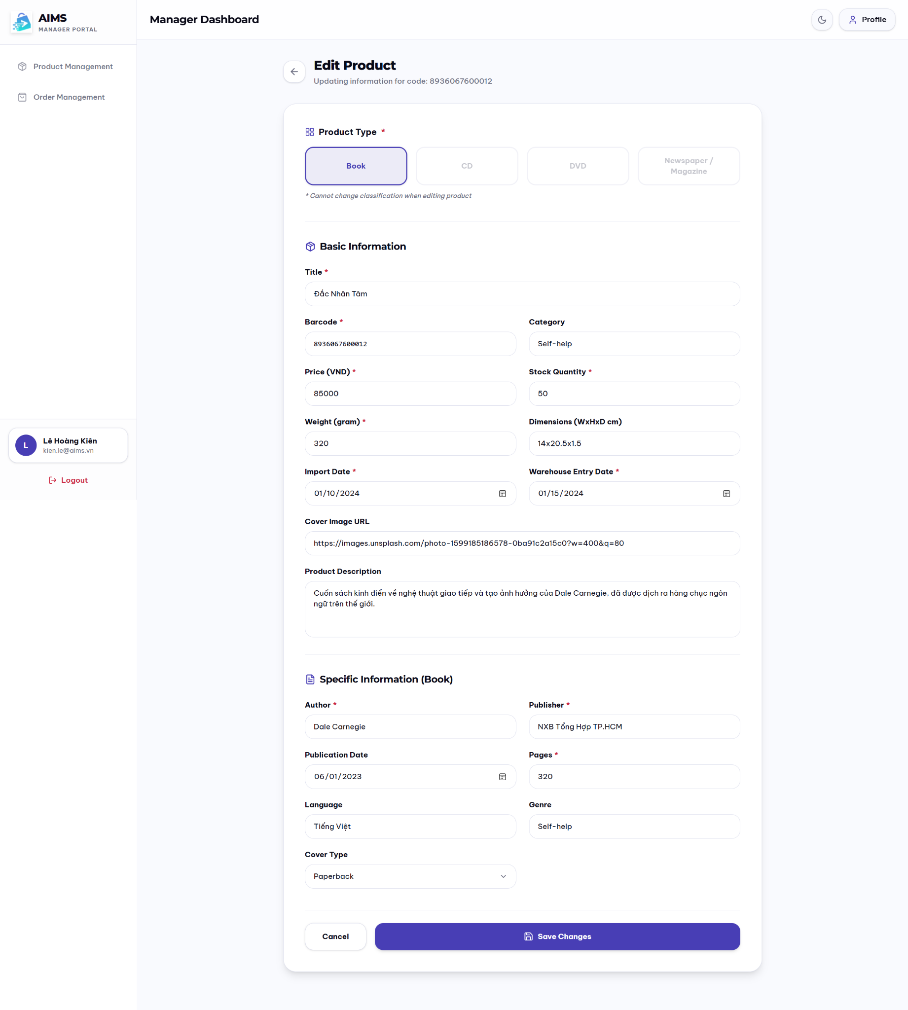
Date of creation | Approved by | Reviewed by | Person in charge
19/4/2026 | Phạm Đức Phước | Nguyễn Huy Diễn | Lê Hoàng Kiên

- Controls, Operations, and Functions

Control | Operation | Function
Book/CD/DVD/Newspaper/Magazine button | Click | Choose the product type
Product Management button | Click | Displays ManagerHomePage
Order Management button | Click | Displays OrderManagerScreen
Profile button | Click | Displays UserProfile
Area to fill in product basic and specific information | Input | Fill in product information
Logout button | Click | Log out of the account, displays LoginSignup screen
Cancel button | Click | Cancel editing product
Save Changes button | Click | Confirm editing product
Screen Specification for “OrderManagementScreen”
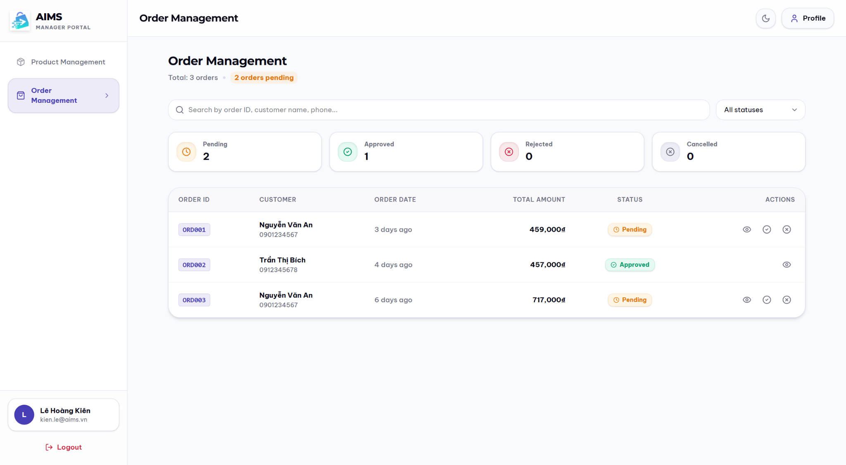
Date of creation | Approved by | Reviewed by | Person in charge
19/4/2026 | Nguyễn Tiến Đạt | Phạm Đức Phước | Lê Hoàng Kiên

- Controls, Operations, and Functions

Control | Operation | Function
Product Management button | Click | Displays ManagerHomePage
Profile button | Click | Displays UserProfile
Logout button | Click | Log out of the account, displays LoginSignup screen
Area to display order information | Initial | Display order information
View details button | Click | Display ManagerOrderDetailScreen
Approve order button | Click | Display ApproveOrderPopup
Reject order button | Click | Display RejectOrderPopup
Pending/Approved/  Rejected/Cancelled button | Click | Show orders with corresponding status
Search bar | Input | Filter orders with corresponding field value

- Field attributes

Item | Length | Type | Color | Remarks
Total | 4 digits | Numeral | Gray | Left-justified
Pending/  Approved/  Rejected/  Cancelled amount | 3 digits | Numeral | Black | Left-justified
ORDER ID | 6 characters | Text | Purple | Left-justified
CUSTOMER name + phone | 30 characters for name  10 digits for phone number | Text & Numeral | Black & Gray | Left-justified
ORDER DATE | 15 characters | Text | Gray | Left-justified
TOTAL AMOUNT | 8 digits + ₫ | Numeral | Black | Left-Justified
STATUS | 12 characters | Text | Yellow / Green / Red / Gray | Center alignment with corresponding symbol
Screen Specification for “ManagerOrderDetailScreen”
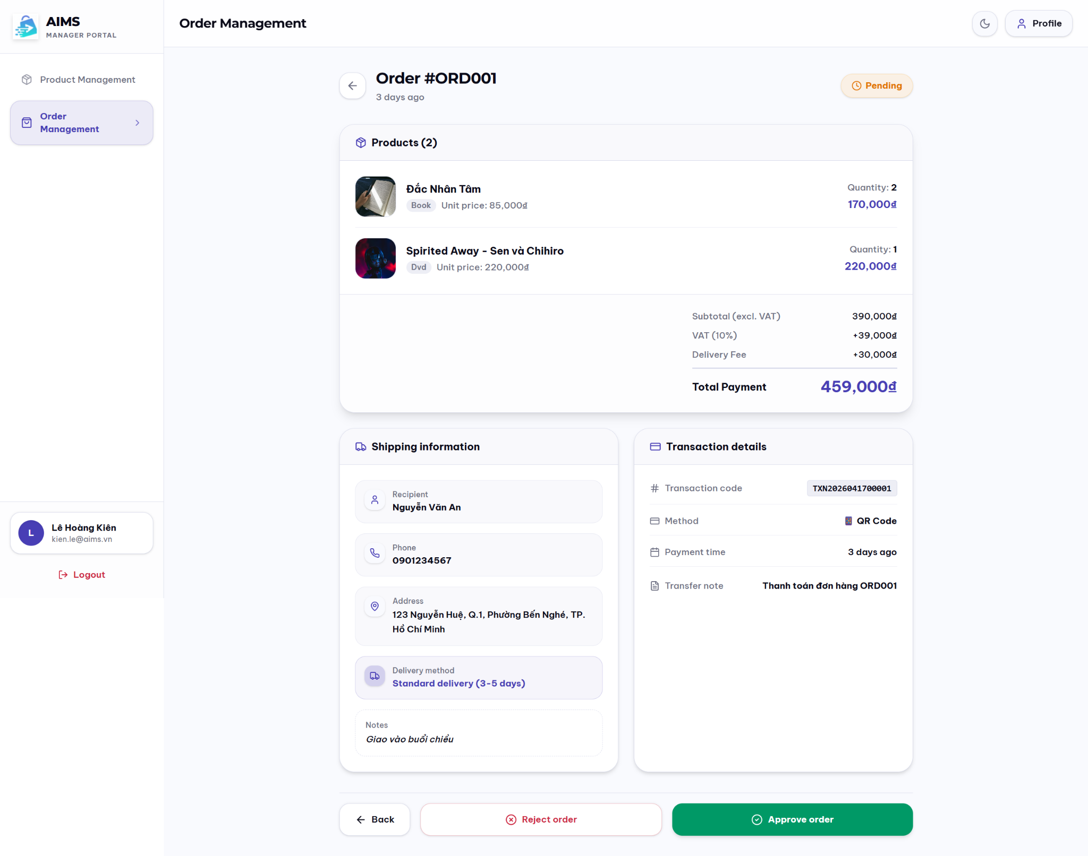
Date of creation | Approved by | Reviewed by | Person in charge
19/4/2026 | Nguyễn Tiến Đạt | Nguyễn Huy Diễn | Lê Hoàng Kiên

- Controls, Operations, and Functions

Control | Operation | Function
Product Management button | Click | Display ManagerHomePage
Profile button | Click | Display UserProfile
Logout button | Click | Log out of the account, displays LoginSignup screen
Button to return to order management screen | Click “⟵” or “⟵ Back” | Return to OrderManagementScreen
Reject order button | Click | Display RejectOrderPopup
Approve order button | Click | Display ApproveOrderPopup
Area to display order information | Initial | Display order information

- Field attributes

Item | Length | Type | Color | Remarks
Product title | 40 characters | Text | Black | Left-justified
Product type | 12 characters | Text | Gray | Left-justified
Unit price | 8 digits + ₫ | Numeral | Purple | Right-Justified
Quantity | 3 digits | Numeral | Black | Right-Justified
Total Payment | 8 digits + ₫ | Numeral | Purple | Right-Justified
Recipient | 2 characters | Text | Black | Left-justified
Phone | 10 digits | Numeral | Black | Left-justified
Address | 100 characters | Text | Black | Left-justified
Delivery method | 50 characters | Text | Purple | Left-justified
Notes | 30 characters | Text | Black | Left-justified
Transaction code | 16 characters | Text | Black | Right-Justified
Method | 20 characters | Text + relevant method symbol | Black | Right-Justified
Payment time | 15 characters | Text | Black | Right-Justified
Transfer note | 30 characters | Text | Black | Right-Justified
Screen Specification for “ManagerProductDetail”
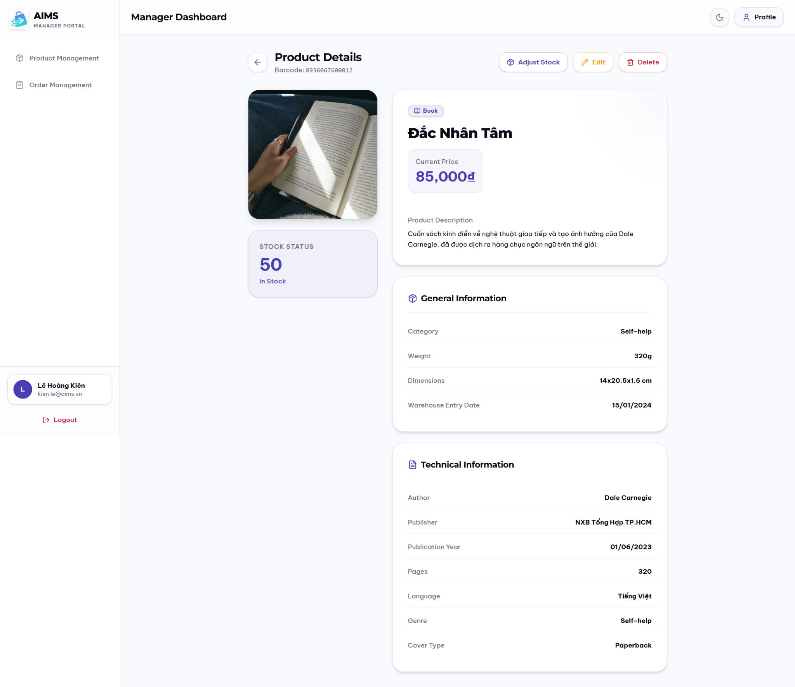
Date of creation | Approved by | Reviewed by | Person in charge
19/4/2026 | Phạm Đức Phước | Nguyễn Tiến Đạt | Lê Hoàng Kiên

- Controls, Operations, and Functions

Control | Operation | Function
Product Management button | Click | Displays ManagerHomePage
Order Management button | Click | Displays OrderManagerScreen
Profile button | Click | Displays UserProfile
Logout button | Click | Log out of the account, displays LoginSignup screen
Area to display product detail | Initial | Display product information
Adjust stock button | Click | Display AdjustStockPopup
Edit button | Click | Display EditProductScreen
Delete button | Click | Display DeleteProductPopup

- Field attributes

Item | Length | Type | Color | Remarks
Title | 40 characters | Text | Black | Right-Justified
Barcode | 13 characters | Text | Gray | Left-justified
Category | 30 characters | Text | Black | Right-Justified
Price | 8 digits + ₫ | Numeral | Purple | Left-justified
Stock Quantity | 3 digits | Numeral | Purple | Left-justified
Weight | 5 digits | Numeral | Black | Right-Justified
Dimensions | 3 digits x 3 digits x 3 digits | Numeral | Black | Right-Justified
Warehouse Entry Date |  | Date | Black | Right-Justified
Product Description | 1000 characters | Text | Black | Right-Justified
Author | 30 characters | Text | Black | Right-Justified
Publisher | 30 characters | Text | Black | Right-Justified
Publication Date |  | Date | Black | Right-Justified
Pages | 5 digits | Numeral | Black | Right-Justified
Language | 10 characters | Text | Black | Right-Justified
Genre | 20 characters | Text | Black | Right-Justified
Cover Type | 10 characters | Text | Black | Right-Justified
Artist/Band | 30 characters | Text | Black | Right-Justified
Record Label | 30 characters | Text | Black | Right-Justified
Release Date |  | Date | Black | Right-Justified
Number of tracks | 2 digits | Numeral | Black | Right-Justified
Studio | 30 characters | Text | Black | Right-Justified
Director | 30 characters | Text | Black | Right-Justified
Runtime | 4 digits | Numeral | Black | Right-Justified
Disc Type | 15 characters | Text | Black | Right-Justified
Main Topic | 30 characters | Text | Black | Right-Justified
Screen Specification for “AdjustStockPopup”
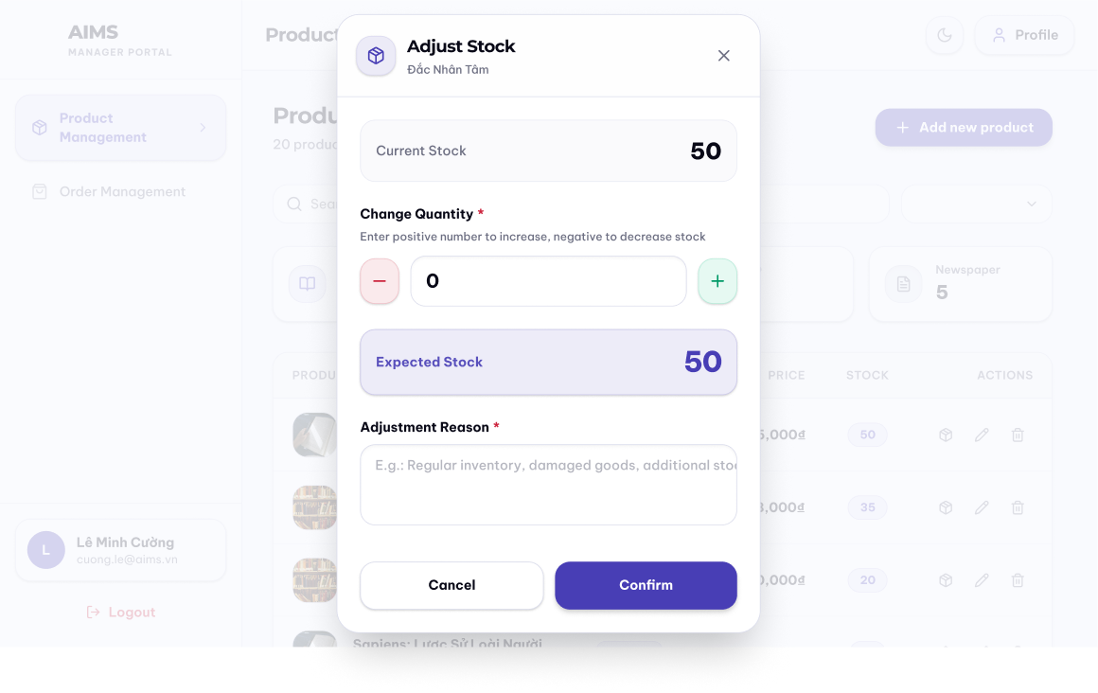
Date of creation | Approved by | Reviewed by | Person in charge
20/4/2026 | Nguyễn Huy Diễn | Nguyễn Tiến Đạt | Lê Hoàng Kiên

- Controls, Operations, and Functions

Control | Operation | Function
Current Stock | Initial | Current stock level of the product
Area to adjust quantity | Click - / + or Input the number of adding / subtracting stock level | Adjust the stock quantity
Textbox input | Input | Reason for adjusting stock
Cancel button | Click | Back to the current page
Confirm button | Click | Confirm adjusting stock level

- Field attributes

Item | Length | Type | Color | Remarks
Current Stock | 3 digits | Numeral | Black | Right-justified
Expected Stock | 3 digits | Numeral | Purple / Indigo | Right-justified

Data Modeling

Conceptual Data Modeling
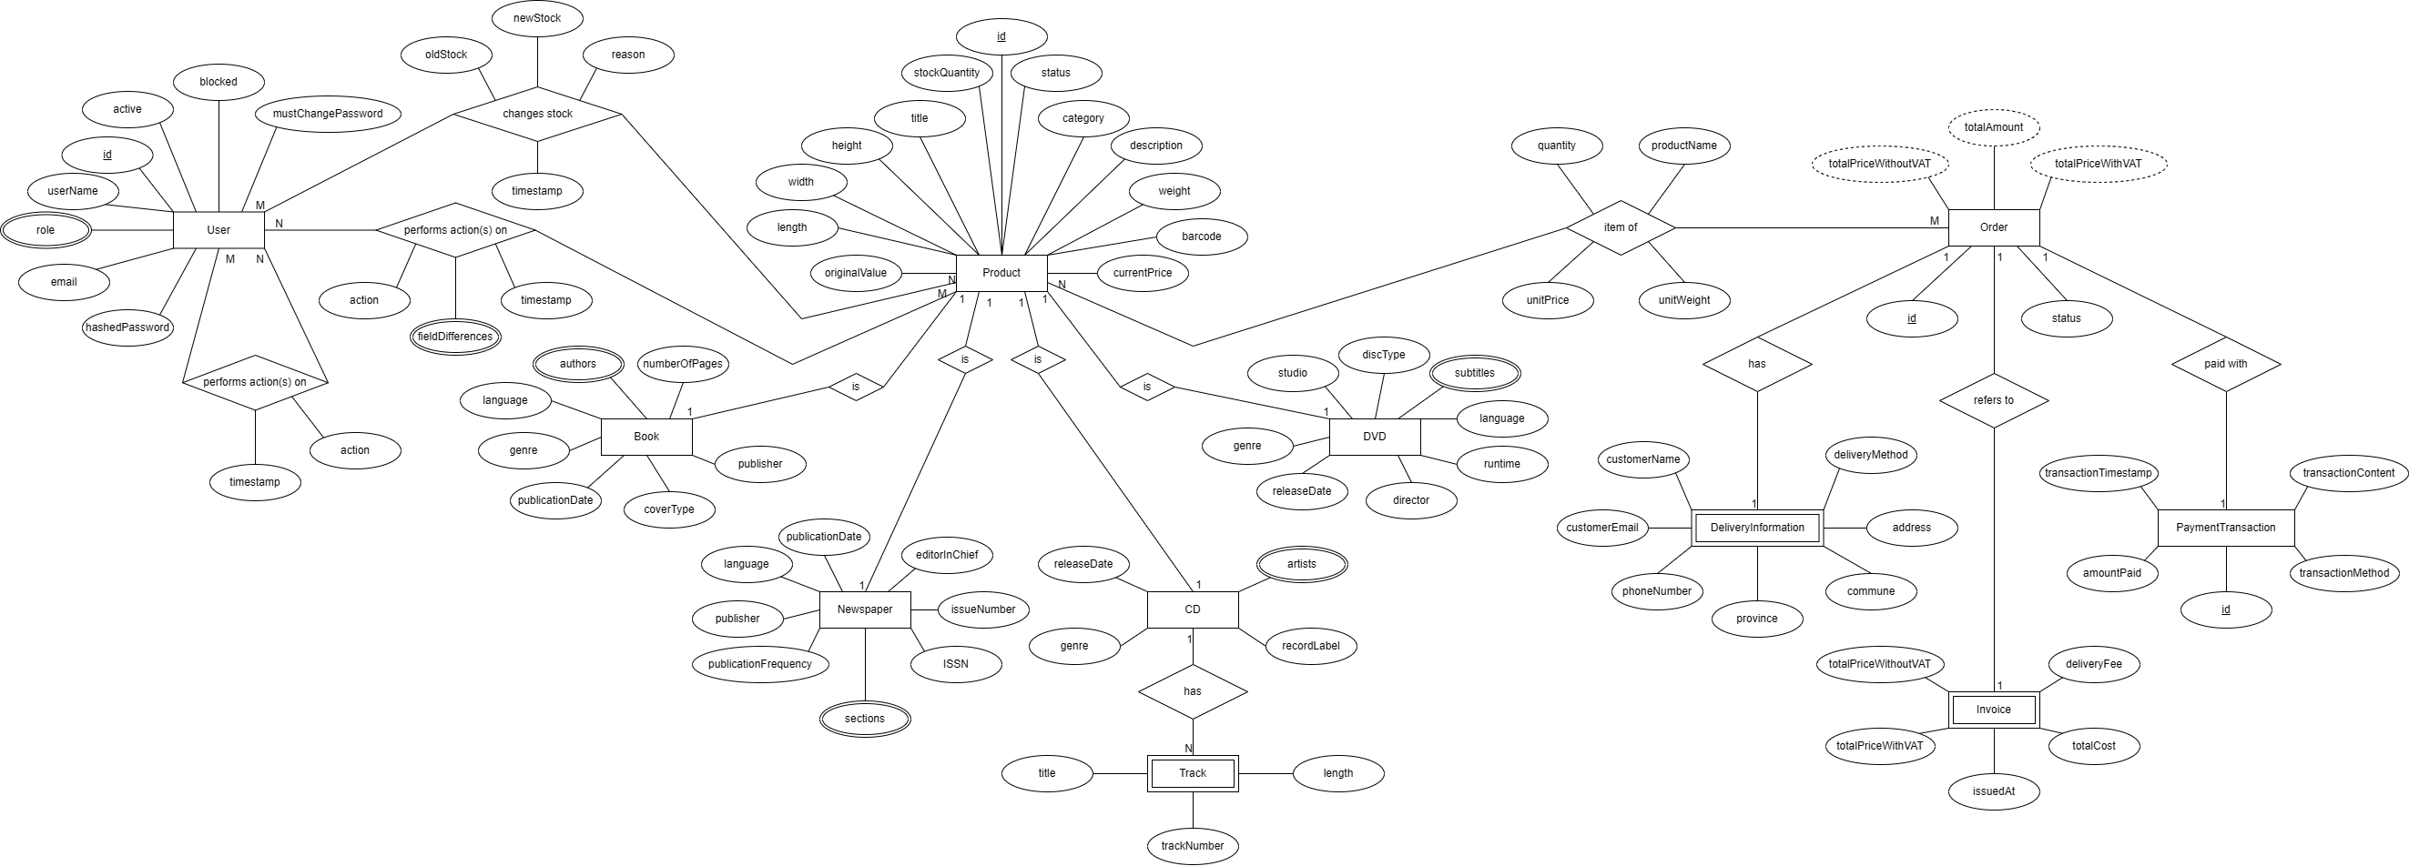
Figure 12. Entity-Relationship Diagram for AIMS System
Major entities of the AIMS system:
- User: The User entity represents all authenticated system actors: Product Managers and Administrators. Key attributes include id, username, email, role, active, blocked, and mustChangePassword. Two multivalued audit trails hang off User: a changeStock history recording stock adjustment actions with reason and timestamp and a “performs action(s) on” history recording product CUD actions with action and timestamp, both linking back to the affected Product. There is also another multivalued audit trails hanging off User: another “performs action(s) on” history recording Admin administrative actions with action and timestamp, linking back to the User entity itself.
- Product (and subtypes): Product is the central entity of the catalog. It carries shared attributes applicable to all media types: id, title, category, description, weight, barcode, originalValue, currentPrice, stockQuantity, status, and ratio. Four specialised subtypes extend Product via an IS-A relationship:
  - Book: adds authors, numberOfPages, publisher, genre, language, coverType, and publicationDate.
  - CD: adds artist, genre, releaseDate, recordLabel, and a “has” relationship to a weak Track entity (with attributes title, length, backNumber).
  - DVD: adds studio, discType, subtitles, language, genre, releaseDate, and director.
  - Newspaper: adds publisher, language, publicationDate, publicationFrequency, issueNumber, ISSN, localNumber, editionChief, genre, and sections.
- Order: The central aggregate root for the order-placing, purchasing workflow, containing an id and a status. It has a many-to-many relationship with the Product entities that represents the Item of an Order, with attributes like productName, unitPrice, unitWeight, and quantity at the time of checkout. It also has a one-to-one relationship with 2 weak entities that has its lifecycle tied to Order:
  - DeliveryInformation: Stores shipping and recipient information required to fulfill an order.
  - Invoice: Stores billing information associated with an order, generated during checkout.
- PaymentTransaction: Represents payment records generated during the checkout process and stores transaction-specific information such as payment method, transaction status, and gateway references. It is currently modeled as having a one-to-one relationship with Order.

Database Design

Database Management System
The AIMS system uses PostgreSQL as its relational database management system. PostgreSQL is a powerful, open-source object-relational DBMS known for its standards compliance, extensibility, and robustness under concurrent workloads. It supports full ACID transactions, row-level locking, rich indexing strategies, and a mature ecosystem of tooling, all of which align with the reliability and data integrity requirements of AIMS.
The backend communicates with PostgreSQL via Spring Data JPA backed by Hibernate as the JPA provider. Entity-to-table mapping, relationship management, and query execution are all handled through this stack, with schema generation managed by Hibernate's DDL auto-update capability during development.
For this project, each team member hosts a PostgreSQL instance independently on their own development machine. There is no shared or centralised database server. Database schema consistency across team members is maintained through Hibernate's schema generation and a shared set of JPA entity definitions in the codebase, any entity-level change automatically propagates to each member's local schema on the next application startup. Seed data scripts are maintained separately and run manually when needed.
This setup is appropriate for a course project context where parallel development occurs on isolated machines. It does introduce the constraint that integration testing across modules requires each developer to ensure their local schema is up to date with the latest entity definitions before running cross-module tests.

Database Diagram
The relational schema is derived from the conceptual ER model following standard ER-to-relational mapping rules. The key design decisions are described below.
IS-A specialization (Product subtypes)
The Product IS-A hierarchy is mapped using the joined table strategy: a central product table holds all shared attributes, and each subtype (book, cd, dvd, newspaper) has its own table containing only subtype-specific attributes, joined to product by a shared primary key. This preserves normalization, avoids sparse columns, and allows the shared product table to serve as the single foreign key target for all relationships involving products (orders, audit logs, stock adjustments).
Multivalued attributes and weak entities
Multivalued attributes and weak entities from the ER model are each promoted to their own table:
- book_authors and cd_artists: each storing one value per row, keyed by the owning product's id.
- cd_tracks: the weak Track entity, storing track_number, title, and length, keyed by cd_id.
- dvd_subtitles and newspaper_sections: similarly promoted to separate tables.
- user_roles: also similarly promoted to separate table, supporting the Administrator's ability to assign and modify roles independently of user identity
Many-to-many: Order ↔ Product
The many-to-many relationship between Order and Product (representing order line items) is resolved into an order_item junction table, carrying the attributes captured at checkout time: product_name, unit_price, unit_weight, and quantity. These are denormalized snapshot values, which means they record the product state at the moment of purchase and are independent of any subsequent changes to the product. The table order_item also contains a surrogate key id instead of making (order_id, product_id) pair as primary key due to the possibility of product “vanishing” from the system for good.
One-to-one weak entities: DeliveryInformation and Invoice
Both DeliveryInformation and Invoice are lifecycle-dependent on Order. They are mapped as separate tables whose primary key is also a foreign key referencing order, enforcing the one-to-one relationship and the existence dependency at the database level.
PaymentTransaction is mapped as an independent table with its own surrogate primary key, linked to order via a foreign key. This accommodates the structural differences between VietQR and PayPal transaction records within a single table.
Audit Log tables
The three audit trail relationships from the ER model are each materialized as a dedicated table:
- product_log: records product CUD actions performed by a Product Manager, with a snapshot of the product title and a reference to both the managing user and the affected product.
- product_update_log: records field-level changes for each product update, storing field_name, old_value, and new_value per changed field. It is a child of product_log, linked by log_id.
- stock_adjust_log: records stock adjustment actions, capturing old_stock, new_stock, and reason.
- admin_log: records administrative actions performed by an Administrator, storing the action, the acting admin, and the affected user.
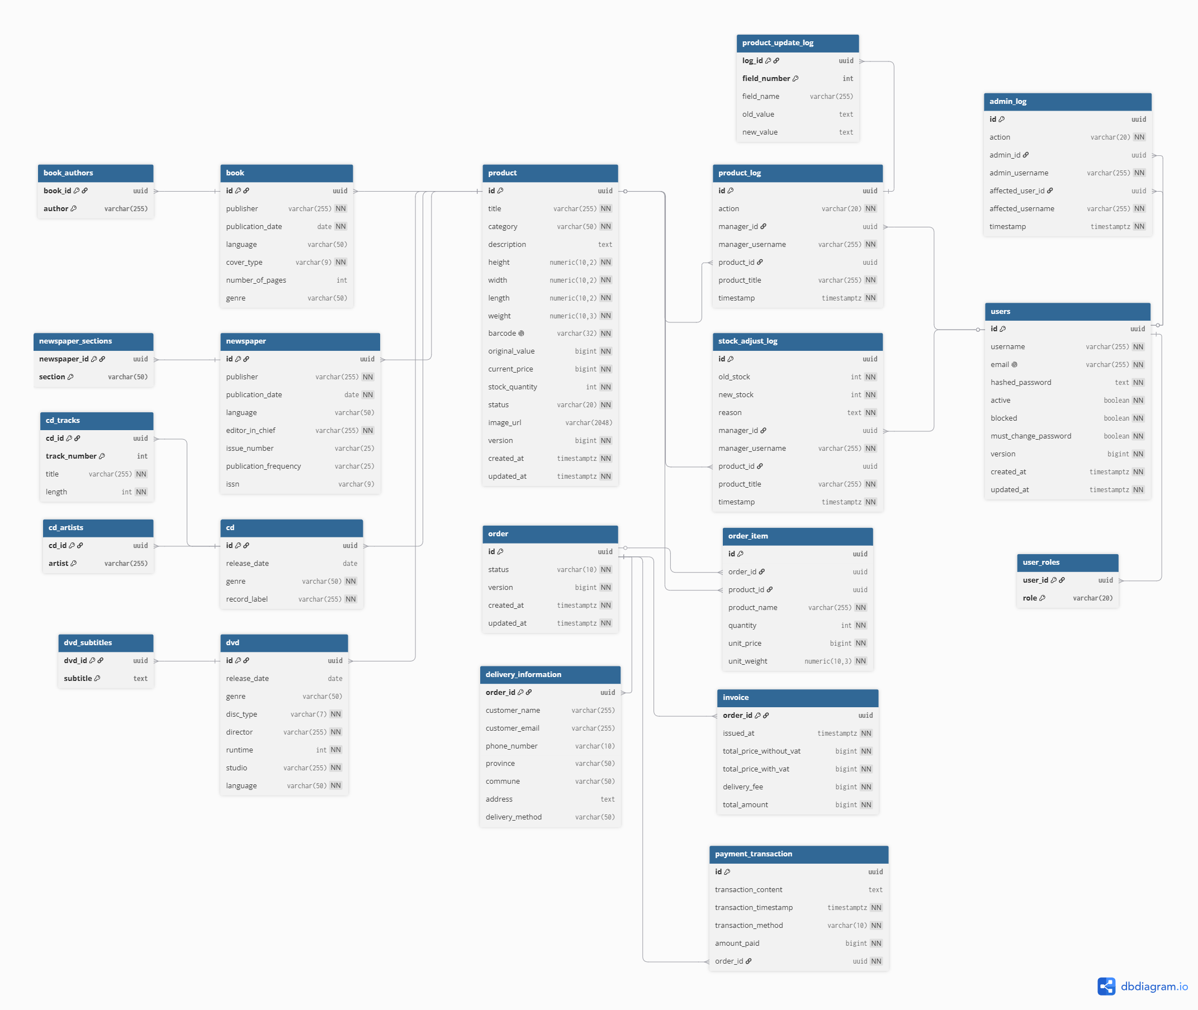
Figure 13. Database Design for AIMS System

Database Detail Design
product
# | PK | FK | Column Name | Data type | Default Value | Mandatory | Description
1 | x |  | id | UUID | Random UUID | Yes | Unique product ID
2 |  |  | title | VARCHAR(255) |  | Yes | Product title
3 |  |  | height | NUMERIC(10,2) |  | Yes | Product height
4 |  |  | width | NUMERIC(10,2) |  | Yes | Product width
5 |  |  | length | NUMERIC(10,2) |  | Yes | Product length
6 |  |  | weight | NUMERIC(10,3) |  | Yes | Product weight
7 |  |  | category | VARCHAR(50) |  | Yes | Product category
8 |  |  | description | TEXT |  | No | General product description
9 |  |  | barcode | VARCHAR(32) |  | Yes | Unique product barcode
10 |  |  | original_value | BIGINT |  | Yes | Original value
11 |  |  | current_price | BIGINT |  | Yes | Current selling price
12 |  |  | stock_quantity | INT |  | Yes | Current quantity in stock
13 |  |  | status | VARCHAR(20) |  | Yes | Product status
14 |  |  | image_url | VARCHAR(2048) |  | No | Product image URL
15 |  |  | created_at | TIMESTAMPTZ | Current Time | Yes | Product creation time
16 |  |  | updated_at | TIMESTAMPTZ | Current Time | Yes | Product update time
17 |  |  | version | BIGINT | 0 | Yes | Product version (for optimistic locking purpose)

book
# | PK | FK | Column Name | Data type | Default Value | Mandatory | Description
1 | x | x | id | UUID |  | Yes | ID, same as Product ID
2 |  |  | language | VARCHAR(50) |  | No | Book language
3 |  |  | genre | VARCHAR(50) |  | No | Book genre
4 |  |  | publication_date | DATE |  | Yes | Book publication date
5 |  |  | cover_type | VARCHAR(9) |  | Yes | Cover type, e.g., paperback/hardcover
6 |  |  | publisher | VARCHAR(255) |  | Yes | Book publisher
7 |  |  | number_of_pages | INTEGER |  | No | Number of pages

book_authors
# | PK | FK | Column Name | Data type | Default Value | Mandatory | Description
1 | x | x | book_id | UUID |  | Yes | ID of the book
2 | x |  | author | VARCHAR(255) |  | Yes | Author name

newspaper
# | PK | FK | Column Name | Data type | Default Value | Mandatory | Description
1 | x | x | id | UUID |  | Yes | ID, same as Product ID
2 |  |  | editor_in_chief | VARCHAR(255) |  | Yes | Editor-in-chief
3 |  |  | issue_number | VARCHAR(25) |  | No | Issue number
4 |  |  | issn | VARCHAR(9) |  | No | ISSN code
5 |  |  | publication_frequency | VARCHAR(25) |  | No | Publication frequency
6 |  |  | publisher | VARCHAR(255) |  | Yes | Newspaper publisher
7 |  |  | language | VARCHAR(50) |  | No | Newspaper language
8 |  |  | publication_date | DATE |  | Yes | Publication date

newspaper_sections
# | PK | FK | Column Name | Data type | Default Value | Mandatory | Description
1 | x | x | newspaper_id | UUID |  | Yes | ID of the newspaper
2 | x |  | section | VARCHAR(50) |  | Yes | Newspaper section

cd
# | PK | FK | Column Name | Data type | Default Value | Mandatory | Description
1 | x | x | id | UUID |  | Yes | ID, same as Product ID
2 |  |  | record_label | VARCHAR(255) |  | Yes | CD record label
3 |  |  | genre | VARCHAR(50) |  | Yes | CD genre
4 |  |  | release_date | DATE |  | No | CD release date

cd_artists
# | PK | FK | Column Name | Data type | Default Value | Mandatory | Description
1 | x | x | cd_id | UUID |  | Yes | ID of the CD
2 | x |  | artist | VARCHAR(255) |  | Yes | Artist name

cd_tracks
# | PK | FK | Column Name | Data type | Default Value | Mandatory | Description
1 | x | x | cd_id | UUID |  | Yes | ID of the CD containing this track
2 | x |  | track_number | INTEGER |  | Yes | The track order number
3 |  |  | title | VARCHAR(255) |  | Yes | Track title
4 |  |  | length | BIGINT |  | Yes | Track length/duration

dvd
# | PK | FK | Column Name | Data type | Default Value | Mandatory | Description
1 | x | x | id | UUID |  | Yes | ID, same as Product ID
2 |  |  | studio | VARCHAR(255) |  | Yes | DVD studio
3 |  |  | disc_type | VARCHAR(7) |  | Yes | Disc type, e.g., Blu-ray
4 |  |  | language | VARCHAR(50) |  | Yes | DVD language
5 |  |  | runtime | BIGINT |  | Yes | Runtime duration
6 |  |  | director | VARCHAR(255) |  | Yes | Director name
7 |  |  | release_date | DATE |  | No | DVD release date
8 |  |  | genre | VARCHAR(50) |  | No | DVD genre

dvd_subtitles
# | PK | FK | Column Name | Data type | Default Value | Mandatory | Description
1 | x | x | dvd_id | UUID |  | Yes | ID of the DVD
2 | x |  | subtitle | TEXT |  | Yes | Subtitle language/content

order
# | PK | FK | Column Name | Data type | Default Value | Mandatory | Description
1 | x |  | id | UUID |  | Yes | Unique order ID
2 |  |  | status | VARCHAR(10) |  | Yes | Order status
3 |  |  | created_at | TIMESTAMPTZ | Current timestamp | Yes | Order creation time
4 |  |  | updated_at | TIMESTAMPTZ | Current timestamp | Yes | Order update time
5 |  |  | version | BIGINT | 0 | Yes | Order version (for optimistic locking purpose)

order_item
# | PK | FK | Column Name | Data type | Default Value | Mandatory | Description
1 | x |  | id | UUID |  | Yes | Surrogate ID of the order item
2 |  | x | order_id | UUID |  | Yes | ID of the order
3 |  | x | product_id | UUID |  | No | ID of the ordered product
4 |  |  | quantity | INTEGER |  | Yes | Ordered quantity
5 |  |  | product_name | VARCHAR(255) |  | Yes | Product name at order time
6 |  |  | unit_price | BIGINT |  | Yes | Unit price at order time
7 |  |  | unit_weight | NUMERIC(10,3) |  | Yes | Unit weight at order time

delivery_information
# | PK | FK | Column Name | Data type | Default value | Mandatory | Description
1 | x | x | order_id | UUID |  | Yes | ID of the related order
2 |  |  | customer_name | VARCHAR(255) |  | Yes | Customer name
3 |  |  | customer_email | VARCHAR(255) |  | Yes | Customer email
4 |  |  | phone_number | VARCHAR(10) |  | Yes | Customer phone number
5 |  |  | province | VARCHAR(50) |  | Yes | Customer province/city
6 |  |  | commune | VARCHAR(50) |  | Yes | Customer commune/ward
7 |  |  | address | VARCHAR(255) |  | Yes | Customer address
8 |  |  | delivery_method | VARCHAR(255) |  | Yes | Delivery method

invoice
# | PK | FK | Column Name | Data type | Default value | Mandatory | Description
1 | x | x | order_id | UUID |  | Yes | ID of the related order
2 |  |  | total_price_without_vat | BIGINT |  | Yes | Total product price before VAT
3 |  |  | total_price_with_vat | BIGINT |  | Yes | Total product price after VAT
4 |  |  | delivery_fee | BIGINT |  | Yes | Delivery fee
5 |  |  | total_amount | BIGINT |  | Yes | Final amount to be paid
6 |  |  | issued_at | TIMESTAMPTZ |  | Yes | The issue time of the invoice

payment_transaction
# | PK | FK | Column Name | Data type | Default value | Mandatory | Description
1 | x |  | id | UUID |  | Yes | Unique payment transaction ID
2 |  | x | order_id | UUID |  | Yes | ID of the related order
3 |  |  | amount_paid | BIGINT |  | Yes | Amount paid by customer
4 |  |  | transaction_method | VARCHAR(10) |  | Yes | Payment method
5 |  |  | transaction_content | TEXT |  | Yes | Payment transaction content
6 |  |  | transaction_timestamp | TIMESTAMPTZ |  | Yes | Payment transaction time

user
# | PK | FK | Column Name | Data type | Default value | Mandatory | Description
1 | x |  | id | UUID |  | Yes | Unique user ID
2 |  |  | username | VARCHAR(255) |  | Yes | User display name
3 |  |  | email | VARCHAR(255) |  | Yes | User email, must be unique
4 |  |  | hashed_password | TEXT |  | Yes | Securely hashed password
5 |  |  | active | BOOLEAN |  | Yes | Whether user is active or not
6 |  |  | blocked | BOOLEAN |  | Yes | Whether user is blocked or not
7 |  |  | must_change_password | BOOLEAN |  | Yes | Whether user is required to change password on their next login
5 |  |  | created_at | TIMESTAMPTZ | Current timestamp | Yes | User creation time
6 |  |  | updated_at | TIMESTAMPTZ | Current timestamp | Yes | User update time
7 |  |  | version | BIGINT | 0 | Yes | User version (for optimistic locking purpose)

user_roles
# | PK | FK | Column Name | Data type | Default value | Mandatory | Description
1 | x | x | user_id | UUID |  | Yes | ID of the user
2 | x |  | role | VARCHAR(20) |  | Yes | Role of the user

product_log
# | PK | FK | Column Name | Data type | Default value | Mandatory | Description
1 | x |  | id | UUID |  | Yes | Unique product log ID
2 |  | x | manager_id | UUID |  | No | Product manager who performed the action
3 |  |  | manager_username | VARCHAR(255) |  | Yes | Product manager username
4 |  | x | product_id | UUID |  | No | Product affected by the action
5 |  |  | product_title | VARCHAR(255) |  | Yes | Product title
6 |  |  | timestamp | TIMESTAMP | Current timestamp | Yes | Time of the action
7 |  |  | action | VARCHAR(20) |  | Yes | Action type, e.g., add, edit, delete

product_update_log
# | PK | FK | Column Name | Data type | Default value | Mandatory | Description
1 | x | x | log_id | UUID |  | Yes | Unique ID product log whose action is “UPDATE”
2 | x |  | field_number | UUID |  | Yes | The order number of the field
3 |  |  | field_name | VARCHAR(255) |  | Yes | Name of the field
4 |  |  | old_value | TEXT |  | Yes | Old value of the field
5 |  |  | new_value | TEXT |  | Yes | New value of the field

stock_adjust_log
# | PK | FK | Column Name | Data type | Default value | Mandatory | Description
1 | x |  | id | UUID |  | Yes | Unique stock adjustment log ID
2 |  | x | manager_id | UUID |  | No | Product manager who performed the action
3 |  |  | manager_username | VARCHAR(255) |  | Yes | Product manager username
4 |  | x | product_id | UUID |  | No | Product affected by the action
5 |  |  | product_title | VARCHAR(255) |  | Yes | Product title
4 |  |  | old_stock | INT |  | Yes | Stock before adjustment
5 |  |  | new_stock | INT |  | Yes | Stock after adjustment
6 |  |  | reason | TEXT |  | Yes | Reason for stock adjustment
7 |  |  | timestamp | TIMESTAMP | Current timestamp | Yes | Time of adjustment

admin_log
# | PK | FK | Column Name | Data type | Default value | Mandatory | Description
1 | x |  | id | UUID |  | Yes | Unique admin log ID
2 |  | x | admin_id | UUID |  | No | Administrator who performed the action
3 |  |  | admin_username | VARCHAR(255) |  | Yes | Administrator username
4 |  | x | affected_user_id | UUID |  | No | User affected by the action
5 |  |  | affected_username | VARCHAR(255) |  | Yes | Affected username
6 |  |  | timestamp | TIMESTAMP | Current timestamp | Yes | Time of action
7 |  |  | action | VARCHAR(20) |  | Yes | Action type, e.g., block, unblock, reset password

Non-Database Management System Files
AIMS uses one non-DBMS file storage system: Supabase Storage, a cloud-based object storage service used to host product images.
- Usage: Output only (read by the frontend). The storage bucket holds image files for each product type. The frontend retrieves images by their public URL, which is stored as a text field (image_url) in the product table in PostgreSQL. Supabase Storage itself is therefore not queried directly by the backend; the backend stores and serves only the URL string, while the browser fetches the image directly from Supabase's CDN.
- Access method: Random access via public HTTPS URL. Each image is independently addressable by its unique URL and requires no sequential traversal of the bucket.
- Record structure: Unstructured binary files (JPEG/PNG/WebP). No record keys or indexes are maintained within the storage layer itself; the image_url column in the product table serves as the application-level reference.
- Update frequency: At the current stage of development, image upload functionality is out of scope. All image_url values have been manually assigned, meaning URLs were copied from publicly available sources and inserted directly into the database as seed data, with one representative image selected per product type. Consequently, the storage bucket is not written to at runtime and no upload transactions occur during normal system operation.
- File size estimate: Minimal. The bucket currently holds a small, fixed set of representative images, each in the range of tens to hundreds of kilobytes.
- Backup and recovery: Supabase Storage provides built-in redundancy and availability guarantees as part of its managed cloud infrastructure. No additional backup procedure is implemented at the application level. Since all image URLs are also stored in the PostgreSQL database, recovery of the URL references is covered by the standard database backup strategy.
- Planned extension: The architecture anticipates a future image upload feature in which the frontend would upload a file directly to Supabase Storage and receive a public URL in return, which would then be submitted to the backend as part of a product create or update request. This flow requires no changes to the backend or database schema; only a frontend upload component needs to be added.

Class Design

General Class Diagram
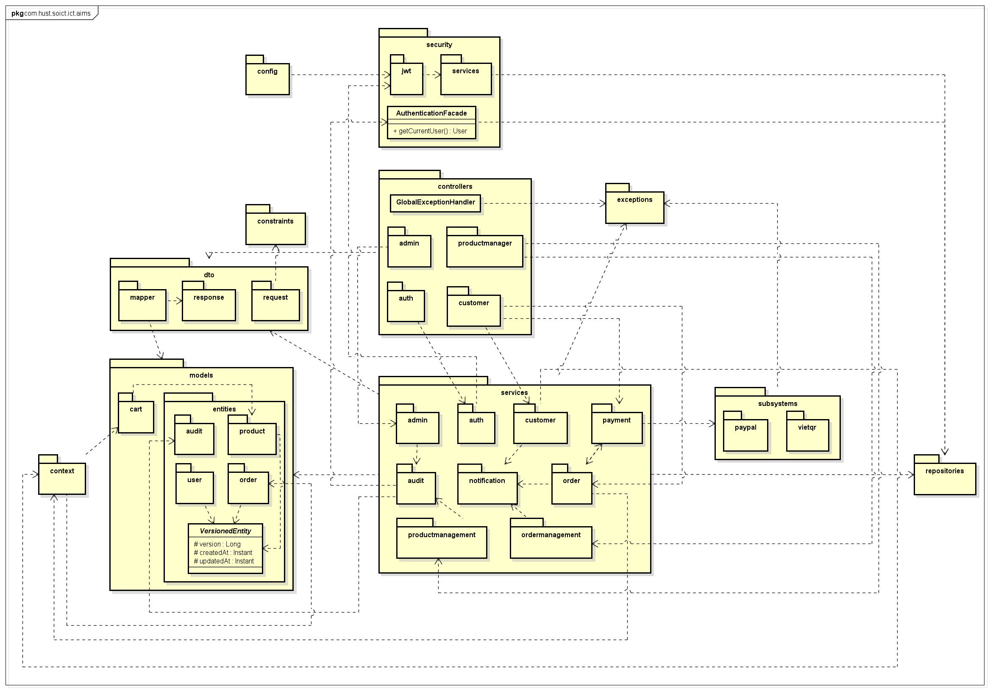

Class Diagrams

Class Diagram for Package models.entities.product
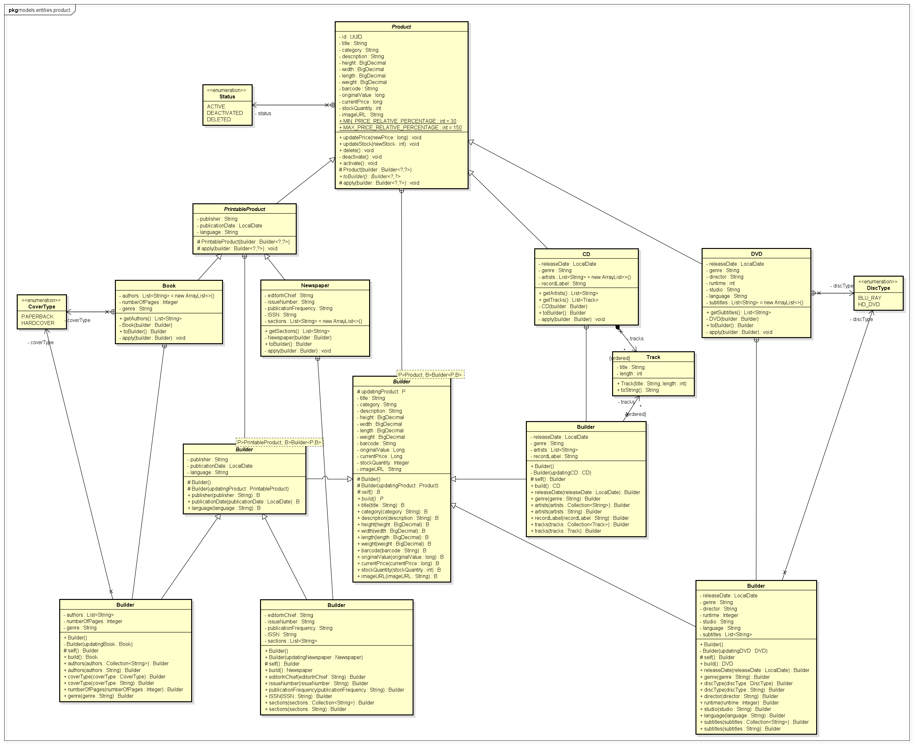

Class Diagram for Package dto.request
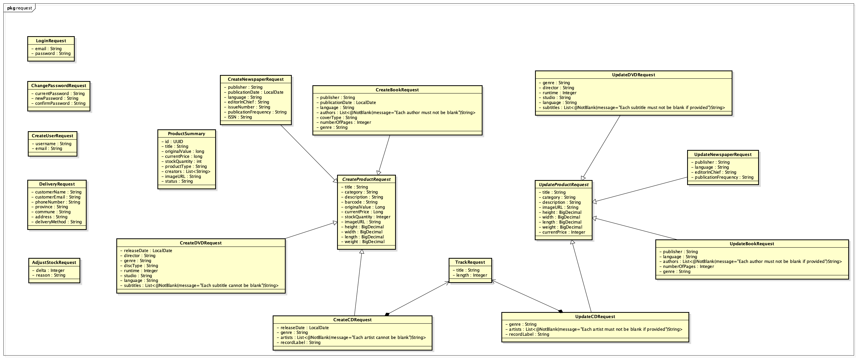

Class Diagram for Package dto.mapper
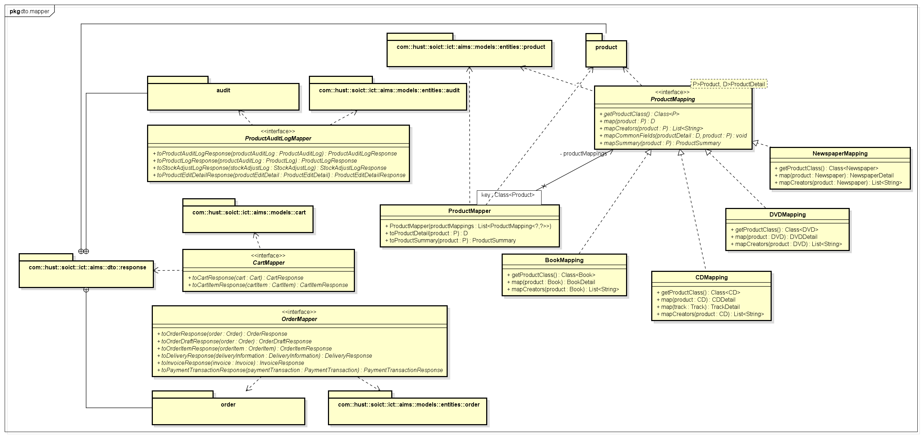

Class Diagram for Package dto.response.product
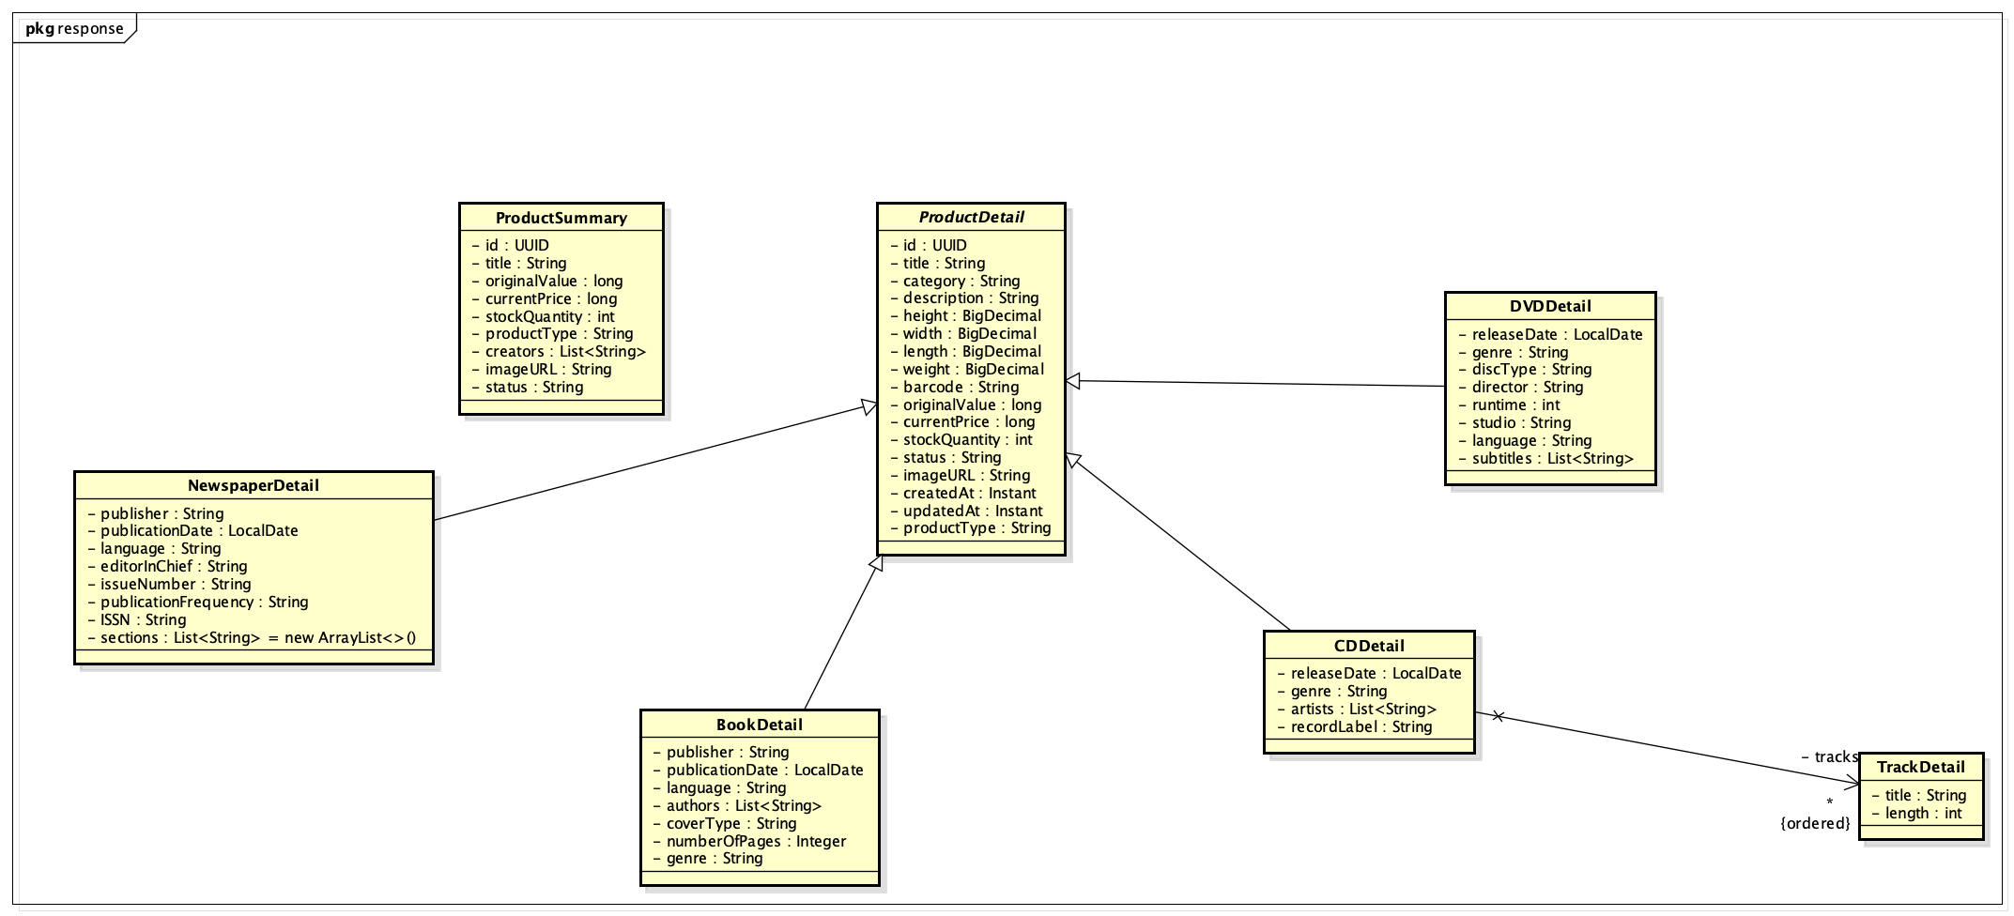

Class Diagram for Package dto.response.order
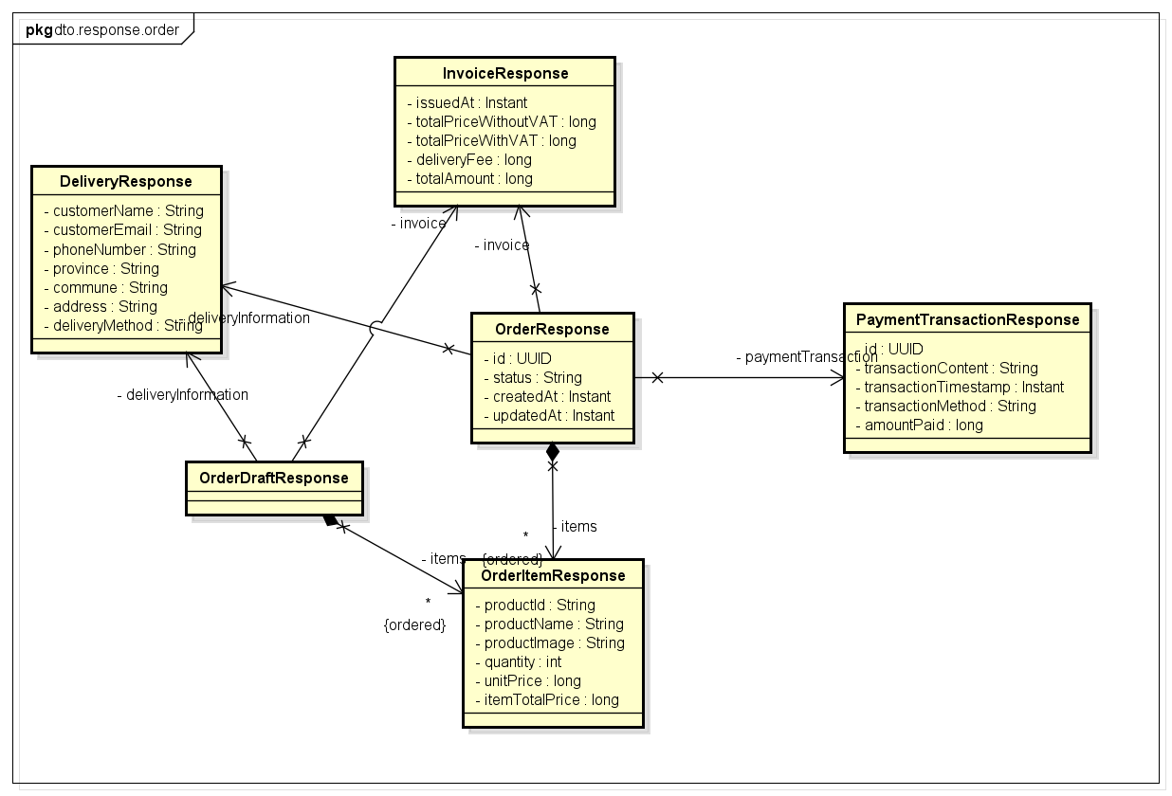

Class Diagram for Package services.productmanagement
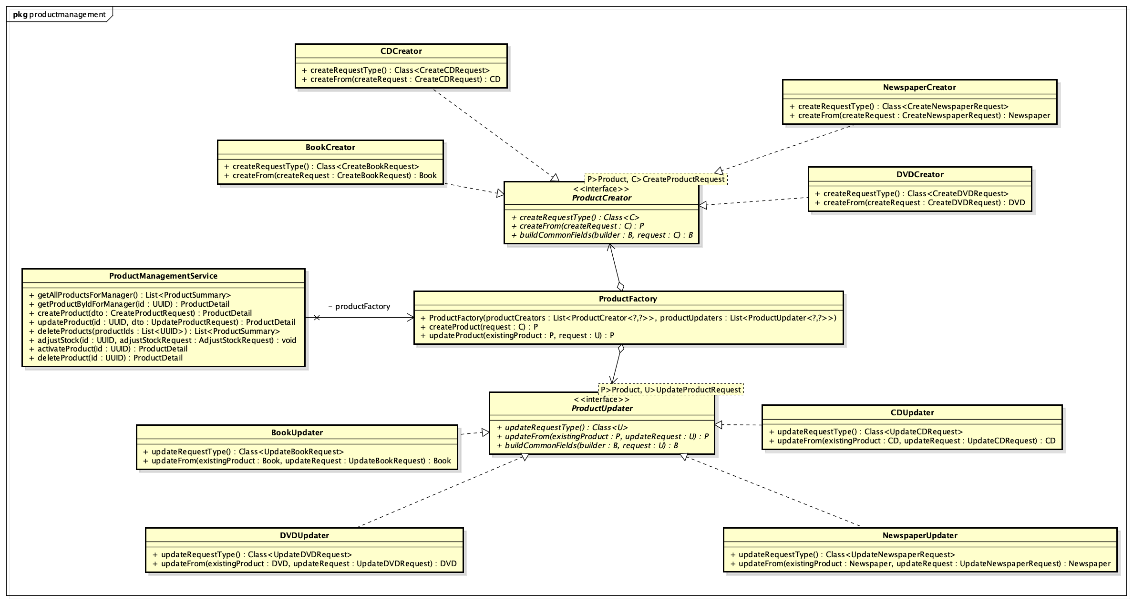

Class Diagram for Package models.entities.order
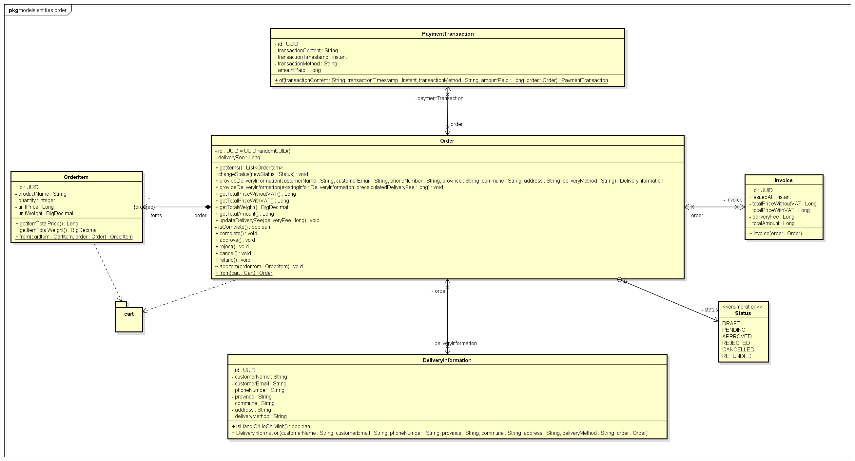

Class Diagram for Package models.cart
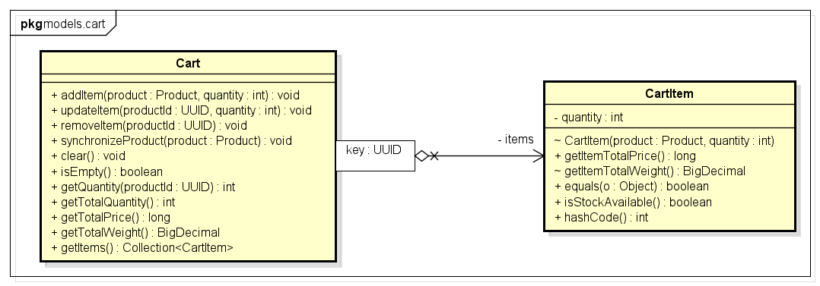

Class Diagram for Package services.order
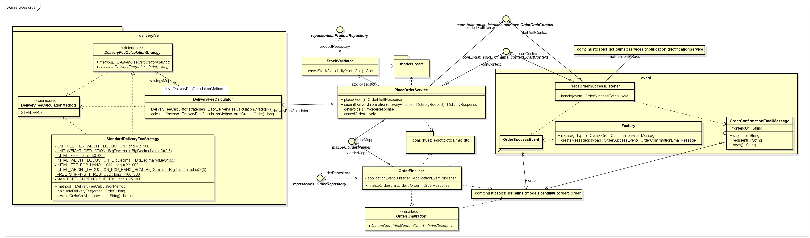

Class Diagram for Package services.customer
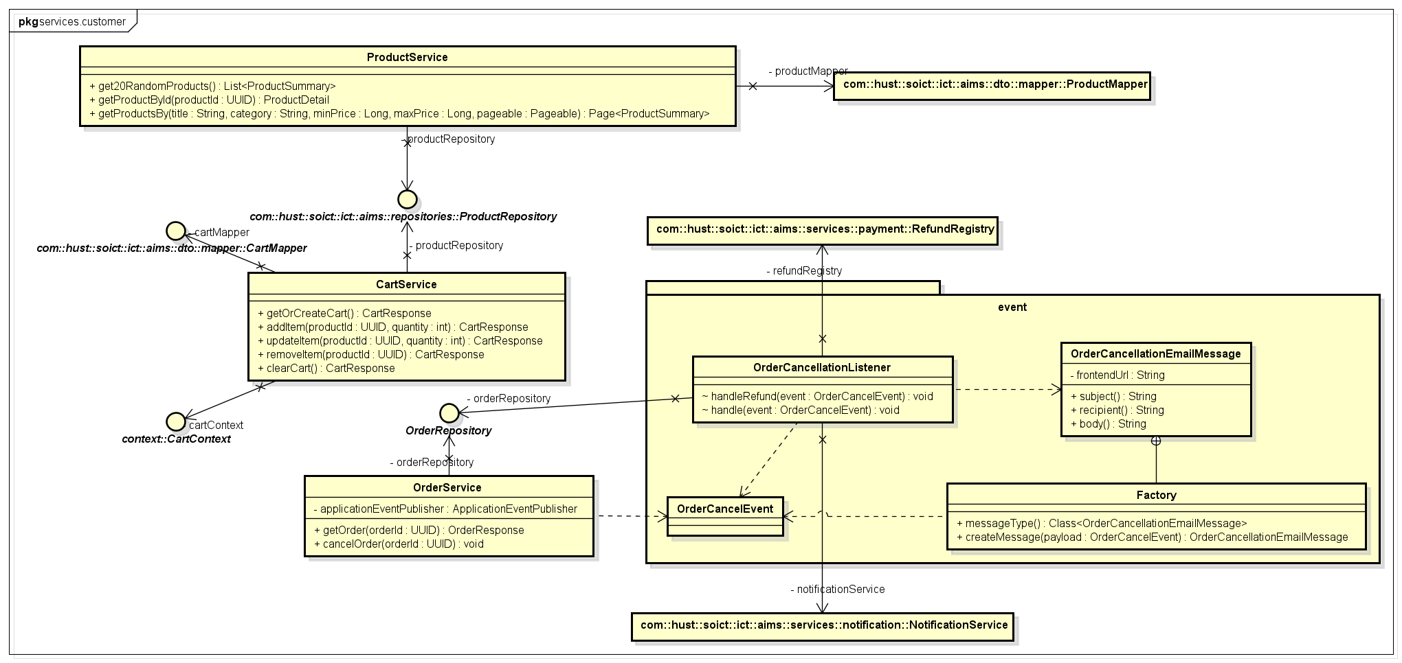

Class Diagram for Package context
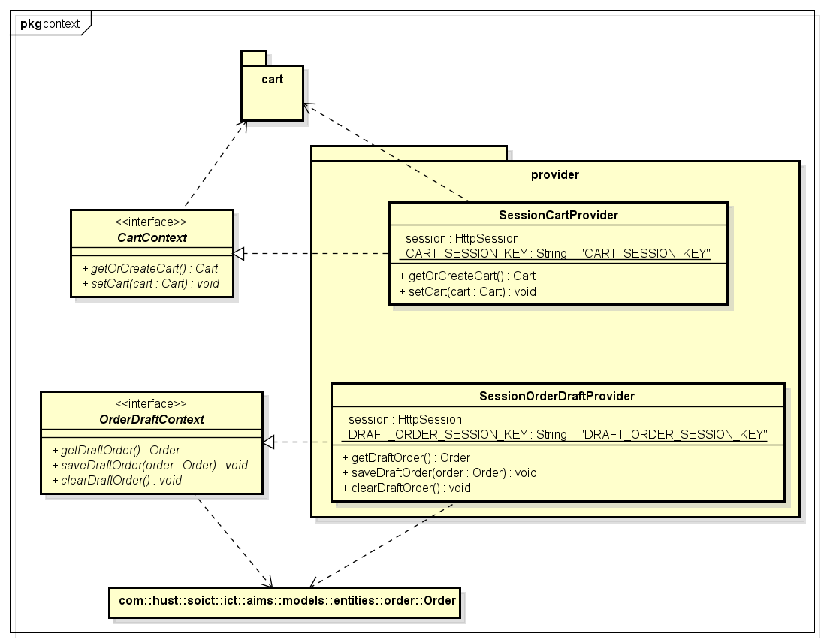

Class Diagram for Package controllers.customer
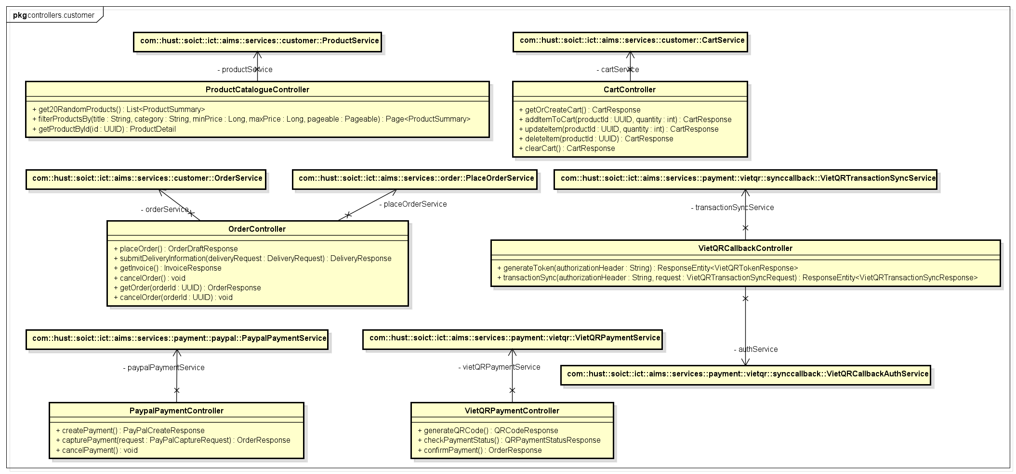

Class Diagram for Package controllers.productmanager
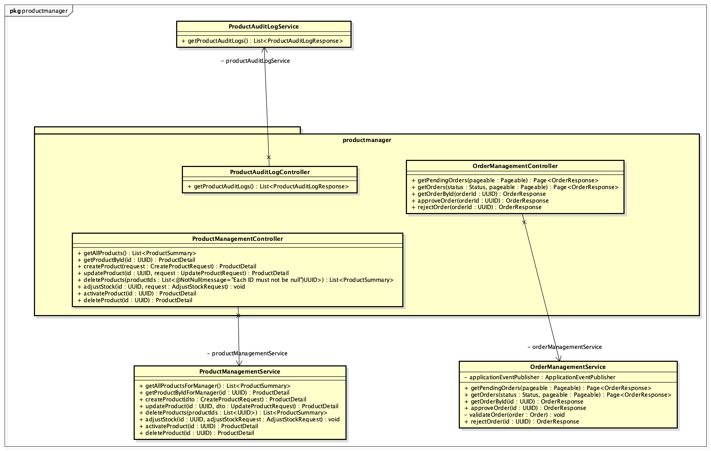

Class Diagram for Package repositories
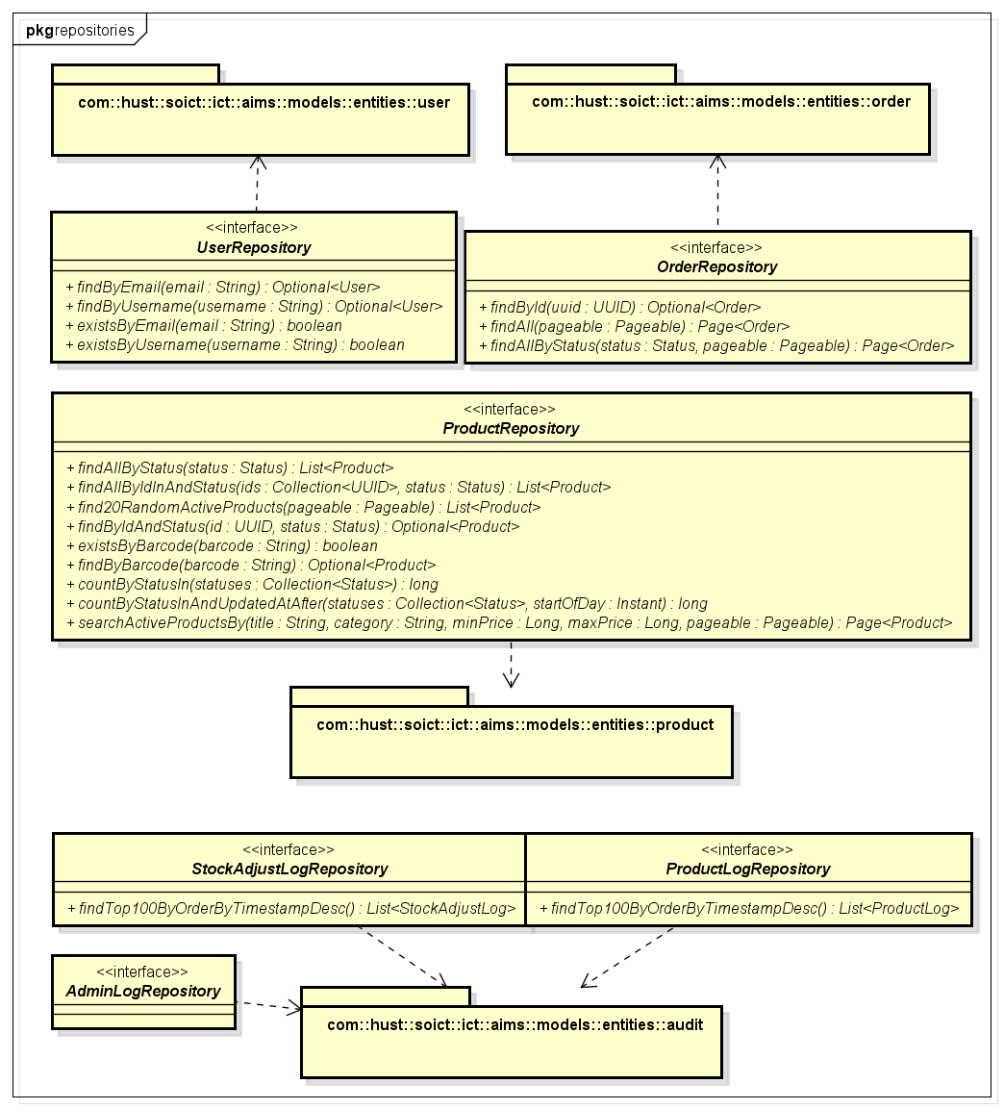

Class Diagram for Package services.payment
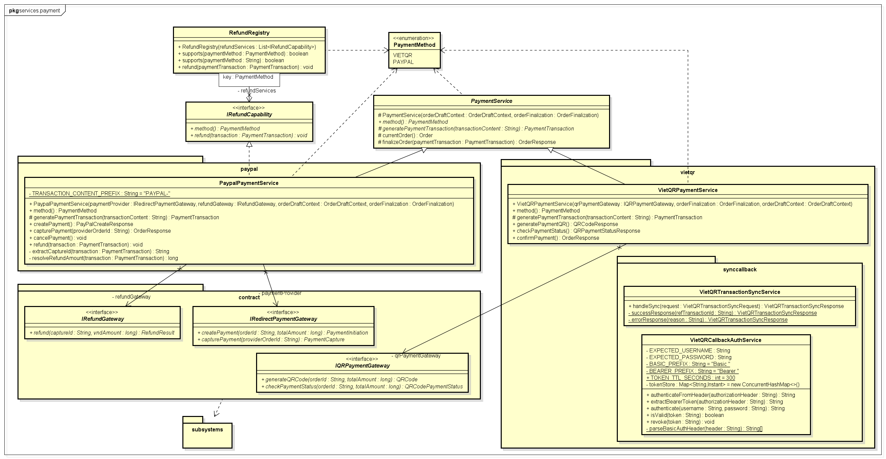

Class Diagram for Subsystem subsystems.vietqr
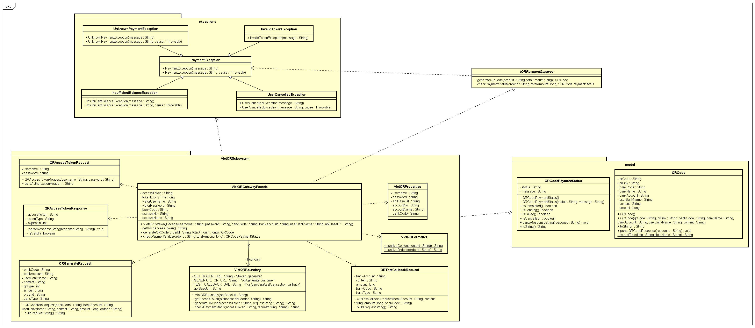

Class Diagram for Subsystem subsystems.paypal
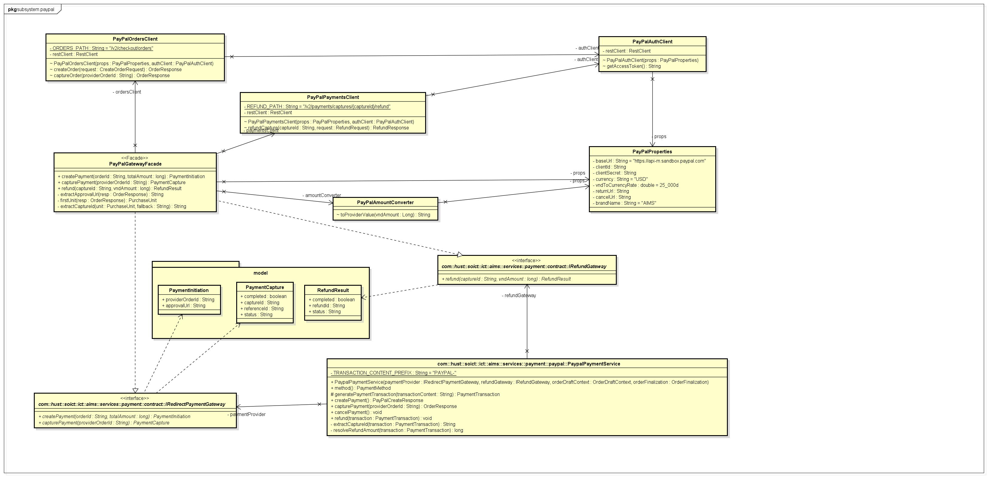

Class Design

Class “Order”
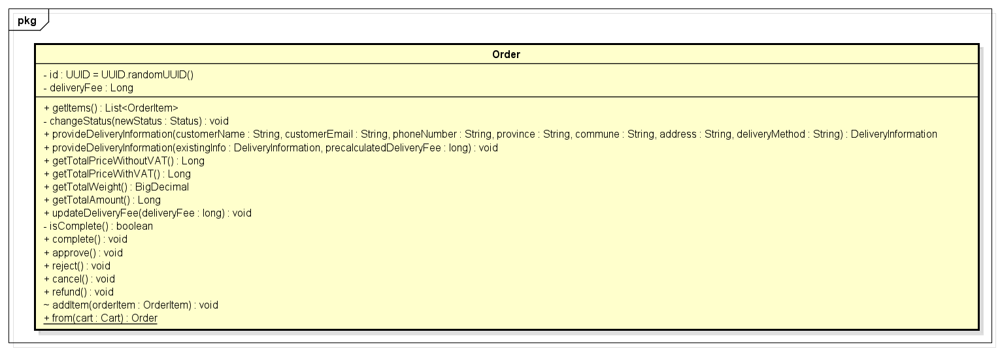
Attributes
# | Name | Data type | Default value | Description
1 | id | UUID | UUID.randomUUID() | Unique identifier, generated on construction
2 | items | List<OrderItem> | new ArrayList<>() | Line items belonging to this order
3 | status | Status (enum) | — | Current lifecycle state of the order
4 | deliveryInformation | DeliveryInformation | null | Shipping and recipient data (set during checkout)
5 | deliveryFee | Long (@Transient) | null | Calculated delivery fee, not persisted (captured in Invoice)
6 | invoice | Invoice | null | Billing snapshot generated after delivery fee is set
7 | paymentTransaction | PaymentTransaction | null | Payment record set by the payment subsystem
Operations
# | Name | Return type | Description (purpose)
1 | from(cart) | Order | Static factory: creates a DRAFT order from a Cart
2 | provideDeliveryInformation(...) | DeliveryInformation | Creates and attaches a DeliveryInformation instance
3 | updateDeliveryFee(deliveryFee) | void | Sets delivery fee and generates the Invoice snapshot
4 | complete() | void | Validates completeness and transitions DRAFT → PENDING
5 | approve() | void | Transitions PENDING → APPROVED
6 | reject() | void | Transitions PENDING → REJECTED
7 | cancel() | void | Transitions PENDING → CANCELLED
8 | refund() | void | Transitions REJECTED/CANCELLED → REFUNDED
9 | getTotalPriceWithoutVAT() | Long | Sums all OrderItem prices (@Transient computed)
10 | getTotalPriceWithVAT() | Long | Applies 10% VAT to subtotal (@Transient computed)
11 | getTotalWeight() | BigDecimal | Sums all OrderItem weights (@Transient computed)
12 | getTotalAmount() | Long | Returns invoice total if placed, otherwise delivery fee + VAT total
13 | addItem(orderItem) | void | Package-private: adds an OrderItem and back-sets its order reference
Parameter:
- from(cart) cart: Cart — the customer's active cart; must be non-empty and stock-validated
- provideDeliveryInformation(...) — customerName, customerEmail, phoneNumber, province, commune, address, deliveryMethod: all String, all @NonNull
- updateDeliveryFee(deliveryFee) — deliveryFee: long — pre-calculated fee in VND; throws UnsupportedOperationException if order is not DRAFT

Exception:
- OrderStateTransitionException — if changeStatus() is called with an invalid transition
- OrderNotCompleteException — if complete() is called before deliveryInformation, deliveryFee, invoice, and paymentTransaction are all set
- UnsupportedOperationException — if updateDeliveryFee() is called on a non-DRAFT order

Method:
- The Order.Status enum encodes a fixed transition table: DRAFT → PENDING → APPROVED / REJECTED → REFUNDED / CANCELLED → REFUNDED. Transitions outside this table throw OrderStateTransitionException.
- The transition map is declared as a static constant inside the Status enum, so adding a new state requires only modifying the enum — no changes to service logic.
State machine diagram

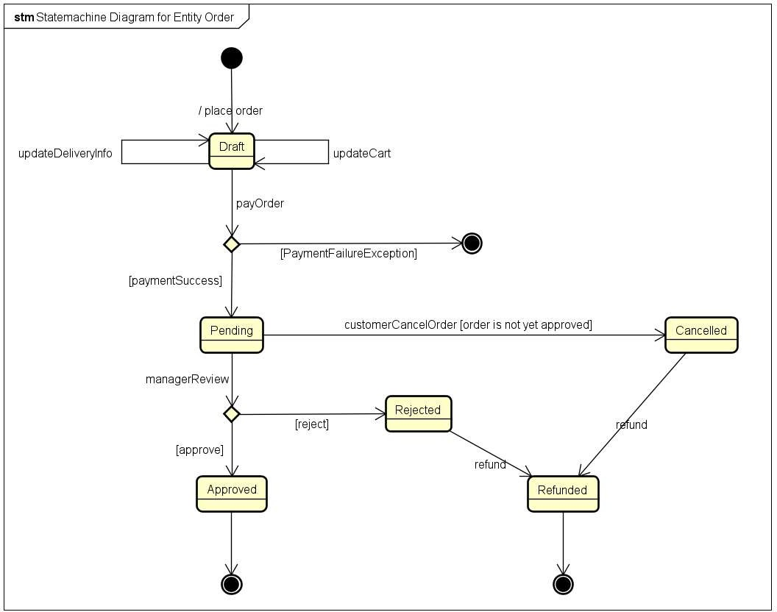

Class “OrderItem”
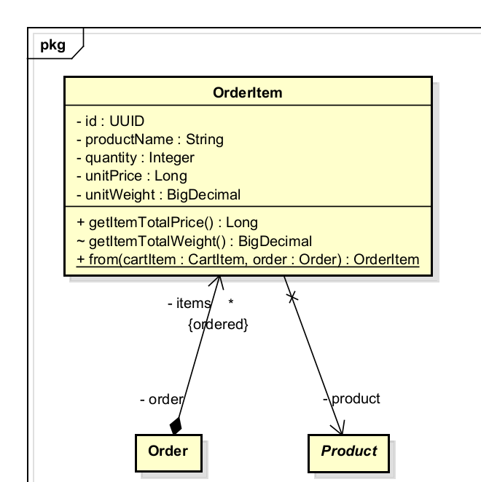
Table 1. Attribute design
# | Name | Data type | Default value | Description
1 | id | UUID | generated | Surrogate primary key
2 | order | Order | — | Parent order (FK)
3 | product | Product | — | Reference to the product at time of purchase
4 | productName | String | — | Snapshot of product title at checkout
5 | quantity | Integer | — | Quantity purchased
6 | unitPrice | Long | — | Snapshot of product price at checkout (VND)
7 | unitWeight | BigDecimal | — | Snapshot of product weight at checkout (kg)
Table 2. Operation design
# | Name | Return type | Description (purpose)
1 | from(cartItem, order) | OrderItem | Static factory: creates an OrderItem from a CartItem, snapshotting current product values
2 | getItemTotalPrice() | Long | @Transient: unitPrice × quantity
3 | getItemTotalWeight() | BigDecimal | @Transient: unitWeight × quantity
Parameter:
- from(cartItem, order) — cartItem: CartItem — source item; product reference and quantity are copied
- from(cartItem, order) — order: Order — the parent order being constructed
Exception:
Method:
- productName, unitPrice, and unitWeight are copied from the live product at the moment from() is called. Subsequent product updates do not affect existing OrderItems (snapshot pattern enforced at the factory level).

Class “Product

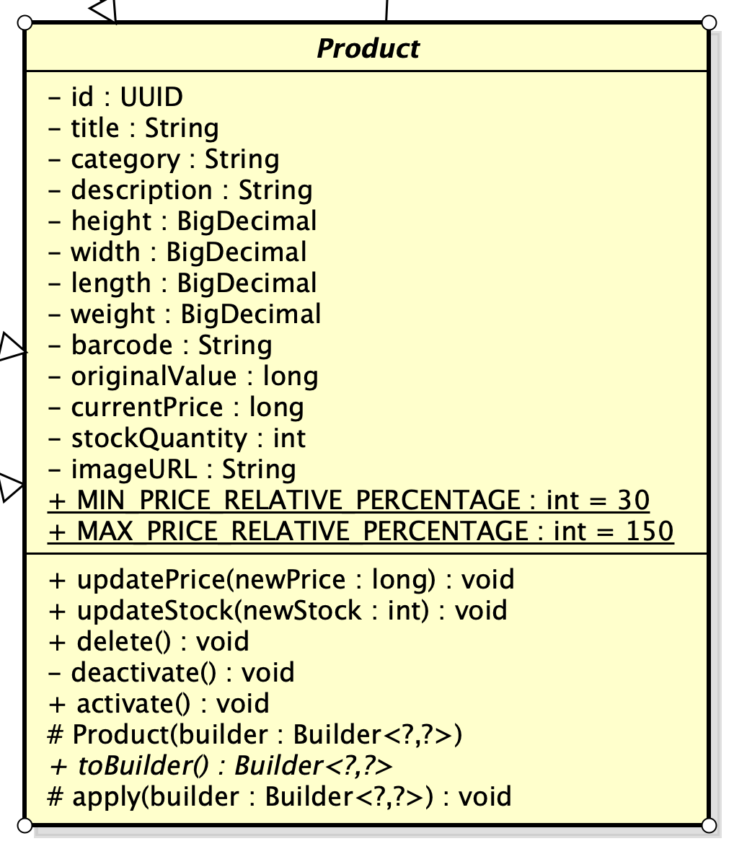

Table 1. Attribute design

# | Name | Data type | Default value | Description
1 | productid | String |  | Unique ID of the product
2 | title | String |  | Title of the product
3 | category | String |  | Category of the product
4 | description | String |  | Product description
5 | height | BigDecimal |  | height
6 | width | BigDecimal |  | width
7 | length | BigDecimal |  | length
8 | weight | BigDecimal |  | weight
9 | barcode | String |  | Unique barcode of the product
10 | originalValue | long |  | Product original value
11 | currentPrice | long |  | Current price of  product
12 | stockQuantity | int |  | Product quantity in stock
13 | imageURL | String |  | URL to load product’s image
14 | MIN_PRICE_RELATIVE | int | 30 | Min current price
15 | MAX_PRICE_RELATIVE | int | 150 | Max current price

Table 2. Operation design

# | Name | Return type | Description (purpose)
1 | Product |  | Contructor of the product entity
2 | toBuilder | Builder<?, ?> | Construct and return a Builder object with the current state of Product entity
3 | apply | void | Update information field of the Product
4 | updatePrice | void | Change product price and validate the price range
5 | updateStock | void | Update stock level
6 | delete | void | Delete a product
7 | deactivate | void | Deactivate a product
8 | activate | void | Activate a product

Class “PrintableProduct”
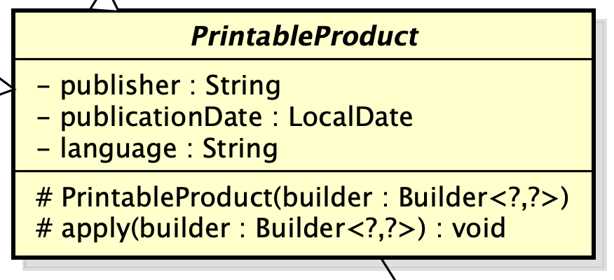

Table 1. Attribute design

# | Name | Data type | Default value | Description
1 | publisher | String |  | Publusher name
2 | publicationDate | LocalDate |  | Publication date
3 | language | String |  | Language written in the product

Table 2. Operation design

# | Name | Return type | Description (purpose)
1 | PrintableProduct |  | Constructor of printable product (Book, Newspaper) entity
2 | apply | void | Update information field

Class “Book”
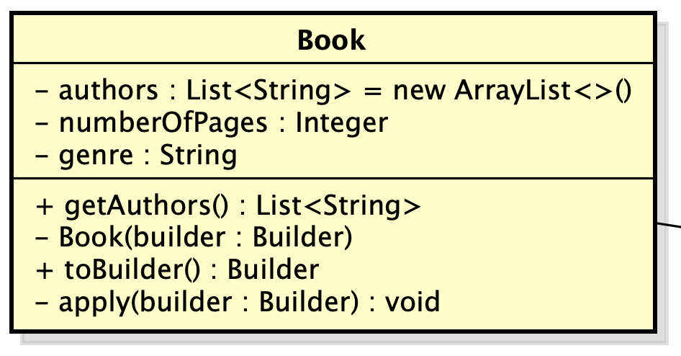

Table 1. Attribute design

# | Name | Data type | Default value | Description
1 | authors | List<String> |  | Name of author(s)
3 | numberOfPages | int |  | Number of pages
4 | genre | String |  | Genre of product

Table 2. Operation design

# | Name | Return type | Description (purpose)
1 | Book |  | Constructor of Book entity
2 | toBuilder | Builder | Construct and return a Builder object with the current state of Book entity
3 | getAuthors | List<String> | Return the list of authors
4 | apply | void | Update information field

Class “Newspaper”
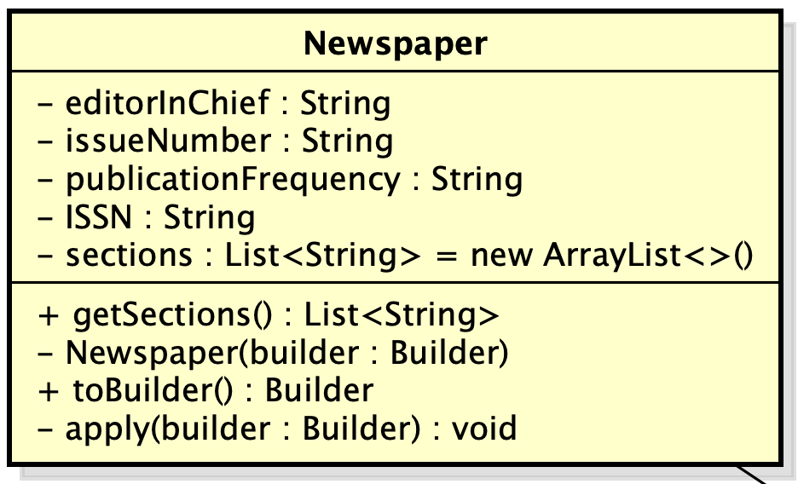

Table 1. Attribute design

# | Name | Data type | Default value | Description
1 | editorInChief | String |  | Name of Chief editor
2 | issueNumber | String |  | Issue number
3 | publicationFrequency | double |  | Publication frequency
4 | ISSN | String |  | ISSN identification
5 | sections | List<String> |  | Sections included in the newspaper

Table 2. Operation design

# | Name | Return type | Description (purpose)
1 | Newspaper |  | Constructor of Newspaper entity
2 | toBuilder | Builder<?, ?> | Construct and return a Builder object with the current state of Newspaper entity
3 | apply | void | Update information field of the Newspaper
4 | getSections | List<String> | Return Newspaper’s section

Class “CD”
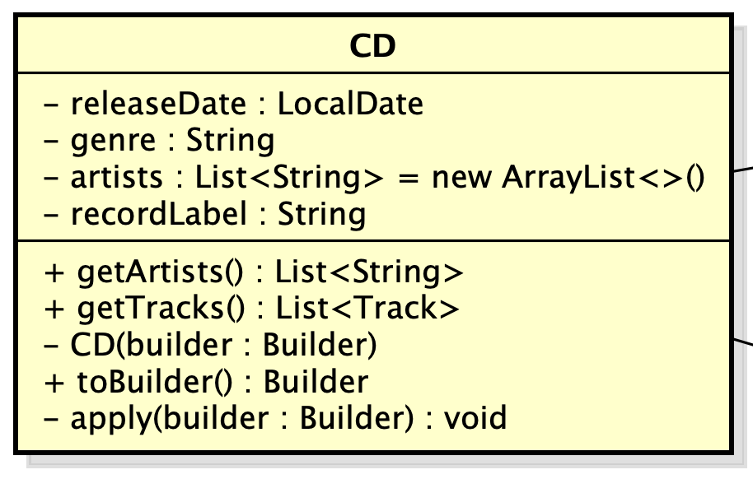

Table 1. Attribute design

# | Name | Data type | Default value | Description
1 | releaseDate | LocalDate |  | Release date
2 | genre | String |  | Genre
3 | artists | List<String> |  | Artist(s) in the CD
4 | recordLabel | String |  | Record label

Table 2. Operation design

# | Name | Return type | Description (purpose)
1 | CD |  | Constructor of CD entity
2 | toBuilder | Builder<?, ?> | Construct and return a Builder object with the current state of CD entity
3 | apply | void | Update information field of the CD
4 | getArtists | List<String> | Return CD’s artists
5 | getTracks | List<Track> | Return CD’s Tracks

Class “Track”
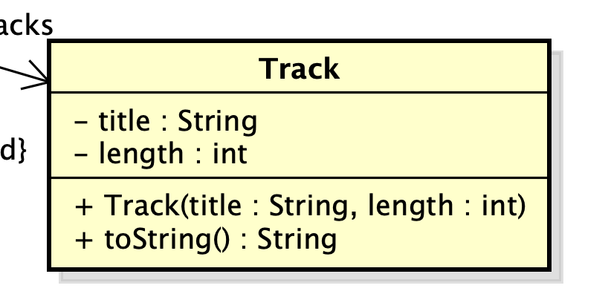

Table 1. Attribute design

# | Name | Data type | Default value | Description
1 | title | String |  | Track title
2 | length | int |  | track duration

Table 2. Operation design

# | Name | Return type | Description (purpose)
1 | Track |  | Constructor of Track entity
2 | toString | String | Display Track’s info

Class “DVD”
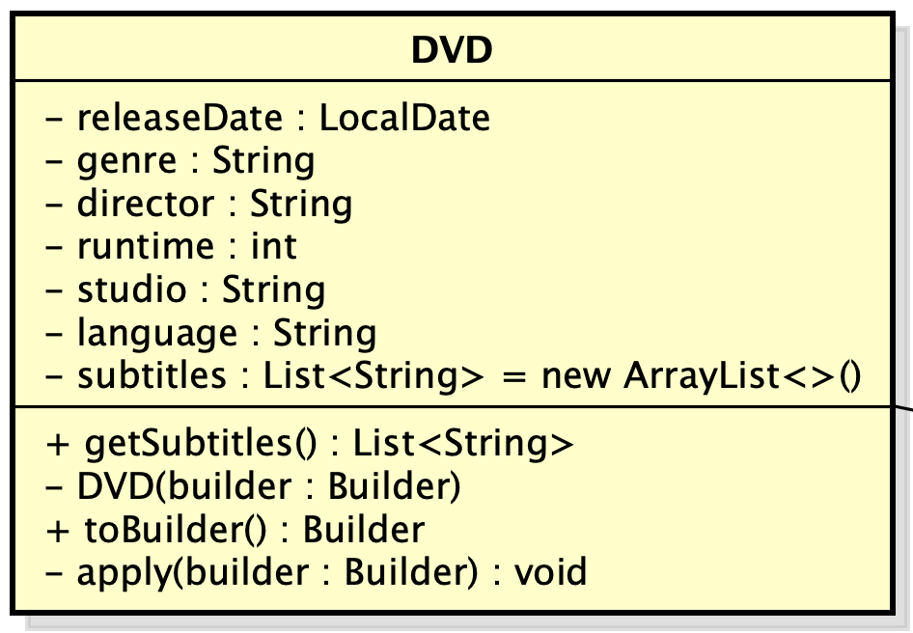

Table 1. Attribute design

# | Name | Data type | Default value | Description
1 | releaseDate | LocalDate |  | Release date
2 | genre | String |  | Genre
3 | director | String |  | Director name
4 | runtime | int |  | Duration
5 | studio | String |  | Studio
6 | language | String |  | Language
7 | subtitles | List<String> |  | Subtitles

Table 2. Operation design

# | Name | Return type | Description (purpose)
1 | DVD |  | Constructor of DVD entity
2 | toBuilder | Builder<?, ?> | Construct and return a Builder object with the current state of DVD entity
3 | apply | void | Update information field of the DVD
4 | getSubtitles | List<String> | Return subtitles

Class “VersionedEntity”
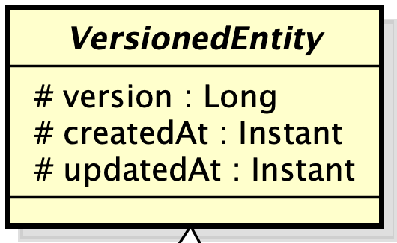

Table 1. Attribute design

# | Name | Data type | Default value | Description
1 | version | Long | 0 | Entity version
2 | createdAt | Timestamp | Current time | Time of creation
3 | updatedAt | Timestamp | Current time | Time of update

Class “ProductRepository”
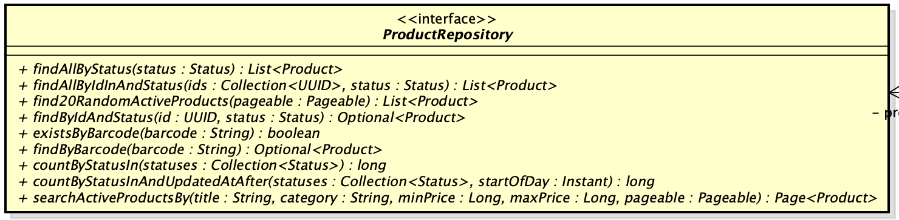

Table 1. Attribute design

# | Name | Data type | Default value | Description
1

Table 2. Operation design

# | Name | Return type | Description (purpose)
1 | findAllByStatus | List<Product> | Return list of products based on status
2 | findAllByIdInAndStatus | List<Product> | Return list of products based on id and status
3 | find20RandomActiveProducts | List<Product> | Return 20 random active products
4 | findByIdAndStatus | Optional<Product> | Return a specific product and verifies its current state
5 | existsByBarcode | Boolean | Check for existence of a product with the same barcode
6 | findByBarcode | Optional<Product> | Return product based on its barcode
7 | countByStatusIn | long | Counts the total number of products that match specified statuses
8 | countByStatusInAndUpdatedAtAfter | long | Counts the total number of products that match specified statuses after a timestamp
9 | searchActiveProductsBy | Page<Product> | Return a paginated object

Parameter:
- findAllByStatus(Product.Status status): The status of the products to retrieve
- findAllByIdInAndStatus(Collection<UUID> ids, Product.Status status)
ids (Collection<UUID>): A collection of product IDs.
status (Product.Status): The status of the products.
- find20RandomActiveProducts(Pageable pageable): Pagination configuration
- findByIdAndStatus(UUID id, Product.Status status)
• id (UUID): The unique ID of the product.
• status (Product.Status): The status of the product.
- existsByBarcode(String barcode): The barcode to check for existence.
- findByBarcode(String barcode): The barcode of the product to find.
- countByStatusIn(Collection<Product.Status> statuses): A collection of statuses to count.
- countByStatusInAndUpdatedAtAfter(Collection<Product.Status> statuses, java.time.Instant startOfDay)
• statuses (Collection<Product.Status>): Statuses to count (usually used for counting deleted/deactivated items).
• startOfDay (Instant): The timestamp to start counting from (e.g., the beginning of today).
- searchActiveProductsBy(...)
• title, category (String): Search strings for pattern matching (LIKE).
• minPrice, maxPrice (Long): Value ranges for filtering.
• pageable (Pageable): Pagination and sorting information.

Exception:
- Spring Data JPA itself might throw a DataAccessException (a runtime exception) if there are database connection errors or query syntax issues. There are no custom exceptions explicitly declared or thrown from this interface.

Class “ProductManagementService”
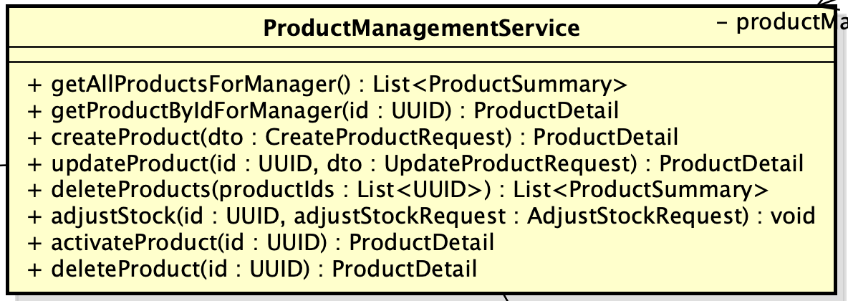

Table 1. Attribute design

# | Name | Data type | Default value | Description

Table 2. Operation design

# | Name | Return type | Description (purpose)
1 | getAllProductsForManager | List<ProductSummary> | Retrieves and maps all products into summary representations for the manager dashboard
2 | getProductByIdForManager | ProductDetail | Fetches specific product details by ID or throws an exception if not found
3 | createProduct | ProductDetail | Validates barcode uniqueness, instantiates via factory, saves to database, and returns product details
4 | updateProduct | ProductDetail | Updates existing product attributes and pricing via factory, saving changes to the database
5 | deleteProducts | List<ProductSummary> | Performs batch deletion of products while strictly enforcing the daily deletion quota limit
6 | adjustStock | void | Adjusts the product's inventory stock quantity based on the provided positive or negative delta
7 | activateProduct | ProductDetail | Restores a previously deactivated product back to the active business status
8 | deleteProduct | ProductDetail | Soft-deletes or deactivates a single product depending on its current stock quantity

Parameter:
- getProductByIdForManager(UUID id): The ID of the product to retrieve.
- createProduct(CreateProductRequest dto): The Data Transfer Object containing all the information needed to create a new product.
- updateProduct(UUID id, UpdateProductRequest dto)
• id (UUID): The ID of the product to update.
• dto (UpdateProductRequest): The DTO containing the fields to update.
- deleteProducts(List<UUID> productIds): A list of product IDs to delete.
- adjustStock(UUID id, AdjustStockRequest adjustStockRequest)
• id (UUID): The product ID.
• adjustStockRequest (AdjustStockRequest): DTO containing the adjustment amount (delta) and the reason.
- activateProduct(UUID id): The ID of the product to reactivate.
- deleteProduct(UUID id): The ID of the product to delete.

Exception:
- ProductNotFoundException: Thrown if no product is found with the provided ID in the database.
- ProductAlreadyExistedException: Thrown if the barcode provided in the dto already exists in the system.
- ExceededDeletionQuotaException: Thrown if the total number of deleted products for the day (already deleted + currently requested) exceeds the daily allowed limit (20 products/day).

Class “ProductFactory”
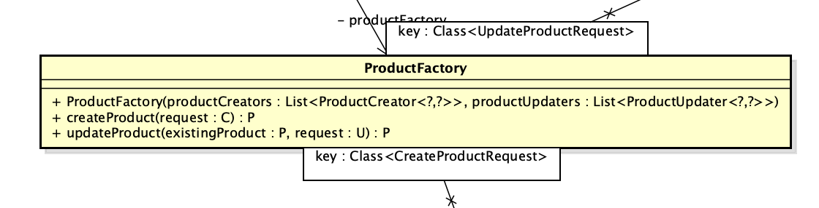

Table 1. Attribute design

# | Name | Data type | Default value | Description

Table 2. Operation design

# | Name | Return type | Description (purpose)
1 | ProductFactory |  | Constructor of ProductFactory
2 | createProduct |  | Delegates product instantiation to the specific creator strategy matching the provided request class type
3 | updateProduct |  | Locates the matching updater strategy and delegates the modification of the existing product entity

Interface “ProductCreator”
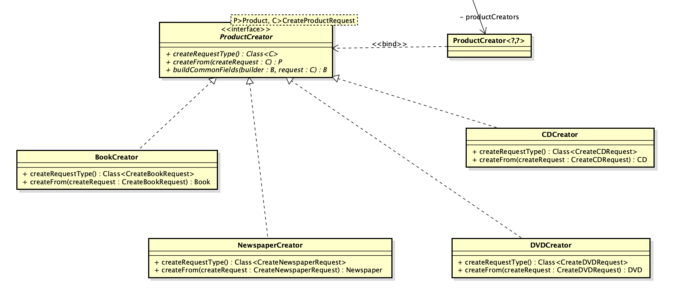

Table 1. Attribute design

# | Name | Data type | Default value | Description

Table 2. Operation design

# | Name | Return type | Description (purpose)
1 | createRequestType |  | Identifies and returns the specific creation request class type handled by this creator strategy
2 | createFrom |  | Instantiates a new specific product entity using data from the provided creation request object
3 | buildCommonFields |  | Populates the product builder with common base attributes extracted from the given creation request

Interface “ProductUpdater”
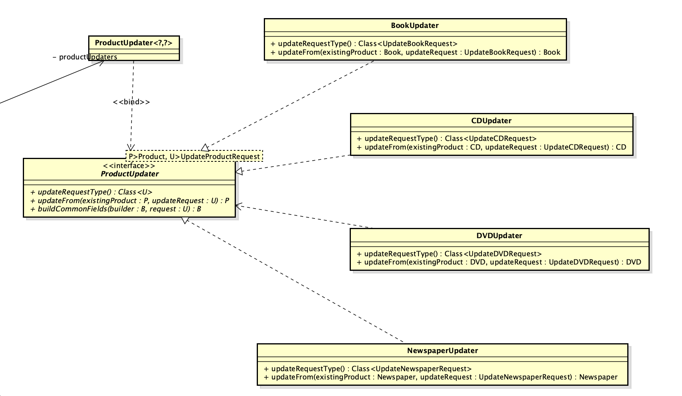

Table 1. Attribute design

# | Name | Data type | Default value | Description

Table 2. Operation design

# | Name | Return type | Description (purpose)
1 | updateRequestType |  | Identifies and returns the specific update request class type handled by this updater strategy
2 | updateFrom |  | Modifies an existing specific product entity using data from the provided update request object
3 | buildCommonFields |  | Populates the product builder with common updatable base attributes extracted from the update request

Class “ProductManagementController”
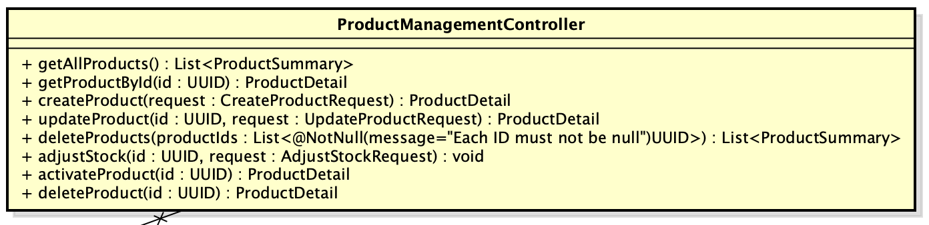

Table 1. Attribute design

Table 2. Operation design

# | Name |  | Data type |  | Default value | Description
# | Name | Return type |  | Description (purpose)
1 | getAllProducts | List<ProductSummary> |  | Exposes an endpoint to retrieve summary data of all products for the manager dashboard
2 | getProductById | ProductDetail |  | Provides an endpoint to fetch and return comprehensive details of a specific product
3 | createProduct | ProductDetail |  | Handles HTTP requests to validate payload and create a new product in the system
4 | updateProduct | ProductDetail |  | Accepts validated partial update payloads to modify specific attributes of an existing product.
5 | deleteProducts | List<ProductSummary> |  | Processes batch deletion requests for multiple products while enforcing validation on the payload size
6 | adjustStock | void |  | Provides an endpoint to modify the inventory stock quantity for a specific product
7 | activateProduct | ProductDetail |  | Handles requests to reactivate a previously deactivated product, restoring it to active status
8 | deleteProduct | ProductDetail |  | Exposes an endpoint to soft-delete or deactivate a single product based on its ID

Class “DeliveryInformation”
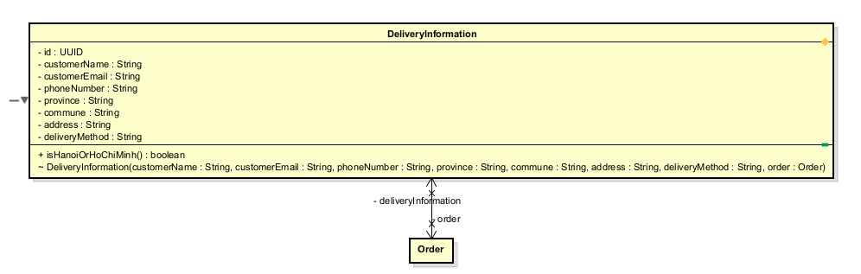
Table 1. Attribute design
# | Name | Data type | Default value | Description
1 | id | UUID | — | Shared PK with Order (via @MapsId)
2 | order | Order | — | Parent order (bidirectional @OneToOne)
3 | customerName | String | — | Recipient full name
4 | customerEmail | String | — | Recipient email address
5 | phoneNumber | String | — | Recipient phone (max 10 chars)
6 | province | String | — | Delivery province (max 50 chars)
7 | commune | String | — | Delivery commune (max 50 chars)
8 | address | String | — | Full street address (TEXT)
9 | deliveryMethod | String | — | Delivery method label (max 50 chars)

Table 2. Operation design
# | Name | Return type | Description (purpose)
1 | isHanoiOrHoChiMinh() | boolean | Returns true if province is Hà Nội or Hồ Chí Minh; used by delivery fee strategy

Parameter:

Exception:

Method:
- Constructor is package-private — instantiation is exclusively through Order.provideDeliveryInformation(...), enforcing that a DeliveryInformation always belongs to a valid Order.

Class “Invoice”
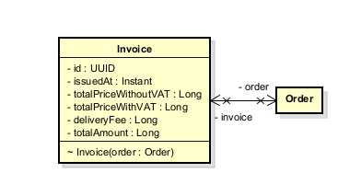
Table 1. Attribute design
# | Name | Data type | Default value | Description
1 | id | UUID | — | Shared PK with Order (via @MapsId)
2 | order | Order | — | Parent order
3 | issuedAt | Instant | Instant.now() | Timestamp of invoice generation
4 | totalPriceWithoutVAT | Long | — | Subtotal snapshot at time of issue (VND)
5 | totalPriceWithVAT | Long | — | VAT-included total snapshot (VND)
6 | deliveryFee | Long | — | Delivery fee snapshot (VND)
7 | totalAmount | Long | — | Grand total: totalPriceWithVAT + deliveryFee

Table 2. Operation design
# | Name | Return type | Description (purpose)
— | Invoice(order) | — | Package-private constructor; snapshots all financial values from Order at instantiation time

Parameter:
- Invoice(order) — order: Order — the order whose financial values are snapshotted

Exception:

Method:
- All financial values are copied from the Order at construction time. The Invoice is immutable after creation — it is a point-in-time billing record. Constructor is package-private; only Order.updateDeliveryFee() creates an Invoice.

Class “PaymentTransaction”
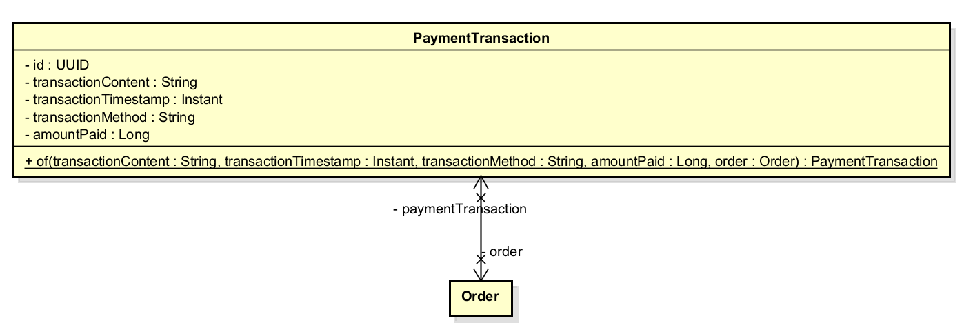
Table 1. Attribute design
# | Name | Data type | Default value | Description
1 | id | UUID | generated | Surrogate primary key
2 | transactionContent | String (TEXT) | — | Gateway-supplied transaction memo/reference
3 | transactionTimestamp | Instant | — | Time of payment confirmation
4 | transactionMethod | String | — | Payment method label (e.g. "VIETQR", "PAYPAL")
5 | amountPaid | Long | — | Amount actually charged (VND)
6 | order | Order | — | Associated order (FK)

Table 2. Operation design
# | Name | Return type | Description (purpose)
1 | of(...) | PaymentTransaction | Static factory: constructs a PaymentTransaction and links it to the Order

Parameter:
- of(...) — transactionContent: String — gateway reference string
- of(...) — transactionTimestamp: Instant — time of confirmation
- of(...) — transactionMethod: String — payment method identifier
- of(...) — amountPaid: Long — confirmed payment amount in VND
- of(...) — order: @NonNull Order — the order being paid; back-sets order.paymentTransaction

Exception:

Method:

Class “StockValidator”
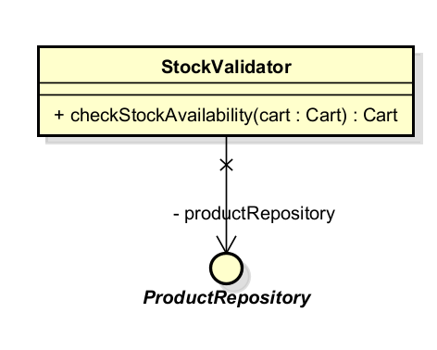
Table 1. Attribute design
# | Name | Data type | Default value | Description
1 | productRepository | ProductRepository | injected | Repository for live product lookup

Table 2. Operation design
# | Name | Return type | Description (purpose)
1 | checkStockAvailability(cart) | Cart | Validates all cart items against live stock; synchronises product references; returns the validated cart

Parameter:
- checkStockAvailability(cart) — cart: Cart — the customer's current cart; must be non-null

Exception:
- EmptyCartException — if cart contains no items
- NotEnoughStockException — if any item's requested quantity exceeds available stock; carries a map of productId → availableQuantity and a list of missing product IDs
- ProductNotFoundException — if a product has been deactivated since being added to cart

Method:
- Fetches all products in the cart in a single batch query (findAllByIdInAndStatus(ids, ACTIVE)). Products absent from the result (deactivated) are removed and flagged. Products present are synchronised back into the cart's item references. Stock insufficiency is collected across all items before throwing, so the error message is complete.

Class “DeliveryFeeCalculator”
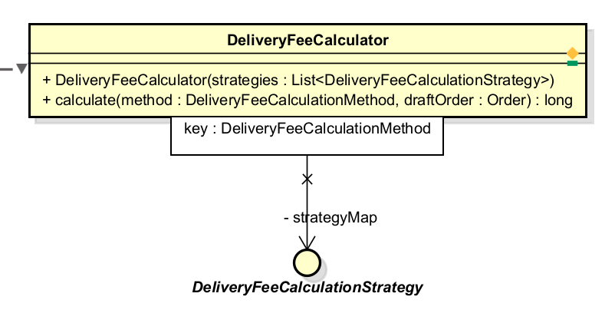
Table 1. Attribute design
# | Name | Data type | Default value | Description
1 | strategyMap | EnumMap<DeliveryFeeCalculationMethod, DeliveryFeeCalculationStrategy> | populated at construction | Registry of all available strategies, keyed by method enum

Table 2. Operation design
# | Name | Return type | Description (purpose)
1 | calculate(method, draftOrder) | long | Looks up strategy by method and delegates fee calculation

Parameter:
- calculate(...) — method: DeliveryFeeCalculationMethod — identifies which strategy to use
- calculate(...) — draftOrder: Order — the draft order containing items and delivery information

Exception:
- UnsupportedDeliveryFeeStrategyException — if no strategy is registered for the given method

Method:
- All DeliveryFeeCalculationStrategy beans are injected as a list at construction time and self-register via strategy.method(). Callers are fully decoupled from concrete strategy classes.

Class "StandardDeliveryFeeStrategy”
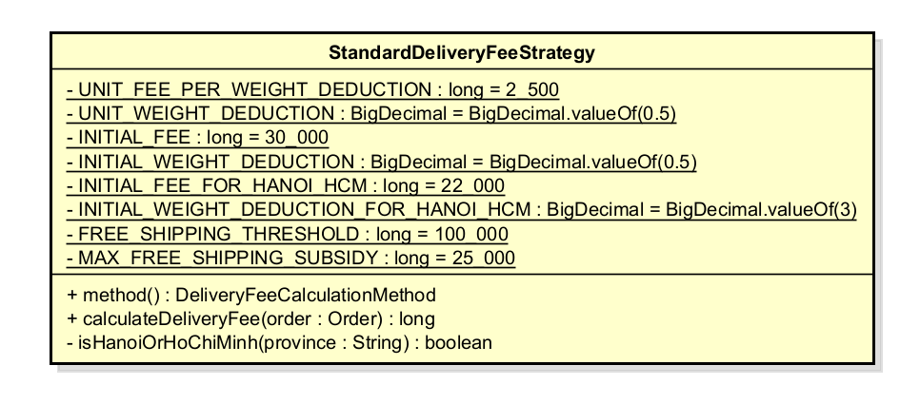
Table 1. Attribute design
# | Name | Data type | Default value | Description
1 | INITIAL_FEE | long (const) | 30,000 | Base fee for non-Hanoi/HCM provinces (VND)
2 | INITIAL_WEIGHT_DEDUCTION | BigDecimal (const) | 0.5 | Free weight allowance for non-Hanoi/HCM (kg)
3 | INITIAL_FEE_FOR_HANOI_HCM | long (const) | 22,000 | Base fee for Hanoi/HCM (VND)
4 | INITIAL_WEIGHT_DEDUCTION_FOR_HANOI_HCM | BigDecimal (const) | 3.0 | Free weight allowance for Hanoi/HCM (kg)
5 | UNIT_FEE_PER_WEIGHT_DEDUCTION | long (const) | 2,500 | Additional fee per 0.5 kg over allowance (VND)
6 | UNIT_WEIGHT_DEDUCTION | BigDecimal (const) | 0.5 | Weight increment unit (kg)
7 | FREE_SHIPPING_THRESHOLD | long (const) | 100,000 | Order subtotal above which subsidy applies (VND)
8 | MAX_FREE_SHIPPING_SUBSIDY | long (const) | 25,000 | Maximum subsidy deducted from fee (VND)

Table 2. Operation design
# | Name | Return type | Description (purpose)
1 | method() | DeliveryFeeCalculationMethod | Returns STANDARD; used for self-registration in registry
2 | calculateDeliveryFee(order) | long | Computes fee based on province, weight, and order subtotal

Parameter:

Exception:

Method:
- Selects base fee and weight allowance by province (Hanoi/HCM vs. other). Calculates excess weight in 0.5 kg increments (ceiling division). Applies free-shipping subsidy (up to 25,000 VND) if order subtotal exceeds 100,000 VND.

Class "PlaceOrderService”
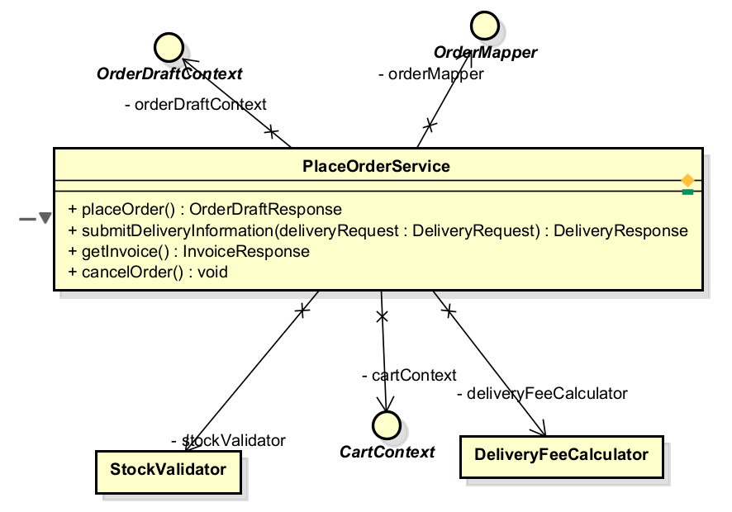
Table 1. Attribute design
# | Name | Data type | Default value | Description
1 | stockValidator | StockValidator | injected | Validates cart stock before order creation
2 | deliveryFeeCalculator | DeliveryFeeCalculator | injected | Calculates delivery fee for the order
3 | cartContext | CartContext | injected | Provides access to the current session's cart
4 | orderDraftContext | OrderDraftContext | injected | Stores and retrieves the in-progress draft order
5 | orderMapper | OrderMapper | injected | Maps domain objects to response DTOs

Table 2. Operation design
# | Name | Return type | Description (purpose)
1 | placeOrder() | OrderDraftResponse | Creates a draft order from cart; carries over delivery info if re-placing
2 | submitDeliveryInformation(request) | DeliveryResponse | Attaches delivery info and calculates+sets delivery fee and invoice
3 | getInvoice() | InvoiceResponse | Returns the current draft order's invoice
4 | cancelOrder() | void | Clears the draft order context (pre-payment cancellation)

Parameter:
- submitDeliveryInformation — deliveryRequest: DeliveryRequest — validated DTO containing all delivery fields

Exception:
- EmptyCartException, NotEnoughStockException, ProductNotFoundException — from placeOrder()
- OrderNotPlacedException — if getInvoice() or submitDeliveryInformation() is called without a current draft
- OrderNotCompleteException — if invoice is missing when getInvoice() is called

Method:

Class "OrderFinalizer”
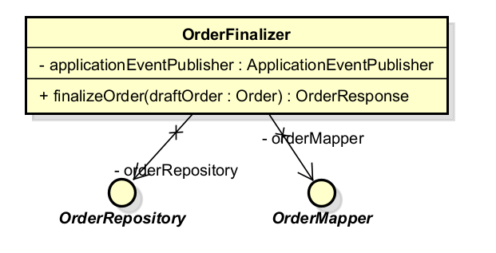
Table 1. Attribute design
# | Name | Data type | Default value | Description
1 | orderRepository | OrderRepository | injected | Persists the completed order
2 | orderMapper | OrderMapper | injected | Maps saved order to response DTO
3 | applicationEventPublisher | ApplicationEventPublisher | injected | Publishes OrderSuccessEvent after commit

Table 2. Operation design
# | Name | Return type | Description (purpose)
1 | finalizeOrder(draftOrder) | OrderResponse | Completes order, persists it, publishes OrderSuccessEvent

Parameter:
- finalizeOrder — draftOrder: Order — a fully populated DRAFT order ready for completion

Exception:
- OrderNotCompleteException — if order.complete() fails due to missing required fields

Method:
- Calls order.complete() (state transition DRAFT → PENDING), saves via repository, then publishes OrderSuccessEvent. The event is handled post-commit by PlaceOrderSuccessListener. OrderFinalizer is invoked by the payment service after payment is confirmed, not directly by PlaceOrderService.

Class "PlaceOrderSuccessListener”
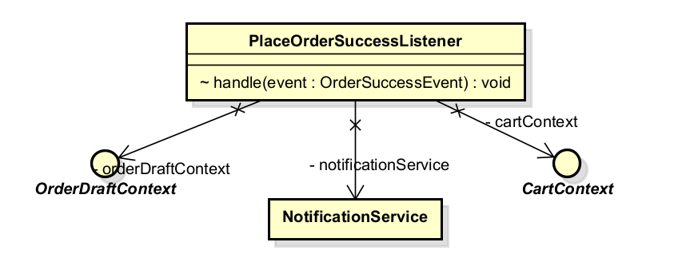
Table 1. Attribute design
# | Name | Data type | Default value | Description
1 | cartContext | CartContext | injected | Clears the cart post-order
2 | orderDraftContext | OrderDraftContext | injected | Clears the draft order post-order
3 | notificationService | NotificationService | injected | Dispatches the confirmation email

Table 2. Operation design
# | Name | Return type | Description (purpose)
1 | handle(event) | void | Reacts to OrderSuccessEvent: clears cart, clears draft, sends confirmation email

Parameter:
- handle — event: OrderSuccessEvent — record carrying the fully persisted Order

Exception:

Method:
- Annotated with @TransactionalEventListener(phase = AFTER_COMMIT). Fires only after the originating transaction commits successfully. Clears both the cart and draft order contexts, then dispatches an OrderConfirmationEmailMessage via NotificationService. A failure here does not roll back the placed order.

Class "OrderSuccessEvent”
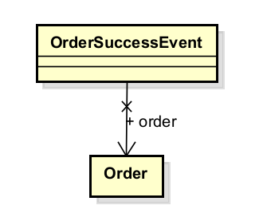
Table 1. Attribute design
# | Name | Data type | Description
1 | order | Order | The fully persisted, PENDING-status order

Method:
- Java record — immutable carrier. All associations required by listeners (deliveryInformation, invoice, paymentTransaction, items) must be eagerly loaded before this event is published, as the Hibernate session is closed by the time listeners fire.

Class "OrderConfirmationEmailMessage”
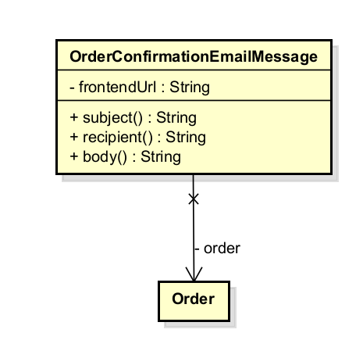
Table 1. Attribute design
# | Name | Data type | Default value | Description
1 | order | Order | — | The order whose details are rendered into the email
2 | frontendUrl | String | — | Base URL for the 'View Order' link in the email body

Table 2. Operation design
# | Name | Return type | Description (purpose)
1 | subject() | String | Returns the email subject line including order ID
2 | recipient() | String | Returns the customer email from DeliveryInformation
3 | body() | String | Builds and returns the full HTML email body

Method:
- Nested class Factory: a Spring @Component extending EmailMessage.Factory<OrderConfirmationEmailMessage, OrderSuccessEvent>. Implements messageType() returning OrderConfirmationEmailMessage.class (routing key in notification registry), and createMessage(event) constructing the message from the event payload.

Class "OrderController”
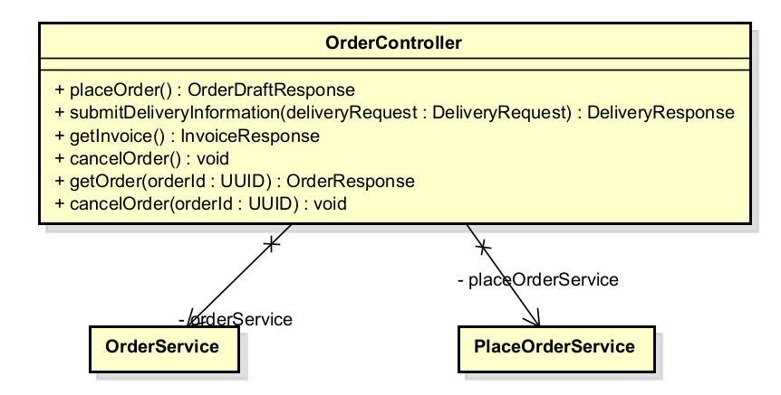
Table 1. Attribute design
# | Name | Data type | Default value | Description
1 | placeOrderService | PlaceOrderService | — | Handles order placement workflow
2 | orderService | OrderService | — | Handles order retrieval and post-placement cancellation

Table 2. Operation design
# | Name | Return type | Description (purpose)
1 | placeOrder() | OrderDraftResponse | POST /order — creates draft order from cart
2 | submitDeliveryInformation(request) | DeliveryResponse | POST /order/delivery — submits delivery info
3 | getInvoice() | InvoiceResponse | GET /order/invoice — retrieves current invoice
4 | cancelOrder() | void | DELETE /order — cancels in-progress draft
5 | getOrder(orderId) | OrderResponse | GET /order/{orderId} — retrieves a placed order
6 | cancelOrder(orderId) | void | POST /order/{orderId}/cancel — cancels a placed order

Exception:
- NotEnoughStockException, EmptyCartException, ProductNotFoundException — from placeOrder()
- OrderNotFoundException — from cancelOrder(orderId) if order not found
- OrderStateTransitionException — from cancelOrder(orderId) if order is not cancellable

Class “VietQRGatewayFacade”
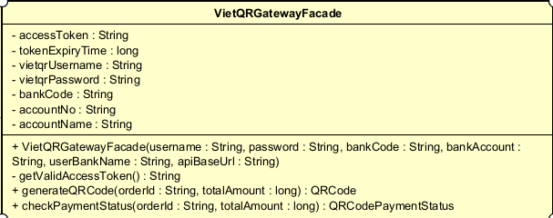
Table 1. Attribute design

# | Name | Data type | Default value | Description
1 | boundary | VietQRBoundary |  | Boundary object used to send HTTP requests to VietQR APIs.
2 | accessToken | String |  | Current VietQR access token used for  authenticated API calls.
3 | tokenExpiryTime | long |  | Expiration time of the current access token in  milliseconds.
4 | vietqrUsername | String |  | Username of VietQR sandbox
5 | vietqrPassword | String |  | Password of VietQR sandbox
6 | bankCode | String |  | Bank code of the receiver account used to generate QR  payment.

7 | accountNo | String |  | Bank account number used to receive  customer payment.
8 | accountName | String |  | Bank account owner name

Table 2. Operation design

# | Name | Return type | Description (purpose)
1 | generateQRCode | QRCode | Generate a QR code for the given order information and return the QRCode
2 | checkPaymentStatus | PaymentStatus | Check the payment status. of the given order and return the  Status.
3 | getValidAccessToken | String | Return a valid VietQR access token, reusing the current one if it is still valid or  requesting a new one if needed.

.Parameter:
generateQRCode(orderId : String, totalAmount : long) : QRCode
- orderId: Unique identifier of the order for which the QR code is generated.
- totalAmount: Total payment amount of the order.

checkPaymentStatus(orderId : String, totalAmount : long) : QRCodePaymentStatus
- orderId: Unique identifier of the order whose payment status is being checked.
- totalAmount: Expected payment amount used to verify the transaction.

Exception
- InvalidTokenException: if VietQR returns an invalid access token.
- PaymentException: if QR generation or payment status checking cannot be completed.
- UnknownException: if an unexpected error occurs during VietQR API communication or response handling.

Method
getValidAccessToken()
• Checks whether the current access token is still valid.
• Requests a new token from VietQR if the current token has expired.
• Returns a valid access token for API communication.
generateQRCode(orderId : String, totalAmount : long)
• Uses a valid access token to call the VietQR QR generation API.
• Generates a payment QR code for the specified order and amount.
• Returns a QRCode object containing QR payment information.
checkPaymentStatus(orderId : String, totalAmount : long)
• Uses a valid access token to call the VietQR payment status API.
• Verifies the payment information for the specified order.
• Returns a QRCodePaymentStatus object containing the current payment status.

Class " VietQRPaymentService”
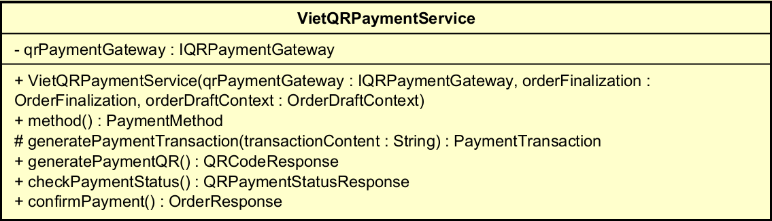Table 1. Attribute design

# | Name | Data type | Default value | Description
1 | qrPaymentGateway | IQRPaymentGateway |  | Gateway interface used to communicate with the QR payment subsystem (e.g., VietQR).
Table 2. Operation design

# | Name | Return type | Description
1 | generatePaymentTransaction | PaymentTransaction | Create and return a payment transaction record.
2 | generatePaymentQR | QRCodeResponse | Generate QR payment information for the current order.
3 | checkPaymentStatus | QRPaymentStatusResponse | Check and return the current payment status.
4 | confirmPayment | OrderResponse | Confirm payment completion and finalize the order.
Parameter:
generatePaymentTransaction(transactionContent : String)
• transactionContent: description or content associated with the payment transaction.

Method
generatePaymentTransaction(transactionContent : String)
• Creates a new payment transaction record.
• Stores the provided transaction content.
• Returns a PaymentTransaction object.
generatePaymentQR()
• Retrieves the current order information.
• Requests QR code generation through the payment gateway.
• Returns a QRCodeResponse object for customer payment.
checkPaymentStatus()
• Retrieves the current order information.
• Checks the payment status through the payment gateway.
• Returns a QRPaymentStatusResponse object.
confirmPayment()
• Verifies that payment has been completed successfully.
• Finalizes the order and records the payment transaction.
• Returns an OrderResponse object containing the completed order information.

Class " QRCode”
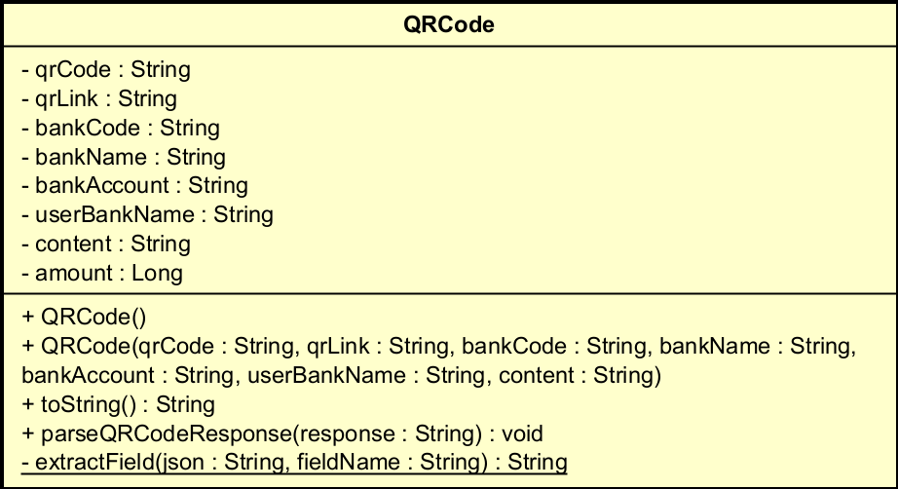

Table 1. Attribute design

# | Name | Data type | Default value | Description
1 | qrCode | String |  | QR code string returned from VietQR API, used for displaying or generating the QR image.
2 | qrLink | String |  | Link to view the generated QR code image.
3 | bankCode | String |  | Code of the receiving bank.
4 | bankName | String |  | Name of the receiving bank.
5 | bankAccount | String |  | Bank account number used for payment.
6 | userBankName | String |  | Name of the bank account owner.
7 | content | String |  | Payment transfer content or transaction description.
8 | amount | Long |  | Payment amount of the order.
Table 2. Operation design

# | Name | Return type | Description
1 | toString | String | Convert QR code information into a readable string format.
2 | parseQRCodeResponse | void | Parse the VietQR QR generation response and extract QR information.
3 | extractField | String | Extract a specified field value from a response string.
Method
toString()
• Converts QR code information into a readable string format.
• Includes important QR and bank information.
• Returns the formatted string.
parseQRCodeResponse(response : String)
• Reads the raw response returned by the VietQR API.
• Extracts QR code information from the response.
• Stores the extracted values in the corresponding attributes.
extractField(json : String, fieldName : String)
• Searches for the specified field in the response string.
• Extracts the corresponding field value.
• Returns the extracted value.

Class " QRGenerateRequest”
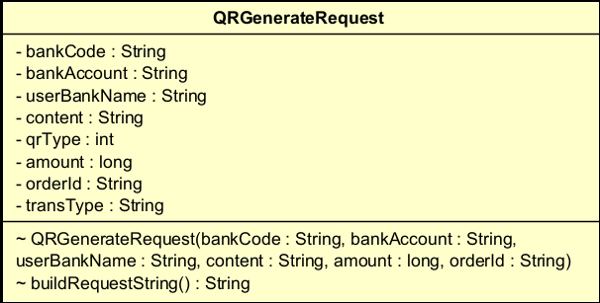

Table 1. Attribute design

# | Name | Data type | Default value | Description
1 | bankCode | String |  | Code of the receiving  bank used for VietQR payment generation.
2 | bankAccount | String |  | Bank account number  used to receive payment.
3 | userBankName | String |  | Name of the bank account owner.
4 | content | String |  | Payment transfer  content / transaction description.

5 | qrType | int |  | Type of QR code (dynamic, static, or  semi-dynamic).
6 | amount | long |  | Payment amount of the order.
7 | orderId | String |  | ID of the order associated with the  payment.
8 | transType | String |  | Type of transaction (e.g. credit  transaction).

Table 2. Operation design

# | Name | Return type | Description (purpose)
1 | QRGenerateRequest | constructor | Initialize request object with payment information for  VietQR API.
2 | buildRequestString | String | Convert request attributes into request  string / JSON format for VietQR API call.

Parameter:
- QRGenerateRequest(bankCode : String, bankAccount : String, userBankName : String, content : String, amount : long, orderId : String)
- bankCode: code of the receiving bank
- bankAccount: bank account number for payment
- userBankName: account owner name
- content: payment transfer content
- amount: payment amount
- orderId: ID of the corresponding order

Method:
buildRequestString() : String
  - Converts all stored attribute values into the request format required by the VietQR API.
  - Constructs a formatted JSON / request string containing payment and bank information.
  - Returns the final request string to be sent by the boundary layer.

Class " QRAccessTokenResponse”
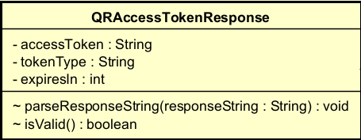

Table 1. Attribute design

# | Name | Data type | Default value | Description
1 | accessToken | String |  | Access token returned from VietQR API, used for authenticated  requests.
2 | tokenType | String |  | Type of token returned by VietQR (e.g.  Bearer).
3 | expiresIn | int |  | Token expiration time returned by VietQR API, usually in  seconds.

Table 2. Operation design

# | Name | Return type | Description (purpose)
1 | parseResponseString | void | Parse raw VietQR token response string and extract token  information.
2 | isValid | boolean | Check whether the parsed token response  is valid.

Parameter:
- parseResponseString(response : String) : void
  - response: response string returned from VietQR token API

Class " QRAccessTokenResponse”

Design for class “PaypalPaymentController”
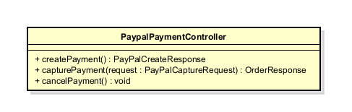
Table 1. Attribute design

# | Name | Data type | Default value | Description
1
2
…
Table 2. Operation design

# | Name | Return type | Description (purpose)
1 | createPayment() | PayPalCreateResponse | POST /order/payment/paypal/create. Starts a PayPal payment for the current draft order and returns the approval URL plus the provider order id.
2 | capturePayment(request) | OrderResponse | POST /order/payment/paypal/capture. Captures the approved PayPal payment and finalizes the order.
3 | cancelPayment() | void | POST /order/payment/paypal/cancel. Records a best-effort customer cancellation; the draft order is kept for retry.
Parameter:
- request : PayPalCaptureRequest — carries the PayPal token (“provider order id”) PayPal appended to the return URL once the customer approved the payment.

Method:
- Thin boundary layer (REST controller): holds no business logic of its own.
- Exchanges only DTOs with PaypalPaymentService (DATA coupling), mirroring the existing VietQR controller for consistency across payment methods.
Other diagrams:
- Sequence diagram — PayPal create/capture lifecycle (see updated SD for this use case).

Design for class “PaypalPaymentService”
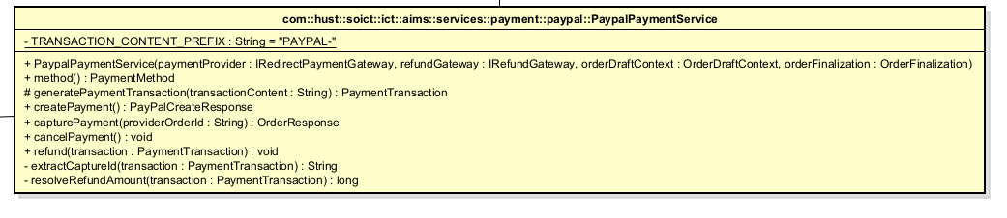
Table 1. Attribute design

# | Name | Data type | Default value | Description
1 | TRANSACTION_CONTENT_PREFIX | String | "PAYPAL-" | Static final. Prefix stamped onto PaymentTransaction.transactionContent at capture time so the write path (capture) and the read path (refund) cannot drift apart.
2 | paymentProvider | IRedirectPaymentGateway | (injected) | Abstraction used to create and capture PayPal payments; implemented by PayPalGatewayFacade.
3 | refundGateway | IRefundGateway | (injected) | Abstraction used to refund a previously captured payment; implemented by PayPalGatewayFacade.
Table 2. Operation design

# | Name |  |  | Return type |  |  |  | Description (purpose)
1 | method() |  |  | PaymentMethod |  |  | Identifies this service to the rest of the system as the PAYPAL payment method.
2 | generatePaymentTransaction(transactionContent) |  | PaymentTransaction |  |  |  |  | Builds the PaymentTransaction entity for the current draft order, in the currency AIMS thinks in (VND).
3 | createPayment() |  |  | PayPalCreateResponse |  |  |  | Step 1: creates a PayPal order for the current draft order and returns the approval URL the frontend must open.
4 | capturePayment(providerOrderId) | OrderResponse |  |  |  |  |  |  |  |  | Step 2: captures the approved PayPal payment, verifies it belongs to the current order, then finalizes the order (persist + email).
5 | cancelPayment() |  |  |  | void |  |  |  |  | Step 2′: best-effort log when the customer cancels on PayPal; the draft order is kept intact.
6 | refund(transaction) |  |  |  |  | void |  |  | Refunds a previously captured PayPal payment, invoked asynchronously from the order-cancellation/rejection flow.
Parameter:
- providerOrderId : String — the PayPal token returned to the frontend on redirect, used to capture the matching PayPal order.
- transaction : PaymentTransaction — the persisted record used to recover the original PayPal capture id and the amount to refund.

Exception:
- PaymentException if the PayPal capture is not completed, if the captured order does not match the current draft order (anti-tampering check), or if the refund does not complete.

Method:
- capturePayment defends against token reuse across orders by comparing capture.referenceId() with the current order id before finalizing — a forged or leaked token cannot finalize someone else’s order.
- refund() reconstructs the raw PayPal capture id by stripping the “PAYPAL-” prefix recorded at capture time, keeping the write path and the read path in sync.
- Shares its order-draft and order-finalization behaviour with the abstract base class PaymentService (also used by VietQRPaymentService), so only the PayPal-specific steps are implemented here.

Other diagrams:
- Sequence diagram — PayPal create/capture lifecycle (redirect flow), replacing the previous “card form” sequence diagram.
- Sequence diagram — refund flow, triggered from the order-cancellation event handler (shared with the cancellation use case).

Design for class “PayPalGatewayFacade”
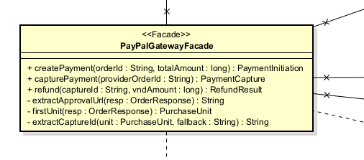

Table 1. Attribute design
# | Name | Data type | Default value | Description
1 | ordersClient | PayPalOrdersClient | (injected) | Thin wrapper over the PayPal v2 Orders endpoints (create-order, capture-order).
2 | paymentsClient | PayPalPaymentsClient | (injected) | Thin wrapper over the PayPal v2 Payments refund endpoint.
3 | amountConverter | PayPalAmountConverter | (injected) | Converts AIMS VND amounts into the 2-decimal value PayPal expects in the configured currency.
4 | props | PayPalProperties | (injected) | Typed configuration: base URL, currency, VND conversion rate, return/cancel URLs, brand name.

Table 2. Operation design
# | Name | Return type | Description (purpose)
1 | createPayment(orderId, totalAmount) | PaymentInitiation | Builds the PayPal create-order request, stamps the AIMS order id as reference_id/custom_id, and returns the provider order id plus the approval URL.
2 | capturePayment(providerOrderId) | PaymentCapture | Captures the PayPal order, detects payer cancellation, and returns a provider-agnostic capture result.
3 | refund(captureId, vndAmount) | RefundResult | Validates input, converts the VND amount to the gateway currency, and refunds the capture via the Payments client.

Parameter:
- orderId : String — the AIMS order id, stamped on both reference_id and custom_id so the capture can later be verified against the right order.
- vndAmount : long — amount to refund expressed in VND; currency conversion stays inside the subsystem.
Exception:
- PaymentException — translated from the internal PayPalApiException so no PayPal-specific exception ever crosses the subsystem boundary.
- UserCancelledException — thrown when PayPal reports a VOIDED or CANCELLED status on capture.
Method:
- Implements the Facade pattern (Section 5): hides PayPalOrdersClient, PayPalPaymentsClient, PayPalAmountConverter and the PayPal JSON/link-parsing details behind two narrow, provider-agnostic interfaces.
- Only PaymentInitiation / PaymentCapture / RefundResult records cross the boundary outward — never a raw PayPal type (DATA coupling outward).
Other diagrams:
- Subsystem sequence diagram — Facade → PayPalOrdersClient / PayPalPaymentsClient → external PayPal REST API, replacing the previous ProcessPayPalPayment.png.

Design for classes “PayPalOrdersClient”, “PayPalPaymentsClient”, “PayPalAuthClient”, “PayPalAmountConverter”
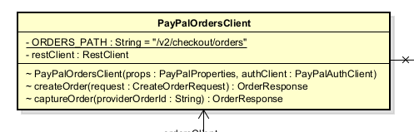
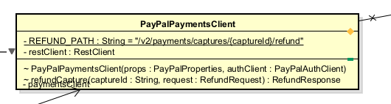

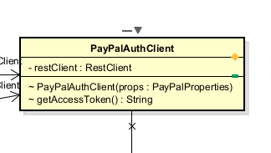
These four classes are small, single-purpose, package-private helpers inside subsystems.paypal. They are grouped in one section because none of them has more than one or two operations.

Table 1. Attribute design
# | Name | Data type | Default value | Description
1 | PayPalOrdersClient.authClient | PayPalAuthClient | (injected) | Used to obtain a bearer token before every Orders API call.
2 | PayPalOrdersClient.restClient | RestClient | (built from baseUrl) | Spring RestClient bound to the PayPal base URL.
3 | PayPalPaymentsClient.authClient | PayPalAuthClient | (injected) | Used to obtain a bearer token before the refund call.
4 | PayPalAuthClient.props | PayPalProperties | (injected) | Supplies clientId / clientSecret for the OAuth2 client-credentials grant.
5 | PayPalAmountConverter.props | PayPalProperties | (injected) | Supplies the configured currency and the VND-to-currency rate.

Table 2. Operation design
# | Name | Return type | Description (purpose)
1 | PayPalOrdersClient.createOrder(request) | PayPalApiModel.OrderResponse | POST /v2/checkout/orders — creates a PayPal order.
2 | PayPalOrdersClient.captureOrder(providerOrderId) | PayPalApiModel.OrderResponse | POST /v2/checkout/orders/{id}/capture — captures an approved order.
3 | PayPalPaymentsClient.refundCapture(captureId, request) | PayPalApiModel.RefundResponse | POST /v2/payments/captures/{id}/refund — refunds a settled capture.
4 | PayPalAuthClient.getAccessToken() | String | POST /v1/oauth2/token — obtains an OAuth2 access token (client-credentials grant).
5 | PayPalAmountConverter.toProviderValue(vndAmount) | String | Converts a VND amount into the 2-decimal string PayPal expects in the configured currency.

Parameter:

request : PayPalApiModel.CreateOrderRequest / RefundRequest — built by PayPalGatewayFacade, never by the AIMS core.

vndAmount : Long — e.g. 250 000 VND with the default rate (25 000) converts to “10.00”.
Exception:

PayPalApiException (package-private) if PayPal returns a non-2xx HTTP response or an empty access token; caught and re-thrown as PaymentException by PayPalGatewayFacade only.
Method:

Each client targets exactly one PayPal API group (Orders / Payments / OAuth) instead of one monolithic client — preserves functional cohesion and SRP (see Cohesion & SRP table, item 1).

PayPalAmountConverter keeps the VND↔currency conversion a gateway-only concern; the AIMS core continues to think purely in VND.
Other diagrams:

Covered by the PayPalGatewayFacade subsystem sequence diagram above; no separate diagram needed.

Design Considerations
<Describe issues which need to be addressed or resolved before attempting to devise a complete design solution. Remember that, you have to refactor your source code to strictly follow the final design>

Goals and Guidelines
The design of the AIMS system is guided by a set of architectural goals, software engineering principles, and implementation guidelines intended to improve maintainability, extensibility, reliability, and long-term sustainability of the system. These goals were established not only to satisfy the functional requirements specified in the SRS but also to support future requirement changes introduced by the additional project requirements.
Goal 1: Separation of concerns is non-negotiable
Every class must have one clearly stateable reason to change. This is the Single Responsibility Principle applied not just as a SOLID checkbox but as the primary filter for every design decision made during the project. Concretely:
- Controllers own only the HTTP boundary. They parse requests, delegate to the service layer, and serialise responses. No business logic, not even a conditional, belongs in a controller.
- Services own all business rules and orchestration. They do not construct HTTP responses, format strings for display, or directly build JPA queries beyond what the repository interface exposes.
- Repositories own all database access. Named query methods and @Query annotations are acceptable; raw SQL embedded in service methods is not.
- Frontend screen components orchestrate layout and user interaction. They do not contain data transformation logic or direct API calls, those belong in the TypeScript service layer.
Violations of this principle were the most common source of coupling problems found during the lab assignments. Enforcing it as a hard guideline prevents the service layer from becoming a dumping ground for all logic that does not fit elsewhere.
Goal 2: Interfaces are defined by the consumer, not the implementor
Whenever the service layer depends on an external capability (a payment gateway, a notification channel, a refund mechanism), the interface contract is defined in the application layer and the external implementation adapts to it, not the reverse. No Spring Boot service class imports a class from a payment SDK directly; it imports an interface that the SDK adapter implements.
This is the Dependency Inversion Principle applied as a coding rule. It keeps the core business logic independent of third-party library details and makes the system testable with stub implementations without modifying production code.
Goal 3: Extension by addition, not modification
When a new product type, payment method, delivery zone, or notification channel needs to be supported, the correct response is to add a new class and register it, not to open an existing class and add a branch. Switch statements and long if-else chains over type enumerations are treated as design defects requiring refactoring, not as acceptable implementation shortcuts.
Reason: The Open/Closed Principle. The product type hierarchy and payment method set are explicitly identified in the requirements as open to future extension. The registry-based dispatch pattern applied throughout the service layer is the direct implementation of this guideline.
Goal 4: Abstractions are earned, not speculated
A shared abstraction (superclass, interface, template) is introduced only when at least two concrete cases exist that genuinely share the abstracted behavior. Speculative abstractions, designed for requirements that do not yet exist, are rejected in favor of a deferred refactor note documented explicitly in the SDD.
Reason: YAGNI (You Aren't Gonna Need It). Premature abstraction adds indirection without benefit, makes the codebase harder to read, and often produces the wrong abstraction because there is insufficient evidence to triangulate the correct shape. Two concrete examples of this guideline in practice:
- The PhysicalProduct / DigitalProduct split was considered and explicitly deferred: AIMS currently sells only physical media, so introducing a PhysicalProduct intermediate layer serves no present purpose.
- The Template Method for payment finalization was introduced only after both VietQRPaymentService and PayPalPaymentService were implemented and the shared skeleton became observable.
Goal 5: Cross-cutting concerns are handled outside business logic
Concerns that apply uniformly across multiple operations (such as audit logging, transaction management, security enforcement) are implemented once at the infrastructure level and woven in declaratively, not repeated inside each business method.
- Audit logging uses AOP.
- Transaction boundaries are declared with @Transactional on service methods, not managed manually.
- Security constraints are enforced on the configuration level, not duplicated inside service methods.
Embedding cross-cutting logic inside business methods violates SRP and produces brittle code where a change to the logging format or transaction strategy requires touching every affected method individually.
Goal 6: Post-commit side effects are never in the main transaction
Notification emails, refund triggers, and other side effects that follow an order state transition are always dispatched after the originating transaction has committed successfully. They may run in their own transaction and must not cause the main transaction to roll back if they fail.
A notification failure must not roll back a successfully placed or cancelled order. Mixing side effects into the main transaction couples unrelated concerns and produces incorrect rollback behaviour. This guideline has a concrete implementation consequence: all associations required by event listeners must be eagerly loaded inside the main transaction before the event is published, because the Hibernate session will have closed by the time the listener fires.
Goal 7: Validated input at the boundary, trusted data inside
All input validation occurs at the controller boundary using Spring Jakarta Validation, along with some additional custom constraint annotations. Once a request has passed validation and entered the service layer, the data is treated as structurally correct. The service layer enforces only business rule violations (e.g., price out of allowed range, stock insufficient), not structural ones (e.g., null checks for fields already validated as non-null).
Duplicating structural validation inside the service layer adds noise without safety, since the service is not a public API and always called through the controller. Business rule enforcement belongs in the service because it requires domain knowledge; structural enforcement belongs at the boundary because it requires no domain knowledge.
Goal 8: Naming conventions
The following naming conventions are applied uniformly across the backend codebase:
- Entities: PascalCase nouns (Product, OrderItem, PaymentTransaction).
- Service interfaces and implementations: I{Name}Service for the interface (where an interface exists); {Name}Service for the implementation.
- Gateway interfaces: I{Method}PaymentGateway (e.g., IQRPaymentGateway, IRedirectPaymentGateway).
- Registry classes: {Concern}Registry (e.g., ProductCreatorRegistry, NotificationChannelRegistry).
- Strategy implementations: {Variant}{Concern}Strategy or {Variant}{Concern} (e.g., HanoiDeliveryFeeCalculator, EmailNotificationChannel).
- Event classes: {Subject}{Outcome}Event (e.g., OrderSuccessEvent, OrderCancelledEvent).
- AOP annotations: @{Concern} in lowercase package (@AuditLog).
- REST endpoints: lowercase hyphenated paths following REST resource conventions (/api/products/{id}, /api/orders/{id}/cancel).
On the frontend:
- React components: PascalCase (ProductFormSection, OrderSummaryCard).
- TypeScript services: PascalCase with Service suffix (ProductManagementService, OrderService).
- API call functions: camelCase verbs describing the action (fetchProductById, submitOrder).
Goal 9: No business logic on the frontend
The frontend is responsible for display and interaction only. Price calculations (VAT, delivery fee, total), order eligibility checks, and stock availability are computed by the backend and returned in API responses. The frontend renders these values; it does not recompute them independently.
Duplicating business logic on the frontend creates a synchronization risk. If the backend rule changes, the frontend silently diverges. Treating the backend as the single source of truth for all computed values eliminates this class of bug.

Architectural Strategies
This section describes the major design decisions that shaped the overall organization of AIMS, the choices that, had they been made differently, would have produced a structurally different system. For each decision, the reasoning and any trade-offs made are explained explicitly.
Strategy 1: Technology stack selection
Decision: Java Spring Boot (backend) + React/TypeScript (frontend) + PostgreSQL (database).
These choices were mandated by the course, but their implications shaped every subsequent design decision. Spring Boot's annotation-driven programming model, @Transactional, @EventListener, @Aspect, made it natural to implement cross-cutting concerns declaratively rather than programmatically. Spring Data JPA reduced the repository layer to interface declarations for the majority of queries. React's component model aligned well with the OOP renderer registry pattern applied on the frontend.
Trade-off: Spring Boot's convention-over-configuration approach introduces a significant framework footprint. For a project of this scale, much of that infrastructure is overhead. However, the course evaluation criteria require demonstrable application of design patterns and SOLID principles, and Spring's ecosystem provides first-class support for AOP, event-driven decoupling, and dependency injection, all of which are central to the design.
Strategy 2: REST API as the sole frontend-backend communication mechanism
Decision: All frontend-backend communication occurs over stateless RESTful HTTP APIs returning JSON. No WebSocket, server-sent events, GraphQL, or RPC mechanism is used.
Each major domain resource (/api/products, /api/orders, /api/users) is addressable by a stable URL. State-changing operations use the appropriate HTTP verb (POST for creation, PUT/PATCH for update, DELETE for removal). The frontend holds no persistent connection to the backend.
Trade-off: A stateless REST model means the frontend must poll for order status updates (e.g., awaiting VietQR payment confirmation) rather than receiving a server push. This is acceptable at the expected scale and simplifies the backend considerably, no WebSocket session management, no event streaming infrastructure.
Strategy 3: Monolithic deployment with internal modular boundaries
Decision: AIMS is deployed as a single Spring Boot application (monolith). There is no microservices decomposition, no message broker, and no inter-process communication.
Internally, the codebase is organised into well-defined packages by domain concern (order, product, payment, notification, audit), with explicit interface contracts between them. This provides the cognitive benefits of modular separation without the operational complexity of a distributed system.
Trade-off: A monolith limits independent scaling and deployment of subsystems. However, at the current scale (course demonstration, up to 1,000 concurrent users on a single server), the operational simplicity of a monolith outweighs any scalability benefit. The internal modular structure means that, if decomposition were needed in future, the boundaries are already defined and the contracts already expressed as interfaces.
Strategy 4: Vertical slice architecture for the payment subsystem
Decision: Rather than a single unified payment abstraction, each payment method (VietQR, PayPal) is a self-contained vertical slice. Two separate interface contracts (IQRPaymentGateway, IRedirectPaymentGateway) represent the two structurally distinct interaction models.
This decision was reached after an earlier attempt to unify both payment methods behind a single PaymentGateway interface was rolled back due to structural incompatibility. VietQR is poll-based (generate QR → wait for bank callback); PayPal is redirect-based (redirect user → capture on return). Forcing a common interface required one or both implementations to expose methods irrelevant to their flow, an ISP violation.
Trade-off: Two separate interfaces means the service layer cannot treat all payment methods identically through a single reference. This is accepted because the alternative, a leaky unified abstraction, is worse. The PaymentService abstract base class handles the shared post-payment finalization sequence via Template Method, preserving the DRY principle for the parts that genuinely are shared.
Strategy 5: Event-driven decoupling for order lifecycle side effects
Decision: Post-state-transition side effects (notification emails, refund triggers) are published as Spring application events after the originating transaction commits and handled by independent @TransactionalEventListener methods.
This means OrderService has zero direct dependencies on NotificationService or any refund service. It publishes a fact (OrderCancelledEvent, OrderSuccessEvent) and is done. Downstream handlers, today an email notification and a refund stub, subscribe independently.
Trade-off: Event-driven decoupling introduces an implicit contract between publisher and subscriber that is harder to trace statically than a direct method call. A developer reading OrderService cannot immediately see what happens after an event is published without searching for listeners. This is mitigated by consistent naming conventions (Section 5.1, G8) and documentation in this SDD. The coupling reduction benefit, OrderService does not need to know how many things happen after an order is cancelled, or what they are, outweighs the traceability cost at this scale.
Strategy 6: AOP for audit logging as a cross-cutting concern
Decision: Product CUD audit logging is implemented via @Around AOP advice on a custom @AuditLog annotation, entirely outside the business methods being logged.
The alternative, calling auditLogService.log(...) at the end of every createProduct, updateProduct, and deleteProduct method, would have required every service method to carry a logging dependency and a logging call, mixing two unrelated responsibilities in one method body.
Trade-off: AOP advice is non-obvious to developers unfamiliar with the pattern. The logging behavior is invisible when reading the service method in isolation. This is accepted because the alternative (manual logging calls) scales poorly, every new auditable operation requires a developer to remember to add the call. The AOP approach is opt-in via annotation and failure-safe: forgetting to add @AuditLog produces a missing log entry (a visible omission) rather than a runtime error.
Strategy 7: JWT-based stateless authentication
Decision: Authentication is implemented using JSON Web Tokens (JWT). The backend issues a signed JWT on successful login; the frontend attaches it as a Bearer token on every subsequent request. The backend validates the token on each request without consulting the database for session state.
No server-side session store, no cookie-based session management. Role-based access control (PRODUCT_MANAGER, ADMINISTRATOR) is enforced at the controller level via Spring Security's @PreAuthorize annotations, reading claims directly from the validated token.
Trade-off: Stateless JWTs cannot be invalidated before expiry without a token blacklist. For this project, token expiry is set to a short window and no blacklist is implemented. This is an accepted limitation within the course scope, a production system would require either short-lived tokens with refresh token rotation, or a server-side session store for immediate revocation.
Strategy 8: Joined table strategy for the Product inheritance hierarchy
Decision: The Product IS-A hierarchy (Book, CD, DVD, Newspaper) is mapped to the database using JPA's InheritanceType.JOINED strategy. Each subtype has its own table containing only subtype-specific columns, joined to the shared product table by primary key.
The alternatives considered were:
- Single table: All columns in one table with null columns for inapplicable subtypes. Rejected because the subtypes have significantly different attribute sets, producing a wide table with many nullable columns and no per-subtype constraints.
- Table per class: Each subtype carries all shared columns. Rejected because it duplicates shared product data across four tables and makes catalog-wide queries (e.g., search across all product types) require a UNION.
Trade-off: Joined table requires a JOIN for every subtype query. At the expected data volumes (product catalog in the hundreds to low thousands), this cost is negligible. The normalisation and constraint benefits outweigh it.
Strategy 9: Denormalized snapshots in order line items and audit logs
Decision: order_item records store product_name, unit_price, and unit_weight as snapshot values at checkout time. product_log and admin_log records store manager_username and affected_username as denormalised strings rather than enforcing foreign key relationships to the users table.
This means order line items and audit records are immutable historical facts, they do not change if the referenced product is later updated or the referenced user is later deactivated.
Trade-off: Denormalization sacrifices strict referential integrity in these specific tables. This is a deliberate choice: an audit log that changes when the audited user changes is not a reliable audit log. The snapshot model is semantically correct for both use cases. Foreign keys to product and user are retained as non-enforced references (stored as UUID columns) for traceability, but the displayed values are self-contained.

Strategy 10: Supabase Storage for product images, with URL-only backend coupling
Decision: Product images are stored in Supabase Storage. The backend stores only the public image URL as a varchar field in the product table. The backend never reads or writes binary image data, it handles only the URL string. The browser fetches images directly from Supabase's CDN.
Trade-off: This creates an external dependency on Supabase availability for image rendering. If the Supabase bucket becomes unavailable, product images break even though the rest of the application is functional. This is accepted for the course scope. A more robust production design would store images behind a backend-controlled endpoint that could fall back to a default image, abstracting the storage provider from the frontend entirely.
Strategy 11: Registry-based polymorphic dispatch over switch statements
Decision: Wherever the system needs to select behaviour based on a type discriminator (product type, payment method, delivery zone, notification channel), the selection mechanism is a registry (EnumMap or Map<Class<?>, Handler>) populated at startup, not a switch statement or chain of if-else branches evaluated at runtime.
Each variant registers itself (or is registered by a configuration class) under its key. The caller looks up the handler by key and invokes it through a shared interface. The caller has no knowledge of which concrete handler it receives.
Trade-off: Registry-based dispatch requires that all variants be registered at startup. A missing registration produces a runtime lookup failure rather than a compile-time error. This is mitigated by fail-fast validation at application startup: if a required handler is absent from the registry, the application fails to start rather than failing silently on the first request.

Design and Program Evaluation

Cohesion & SRP
Explain in detail for each class in the table.
Table 10. Cohesion & SRP of AIMS
# | Class Name |  | PIC | Cohesion | SRP | Solution
1 | Order |  | Huy Diễn | Communicational — all fields and methods operate on the same Order aggregate and its directly related state (items, delivery, invoice, payment, status transitions) | Yes — single responsibility: represent and protect the lifecycle of one order aggregate | —
2 | OrderItem |  | Huy Diễn | Functional — all attributes and methods contribute solely to representing one purchased line item and computing its price/weight | Yes — single responsibility: snapshot and represent one order line item | —
3 | DeliveryInformation |  | Huy Diễn | Communicational — all fields and the single method operate on the same delivery-related data for one Order | Yes — single responsibility: hold shipping and recipient data for an order | —
4 | Invoice |  | Huy Diễn | Functional — represents billing data and the logic to capture it as a snapshot from an Order | Yes — single responsibility: produce and hold a point-in-time billing record | —
5 | PaymentTransaction |  | Huy Diễn | Communicational — all fields operate on payment record data for a single transaction | Yes — single responsibility: store the outcome of one payment event | —
6 | StockValidator |  | Huy Diễn | Functional — all logic contributes solely to validating stock availability and cart consistency | Yes — single responsibility: validate that a cart's contents can be fulfilled by current stock | —
7 | DeliveryFeeCalculator |  | Huy Diễn | Functional — all logic contributes to resolving and delegating to the correct delivery fee strategy | Yes — single responsibility: dispatch to the correct fee strategy by method key | —
8 | StandardDeliveryFeeStrategy |  | Huy Diễn | Functional — all constants and methods contribute solely to computing the standard delivery fee | Yes — single responsibility: implement the standard delivery fee calculation rule | —
9 | PlaceOrderService |  | Huy Diễn | Procedural — coordinates sequential steps in the order placement workflow (stock check → draft → delivery info → invoice retrieval → cancellation) | Partial — currently owns multiple workflow steps. Changes to any one step may require modifying this class. | If the application grows significantly, consider separating into OrderDraftService, OrderDeliveryService, and OrderQueryService. For the current project scope, the cohesion within the workflow justifies the current grouping.
10 | OrderFinalizer |  | Huy Diễn | Functional — all logic contributes to the single act of finalizing and persisting a completed order and publishing its event | Yes — single responsibility: transition the order to PENDING, persist it, and publish the success event | —
11 | PlaceOrderSuccessListener |  | Huy Diễn | Communicational — all operations react to the same OrderSuccessEvent and handle related post-order cleanup and notification | Yes — single responsibility: handle post-commit side effects of a successful order placement | —
12 | OrderSuccessEvent |  | Huy Diễn | Functional — a pure data carrier for the order success fact | Yes — single responsibility: carry the placed order to post-commit event listeners | —
13 | OrderConfirmationEmailMessage |  | Huy Diễn | Functional — all methods contribute to producing one specific email message for one specific event | Yes — single responsibility: produce the order confirmation email content | —
14 | OrderController |  | Huy Diễn | Procedural — coordinates the HTTP surface of the order placement workflow; methods participate in the same sequential order procedure | Yes — single responsibility: expose the order placement workflow as REST endpoints and delegate to service layer | —
15 | PayPalOrdersClient PayPalPaymentsClient PayPalAuthClient | Pham Duc Phuoc | Previous design used one PaypalAPIClient for the Orders call, the refund call and the OAuth token call together → communicational cohesion only. |  | The old single client had three independent reasons to change (three different PayPal endpoint groups). | Split into three single-purpose clients, one per PayPal endpoint group (Orders v2, Payments/refund, OAuth2 token). Each class now has functional cohesion and one reason to change.
16 | PaypalPaymentService (formerly CreditCardPaymentService) |  | Pham Duc Phuoc | Old design held PaymentGateway, INotificationService, PaymentTransactionRepository and IOrderRepository directly inside one class → low cohesion (4 unrelated concerns). | The old class changed for payment, notification, persistence AND order-state reasons — four responsibilities in one place. | Narrowed to orchestrate only the PayPal create / capture / cancel / refund lifecycle. Draft-order access and order finalization are delegated to the shared OrderDraftContext / OrderFinalization abstractions, restoring functional cohesion.
17 | PayPalGatewayFacade |  | Pham Duc Phuoc | Functional cohesion: the class exposes exactly the create / capture / refund lifecycle of the PayPal gateway, nothing else. | Single responsibility: translate provider-agnostic calls into PayPal API calls and back. | Already compliant. Kept as a documented example of the Facade pattern applied to this use case (see Section 5).

Coupling & Other SOLID
Explain in detail for each problem in the table. Each problem, you may provide a class diagram before and after the improvement.
Table 11. Coupling & other SOLID of AIMS
# | Problem | PIC | Location | Solution
1 | Stamp coupling — PlaceOrderService and OrderFinalizer receive full Order objects and traverse their internal structure | Huy Diễn | PlaceOrderService, OrderFinalizer, StockValidator | Accepted as appropriate: these classes are part of the same domain layer and the Order aggregate is their shared subject. Passing primitive data instead would require reconstructing the aggregate, which is worse. Stamp coupling at domain boundaries is the expected trade-off in aggregate-oriented design.
2 | Stamp coupling — OrderSuccessEvent carries the full Order object | Huy Diễn | OrderSuccessEvent, PlaceOrderSuccessListener, OrderConfirmationEmailMessage | Accepted with a documented constraint: since the event fires post-commit (Hibernate session closed), all required associations (deliveryInformation, invoice, paymentTransaction, items) must be eagerly loaded before the event is published. This is enforced by @NamedEntityGraph("Order-aggregate") on the repository fetch used in the listener path.
3 | DIP violation — OrderController depends on concrete classes PlaceOrderService and OrderService rather than abstractions | Huy Diễn | OrderController | Improvement direction: introduce use-case interfaces (PlaceOrderUseCase, OrderQueryUseCase) that the concrete services implement, and inject those interfaces into the controller. For the current project scope with a single implementation per use case, this is noted as a known minor violation.
4 | OCP — PlaceOrderService completion logic is hardcoded — adding a new required field requires modifying Order.isComplete() and potentially PlaceOrderService | Huy Diễn | Order.isComplete(), PlaceOrderService | Improvement direction: introduce an OrderCompletionRule interface and a registry of rules checked by isComplete(). Each new completion requirement is a new rule implementation, not a modification to Order. Deferred for current scope.
5 | Data coupling (positive) — DeliveryFeeCalculator and StandardDeliveryFeeStrategy communicate through the DeliveryFeeCalculationStrategy interface using only the Order and a return value | Huy Diễn | DeliveryFeeCalculator → DeliveryFeeCalculationStrategy → StandardDeliveryFeeStrategy | This is the target coupling level. Adding a new strategy requires only a new class implementing DeliveryFeeCalculationStrategy and a new enum value — no changes to DeliveryFeeCalculator or any caller.
6 | ISP — DeliveryFeeCalculationStrategy is minimal and cohesive | Huy Diễn | DeliveryFeeCalculationStrategy | The interface exposes exactly two methods: method() (for self-registration) and calculateDeliveryFee(order) (the calculation). No implementor is forced to implement methods it does not use. ISP is satisfied.
7 | Event-driven OCP — PlaceOrderSuccessListener isolates post-commit side effects from OrderFinalizer | Huy Diễn | OrderFinalizer → ApplicationEventPublisher → PlaceOrderSuccessListener | Adding a new post-order side effect requires only a new @TransactionalEventListener method — OrderFinalizer and PlaceOrderService are not modified. OCP is satisfied at the event boundary.
8 | LSP — Order status transition encapsulation | Huy Diễn | Order.Status, Order.changeStatus() | All status transitions go through changeStatus(), which validates against the transition map before applying. No external class can bypass this — changeStatus() is private. LSP holds: any code that expects an Order in PENDING state will always find it transitioned correctly by the defined operations.
9 | Earlier subsystem design (PayPalSubsystem.png / ProcessPayPalPayment.png) had AIMS build its own request DTO carrying the raw card number, CVV and expiration date, so the core was content-coupled to sensitive cardholder data and the application itself sat inside PCI-DSS scope. | Pham Duc Phuoc | Old PayPal subsystem class diagram and subsystem sequence diagram (superseded). | Replaced with PayPal's redirect / Orders v2 flow: AIMS never receives card data. Only an opaque providerOrderId/token and the provider-agnostic PaymentInitiation / PaymentCapture records cross the subsystem boundary (data coupling only).
10 | A leftover code comment on IRedirectPaymentGateway claims the interface “lives inside the low-level subsystems.paypal package” (a DIP ownership-inversion problem), but the interface already sits in the core-owned services.payment.contract package. | Pham Duc Phuoc | services/payment/contract/IRedirectPaymentGateway.java | Verified the structure is already correct: the core owns the abstraction, subsystems.paypal only provides the package-private implementation (PayPalGatewayFacade). The stale comment should be corrected so the documentation matches the code.
11 | A comment in PaypalPaymentService describes OrderDraftContext as injected as a “concrete class” and the file keeps an | Pham Duc Phuoc | services/payment/paypal/PaypalPaymentService.java | OrderDraftContext and OrderFinalization are already interfaces, so DIP is respected for both collaborators. Removed the dead import

Design Patterns

