Study overview paragraph introduces the dataset and experiment scope.
Figure one discusses category sales before the comparison table.
Metric | Value
Accuracy | 92%
Samples | 128
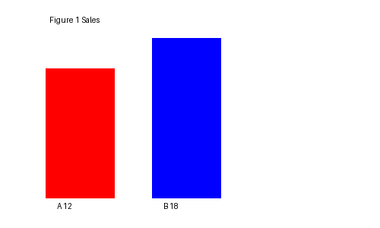
Figure two explains growth rate after the first chart.
