1. **Sensors connection**

**Overview**

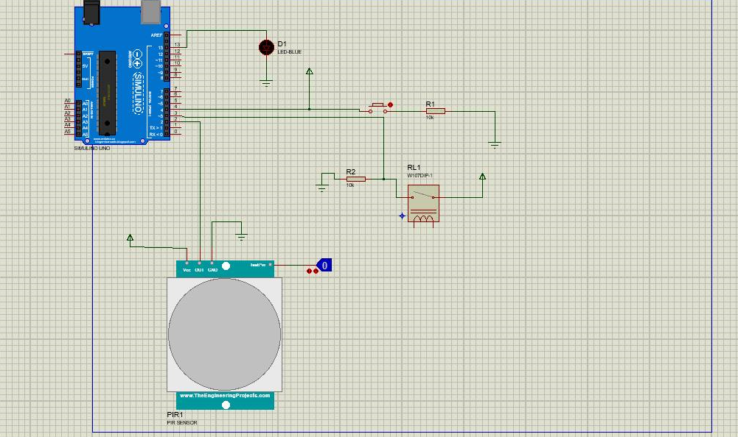

***PIR sensor system:***

* Output pin to Pin 2
* VCC to Power Pin
* Ground to Ground Pin

***Bell system:***

* One Pin of PushButton connect to Pin 4 and Power Pin. The other Pin connect through an 10k Ohm resistor to Ground.

***Magnetic Reed Switch system:***

* One Pin of the Switch connect to Ground through an 10K Ohm resistor. Connect Pin 3 to the node between Resistor and the Switch. Another Pin of the Switch connect to Power Pin.

1. **Components**

***PIR Sensor:***

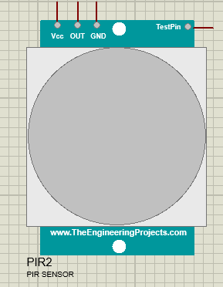

***Magnetic Reed Switch:***

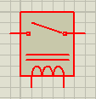

***Push Button:***

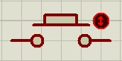

***Arduino Uno:***

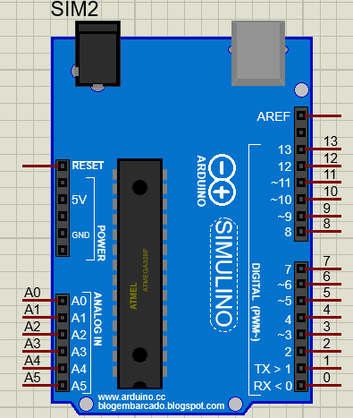

1. **Sensors diagram**
2. *Door bell notification system*

Android App

Raspberry Pi

Buzzer alarm

Arduino

Press button

Users

* When user press the button, Buzzer in Arduino will alarm, Arduino will send “1” character to Raspberry Pi via Serial USB Port (output type: char). If Raspberry Pi receives “1” character from Arduino, it will send signal to Android App. A push notification (ex. Someone press the doorbell) will appear in App screen.

1. *PIR notification system*

Arduino

Android App

Raspberry Pi

Buzzer alarm/ LED on

Motion Detected

* When a motion was detected by PIR sensor, Buzzer in Arduino will alarm, LED will turn on, Arduino will send “2” character to Rapberry Pi via Serial USB Port. If Raspberry Pi receives “2” character from Arduino, it will send signal to Android App. A push notification (ex. Motion detected) will appear in App screen.
* When the motion ended, Led will turn off, Arduino will send “3” character to Raspberry Pi via Serial USB Port. If Raspberry Pi receives “3” character from Arduino, it will send signal to Android App. A push notification (ex. Motion ended) will appear in App Screen.

1. *Magnetic Reed Switch System*

Arduino

Android App

Raspberry Pi

Buzzer alarm/LED on

Door opened

* When door was opened, Buzzer in Arduino will alarm, LED will turn on, Arduino will send “4” character to Rapberry Pi via Serial USB Port. If Raspberry Pi receives “4” character from Arduino, it will send signal to Android App. A push notification (ex. Door opened) will appear in App screen.
* When door was closed, Led will turn off, Arduino will send “5” character to Raspberry Pi via Serial USB Port. If Raspberry Pi receives “5” character from Arduino, it will send signal to Android App. A push notification (ex. Door closed) will appear in App Screen.