**1. Login**

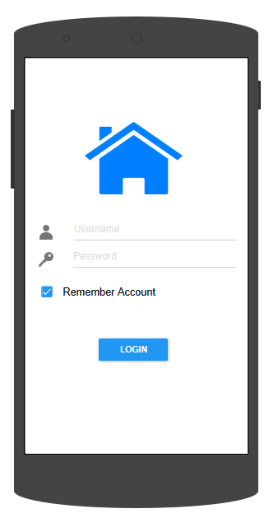

If login process is successful, move to Home Screen

Dialog box if enter wrong user/password “Invalid account or password. Please re-enter”.

**2. Authenticate**

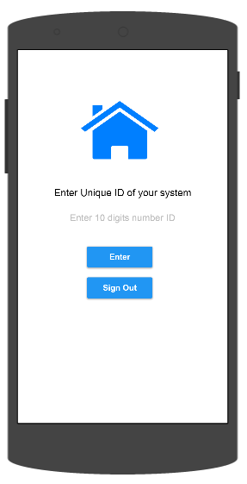

User enter unique ID of system (assigned to Raspberry Pi)

Dialog box if enter wrong user/password “Invalid ID device. Please re-enter”.

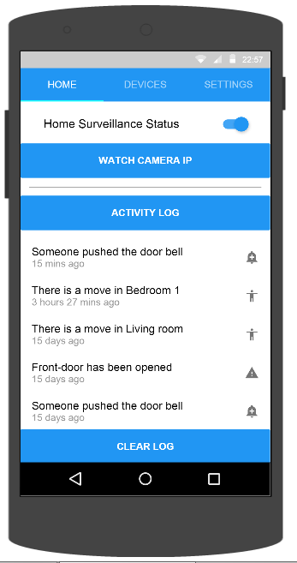

3. Activate/De-activate System

User active/deactive whole system remotely by touching on/off switch in Home Serveillance Status

4. View activity log

User can view activity log in Home_Tab

5. Clear activity log

User can clear activity log in Home_Tab. A dialog box appears to confirm clear

6. Watch Camera IP

User can watch Camera IP directly

7.