1. **Sensors connection**

***PIR sensor system:***

* Output pin to Pin 2
* VCC to Power Pin
* Ground to Ground Pin

***Bell system:***

* One Pin of PushButton connect to Pin 4 and Power Pin. The other Pin connect through an 10k Ohm resistor to Ground.

***Magnetic Reed Switch system:***

* One Pin of the Switch connect to Ground through an 10K Ohm resistor. Connect Pin 3 to the node between Resistor and the Switch. Another Pin of the Switch connect to Power Pin.

1. **Components**

***PIR Sensor:***

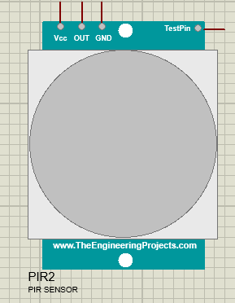

***Magnetic Reed Switch:***

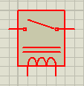

***Push Button:***

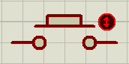

***Arduino Uno:***

