KINS SIMULATOR DEVELOPMENT - R DOCUMENT 2
1. SERVER SIDE 2
recalc.risk 2
recalc.days 2
datasetInput 2
do.judgement 3
output$checkboxOut 3
updatedParam 3
datasetInput 3
datasetRiskProfile 4
output$distPlot 4
output$view 4
output$ratio 4
output$recommend 5
output$premium 5
output$riskPlot 5
output$comment 5
2. UI SIDE 6
dashboardPage 6
Insert 2 tab menus for dashboardSidbar 7
Tab menus contents setup. 7
checkboxGroupInput 9

KINS SIMULATOR DEVELOPMENT - R DOCUMENT

- SERVER SIDE

recalc.risk
recalc.risk<-function(data){}
Calculate the risk by data frame that contains input information from UI such as age, BMI, BP_H, BP_L, HbA1c_HOKAN and other indicators.
Note:
Parameters:
data – a data frame that contain input information for calculating the risk.
Returns:
a new data frame object, containing the risk information.

recalc.days
recalc.days<-function(data){}
# to be implemented.
Note:
Parameters:
data – a data frame that contain input information for calculating.
Returns:
a new data frame object, containing the output information.

datasetInput
datasetInput <- reactive({})
Reactive calculate the risk by age. This data frame is used as a data-source for Risk Ratio plot.
Note: Overview the logic:
- Get all columns from db excepts the "age" column
- The "age" will hard-code init by a sequence from 30 to 80
- Re-combine the age into the basedata
- Calculate the risk at the standard data (do not check checkboxes, preds is zero)
- Get the real input from the UI
- Calculate the risk base on the real input data that get from UI
- Build a data frame that includes age, risk base on the standard data, risk base on the input data and the ratio between them.
Parameters:
Returns:
a new data frame object, containing age, hyoujun, youin and ratio.

do.judgement
do.judgement<-function(dataset, val){}
Set judgement by ratio
Note:
Parameters:
dataset – the data frame that need to be added the judgement.
val – value to compare with ratio to decide the judgement.
Returns:
a new data frame object that is adjusted.

output$checkboxOut
output$checkboxOut<-renderPrint({})
Get input of checkbox.
Note:
This is not used currently.
Parameters:
Returns:
names of selected checkboxes.

updatedParam
updatedParam <- reactive({})
Reactive to only update changes that get from the inputs such as age, BMI, BP_H, BP_L, HbA1c_HOKAN and checkboxes.
Note:
Parameters:
Returns:
a new data frame object that contain input values.

datasetInput
datasetInput <- reactive({})
Calculate the risk by age. This data frame is used as a data source for Risk Ratio plot
Note: Overview the logic:
- Get all columns from db excepts the "age" column
- The "age" will hard-code init by a sequence from 30 to 80
- Re-combine the age into the basedata
- Calculate the risk at the standard data (do not check checkboxes, preds is zero)
- Get the real input from the UI
- Calculate the risk base on the real input data that get from UI
- Build a data frame that includes age, risk base on the standard data, risk base on the input data and the ratio between them
Parameters:
Returns:
a new data frame object, containing age, hyoujun, youin and ratio.

datasetRiskProfile
datasetRiskProfile <- reactive({})
Calculate the risk by profile. This data frame is used as a data source for Risk Profile plot.
Note: Overview the logic:
- Get all columns from db excepts the "age" column
- The "age" will hard-code init by a sequence from 30 to 80
- Re-combine the age into the basedata
- Calucate the risk by age base on the real input data that get from UI
- Get the risk by a specificed age that is inputed from UI
- Detached the age column for get sum in the next step
- Get sum for each indicator
- Calculate the ratio between each indicator per sum
Parameters:
Returns:
a new data frame object

output$distPlot
output$distPlot <- renderPlot({})
Render Risk Ratio plot.
Note:
Parameters:
Returns:

output$view
output$view<-renderDataTable({})
Render the data table that list all values.
Note:
Parameters:
Returns:

output$ratio
output$ratio <- renderValueBox({})
Render a box that displays the risk ratio (the left one).
Note:
Parameters:
Returns:

output$recommend
output$recommend <- renderValueBox({})
Render a box that display Recomments (the middle one).
Note:
Parameters:
Returns:

output$premium
output$premium <- renderValueBox({})
Render a box that display Add on premium (the right one).
Note:
Parameters:
Returns:

output$riskPlot
output$riskPlot <- renderPlot({})
Render the plot that show the Risk profile of Admission.
Note:
Parameters:
Returns:

output$comment
output$comment <- renderPrint({})
Render the footer comments.
Note:
Parameters:
Returns:

- UI SIDE

dashboardPage

Using shinydashboard library to make the layout more professional.

Code:
ui <- dashboardPage(
skin = "color",
dashboardHeader(),
dashboardSidebar(),
dashboardBody()
)
Display:
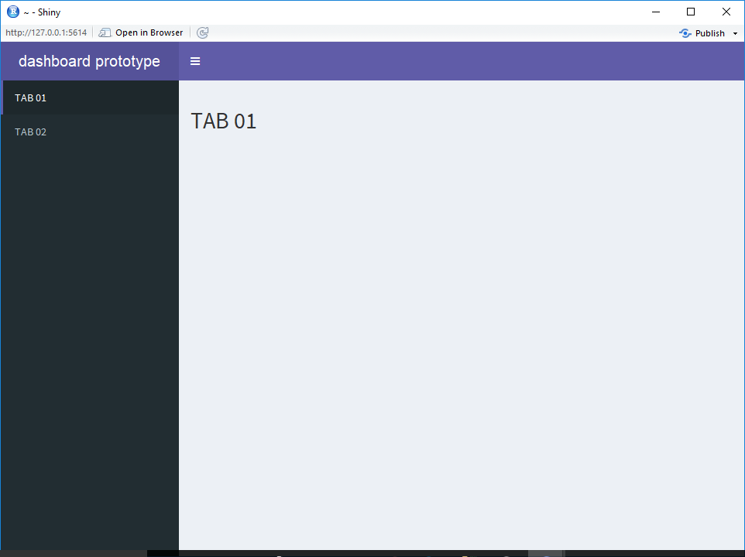
dashboardHeader
dashboardBody
dashboardSidebar

Insert 2 tab menus for dashboardSidbar
Code:
dashboardSidebar(
sidebarMenu(
menuItem("Dashboard", tabName = "dashboard"),
menuItem("Raw data", tabName = "rawdata")),
Display:
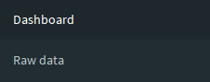

Tab menus contents setup.
Code:
tabItem("dashboard",
fluidRow(valueBoxOutput("ratio"), valueBoxOutput("recommend"), valueBoxOutput("premium")),
fluidRow(
column(7, plotOutput("distPlot", width = "100%", height = "600px")),
column(5, plotOutput("riskPlot", width = "100%", height = "600px"))
),
verbatimTextOutput("comment")
),
tabItem("rawdata",
dataTableOutput("view"),
actionButton("Save","Save as .csv"),
verbatimTextOutput("saved")
)
Display:

Dashboard tab layout: 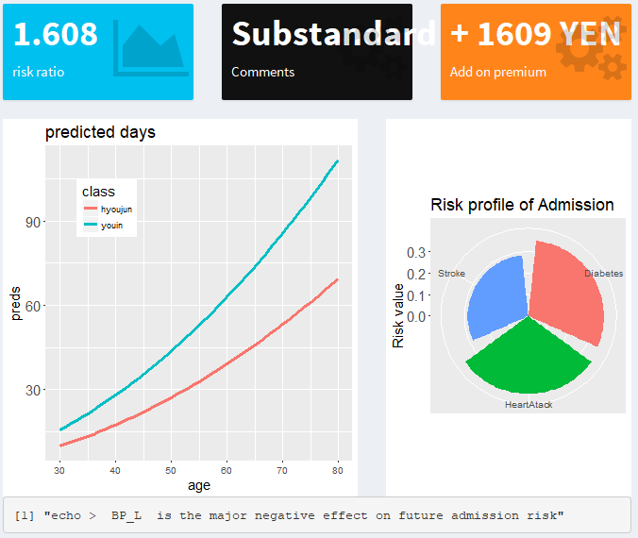

rawdata tab layout:

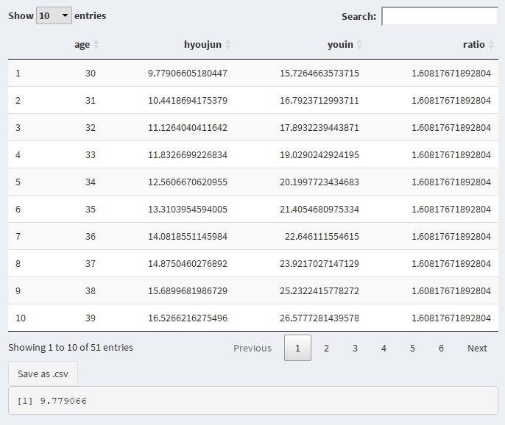

checkboxGroupInput
Display a group of checkboxes on screen.
Code:
checkboxGroupInput( 'selected_youin',
'labels:',
c(names(df_learn)[21:28],
names(df_learn[35:37]))))
Display:
