Find the variance and standard deviation of the scores on the most recent reading test in calculator:

7.7, 7.4, 7.3, and 7.9

1. Enter data

1

3

Modee

7.7 7.4 7.3 7.9

AC

=

=

=

=

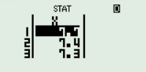

2. Find the mean

=

2

4

1

Shift

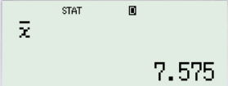

Display: 7.575

3. Find the Standard Deviation

=

4

4

1

Shift

Display: 7.575 S = 0.2754

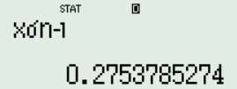

4. Find Variance

=

$x^{2}$ 1

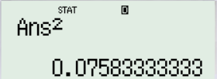

Display: 0.076 $S^{2}=0.076$