http://fit.tdc.edu.vn/addons/default/themes/bootstrapThree/img/logo.pngTRƯỜNG CAO ĐẲNG CÔNG NGHỆ THỦ ĐỨC

KHOA CÔNG NGHỆ THÔNG TIN

--------------------------------

**Software Design Specification**

**APP STORE SHOP SALE PHONE**

**May 19, 2022**

Nguyen Nhat Truong

Tran Quy Dang

Tran Diep Vu

Nguyen Dang Ngoc Duan

Le Hoai Thuong

MENU

1.0 Architectural design 4

1.1.1 Architecture diagram 4

2.0 Schedule 4

2.1 Definition of milestones 4

2.2.1 Concept/Doc Complete 1/11/2022 4

2.2.2 Module Code Complete 5/11/2022 4

2.2.3 Testing Complete 12/11/2022 4

3.0 Component-level design 5

3.1 Description for Main Menu 5

3.1.1 Narration Processing for Main Menu 5

3.1.2 Description of the Main Menu interface 5

3.1.3 Main Menu processing detail 5

3.1.3.1 Performance issues 5

3.2.3.2 Design constraints 5

3.2 Description of the froducts 5

3.2.1 Narrative processing for froducts 5

3.2.2 Description of individual functional interfaces. 6

3.2.3 Application handling details 6

3.2.3.1 Performance issues 6

3.2.3.2 Design constraints 6

4.0 User interface design 6

4.1 Description of the user interface 6

4.1.1 Login Screen 6

4.1.1.1 Screen Shot for login screen 6

4.1.1.2 Objects and actions for login Screen 7

4.1.2 Shop Sale Phone Home Screen 8

4.1.2.1 User Interfaces 8

4.1.2.2 Objects and actions 8

4.1.3 Shop Sale Phone Register Screen 10

4.1.3.1 User Interfaces 10

4.1.3.2 Objects and actions for Enter user information 10

4.1.4 Shop Sale Phone Cart Screen 11

4.1.4.1 User Interfaces 11

4.1.4.2 Objects and actions 12

4.1.5 Shop Sale Phone References Screen 12

4.1.5.1 User Interfaces 12

4.1.5.2 Objects and actions 13

4.1.6 Shop Sale Phone Account Screen 13

4.1.6.1 User Interfaces 13

4.1.6.2 Objects and actions 13

4.1.7 Shop Sale Phone Shop Account Screen 14

4.1.7.1 User Interfaces 14

4.1.7.2 Objects and Action 14

4.1.8 Shop Sale Phone Order Screen 16

4.1.8.1 User Interfaces 16

4.1.8.2 Objects and actions 16

4.1.9 Shop Sale Phone Add Product Screen 17

4.1.9.1 User Interfaces 17

4.1.9.2 Objects and actions 17

4.1.10 Shop Sale Phone Shop Order Screen 18

4.1.10.1 User Interfaces 18

4.1.10.2 Object and actions 19

4.1.11 Shop Sale Phone Account User Screen 20

4.1.11.1 User Interfaces 20

4.1.11.2 Object and actions 20

4.1.12 Shop Sale Phone Preview Screen 21

4.1.12.1 User Interfaces 21

4.1.12.2 Object and actions 21

4.2 Interface design rules 22

5.0 Restrictions, limitations, and constraints 22

6.0 Testing Issues 22

6.1 Classes of tests 22

6.2 Expected software response 23

7.0 Appendices 23

7.1 Packaging and installation issues 23

7.2 Legal Considerations 23

# 

# 1.0 Architectural design

### 1.1.1 Architecture diagram

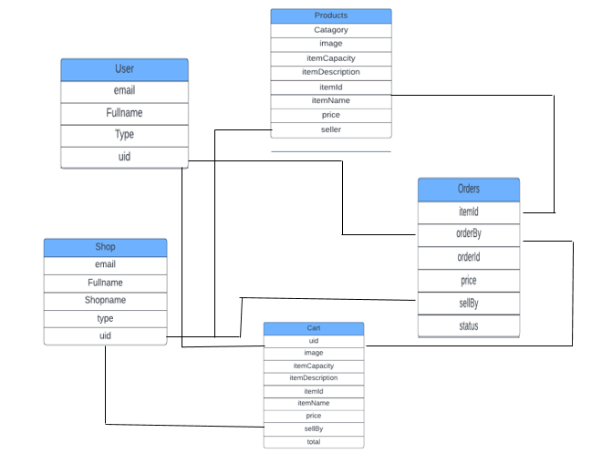

# 2.0 Schedule

## 2.1 Definition of milestones

### 2.2.1 Concept/Doc Complete 1/11/2022

All concept related documentation such as module definitions, data flow diagrams, user diagrams, etc will be completed by this date. The Requirements Documentation and System Design Documentation will be completed by this date such that module design and coding may begin.

### 2.2.2 Module Code Complete 5/11/2022

All module coding should be completed by this date so that module integration and system testing begin. Depending on Integration complexity, integration may begin 1 week before this milestone. All modules and sub-programs are expected to be fully functional and extensively tested.

### 2.2.3 Testing Complete 12/11/2022

All testing should be finished by this date and the program should be essentially complete. The remaining time may be used for small UI tweaking and documentation updates.

# 3.0 Component-level design

Our system is based on a main interface through which each product can be accessed on a screen-by-screen basis. Anytime the user can exit the app, it will return them to the home screen.

## 3.1 Description for Main Menu

The interface is the first thing users see when launching an app on their Android phone.

### 3.1.1 Narration Processing for Main Menu

In the main screen the user can select the products or exit the application. When giving a product, the product will run to the product detail screen. If the customer wants to go back, just press back to the main screen of the android operating system.

### 3.1.2 Description of the Main Menu interface

The main interface will include products and product lists as well as an exit button to the main application screen.

### 3.1.3 Main Menu processing detail

### 3.1.3.1 Performance issues

The main menu will use relatively little resources, as it will just be a list of buttons.

### 3.2.3.2 Design constraints

The home screen should be simple and easy to use to access each product.

## 3.2 Description of the Product

The individual functional elements will be launched from the main menu and will run independently of each other.

### 3.2.1 Narrative processing for Product

As each product is launched, the user will be given several options such as viewing ingredient information, purchasing. User selection will lead to another screen corresponding to it. The process by which the user makes selections and the results are processed will continue until the product is purchased, successful or otherwise, or the user chooses to exit the product. Users will also have the option to return to the home screen, which will result in the process starting all over again.

### 3.2.2 Description of individual Product interfaces.

Each product has buttons to view ingredients and order. When the corresponding buttons are pressed, the relative screens of that function are displayed

### 3.2.3 Application handling details

### 3.2.3.1 Performance issues

Each product responds quickly to user input via on-screen buttons. Delayed responses can lead users to despair or believe that the application is frozen.

### 3.2.3.2 Design constraints

Product interface design should be simple and intuitive so that users can easily determine what options they currently have for purchase.

# 4.0 User interface design

Below is the prototype design of each application functional interface.

## 4.1 Description of the user interface

Screenshots from each app are shown using the Software Development Kit via lightshot.

### 4.1.1 Login Screen

### 4.1.1.1 Screen Shot for login screen

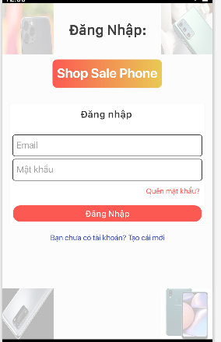

Hình 1: Login Screen

### 4.1.1.2 Objects and actions for login Screen

Objects:

|  |  |  |
| --- | --- | --- |
| **Item** |  |  |
| **Login button** | Tap on the button | The main screen will be displayed when the login is successful |
| Tap on the button | If you enter the wrong password or account, a message window will appear asking you to re-enter it. |
| **“Quên mật khẩu”** | Tap on the link | Forgot password screen allows to create a new password based on the phone number or gmail created when registering |
| **“Bạn chưa có tải khoản?Tạo cái mới”** | Tap on the link | Show the register screen |
| **EditText ”Gmail”** | Tap on the EditText | Show the characters the user enters from the keyboard |
| **EditText “Mật khẩu”** | Tap on the EditText | Show the characters the user enters from the keyboard |

### 4.1.2 Shop Sale Phone Home Screen

### 4.1.2.1 User Interfaces

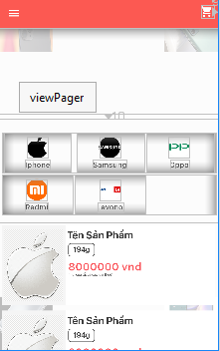

Hình 2: Home Screen

### 4.1.2.2 Objects and actions

|  |  |  |
| --- | --- | --- |
| **Item** | **Action** | **Response** |
| **Cart button** | Tap on the button | Show products that have been added to the cart |
| Iphone button | Tap on the button | Show products from iphone |
| Samsung button | Tap on the button | Show products from SamSung |
| Oppo button | Tap on the button | Show products from Oppo |
| Redmi button | Tap on the button | Show products from Redmi |
| Levono | Tap on the button | Show products from Lenovo |
| List of product | Click product | Show product details |

### 

### 4.1.3 Shop Sale Phone Register Screen

### 4.1.3.1 User Interfaces

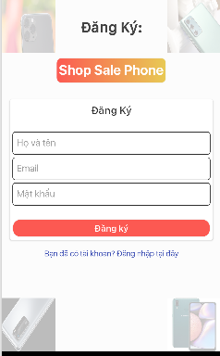

Hình 3: Register

### 4.1.3.2 Objects and actions for Enter user information

|  |  |  |
| --- | --- | --- |
| **Item** | **Action** | **Response** |
| **Register button** | Tap on the button | Sign Up Success |
| Tap on the button | Display a message that has the same name or gmail |
| “Bạn đã có tài khoản? Đăng nhập tại đây” | Tap on the link | show login screen |
| **EditText ”Gmail”** | Tap on the EditText | Show the characters the user enters from the keyboard |
| **EditText “Mật khẩu”** | Tap on the EditText | Show the characters the user enters from the keyboard |
| **EditText “Họ Tên”** | Tap on the EditText | Show the characters the user enters from the keyboard |

### 4.1.4 Shop Sale Phone Cart Screen

### 4.1.4.1 User Interfaces

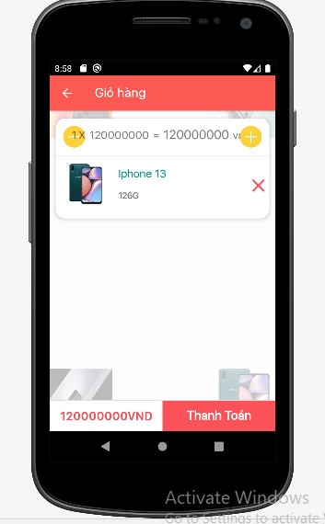

Hình 4: Cart

### 4.1.4.2 Objects and actions

|  |  |  |
| --- | --- | --- |
| **Item** | **Action** | **Response** |
| **Pay button** | Tap on the button | switch to payment screen |
| **Delete Button** | Tap on the button | allow users to cancel products in the cart |
| Back button | Tap on the button | back to home screen |
| TextView | N/A | Show product price |
| List of product | Click product | Edit products (quantity, color) |

### 4.1.5 Shop Sale Phone References Screen

### 4.1.5.1 User Interfaces

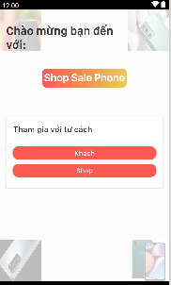

Hình 5: References

### 4.1.5.2 Objects and actions

|  |  |  |
| --- | --- | --- |
| **Item** | **Action** | **Response** |
| **“Khách” button** | Tap on the button | switch to home screen |
| “Shop” | Tap on the button | switch to home screen |

### 4.1.6 Shop Sale Phone Account Screen

### 4.1.6.1 User Interfaces

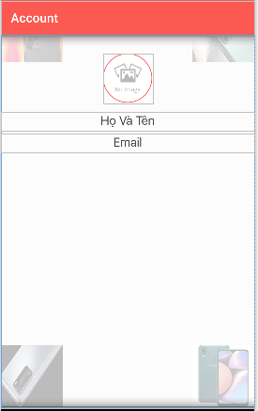

Hình 6: Account

### 4.1.6.2 Objects and actions

|  |  |  |
| --- | --- | --- |
| **Item** | **Action** | **Response** |
| **“Họ và tên” TextView** | N/A | N/A |
| **“Gmail” TextView** | N/A | N/A |
| **ImageView** | Tap on the Image | allow the user to change the image |

### 4.1.7 Shop Sale Phone Shop Account Screen

### 4.1.7.1 User Interfaces

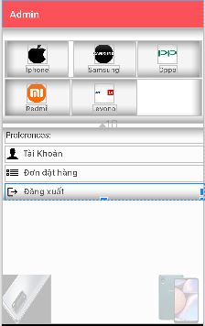

Hình 7: Shop Account

### 4.1.7.2 Objects and Action

|  |  |  |
| --- | --- | --- |
| **Item** | **Action** | **Response** |
| **“Đăng xuất” button** | Tap on the button | exit the app |
| Iphone button | Tap on the button | Show products from iphone |
| Samsung button | Tap on the button | Show products from SamSung |
| Oppo button | Tap on the button | Show products from Oppo |
| Redmi button | Tap on the button | Show products from Redmi |
| Levono button | Tap on the button | Show products from Lenovo |
| “Đơn đặt hàng” button | Tap on the button | show orders placed |
| “Tài khoản” button | Tap on the button | Show shop information and edit |

### 4.1.8 Shop Sale Phone Order Screen

### 4.1.8.1 User Interfaces

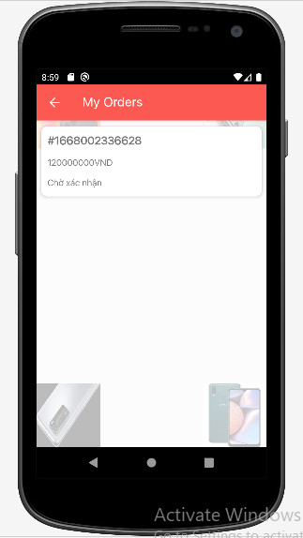

Hình 8: Order

### 4.1.8.2 Objects and actions

|  |  |  |
| --- | --- | --- |
| **Item** | **Action** | **Response** |
| Back button | Tap on the button | back to home screen |
| List of product | Click product | view customer information and payment method selected customer and ship |
| **“Mã đơn hàng” TextView** | N/A | Show order number |
| **“Giá” TextView** | N/A | Show product price |
| **“Chờ xác nhận”** | N/A | order status |

### 4.1.9 Shop Sale Phone Add Product Screen

### 4.1.9.1 User Interfaces

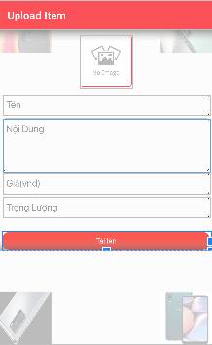

Hình 9: Add product

### 4.1.9.2 Objects and actions

|  |  |  |
| --- | --- | --- |
| **Item** | **Action** | **Response** |
| Back button | Tap on the button | back to home screen |
| ImageView | Tap on the Image | lets choose the right image |
| “Product Name” EditText | Tap on the TextView | Allow the user to input from the keyboard |
| “Description” EditText | Tap on the TextView | Allow the user to input from the keyboard |
| “Price” EditText” | Tap on the EditText | Show the character entered by the user |
| “Weight” EditText | Tap on the TextView | Show the character entered by the user |
| “Add” button | Tap on the button | Products will be displayed on the homepage |

### 4.1.10 Shop Sale Phone Shop Order Screen

### 4.1.10.1 User Interfaces

Hình 10: Shop Order

### 4.1.10.2 Object and actions

|  |  |  |
| --- | --- | --- |
| **Item** | **Action** | **Response** |
| Back button | Tap on the button | back to home screen |
| “Xác nhận” button | Tap on the button | order confirmation from customer and ship |
| List of product | Click product | view customer information and payment method selected customer and ship |

### 4.1.11 Shop Sale Phone Account User Screen

### 4.1.11.1 User Interfaces

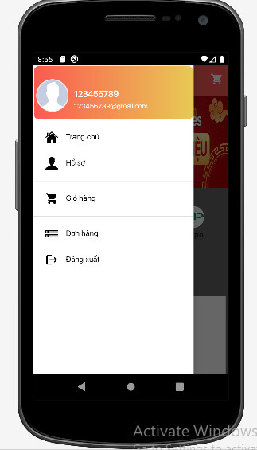

Hình 11: Acount User

### 4.1.11.2 Object and actions

|  |  |  |
| --- | --- | --- |
| **Item** | **Action** | **Response** |
| **“Đăng xuất” button** | Tap on the button | exit the app |
| Home button | Tap on the button | Go to the homepage interface |
| Account button | Tap on the button | go to profile interface |
| Cart button | Tap on the button | go to cart interface |
| Name TextView | N/A | N/A |
| Gmail TextView | N/A | N/A |
| Avatar ImageView | N/A | N/A |

### 4.1.12 Shop Sale Phone Preview Screen

### 4.1.12.1 User Interfaces

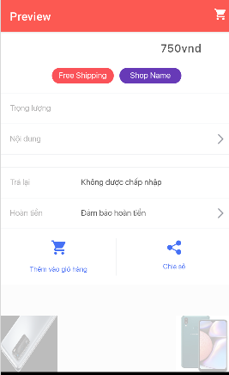

Hình 12: Preview

### 4.1.12.2 Object and actions

|  |  |  |
| --- | --- | --- |
| **Item** | **Action** | **Response** |
| FreeShip button | Tap on the button | Clicking on this button will display the offers that this product has available |
| Shop Name button | Tap on the button | View shop information |
| Cart button | Tap on the button | go to cart interface |
| “Trả lại” button | Tap on the button |  |
| “Hoàn tiền” nutton | N/A | N/A |
| Add Cart button | Tap on the button | Clicking this button will add the product to your cart |
| Share button |  |  |
| Price TextView | N/A | N/A |
| KG TextView | N/A | N/A |
| Description TextView | N/A | N/A |

# 5.0 Restrictions, limitations, and constraints

All development for the Shop Sale Phone was done in the Android Software Development Kit (SDK). Testing of the application was done on the Android Emulator that was included with the Android SDK. As long as the Android is available to Android mobile Operating System users, the software will be marketable, maintainable and functional to both users and developers

# 6.0 Testing Issues

## 6.1 Classes of tests

We will conduct tests on each interface as separate entities using the Android Emulator provided by the Android Software Development Kit (SDK). After each individual interface is thoroughly tested, the package is built together and tested as a whole. All known valid input will be checked as well as known invalid input. A more comprehensive overview of our testing strategies will be included in our test specification document.

## 6.2 Expected software response

Each test performed will be clearly observed as either failing or succeeding.

# 7.0 Appendices

## 7.1 Packaging and installation issues

Phần mềm sẽ được đóng gói và phân phối dưới dạng gói cài đặt ứng dụng trong Android. Nó sẽ có sẵn cho tất cả người dùng thiết bị di động chạy Hệ điều hành Android phiên bản 1.5 trở lên.

## 7.2 Legal Considerations

We will use the Android Software Development Kit (SDK) under the Android SDK License Agreement distributed by Google (Origin SDK's Copyright Holder). This agreement grants us as developers a “limited, worldwide, royalty-free, non-transferable, and non-exclusive license to use the SDK solely to develop applications for Android platform”.