Software Requirement Specification

TMSO-SRS-001

Version 1.0

**Revision History**

| Date | Version | Description | Author | Revised by |
| --- | --- | --- | --- | --- |
| 29/07/2013 | 1.0 | First version | Kha Nguyen | Khanh Nguyen |
| 09/08/2013 | 1.0 | Remove Close icon (“X” icon) on all pop-up, replace by Cancel button instead | Kha Nguyen | Khanh Nguyen |
| 13/08/2013 | 1.0 | Replace Advertise screen by Repair screen | Kha Nguyen | Khanh Nguyen |
|  |  |  |  |  |
|  |  |  |  |  |

Table of Contents

**1.** **Introduction** 5

**1.1** **Overview** 5

**1.2** **Scope** 5

**2.** **Functional Requirements** 5

**2.1** **Feature/Component #1: Shop Sale Phone Screen** 5

2.1.1 User Interfaces 6

2.1.2 Functional Requirements 6

**2.2** **Feature/Component #2: Shop Sale Phone register Screen** 8

2.2.1 User Interfaces 8

2.2.2 Functional Requirements 8

**2.3** **Feature/Component #3: Shop Sale Phone Home Screen** 9

2.3.1 User Interfaces 9

2.3.2 Functional Requirements 9

**2.4** **Feature/Component #4: Shop Sale Phone Cart Screen** 11

2.4.1 User Interfaces 11

2.4.2 Functional Requirements 11

**2.5** **Feature/Component #5: Reference Screen** 13

2.5.1 User Interfaces 13

2.5.2 Functional Requirements 13

**2.6** **Feature/Component #5: Shop Sale Phone Account Screen** 14

2.6.1 User Interfaces 14

2.6.2 Functional Requirements 14

**2.7** **Feature/Component #6: Shop Sale Phone Shop Account Screen** 15

2.7.1 User Interfaces 15

2.7.2 Functional Requirements 15

**2.8** **Feature/Component #7: Shop Sale Phone Order Screen** 17

2.8.1 User Interfaces 17

2.8.2 Functional Requirements 17

2.8.3 18

**2.9** **Feature/Component #8: Shop Sale Phone Add Product Screen.** 19

2.9.1 User Interfaces 19

2.9.2 Functional Requirements 19

**2.10** **Feature/Component #9: Shop Sale Phone Shop Order Screen** 21

2.10.1 User Interfaces 21

2.10.2 Functional Requirements 21

**2.11** **Feature/Component #9: Shop Sale Phone Acciunt User Screen** 22

2.11.1 User Interfaces 23

2.11.2 Functional Requirements 23

**2.12** **Feature/Component #9: Shop Sale Phone Preview Screen** 24

2.12.1 User Interfaces 25

2.12.2 Functional Requirements 25

# **Introduction**

## **Overview**

This app allows users to buy or sell electronic device products

## **Scope**

• Demo version is for display purposes only, does not link to Database, does not link to affiliate sites

• Android operating system: Android:

• Android test device: Galaxy Nexus, Nexus WILL

• Android screen resolution: 480x800, 720x1280

• Only supports screen orientation in portrait mode

# **Functional Requirements**

## **Feature/Component #1: Shop Sale Phone Screen**

### User Interfaces

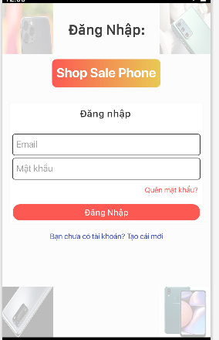

*Image1: Login screen*

### Functional Requirements

|  |  |  |  |
| --- | --- | --- | --- |
| **Item** | **Description** | **Action** | **Response** |
| **Shop Sale Phone**  **Login screen** | Login Screen has 1 buttons:   * Login button   The login screen has 2 links:   * Forgot password screen * Registration screen | N/A | N/A |
| **Login button** | The main screen will be displayed when the login is successful | Tap on the button | The main screen will be displayed when the login is successful |
| If you enter the wrong password or account, a message window will appear asking you to re-enter it. | Tap on the button | notification window will appear |
| **“Quên mật khẩu”** | Forgot password screen allows to create a new password based on the phone number or gmail created when registering | Tap on the link | Display forgot password interface |
| **“Bạn chưa có tải khoản?Tạo cái mới”** | Show the register screen | Tap on the link | Show the register screen |

### 

## **Feature/Component #2: Shop Sale Phone register Screen**

### User Interfaces

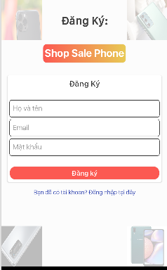

*Image2: Register*

### Functional Requirements

|  |  |  |  |
| --- | --- | --- | --- |
| **Item** | **Description** | **Action** | **Response** |
| **Shop Sale Phone**  **Register screen** | Register Screen has 1 buttons:   * Register button   The Register screen has 1 links:   * “Bạn đã có tài khoản? Đăng nhập tại đây” | N/A | N/A |
| **Register button** | Show successful registration message | Tap on the button | Sign Up Success |
| if same name or gmail will ask to re-enter | Tap on the button | Display a message that has the same name or gmail |
| “Bạn đã có tài khoản? Đăng nhập tại đây” | show login screen | Tap on the link | show login screen |

### 

## **Feature/Component #3: Shop Sale Phone Home Screen**

### User Interfaces

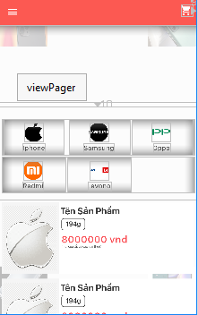

*Image3: Home*

### Functional Requirements

|  |  |  |  |
| --- | --- | --- | --- |
| **Item** | **Description** | **Action** | **Response** |
| **Shop Sale Phone**  **Home screen** | Register Screen has 6 buttons:   * Cart button * Iphone button * Samsung button * Oppo button * Redmi button * Levono button   The main screen has 1 list of products and 1 list bar:   * list of products * list bar | N/A | N/A |
| **Cart button** | Show products that have been added to the cart | Tap on the button | Show products that have been added to the cart |
| Iphone button | Show products from iphone | Tap on the button | Show products from iphone |
| Samsung button | Show products from SamSung | Tap on the button | Show products from SamSung |
| Oppo button | Show products from Oppo | Tap on the button | Show products from Oppo |
| Redmi button | Show products from Redmi | Tap on the button | Show products from Redmi |
| Levono | Show products from Lenovo | Tap on the button | Show products from Lenovo |
| List of product | Show all products | Click product | Show product details |
| List bar |  |  |  |

## 

## **Feature/Component #4: Shop Sale Phone Cart Screen**

### User Interfaces

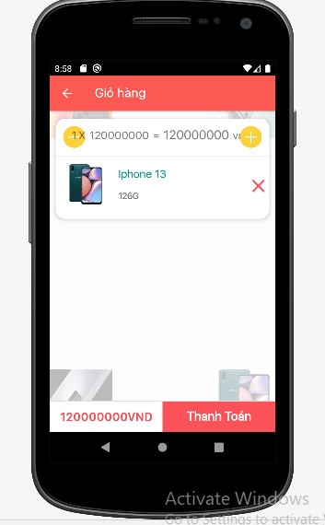

*Image4: Cart*

### Functional Requirements

|  |  |  |  |
| --- | --- | --- | --- |
| **Item** | **Description** | **Action** | **Response** |
| **Shop Sale Phone**  **Cart screen** | Cart Screen has 2 buttons:   * Pay button * Back   The Cart screen has 1 Textview and 1 list of product:   * TextView * List of product | N/A | N/A |
| **Pay button** | confirm payment and go to payment screen | Tap on the button | switch to payment screen |
| Back button | back to home screen | Tap on the button | back to home screen |
| TextView | Show total amount of selected products |  |  |
| List of product | Show products added to cart | Click product | Edit products (quantity, color) |

### 

## **Feature/Component #5: Reference Screen**

### User Interfaces

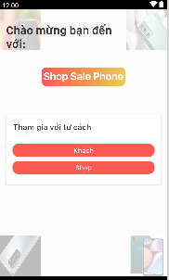

*Image5: Reference*

### Functional Requirements

|  |  |  |  |
| --- | --- | --- | --- |
| **Item** | **Description** | **Action** | **Response** |
| **Shop Sale Phone**  **Reference screen** | **Reference** Screen has 2 buttons:   * “Khách” button * “Shop” button | N/A | N/A |
| **“Khách” button** | switch to home screen | Tap on the button | switch to home screen |
| “Shop” | switch to home screen | Tap on the button | switch to home screen |

## **Feature/Component #5: Shop Sale Phone Account Screen**

### User Interfaces

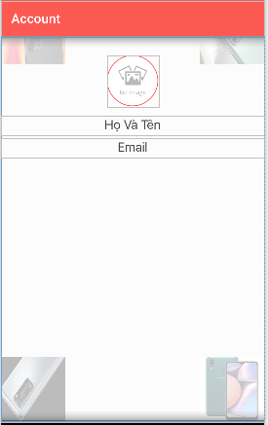

*Image6: Account*

### Functional Requirements

|  |  |  |  |
| --- | --- | --- | --- |
| **Item** | **Description** | **Action** | **Response** |
| **Shop Sale Phone**  **Account screen** | **Account** Screen has 2 TextView and 1 ImageView:   * “Họ và tên” TextView * “Gmail” TextView * ImageView | N/A | N/A |
| **“Họ và tên” TextView** | show registered username | N/A | N/A |
| **“Gmail” TextView** | show registered Gmail | N/A | N/A |
| **ImageView** | * display user selected image * allow the user to change the image | Tap on the Image | allow the user to change the image |

## **Feature/Component #6: Shop Sale Phone Shop Account Screen**

### User Interfaces

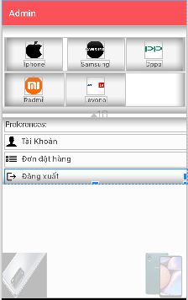

*Image7: Shop Account*

### Functional Requirements

|  |  |  |  |
| --- | --- | --- | --- |
| **Item** | **Description** | **Action** | **Response** |
| **Shop Sale Phone**  **Shop Account screen** | Shop Account Screen has 8 buttons:   * Cart button * Iphone button * Samsung button * Oppo button * Redmi button * Levono button * “Tài khoản" button * “Đơn đặt hàng” button * “Đăng xuất” button | N/A | N/A |
| **“Đăng xuất” button** | display a message window do you want to exit the application?  Yes: exit the app  No: turn off notification display | Tap on the button | exit the app |
| Iphone button | Show products from iphone | Tap on the button | Show products from iphone |
| Samsung button | Show products from SamSung | Tap on the button | Show products from SamSung |
| Oppo button | Show products from Oppo | Tap on the button | Show products from Oppo |
| Redmi button | Show products from Redmi | Tap on the button | Show products from Redmi |
| Levono button | Show products from Lenovo | Tap on the button | Show products from Lenovo |
| “Đơn đặt hàng” button | B1:View orders placed by customers  B2:ship confirmed orders | Tap on the button | show orders placed |
| “Tài khoản” button | Allows editing shop information | Tap on the button | Show shop information and edit |

## **Feature/Component #7: Shop Sale Phone Order Screen**

### User Interfaces

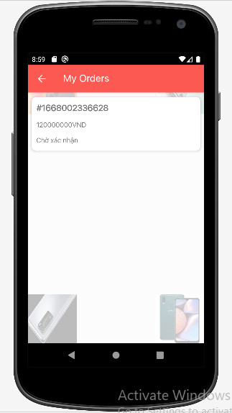

*Image8: Order*

### Functional Requirements

|  |  |  |  |
| --- | --- | --- | --- |
| **Item** | **Description** | **Action** | **Response** |
| **Shop Sale Phone**  **Order screen** | The Order screen has 1 list of product:   * List of product | N/A | N/A |
| Back button | back to home screen | Tap on the button | back to home screen |
| List of product | Show a list of products the customer has ordered  When ordering products, wait for the shop to confirm the order and ship | Click product | view customer information and payment method selected customer and ship |

### 

## **Feature/Component #8: Shop Sale Phone Add Product Screen.**

### User Interfaces

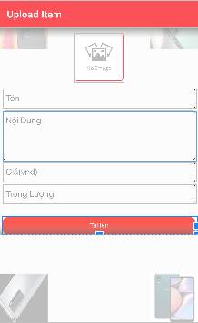

*Image9: Repair*

### Functional Requirements

|  |  |  |  |
| --- | --- | --- | --- |
| **Item** | **Description** | **Action** | **Response** |
| **Shop Sale Phone**  **Add Product screen** | The Add Product screen has 1 ImageView and 4 EditText:   * ImageView * “Product Name” EditText * “Description” EditText * “Price” EditText * “Weight” EditText   The Add Product Screen has 1 button:   * “Add” button | N/A | N/A |
| Back button | back to home screen | Tap on the button | back to home screen |
| ImageView | Show product pictures | Tap on the Image | lets choose the right image |
| “Product Name” EditText | allow the user to input from the keyboard | Tap on the TextView | Allow the user to input from the keyboard |
| “Description” EditText | Allow the user to input from the keyboard | Tap on the TextView | Allow the user to input from the keyboard |
| “Price” EditText” | only allow users to enter numbers | Tap on the TextView | Show the character entered by the user |
| “Weight” EditText | only allow users to enter numbers | Tap on the TextView | Show the character entered by the user |
| “Add” button | Products will be displayed on the homepage | Tap on the button | Products will be displayed on the homepage |

## **Feature/Component #9: Shop Sale Phone Shop Order Screen**

### User Interfaces

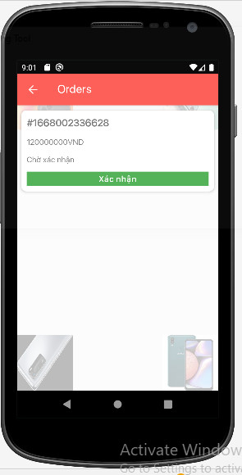

*Image10: Order*

### Functional Requirements

|  |  |  |  |
| --- | --- | --- | --- |
| **Item** | **Description** | **Action** | **Response** |
| **Shop Sale Phone**  **Shop**  **Order screen** | The Order screen has 1 list of product and 2 button:   * List of product * “Xác nhận” button | N/A | N/A |
| Back button | back to home screen | Tap on the button | back to home screen |
| “Xác nhận” button | order confirmation from customer and ship | Tap on the button | order confirmation from customer and ship |
| List of product | Show a list of products the customer has ordered  When ordering products, wait for the shop to confirm the order and ship | Click product | view customer information and payment method selected customer and ship |

## **Feature/Component #9: Shop Sale Phone Acciunt User Screen**

### User Interfaces

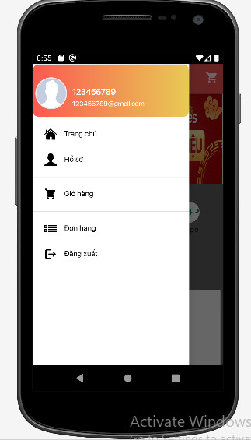

*Image11: Account User*

### Functional Requirements

|  |  |  |  |
| --- | --- | --- | --- |
| **Item** | **Description** | **Action** | **Response** |
| **Shop Sale Phone**  **User Account screen** | User Account Screen has 5 buttons:   * Home button * Account button * Cart button * Order button * Logout button   User Account Screen has 2 TextView and 1 img:   * Name TextView * Gmail TextView * Avatar Image | N/A | N/A |
| **“Đăng xuất” button** | display a message window do you want to exit the application?  Yes: exit the app  No: turn off notification display | Tap on the button | exit the app |
| Home button | Go to the homepage interface | Tap on the button | Go to the homepage interface |
| Account button | go to profile interface | Tap on the button | go to profile interface |
| Cart button | go to cart interface | Tap on the button | go to cart interface |
| Name TextView | show username | N/A | N/A |
| Gmail TextView | Show Gmail | N/A | N/A |
| Avatar ImageView | Show Image | N/A | N/A |

## **Feature/Component #9: Shop Sale Phone Preview Screen**

### 

### User Interfaces

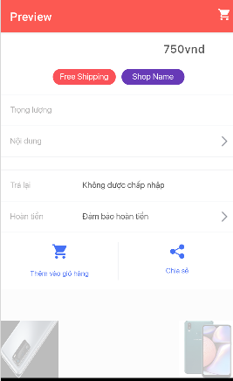

*Image12: Preview*

### Functional Requirements

|  |  |  |  |
| --- | --- | --- | --- |
| **Item** | **Description** | **Action** | **Response** |
| **Shop Sale Phone**  **Preview screen** | User Account Screen has 7 buttons:   * FreeShip button * ShopName button * Cart button * “Ưu đãi” button * “Điều khoản” button * Add Cart button * Share button   User Account Screen has 3 TextView :   * KG TextView * Description TextView * Price TextView | N/A | N/A |
| FreeShip button | Clicking on this button will display the offers that this product has available | Tap on the button | Clicking on this button will display the offers that this product has available |
| Shop Name button | View shop information | Tap on the button | View shop information |
| Cart button | go to cart interface | Tap on the button | go to cart interface |
| “Trả lại” button |  | Tap on the button |  |
| “Hoàn tiền” nutton |  | N/A | N/A |
| Add Cart button | Clicking this button will add the product to your cart | Tap on the button | Clicking this button will add the product to your cart |
| Share button |  |  |  |
| Price TextView | Show product price | N/A | N/A |
| KG TextView | Show product weight | N/A | N/A |
| Description TextView | Show detailed description of the product | N/A | N/A |

***---------- End of Document ----------***