CS 4400 System Administration

Project 2: Getting started with Windows Server

**Description:**

Most of us are used to running Windows from a typical user point of view. Now we need to shift gears and look deeper into Windows for the bits and pieces that will help us administrate a Windows server. This project will be divided into main steps:

1. Install Windows server in your virtual folder on vSphere, and configure it so that it has access to the Internet.
2. Answer questions about how to administrate your Windows server install below.

Before you begin, create a new Google Document for this project using the project template in your Google Folder. Remember, I expect a lot of documentation to prove to me you understand what you are doing (and to build your final deliverable). This project is worth 1 point.

Step 1 – Install Windows

Follow the directions Dr. Diesburg gives you for creating a new virtual machine that boots from iso. Be sure to pick the Windows server!

As part of your install, you will need to configure your install to connect to the Internet. Remember, **there is no dhcp server yet to automatically give you an IP address.** (Later on in the semester, you will configure one.) Instead, you will need to manually input values for IP address, netmask, gateway, and DNS servers. Be sure to pick a ***different*** static IP address than the one you gave your Ubuntu server. Once you figure out what these values are, you ***must*** record them in your documentation, as well as the steps you took to get the networking to work.

(Hint: You *may* need to allocate 16GB of RAM to Windows – this OS tends to not be as efficient with memory usage as Linux.)

When given a choice, be sure to pick the Windows Server Standard (Desktop Experience).

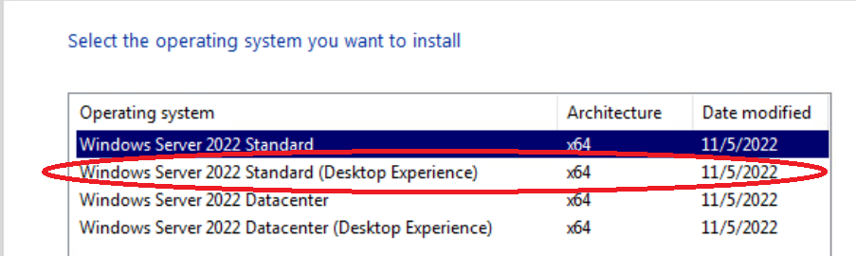

You might want to Google the difference between Standard and Datacenter editions, but it comes down to being able to host more virtual machines.

Step 2 – Answer System Administration Questions

Log into your Windows Server machine through vSphere. Using the resources linked at the bottom of the page, answer the following with as much detail as possible in your Google Documentation:

1. Where can you find installed programs? (I’m not asking about the start menu, but instead where you can see a list of installed programs with options to modify or uninstall them.)

2. How do you modify Explorer to show hidden files and directories?

3. Where can you find the system logs? What are they?

4. What does the Windows Services Manager do? Pick 5 services listed that start when the OS boots and describe what they do.

5. How do you add users to a Windows system? How do you remove users?

6. Suppose you need a custom Windows powershell or batch script to run once a day every day. How would you set this up? (In other words, does Windows have a cron equivalent)?

7. Go to the Server Manager (this generally pops up when you boot into your server).

1. How would you assign a new role to your Server, like a webserver? (Don’t actually do this, but instead tell me what menus/buttons you would click on to start the process.
2. In your local server, where can you see if Remote Desktop is turned on or off?
3. In your local server, find an event with an error or warning message. Explain what that message means.
4. On your dashboard, if there are any areas in red, please describe what you did to resolve it.

**Resources:**

* Windows Task Scheduler - <https://en.wikipedia.org/wiki/Windows_Task_Scheduler>
* Installed Programs - <https://www.makeuseof.com/tag/list-installed-programs-windows/>
* Event Viewer - <https://en.wikipedia.org/wiki/Event_Viewer>
* Windows Services - <https://www.thewindowsclub.com/open-windows-services>
* Windows Server 2022 Server Manager Documentation: <https://learn.microsoft.com/en-us/windows-server/administration/server-manager/server-manager#tasks-that-you-can-perform-in-server-manager>