CS 4400 System Administration

Project 3: Setting up a Network

**This is a big activity and worth 2 points in total.**

**Before we start:**

You are a new system administrator, and it’s time for you to pick out some things about your employer. (Usually things don’t work quite this way, but hey.) Decide on the following 2 things, and let Diesburg know about it through email or talking to her. The choices you decide now will have ramifications later…

1. Choose your organization type: (1) Education, (2) Medical, or (3) Small Business.
2. Choose your organization name.

**Description:**

We're starting from scratch here at <company name> and need your help designing our network. At the moment we aren't 100% sure what services we'll need, but we do know we'll want to have our employees connect to the network from internal desktops and be able to access the Internet. We also know that we'll need some servers that people will need to connect with outside of the company, like a remote desktop and a web server. Can you build this for us?

Your tasks for this activity are:

1. Create a network diagram of your proposed architecture. Use software that keeps your diagram in an easy-to-update/edit format. Your network diagram should include at least the following:

* IP address for each interface (static) and/or subnet range for dynamic (dhcp) addresses
* Internet cloud (out) – this is the space you started in with 10.161.x.1 gateway
* Firewall that acts as router and dhcp server
* Windows server behind firewall
* Linux server behind firewall
* Two “work” desktops (Windows) behind firewall

Pick some free Internet software to make this chart and to periodically update it as you add new services. (Services should also be labeled on the chart.) One free web chart drawing tool is called Lucidchart, but you can use something else. Here is a sample network diagram from Lucidchart (without labels).

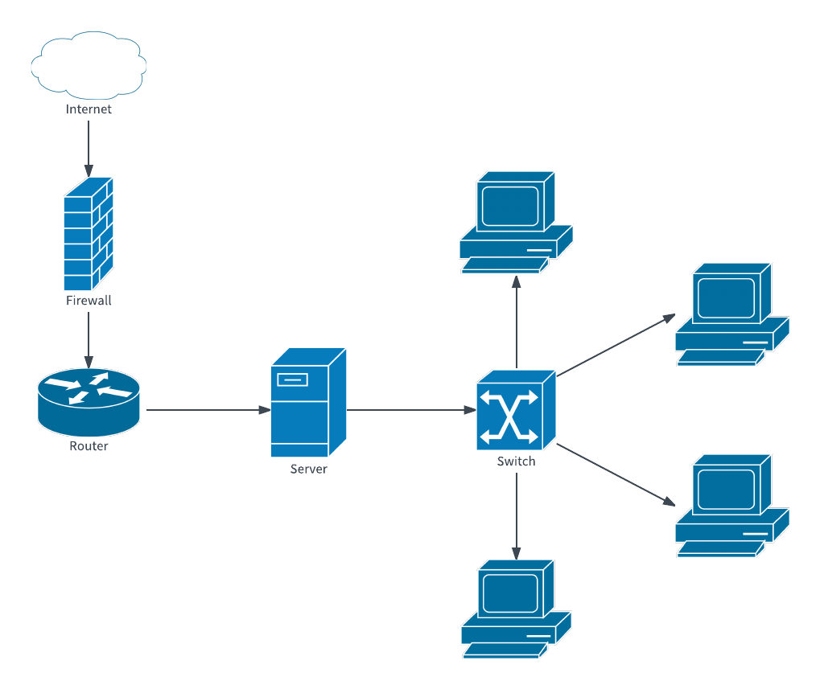

This is a very simple network diagram, and it doesn’t yet have IP addresses for the workstations, server, router, and firewall.

2. Write a few paragraphs describing why you chose the architecture you did, and how it will work. Possible architectures include:

* Everything behind a Firewall (both workstations and servers) in a single private subnet.
* Everything behind a Firewall, but divided into a DMZ and private subnet. Your servers would go into the DMZ, and your workstations would go into a private subnet. This is preferred, because you can create different firewall policies for the two internal networks. (For example, your servers should be accessible to the outside world, but not your workstations.)

3. Place the above artifacts in a Google doc inside of your Google folder. You may either link to an online version of your chart or else copy/paste it directly in the Google doc. (Just make sure I can get to it if you share it via a link.)

4. Once I've approved your network diagram, go ahead and set up the two Windows workstations and a firewall in your vSphere network. At the moment, your firewall should only allow ping, http, https, and dns traffic out to the Internet, and nothing into the private subnet. (As an example, for one of your private subnets, you could use use 192.168.1.0/24) Move the Linux and Windows server behind the firewall and give them private IP addresses. Make sure the Windows workstations are also behind the firewall with private IP addresses. Show me how both your servers and Windows workstations can access the Internet by using the firewall as their gateway and pinging [www.google.com](http://www.google.com).

**Resources:**

* IPv4 addressing and subnetting – ULSAH pp.387-394
* Another basic review of networking/ip addresses/subnets - Basic Review of Networking - <https://support.microsoft.com/en-us/help/164015/understanding-tcp-ip-addressing-and-subnetting-basics>
* IPv6 (ignore it for now, but know the train is coming) – ULSAH pp. 394-399
* DHCP – ULSAH pp. 402-404
* Static addressing for Linux – ULSAH pp. 418-419
* Windows Server static addressing -- <https://www.snel.com/support/how-to-configure-static-ip-on-windows-server-2019/>
* What services belong to which ports? – go to Linux server, issue: “nano /etc/services”