Fundamentals of Programming
Module 2 Day 3 Guided Practice

Directions:
Please print this lab and fill it in as you complete the exercises below. If any part is confusing, be sure to watch the class video explaining each part.

Before starting this lab, make sure IDLE is open to the interpreter screen. That screen should look similar to this:

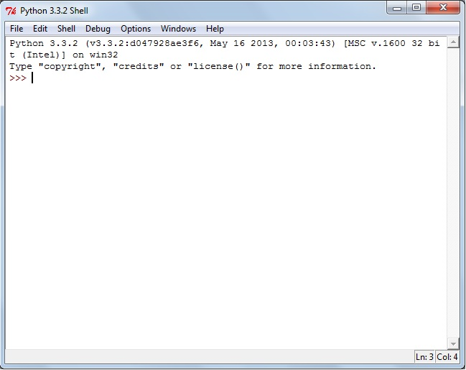

The topic for today is the idea of conditionals - statements that evaluate to either True or False - and selection statements - program control structures that decide whether or not to perform some action based on the result of one or more conditionals.
There are six basic Boolean Operators that we use as a starting point for writing conditionals. For the most part these are operators that you have used in your math classes although the format may be a little different than you are used to seeing.

[Q1] Predict what will happen when you type the following expressions. After making your prediction, enter the statement at the interactions prompt and check if you were correct. Warning, one of these statements is invalid and will produce an error.
Expression | Predicted Result | Actual Result
10 < 11
10 > 11
12 < 12
12 <= 12
12 >= 12
12 = 12
12 = = 12
13 = = 12
13 != 12

[Q2] Predict what will happen when you invoke the following statements. After making your prediction, enter the statement at the interactions prompt and check if you were correct.
Command | Predicted Result | Actual Result
print ('a' < 'b')
print ('A' < 'B')
print('A' < 'b')
print( 'a' < 'B')

[Q3] Enter each of the following commands in to the command prompt in the interactions window. Record the results in the table below.
Command | Actual Result
print (ord('A'))
print (ord('B'))
print (ord('a'))
print (ord('b'))

[Q4] Using what you observed in your responses to Q3, what do you THINK is happening when you make comparison operators such as in Q2?

[Q5] Predict what will happen when you invoke the following expressions. After making your prediction, enter the statement at the interactions prompt and check if you were correct.
Expression | Predicted Result | Actual Result
10 < 11 and 11<12
10 < 11 and 13 < 12
13 < 12 and 10 < 11
13 < 12 and 11 < 10
10 < 11 or 11<12
10 < 11 or 13 < 12
13 < 12 or 10 < 11
13 < 12 or 11 < 10
not 10 < 11
not (10 < 11)
not 13 < 12
not (13 < 12)

