Weißt eh
On the German particle eh in the discourse marker weißt eh ‘you know’

? Course code:
Candidate number: 5355
? Word count: 4260
Date: 30.05.2026

Table of Contents
1 Introduction 1
2 Corpus study 1
3 Survey 2
3.1 Method 2
3.2 Results 2
3.3 Discussion 2
4 Conclusion 2
5 Data availability 3
6 Literature 4
Appendix 5

between 20 700 and 25 300 characters (no spaces))

CHECK ALL NUMBERS!!!

Introduction
A so far little investigated but colloquially frequently used word is the German particle eh. It can appear as the only particle in a sentence (1a) and in combination with other particles (1b).
(1a) Du kennst dich hier eh aus.
You know yourself here EH out
‘You know this place EH.’
(1b) Du kennst dich hier ja eh aus.
You know yourself here JA EH out
‘You know this place JA EH.’
Germany, Austria and Switzerland, have their own standard variety of German to which I will refer to as “Federal German”, “Austrian German” and “Swiss German”. Zobel (2017) is the first to differentiate between eh_{D} and eh_{A} showing that the particles meaning and therefore usage differs between Federal German and Austrian German. Both are stress bearing, but only EHD is always synonymous with sowieso ‘anyways’. EHA conveys an inner attitude. In declarative sentences, the owner of that attitude is the addressee whereas it is the speaker’s attitude that is communicated in interrogatives (Zobel, 2017, pp. 324-325).
The author describes the meaning of EHA regarding a proposition p as the following: “The speaker (cS) believes that the addressee’s (cA)/her belief worlds are compatible with both p and ¬p and that the addressee/she wants p to hold” (Zobel, 2017, p.325). In example (2), B claims that they manage to do something on their own (=p). As B includes EHA in their answer, B communicates that they believe that A is unable to rule out ¬p but wants to eliminate it. In other words, B states that they do not need help (=p) to accomplish something and by adding EHA to their utterance, B shows that they think A is unsure if they need help (¬p) but wants them to not need help (p).
(2) A: Do you need help?
B: Nein, ich schaffe das EHA allein.
No, I manage that EHA alone.
‘No, I can manage that EHA on my own.’
After conducting a corpus study, Zobel (2017) concludes that Federal German only has EHD, while Austrian German has eh both in the form of EHD and EHA. Even in Bavaria, the southern area of Germany at the border to Austria, the distinction between EHD and EHA remained true as EHA was not found.
A recent study by Vergeiner and Bülow (2025) looked at the different functions of eh comparing their acceptability and usage between Austria and Germany. By analysing spoken corpus data from Austria, the authors destinguish eleven unique ways of using eh which they investigated in a further online study. Participants from Bavaria, Northern Germany and Austria were asked whether they would use eh as in the provided example and had to rate its appropriateness.
Out of the eleven items, only one was used by the majority of all three groups (96 %, 89 %, 96%). It that example, eh can easily be exchanged with sowieso and thus is the EHD. The results from eight other examples, in which the used eh corresponds to the meaning of EHA described by Zobel (2017), show it exclusive use in Austria, thus confirming Zobel’s (2017) conclusion.
However, two items diverge – in combination with the word weißt ‘you know’, eh can be used as a discourse marker, to point to known or understandable issues. Here, 51% of the Bavarian participants reports to use eh in that way, while the 84% the participants from Northern Germany report to not use it.
(3) A: By the way, sorry for leaving so early yesterday
B: No worries
B: But what happened?
A: Weißt eh, anstrengende Woche
you.know EH, exhausting week
‘You know, exhausting week’
A: And I still have to do some uni-stuff today (Vergeiner & Bülow, 2025, p. 89)
Interestingly, when eh is combined with siehst ‘you see’, both groups report to not use it (51% and 82%). The second item that breaks the pattern is eh klar where eh is combined with klar ‘obvious’ and used as Back-Channel-Behaviour that signals the speaker’s agreement on the adressee’s evaluation (Vergeiner & Bülow, 2025).
Due to the temporal limitations of this thesis, I had to choose one of those irregular findings, which is the phrase weißt eh. The aim of the current thesis is to further explore the use and meaning of weißt eh by conducting a small corpus study as well as using an online questionnaire to collect native speakers’ intuition on its meaning and verify how people use it. Additionally, I aim to find out if the eh in weißt eh is the EHD or EHA.
As the current literature does not include Swiss German, I am including that variety in addition to Austrian and Federal German in the corpus study described in the following part.

Corpus study
The corpus study is a means to investigate in which standard varieties of the German language the combination weißt eh is found and whether it really is a pragmatized phrase as Vergeiner and Bülow (2025) state. Moreover, I am looking into the different conjugations of the verb wissen ‘to know’ and dialectic versions of it. The data used in the corpus study was derived from the Deutscher Referenzkorpus – DeReKo on ‎29th March ‎2026 and 19th April 2026 and is available through the osf repository (see 5 Data availability).
Figure 1 illustrates the distribution of word forms across the different countries. In total, the corpus search gave 283 results, with five different word forms of the verb wissen ‘to know’. Three of them are conjugated in 2nd person singular, like the standardized (du) weißt (n = 228). In addition to that, two dialectic version waßt (n = 26) and woaßt (n = 13) were found too. Word forms that differed only in the spelling of the ß/ss are treated as the same form. Moreover, wisst’s (n = 5) conjugated in the 2nd person plural and wissen’s (n = 11) in 1st or 3rd person plural occurred.
Looking at the distribution across the countries, 78% of the entries were from Austrian newspapers (n = 220), 21% from German sources (n = 60) and only 1% were Swiss (n = 3).
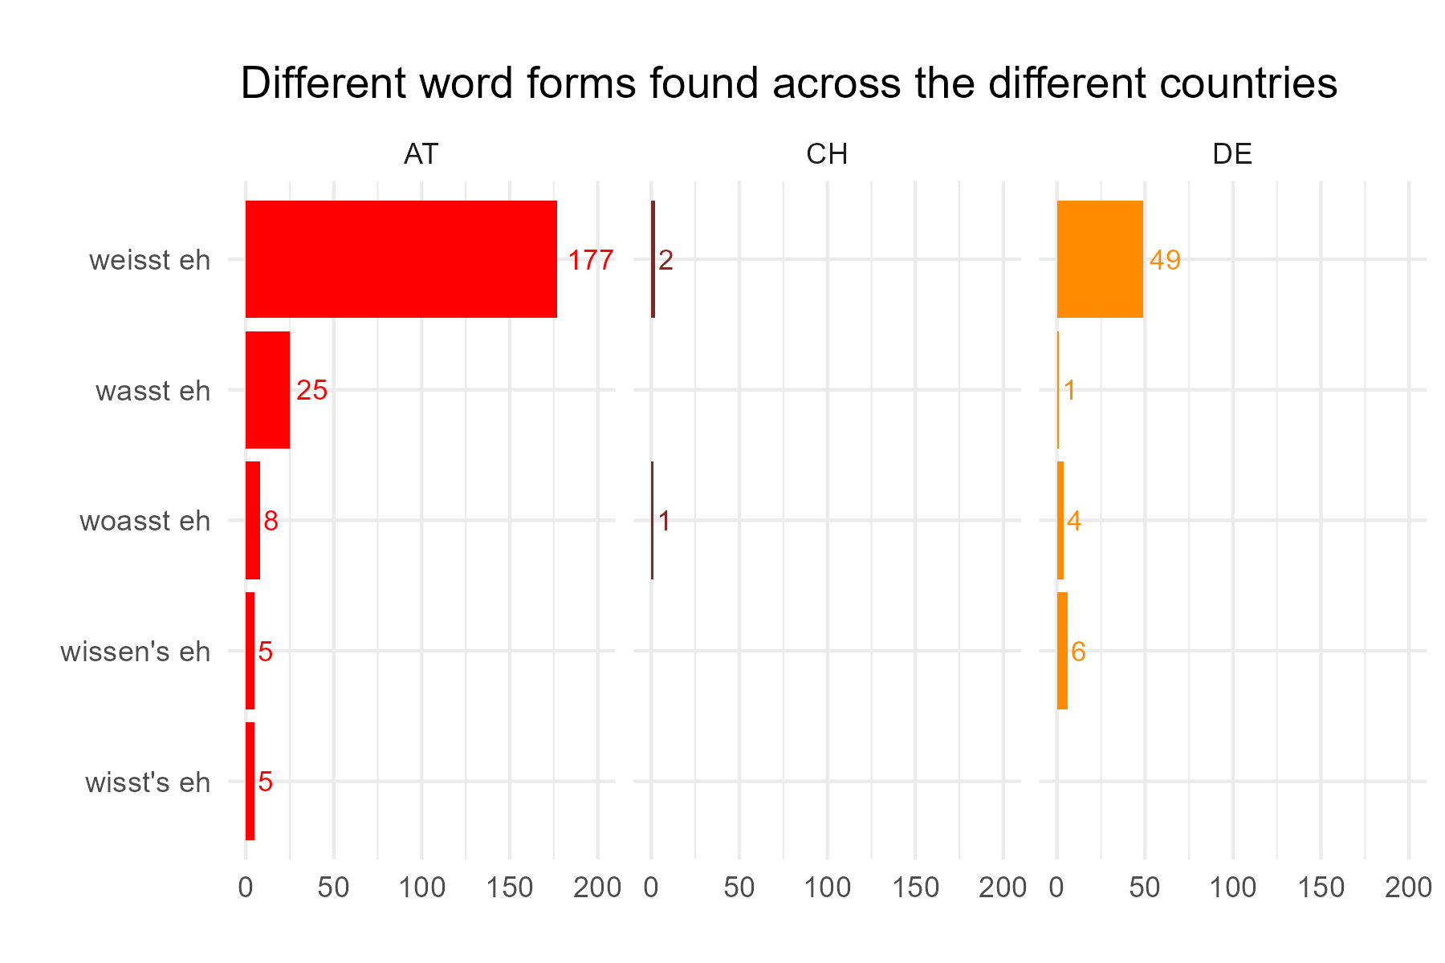
Figure 1 – Distribution of the different word forms across the countries Austria (AT), Switzerland (CH) and Germany (DE), illtustrating the predominance of ‘weißt eh’ followed by the other 2nd person singular forms ‘waßt eh’ and ‘woaßt eh’.
Regarding the position and function of WEISST EH, it is either standing completely on its own (see example (4)) or embedded in another sentence. The latter can be as part of a declarative sentence, where the verb wissen is the main verb of the main clause (5a), or as a discourse marker, marked by a comma in the beginning and/or end of the phrase depending on its position within the sentence (5b).
(4) example freistehend als „“
(5a) example embedded, dass/wie…
(5b) example discourse marker
In only 8 examples, WEISST EH was standing free. In the other 97% of the data, it was embedded. Out of the 283 examples, 61% (n=172) of the time, it functioned as a discourse marker while in 31% (n=111) of the examples, it was embedded in the main clause of the sentence. Figure 2 illustrates how the different positions and functions combined with each other.
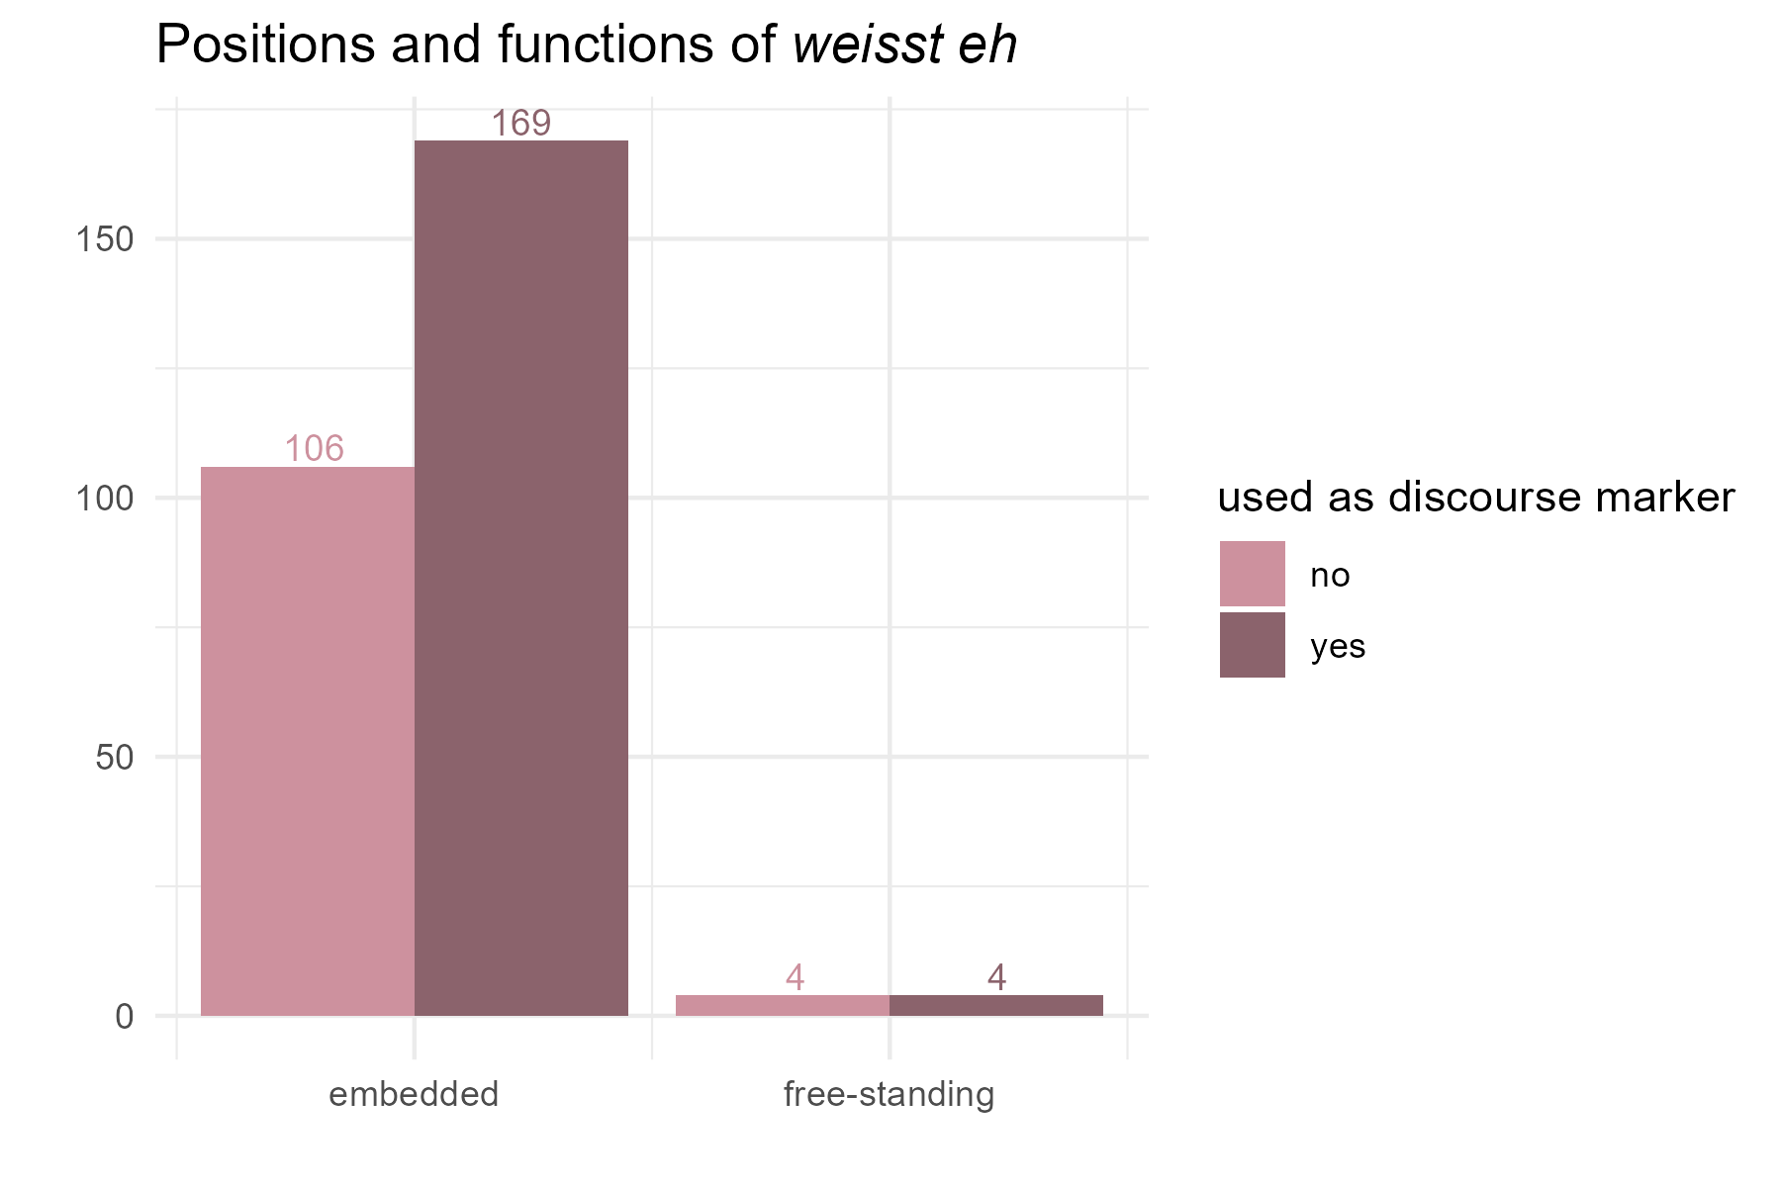
Figure 2 – Distribution of position and function of the corpus data (n= 283).
The biggest difference between functioning as a discourse marker or being part of the main clause seems to be that the former can be removed without turning the same utterance ungrammatical. For the free-standing examples, it was more difficult to use that distinction, as WEISST EH was a complete utterance on its own. In three of the four examples I classified as free-standing and discourse marker, however, the utterance continued. The only reason they were classified as free-standing in the first place was due to the orthographic choices of the journalist, who marked the end of the sentence by using an exclamation mark right after the WEISST EH. In the other example, WEISST EH was given in direct speech and as it was the only two words of that utterance, I classified them as free-standing too. From the context, it is likely that the speaker continued speaking after those words, even though it is not reported. The other four examples classified as free-standing without being a discourse marker, were either cases where several phrase like WEISST EH were named and discussed or a comment on this phrase was given.
I am not only interested in how often WEISST EH is used a discourse marker but especially in whether this function is found in the different varieties of German. With their example of WEISST EH Vergeiner and Bülow (2025) only investigated if participants would use it as a discourse marker, not if they would use this word combination in general. Figure 3 shows that the countries differ strongly in how they use WEISST EH. In few instances found in Swiss German were never as a discourse marker. Austrian German to Federal German show opposite patterns – around 70% of the time Austrians use the phrase as discourse marker while Germans only do that 27% of the time. Instead, it seems more common (73%) to use WEISST EH in the main clause of the utterance.
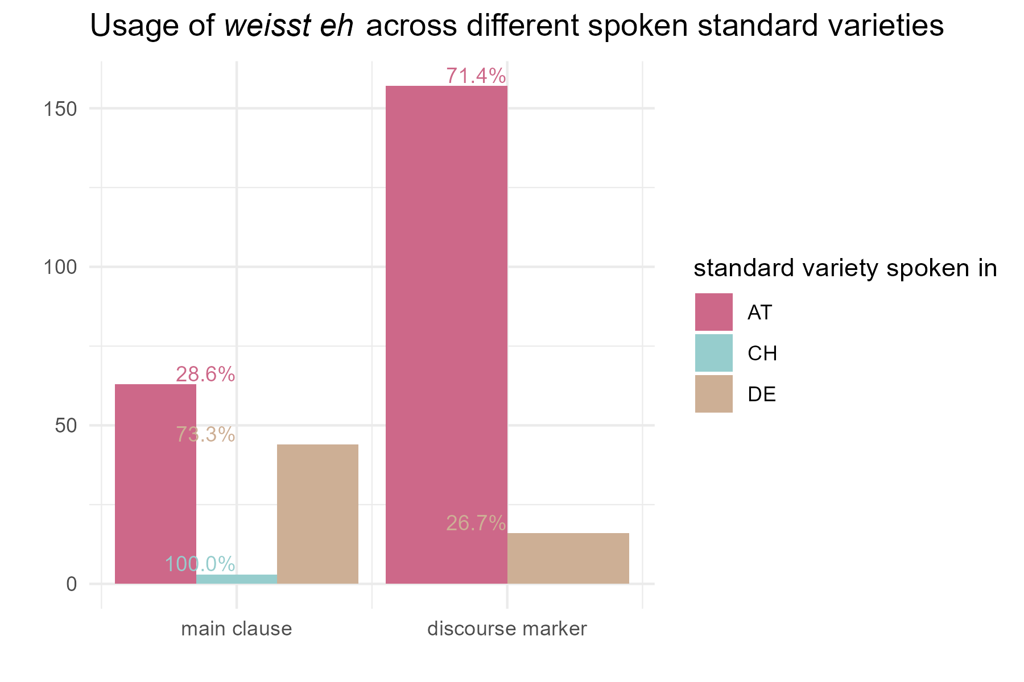
Figure 3 – Usage of ‘weißt eh’ across the different countries and their spoken standard variety
As noted above, Vergeiner and Bülow (2025) describe WEISST EH as pragmatized phrase. To test that my corpus search included the modal particles ja, denn and leicht. If another particle, can be inserted in weißt _ eh, it is not a closed phrase yet. Moreover, knowing which particles are found in combination with WEISST EH, would provide information on the phrase itself. Ja is only found in declarative sentences, whilst denn and leicht are restricted to interrogatives (Thurmair, 1993). However, there were no results in the corpus for WEISST denn EH and WEISST leicht EH. There were 19 results, one for waßt ja eh and 18 for weißt ja eh, distributed across all three countries, but in none of the 19 example the phrase was used as a discourse marker.
Even though the corpus search did not elicit any finding, that does not necessarily mean that it is completely unnatural or ungrammatical to use either of them. My native speaker intuition tells me that both (6a) and (6b) are very bad, while (6c) sounds quite fine.
(6) examples with denn, Leicht and ja.
At next, I looked at the distribution of pronouns. In the example used by Vergeiner and Bülow (2025), the phrase WEISST EH did not include a pronoun. The corpus research showed that it is possible to use a pronoun even when WEISST EH is used as discourse marker, even though it is very rare (6%, n = 10 out of 171). Used as a part of the main clause, there was almost no difference. Here, WEISST EH appeared 50% (n = 56 out of 112) without a pronoun and 50% with.
While most pronouns used were personal pronouns, demonstrative pronouns and proper nouns preceded the phrase in five examples, none of them are discourse markers.

conjunctions!!!

positioning of phrase within sentence/clause: patterns?
How do sentences continue?
which are more common? some percentages!

In the exploratory study I will therefore include examples and questions that include other particles. However, as my goal is to find out more about weißt eh used as discourse marker, all examples are restricted to that function only. In the next part, I am elaborating on the method and decisions behind the questionnaire before the results are reported and discussed.
-> write about the question found in corpus! …, weisst eh?

Survey

Method

all examples without pronouns as it is more common

around 1 page
!!! how I categorized the examples!!!
position of phrase within clause and sentence! some percentages!!!
And how they end/continue!
how did I do everything?
EXCLUSION CRITERIA!!!
born/grown up somewhere else?
not german as mother tongue
if someone say one version is very natural but votes completely or unnatural for all the weisst eh ellers
nevne det med min scale

Results
around 3 pages
analyzing results

Discussion
around 2 pages
mention:
weisst’e in northern Germany
some people might have misunderstood the task?
scale I used is very uncommon thinking of the grading system used in both Austria and Germany where 1 is best and 5 is worst. This

Conclusion
around 1 page

Data availability
All materials needed to re-run the experiment as well as the data collected and analysed can be accessed in the online repository through the following link: https://osf.io/urvpx/?view_only=6b5c1ff64dc440e187cd59496e995ec5
- where to find my exel table of corpora data
- find copy of my questionnaire as a png or just some documentation of how the questions were formulated
- examples
- answer options
- raw data of my analysis
- if I have any form of code for descriptive statistics
- and all tables used

Literature
Thurmair, M. (1993). Äußerungsform oder Äußerungsfunktion? Zu den Bedingungen für das Auftreten von Modalpartikeln. Deutsche Sprache, 21(1), 22–43.
Vergeiner, P. C., & Bülow, L. (2025). Zur funktionalen Variation von eh in Österreich und darüber hinaus. In S. Stumpf, M.-L. Merten, S. Kabatnik, & S. Zollner (Eds.), Variationspragmatik: Regionale Vielfalt und situative Unterschiede im Sprachgebrauch (Studien zur Pragmatik, Bd. 8, pp. 53–89). Narr.
Zobel, S. (2017). “Eh ist eh anders” – eh and sowieso in Federal German and Austrian German. In C. Mayr & E. Williams (Eds.), Festschrift für Martin Prinzhorn (Wiener Linguistische Gazette, No. 82, pp. 323–330). Universität Wien.

Notes on how to cite correctly:
Paraphrase: (Zobel, 2017)
Quote: (Zobel, 2017, p. 325)
Multiple pages: (Zobel, 2017, pp. 325–327)

Appendix
include the questionnaire examples 1-9 for all three conditions or just one

Example (3) is my free translation of the original example ‘item11’ used in the questionnaire by Vergeiner and Bülow (2025): “Sorry übrigens dass ich gestern so früh weg war Egal Aber was war los? Weißt eh, anstrengende Woche Und heute muss ich noch was für die Uni machen“ (Vergeiner & Bülow, 2025, p. 89).
The Deutscher Referenzkorpus – DeReKo can be found through the following link: https://cosmas2.ids-mannheim.de/cosmas2-web/
Due to programming issues with the language specific letter ß, it is replaced by ss in all figures within this thesis.
Several results of the exact same utterance were reduced to one.
Word forms that differed only in the spelling of the ß/ss are treated as the same form. Otherwise, it would be seven word forms of the verb in total, five of them conjugated in the 2nd person singular: weißt, weisst, waßt, woaßt, woasst.
The sources of the German corpora included Wikipedia. There were 14 examples form Wikipedia discussions, that are public. Therefore, it cannot be said that the authors of those discussion entries were speakers of Federal German. In half of the examples from Wikipedia, weißt eh was used as a discourse marker. When removing all examples from that source, the percentages change slightly to 80,4% main clause use and 19,6% discourse marker use.

