Kickstart Campaign Analysis

# Kickstarting with Excel

## Overview of Project

### Purpose – Analyze crowdfunding projects for Louise to potentially uncover any trends in the data (focused more on Theater-Plays). Organize the dataset for easier understanding to generate insights that will help Louise. She wants $12k for her play. Need to help her determine if she should pursue it for $12k, more, less, or recommend not at all. Create visualizations using the data to help see patterns or other important insights.

## Analysis and Challenges

### Analysis of Outcomes Based on Launch Date – Theater campaigns were most successful in May, June and July. Most Theater failures are in May with another spike in failures in October.

### Analysis of Outcomes Based on Goals – When the goal is less than $5,000, the campaign is three times more likely to succeed. When the goal is greater than $50,000 the campaign has almost no chance of success.

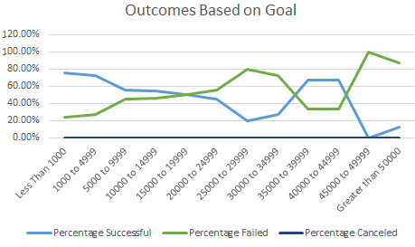

### Challenges and Difficulties Encountered – countifs formulas were tough for me, fixing errors in the data can be a challenge, and knowing what steps to take in the analysis and why takes time to figure out and execute.

## Results

- What are two conclusions you can draw about the Outcomes based on Launch Date? Theater campaigns follow the same trend as all campaigns in that June has the highest number for success. Looking at all campaigns, June has the most cancellations.

- What can you conclude about the Outcomes based on Goals? Campaigns are more successful when the goal is <$5,000. Louise is looking for twice the average goal for her campaign. She should consider lowering her goal amount.

- What are some limitations of this dataset? Although the data set is broken down for Louise, she’ll need to align with the analysis. There is no guarantee the goal amount of $2k or $4k or $12k for her play will be successful.

- What are some other possible tables and/or graphs that we could create?

1. Total campaigns and outcome

2. Total pledged to total goal

3. Total backers to donations by category