DATABASE RESCUE
Chapter 4 — CRUD Mini System
Student Submission — Team Wonder Pets
Team name | Wonder Pets
Organization (Case) | First Step Rural Bank (Banking, Industry Option 1)
Team leader | [Team leader: Last, First]
Members | Carpio, Diether Justin  Carpio, Lorman  Apostol, Kim  Tallada, John Lloyd  Magtalas, Richmon  [Sixth member: Last, First]
Table chosen | Borrower
Section / Course | [Section / Course]
Date submitted | [Month DD, YYYY]

Instructions for Students
Chapter 4 turns one table from your Chapter 2 design into a small working system. The goal is simple: a user can Create, Read, Update and Delete (CRUD) records that are stored in a real database.

Ground rules
- Choose ONE table from your own Chapter 2 design (for example Product, Customer, Room, Student, Patient or Member). Pick a table with at least five fields.
- Build a program with a screen or menu for each operation: Create, Read, Update and Delete.
- Use a real database (MySQL, PostgreSQL, SQL Server, SQLite, etc.). Spreadsheets, text files and hard-coded lists do not count.
- Any programming language is allowed (PHP, Python, Java, C#, JavaScript, etc.). A web or desktop interface with buttons or forms is expected.
- Load at least 10 sample records so Read, Update and Delete can be shown.
- Login, user roles and audit logs are NOT required for this chapter.
- Every member must be able to explain the code during the demo.
- Keep the section numbers. Replace text in [brackets], delete the gray Guide lines, and add table rows if needed.

4.1 Table Selection
Item | Your answer
Table name (from Chapter 2) | Borrower (Chapter 2, Section 2.1 and Figure 1 ERD; 10 fields)
Chapter 1 symptom it helps solve | Symptom 1: Borrowers have multiple ledger entries under slightly different name spellings, so loan officers cannot tell whether someone already has other loans (data redundancy / duplication).
Who would use this screen in the business? | Loan Officer (registers and searches borrowers) and Teller (looks up the borrower before recording a payment).
Why this table? (1–2 sentences) | Every loan, payment, and collateral record depends on a borrower, so keeping exactly one clean record per person is the foundation of the whole database. The table has 10 fields and built-in rules (unique government ID; unique name + birth date), so it also shows how duplicate borrowers are blocked.

4.2 Database

4.2.1 Data dictionary
Column | Data type | Key | Rules (NOT NULL, UNIQUE, DEFAULT) | Description
BorrowerID | INTEGER | PK | NOT NULL; AUTOINCREMENT | Unique number the system gives to each borrower automatically
FirstName | VARCHAR(50) | UK2 | NOT NULL; letters, spaces, - ' . only | Borrower's given name
MiddleName | VARCHAR(50) | — | Optional (NULL allowed) | Borrower's middle name
LastName | VARCHAR(50) | UK2 | NOT NULL; letters, spaces, - ' . only | Borrower's family name
BirthDate | DATE | UK2 | NOT NULL; age 18 to 100 (checked by the program) | Date of birth, stored as YYYY-MM-DD
ContactNo | VARCHAR(13) | — | NOT NULL; 09XXXXXXXXX or +639XXXXXXXXX (program check) | Mobile number used to reach the borrower
Address | VARCHAR(150) | — | NOT NULL; 10 to 150 characters | Home address (purok / barangay, municipality, province)
GovIDType | VARCHAR(30) | UK1 | NOT NULL; must be one of the listed ID types | Type of government ID presented (e.g., PhilSys ID)
GovIDNo | VARCHAR(30) | UK1 | NOT NULL; UNIQUE together with GovIDType; 5 to 30 characters | Government ID number; the main duplicate check
DateRegistered | DATE | — | NOT NULL; DEFAULT CURRENT_DATE | Date the borrower was registered (set automatically)
PK = primary key. UK1 = UNIQUE (GovIDType, GovIDNo). UK2 = UNIQUE (FirstName, LastName, BirthDate). The columns and names match the Borrower table in Chapter 2, Section 2.1 exactly; no columns were added or removed. SQLite stores DATE values as text in YYYY-MM-DD form.

4.2.2 SQL script
CREATE TABLE Borrower (
BorrowerID INTEGER PRIMARY KEY AUTOINCREMENT,
FirstName VARCHAR(50) NOT NULL,
MiddleName VARCHAR(50),
LastName VARCHAR(50) NOT NULL,
BirthDate DATE NOT NULL,
ContactNo VARCHAR(13) NOT NULL,
Address VARCHAR(150) NOT NULL,
GovIDType VARCHAR(30) NOT NULL,
GovIDNo VARCHAR(30) NOT NULL,
DateRegistered DATE NOT NULL DEFAULT CURRENT_DATE,
-- One borrower = one government ID (fixes Symptom 1: duplicate borrowers)
CONSTRAINT uq_borrower_govid UNIQUE (GovIDType, GovIDNo),
-- Same name + same birth date cannot be registered twice
CONSTRAINT uq_borrower_identity UNIQUE (FirstName, LastName, BirthDate)
);
-- Sample data excerpt (all 12 fictional records are in database.sql):
INSERT INTO Borrower (FirstName, MiddleName, LastName, BirthDate, ContactNo, Address, GovIDType, GovIDNo, DateRegistered) VALUES
('Maria', 'Luisa', 'Santos', '1985-03-12', '09171230001', 'Purok 3, Brgy. San Vicente, Capas, Tarlac', 'PhilSys ID', '4521-8830-1127-0001', '2026-01-12'),
('Juan', 'Pablo', 'Dela Cruz', '1979-07-25', '09181230002', 'Brgy. Sta. Maria, Concepcion, Tarlac', 'Driver''s License','N03-26-004512', '2026-01-15'),
('Rosario', NULL, 'Dela Cruz', '1990-11-02', '09191230003', 'Brgy. Poblacion, Gerona, Tarlac', 'Voter''s ID', '7102-0045-8890', '2026-01-20'),
-- ... 9 more records ...
Script file name: database.sql (CREATE TABLE + 12 INSERT rows; runs on an empty SQLite database)
Number of sample records loaded: 12 (fictional borrowers from Tarlac municipalities)

4.3 System Screens
Component | Tool / version
Interface | HTML/CSS (Flask / Jinja2 templates, one stylesheet)
Programming language | Python 3.12 with Flask 3.1
Database | SQLite 3.45 (file borrowers.db, built from database.sql)
Other tools | VS Code; Google Chrome / Microsoft Edge; automated tests in tests/run_tests.py

# | Screen | Purpose | CRUD operation
1 | Borrower list (home page) — / | Shows all borrowers with search, ID-type filter, and sorting | Read
2 | Add Borrower form — /add | Adds a new borrower; checks every field before saving | Create
3 | Edit Borrower form — /edit/<id> | Changes an existing borrower; ID and registration date are locked | Update
4 | Delete confirmation — /delete/<id> | Asks "Are you sure?", then removes the chosen record | Delete

4.4 CRUD Operations

4.4.1 Create
Item | Description
Screen / button name | Add Borrower form ("+ Add Borrower" in the top bar, then "Save Borrower")
Fields entered and checks | First name, Last name – required, 2 to 50 letters (spaces, - ' . allowed)  Middle name – optional, letters only  Birth date – required, valid date, not in the future, age 18 to 100  Contact number – required, 09XXXXXXXXX or +639XXXXXXXXX  Address – required, 10 to 150 characters  Government ID type – required, chosen from the list  Government ID number – required, 5 to 30 characters, and not already registered  Same first name + last name + birth date as an existing borrower is rejected  BorrowerID and DateRegistered are generated automatically
SQL statement used | INSERT INTO Borrower (FirstName, MiddleName, LastName, BirthDate,  ContactNo, Address, GovIDType, GovIDNo)  VALUES (?, ?, ?, ?, ?, ?, ?, ?);  -- duplicate check before saving:  SELECT BorrowerID FROM Borrower WHERE GovIDType = ?  AND UPPER(GovIDNo) = ? AND BorrowerID != ?;
Message shown (success / error) | Success: "Borrower #13 (Angelica Cruz) was added successfully." (new row highlighted)  Error: "The borrower was NOT saved. Please fix the errors below." plus a red message under each bad field
Screenshot – before | 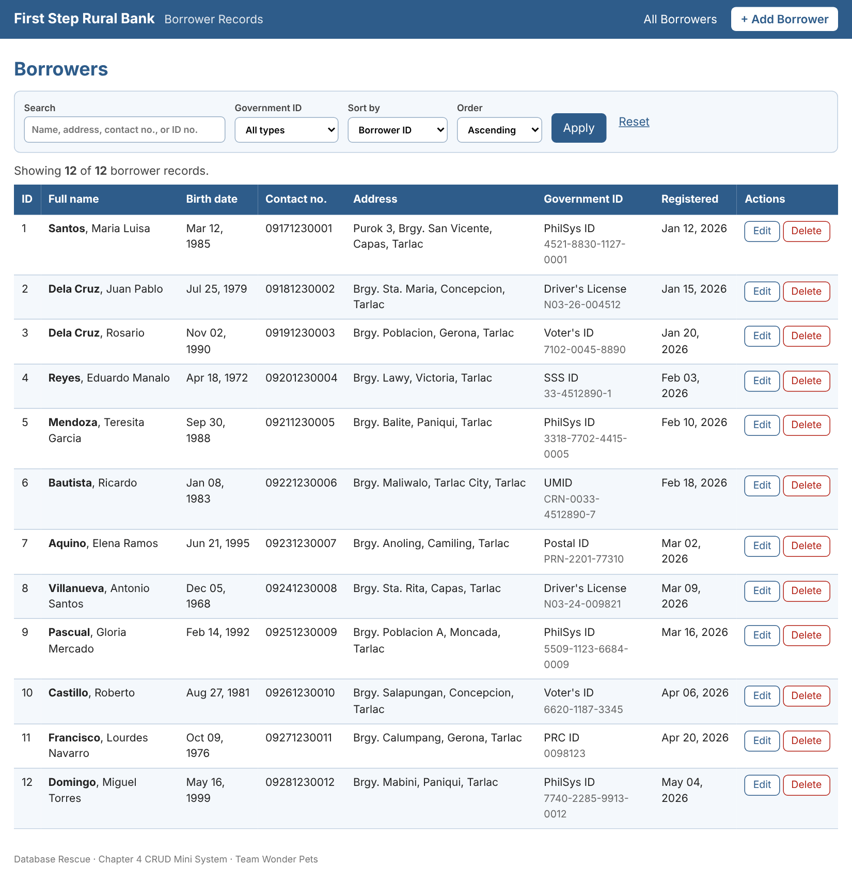  Figure 4.1 – Borrower list before adding a record (12 records)
Screenshot – form filled in | 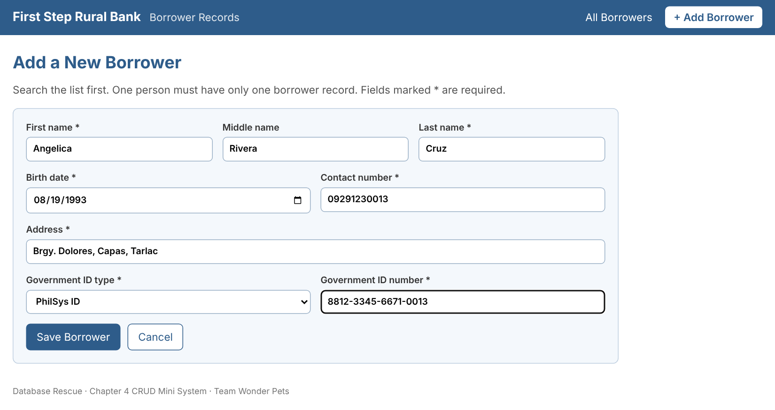  Figure 4.2 – Add Borrower form filled with a new borrower
Screenshot – invalid input rejected | 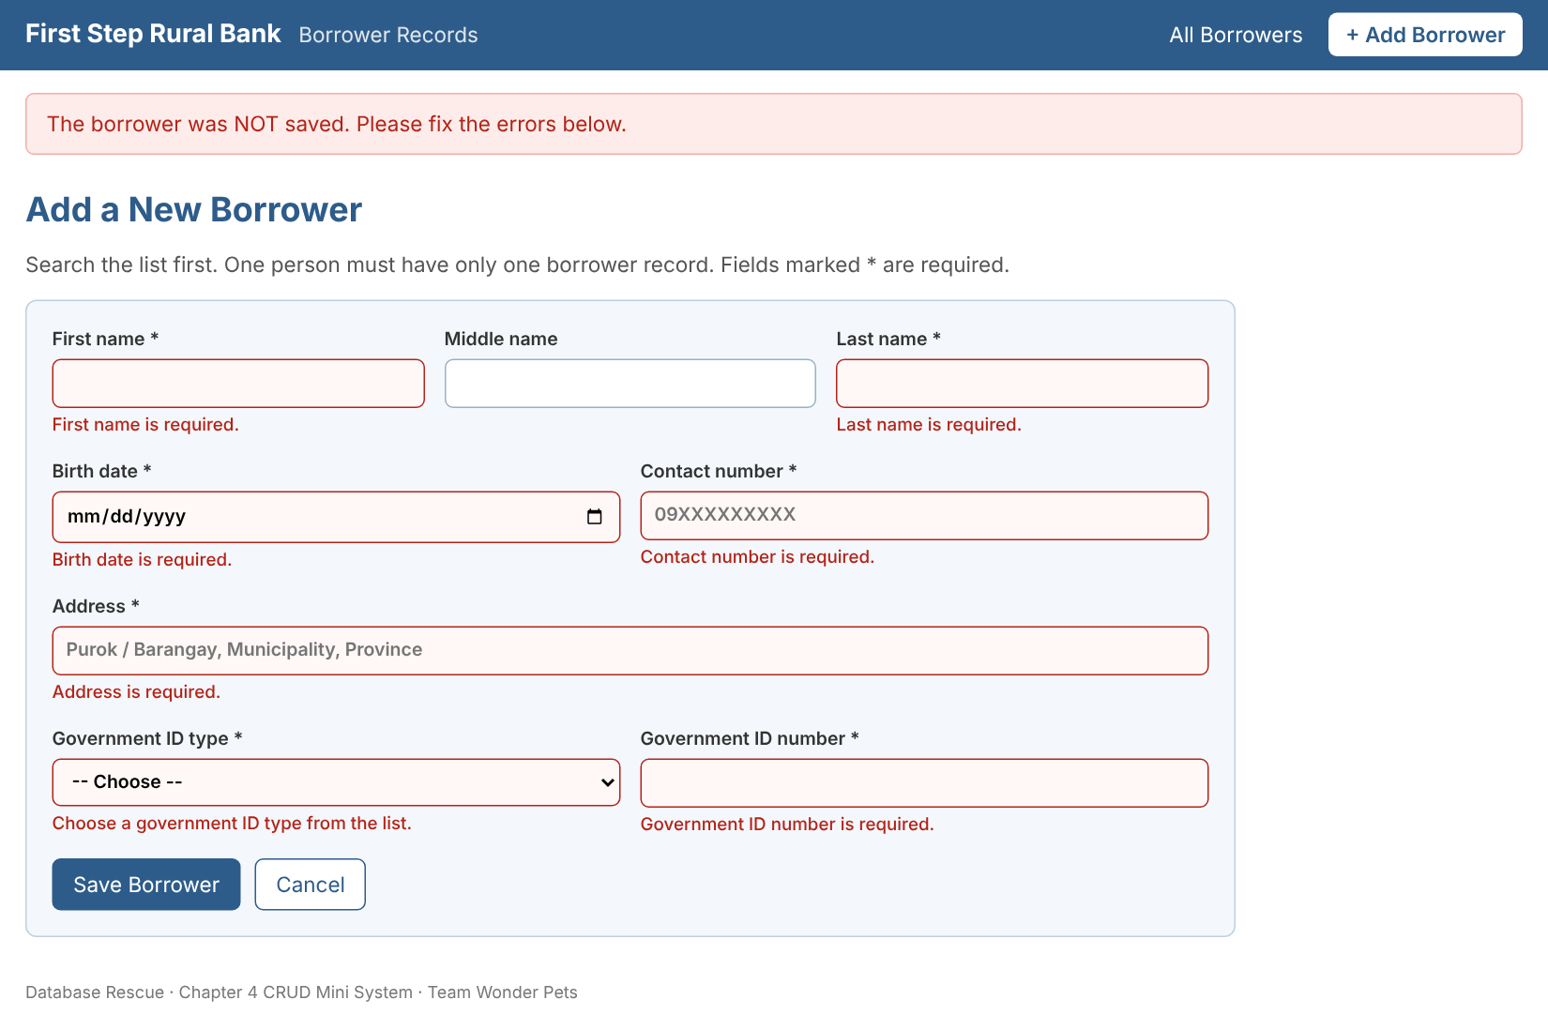  Figure 4.3 – Empty form submitted: nothing is saved and every required field shows a message
Screenshot – after | 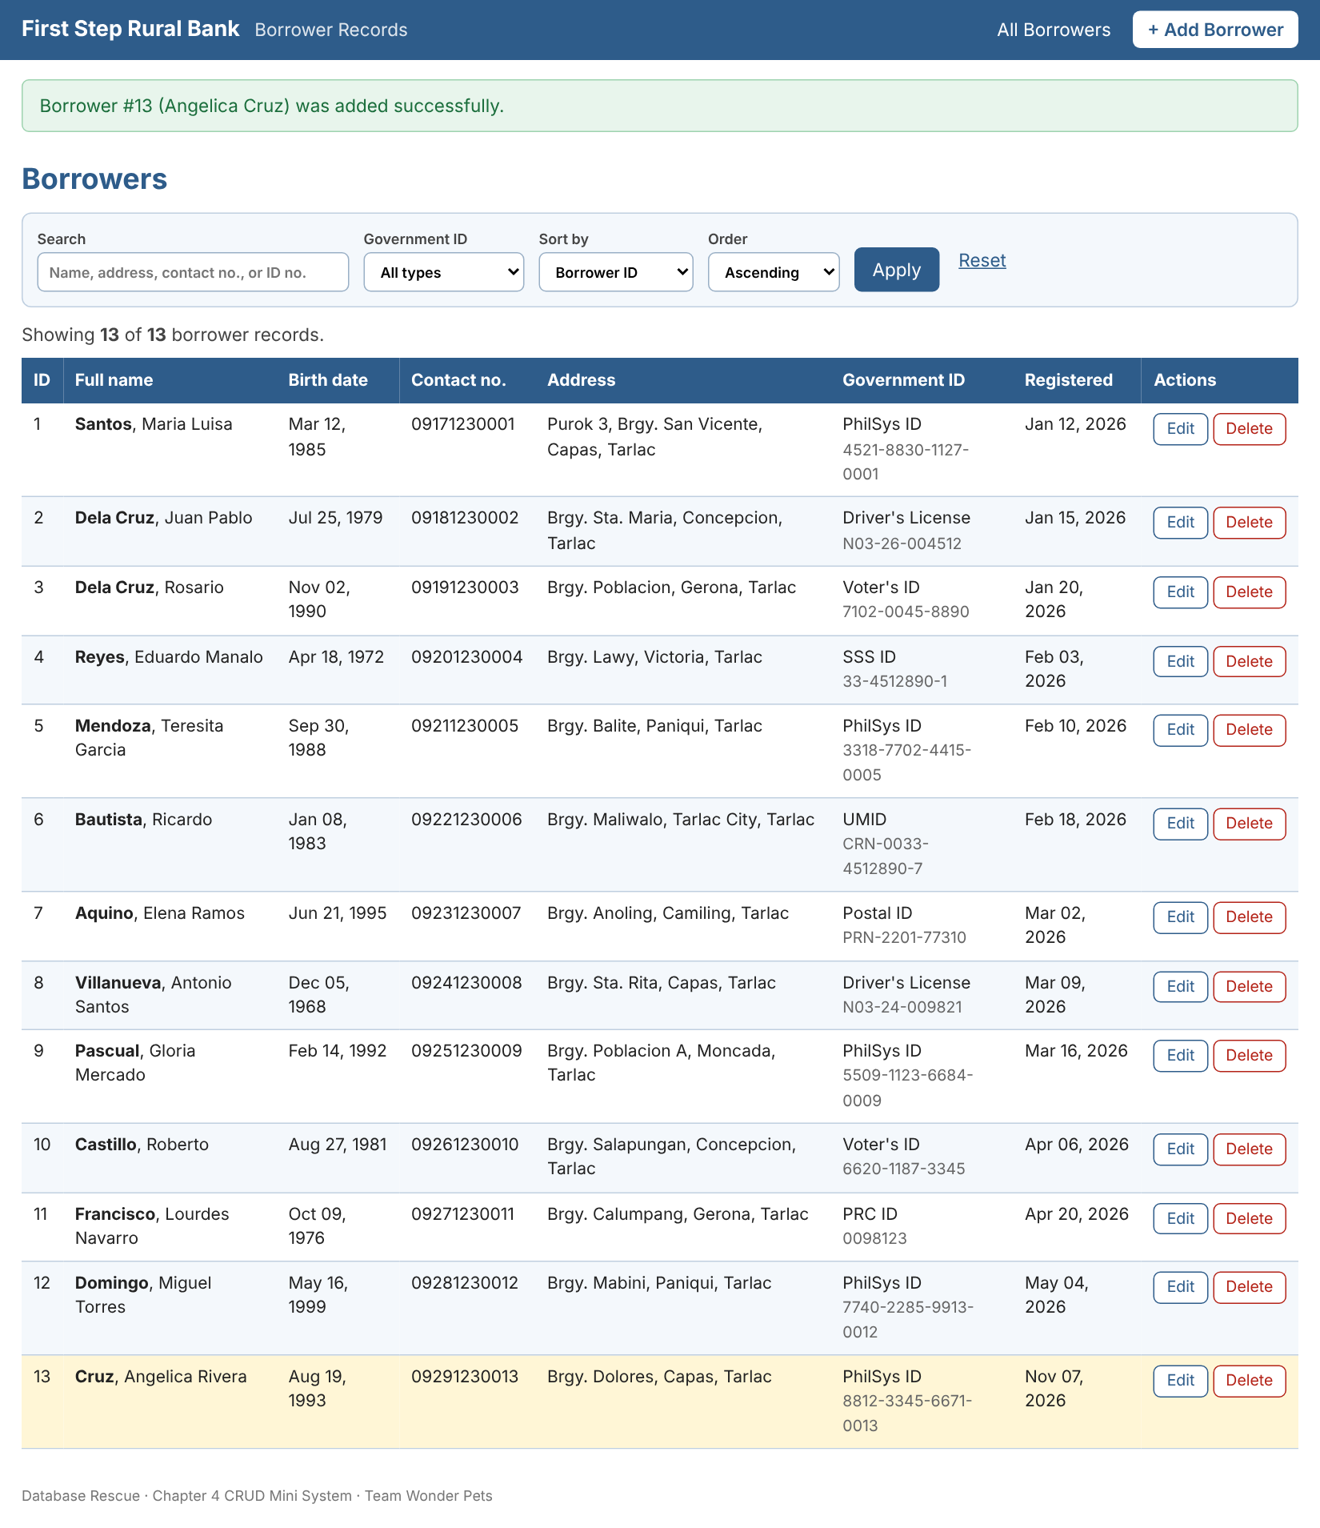  Figure 4.4 – After saving: success message and new Borrower #13 (13 records)

4.4.2 Read
Item | Description
Screen / button name | Borrower list (home page) with Search, Government ID, Sort by, Order, and Apply / Reset controls
What is displayed | ID, Full name, Birth date, Contact no., Address, Government ID (type and number), Date registered, and Edit / Delete buttons. A line above the table shows "Showing X of Y borrower records".
Search or filter (if any) | Search: every word typed must match the first, middle, or last name, address, contact no., or ID no.  Filter: by Government ID type  Sort: by Borrower ID, Last name, Birth date, or Date registered (ascending or descending)
SQL statement used | SELECT * FROM Borrower  WHERE (FirstName LIKE ? OR MiddleName LIKE ? OR LastName LIKE ?  OR Address LIKE ? OR GovIDNo LIKE ? OR ContactNo LIKE ?  OR CAST(BorrowerID AS TEXT) = ?) -- one group per search word  AND GovIDType = ? -- only when a filter is chosen  ORDER BY LastName ASC, FirstName ASC; -- column chosen from a fixed list
Message shown (success / error) | Count line, e.g. "Showing 2 of 13 borrower records."  Nothing found: "No borrowers found for your search or filter." with a Reset link
Screenshot – before | Figure 4.5 – Home page: all 12 records loaded from the database
Screenshot – after (search) | 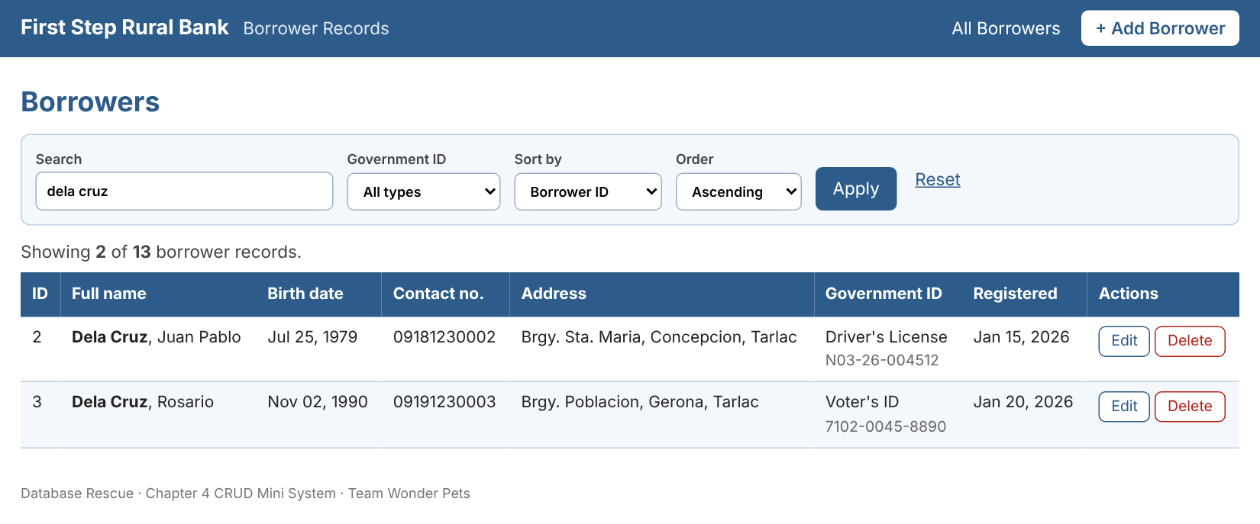  Figure 4.6 – Search "dela cruz": 2 of 13 records returned
Screenshot – no results | 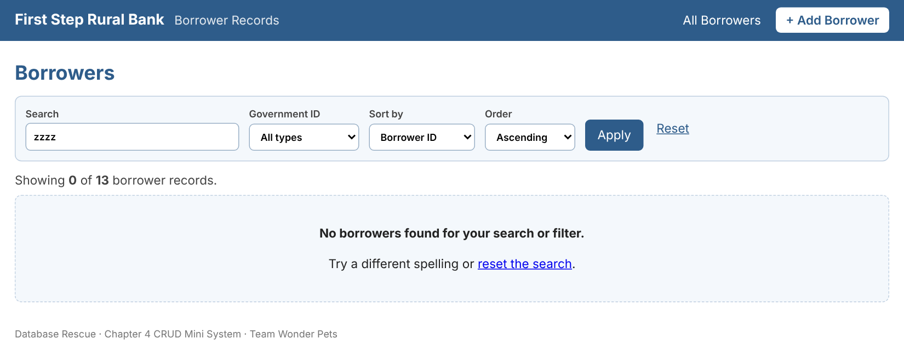  Figure 4.7 – Search "zzzz": clear "No borrowers found" message
Screenshot – filter and sort | 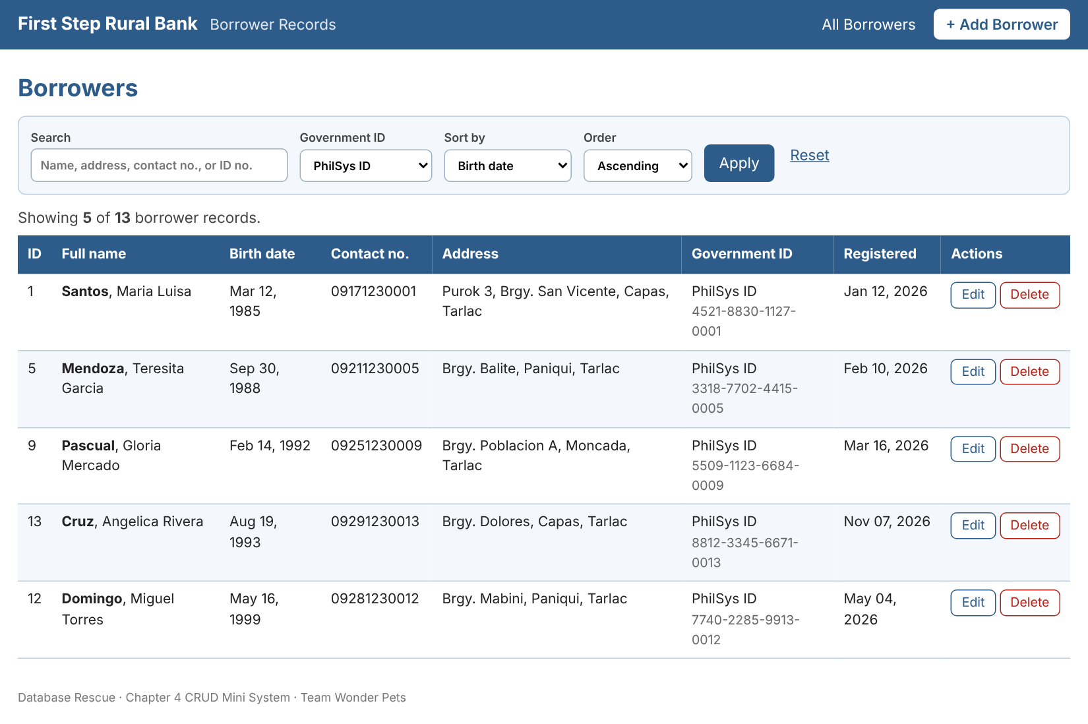  Figure 4.8 – Filter PhilSys ID, sorted by birth date

4.4.3 Update
Item | Description
Screen / button name | Edit Borrower form ("Edit" button on a row, then "Save Changes")
How the form is filled in | The record is loaded with SELECT * FROM Borrower WHERE BorrowerID = ?, so the current values appear automatically.
Fields that cannot be changed | BorrowerID and DateRegistered. They are shown as read-only boxes and the program never reads them from the submitted form.
SQL statement used | UPDATE Borrower  SET FirstName = ?, MiddleName = ?, LastName = ?, BirthDate = ?,  ContactNo = ?, Address = ?, GovIDType = ?, GovIDNo = ?  WHERE BorrowerID = ?;
Message shown (success / error) | Success: "Borrower #3 (Rosario Dela Cruz) was updated successfully." (row highlighted)  Error: "The changes were NOT saved. Please fix the errors below." plus a message under each bad field
Screenshot – before | 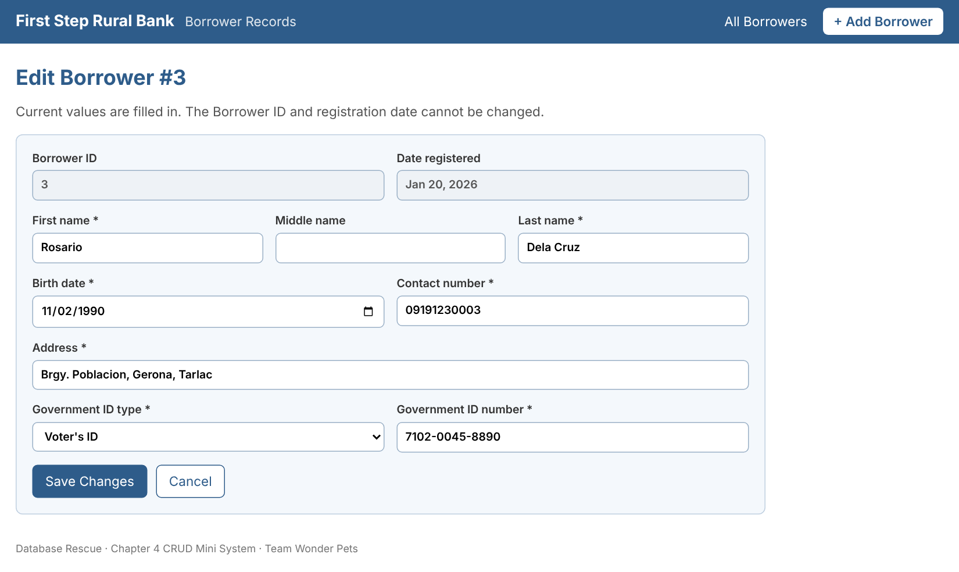  Figure 4.9 – Edit form for Borrower #3 with current values; ID and registration date locked
Screenshot – invalid change rejected | 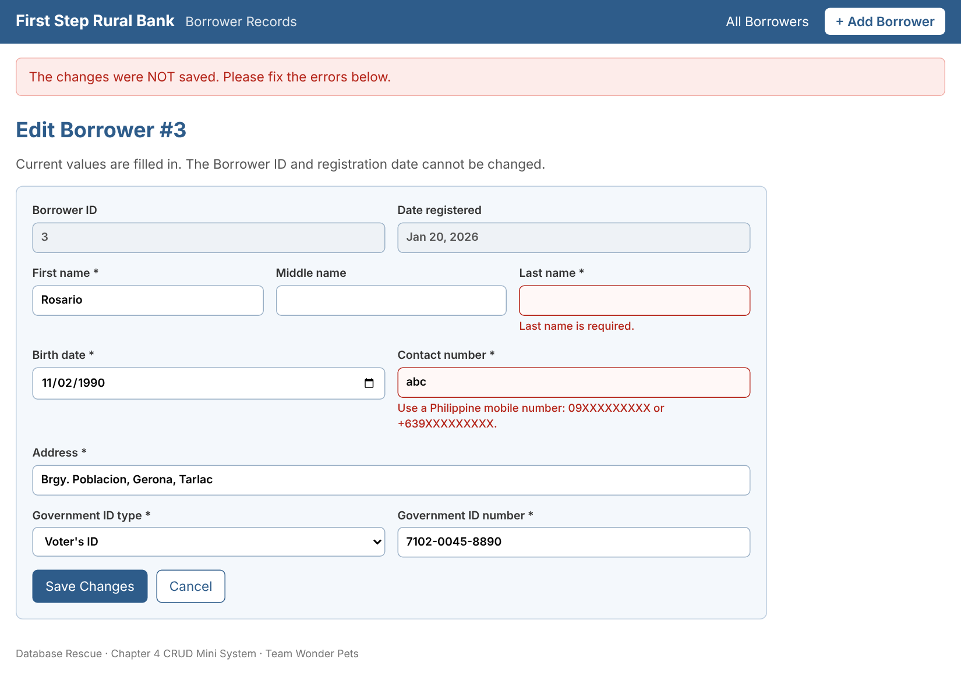  Figure 4.10 – Blank last name and bad contact number: change rejected, old data kept
Screenshot – after | 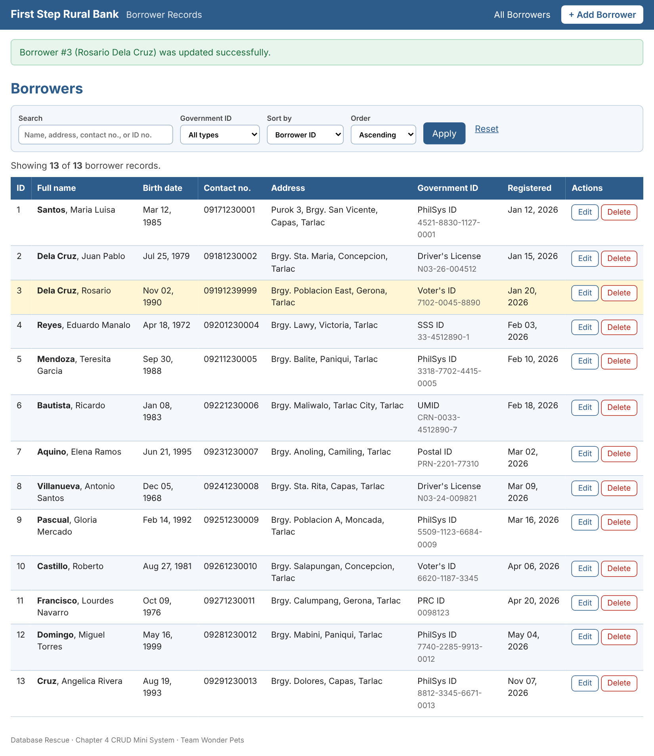  Figure 4.11 – After saving: Borrower #3 shows the new contact number and address

4.4.4 Delete
Item | Description
Screen / button name | Delete confirmation screen ("Delete" button on a row, then "Yes, delete this borrower")
Confirmation step | A separate page asks "Are you sure?", shows the full record, and offers "Yes, delete this borrower" or "No, cancel". Opening the page alone never deletes anything.
SQL statement used | DELETE FROM Borrower WHERE BorrowerID = ?;
Message shown (success / error) | Success: "Borrower #5 (Teresita Mendoza) was deleted." and the list refreshes immediately  Error: "Borrower #999 was not found. Nothing was deleted."
Business-rule note | Delete is built here because Chapter 4 requires it. In the full bank system (Chapter 3, Section 3.2) no role has Delete rights, and a borrower with loans would be deactivated instead. This mini system has no Loan table, so there is no linked data to protect.
Screenshot – before | 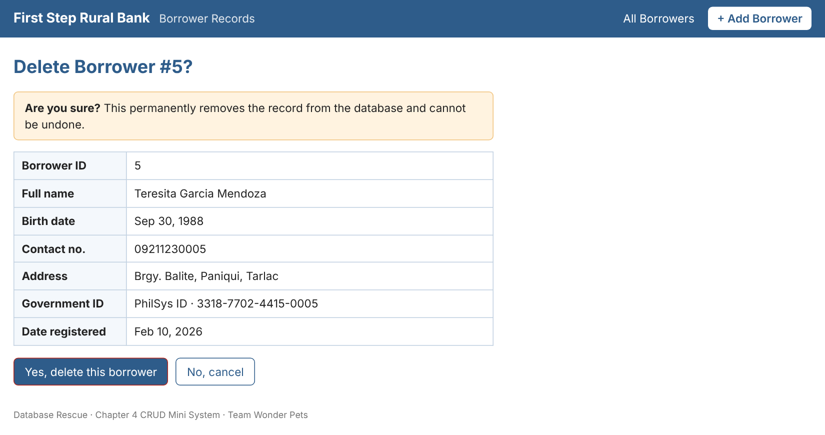  Figure 4.12 – Confirmation screen for Borrower #5
Screenshot – after | 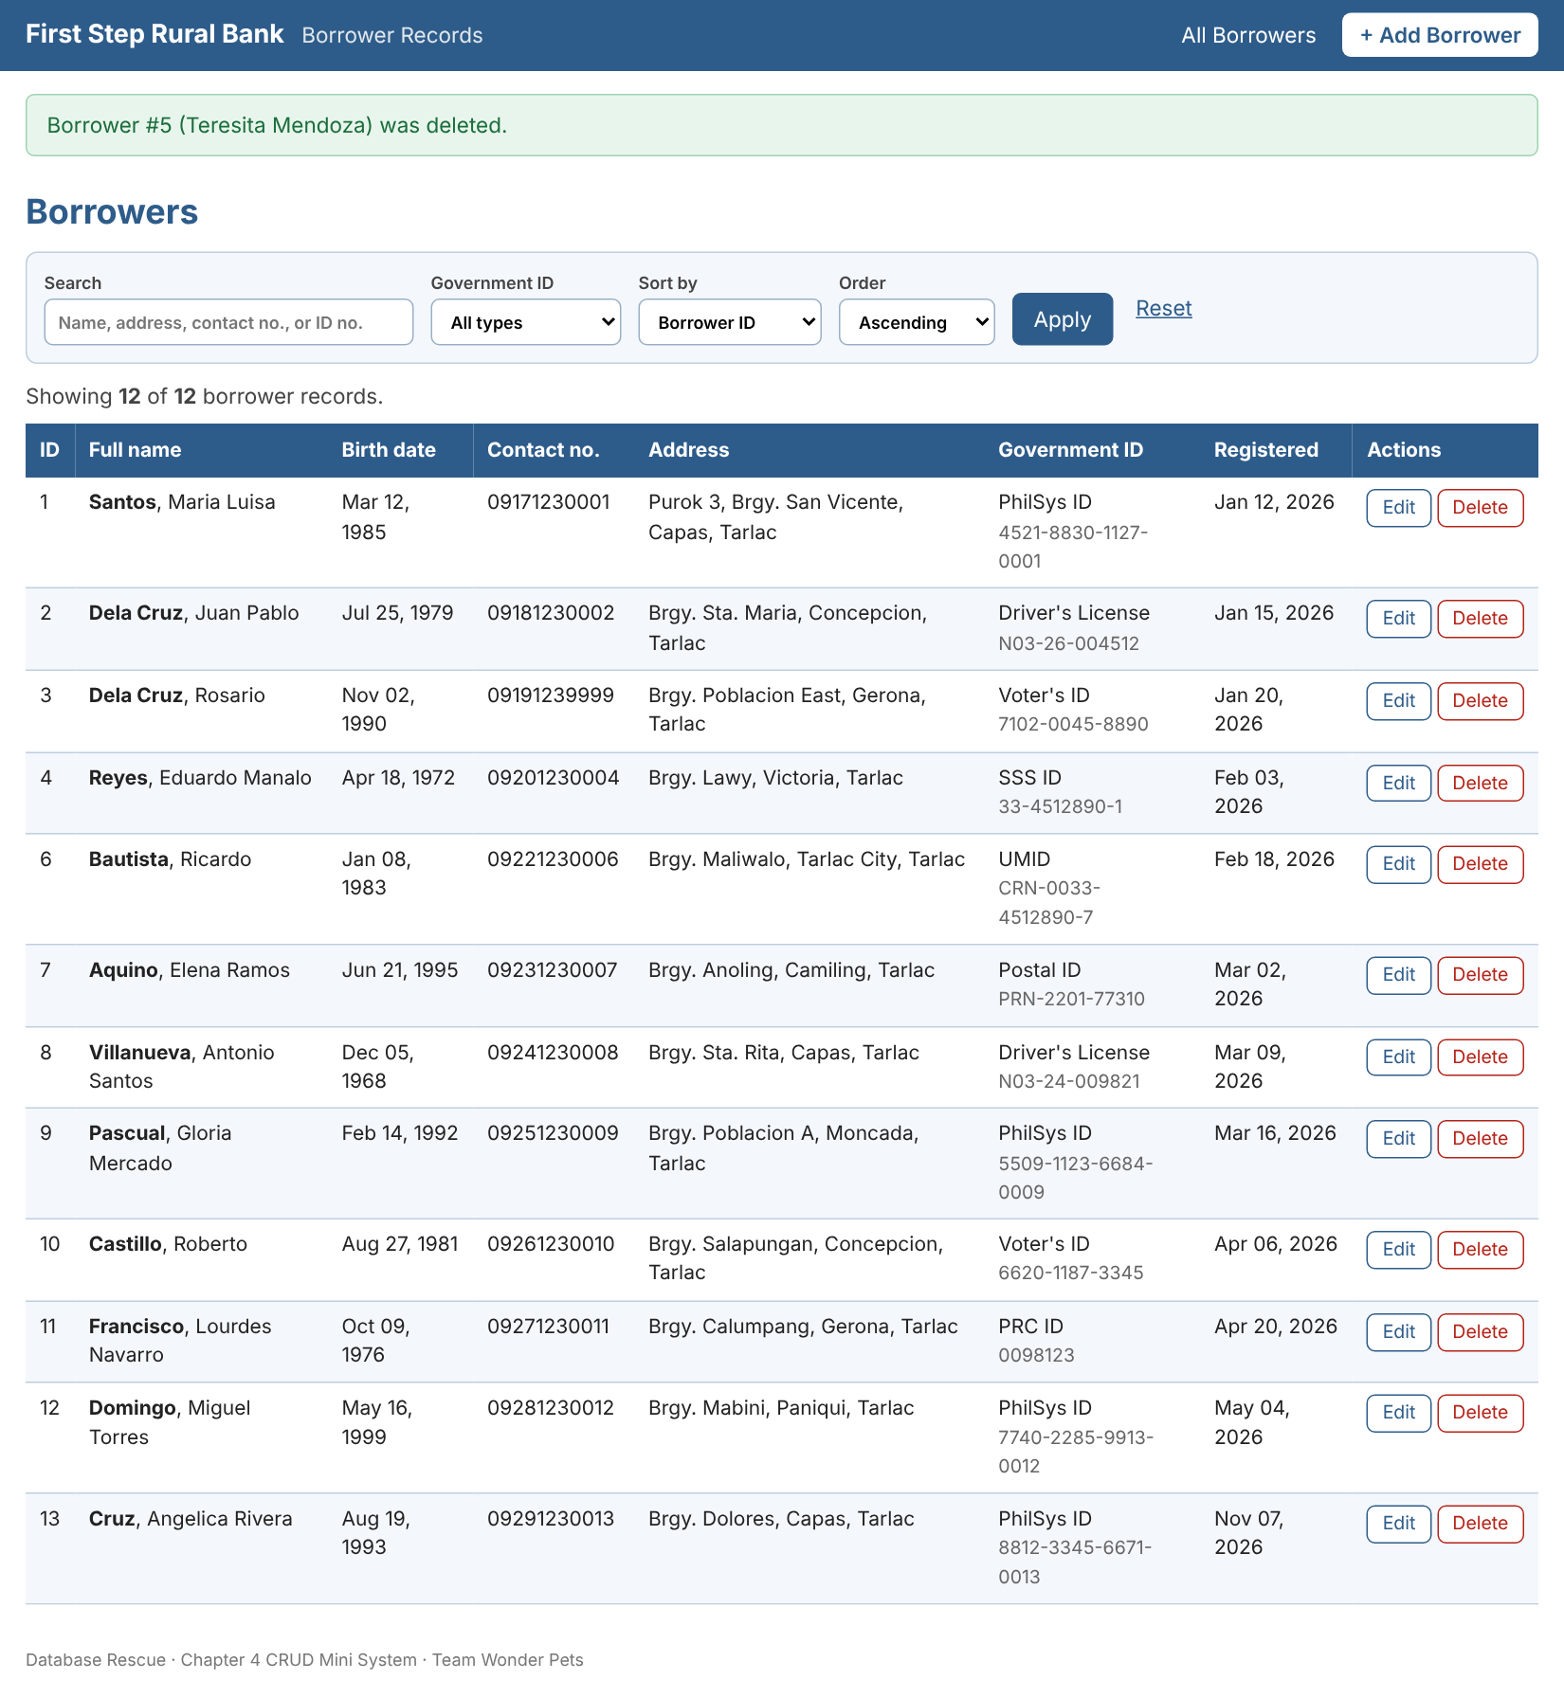  Figure 4.13 – After confirming: Borrower #5 is gone from the list (12 records)

4.5 Testing
The team wrote 20 test cases (5 Create, 6 Read, 5 Update, 4 Delete), including invalid input for every operation that accepts input. They run with python tests/run_tests.py on a fresh copy of the database, so the real data is never touched. The "Actual result" column is the output of that run. Result: 20 of 20 test cases passed.
ID | Test case and input | Expected result | Actual result (from the run) | Result
C1 | Create – Add a valid borrower  All fields filled with valid data (Angelica Rivera Cruz, PhilSys ID 8812-...-0013) | Record saved, ID generated, DateRegistered defaults to today, success message, count 12 to 13 | Saved as Borrower #13, DateRegistered 2026-11-07, count 12 to 13; message: "Borrower #13 (Angelica Cruz) was added successfully." | Pass
C2 | Create – Submit an empty form  Every field left blank | Rejected with required-field messages; nothing saved | Rejected with 7 messages (e.g. "First name is required."); count stayed 12 | Pass
C3 | Create – Invalid values in several fields  First name "J0hn", birth date 10 years ago, contact no. "12345" | Rejected with a message for each bad field; nothing saved | Rejected; 3 messages: First name may contain letters, spaces, hyphens, apostrophes, and periods only. | Borrower must be at least 18 years old. | Use a Philippine mobile number: 09XXXXXXXXX or +639XXXXXXXXX. | Pass
C4 | Create – Duplicate government ID  New person but PhilSys ID 4521-8830-1127-0001 (already used by Borrower #1) | Rejected with a duplicate-ID message; nothing saved | Rejected: "This PhilSys ID number is already registered (Borrower #1)."; count stayed 12 | Pass
C5 | Create – Same name and birth date, different ID  Maria Santos, born 1985-03-12, with a new PhilSys ID number | Rejected as a duplicate borrower; nothing saved | Rejected: "A borrower with the same name and birth date already exists (Borrower #1)."; count stayed 12 | Pass
R1 | Read – List all saved records  Open the home page with no search | All 12 records from the database are shown in a table | Table shows 12 rows (IDs 1 to 12); text "Showing 12 of 12 borrower records" present: True | Pass
R2 | Read – Search by name  Search box: "dela cruz" | Only Borrower #2 and #3 are shown | Rows returned: IDs [2, 3] | Pass
R3 | Read – Filter by government ID type  Government ID filter: PhilSys ID | Only the four PhilSys ID borrowers (#1, #5, #9, #12) are shown | Rows returned: IDs [1, 5, 9, 12] | Pass
R4 | Read – Sort by birth date  Sort by: Birth date, Ascending | Oldest borrower first (#8, born 1968), youngest last (#12, born 1999) | First row #8, last row #12, 12 rows | Pass
R5 | Read – Search with no match  Search box: "zzzz" | A clear "No borrowers found" message, no table rows | Message "No borrowers found for your search or filter." displayed; 0 rows | Pass
R6 | Read – SQL-injection style text in the search box  Search box: ' OR 1=1 -- | Treated as plain text (parameterized query): 0 matches, no error, table intact | HTTP 200; 0 rows returned; table still has 12 records | Pass
U1 | Update – Edit form is pre-filled and ID is locked  Click Edit on Borrower #3 | Current values appear in the form; Borrower ID is shown but cannot be edited | First name, last name, contact no. etc. pre-filled for #3; Borrower ID box is read-only/disabled and not a submitted field | Pass
U2 | Update – Save a valid change  Borrower #3: contact no. changed to 09191239999, address changed | Only #3 changes; success message; other 11 records unchanged | Changed record(s): [3]; new contact no. 09191239999; message: "Borrower #3 (Rosario Dela Cruz) was updated successfully." | Pass
U3 | Update – Invalid change is rejected  Borrower #3: last name blank, contact no. "abc" | Rejected with messages; record #3 keeps its old values | Rejected; 2 messages: Last name is required. | Use a Philippine mobile number: 09XXXXXXXXX or +639XXXXXXXXX.; record #3 unchanged | Pass
U4 | Update – ID and registration date cannot be tampered with  Edit #3 but also send BorrowerID=99 and DateRegistered=2000-01-01 in the request | Extra fields ignored: ID stays 3, DateRegistered unchanged | Still Borrower #3 with DateRegistered 2026-01-20; no record #99 was created | Pass
U5 | Update – Change to another borrower's government ID  Borrower #3 given PhilSys ID 4521-8830-1127-0001 (belongs to #1) | Rejected as duplicate; record #3 unchanged | Rejected: "This PhilSys ID number is already registered (Borrower #1)."; record #3 unchanged | Pass
D1 | Delete – Confirmation appears before deleting  Click Delete on Borrower #5 | "Are you sure?" page with the record details; nothing deleted yet | Confirmation page shown for #5 (Teresita Garcia Mendoza); count still 12 | Pass
D2 | Delete – Confirm the deletion  On the confirmation page, click "Yes, delete this borrower" for #5 | Only #5 is removed from the database; list updates immediately; count 12 to 11 | Count 12 to 11; #5 missing from DB and from the list; message: "Borrower #5 (Teresita Mendoza) was deleted." | Pass
D3 | Delete – Delete a record that does not exist  Open /delete/999 and submit | Friendly "not found" message, no crash, no data lost | HTTP 200; message: "Borrower #999 was not found. Nothing was deleted."; count stayed 12 | Pass
D4 | Delete – Cancel keeps the record  Open the confirmation for #7, then choose "No, cancel" (back to the list) | Record #7 is still in the database and the list | Record #7 still listed; count 12 | Pass

4.6 How to Run the System

4.6.1 Steps
Needs Python 3.10 or newer. No database server is required; the database is a single file created automatically.
Step 1 | Unzip the project folder borrower_crud and open it in VS Code (or any terminal).
Step 2 | Install Flask once: pip install -r requirements.txt (on Windows you can also use: py -m pip install -r requirements.txt)
Step 3 | Start the system: python app.py (or: py app.py). The first run creates borrowers.db from database.sql with 12 sample records.
Step 4 | Open http://127.0.0.1:5000 in Chrome or Edge. Use Add Borrower, the Edit and Delete buttons, and the search bar.
Step 5 | To restore the sample data: press Ctrl+C, then run python app.py --reset
Step 6 | To run the tests: python tests/run_tests.py (expected: "20 of 20 test cases passed")

4.6.2 Project files
File / folder | Purpose
app.py | The whole program: database connection, validation, and the Create, Read, Update, and Delete routes
database.sql | CREATE TABLE Borrower plus 12 sample records (runs on an empty database)
templates/ | base.html (layout and messages), list.html (Read), form.html (Create and Update), confirm_delete.html (Delete)
static/style.css | Colors and layout of every screen
tests/run_tests.py | The 20 automated test cases (results saved in tests/test_results.json)
tests/take_screenshots.py | Optional helper that produced the screenshots in this document
requirements.txt | Python packages needed (Flask)

4.6.3 Code map for the demo
Every member should be able to explain any row below.
Part of app.py | What it does
init_db() / get_db() | Builds borrowers.db from database.sql the first time and opens a connection for each request
validate() | Cleans the input and applies every field rule, including the duplicate government ID and duplicate name + birth date checks
index() – Read | Builds the SELECT with ? placeholders for the search words and ID filter; the ORDER BY column comes from a fixed list
add() – Create | Validates, then runs the parameterized INSERT and redirects to the list with a success message
edit() – Update | Loads the record to pre-fill the form; on save, validates and runs UPDATE ... WHERE BorrowerID = ?
delete() – Delete | GET shows the "Are you sure?" page; only a POST runs DELETE ... WHERE BorrowerID = ?

4.7 Member Contributions
Member | Tasks done (database, coding, testing, documentation) | Contribution % | Initials
Carpio, Diether Justin
Carpio, Lorman
Apostol, Kim
Tallada, John Lloyd
Magtalas, Richmon
[Sixth member: Last, First]

