DATABASE RESCUE
From Paper Trails to a Trusted Record: Fixing Data Chaos at First Step Rural Bank
Industry Option 1 — Banking: First Step Rural Bank
Group Name | Wonder Pets
Members | 1. Carpio, Diether Justin  2. Carpio, Lorman  3. Apostol, Kim  4. Tallada, John Lloyd  5. Magtalas, Richmon  6. [Sixth member — to be added]
Course | [Course Code and Title]
Instructor | [Instructor Name]
School | Tarlac State University — BS Information Technology
Date Submitted | October 3, 2026
Term Paper — Chapters 1 to 3: Problem Discovery · Database Design · Data Protection Policies

Chapter 1 — Problem Discovery

1.1 Symptoms Observed and Classification
Based on the site-visit narrative, the team identified eight distinct symptoms and classified each against a standard database-problem taxonomy (redundancy, inconsistency, integrity, missing or inaccessible data, security risk, or lack of backup).
# | Symptom Observed | Database Problem Classification
1 | Borrowers have multiple ledger entries under slightly different name spellings, so loan officers cannot tell whether someone already has other loans. | Data redundancy / duplication — no unique borrower identifier is enforced at registration.
2 | The same loan account shows different outstanding balances depending on which teller's notebook is checked. | Data inconsistency — no single authoritative record of the balance; every notebook is a separate copy.
3 | Interest is calculated manually per loan, and some clients were charged different rates for identical loan terms. | Data inconsistency / lack of integrity constraints — no central rate table and no automated computation.
4 | All tellers share one login to the banking software, so nobody can tell who processed a given transaction. | Security risk — no individual authentication, accountability, or audit trail.
5 | Land titles and ID copies sit in an unlocked filing cabinet accessible to all staff, including the cleaners. | Security risk — no physical access control over highly sensitive collateral and identity documents.
6 | The branch's one computer crashed and three days of transaction records were permanently lost. | Lack of backup and recovery — a single point of failure with no copy of the transactions.
7 | Loan officers approved new loans without knowing the applicant was already delinquent elsewhere in the same branch. | Missing / inaccessible data — no consolidated borrower view and no credit check enforced before approval.
8 | Audits keep turning up numbers that do not match across ledgers, the shared Excel sheet, and teller notebooks. | Lack of data integrity — several uncoordinated data sources with no validation, reconciliation, or single source of truth.

1.2 Problem Statement
First Step Rural Bank currently manages borrower, loan, payment, and collateral records with paper ledgers, teller notebooks, an uncontrolled shared Excel sheet, and a single teller terminal that all staff log into with one shared password. This informal setup has produced duplicate borrower records, conflicting loan balances, inconsistent interest charges, transactions that cannot be traced to a person, collateral documents open to everyone in the branch, a total loss of three days of transactions after a crash, and loan approvals made without knowing an applicant's delinquency elsewhere in the branch. The branch manager suspects that the rising loan defaults and mismatched audit figures come from poor record keeping rather than from the borrowers themselves. The bank needs a centralized, secure, and properly backed-up database that keeps one accurate record per borrower and per loan, applies interest consistently, identifies who processed each transaction, protects sensitive documents, and lets loan officers see a borrower's complete credit standing before they approve a loan.

1.3 Objectives
- Eliminate duplicate borrower records by enforcing one unique Borrower record, identified by BorrowerID and a government ID number, at registration and at every new loan application. (Symptom 1)
- Keep exactly one authoritative balance per loan by computing the outstanding balance from recorded payments in a central database instead of from separate teller notebooks. (Symptom 2)
- Standardize interest by storing rates in a LoanProduct table, copying the agreed rate onto each Loan at release, and letting the system compute interest and repayment schedules. (Symptom 3)
- Replace the shared login with individual, role-based staff accounts so that every transaction is tied to a named user and recorded in an audit log. (Symptom 4)
- Register every collateral item and document digitally and place the physical originals under locked, logged custody with restricted access. (Symptom 5)
- Implement scheduled, encrypted, off-site backups and a tested recovery procedure so that no more than one day of transactions can ever be lost. (Symptom 6)
- Require a system-recorded credit check, showing the borrower's active and delinquent loans across the whole branch, before any loan application can be approved. (Symptom 7)
- Give the branch manager and auditors one reconciled source of data, backed by database constraints and monthly reconciliation, so that audit figures match. (Symptom 8)

1.4 Interview Questions for Staff
- Walk me through a loan from the moment a borrower applies to the final payment. Which ledger, notebook, or spreadsheet does each staff member write into at each step?
- When a borrower applies, how do you check whether they already have a loan or a delinquent account with the branch, and what do you do when the name is spelled differently?
- When two notebooks show different balances for the same loan, how do you decide which one is correct, and how long does it take to settle?
- How is interest computed for a loan? Is there a written rate table, who applies it, and who double-checks the result?
- Who holds the key to the filing cabinet, who knows the shared software login, and how do you find out who processed a particular transaction?
- What happened during last month's crash? What was stored only on that computer, how did you reconstruct the three lost days, and what is still missing?
- What information would a loan officer need at the moment of approval that they cannot see today?
- How do you decide a loan is delinquent, and how are late payments currently flagged and followed up?
- What reports do the branch manager and the auditors ask for, and how long does it take to produce them at the moment?

Chapter 2 — Database Design

2.1 Entities & Attributes
Twelve entities were identified from the problem discovery in Chapter 1. Primary keys and foreign keys are listed for every entity.
Entity | Attributes | Primary Key | Foreign Key(s)
Borrower | BorrowerID, FirstName, MiddleName, LastName, BirthDate, ContactNo, Address, GovIDType, GovIDNo, DateRegistered | BorrowerID | —
Staff | StaffID, FirstName, LastName, Position, DateHired, Status | StaffID | —
UserAccount | UserID, StaffID, Username, PasswordHash, Role, Status | UserID | StaffID → Staff
LoanProduct | ProductID, ProductName, InterestRate, TermMonths, MinAmount, MaxAmount, PenaltyRate | ProductID | —
LoanApplication | ApplicationID, BorrowerID, ProductID, StaffID, AmountRequested, DateApplied, Status, DecisionDate | ApplicationID | BorrowerID → Borrower; ProductID → LoanProduct; StaffID → Staff
CreditCheck | CheckID, ApplicationID, CheckDate, ActiveLoans, DelinquentLoans, Outcome | CheckID | ApplicationID → LoanApplication
Loan | LoanID, ApplicationID, PrincipalAmount, InterestRate, TermMonths, DateReleased, MaturityDate, Status | LoanID | ApplicationID → LoanApplication
RepaymentSchedule | ScheduleID, LoanID, DueDate, PrincipalDue, InterestDue, Status | ScheduleID | LoanID → Loan
Payment | PaymentID, LoanID, ScheduleID, StaffID, AmountPaid, PaymentDate, ReceiptNo | PaymentID | LoanID → Loan; ScheduleID → RepaymentSchedule; StaffID → Staff
Collateral | CollateralID, LoanID, Type, Description, AppraisedValue, Status, StorageLocation | CollateralID | LoanID → Loan
CollateralDocument | DocumentID, CollateralID, DocType, DateReceived, FileReference | DocumentID | CollateralID → Collateral
AuditLog | LogID, UserID, Action, TableName, RecordID, LogTimestamp | LogID | UserID → UserAccount

Design notes
- One record per borrower. Borrower carries a uniqueness rule on GovIDType + GovIDNo (and BirthDate with the name), so a borrower cannot be registered twice under a different spelling. (Symptom 1)
- No stored balance. The outstanding balance is deliberately not a column. It is calculated as the loan principal plus interest due, minus the sum of Payment rows, so two notebooks can no longer disagree. (Symptoms 2 and 8)
- One rate source. InterestRate lives in LoanProduct and is copied onto Loan at release, so identical terms always receive the same rate and later product changes do not alter existing loans. (Symptom 3)
- Who did it. Payment.StaffID, LoanApplication.StaffID, and AuditLog.UserID tie each action to a named person. (Symptom 4)
- Credit check on record. CreditCheck stores the number of active and delinquent loans found for the borrower at the time of the decision, giving proof that the check happened. (Symptom 7)

2.2 Relationships & Cardinality
Relationship | Cardinality | Business Rule Justification
Borrower — LoanApplication | 1 : M | One borrower may apply for many loans over time, but each application belongs to exactly one borrower. Because every application points to the same Borrower record, a borrower's full loan history is always in one place.
Staff — LoanApplication | 1 : M | One loan officer handles many applications; each application is recorded under exactly one responsible officer.
LoanProduct — LoanApplication | 1 : M | One loan product (with its standard rate and term) is used by many applications; each application applies for exactly one product.
LoanApplication — CreditCheck | 1 : 0..1 | An application receives at most one recorded credit check, and it must exist before the application can be approved; each check belongs to exactly one application.
LoanApplication — Loan | 1 : 0..1 | An application either becomes a released loan or is rejected or withdrawn; every loan traces back to exactly one approved application.
Loan — RepaymentSchedule | 1 : M | A loan is repaid in many installments, each listed in the schedule; each installment belongs to exactly one loan.
Loan — Payment | 1 : M | A loan receives many payments over its life; each payment is applied to exactly one loan.
RepaymentSchedule — Payment | 1 : M | One installment can be settled by one or several partial payments; each payment is credited to one installment.
Staff — Payment | 1 : M | One teller records many payments; each payment is recorded by exactly one teller, which removes the anonymity of the shared login.
Loan — Collateral | 1 : M | A loan may be secured by several collateral items (for example, a land title and a vehicle); each collateral item secures exactly one loan.
Collateral — CollateralDocument | 1 : M | One collateral item has several documents (title, tax declaration, ID copy); each document belongs to exactly one collateral item.
Staff — UserAccount | 1 : 1 | Every staff member has exactly one individual login account, replacing the single shared login.
UserAccount — AuditLog | 1 : M | One user account generates many audit log entries; each entry names exactly one user.

2.3 Independent vs. Dependent Tables
Table | Type | Justification
Borrower | Independent | A borrower record exists once the person is registered, regardless of any loan application.
Staff | Independent | A staff record exists once a person is hired, independent of any transaction.
LoanProduct | Independent | A loan product and its standard rate are defined by the bank before any borrower applies.
UserAccount | Dependent | Cannot exist without a referenced Staff member.
LoanApplication | Dependent | Cannot exist without a referenced Borrower, LoanProduct, and Staff (loan officer).
CreditCheck | Dependent | Cannot exist without a referenced LoanApplication.
Loan | Dependent | Cannot exist without a referenced (approved) LoanApplication.
RepaymentSchedule | Dependent | Cannot exist without a referenced Loan.
Payment | Dependent | Cannot exist without a referenced Loan, RepaymentSchedule, and Staff (teller).
Collateral | Dependent | Cannot exist without a referenced Loan that it secures.
CollateralDocument | Dependent | Cannot exist without a referenced Collateral item.
AuditLog | Dependent | Cannot exist without a referenced UserAccount.

2.4 UML Entity-Relationship Diagram
The ERD below keeps every foreign key on the “many” side of each one-to-many relationship. Payment sits at the center of the accountability fix because it links a loan, an installment, and the teller who recorded the payment.
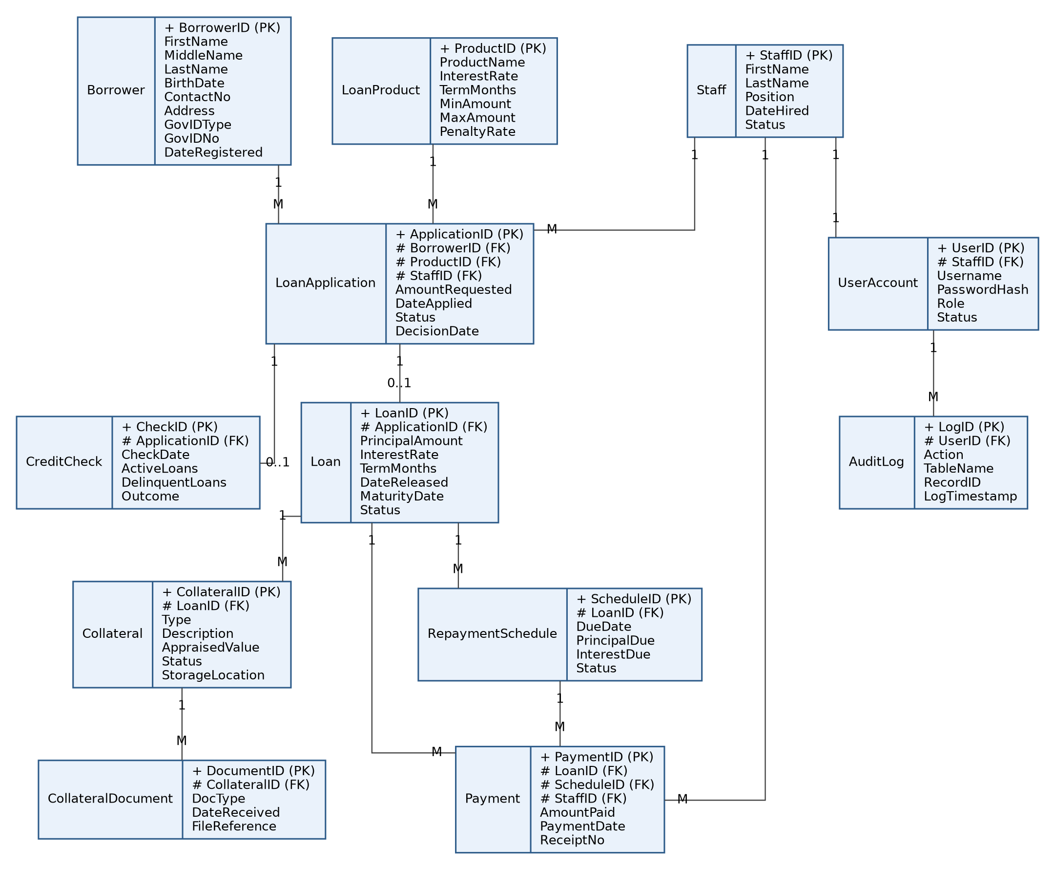
Figure 1 — UML-style ERD for the First Step Rural Bank database (record notation; + = primary key, # = foreign key).

2.5 Use Case Diagram
Actors and their functions
Actor | Functions in the system
Teller | • Record loan payments and print receipts  • View a loan's balance and statement  • Search for a borrower (included in Record Loan Payment)
Loan Officer | • Register new borrowers (after searching for duplicates)  • Create loan applications and perform the credit check  • Record collateral and upload collateral document details  • View a loan's balance and statement
Branch Manager | • Approve or reject loan applications and release loans  • Manage loan products and interest rates  • Manage staff accounts and roles  • Generate reports and review the audit log
Auditor | • Generate reports (read-only)  • Review the audit log  • View a loan's balance and statement

Search Borrower is shared by Register Borrower, Create Loan Application, and Record Loan Payment, so those use cases connect to it through «include». Perform Credit Check is included in Create Loan Application, and Log Activity is included in every action that changes financial or collateral records.
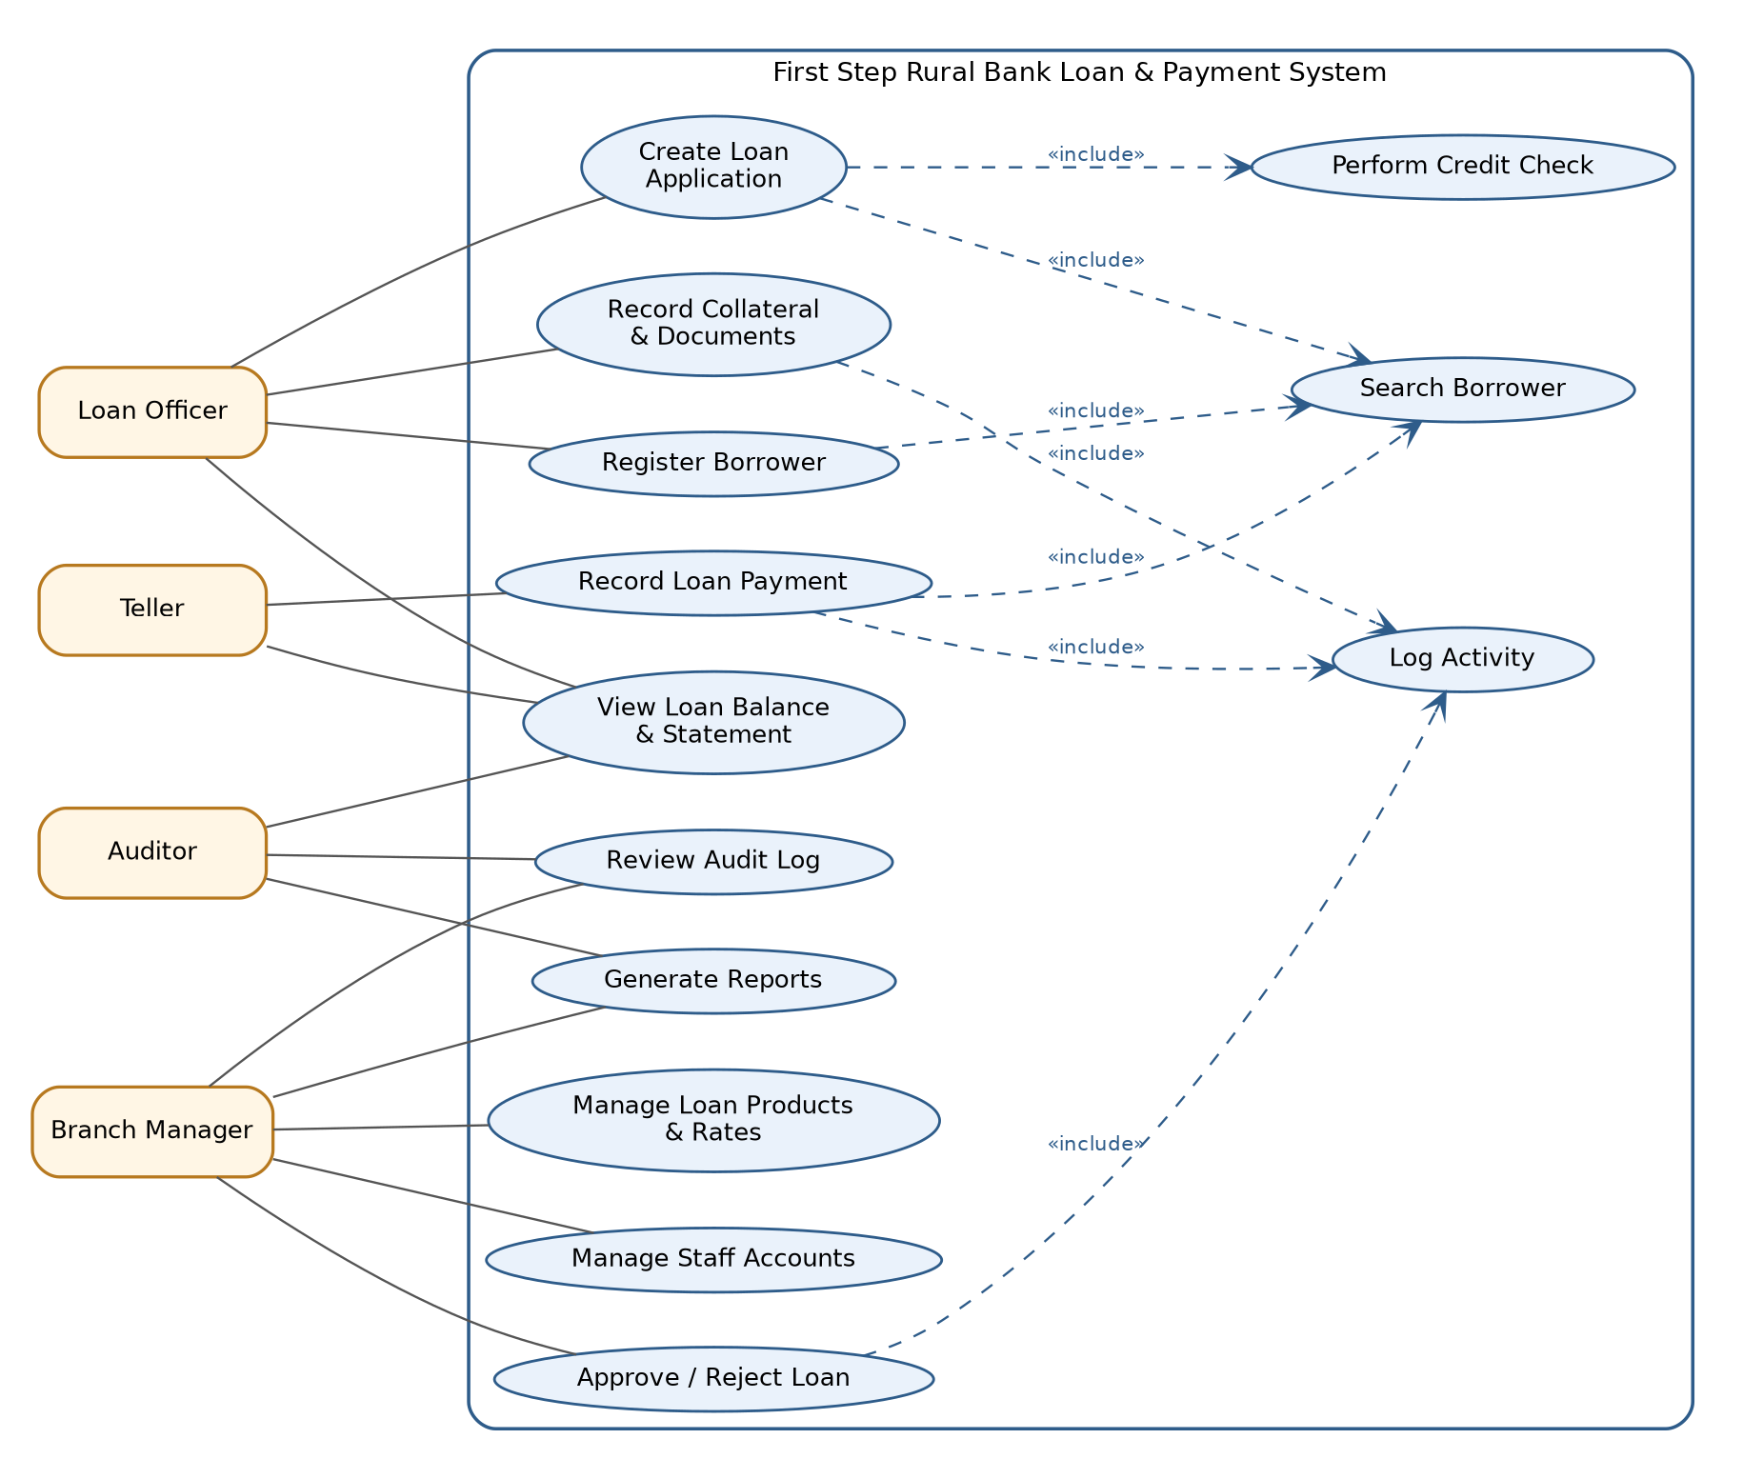
Figure 2 — UML use case diagram for the bank's loan and payment system.
Critical Use Case 1 — Create and Approve a Loan Application
Actors: Loan Officer (creates), Branch Manager (approves)
Preconditions: The officer and manager are logged in with their own accounts; the requested LoanProduct exists.
Main flow:
- Officer searches for the borrower by ID number or name; the system returns the existing Borrower record or prompts registration of a new one.
- Officer selects the LoanProduct and enters the requested amount; the system creates a LoanApplication with Status = “Pending”.
- The system runs the credit check across all of the borrower's Loans in the branch and stores the number of active and delinquent loans in CreditCheck.
- If a delinquent loan exists, the system flags the application as “Requires manager review” and does not allow routine approval.
- Manager reviews the application and credit check, then approves or rejects it; on approval the system creates the Loan (copying the product's rate) and generates the RepaymentSchedule.
- The system writes an AuditLog entry for the application, credit check, and decision.
Critical Use Case 2 — Record Loan Payment
Actor: Teller
Preconditions: The teller is logged in with an individual account; the loan is active and has a RepaymentSchedule.
Main flow:
- Teller searches for the borrower and selects the loan.
- The system displays the current outstanding balance and the next installment due, calculated from the database rather than from any notebook.
- Teller enters the amount paid; the system creates a Payment row with the teller's StaffID and a unique ReceiptNo, and credits the RepaymentSchedule.
- The system marks the installment “Paid” when fully settled, or “Partial” otherwise, and prints the receipt.
- The system writes an AuditLog entry for the payment. Payment rows cannot be edited or deleted; a mistake is fixed with a manager-approved reversing entry.

Chapter 3 — Data Protection Policies

3.1 Data Classification
Each table was classified as Highly Sensitive, Confidential, Internal, or Public Facing, with a short rationale.
Table(s) | Classification | Rationale
Borrower | Highly Sensitive | Holds personal information and government ID numbers; a leak enables identity theft and fraud and is sensitive personal information under RA 10173.
Collateral, CollateralDocument | Highly Sensitive | Land titles and ID copies are proof of ownership and identity; theft or forgery could cost borrowers their property.
LoanApplication, CreditCheck | Confidential | Income, credit standing, and approval decisions tied to an identifiable borrower.
Loan, RepaymentSchedule, Payment | Confidential | Financial data on balances and repayment behavior; misuse could expose or manipulate a borrower's finances.
UserAccount | Confidential | Contains credentials; compromise enables broader unauthorized access to every table.
AuditLog | Confidential | Reveals who did what and when; must be protected from tampering to remain trustworthy evidence.
Staff | Internal | Employment data for internal use; not for release outside the bank.
LoanProduct | Internal / Public Facing | Standard rates, terms, and loan limits are meant to be disclosed to prospective borrowers; only edit rights are restricted.

3.2 Access Control (Role × Table × Permission)
Permissions use C = Create, R = Read, U = Update, D = Delete. This replaces the single shared login with individually authenticated, role-scoped access.
Role | Borrower | Loan Application / Credit Check | Loan / Schedule | Payment | Collateral / Documents | Loan Product | UserAccount / AuditLog
Teller | R | — | R | CR | — | R | —
Loan Officer | CRU | CRU | R | R | CRU | R | —
Branch Manager | RU | RU | CRU | CR | R | CRU | CRU / R
Auditor | R | R | R | R | R | R | — / R

Notes: No role has Delete rights. Records are deactivated or reversed, never erased, so the audit trail stays intact. The Branch Manager's Create right on Payment is limited to reversing entries. Cleaners and other non-system staff have no access to any table.

3.3 Authentication
- Every staff member receives an individual UserAccount tied to their StaffID; the shared teller login is retired on the day the system goes live.
- Passwords must have at least 10 characters mixing letters, numbers, and symbols, and are stored only as salted hashes (for example, bcrypt), never in plain text.
- Accounts lock for 15 minutes after 5 consecutive failed logins, and sessions on the teller terminal time out after 5 minutes of inactivity.
- Two-factor authentication is required for the Branch Manager role and for any remote access.
- Accounts are deactivated on the same day a staff member leaves, and access rights are reviewed every quarter.
- These controls follow the security-of-personal-information requirements of the Data Privacy Act of 2012 (RA 10173) and the BSP information security guidelines (Circular No. 982).

3.4 Encryption
- At rest: the production database, scanned collateral files, and every backup are encrypted with AES-256; GovIDNo is additionally encrypted at field level.
- In transit: all connections to the database, including any remote access or off-site backup sync, use TLS 1.2 or higher.
- Encryption keys are stored separately from the data they protect, restricted to the Branch Manager and one designated custodian, and rotated at least once a year.

3.5 Backup & Recovery
- Incremental backup every day at close of business and a full backup every week, so at most one working day of transactions can ever be lost (the current loss was three days).
- Backups are kept in two places: an encrypted external drive stored in the branch vault and an encrypted off-site copy (head-office server or cloud) synced whenever connectivity allows, with the drive rotated off-site weekly if the connection is unreliable.
- Backups are kept for 12 months on a rolling basis, and a spare terminal is kept ready so the branch can resume within a target of 4 hours (RTO).
- A test restore is performed every quarter and the result is logged and signed by the Branch Manager.

3.6 Retention & Disposal
- Loan, payment, and borrower transaction records are kept for at least five years from the date of the transaction or the closing of the account, in line with the Anti-Money Laundering Act (RA 9160) record-keeping requirement, and are then archived to encrypted cold storage.
- Original collateral documents are returned to the borrower once the loan is fully paid, with a signed release entry in the custody log.
- Paper records that are no longer needed are destroyed by cross-cut shredding, never thrown into ordinary trash.
- Retired computers and drives are securely wiped or physically destroyed before disposal or reuse.
- Every disposal is logged with the date, method, records affected, and the authorizing staff member.

3.7 Audit Logging & Compliance
- Every create, read, update, and reversal on the Borrower, Loan, Payment, Collateral, and CollateralDocument tables is logged with UserID, timestamp, action, and affected record ID.
- The Branch Manager reviews the logs monthly and follows up on unusual patterns, such as a teller opening collateral records or payments recorded outside working hours.
- Loan balances are reconciled against the ledgers every month until the paper ledgers are fully retired.
- The bank designates a Data Protection Officer, gives borrowers a privacy notice and obtains consent at registration, and reports a personal data breach to the National Privacy Commission within 72 hours.
- The design follows the Data Privacy Act of 2012 (RA 10173) and applicable BSP regulations, and uses the EU GDPR as a reference standard for data-subject rights.
- A privacy and security review is carried out once a year to reassess classifications, access rights, and retention schedules.

3.8 Physical Security & Collateral Custody
- Original land titles, ID copies, and other collateral documents are kept in a fireproof, locked cabinet or vault instead of the open filing cabinet.
- Keys are held only by the Branch Manager and one designated Records Custodian; no other staff member, including cleaning staff, holds a key.
- Each removal or return of a document is entered in a custody log (date, document, borrower, staff member, purpose) and countersigned.
- Cleaning is done while the cabinet is locked and the records room is locked when unattended.
- Every physical document has a matching CollateralDocument entry, so a missing item is noticed at the next monthly custody count.

