**Collaboration and Consulting Agreement**

**Preamble**

This "Collaboration and Consulting Agreement" between "Fondation Arbre de Vie" and "[Company Name]" aims to facilitate, streamline, support, and finalize consultant payments.

**Activities**

**Article 1.** This agreement implies the confidentiality, non-disclosure, and secrecy of the information contained herein.

**Article 2.** "[Company Name]" undertakes to honor and pay invoices presented by "Fondation Arbre de Vie," located in Kalemie, Democratic Republic of Congo, to the bank indicated by the latter.

**Article 3.** "Fondation Arbre de Vie" commits to remunerating all consultants, each in the bank of their choice and in the specified country.

**Article 4.** "Fondation Arbre de Vie" will make various payments upon receipt of the invoice payment.

**Article 5.** Consultants from "[Company Name]" and "Fondation Arbre de Vie" will be designated by their respective organizations.

**Article 6.** Consultant payments will strictly adhere to the agreed-upon division percentages: 45 for the foundation and 55 for [Company Name].

**Article 7.** This "Collaboration and Consulting Agreement" is valid and thus holds legal and moral value between the parties who sign it by mutual agreement.

**Article 8.** This understanding will come into effect upon the signing by the parties.

Read and approved.

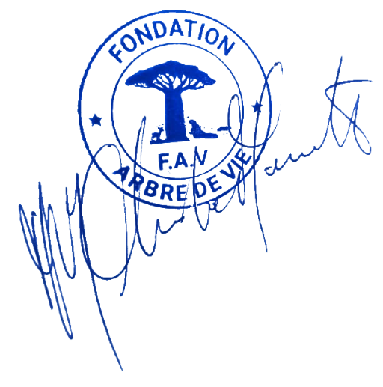For "Fondation Arbre de Vie," located in Kalemie, Avenue Lumumba – Democratic Republic of Congo. Here represented by its President, Jean Claude Mugabo Manda.

For "[Company Name]," located in [Company Address]. Here represented by its Chief Executive Officer, Mr. [CEO's Name].

Done in Uvira on 26/06/2025