# FTPSReportsDownloader

The delivery “FTPSReportsDownloader.zip” includes the following files:

* FTPSReportsDownloader.exe – the program that allows trading members automatically collect MOEX reports,
* FTPSReportsDownloader.exe.config – the configuration file,
* FTPSReportsDownloader.docx – the guide,
* FTPSReportsDownloader_src.7z – software source code (C#, Microsoft Framework 4.5).

To configure the application, the file “FTPSReportsDownloader*.exe.config*” should be modified as follows:

|  |  |
| --- | --- |
| Key | Value |
| Server | FTPS server:  *ftps.moex.com* |
| UserName | Email of the user registered on passport.moex.com and permitted to access the “My Account” service |
| Password | Password of the user registered on passport.moex.com and permitted to access the “My Account” service |
| DownloadDirectory | Local folder for files from the server:  *C:\ftp (the folder should be created on your PC)* |
| DownloadLog | Write the history of files downloaded to a log file. The path to the log file should be specified.  C:\ftp\DownloadHistory.log *(the file is created automatically upon running “FTPSReportsDownloader.exe”)* |

Run the program “FTPSReportsDownloader*.exe”*. After the first run, please go to the folder specified by you in the parameter “*DownloadDirectory”* of the configuration file:

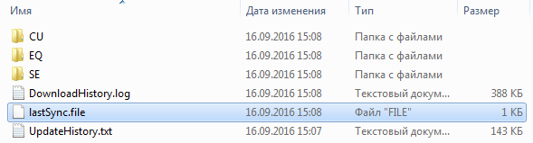

UpdateHistory.txt – contains a list of files to download.

lastSync.file – contains the last file downloaded.

When the application is re-run, only new files are downloaded.