M1C2

# TASK ONE

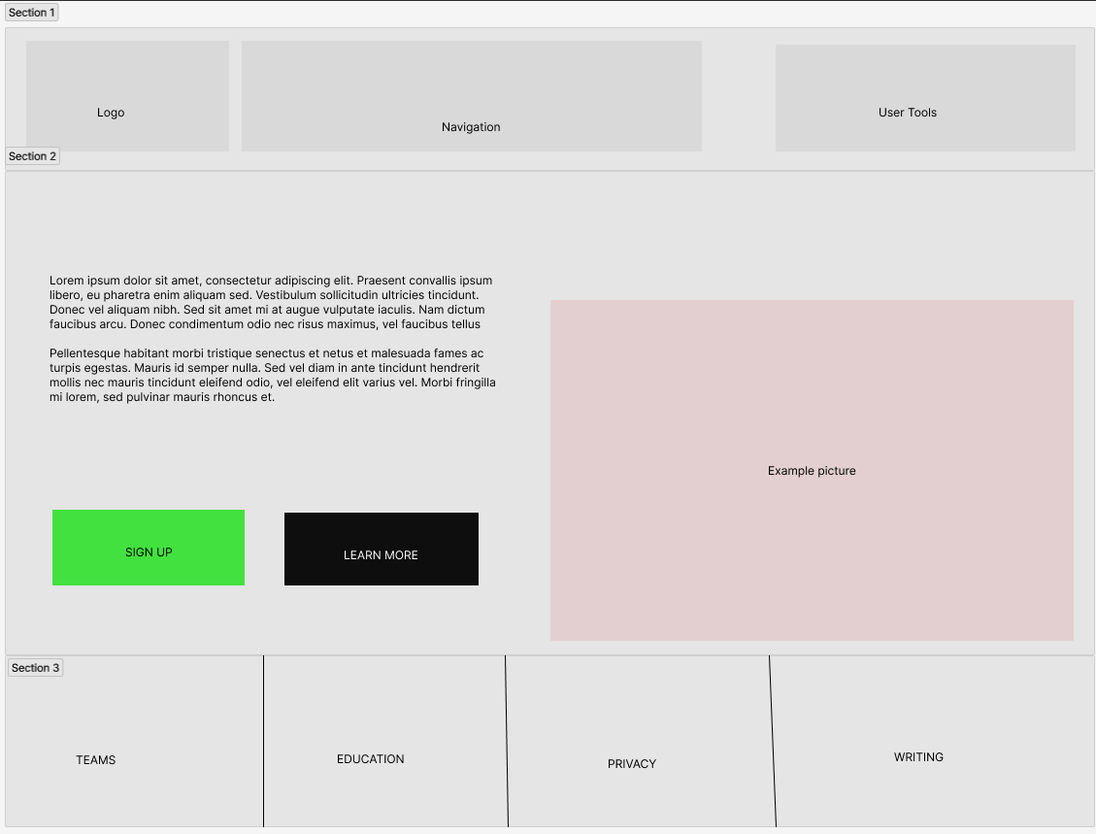

# TASK TWO

Jonny.me

Purple #452bc7

Main color used to exalt all buttons and core sections

White #FFFFFF

Secondary color used to generate contrast with the main color. It is used in most of the background.

Gold #ffbf0d

While only used twice, this color is used in two key elements of the page to generate a strong contrast with the main purple color and make the options it presents more enticing

# TASK THREE

Youtube

As a user whose native language is not English, Pablo wants to have subtitles on videos, so he can watch content in English

# TASK FOUR

## Facebook

Keeping up with the lifes of family and friends

## Twitter

Sharing quick, short thoughts or news

## Google

Quickly finding the right website to feel your need

## Youtube

Finding and watching vídeos on any subject or lenght