Encuesta sobre servicios de diagnóstico de laboratorios de micología en Perú

Resultados

Diego Villa

19 October, 2022

Table of Contents

# General information

## Departament where the hospital/laboratory is located

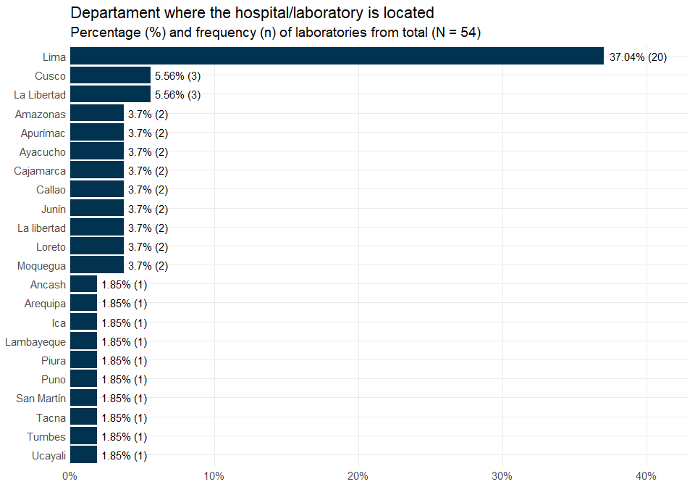

## Time the laboratory has been carrying out mycological diagnoses

| Variable | Lima, N = 20 | Other departments, N = 34 | Overall, N = 54 |
| --- | --- | --- | --- |
| Time the laboratory has been carrying out mycological diagnoses1 |  |  |  |
| Responses | 20 | 34 | 54 |
| Range | 4, 50 | 0, 56 | 0, 56 |
| Median (IQR) | 20.00 (9.25, 25.00) | 6.50 (3.25, 13.75) | 10.00 (5.00, 22.25) |
| Mean (SD) | 19.50 (12.92) | 12.06 (14.03) | 14.81 (13.99) |
| 1Years | | | |

# Additional information about the hospital/health facility the laboratory belongs

## Total number of hospital beds

### Total number of hospital beds by region

| Variable | Lima, N = 20 | Other departments, N = 34 |
| --- | --- | --- |
| Total number of hospital beds |  |  |
| Responses | 19 | 32 |
| Range | 0, 1,000 | 0, 565 |
| Median (IQR) | 208.00 (100.00, 444.00) | 70.00 (11.75, 210.00) |
| Mean (SD) | 328.95 (335.10) | 125.94 (141.98) |
| No response | 1 | 2 |

### Total number of hospital beds by capacity level

| Variable | Laboratorio de mayor capacidad, N = 37 | Laboratorio de menor capacidad, N = 17 |
| --- | --- | --- |
| Total number of hospital beds |  |  |
| Responses | 35 | 16 |
| Range | 0, 1,000 | 0, 302 |
| Median (IQR) | 200.00 (40.00, 340.00) | 37.50 (15.25, 105.00) |
| Mean (SD) | 259.31 (279.46) | 75.25 (85.73) |
| No response | 2 | 1 |

## Available services in the hospital/health facility

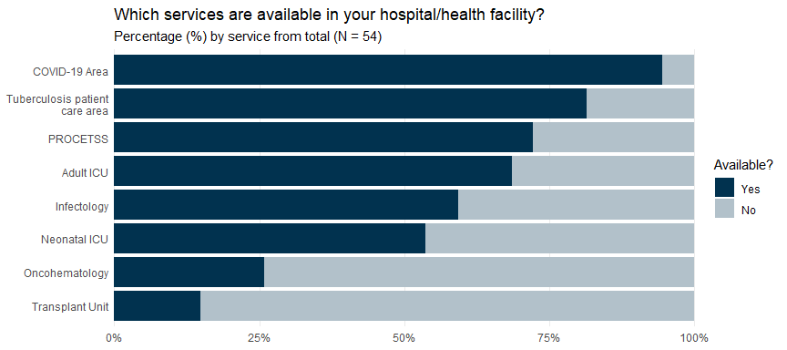

# Additional information about the micology/microbiology laboratory

## Approximate area of the microbiology work zone

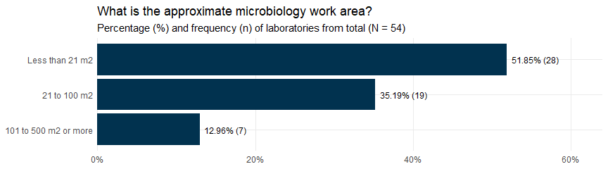

## Separated work zone for fungal diagnostic tests

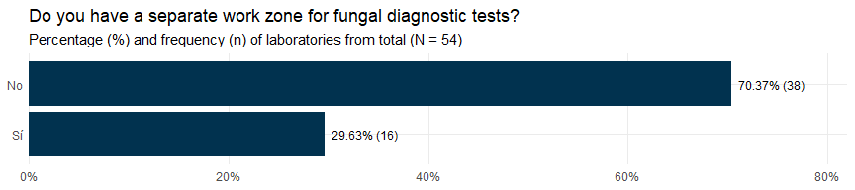

## Work zone area for fungal diagnostic tests

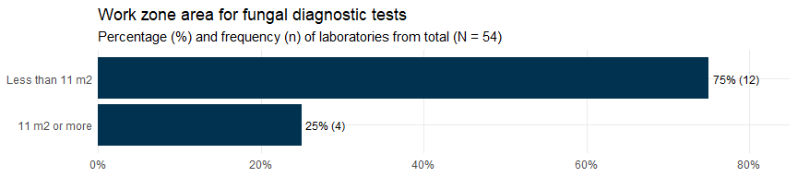

## Available equipments for the diagnostic of fungi

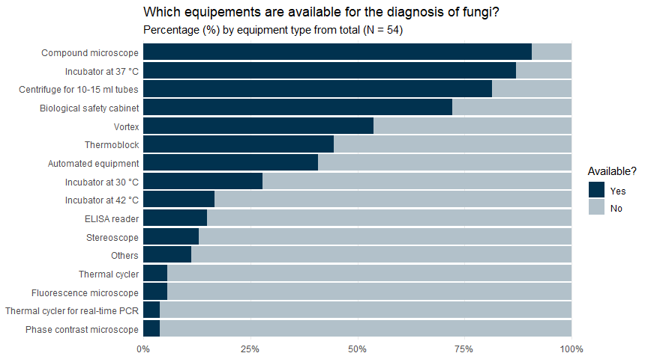

# Accreditation and quality assessment

## Participation of the mycology laboratory in an external quality assessment scheme

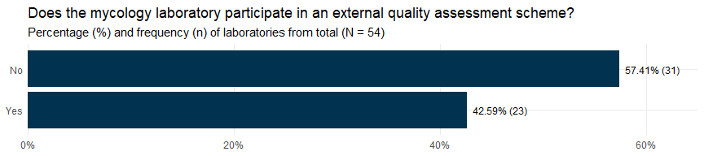

## Areas in which the mycology laboratory is evaluated

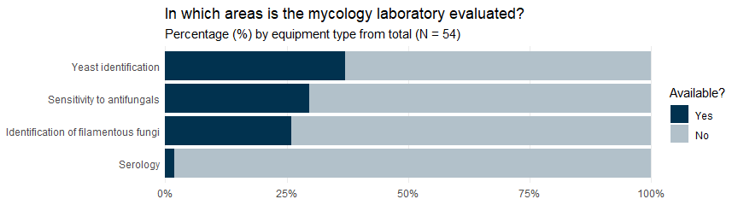

# Human resources

## Technical staff in the microbiology laboratory

| Variable | N = 54 |
| --- | --- |
| Technical staff in the microbiology laboratory |  |
| Responses | 53 |
| Range | 0, 20 |
| Median (IQR) | 1.00 (1.00, 2.00) |
| Mean (SD) | 2.45 (3.71) |
| No response | 1 |

## Professional staff in the microbiology laboratory

| Variable | N = 54 |
| --- | --- |
| Professional staff in the microbiology laboratory |  |
| Responses | 53 |
| Range | 0, 28 |
| Median (IQR) | 3.00 (1.00, 5.00) |
| Mean (SD) | 4.79 (6.04) |
| No response | 1 |

## Total staff in the microbiology laboratory

| Variable | N = 54 |
| --- | --- |
| Total staff in the microbiology laboratory |  |
| Responses | 53 |
| Range | 1, 35 |
| Median (IQR) | 4.00 (2.00, 7.00) |
| Mean (SD) | 7.25 (8.33) |
| No response | 1 |

## Total staff in the mycology area

| Variable | N = 54 |
| --- | --- |
| Total staff in the mycology area |  |
| Responses | 46 |
| Range | 0, 6 |
| Median (IQR) | 1.00 (1.00, 3.00) |
| Mean (SD) | 1.67 (1.49) |
| No response | 8 |

## Mycology training/education program for mycology laboratory staff

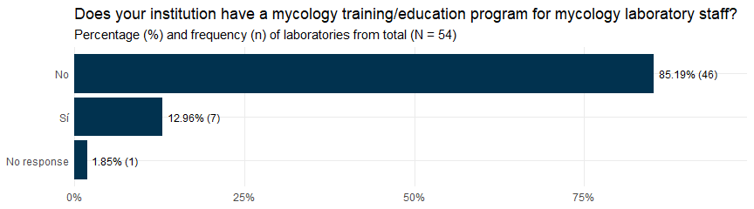

## Times a year the mycology trainigs are held

| Variable | N = 7 |
| --- | --- |
| Times a year the mycology trainigs are held |  |
| Responses | 7 |
| Range | 1, 4 |
| Median (IQR) | 2.00 (1.00, 2.00) |
| Mean (SD) | 1.86 (1.07) |

## Training to other areas of the hospital/health facility

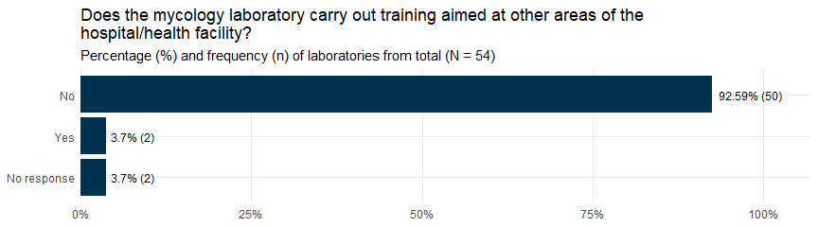

## Audience of the trainings carried out by the mycology laboratory

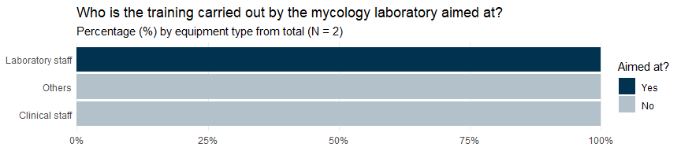

# Internal demand for mycological tests

## Average number of samples for mycosis diagnosis before COVID-19

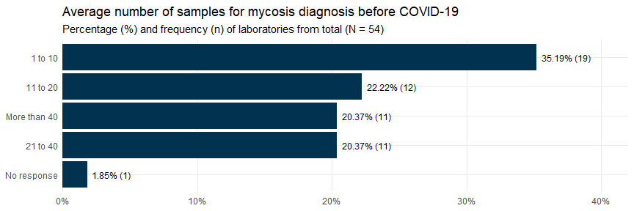

## Average number of samples for mycosis diagnosis in the last 3 months

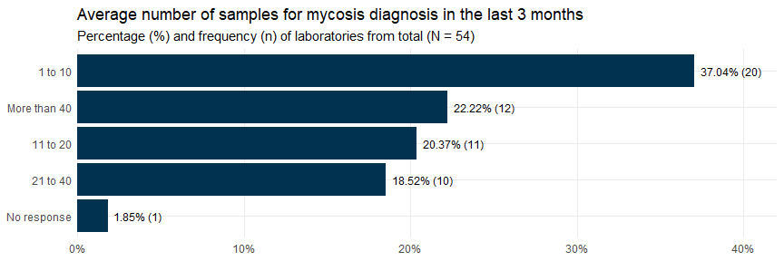

## Departments/units that have sent samples for the diagnosis of mycoses

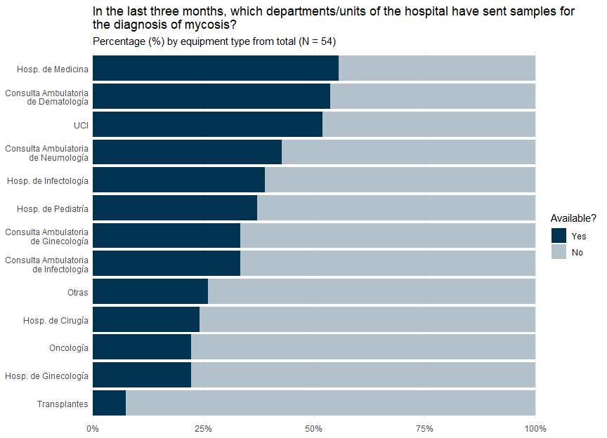

## Most frequent sample types processed in the last 3 months

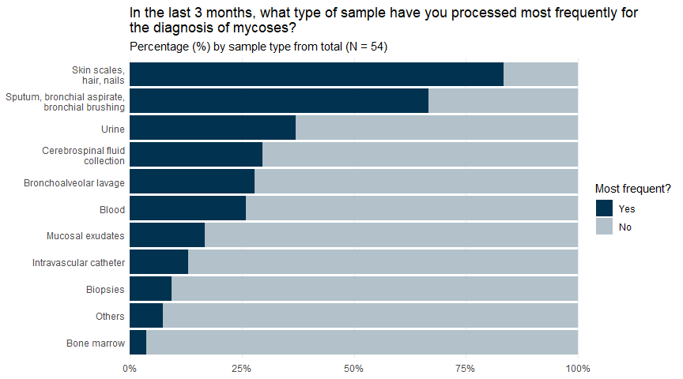

## Average number of processed samples (last 3 months)

| Average number of processed samples (last 3 months) |  |
| --- | --- |
| Skin scales, hair or nails |  |
| Responses | 44 |
| Range | 1, 70 |
| Median (IQR) | 10 (5.00, 25) |
| Mean (SD) | 17 (17) |
| No response | 1 |
| Sputum, bronchoaspirate or bronchial brushing |  |
| Responses | 34 |
| Range | 1, 500 |
| Median (IQR) | 18 (10.00, 50) |
| Mean (SD) | 49 (92) |
| No response | 2 |
| Mucosal exudates |  |
| Responses | 8 |
| Range | 2, 150 |
| Median (IQR) | 18 (8.75, 49) |
| Mean (SD) | 38 (49) |
| No response | 1 |
| Biopsies |  |
| Responses | 5 |
| Range | 1, 15 |
| Median (IQR) | 5 (1.00, 8) |
| Mean (SD) | 6 (6) |
| No response | 0 |
| Urine |  |
| Responses | 20 |
| Range | 3, 11,000 |
| Median (IQR) | 32 (13.75, 262) |
| Mean (SD) | 707 (2,437) |
| No response | 0 |
| Blood |  |
| Responses | 14 |
| Range | 3, 1,000 |
| Median (IQR) | 85 (21.50, 296) |
| Mean (SD) | 235 (347) |
| No response | 0 |
| Intravascular catheter |  |
| Responses | 7 |
| Range | 4, 200 |
| Median (IQR) | 10 (10.00, 40) |
| Mean (SD) | 45 (71) |
| No response | 0 |
| Cerebrospinal fluid collection |  |
| Responses | 16 |
| Range | 5, 120 |
| Median (IQR) | 12 (9.00, 20) |
| Mean (SD) | 22 (28) |
| No response | 0 |
| Bone marrow |  |
| Responses | 2 |
| Range | 3, 3 |
| Median (IQR) | 3 (3.00, 3) |
| Mean (SD) | 3 (0) |
| No response | 0 |

# Microscopic examinations

## Does the mycology laboratory perform microscopic examinations?

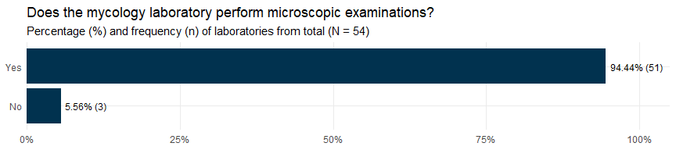

## Available microscopic examinations

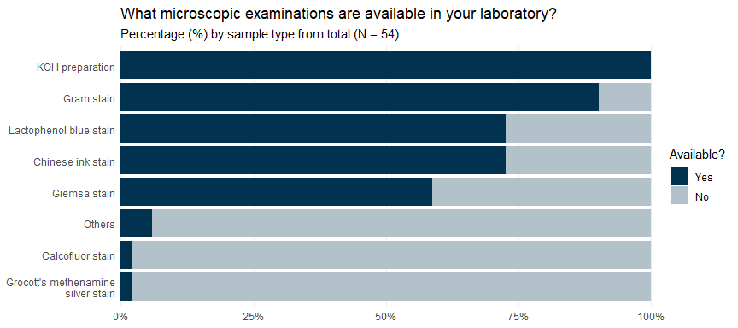

## Delivery time of Chinese ink stain test results

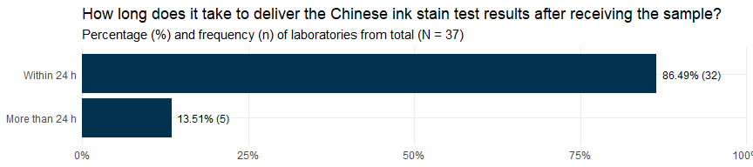

## Delivery time of Giemsa ink stain test results

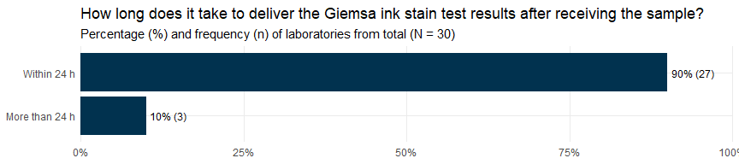

## Results delivery method

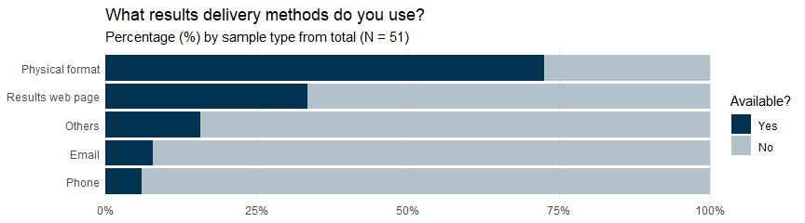

# Fungal identification: Yeast

## Available culture medias for yeast identification

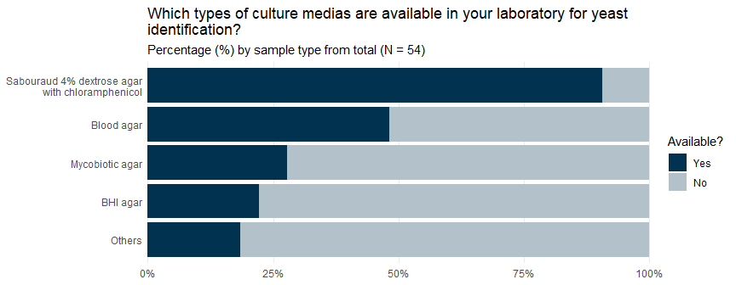

## Does the laboratory has yeast identification systems?

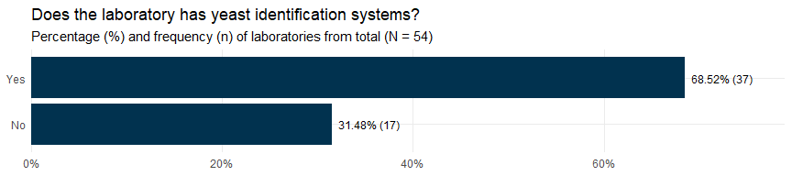

## What yeast identification systems are available in your laboratory?

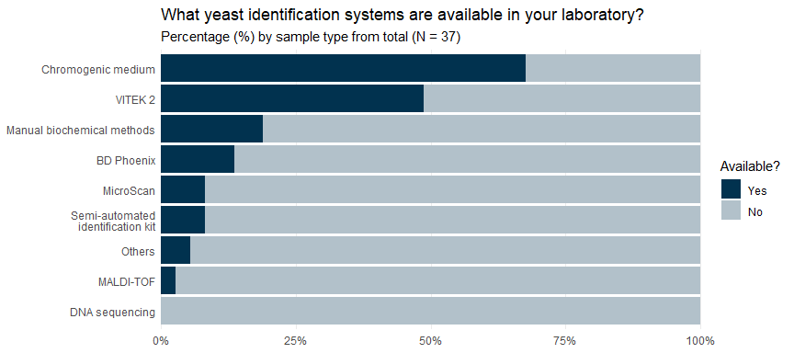

## Routine storage of clinical yeast isolates

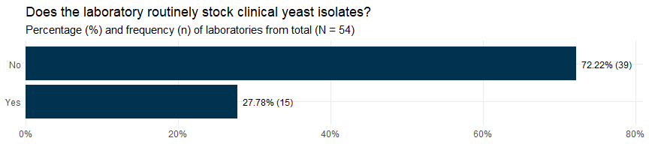

# Fungal identification: Mold (Filamentous/Dimorphic Fungi)

## Available culture medias for mold identification

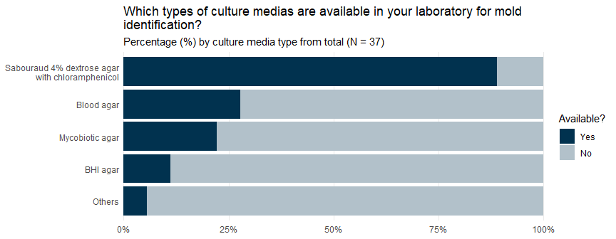

## Does the laboratory has mold identification systems?

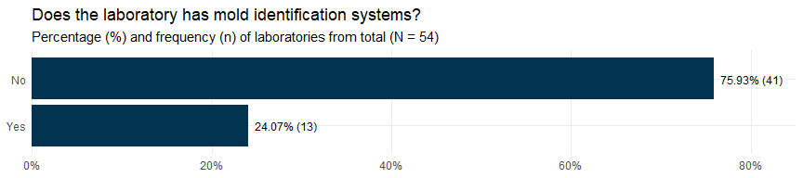

## Does the laboratory send mold isolates to external labs for identification?

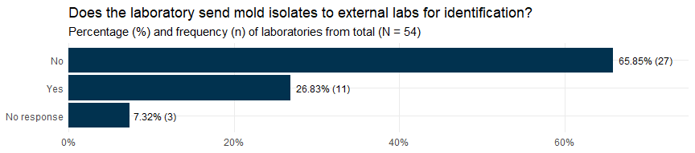

## ¿Qué sistemas de identificación de moho se encuentran disponibles en su laboratorio?



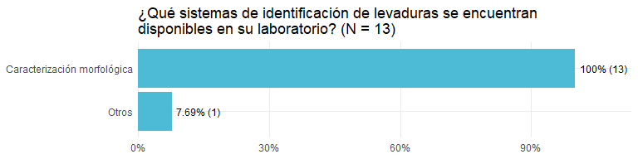

## Almacenamiento reutinario de aislados clínicos de moho

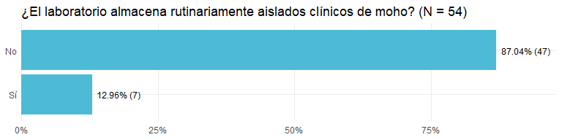

# Pruebas de susceptibilidad a antifúngicos

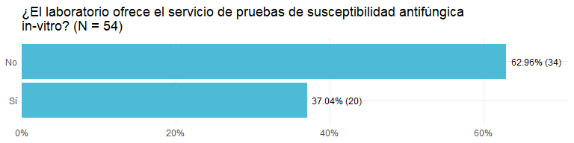

## ¿El laboratorio realiza las pruebas de susceptibilidad a antifúngicos o se envían a un laboratorio externo?

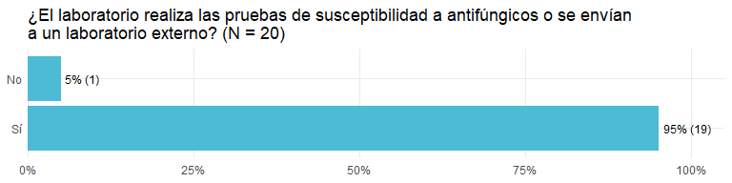

## ¿Para qué tipos de hongos están disponibles las pruebas de susceptibilidad antifúngica?

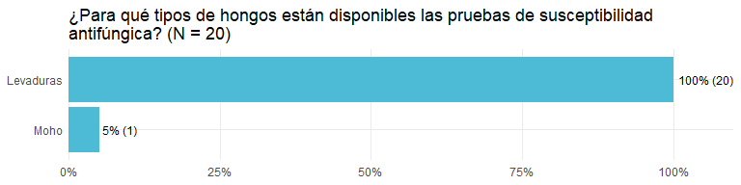

# Pruebas serológicas

## ¿Las pruebas de detección de anticuerpos contra hongos (*Aspergillus sp.*, *Histoplasma capsulatum*, *Paracoccidioides brasiliensis*) está disponibles en su laboratorio?

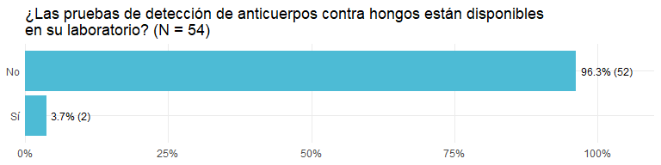

## ¿Las pruebas de detección de anticuerpos contra hongos (*Aspergillus sp.*, *Histoplasma capsulatum*, *Paracoccidioides brasiliensis*) están disponibles en otro laboratorio en su hospital?

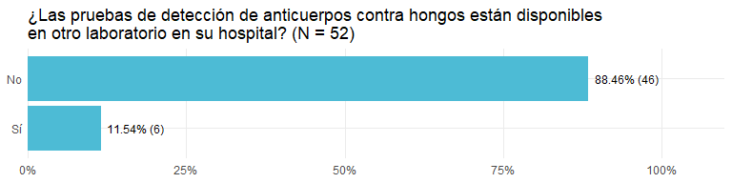

## ¿Las pruebas de detección de anticuerpos contra hongos (*Aspergillus sp.*, *Histoplasma capsulatum*, *Paracoccidioides brasiliensis*) se envían a un laboratorio externo?

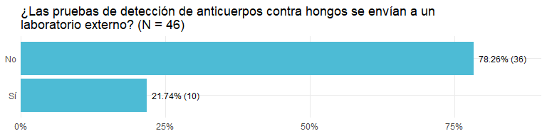

## ¿Las pruebas de detección de antígenos contra *Cryptococcus* están disponibles en su laboratio?

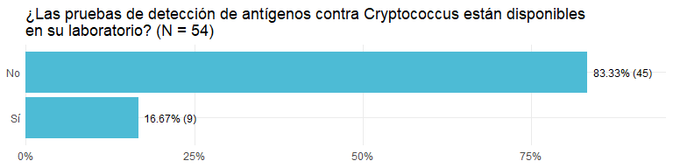

## ¿Las pruebas de detección de antígenos contra *Cryptococcus* están disponibles en otro laboratorio del hospital?

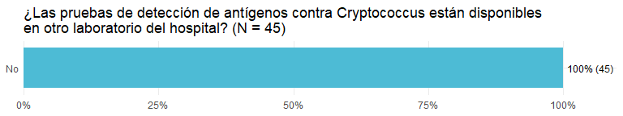

## ¿Las pruebas de detección de antígenos contra Cryptococcus se envían a un laboratorio externo?

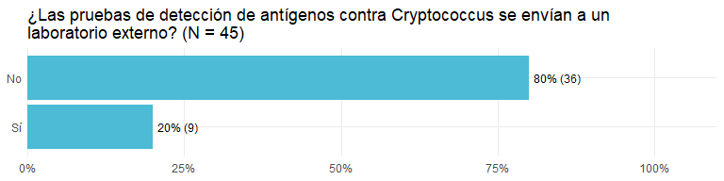

## Are antigen detection tests for Cryptococcus available in your laboratory?

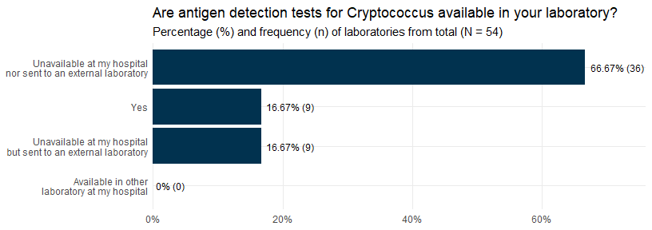

## Which antigen detection tests for Cryptococcus are available in your laboratory or hospital?

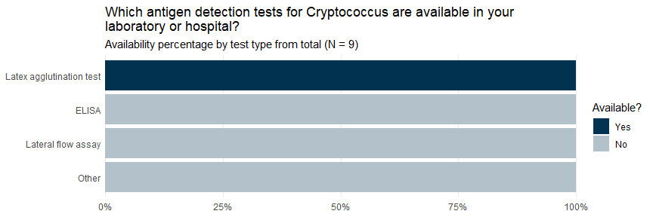

## Are antigen detection tests for Histoplasma capsulatum available in your laboratory?

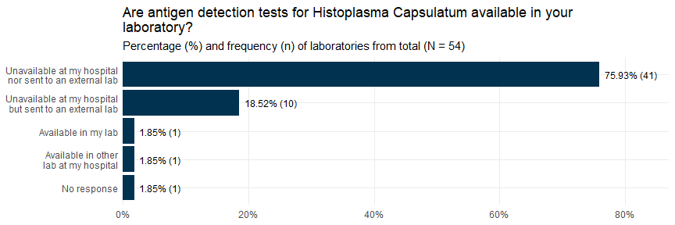

## Are antigen detection tests for Aspergillus sp. available in your laboratory?

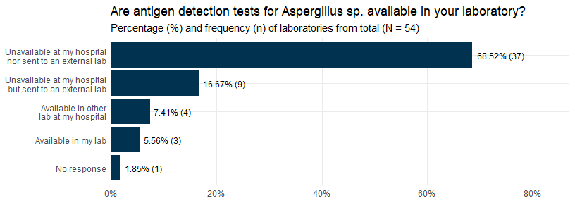

# Molecular diagnosis

## Are PCR tests for the diagnosis of fungi available in your laboratory/hospital?

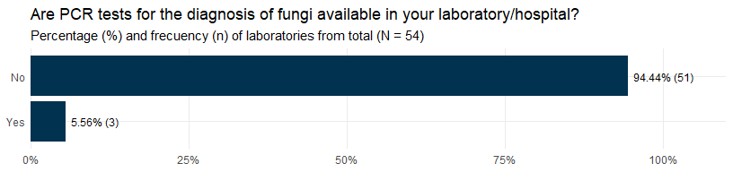

## Available PCR tests for the diagnosis of fungi

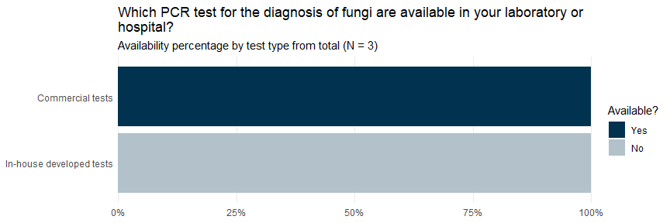

# Other capacities

## Available antifungals for the treatment of patients

