Encuesta sobre servicios de diagnóstico de laboratorios de micología en Perú

Resultados

Diego Villa

31 October, 2022

Table of Contents

# General information

## Departament where the hospital/laboratory is located

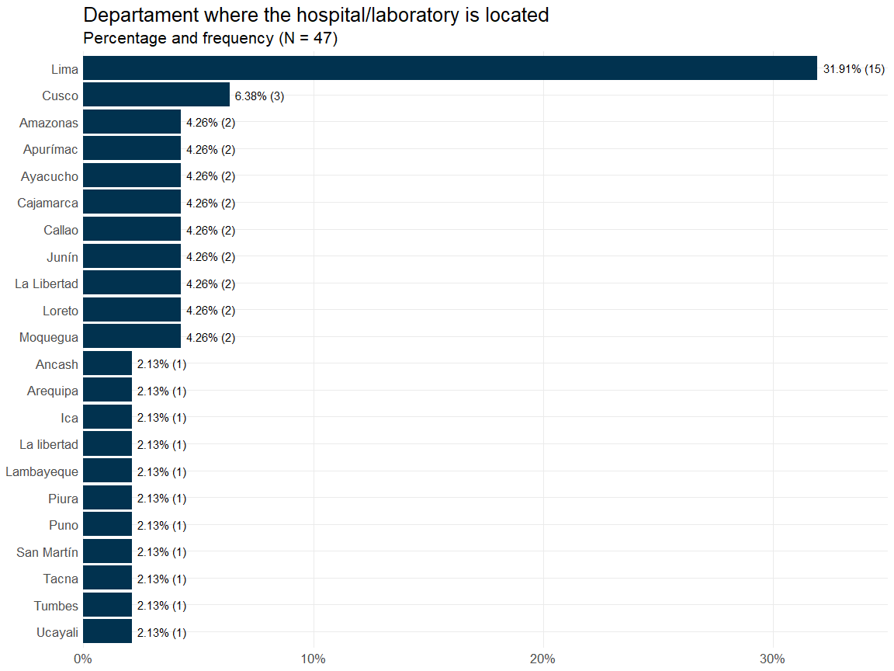

## Time the laboratory has been carrying out mycological diagnoses

| Variable | N = 47 |
| --- | --- |
| Time the laboratory has been carrying out mycological diagnoses1 |  |
| Responses | 47 |
| Range | 0, 56 |
| Median (IQR) | 9.00 (4.50, 21.50) |
| Mean (SD) | 14.19 (13.83) |
| 1Years | |

### Time the laboratory has been carrying out mycological diagnoses by region

| Variable | Lima, N = 15 | Other departments, N = 32 | Overall, N = 47 |
| --- | --- | --- | --- |
| Time the laboratory has been carrying out mycological diagnoses1 |  |  |  |
| Responses | 15 | 32 | 47 |
| Range | 4, 50 | 0, 56 | 0, 56 |
| Median (IQR) | 20.00 (8.50, 22.50) | 6.50 (3.75, 13.25) | 9.00 (4.50, 21.50) |
| Mean (SD) | 18.33 (11.98) | 12.25 (14.38) | 14.19 (13.83) |
| 1Years | | | |

### Time the laboratory has been carrying out mycological diagnoses by capacity

| Variable | Low capacity, N = 16 | High capacity, N = 31 | Overall, N = 47 |
| --- | --- | --- | --- |
| Time the laboratory has been carrying out mycological diagnoses1 |  |  |  |
| Responses | 16 | 31 | 47 |
| Range | 0, 31 | 1, 56 | 0, 56 |
| Median (IQR) | 5.00 (3.50, 8.00) | 15.00 (5.50, 25.00) | 9.00 (4.50, 21.50) |
| Mean (SD) | 7.44 (8.25) | 17.68 (14.91) | 14.19 (13.83) |
| 1Years | | | |

# Additional information about the hospital/health facility the laboratory belongs

## Total number of hospital beds

### Total number of hospital beds by region

| Variable | Lima, N = 15 | Other departments, N = 32 | Overall, N = 47 |
| --- | --- | --- | --- |
| Total number of hospital beds |  |  |  |
| Responses | 14 | 31 | 45 |
| Range | 0, 1,000 | 0, 565 | 0, 1,000 |
| Median (IQR) | 173.00 (100.00, 399.50) | 100.00 (8.50, 220.00) | 100.00 (25.00, 280.00) |
| Mean (SD) | 271.43 (269.37) | 129.35 (142.99) | 173.56 (199.50) |
| No response | 1 | 1 | 2 |

### Total number of hospital beds by capacity

| Variable | Low capacity, N = 16 | High capacity, N = 31 | Overall, N = 47 |
| --- | --- | --- | --- |
| Total number of hospital beds |  |  |  |
| Responses | 15 | 30 | 45 |
| Range | 0, 302 | 0, 1,000 | 0, 1,000 |
| Median (IQR) | 40.00 (13.00, 110.00) | 199.00 (26.25, 327.50) | 100.00 (25.00, 280.00) |
| Mean (SD) | 78.93 (87.42) | 220.87 (223.05) | 173.56 (199.50) |
| No response | 1 | 1 | 2 |

## Available services in the hospital/health facility

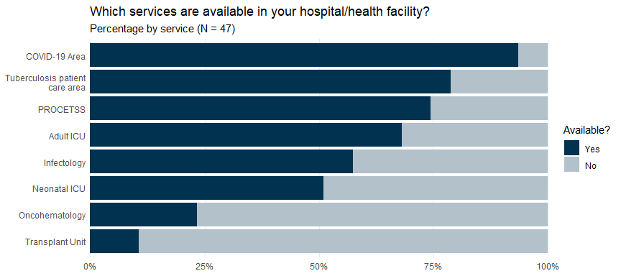

# Additional information about the micology/microbiology laboratory

## Approximate area of the microbiology work zone

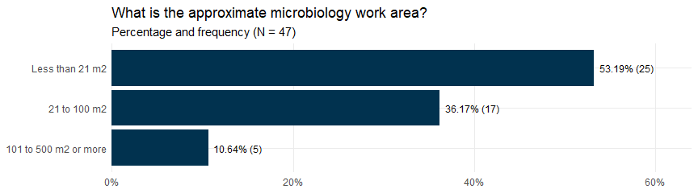

## Separated work zone for fungal diagnostic tests

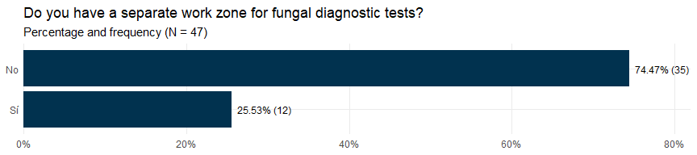

## Work zone area for fungal diagnostic tests

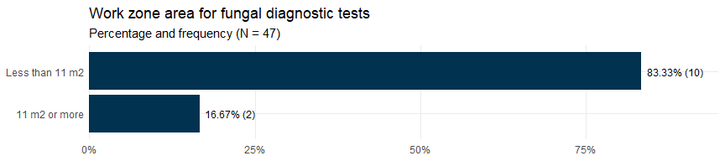

## Available equipments for the diagnostic of fungi

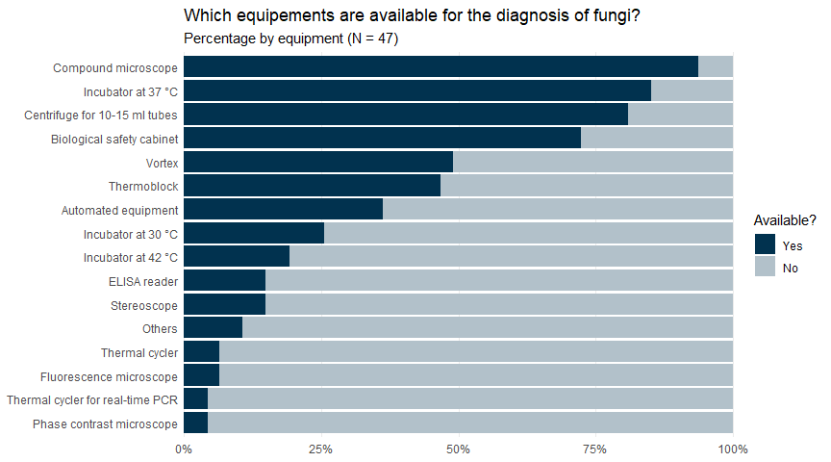

# Accreditation and quality assessment

## Participation of the mycology laboratory in an external quality assessment scheme

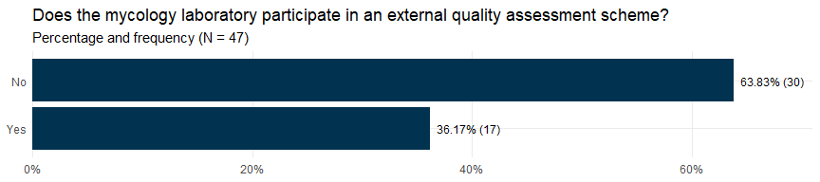

## Areas in which the mycology laboratory is evaluated

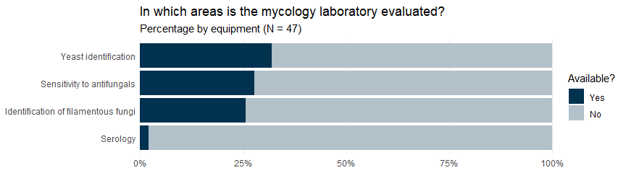

# Human resources

## Technical staff in the microbiology laboratory

| Variable | N = 47 |
| --- | --- |
| Technical staff in the microbiology laboratory |  |
| Responses | 46 |
| Range | 0, 20 |
| Median (IQR) | 1.00 (1.00, 2.00) |
| Mean (SD) | 2.57 (3.87) |
| No response | 1 |

## Technical staff in the microbiology laboratory by region

| Variable | Lima, N = 15 | Other departments, N = 32 | Overall, N = 47 |
| --- | --- | --- | --- |
| Technical staff in the microbiology laboratory |  |  |  |
| Responses | 14 | 32 | 46 |
| Range | 1, 11 | 0, 20 | 0, 20 |
| Median (IQR) | 2.00 (1.00, 3.00) | 1.00 (0.75, 2.00) | 1.00 (1.00, 2.00) |
| Mean (SD) | 2.86 (2.82) | 2.44 (4.29) | 2.57 (3.87) |
| No response | 1 | 0 | 1 |

## Technical staff in the microbiology laboratory by capacity

| Variable | Low capacity, N = 16 | High capacity, N = 31 | Overall, N = 47 |
| --- | --- | --- | --- |
| Technical staff in the microbiology laboratory |  |  |  |
| Responses | 16 | 30 | 46 |
| Range | 0, 20 | 0, 15 | 0, 20 |
| Median (IQR) | 2.00 (1.00, 2.25) | 1.00 (1.00, 2.00) | 1.00 (1.00, 2.00) |
| Mean (SD) | 3.25 (4.95) | 2.20 (3.20) | 2.57 (3.87) |
| No response | 0 | 1 | 1 |

## Professional staff in the microbiology laboratory

| Variable | N = 47 |
| --- | --- |
| Professional staff in the microbiology laboratory |  |
| Responses | 46 |
| Range | 0, 28 |
| Median (IQR) | 3.00 (1.00, 4.00) |
| Mean (SD) | 4.59 (6.05) |
| No response | 1 |

### Professional staff in the microbiology laboratory by region

| Variable | Lima, N = 15 | Other departments, N = 32 | Overall, N = 47 |
| --- | --- | --- | --- |
| Professional staff in the microbiology laboratory |  |  |  |
| Responses | 14 | 32 | 46 |
| Range | 1, 28 | 0, 20 | 0, 28 |
| Median (IQR) | 3.00 (3.00, 5.75) | 2.00 (1.00, 3.00) | 3.00 (1.00, 4.00) |
| Mean (SD) | 7.36 (8.75) | 3.38 (4.01) | 4.59 (6.05) |
| No response | 1 | 0 | 1 |

### Professional staff in the microbiology laboratory by capacity

| Variable | Low capacity, N = 16 | High capacity, N = 31 | Overall, N = 47 |
| --- | --- | --- | --- |
| Professional staff in the microbiology laboratory |  |  |  |
| Responses | 16 | 30 | 46 |
| Range | 0, 7 | 1, 28 | 0, 28 |
| Median (IQR) | 3.00 (1.00, 3.00) | 3.00 (1.25, 5.00) | 3.00 (1.00, 4.00) |
| Mean (SD) | 2.62 (1.82) | 5.63 (7.20) | 4.59 (6.05) |
| No response | 0 | 1 | 1 |

## Total staff in the microbiology laboratory

| Variable | N = 47 |
| --- | --- |
| Total staff in the microbiology laboratory |  |
| Responses | 46 |
| Range | 1, 35 |
| Median (IQR) | 4.00 (2.00, 6.75) |
| Mean (SD) | 7.15 (8.47) |
| No response | 1 |

### Total staff in the microbiology laboratory by region

| Variable | Lima, N = 15 | Other departments, N = 32 | Overall, N = 47 |
| --- | --- | --- | --- |
| Total staff in the microbiology laboratory |  |  |  |
| Responses | 14 | 32 | 46 |
| Range | 2, 32 | 1, 35 | 1, 35 |
| Median (IQR) | 5.50 (4.00, 9.00) | 3.50 (2.00, 5.25) | 4.00 (2.00, 6.75) |
| Mean (SD) | 10.21 (10.06) | 5.81 (7.46) | 7.15 (8.47) |
| No response | 1 | 0 | 1 |

### Total staff in the microbiology laboratory by capacity

| Variable | Low capacity, N = 16 | High capacity, N = 31 | Overall, N = 47 |
| --- | --- | --- | --- |
| Total staff in the microbiology laboratory |  |  |  |
| Responses | 16 | 30 | 46 |
| Range | 1, 27 | 1, 35 | 1, 35 |
| Median (IQR) | 4.00 (2.75, 5.25) | 4.00 (2.00, 7.00) | 4.00 (2.00, 6.75) |
| Mean (SD) | 5.88 (6.47) | 7.83 (9.40) | 7.15 (8.47) |
| No response | 0 | 1 | 1 |

## Total staff in the mycology area

| Variable | N = 47 |
| --- | --- |
| Total staff in the mycology area |  |
| Responses | 40 |
| Range | 0, 6 |
| Median (IQR) | 1.00 (1.00, 3.00) |
| Mean (SD) | 1.73 (1.57) |
| No response | 7 |

### Total staff in the mycology area by region

| Variable | Lima, N = 15 | Other departments, N = 32 | Overall, N = 47 |
| --- | --- | --- | --- |
| Total staff in the mycology area |  |  |  |
| Responses | 12 | 28 | 40 |
| Range | 0, 5 | 0, 6 | 0, 6 |
| Median (IQR) | 1.00 (1.00, 1.50) | 1.00 (1.00, 3.00) | 1.00 (1.00, 3.00) |
| Mean (SD) | 1.58 (1.56) | 1.79 (1.60) | 1.73 (1.57) |
| No response | 3 | 4 | 7 |

### Total staff in the mycology area by capacity

| Variable | Low capacity, N = 16 | High capacity, N = 31 | Overall, N = 47 |
| --- | --- | --- | --- |
| Total staff in the mycology area |  |  |  |
| Responses | 14 | 26 | 40 |
| Range | 0, 6 | 0, 5 | 0, 6 |
| Median (IQR) | 1.50 (1.00, 3.00) | 1.00 (1.00, 2.50) | 1.00 (1.00, 3.00) |
| Mean (SD) | 2.21 (1.76) | 1.46 (1.42) | 1.73 (1.57) |
| No response | 2 | 5 | 7 |

## Mycology training/education program for mycology laboratory staff

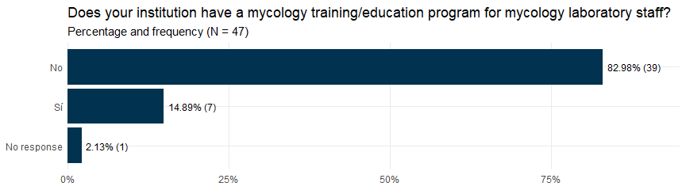

## Times a year the mycology trainigs are held

| Variable | N = 7 |
| --- | --- |
| Times a year the mycology trainigs are held |  |
| Responses | 7 |
| Range | 1, 4 |
| Median (IQR) | 2.00 (1.00, 2.00) |
| Mean (SD) | 1.86 (1.07) |

## Training to other areas of the hospital/health facility

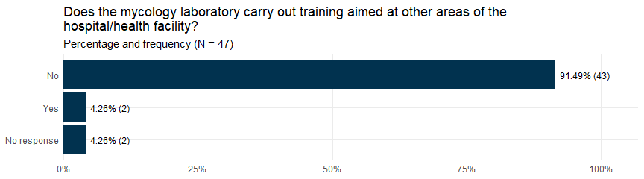

## Audience of the trainings carried out by the mycology laboratory

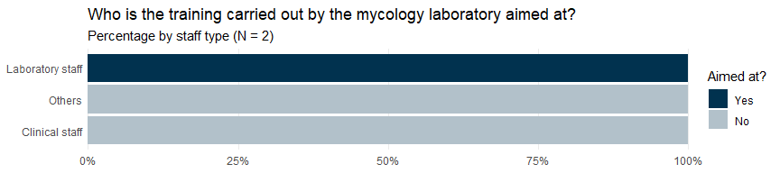

# Internal demand for mycological tests

## Average number of samples for mycosis diagnosis before COVID-19

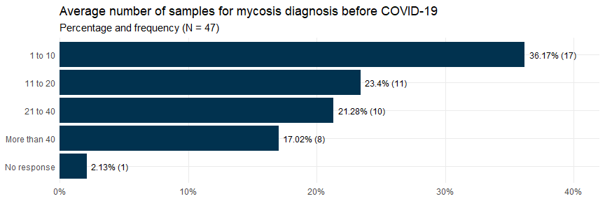

## Average number of samples for mycosis diagnosis in the last 3 months

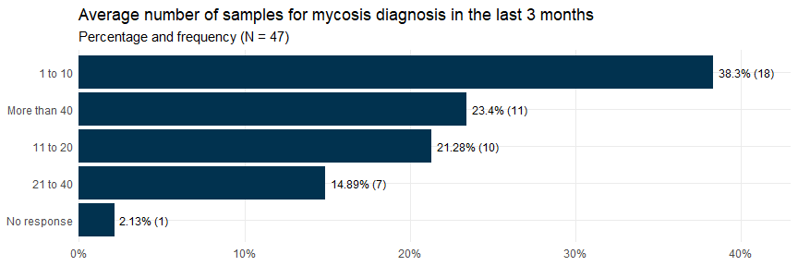

## Departments/units that have sent samples for the diagnosis of mycoses

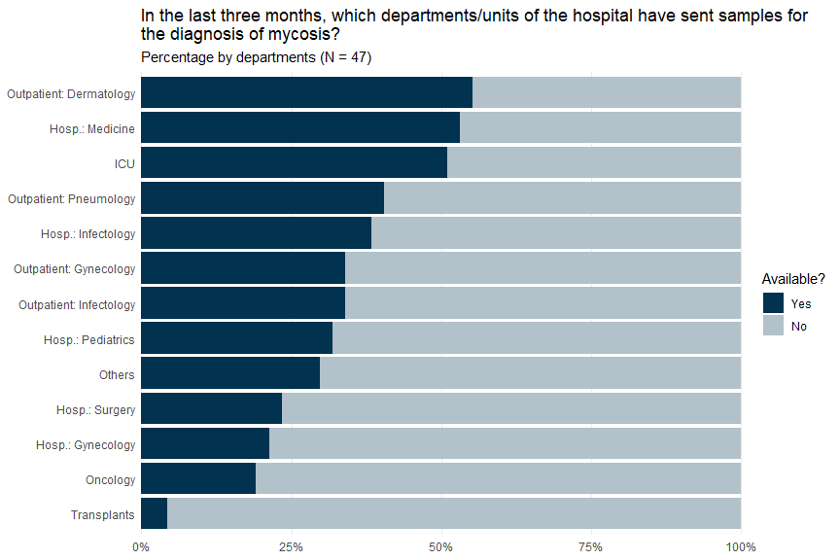

## Most frequent sample types processed in the last 3 months

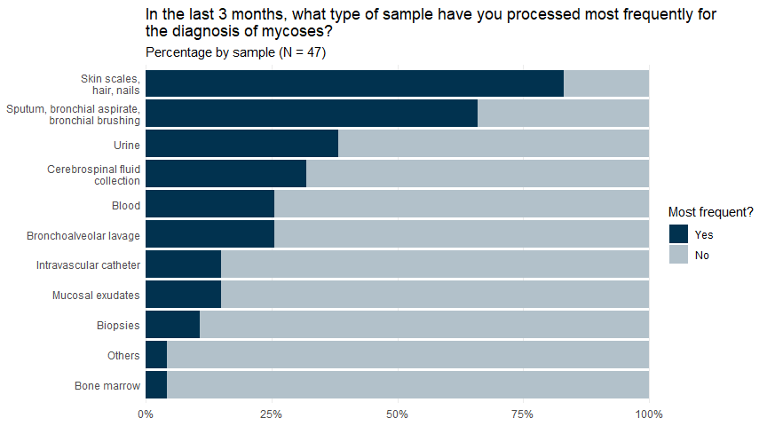

## Average number of processed samples (last 3 months)

| Average number of processed samples (last 3 months) |  |
| --- | --- |
| Skin scales, hair or nails |  |
| Responses | 39 |
| Range | 1, 70 |
| Median (IQR) | 10 (5.00, 20) |
| Mean (SD) | 16 (17) |
| No response | 0 |
| Sputum, bronchoaspirate or bronchial brushing |  |
| Responses | 31 |
| Range | 1, 500 |
| Median (IQR) | 12 (10.00, 50) |
| Mean (SD) | 49 (96) |
| No response | 0 |
| Mucosal exudates |  |
| Responses | 7 |
| Range | 5, 150 |
| Median (IQR) | 20 (12.50, 52) |
| Mean (SD) | 44 (51) |
| No response | 0 |
| Biopsies |  |
| Responses | 5 |
| Range | 1, 15 |
| Median (IQR) | 5 (1.00, 8) |
| Mean (SD) | 6 (6) |
| No response | 0 |
| Urine |  |
| Responses | 18 |
| Range | 3, 11,000 |
| Median (IQR) | 42 (16.25, 288) |
| Mean (SD) | 784 (2,564) |
| No response | 0 |
| Blood |  |
| Responses | 12 |
| Range | 3, 1,000 |
| Median (IQR) | 125 (24.50, 362) |
| Mean (SD) | 270 (364) |
| No response | 0 |
| Intravascular catheter |  |
| Responses | 7 |
| Range | 4, 200 |
| Median (IQR) | 10 (10.00, 40) |
| Mean (SD) | 45 (71) |
| No response | 0 |
| Cerebrospinal fluid collection |  |
| Responses | 15 |
| Range | 5, 120 |
| Median (IQR) | 12 (8.00, 20) |
| Mean (SD) | 22 (29) |
| No response | 0 |
| Bone marrow |  |
| Responses | 2 |
| Range | 3, 3 |
| Median (IQR) | 3 (3.00, 3) |
| Mean (SD) | 3 (0) |
| No response | 0 |

# Microscopic examinations

## Does the mycology laboratory perform microscopic examinations?

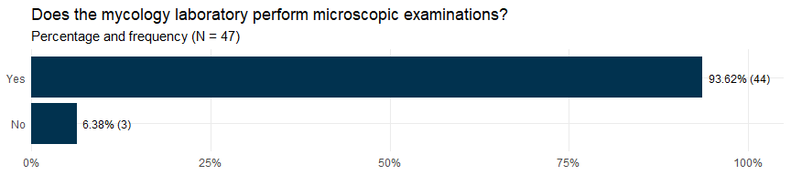

## Available microscopic examinations

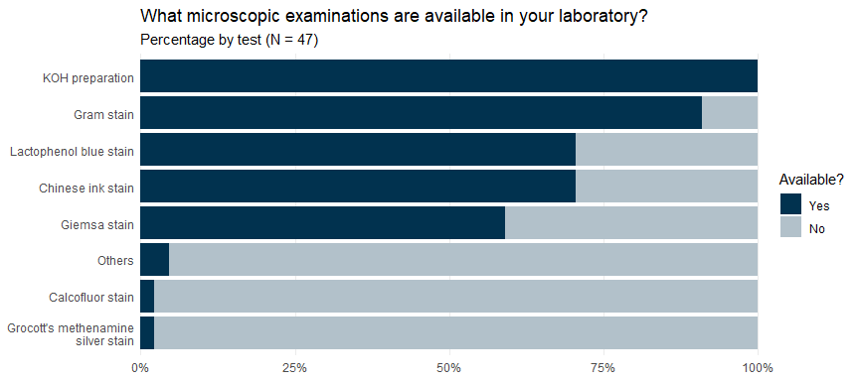

## Delivery time of Chinese ink stain test results

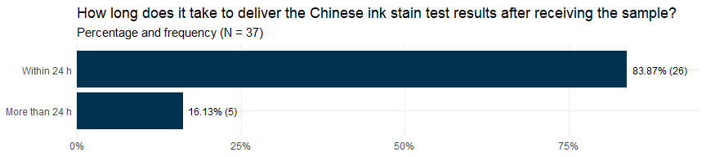

## Delivery time of Giemsa ink stain test results

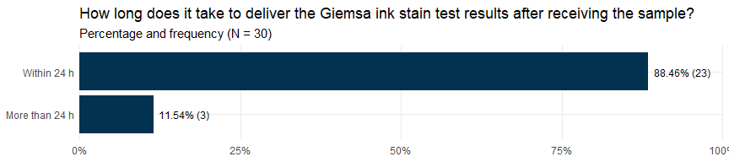

## Results delivery method

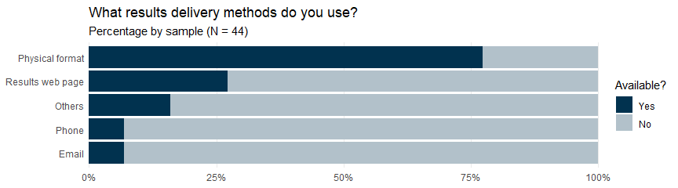

# Fungal identification: Yeast

## Available culture medias for yeast identification

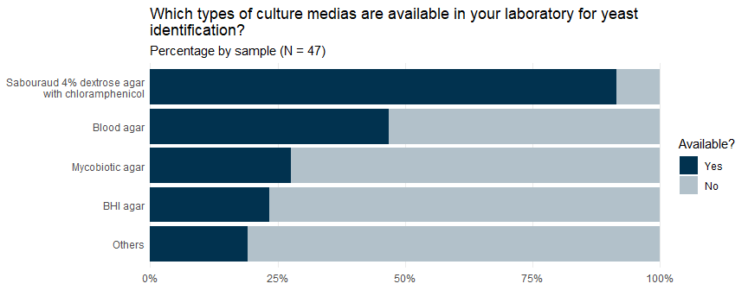

## Does the laboratory has yeast identification systems?

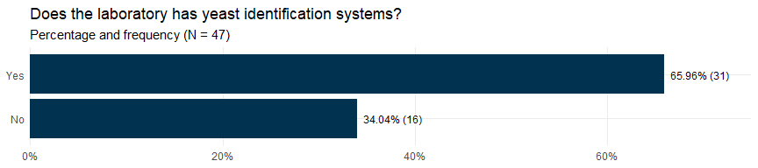

## Available yeast identification systems

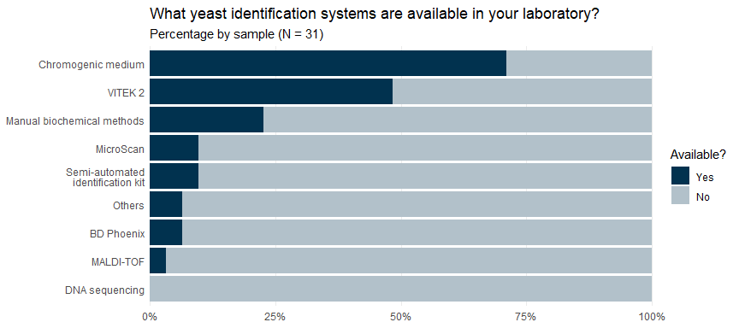

## Routine storage of clinical yeast isolates

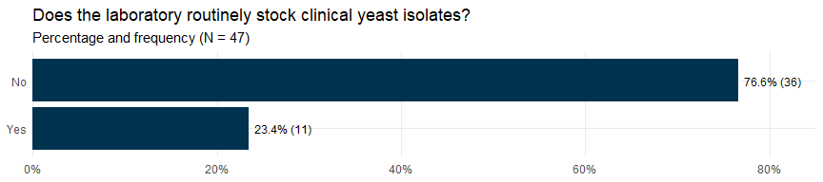

# Fungal identification: Mold (Filamentous/Dimorphic Fungi)

## Available culture medias for mold identification

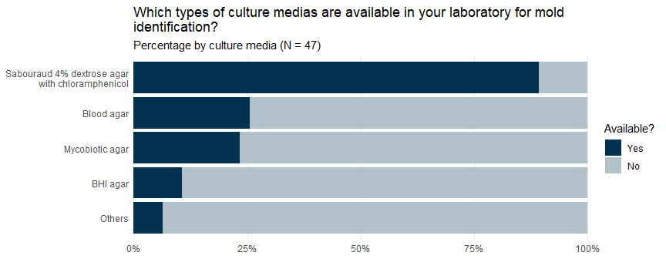

## Does the laboratory has mold identification systems?

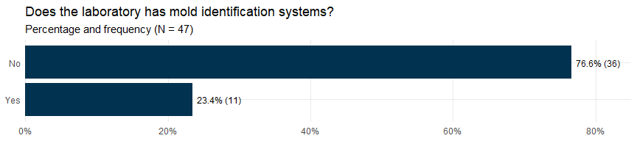

## Does the laboratory send mold isolates to external labs for identification?

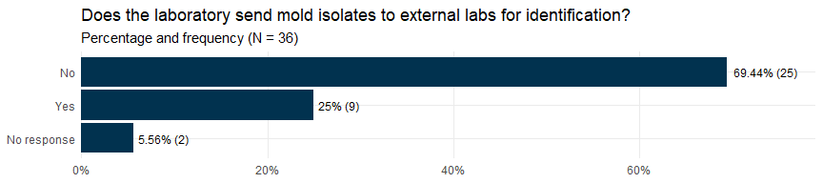

## Available mold identification systems

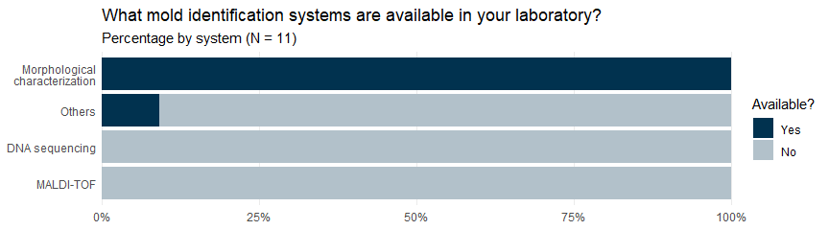

## Routine storage of clinical yeast isolates

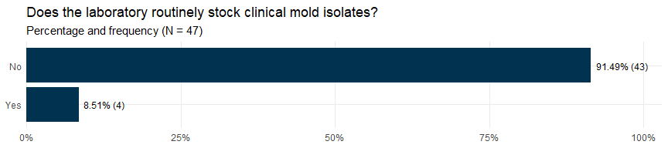

# Antifungal susceptibility testing

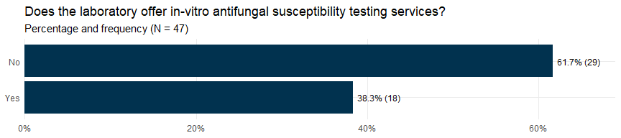

## Does the laboratory perform the antifungal susceptibility tests or are they sent to an external laboratory?

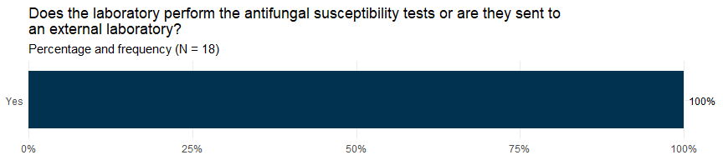

## What types of fungi are antifungal susceptibility tests available for?

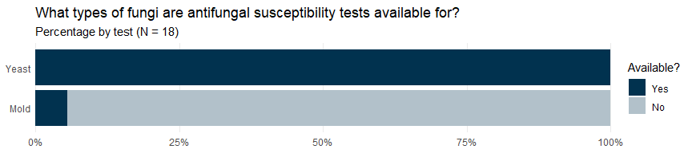

# Serological tests

## Are antibody tests against fungi (*Aspergillus sp.*, *Histoplasma capsulatum*, *Paracoccidioides brasiliensis*) available in your laboratory?

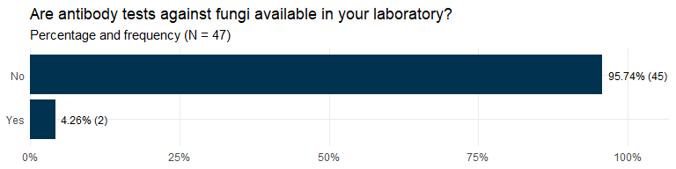

## Are antibody tests against fungi available in another laboratory in your hospital?

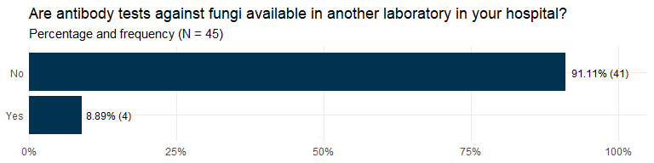

## Are the tests for the detection of antibodies against fungi sent to an external laboratory?

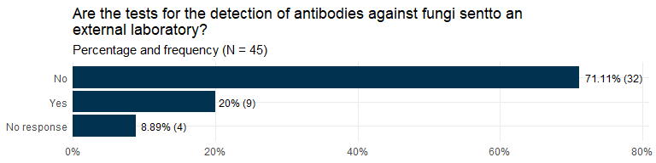

## Are *Cryptococcus* antigen detection tests available in your laboratory?

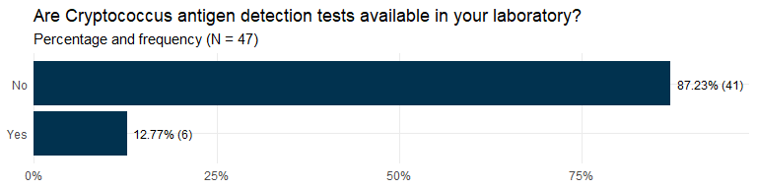

## Are *Cryptococcus* antigen tests available at another hospital lab?

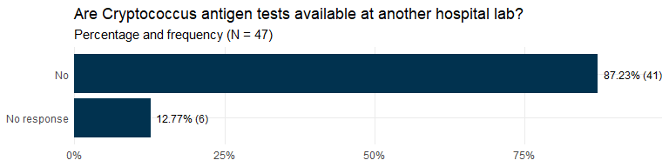

## Are Cryptococcus antigen tests sent to an external laboratory?

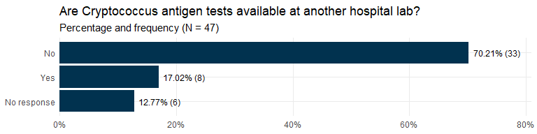

## Are antigen detection tests for Cryptococcus available in your laboratory?

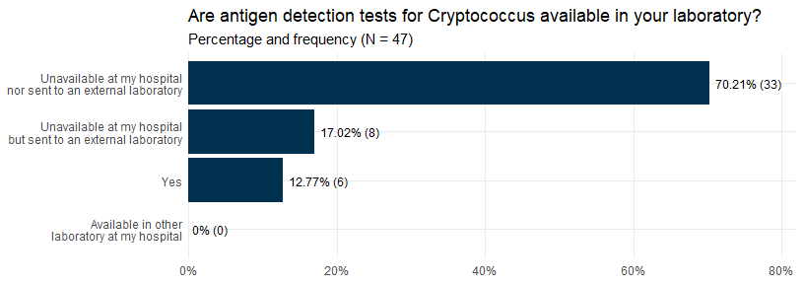

## Which antigen detection tests for Cryptococcus are available in your laboratory or hospital?

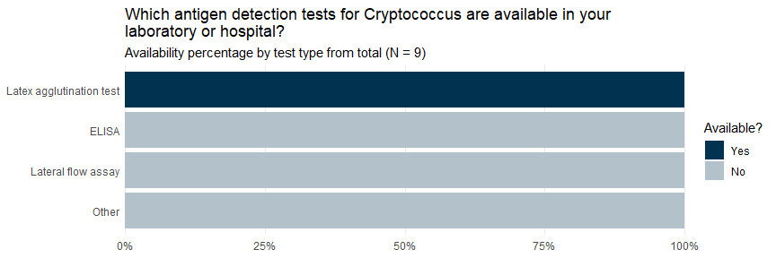

## Are antigen detection tests for Histoplasma capsulatum available in your laboratory?

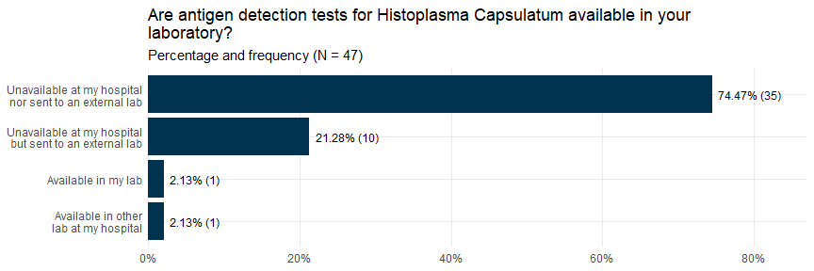

## Are antigen detection tests for Aspergillus sp. available in your laboratory?

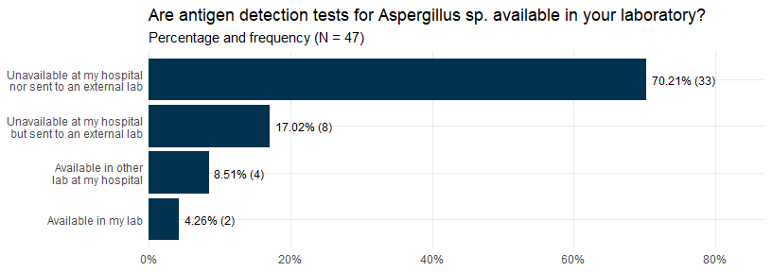

# Molecular diagnosis

## Are PCR tests for the diagnosis of fungi available in your laboratory/hospital?

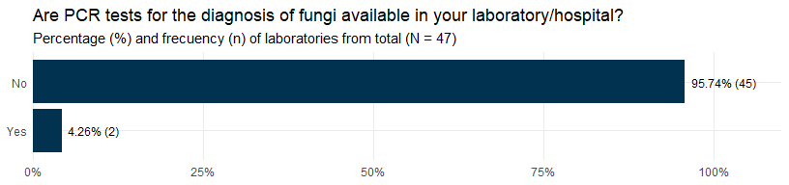

## Available PCR tests for the diagnosis of fungi

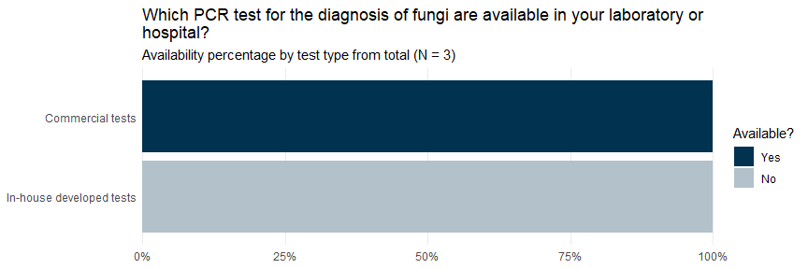

# Other capacities

## Available antifungals for the treatment of patients

