Mysql主从复制
- 在master上面创建专有用户，并授予其复制权限用于主从复制数据。
创建用户：
CREATE USER 'repl_1' IDENTIFIED BY 'acsno';
给用户授权：
GRANT REPLICATION SLAVE ON *.* TO 'repl_1';
If you have existing data on your master that you want to synchronize on your slaves before starting the replication process, you must stop processing statements on the master, and then obtain its current binary log coordinates and dump its data, before permitting the master to continue executing statements. If you do not stop the execution of statements, the data dump and the master status information that you use will not match and you will end up with inconsistent or corrupted databases on the slaves.
- 在你同步数据到从数据库时，若master已经有数据了，在复制前必须使mysql的所有进程停掉。

出现slave的两个线程起不来的解决办法：
mysql> stop slave;
Query OK, 0 rows affected (0.00 sec)

mysql> reset slave;
Query OK, 0 rows affected (0.25 sec)

mysql> change master to master_log_file='mysql-bin.000001', master_log_pos=670;
Query OK, 0 rows affected (0.35 sec)

mysql> start slave;
Query OK, 0 rows affected (0.00 sec)
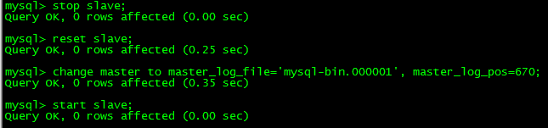
查看slave的状态：
