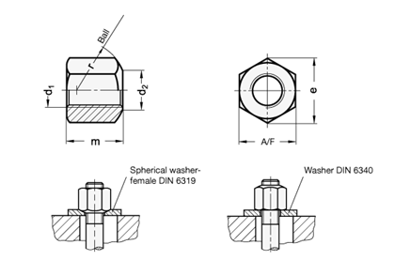

|  |  |  |  |  |  |  |
| --- | --- | --- | --- | --- | --- | --- |
| **d1** | **d2 H14** | **e min.** | **m** | **A/F** | **r** | **Quantidade** |
| M 12 | 14 | 20 | 18 | 18 | 17 | **8.000** |
| M 16 | 18 | 26.8 | 24 | 24 | 22 | **2.700** |