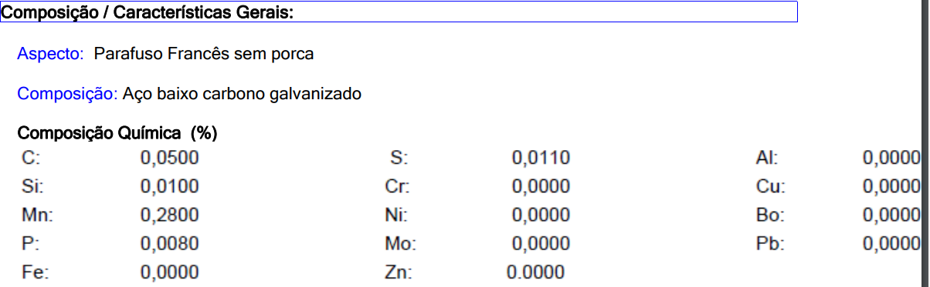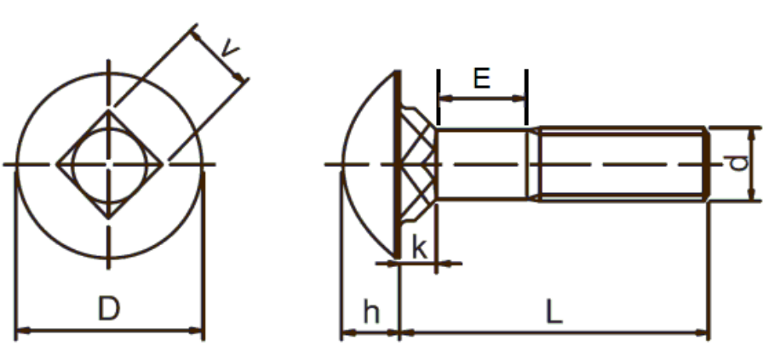

D (diâmetro cabeça/ head diameter) mm 19,8 - 21,4 MTU-100 ANSI / ASME B 18. 5

V (quadrado/square neck size) mm 9,25 - 9,85 MTU-100 ANSI / ASME B 18. 5

E (pescoço/ neck) mm máx 2,0 MTU-100 ANSI / ASME B 18. 5

k (altura quadrado/square neck height) mm 5,16 +/- 0,4 MTU-100 ANSI / ASME B 18. 5

h (altura cabeça/ head height) mm 4,78 - 5,28 MTU-100 ANSI / ASME B 18. 5

Bitola (External Thread Diameter) pol (in) 3/8 MTU-100 ANSI / ASME B 18. 5 CC Comprimento (Length) pol (in) 2 MTU-100 ANSI / ASME B 18. 5

**Frances 3/8x2 sem porcas, zincado branco**