Assignment 3 Report
Name: Didier Fernando Salazar Estrada
Institution (school): National Tsing Hua University (NTHU)
Student ID: 113065892
Platform (Colab/Kaggle/Local): Local
Python version: 3.11.14
Operating system: Linux – Ubuntu 22.04.4 LTS
CPU: AMD Ryzen 7 2700X Eight-Core Processor (2 threads per core)
GPU requirement: Server with 2 GPUs: NVIDIA GeForce RTX 3090 (Used this one for training) and NVIDIA GeForce GTX 1070 Ti (not used). CUDA Version 12.2 (changed to this server due to GPT-2 not working in the previous one I worked for previous assignments because of having older CUDA 11.8)
For full exercises’ results the following GitHub Repository can be checked: https://github.com/difersalest/NLP-Exercise-3
I was not so clean with the code comments when running the experiments with the additional models in the repository, but I tried to record everything I tried.
Remark: For ease of grading, you are encouraged to present data in textual form rather than as images.

- Train a RoBERTa-base model on the same dataset and report the performance of both BERT-base and RoBERTa-base models. (10%)
Results:
Table 1 – Baseline hyperparameters for experiments with BERT, RoBERTa and GPT-2. Models used: bert-base-uncased (110M param), roberta-base (125M param) and gpt2 (117M param small version). All models from huggingface transformers’ library.
Hyperparameters | Values
Batch Size (train/val) | 8
Epochs | 3
Learning Rate | 3e-5
Multi-Output Model Architecture | BERT/RoBERTa/GPT-2 Model  Dropout: 0.3  Linear Layers: Regression (1 dim) and Classification Heads (3 dims)
Loss functions | Cross-Entropy Loss for classification and MSE Loss for Regression
Multi-Output Loss Pooling Method | Simple Addition of the Losses of both tasks.
Optimizer | AdamW

Table 2 – Test set results with both BERT-base and RoBERTa-base models trained on 3 epochs with baseline hyperparameters.
Models | Pearson Correlation | Accuracy
BERT-base-uncased  (Fig. 9) | 0.8772 | 0.8593
RoBERTa-base  (Fig. 10) | 0.8953 | 0.8926

  - Discuss the main differences between BERT and RoBERTa, and explain how these differences may affect performance. (5%)
Answer:
From the original BERT paper Devlin et al. (2019) trained a model with an encoder architecture (As the full name indicates: Bidirectional Encoder Representations from Transformers) that can understand text better than previous models at the time, and that can be finetuned very easily with just one additional output layer, the final model size for BERT-base was of around 110M parameters. The amount of data used to trained BERT was around 16 GB (Phung, T. M., 2023). The RoBERTa model, as the name indicates, builds upon the BERT model (still encoder architecture) making improvements on the original design, like implementing dynamic masking for predicting tokens instead of the original static one, and also getting rid of the Next Sentence Prediction loss that was thought to be important in BERT’s original architecture, but then later on Radford et al. (2019) found that without it and training with blocks of text from a single document, they could outperform the original model. RoBERTa was trained with 160 GB with the previously mentioned improvements and other optimizations from BERT, and the final model size for RoBERTa-base was 125M parameters.
So with this in mind we can observe in Table 1 the hyperparameters for the experiment and Table 2 for the results on our test set, and we can see that it correlates with our understanding, that with the same settings RoBERTa base outperforms BERT base uncased, which might stem from the fact that RoBERTa base for our sentence pair classification and regression predictions finetuning can learn more because it understands the language better than BERT as it already has learned good representations in its pre-training.
- Train a GPT-2 model on the same dataset and evaluate its performance. (10%)
Results:
Table 3 – Test set results with both BERT-base and GPT-2 models trained on 3 epochs with baseline hyperparameters.
Models | Pearson Correlation | Accuracy
BERT-base-uncased  (Fig. 9) | 0.8772 | 0.8593
GPT-2  (Fig. 11) | 0.8399 | 0.8534

  - What are the main difference of BERT and GPT2? Discuss the main differences between BERT and GPT-2, and analyze how these differences influence their performance. (5%)
Answer:
Like mentioned before, BERT uses an Encoder architecture based on transformer blocks, which is suitable when trying to understand the whole input sequence at once for subsequent language tasks, while GPT-2 uses a decoder architecture based on transformer blocks, which is suitable for zero-shot generation setting, because it was trained in an auto-regressive way to predict the next token (Radford et al., 2019) (Alammar, 2024). So the main difference is that BERT can see both sides of a word, while GPT-2 can only see one side when generating the next token.
So with this understanding of both models we can now understand Table 3 values, where BERT seems to outperform GPT-2 on both tasks. BERT-base-uncased size is 110M parameters and the GPT-2 Small size used is 117M parameters, so there is not much difference in the size part, so while GPT-2 might be well suited for few-shot language task understanding, because of the limitation of only being able to look at one side of the word maybe for this task of sentence pair classification/regression it didn’t reach an as good understanding as BERT that can Encode and pool-in the whole representation at once.
- Compare the performance of a multi-output learning model with BERT models trained separately on each sub-task. Does multi-output learning improve performance? Explain why or why not. (5%)
Answer:
Table 4 – Test set results with both BERT-base multioutput model and separate BERT-base models for both regression and multi-label classification tasks trained on 3 epochs with baseline hyperparameters.
Models | Pearson Correlation | Accuracy
BERT-base-uncased multioutput  (Fig. 9) | 0.8772 | 0.8593
Separate BERT-base models output  (Fig. 12) | 0.8881 | 0.8794

It seems that by training the model in a separate way we can obtain better results than the multi-output method for both tasks. This can be due to the loss pooling method in the multi-output model for these distinct tasks of regression and classification, the one tried was a simple addition of the losses, maybe it can introduce some noise when training the model that can limit the learning ability for both tasks.
- Why does your model fail to correctly predict some data points? Please provide an error analysis and introduce how do you improve your performance. (10%)
Answer:
Fig. 1 – BERT Multi-Output Model Results for Relatedness Scores and Entailment Judgement with baseline hyperparameters explained in Table 1.
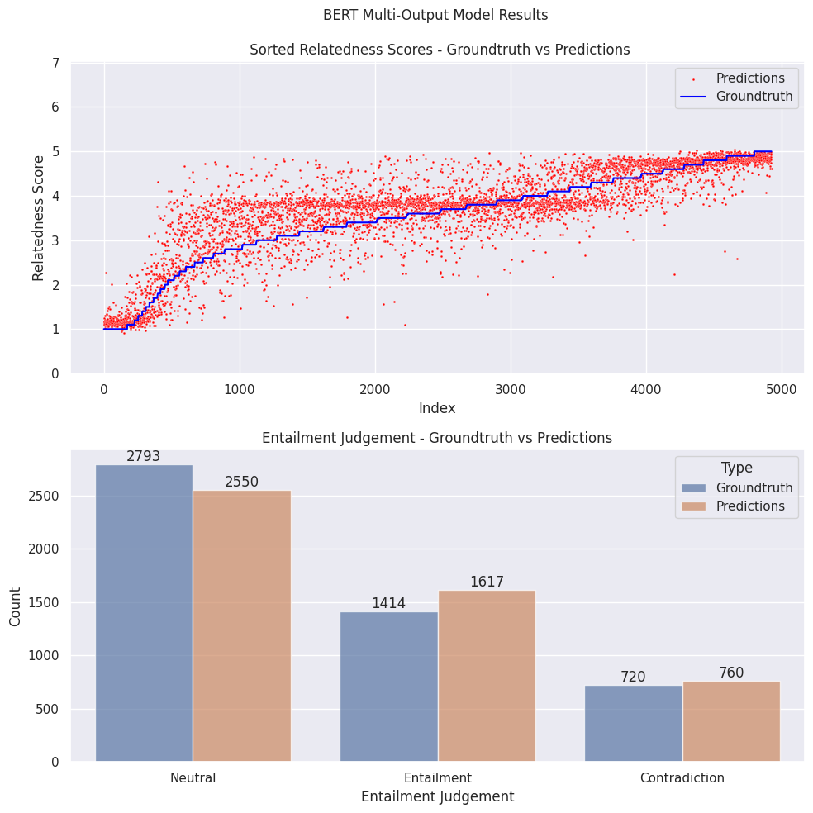
Fig. 2 – Baseline BERT Multi-Output Model Confusion Matrix.
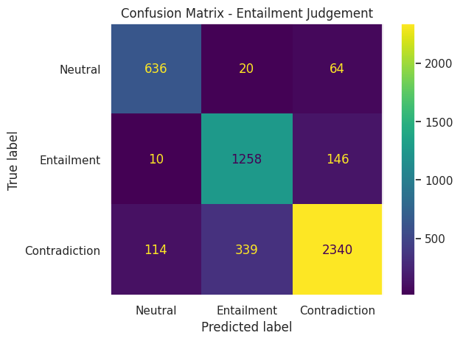
Fig. 3 – Baseline BERT Multi-Output Model Classification Report.
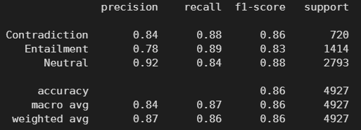
Fig. 4 – Top 5 sentence pairs with highest difference in relatedness scores from real vs predicted with baseline BERT Multi-Output Model.
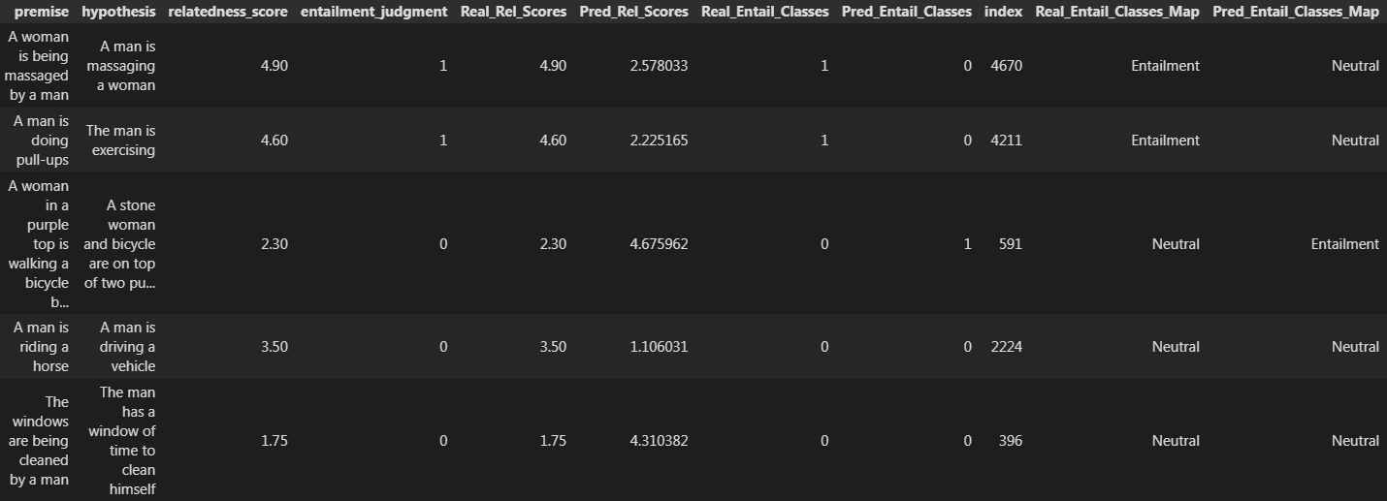

We can see from Fig. 1 that even though the relatedness score has high positive correlation with the ground-truth scores, the predicted ones are still too spread out against the real values. We can also see the Entailment Judgement results from Fig. 1, 2 and 3 where it seems that the model, even with less examples of contradiction in the training data seems to do better than Entailment, while Neutral does seem to do better because it has the highest distribution in the training data as shown in the F1 scores for the classes. Training data distribution: {Neutral: 2536, Entailment: 1299, Contradiction: 665}. So, this means the contradiction sentence pairs have features that the model can learn more easily, and this can also be seen in Fig 4 that when sorting for the Top 5 highest difference in relatedness scores we obtain sentence pairs that belong to the Entailment and Neutral classes, that were also misclassified.
So with these results in mind the approach to improve this model is to adapt a weighted loss calculation based on the distribution of our class labels, because we observe that the errors might stem from this label unbalanced distribution when training the model, and from this as starting point just finetune more hyperparameters.

From Table 5 we can observe that adding the weight for the cross-entropy loss does seem to help as a whole for both tasks when training with the same hyperparameters in 3 epochs, and another improvement upon the regression task is that when adding an intermediate Linear Layer between the regression and classification heads in the model does seem to capture better correlation with the data. So, upon finetuning with these big changes in mind we get to the best classification accuracy and second best pearson correlation with the following changes: Weighted cross-entropy loss, intermediate linear layer with 512 dim, Batch 4, and Learning Rate 1e-5.
Based on the results when changing to a lower batch (batch 4) we can see that the results obtained the best pearson correlation with 3 epochs, so we hypothesize that maybe training with lower batches (batch 2 or iterating over each sample) we might get better results. Due to time constraints this could not be tested.
The conclusion here is that even with everything tried, the accuracy is still not as good as the RoBERTa model trained on only 3 epochs, as seen in Table 2, and only marginally better for the pearson correlation when comparing the best model trained on 3 epochs (+0.0018), with 50 epochs the correlation is worse (-0.0046), so we can see the limitation of using BERT for this task compared to its improved counterpart RoBERTa.

Table 5 – Test set results from the experiments to improve the BERT-base-uncased multi-output model.
Models | Pearson Correlation | Accuracy
Baseline – 3 Epochs  (Fig. 9) | 0.8772 | 0.8593
Baseline – 50 epochs  (Fig. 13) | 0.8848 | 0.8766
With Weighted Loss – Other Hyperparameters the same – 3 Epochs  (Fig. 14) | 0.8777 | 0.8705
With Weighted Loss – Other Hyperparameters the same – 50 Epochs  (Fig. 15) | 0.8805 | 0.8583
With Weighted Loss – Added Intermediate Linear Layer (512 dim) - Other Hyperparameters the same – 3 Epochs  (Fig. 16) | 0.8839 | 0.8529
With Weighted Loss – Added Intermediate Linear Layer (512 dim) – Batch 16 and LR 1e-5 – Other Hyperparameters the same – 3 Epochs  (Fig. 17) | 0.8686 | 0.8391
With Weighted Loss – Added Intermediate Linear Layer (512 dim) – Batch 4 and LR 1e-5 – Other Hyperparameters the same – 3 Epochs  (Fig. 18) | 0.8971 | 0.8697
With Weighted Loss – Added Intermediate Linear Layer (512 dim) – Batch 4 and LR 1e-5 – Other Hyperparameters the same – 50 Epochs  (Fig. 19) | 0.8907 | 0.8861

Table 6 – Final best model’s hyperparameters and architecture using bert-base-uncased.
Hyperparameters | Values
Batch Size (train/val) | 4
Epochs | 50
Intermediate Linear Layer Hidden Dimension | 512
Learning Rate | 1e-5
Multi-Output Model Architecture | BERT Base Uncased Model  Dropout: 0.3  Intermediate Linear Layer: 512 dim size  ReLU Layer  Regression (1 dim) and Classification Heads (3 dims)
Loss functions | MSE Loss for Regression and Weighted Cross-Entropy Loss for Classification:  Using Inverse Frequency Weights:  Counting labels in train data:  {0: 2536, 1: 1299, 2: 665}  Weights: [0.5915, 1.1547, 2.2556]
Multi-Output Loss Pooling Method | Simple Addition of the Losses of both tasks.
Optimizer | AdamW

Fig. 5 – Final Best BERT Multi-Output Model Results for Relatedness Scores and Entailment Judgement with hyperparameters explained in Table 6.
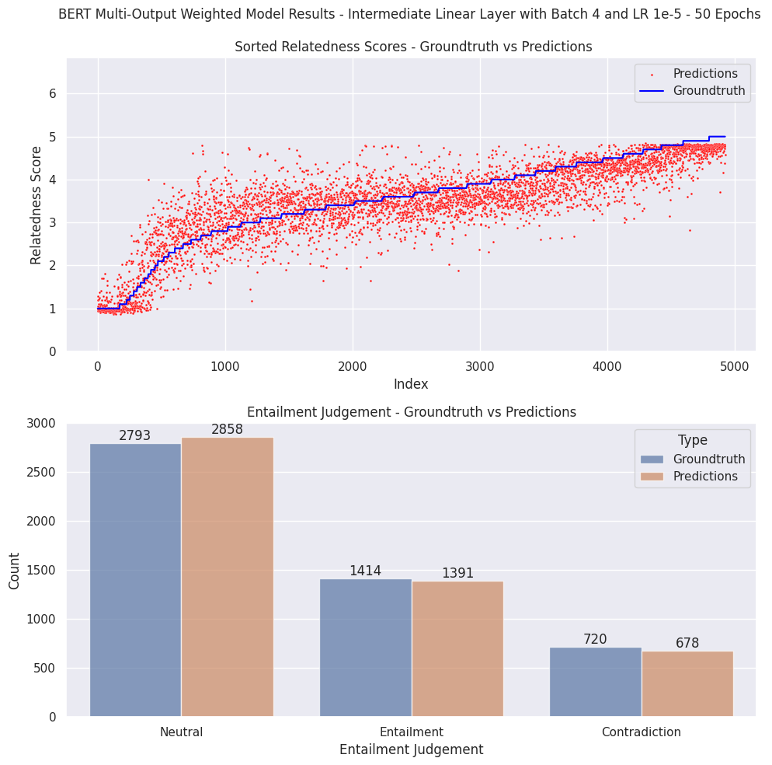
Fig. 6 – Final Best BERT Multi-Output Model Confusion Matrix.
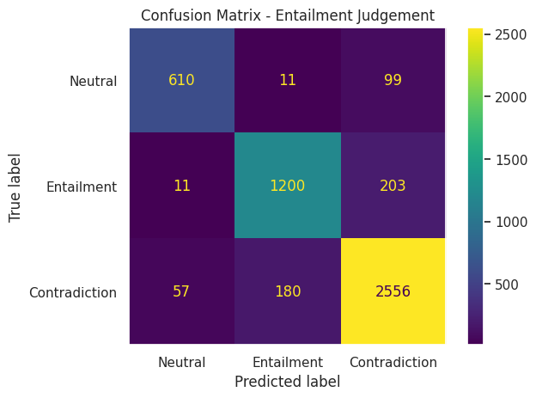
Fig. 7 – Final Best BERT Multi-Output Model Classification Report.
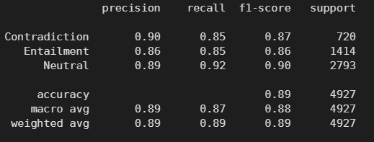
Fig. 8 – Top 5 sentence pairs with highest difference in relatedness scores from real vs predicted with Final Best BERT Multi-Output Model.
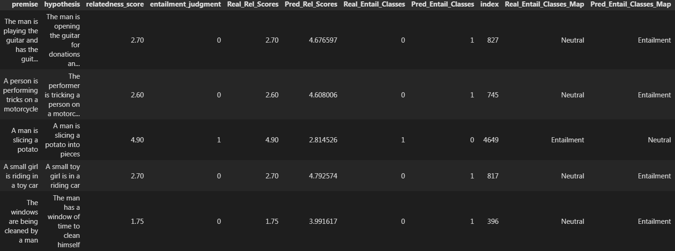
When comparing Fig.1 to Fig. 5 (baseline against the best model) we can see that the best model’s relatedness score seem to follow a little more closely the ground-truth scores, and it happens the same with the entailment judgement predictions. And for the latter it can be more evidences with Fig.6 and 7 where adopting a weighted approach seems to have worked well to improve 0.03 points the Entailment classification in its F1 score (baseline 0.83, best model 0.86), for contradiction it improved 0.01 points and Neutral improved 0.02 points. Now for the relatedness score in Fig. 8, although it still seems to be misclassifying Neutral and Entailment classes in the top 5 sentences pairs with highest difference in this score, but the highest difference got reduced overall, with the top 1 difference in the baseline being 2.56 and the best model’s one being 2.24.
- Anything that can strengthen your report. (5%)
Answer:
Here I will only put the training/validation/test graphs of my experiments, but inside the GitHub repository link, that I mentioned in the beginning, you can find the full results if the TA wants to check.
Fig. 9 – Baseline BERT-base-uncased Multi-Output Model Training loss and validation/test results.
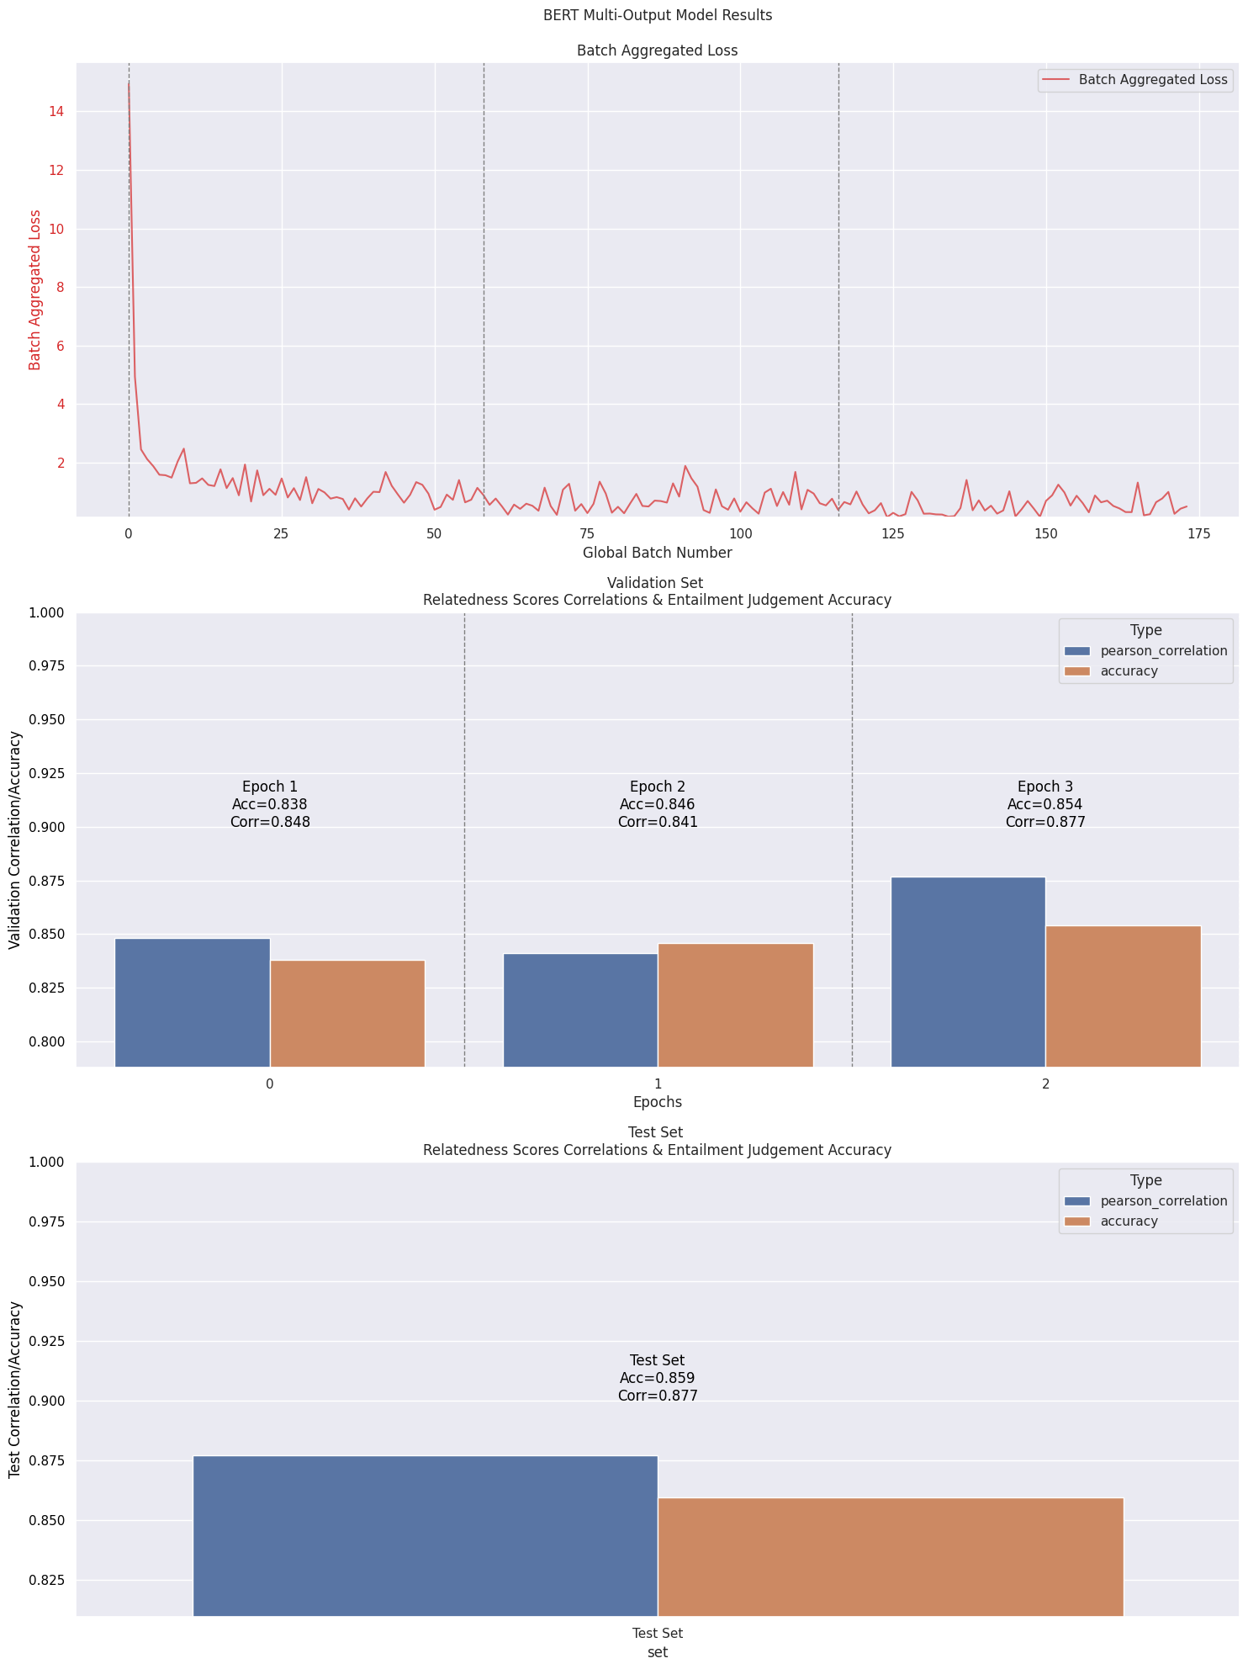
Fig. 10 – RoBERTa-base Multi-Output Model Training loss and validation/test results.
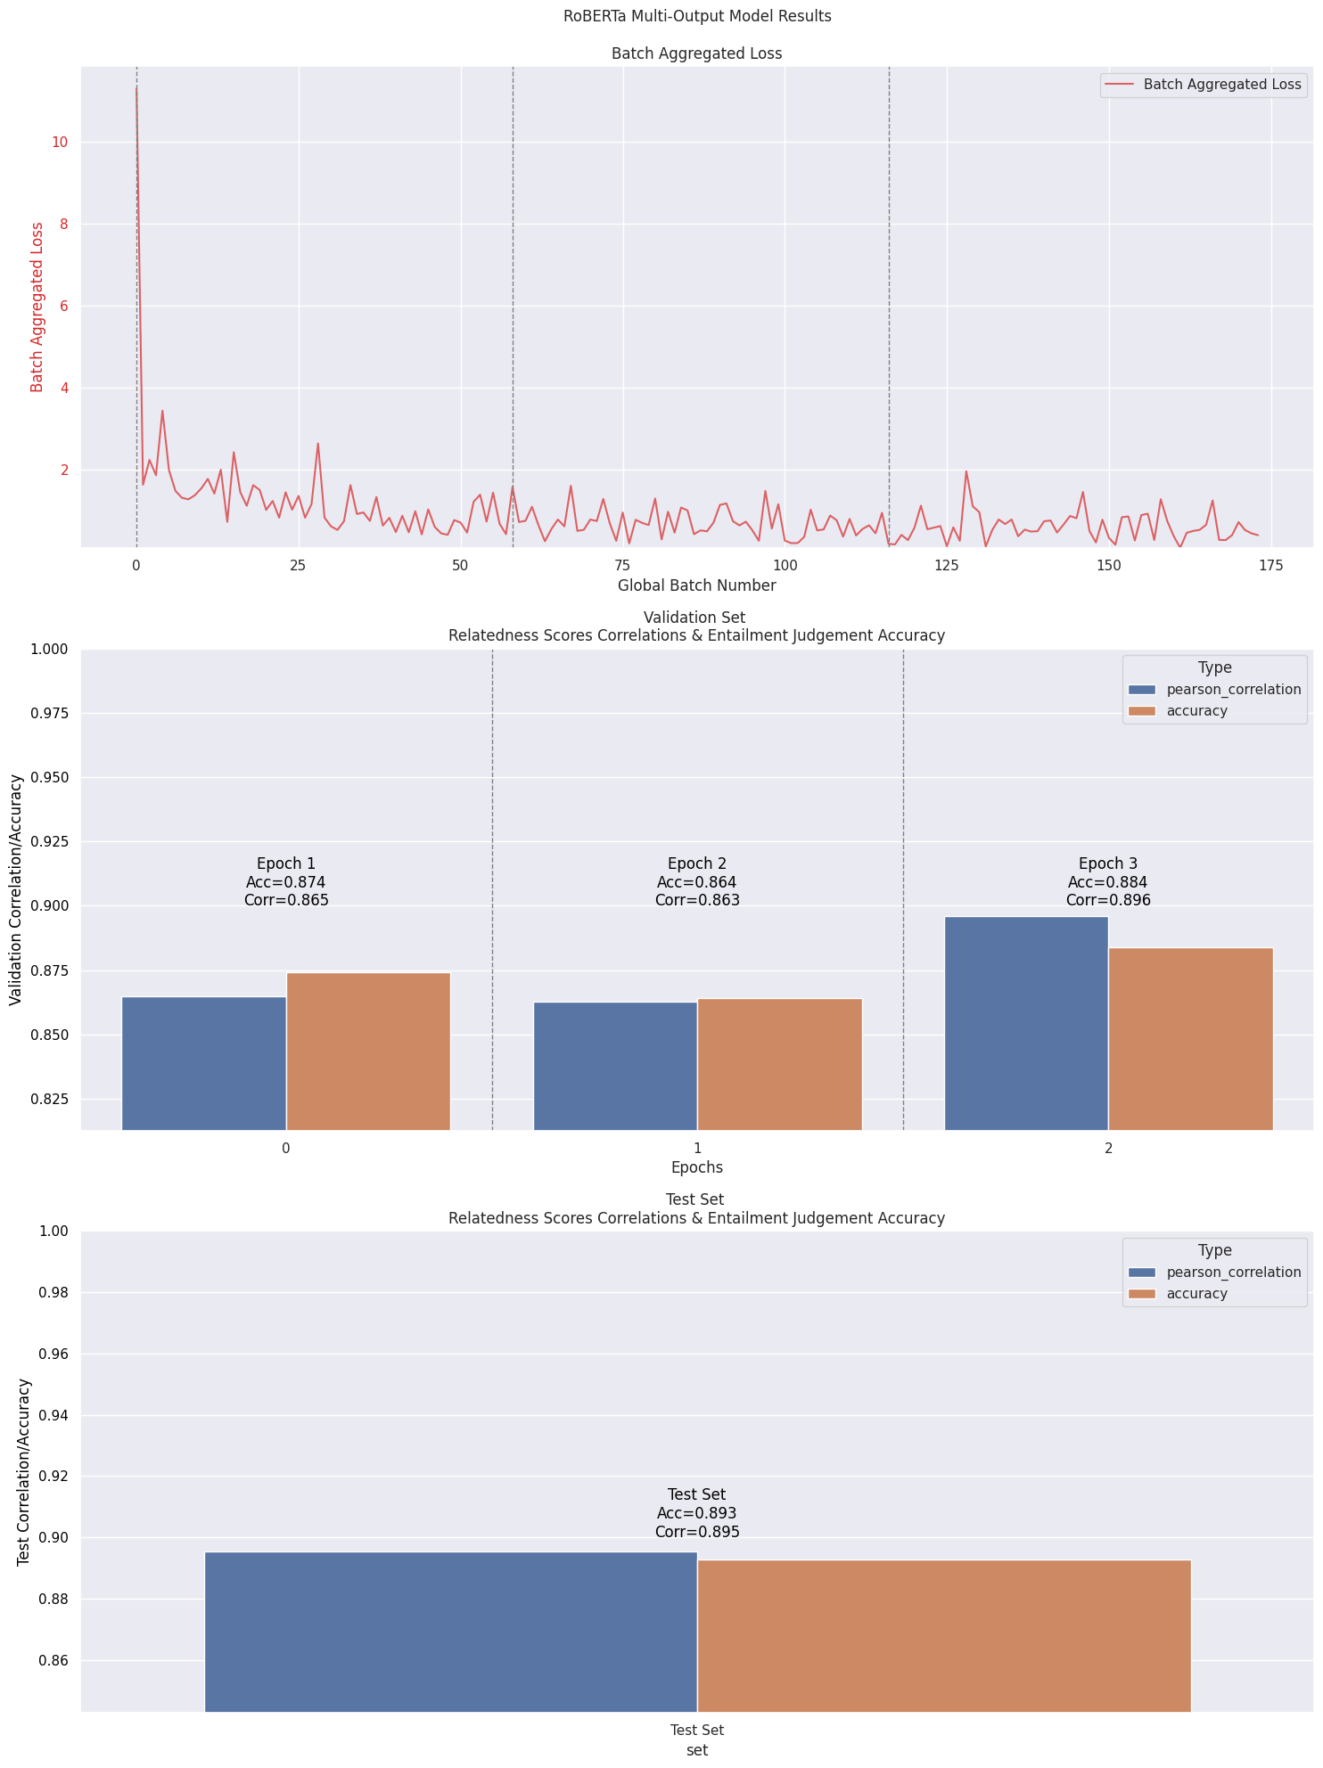
Fig. 11 – GPT-2 Small Multi-Output Model Training loss and validation/test results.
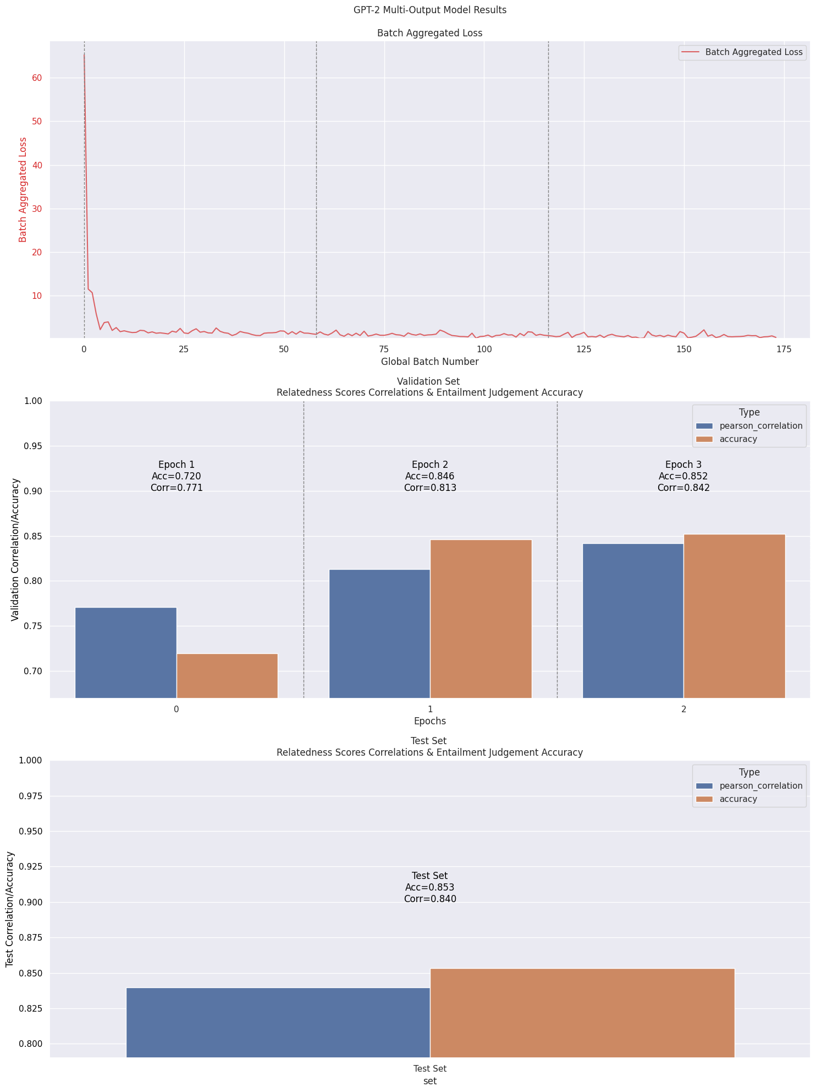
Fig. 12 – Baseline BERT-base-uncased Separate Predicting Models (Regression and Classification)- Training loss and validation/test results.
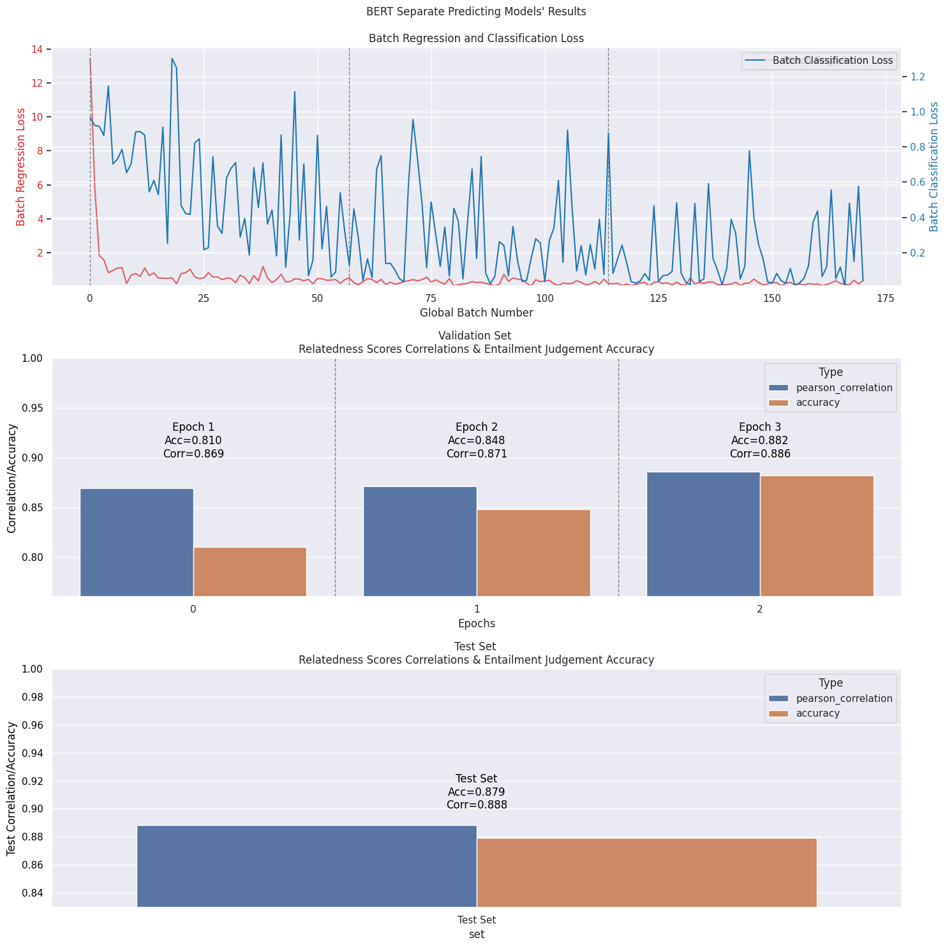
Fig. 13 – Baseline BERT-base-uncased Multi-Output Model Training loss and validation/test results – 50 Epochs.
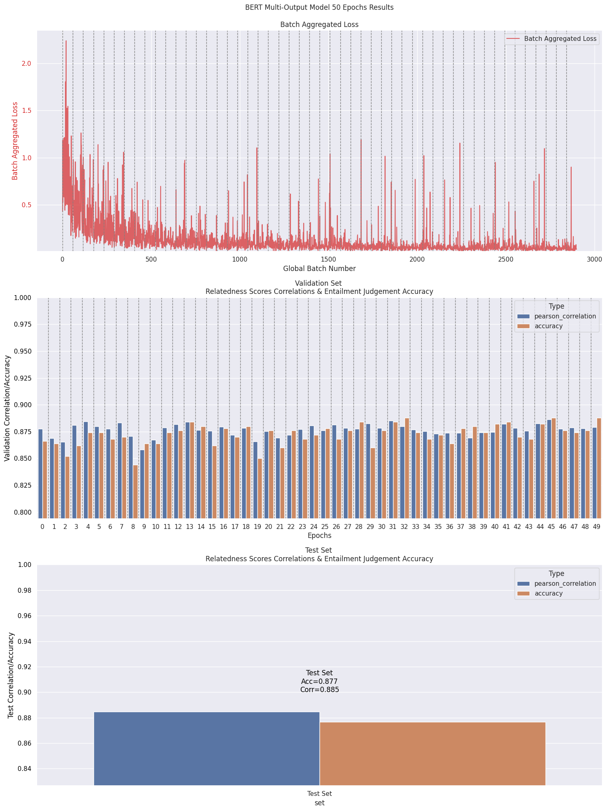
Fig. 14 – BERT-base-uncased Multi-Output Model with Weighted Cross-Entropy Loss - Training loss and validation/test results.
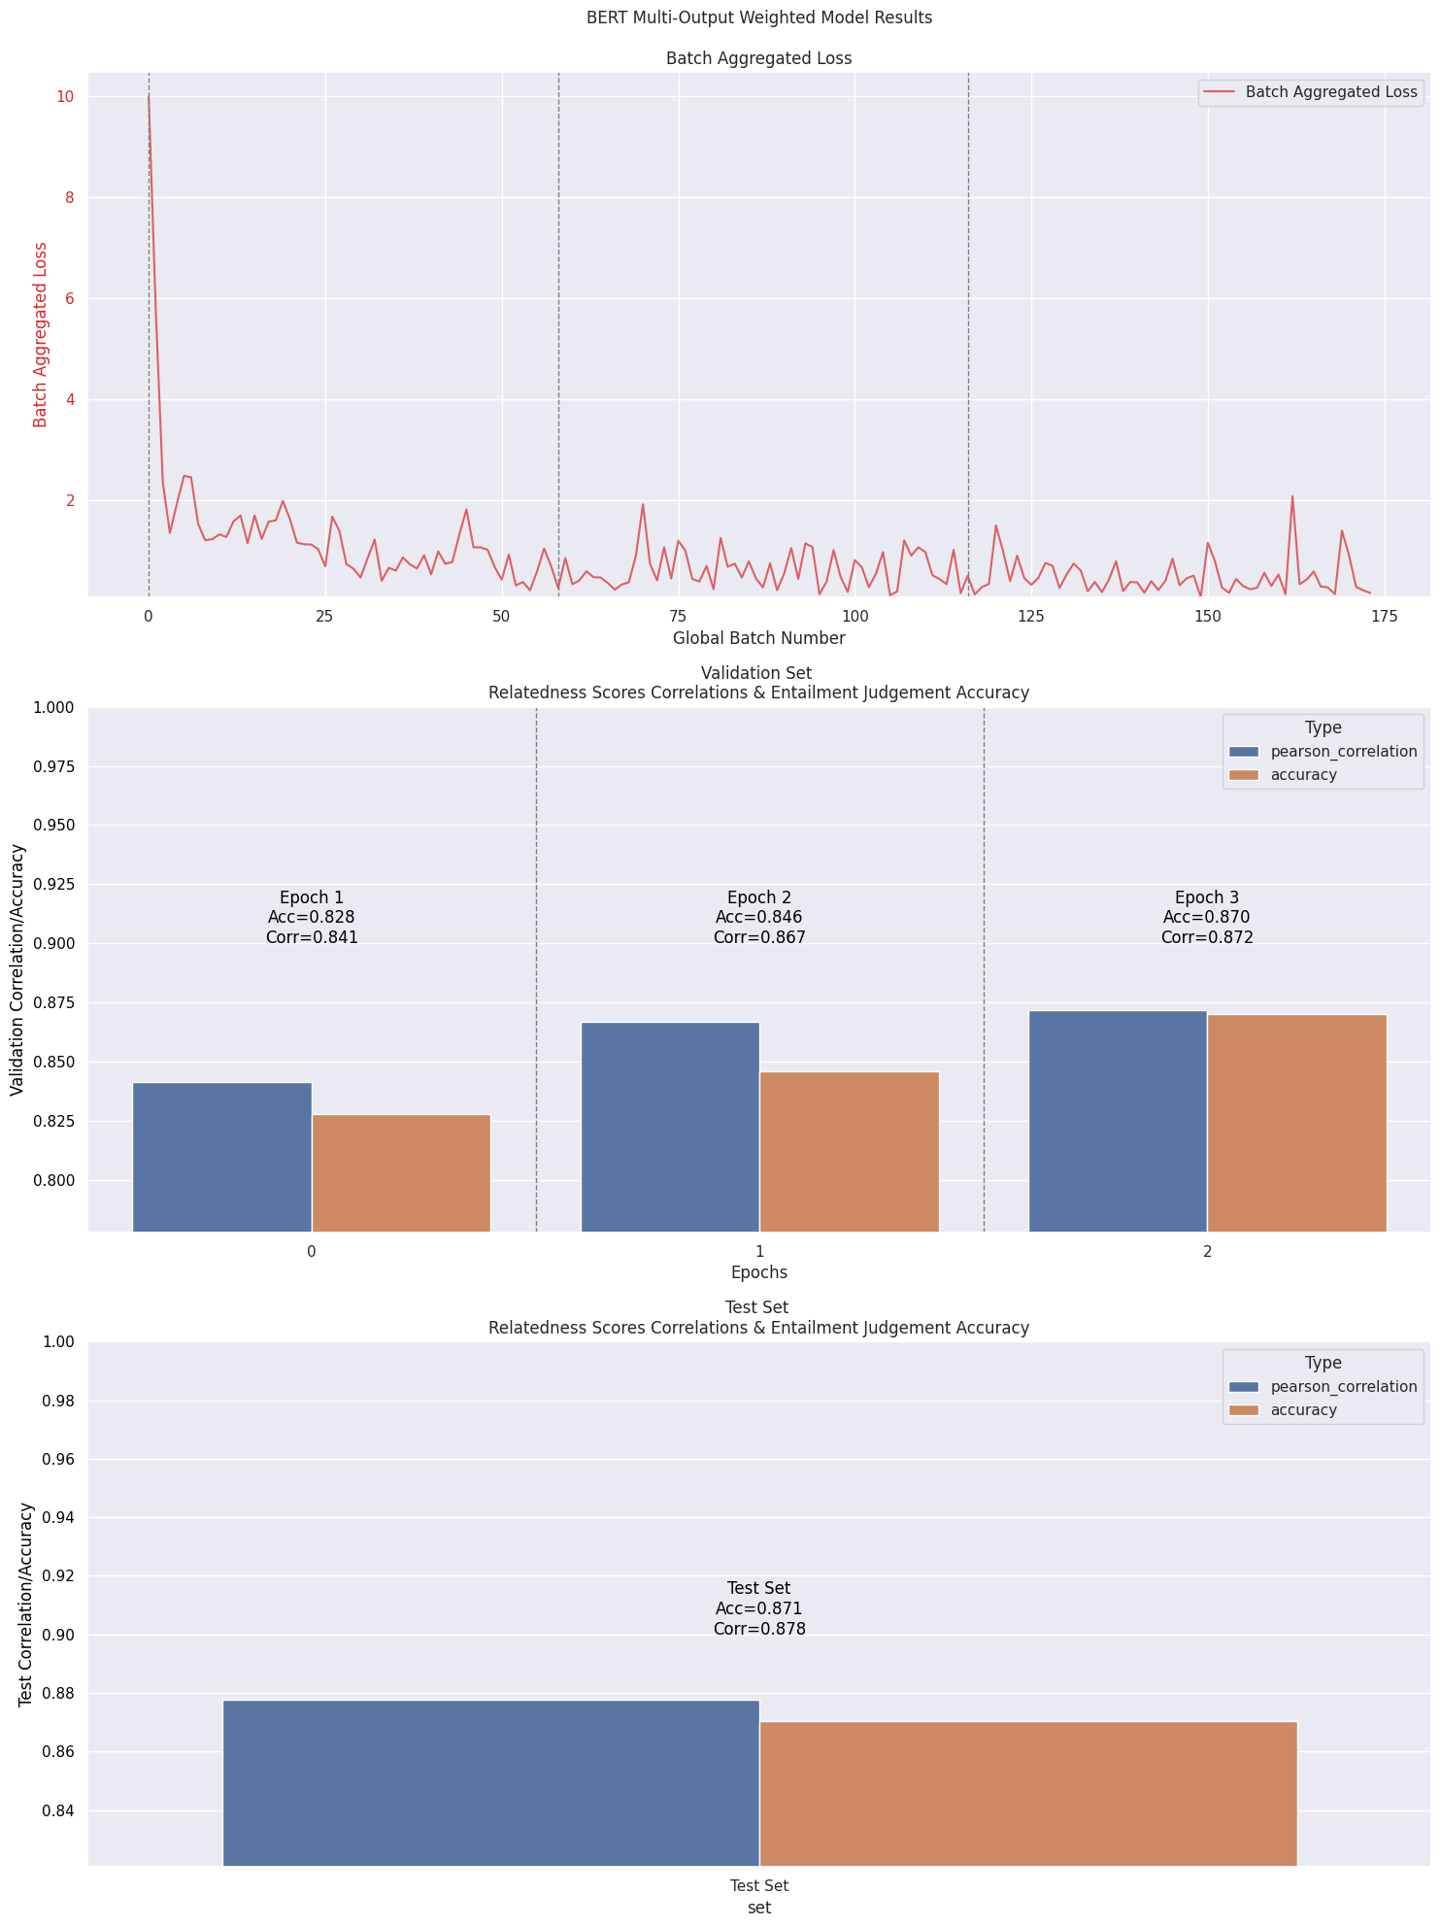
Fig. 15 – BERT-base-uncased Multi-Output Model with Weighted Cross-Entropy Loss - Training loss and validation/test results – 50 Epochs.
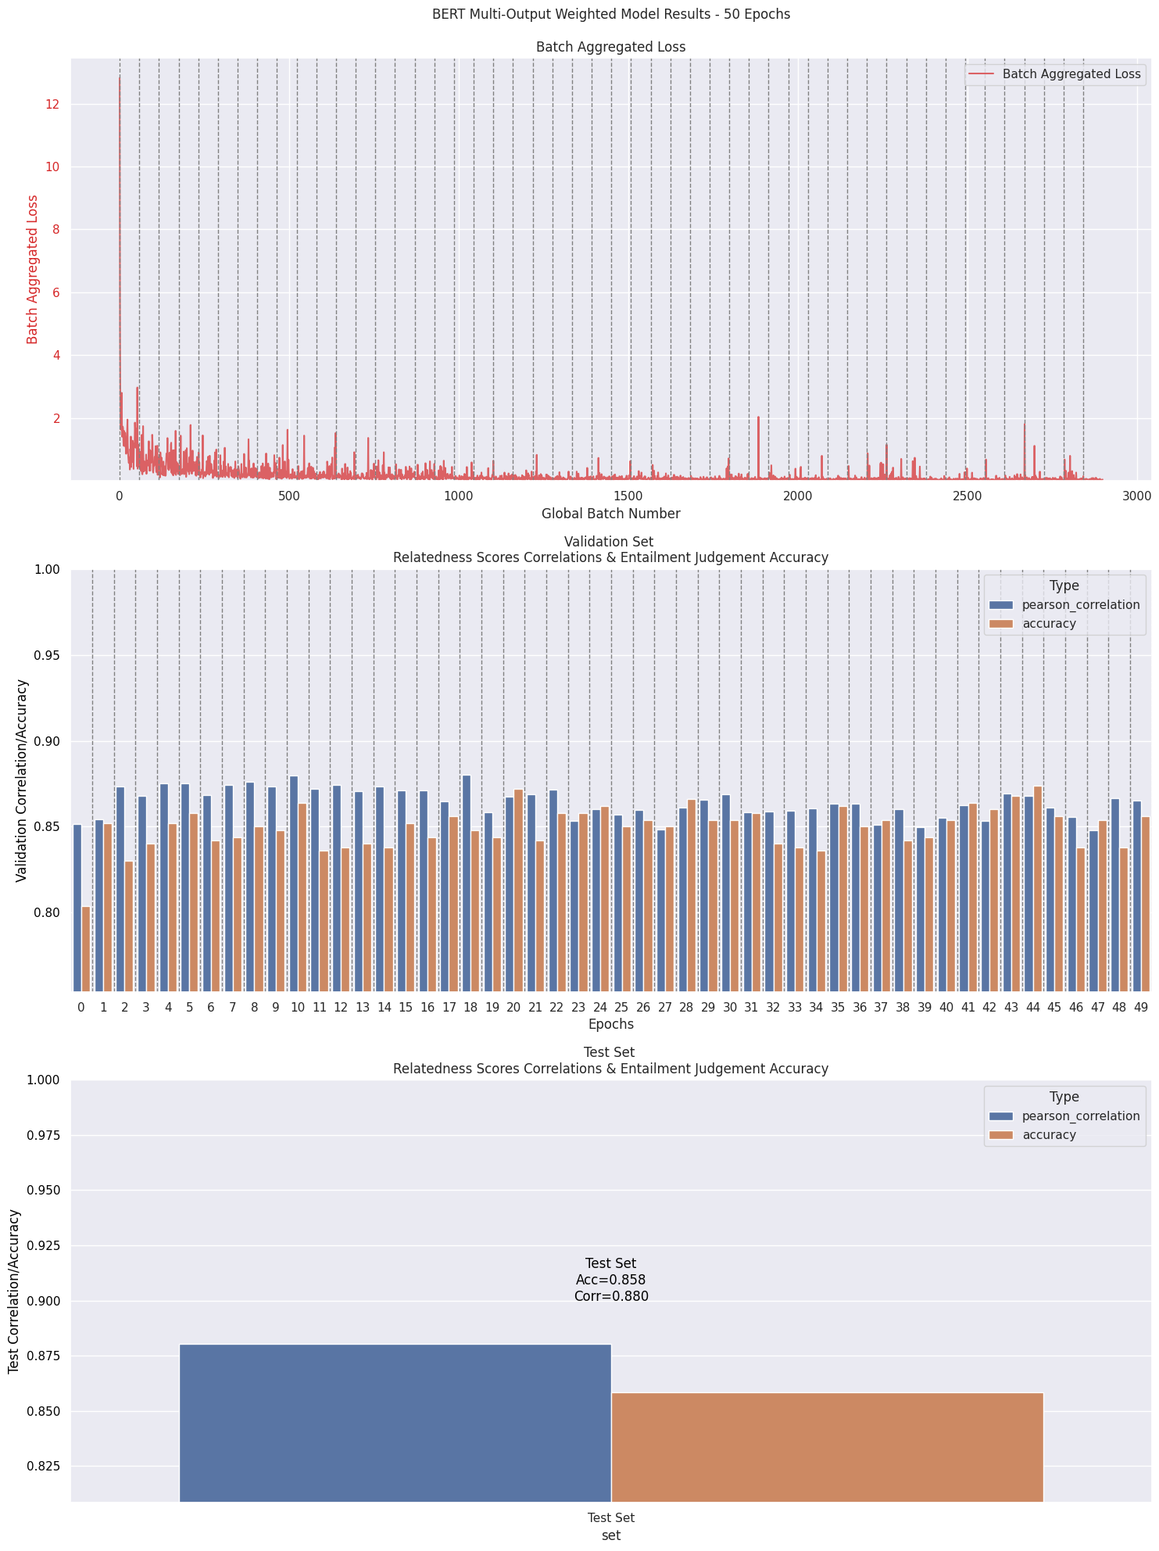
Fig. 16 – BERT-base-uncased Multi-Output Model with Weighted Cross-Entropy Loss - Intermediate Linear Layer (512 dim) - Training loss and validation/test results.
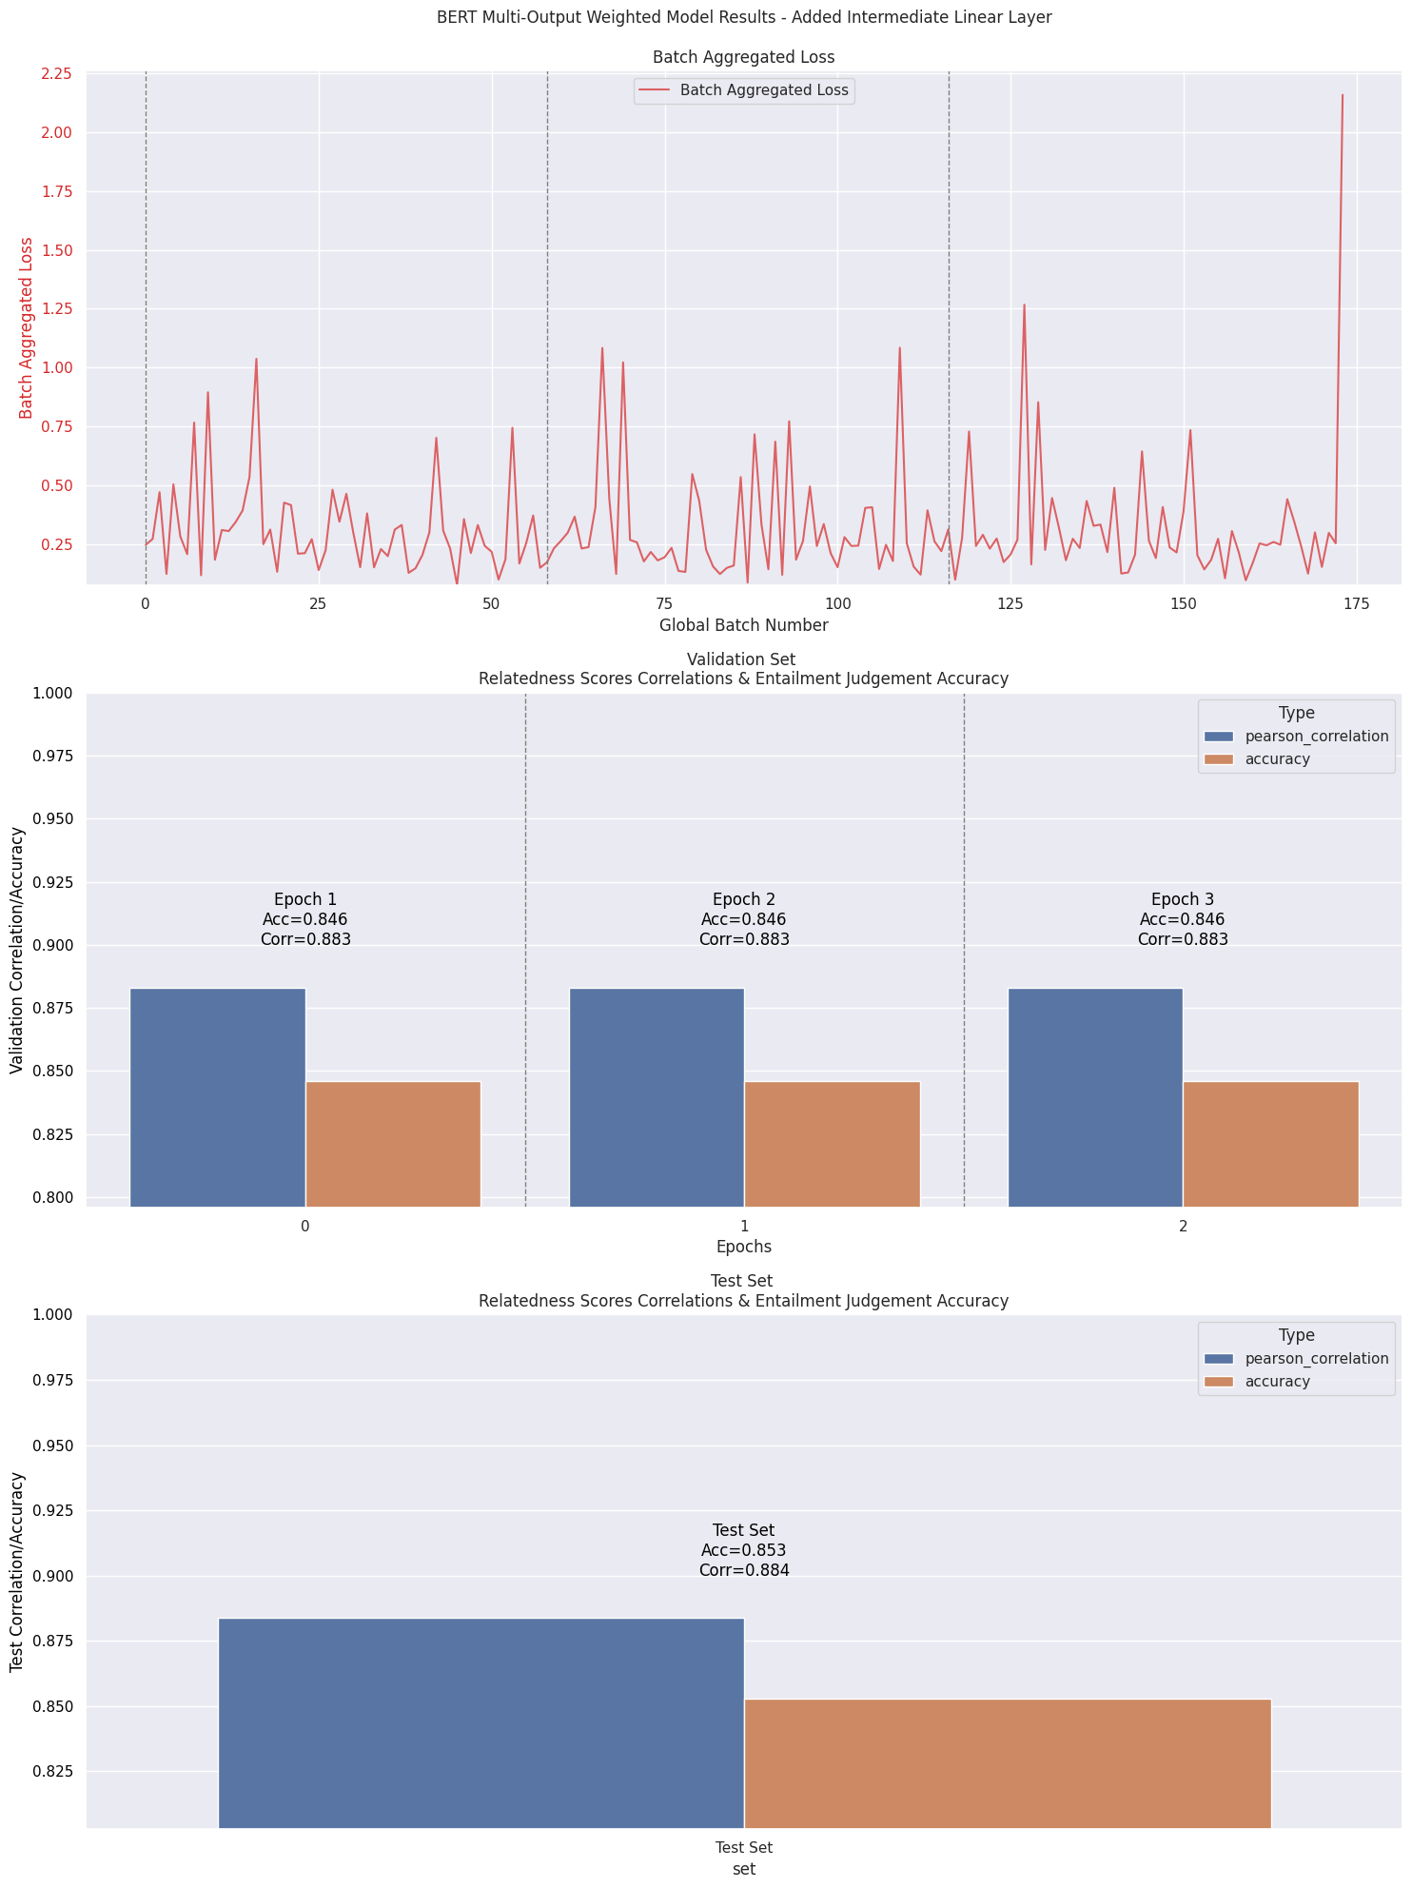
Fig. 17 – BERT-base-uncased Multi-Output Model with Weighted Cross-Entropy Loss - Intermediate Linear Layer (512 dim) – Batch 16 and LR 1e-5 - Training loss and validation/test results.
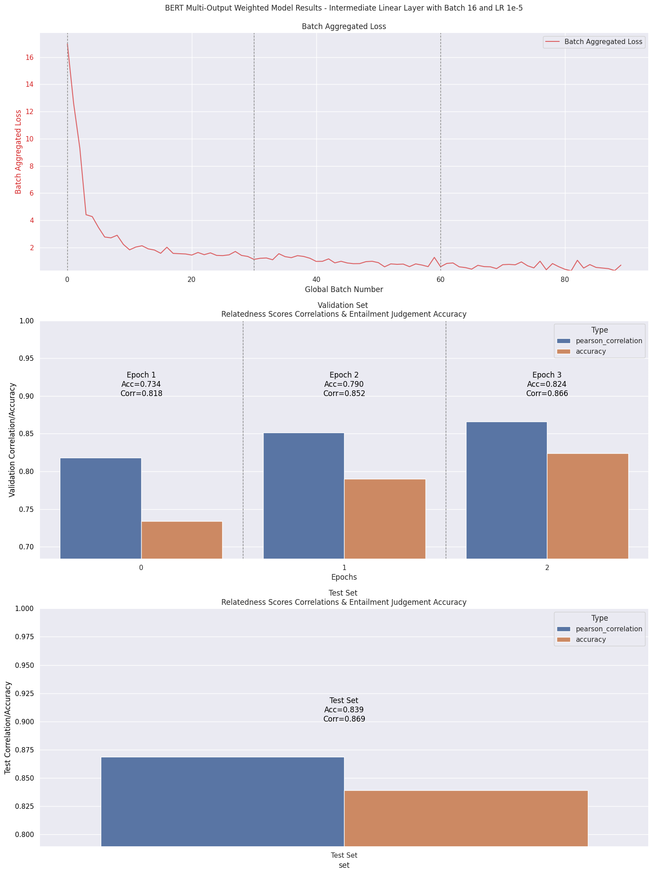
Fig. 18 – Second Best Model - BERT-base-uncased Multi-Output Model with Weighted Cross-Entropy Loss - Intermediate Linear Layer (512 dim) – Batch 4 and LR 1e-5 - Training loss and validation/test results.
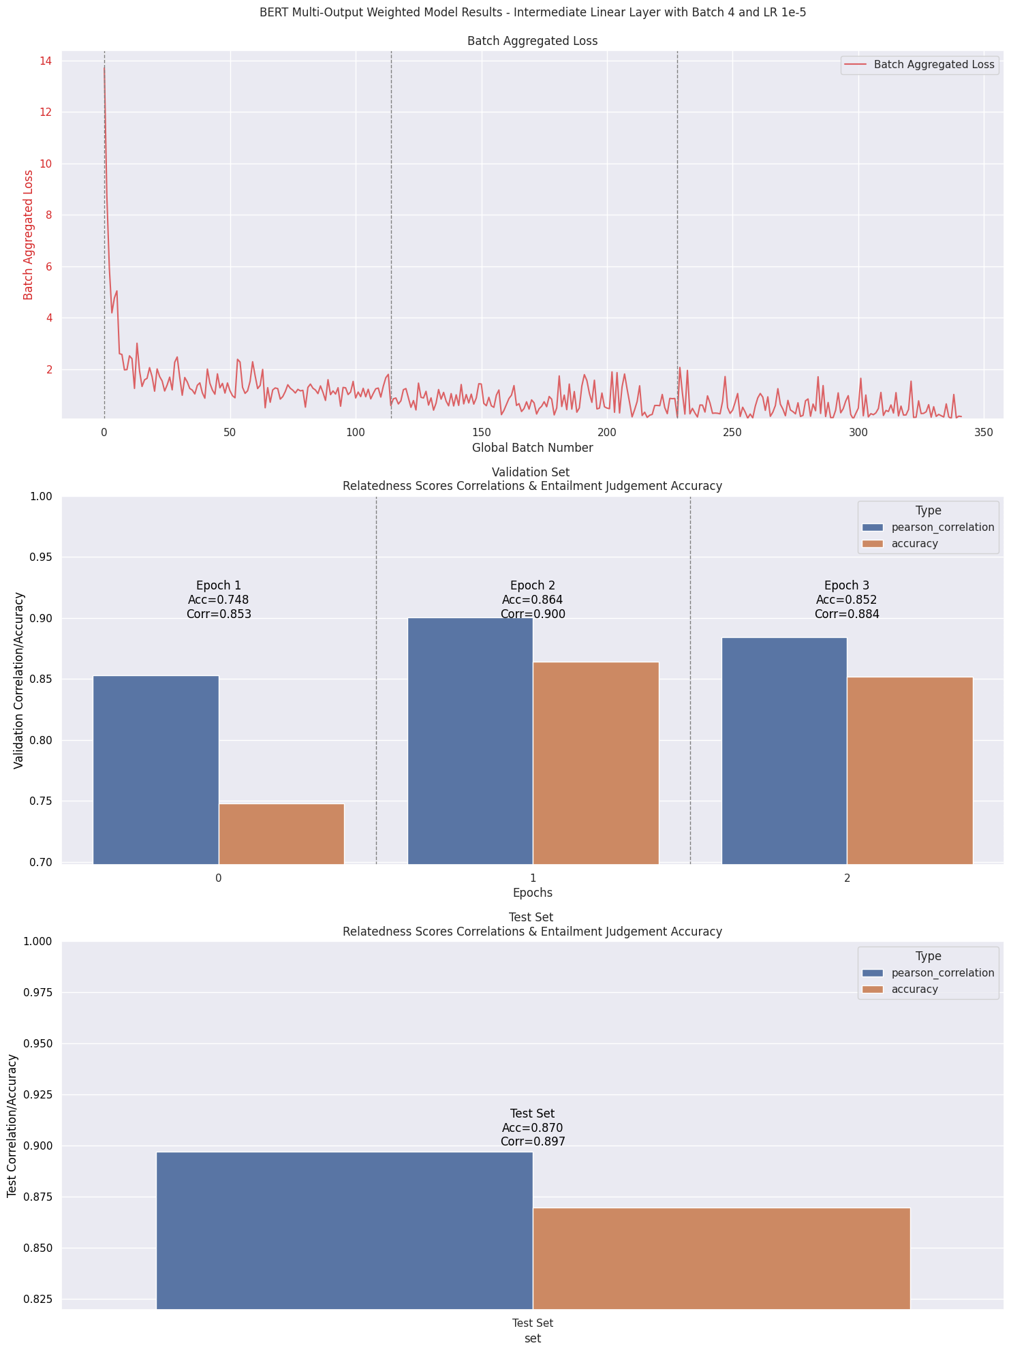
Fig. 19 – Final Best Model - BERT-base-uncased Multi-Output Model with Weighted Cross-Entropy Loss - Intermediate Linear Layer (512 dim) – Batch 4 and LR 1e-5 - Training loss and validation/test results – 50 Epochs.
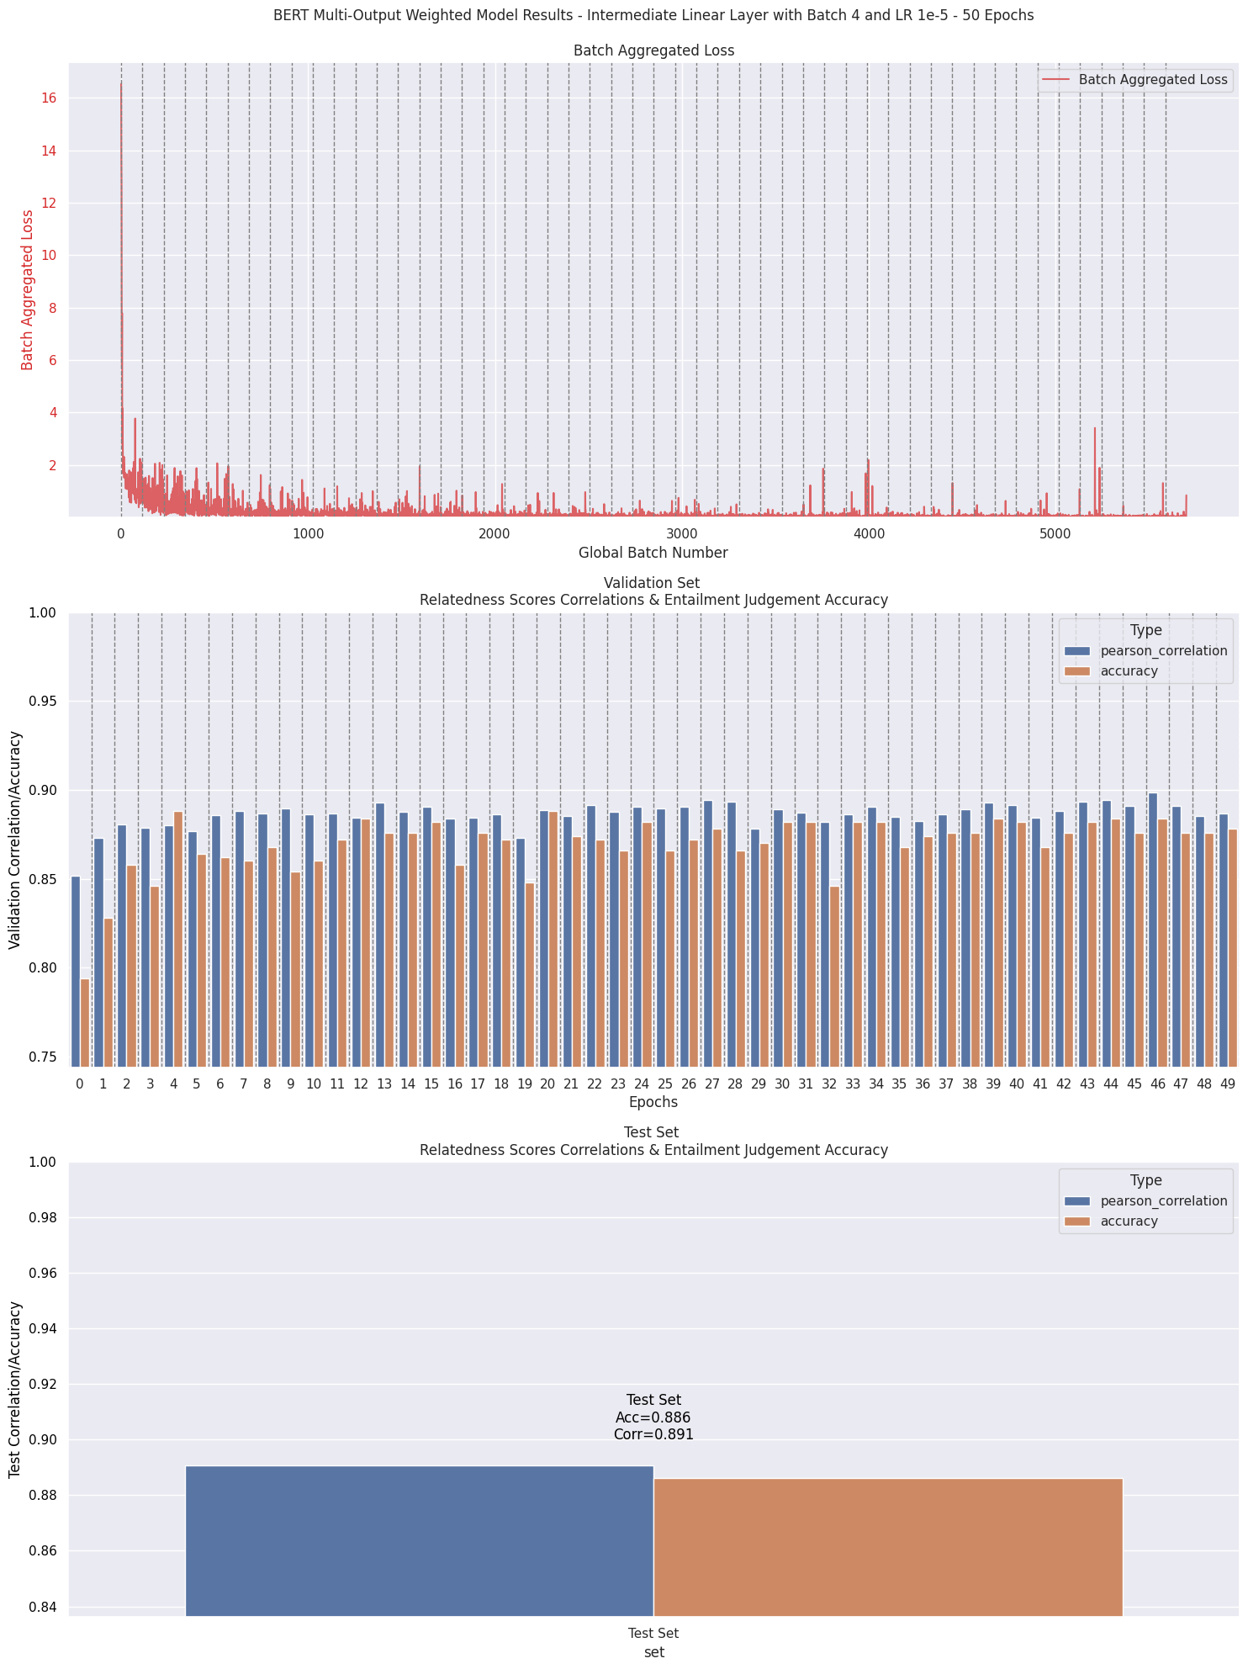
The screenshot of your training logs and evaluation accuracy. (One Figure only) (10%)
Fig. 20 – Screenshot of Best Model’s training logs, evaluation metrics and test results. Epochs start from 0 to 49 (50 epochs).
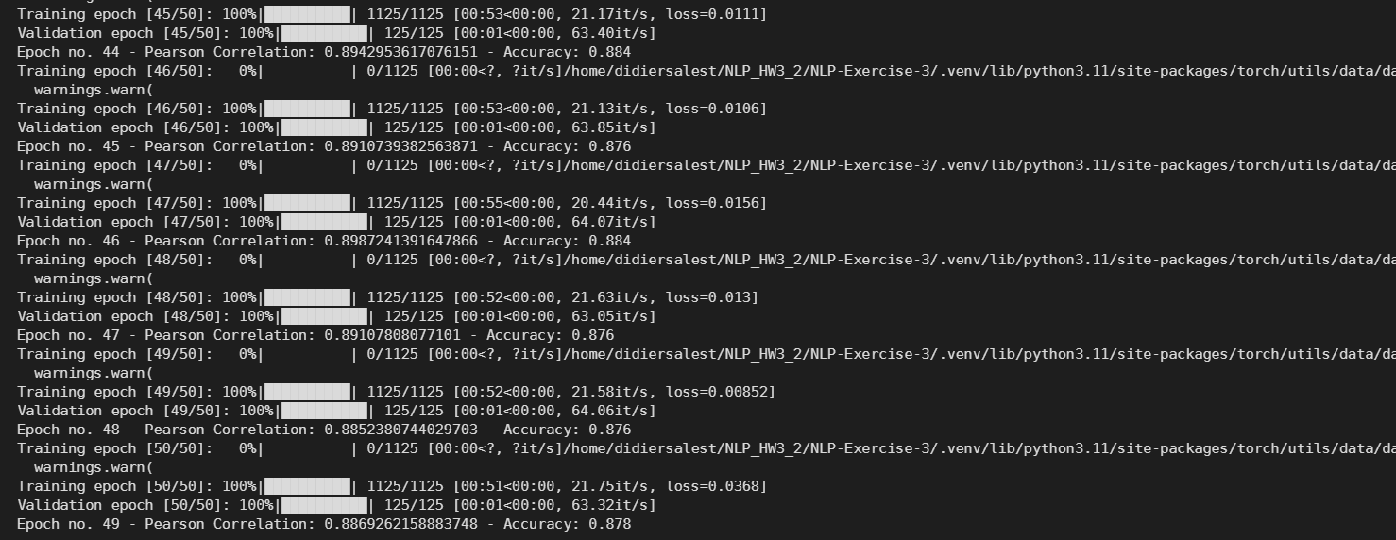

Code References Links:
https://stackoverflow.com/questions/76065460/training-bert-bert-base-uncased-for-a-custom-dataset-for-multi-label-task
https://docs.pytorch.org/docs/main/optim.html
https://discuss.pytorch.org/t/help-with-multilabel-classification-and-bcewithlogitsloss/208094
https://docs.pytorch.org/docs/main/generated/torch.nn.MSELoss.html#torch.nn.MSELoss
https://docs.pytorch.org/docs/main/generated/torch.nn.CrossEntropyLoss.html#crossentropyloss
https://medium.com/@shahrukhx01/multi-task-learning-with-transformers-part-1-multi-prediction-heads-b7001cf014bf
https://medium.com/@piyushkashyap045/guide-to-tokenization-and-padding-with-bert-transforming-text-into-machine-readable-data-5a24bf59d36b
https://github.com/theartificialguy/NLP-with-Deep-Learning/blob/master/BERT/Multi%20Label%20Text%20Classification%20using%20BERT%20PyTorch/bert_multilabel_pytorch_standard.ipynb
https://stackoverflow.com/questions/76065460/training-bert-bert-base-uncased-for-a-custom-dataset-for-multi-label-task
https://huggingface.co/transformers/v3.0.2/main_classes/tokenizer.html
https://www.youtube.com/watch?v=f-86-HcYYi8
https://stackoverflow.com/questions/63453831/seaborn-draw-multiple-barplots-on-same-x-axis
https://stackoverflow.com/questions/67051277/plotting-two-seaborn-graphs-in-subplots
https://www.geeksforgeeks.org/python/how-to-overlap-two-barplots-in-seaborn/
https://docs.pytorch.org/docs/main/generated/torch.nn.CrossEntropyLoss.html#crossentropyloss

Bibliographic References:
Devlin, J., Chang, M.-W., Lee, K., & Toutanova, K. (2019). BERT: Pre-training of Deep Bidirectional Transformers for Language Understanding. arXiv [Cs.CL]. Retrieved from http://arxiv.org/abs/1810.04805
Liu, Y., Ott, M., Goyal, N., Du, J., Joshi, M., Chen, D., … Stoyanov, V. (2019). RoBERTa: A Robustly Optimized BERT Pretraining Approach. arXiv [Cs.CL]. Retrieved from http://arxiv.org/abs/1907.11692
Radford, A., Wu, J., Child, R., Luan, D., Amodei, D., & Sutskever, I. (2019). Language Models are Unsupervised Multitask Learners.
Phung, T. M. (2023, March 26). A review of pre-trained language models: From Bert, Roberta, to electra, deberta, BigBird, and more. Tung M Phung’s Blog. https://tungmphung.com/a-review-of-pre-trained-language-models-from-bert-roberta-to-electra-deberta-bigbird-and-more/#:~:text=Longer%20training%20time.,some%20values%20in%20the%20pretraining.
Alammar, J. (2024). The illustrated GPT-2 (Visualizing Transformer language models). The Illustrated GPT-2 (Visualizing Transformer Language Models) – Jay Alammar – Visualizing machine learning one concept at a time. https://jalammar.github.io/illustrated-gpt2/

