

2018

3SC2

1. Diffa Dhania Arfani (1710010024)
2. Fajar Rahman Hakim (1710010031)

Group 6

Just Do It



**Developed By**

1. **Diffa Dhania Arfani**
2. **Fajar Rahman Hakim**

**PROJECT ON**

*Just Do It*

Batch Code : 3SC2

Start Date : November 6, 2018

End Date : December 5, 2018

Name of Faculty : Mr. Riza Muhammad Nurman

Name of Developer:

1. Diffa Dhania Arfani
2. Fajar Rahman Hakim

Date of Submission: December 6, 2018

**Just Do It**



**CERTIFICATE**

This is to certify that this report titled “Just Do It” embodies the original work done by Diffa Dhania Arfani and Fajar Rahman Hakim. Project in partial fulfillment of their course requirement at NIIT.

Coordinator :

Mr. Riza Muhammad Nurman

**ACKNOWLEDGEMENT**

Just Do It is an android application is made to manage our daily activities. You can add your tittle task, description and choose the category on the application. Our project using Android Studio application.

**SYSTEM ANALYSIS**

**System Summary:**

A list of task that must be done in a time span is also colled to do list. Usually made daily, weekly or monthly. This is part of planning.

To do list can be made for teams or for personal. Of course this list does not have to be written in writting. We can schedule our work in the memory of our brain. Our project is to facilitate everything about to do list by creating an application called Just Do It.

**ACTIVITY LIST**

|  |  |  |  |  |
| --- | --- | --- | --- | --- |
| **No.** | **Activity Description** | **Planned Date of Completion** | **Actual Date** | **Responsibility** |
| 1. | Creating the Concept of the Application | 27 November 2018 | 27 November 2018 | Fajar & Diffa |
| 2. | Creating the Algorithm | 27 November 2018 | 27 November 2018 | Fajar & Diffa |
| 3. | Creating the Main Page, Add Task Page, and the Function | 27 November 2018 | 27 November 2018 | Fajar |
| 4. | Creating the Delete Button Function | 3 December 2018 | 3 December 2018 | Fajar |
| 5. | Adding the design of Application | 5 December 2018 | 5 December 2018 | Fajar & Diffa |
| 6. | Fix the Application | 5 December 2018 | 5 December 2018 | Fajar & Diffa |
| 7. | Create The Paper | 5 December 2018 | 5 December 2018 | Diffa |
| 8. | Create The Slide for Presentation | 5 December 2018 | 5 December 2018 | Diffa |

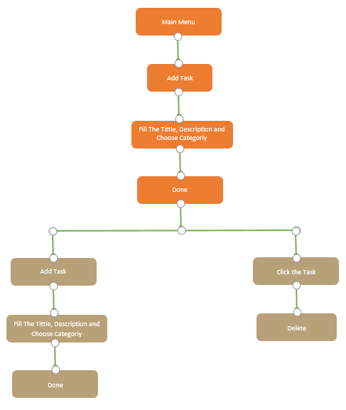

Edit the Tittle, Description and Choose Category

Click the Task

Main Menu

Done

Edit The Tittle, Description and Categoriy

Click the Task

**FLOW DESIGN OF APPS**

**PREVIEW OF APPS**

Application Preview using Screenshot:



(Splash Screen)

**PREVIEW OF APPS**

Application Preview using Screenshot:

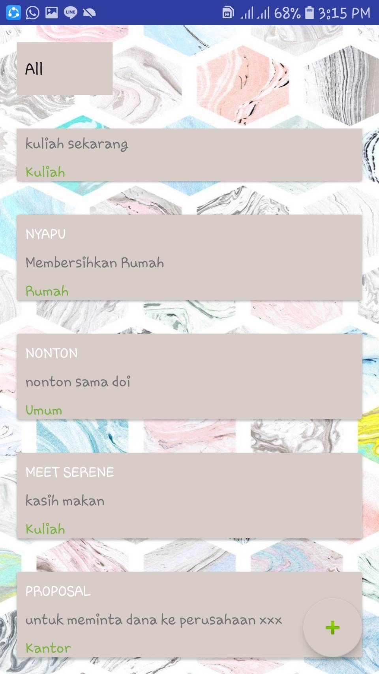

(Main Page)

**PREVIEW OF APPS**

Application Preview using Screenshot:

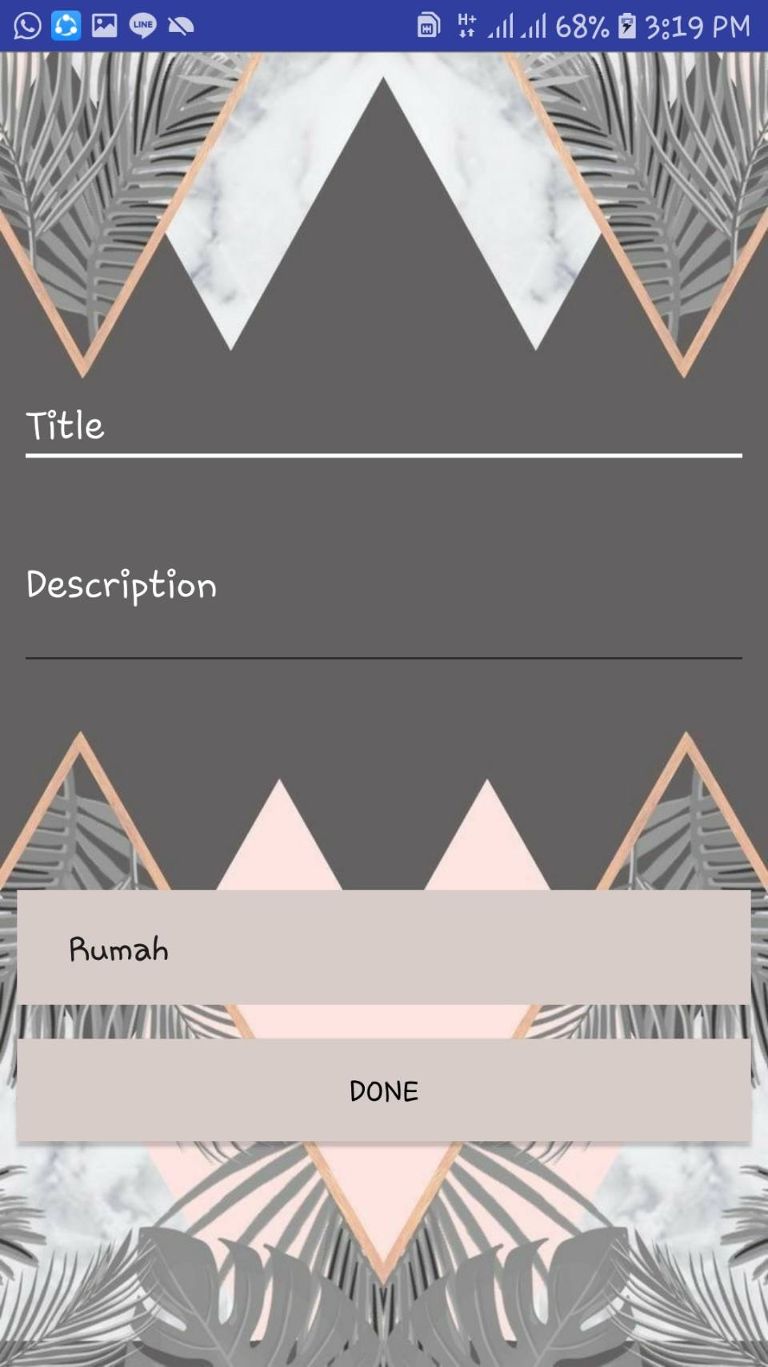

(Add and Edit Page)

**PREVIEW OF APPS**

Application Preview using Screenshot:

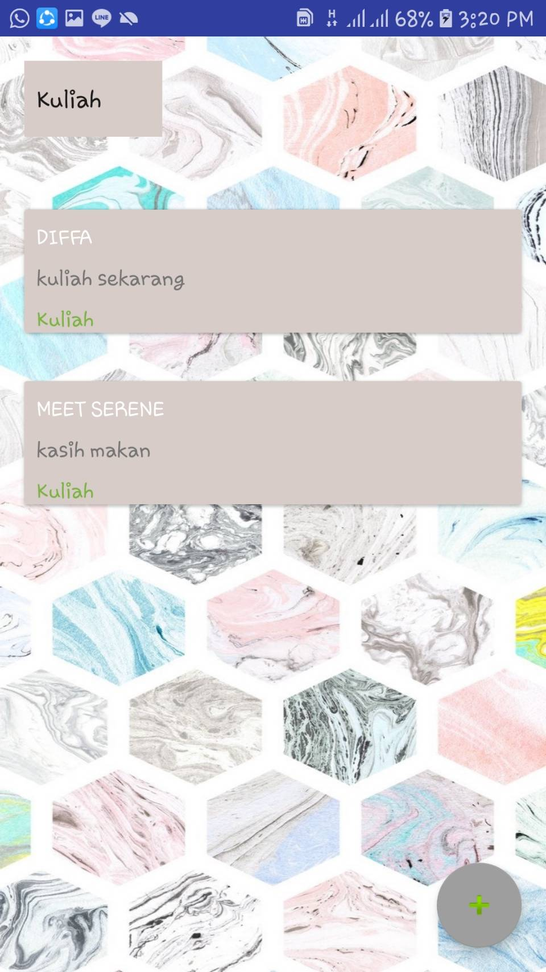

(Main Page if Choose Categories)

**Hardware :** *Intel(R) Core(TM) i7-7700HQ CPU @ 2.80GHz (8 CPUs), 2.8GHz 500 GB HDD, ASUS X450C 802.11b/g/n,6 cell Li-ion battery*

**Operating System :** *Windows 10 Home*

**Software :**  *Android Studio, Picsart*

|  |  |  |
| --- | --- | --- |
| **PROJECT FILE DETAILS** | | |
| **S.No** | **File Name** | **Remarks** |
| 1 | Just Do It | XML, Java |

**CONFIGURATION**