Predicting MLS Match Outcomes Using Random Forest Classification
Nathan Diffey
Table of Contents

1 Introduction
Major League Soccer (MLS) has grown substantially in recent years, with increasing interest in data-driven approaches to predicting match outcomes (Major League Soccer, 2024). Predicting the result of a football match — classified as a home win, away win, or draw — is inherently difficult due to the stochastic nature of the sport (Dixon & Coles, 1997), though machine learning methods have shown promise in extracting predictive signals from match statistics (Baboota & Kaur, 2019).
This report develops a Random Forest classifier (Breiman, 2001) to predict MLS match outcomes using a custom relational database of historical match and team statistics, covering feature engineering, temporal validation on 2025 data, and live prediction against early 2026 results. All modelling was conducted in R (R Core Team, 2024) using the randomForest (Liaw & Wiener, 2022) and caret (Kuhn, 2023) packages. A temporal train/test split is used throughout to reflect real-world forecasting conditions.

2 Background and Data

2.1 Data Sources
Match statistics were sourced from the MLS website via a custom web scraping pipeline built with Selenium and BeautifulSoup (Major League Soccer, 2024). Player and team attribute ratings were sourced from SoFIFA (SoFIFA, 2024), which provides FIFA-style ratings updated at regular intervals throughout the season. All data were stored in a custom MySQL relational database containing eight tables, summarised in Table 1.
Table 1: Database schema summary.
Table | Description
matches | Match date, teams, and final score
match_team_stats | In-match team-level performance statistics
match_player_stats | In-match player-level performance statistics
team_stats | FIFA-style team ratings (overall, attack, midfield, defence)
players_stats | FIFA-style individual player attribute ratings
team_roster | Player-team stint records with start and end dates
roster_snapshots | Point-in-time roster snapshots by team and date
teams | Team identifiers and abbreviations

2.2 Target Variable
The match outcome is encoded as a three-class factor variable: home_win, away_win, and draw. Home and away wins are kept as distinct classes rather than collapsed to a binary win/loss, as home advantage is a well-documented phenomenon in professional football (Dixon & Coles, 1997). Table 2 summarises the class distribution across all 1506 matches in the database.
Table 2: Distribution of match outcomes across all matches.
Result | Count | Percentage
Away Win | 426 | 28.3%
Draw | 393 | 26.1%
Home Win | 687 | 45.6%

3 Exploratory Data Analysis

3.1 Match Outcome Distribution
Figure 1 shows the distribution of match outcomes across all seasons in the database. Home wins are the most frequent outcome, consistent with the well-known home advantage effect in football, while draws are the least common.
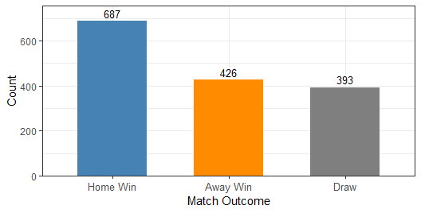
Figure 1: Distribution of match outcomes across all MLS matches in the database.

3.2 Outcome Distribution by Season
The class distribution remains broadly consistent across 2024, 2025, and 2026, confirming that the temporal train/test split does not introduce distributional shift.

4 Feature Engineering
Four feature blocks were constructed from the database. All joins use match_id as the primary key, and team rating lookups are strictly limited to snapshots prior to the match date to prevent data leakage.
Block A — Match Team Statistics. In-match metrics from match_team_stats including possession, shots, xG, crosses, and clearances. Four columns encoding the scoreline are removed to prevent leakage, yielding 104 candidate features.
Block B — Match Player Statistics. Per-player stats from match_player_stats aggregated to match level — counting stats summed, percentage stats averaged. Contributes 27 features.
Block C — Team Ratings. FIFA-style team ratings from team_stats (overall, attack, midfield, defence), using the most recent snapshot prior to each match date. Contributes 8 features.
Block D — Squad Player Ratings. FIFA attribute ratings from players_stats averaged across the active squad per team at match time, via team_roster stint dates. Contributes 88 features.
After joining all blocks, the working dataset contains 1506 matches before redundancy removal and cleaning.
The final dataset contains 986 matches across the 2024, 2025, and 2026 seasons after redundancy removal and cleaning. The reduction from 1506 raw matches arises from scraping coverage gaps in match_team_stats and early-season matches with no prior team rating snapshot.

4.1 Redundancy Analysis
Before feature selection, all home/away column pairs were examined to identify statistically redundant features. For each pair, the mean sum (home + away) across all matches was computed. Table 3 shows the results, ordered by mean sum.
Table 3: Home/away feature pairs with mean sums in the boundary region (90-110). Pairs with mean sum >= 100 are converted to differentials; those below are retained as independent features.
Feature (Home) | Mean Sum | Differential?
squad composure home | 108.07 | Yes
squad dribbling home | 107.78 | Yes
squad long passing home | 104.36 | Yes
squad vision home | 103.86 | Yes
general possession pct home | 100.00 | Yes
possession 36 40 home | 100.00 | Yes
possession 0 5 home | 100.00 | Yes
possession 6 10 home | 100.00 | Yes
possession 11 15 home | 100.00 | Yes
possession 16 20 home | 100.00 | Yes
possession 21 25 home | 100.00 | Yes
possession 26 30 home | 100.00 | Yes
possession 31 35 home | 100.00 | Yes
possession 41 45 home | 100.00 | Yes
possession 46 50 home | 100.00 | Yes
possession 51 55 home | 100.00 | Yes
possession 56 60 home | 100.00 | Yes
possession 61 65 home | 100.00 | Yes
possession 71 75 home | 100.00 | Yes
possession 76 80 home | 100.00 | Yes
possession 81 85 home | 100.00 | Yes
possession 86 90 home | 100.00 | Yes
possession 66 70 home | 100.00 | Yes
squad heading accuracy home | 98.97 | No
squad attack position home | 96.09 | No
squad standing tackle home | 95.08 | No
squad defensive awareness home | 93.10 | No
squad crossing home | 91.43 | No
squad interceptions home | 91.40 | No
squad penalties home | 90.31 | No
Two categories of redundancy were identified. First, all possession band columns sum to exactly 100% across all matches — home and away possession are mathematically complementary. Second, passing accuracy and overall percentage statistics have mean sums above 100, measuring the same construct from both perspectives.
A threshold of mean sum $≥$ 100 was applied (line 1 in the code), cleanly separating these from independent count statistics such as shots, crosses, and fouls which sum well below 100 (line 2). All qualifying pairs were replaced with a single differential feature (home − away):
$$Δ_{j}=x_{j,\text{home}}−x_{j,\text{away}}$$
A positive value indicates home team superiority. After this transformation, the feature space was reduced from 227 to 172 features.

5 Feature Selection

5.1 Method 1 — Random Forest Variable Importance
A preliminary Random Forest model was trained on all 172 candidate features using 200 trees (ntree = 200) with balanced class weights. Variable importance was measured via the mean decrease in Gini impurity, which quantifies how much each feature contributes to homogeneous splits across all trees in the forest (Breiman, 2001). Formally, the importance of feature $j$ is defined as:
Ij=1Bb=1Bt∈Tb​ΔGt,j
where $B$ is the number of trees, $T_{b}$ is the set of nodes in tree $b$ that split on feature $j$, and $ΔG\left(t,j\right)$ is the decrease in Gini impurity at node $t$. Figure 2 shows the top 15 features ranked by this criterion.
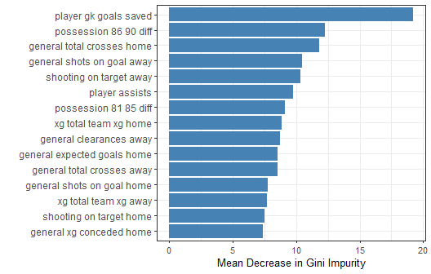
Figure 2: Top 15 features ranked by mean decrease in Gini impurity from the screening Random Forest.

5.2 Method 2 — Pearson Correlation with Target
The target variable was numerically encoded as $y∈\{1,2,3\}$ (away win = 1, draw = 2, home win = 3), and absolute Pearson correlation was computed for each feature:
$$r_{j}=\left|\frac{\sum_{i=1}^{n}{\left(x_{ij}−{\overset{‾}{x}}_{j}\right)}\left(y_{i}−\overset{‾}{y}\right)}{\sqrt{\sum_{i=1}^{n}{{\left(x_{ij}−{\overset{‾}{x}}_{j}\right)}^{2}}\sum_{i=1}^{n}{{\left(y_{i}−\overset{‾}{y}\right)}^{2}}}}\right|$$
Using two independent methods — one tree-based and one linear — ensures that selected features have convergent evidence of predictive value. Figure 3 shows the top 15 features by absolute correlation.
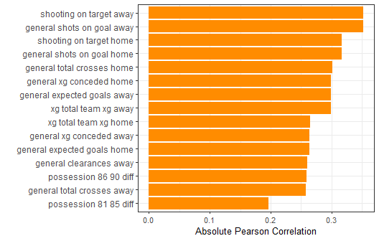
Figure 3: Top 15 features ranked by absolute Pearson correlation with the encoded match outcome.

5.3 Final Feature Set
Features appearing in the top 15 of both methods were retained, reducing the risk of including features predictive by chance in only one method. Table 4 lists the 13 selected features. Notably, FIFA-style squad and team rating features (Blocks C and D) did not appear in the top features of either method, suggesting in-match performance metrics are substantially more predictive than pre-match squad quality (Baboota & Kaur, 2019).
Table 4: Final selected features.
Feature | Description
possession_86_90_diff | possession 86 90 diff
general_total_crosses_home | general total crosses home
general_shots_on_goal_away | general shots on goal away
shooting_on_target_away | shooting on target away
possession_81_85_diff | possession 81 85 diff
xg_total_team_xg_home | xg total team xg home
general_clearances_away | general clearances away
general_expected_goals_home | general expected goals home
general_total_crosses_away | general total crosses away
general_shots_on_goal_home | general shots on goal home
xg_total_team_xg_away | xg total team xg away
shooting_on_target_home | shooting on target home
general_xg_conceded_home | general xg conceded home

6 Model Development

6.1 Temporal Train/Test Split
A temporal split was used rather than random partitioning — trained on 2024 ($n=$ 472) and evaluated on 2025 ($n=$ 472). This reflects real deployment conditions and avoids the optimistic bias of random splitting when observations are temporally autocorrelated (Baboota & Kaur, 2019). Table 5 confirms the class distribution is consistent across both sets.
Table 5: Class distribution across training and test sets.
Set | Matches | Home.Wins | Away.Wins | Draws
Training (2024) | 472 | 207 | 149 | 116
Test (2025) | 472 | 208 | 145 | 119

6.2 Random Forest Classifier
A Random Forest classifier (Breiman, 2001) was selected as it handles non-linear feature interactions, is robust to correlation, provides interpretable importance scores, and is less prone to overfitting than single decision trees through ensemble averaging.
The Random Forest model consists of $B$ classification trees, each trained on a bootstrap sample of the training data. At each split, only $m$ randomly selected features are considered, where $m$ is set to $⌊\sqrt{p}⌋$ and $p$ is the total number of features — the standard recommendation for classification tasks (Breiman, 2001). The final prediction is the majority class across all trees:
$$\hat{y}=\text{mode}{\left\{h_{b}\left(x\right)\right\}}_{b=1}^{B}$$
where $h_{b}\left(x\right)$ is the prediction of the $b$-th tree for feature vector $x$.
The model was trained with ntree = 500 trees and mtry = 3 features considered at each split. Class weights were set to equal values across all three outcome classes to prevent the model from being biased toward the majority class (home win).

7 Results

7.1 Evaluation on 2025 Test Data
The model was evaluated on the held-out 2025 season using overall accuracy, sensitivity, specificity, and macro-averaged F1-score. These metrics are defined as follows:
$$\text{Accuracy}=\frac{TP+TN}{TP+TN+FP+FN}$$
$$\text{Precision}=\frac{TP}{TP+FP}, \text{Recall}=\frac{TP}{TP+FN}$$
$$F_{1}=\frac{2⋅\text{Precision}⋅\text{Recall}}{\text{Precision}+\text{Recall}}$$
The model achieved a test accuracy of 60.4% on the 2025 season, substantially above the no-information rate of 44.1% (the accuracy of always predicting the majority class). Table 6 presents the per-class performance metrics.
Table 6: Per-class performance metrics on the 2025 test set (overall accuracy = 60.4%).
 | Class | Sensitivity | Specificity | Precision | F1-Score
Away Win | Away Win | 0.648 | 0.829 | 0.627 | 0.637
Draw | Draw | 0.151 | 0.904 | 0.346 | 0.211
Home Win | Home Win | 0.832 | 0.633 | 0.641 | 0.724
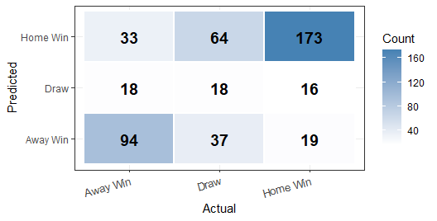
Figure 4: Confusion matrix for 2025 test set predictions.
The model performs best at predicting home wins, which is consistent with the higher frequency of this class in the training data. Draw prediction is weakest, which is expected given the inherently lower predictability of drawn matches in football — a finding consistent with the broader sports prediction literature (Dixon & Coles, 1997).
xG and shots on goal differentials are the strongest predictors of match outcome, followed by late-game possession differentials and total crosses — consistent with the feature importance rankings from the screening stage.

7.2 2026 Validation
To provide an additional out-of-sample validation, the model was retrained on all available 2024 and 2025 data ($n=$ 944 matches) and applied to the 42 MLS matches played in early 2026, for which results are already known.
The retrained model achieved a validation accuracy of 64.3% on the 2026 matches, compared to the 2025 test accuracy of 60.4%. This suggests the model generalises well to a new, unseen season and that the selected features remain predictive beyond the training period.
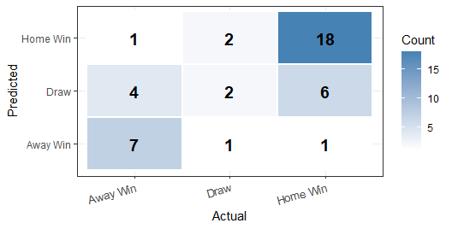
Figure 5: Confusion matrix for 2026 validation predictions.

8 Summary and Discussion
Table 7: Summary of dataset, modelling pipeline, and results.
Stage | Result
Total matches in database | 1,506
Matches after cleaning | 986
Features before redundancy removal | 227
Features after redundancy removal | 172
Training set (2024) | 472
Test set (2025) | 472
Final features selected | 13
Test accuracy (2025) | 60.4%
2026 validation accuracy | 64.3%
This report developed a Random Forest classifier to predict MLS match outcomes using in-match team statistics, player statistics, and FIFA-style ratings. A systematic redundancy analysis converted complementary home/away feature pairs to differentials prior to model training. The model achieved a test accuracy of 60.4% on the held-out 2025 season and 64.3% on early 2026 matches, substantially above the no-information baseline.
Limitations include reliance on post-match statistics (limiting pre-match forecasting utility), weak draw prediction, limited training data coverage, and residual class imbalance. Future work could explore rolling form features, pre-match betting odds, and gradient boosting methods such as XGBoost.

References
Baboota, R., & Kaur, H. (2019). Predictive analysis and modelling football results using machine learning approach for English Premier League. International Journal of Forecasting, 35(2), 741–755. https://doi.org/10.1016/j.ijforecast.2018.01.003
Breiman, L. (2001). Random forests. Machine Learning, 45(1), 5–32. https://doi.org/10.1023/A:1010933404324
Dixon, M. J., & Coles, S. G. (1997). Modelling association football scores and inefficiencies in the football betting market. Journal of the Royal Statistical Society: Series C (Applied Statistics), 46(2), 265–280. https://doi.org/10.1111/1467-9876.00065
Kuhn, M. (2023). caret: Classification and regression training. https://CRAN.R-project.org/package=caret
Liaw, A., & Wiener, M. (2022). randomForest: Breiman and cutler’s random forests for classification and regression. https://CRAN.R-project.org/package=randomForest
Major League Soccer. (2024). MLS match statistics and player data. https://www.mlssoccer.com
R Core Team. (2024). R: A language and environment for statistical computing. R Foundation for Statistical Computing. https://www.R-project.org/
SoFIFA. (2024). SoFIFA player and team ratings. https://sofifa.com

