Christian Campbell
CSC500-1
Module 8
Source Code:

# Online shopping cart
# Author: Christian Campbell
# Course: CSC500 Module 8
# Date: 3/3/2026

class ItemToPurchase:
def __init__(self, item_name="none", item_price=0.0, item_quantity=0, item_description="none"):
self.item_name = item_name
self.item_price = item_price
self.item_quantity = item_quantity
self.item_description = item_description

def print_item_cost(self):
print(f"{self.item_name} {self.item_quantity} @ ${self.item_price} = ${self.item_price * self.item_quantity}")

class ShoppingCart:
def __init__(self, customer_name="none", current_date="January 1, 2020"):
self.customer_name = customer_name
self.current_date = current_date
self.cart_items = []

def add_item(self, item):
self.cart_items.append(item)

def remove_item(self, item_name):
for item in self.cart_items:
if item.item_name == item_name:
self.cart_items.remove(item)
return
print("Item not found in cart. Nothing removed.")

def modify_item(self, modified_item):
for item in self.cart_items:
if item.item_name == modified_item.item_name:
if modified_item.item_description != "none":
item.item_description = modified_item.item_description
if modified_item.item_price != 0.0:
item.item_price = modified_item.item_price
if modified_item.item_quantity != 0:
item.item_quantity = modified_item.item_quantity
return
print("Item not found in cart. Nothing modified.")

def get_num_items_in_cart(self):
return sum(item.item_quantity for item in self.cart_items)

def get_cost_of_cart(self):
return sum(item.item_price * item.item_quantity for item in self.cart_items)

def print_total(self):
print(f"\n{self.customer_name}'s Shopping Cart - {self.current_date}")
print(f"Number of Items: {self.get_num_items_in_cart()}")
if not self.cart_items:
print("SHOPPING CART IS EMPTY")
else:
for item in self.cart_items:
item.print_item_cost()
print(f"Total: ${self.get_cost_of_cart()}")

def print_descriptions(self):
print(f"\n{self.customer_name}'s Shopping Cart - {self.current_date}")
print("Item Descriptions")
for item in self.cart_items:
print(f"{item.item_name}: {item.item_description}")

def print_menu(cart):
menu = """
MENU
a - Add item to cart
r - Remove item from cart
c - Change item quantity
i - Output items' descriptions
o - Output shopping cart
q - Quit
"""
while True:
print(menu)
choice = input("Choose an option: ").strip().lower()

if choice == 'q':
break
elif choice == 'a':
print("\nADD ITEM TO CART")
name = input("Enter the item name: ")
desc = input("Enter the item description: ")
price = float(input("Enter the item price: "))
qty = int(input("Enter the item quantity: "))
cart.add_item(ItemToPurchase(name, price, qty, desc))
elif choice == 'r':
print("\nREMOVE ITEM FROM CART")
name = input("Enter name of item to remove: ")
cart.remove_item(name)
elif choice == 'c':
print("\nCHANGE ITEM QUANTITY")
name = input("Enter the item name: ")
qty = int(input("Enter the new quantity: "))
cart.modify_item(ItemToPurchase(name, item_quantity=qty))
elif choice == 'i':
print("\nOUTPUT ITEMS' DESCRIPTIONS")
cart.print_descriptions()
elif choice == 'o':
print("\nOUTPUT SHOPPING CART")
cart.print_total()
else:
print("Invalid option. Please try again.")

def main():
print("Enter customer's name:")
name = input()
print("Enter today's date:")
date = input()
print(f"\nCustomer name: {name}")
print(f"Today's date: {date}")

cart = ShoppingCart(name, date)
print_menu(cart)

if __name__ == "__main__":
main()
Output:
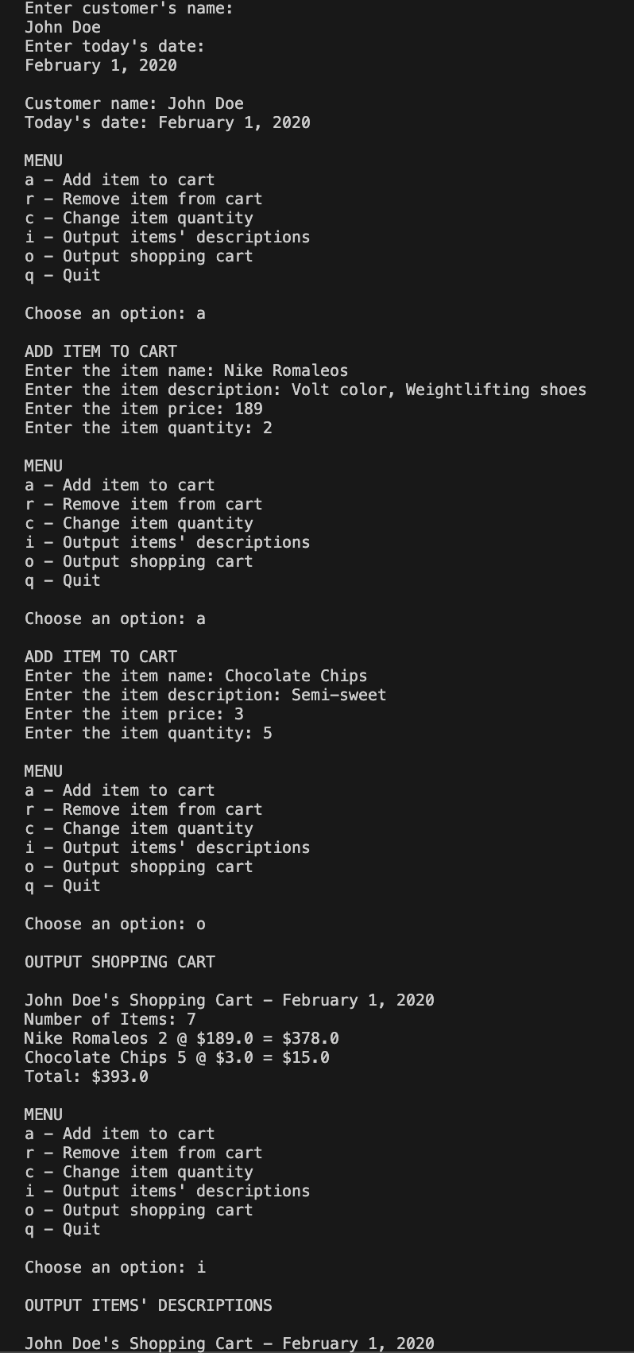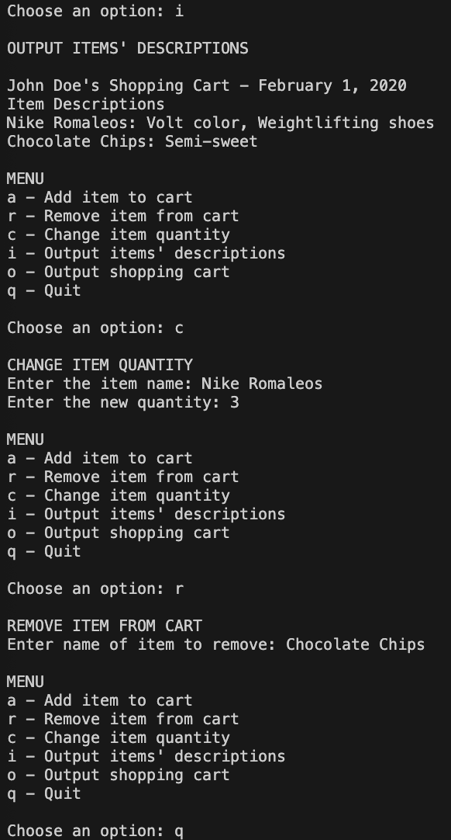
THANK YOU !!!

