Christian Campbell
CSC500-1
2/13/2026

PART 1 Results

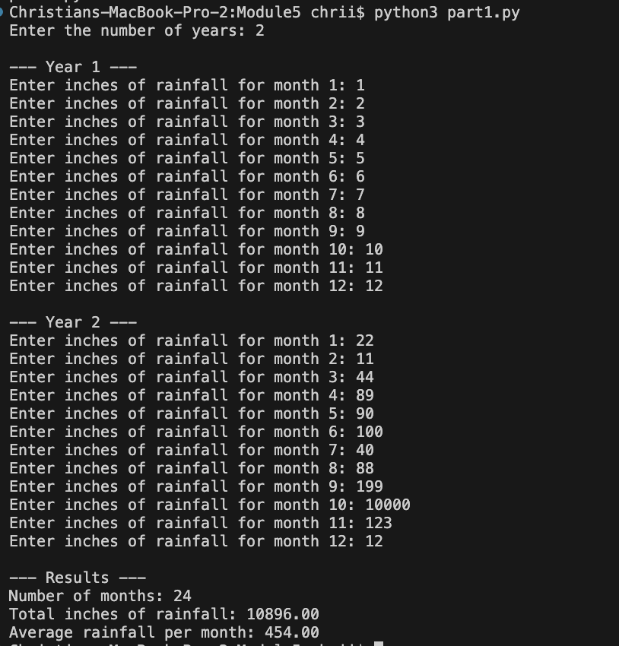
PART 2 Results
