Christian Campbell
CSC500-1
Module 3

Part 1
# Part 1: Restaurant Meal Calculator
# Author: Christian Campbell
# Course: CSC500 Module 3
# Date: 2/30/26

def calculate_meal_total():
"""
Calculates the total cost of a meal with tip and sales tax.
Prompts user for food charge, then computes and displays:
- Food charge
- Tip amount (18%)
- Sales tax (7%)
- Total cost
"""

food_charge = float(input("Enter the charge for the food: $"))

tip_rate = 0.18
tip_amount = food_charge * tip_rate

tax_rate = 0.07
tax_amount = food_charge * tax_rate

total = food_charge + tip_amount + tax_amount

# Display results
print("\n--- Meal Cost Breakdown ---")
print(f"Food Charge: ${food_charge:,.2f}")
print(f"Tip (18%): ${tip_amount:,.2f}")
print(f"Sales Tax (7%): ${tax_amount:,.2f}")
print(f"{'─' * 30}")
print(f"Total: ${total:,.2f}")

# Run the program
if __name__ == "__main__":
calculate_meal_total()

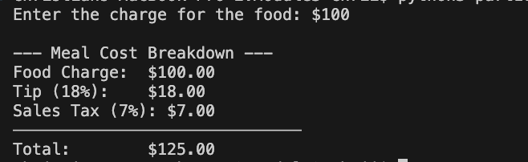

Part 2

# Part 2: 24-Hour Clock Alarm Calculator
# Author: Christian Campbell
# Course: CSC500 Module 3
# Date: 2/30/26

def calculate_alarm_time():
"""
Calculates the time an alarm will go off on a 24-hour clock.
Prompts user for:
- Current time (0-23 hours)
- Hours to wait for alarm
Outputs the alarm time on a 24-hour clock.
"""

# Get current time from user
current_time = int(input("Enter the current time (0-23 hours): "))

while current_time < 0 or current_time > 23:
print("Invalid time. Please enter a value between 0 and 23.")
current_time = int(input("Enter the current time (0-23 hours): "))

hours_to_wait = int(input("Enter the number of hours to wait for the alarm: "))

# Validate hours to wait is non-negative
while hours_to_wait < 0:
print("Invalid input. Hours to wait must be a non-negative number.")
hours_to_wait = int(input("Enter the number of hours to wait for the alarm: "))

# Calculate alarm time using modulo operator for 24-hour wraparound
alarm_time = (current_time + hours_to_wait) % 24

# Display result
print(f"\nThe alarm will go off at {alarm_time}:00 on the 24-hour clock.")

# Run the program
if __name__ == "__main__":
calculate_alarm_time()
