DOOR SYSTEM PROJECT

Power Consumption Characteristics

1. ESP8266

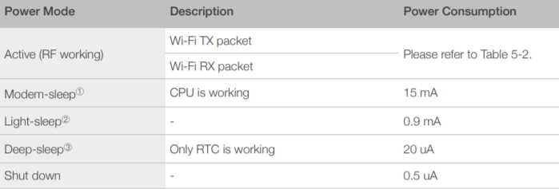

Figure 1- Power Consumption by Power Modes

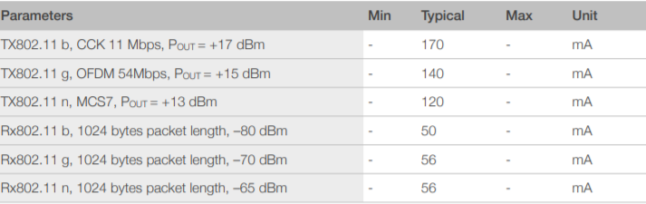

Figure 2- RF Power Consumption

1. MFRC522 Card Reader

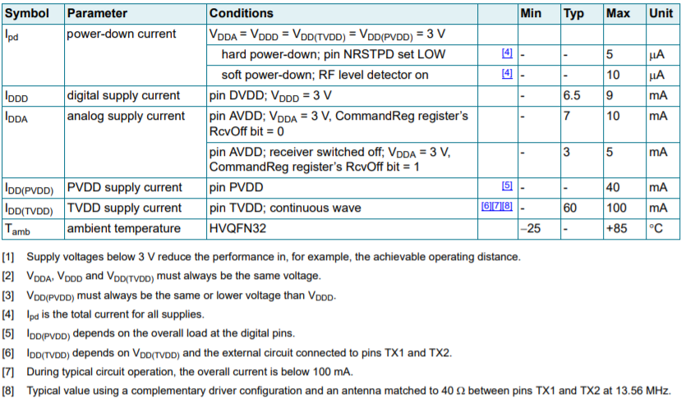

Figure 3- Power Consumption by Power Modes

1. IR LED

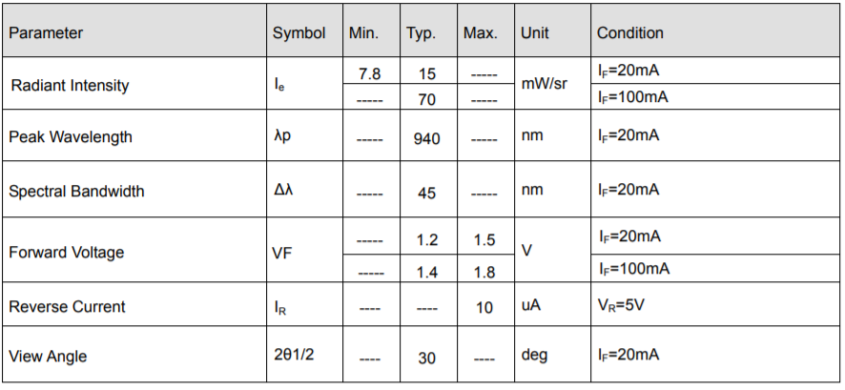

Figure 4- Power Consumption of IR LED

1. TSOP48

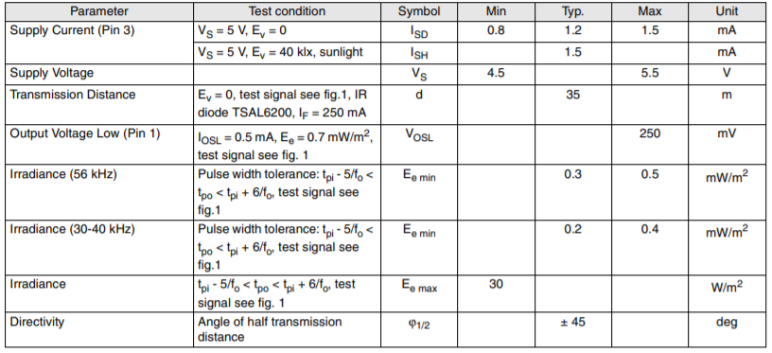

Figure 5 – Power Consumption of TSOP IR Receiver

There are 4 main scenarios.

1. NO OBSTACLE

While ESP is Sleeping

|  |  |  |  |
| --- | --- | --- | --- |
| ESP8266 | Deep Sleep Mode | 20 uA | 100 ms |
| MFRC522 | Hard Power Down | 5 uA |  |
| TSOP |  | 1.5 mA |  |
| IR LED |  | 0 mA |  |

When ESP woke up

|  |  |  |  |
| --- | --- | --- | --- |
| ESP8266 | Modem Sleep Mode | 15mA |  |
| MFRC522 | Hard Power Down | 5 uA |  |
| TSOP |  | 1.5 mA |  |
| IR LED |  | 20 mA |  |

1. OBSTACLE IS NOT CARD

|  |  |  |  |
| --- | --- | --- | --- |
| ESP8266 | Modem Sleep Mode | 15mA |  |
| MFRC522 | Active Mode | 100 mA |  |
| TSOP |  | 1.5 mA |  |
| IR LED |  | 20 mA |  |

1. OBSTACLE IS CARD

|  |  |  |  |
| --- | --- | --- | --- |
| ESP8266 | Modem Sleep Mode | 15 mA |  |
| MFRC522 | Active Mode | 100 mA | 9 ms |
| TSOP |  | 1.5 mA |  |
| IR LED |  | 20 mA |  |

1. WHEN ESP CONNECTED TO WIFI

|  |  |  |  |
| --- | --- | --- | --- |
| ESP8266 | Active mode | 170 mA |  |
| MFRC522 | Hard Power Down | 5 uA |  |
| TSOP |  | 0 mA |  |
| IR LED |  | 0 mA |  |

3.3v 250 mA regulator

Suitable Regulators

1. TPS76733 has rated current 150 mA and Quiescent current 85uA
2. LP2985 has rated current 150mA and quiescent current 1uA
3. MCP1825S33 has rated current 500mA and Quiescent current 0.1uA mA.

Linear Regulators

The most commonly used 3.3 volts regulator is AMS1117 (SOT-223) or LM1117 Voltage Regulator. It is designed to automatically maintain a constant 3.3v output voltage and up to 1A output current and can be used with the ESP8266 module. But one disadvantage of these Linear Regulators like the LM78xx series (where XX is the output voltage) is, AMS1117or LM1117 requires about 2V more on Vin than the expected Vout to function. So, if we want to get a stable 3.3 volts output from AMS1117 regulator the input voltage must be 5.5 volts or at least 5 volts.

Low Drop Out Regulators

There is one variant of the linear regulator called the Low Drop Out regulator or more commonly LDO. These regulators are designed to operate with an input voltage much closer to the output voltage compared to traditional linear regulators. TLV74133PDBVR (150mA), TPS76733 and LP2985 (150mA) from Texas Instruments (National), LDK320ADU33R (200mA) from STMicroelectronics and MCP1825S33 (500mA) from Microchip are some 3.3 volts LDO. All of these regulators will work in our case but which one should we select? The **Quiescent Current** and **Standby Current** will give us the answer.

|  |  |  |  |  |  |
| --- | --- | --- | --- | --- | --- |
| Name | Input V | Output V | Input A | Output A | Quiescent |
| Mcp16311 | 4.4 - 30 | 2 - 24 |  | 1A | 60uA |
| Mcp16301 | 4 - 30 | 2 - 15 |  | 600 mA | 7.5 mA |
| TLV70433 | 2.5 - 24 | 1.2 - 5 |  | 150 mA | 3.2 uA |
| Lm2596 | 1.2 - 37 | 3.3, 5, 12 |  | 3 A | 80 uA |
| TPS54040 | 3.5 - 42 | 0.6 - 47 |  | 500 mA | 116 uA |
|  |  |  |  |  |  |