《数据库系统实验》

实验报告

|  |  |
| --- | --- |
| **题目** | （实验11） |
| **姓名** | 陈欣宇 |
| **学号** | 21307347 |
| **班级** | 人工智能与大数据 |

1. 实验环境：

1、操作系统：Windows 10

2、DBMS：mysql 8.0.31

1. 实验内容与完成情况：

**2.1 创建一个教工表 teacher(tno, tname, tadd, telphone, tsex, id)，将教工号tno设为主键，性别默认值为“男”。**

在jgxl数据库中，执行代码如下：

Create table teacher

( tno char(7) NOT NULL,

tname varchar(16),

tadd char(10),

telphone char(15),

tsex enum('男','女') default '男',

id char(10),

primary key(tno)) engine=InnoDB;

结果检验：

尝试插入主键为空值的行

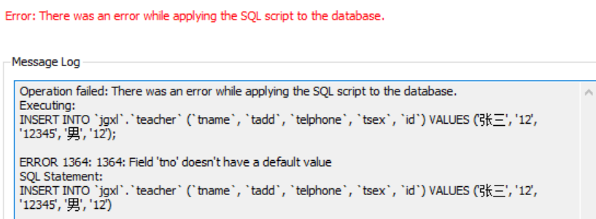

尝试插入tsex不为’男’’女’的行

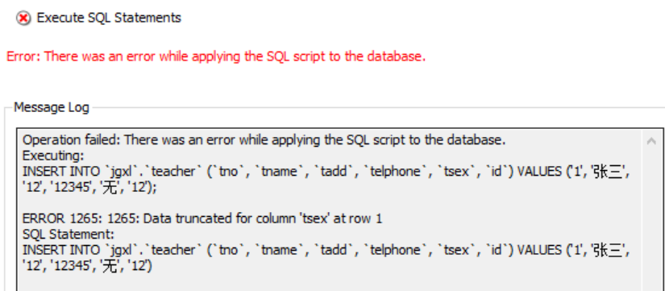

插入tsex为NULL的行，插入成功

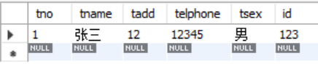

尝试插入主键重复的行

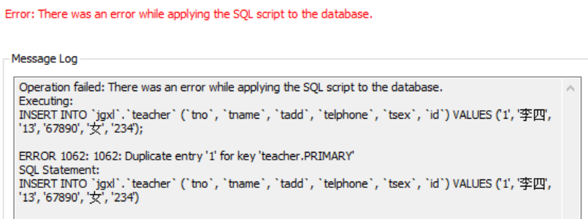

**2.2 根据教工表teacher完成以下任务：**

(1) 设置telphone默认值为00000000 。

代码：

alter table `teacher` alter column `telphone` set default '00000000';

结果检验：

mysql> insert into teacher (tno,tname,tadd,tsex,id) values

('2','王五','14','女','678');

Query OK, 1 row affected (0.00 sec)

mysql> select * from teacher;

+-----+--------+------+----------+------+------+

| tno | tname  | tadd | telphone | tsex | id   |

+-----+--------+------+----------+------+------+

| 1   | 张三   | 12   | 12345    | 男   | 123  |

| 2   | 王五   | 14   | 00000000 | 女   | 678  |

+-----+--------+------+----------+------+------+

2 rows in set (0.00 sec)

(2) 设置tsex的check检查约束为输入值只能为“男”或“女”。

执行代码：

alter table teacher add constraint check_sex check(tsex='男' or tsex='女');

结果检验：

mysql> select * from teacher;

+-----+--------+------+----------+------+------+

| tno | tname  | tadd | telphone | tsex | id   |

+-----+--------+------+----------+------+------+

| 1   | 张三   | 12   | 12345    | 男   | 123  |

+-----+--------+------+----------+------+------+

1 row in set (0.00 sec)

mysql> update teacher set tsex='a' where tno='1';

ERROR 1265 (01000): Data truncated for column 'tsex' at row 1

(3) 设置id的位数为15位或18位，每位都是数字。

更正id的范围

alter table teacher modify id char(20);

先创建函数IsNum用于判断是否id为数字

DELIMITER $$

drop function if exists IsNum $$

create function IsNum(str varchar(25))

returns int

begin

declare iResult int default 0;

if isnull(str) then return 0;end if;

if str='' then return 0;end if;

select str regexp '^[0-9]*$' into iResult;

if iResult=1 then

return 1;

else

return 0;

end if;

end $$

直接运行可能会报错：

ERROR 1418 (HY000): This function has none of DETERMINISTIC, NO SQL, or READS SQL DATA in its declaration and binary logging is enabled (you *might* want to use the less safe log_bin_trust_function_creators variable)

原因是开启了bin-log，可以通过以下代码得以运行：

set global log_bin_trust_function_creators=TRUE;

创建触发器代码：

delimiter //

create trigger in_id after insert on teacher

for each row

begin

if (length(new.id)!=15 and length(new.id)!=18) or (IsNum(new.id)!=1) then

SIGNAL SQLSTATE '45000'

set message_text='Insert Error';

end if;

end;//

delimiter ;

delimiter //

create trigger up_id after update on teacher

for each row

begin

if (length(new.id)!=15 and length(new.id)!=18) or (IsNum(new.id)!=1) then

SIGNAL SQLSTATE '45000'

set message_text='Update Error';

end if;

end;//

delimiter ;

结果测试：

mysql> update teacher set id='12345678912345678';

ERROR 1644 (45000): Update Error

mysql> update teacher set id='123456789123456789';

Query OK, 1 row affected (0.00 sec)

Rows matched: 1  Changed: 1  Warnings: 0

mysql> update teacher set id='123456789123456';

Query OK, 1 row affected (0.00 sec)

Rows matched: 1  Changed: 1  Warnings: 0

mysql> insert into teacher values ('3','赵六','123','8989','男','12345678912345678');

ERROR 1644 (45000): Insert Error

mysql> insert into teacher values ('3','赵六','123','8989','男','123456789123456789');

Query OK, 1 row affected (0.00 sec)

mysql> insert into teacher values ('4','赵六','123','8989','男','123456789123456');

Query OK, 1 row affected (0.00 sec)

**2.3 设有订报管理子系统数据库DingBao中的表PAPER，请在掌握数据库完整性知识的基础上，根据表内容设定尽可能多的完整性规则于该表，用于保障该表的正确性与完整性。**

已有完整性约束：pno为主键

数据类型：

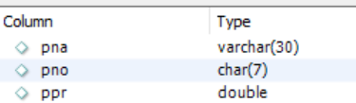

可添加约束：pno需为六位数字，pna非空且不重名，ppr大于0

需要在dingbao数据库中定义上题函数IsNum

代码如下：

alter table paper modify pna varchar(30) not null;

alter table paper add unique (pna);

delimiter //

create trigger in_pa after insert on paper

for each row

begin

if (length(new.pno)!=6 or new.ppr<0 or IsNum(new.pno)!=1)

then

SIGNAL SQLSTATE'45000';

end if;

END//

delimiter //

create trigger up_pa after update on paper

for each row

begin

if (length(new.pno)!=6 or new.ppr<0 or IsNum(new.pno)!=1)

then

SIGNAL SQLSTATE'45000';

end if;

END//

验证测试：

pno需为六位数字

mysql> insert into paper values ('00000','经济日报',14.4);

ERROR 1644 (45000): Unhandled user-defined exception condition

mysql> insert into paper values ('000006','经济日报',14.4);

Query OK, 1 row affected (0.00 sec)

pna非空且不重名

mysql> insert into paper (pno,ppr) values ('000007',14.4);

ERROR 1364 (HY000): Field 'pna' doesn't have a default value

mysql> insert into paper values ('000007','经济日报',14.4);

ERROR 1062 (23000): Duplicate entry '经济日报' for key 'paper.pna'

ppr大于0

mysql> insert into paper values ('000008','新闻日报',-14.4);

ERROR 1644 (45000): Unhandled user-defined exception condition