**Introduction**

The main objective of this lab session is to simulate and characterize several acoustic effects using MATLAB and some basic tools of digital signal processing. More concretely, the objective is to simulate the acoustic reverberation (i.e., the echoes) in a room.

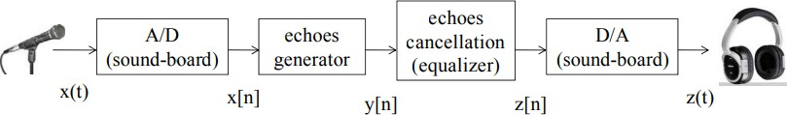

Figure 1: Flow Diagram.

* A/D (Analogical to Digital): digitalization of the analogical signal.
* Echoes generator: simulate the effect of the acoustic reverberation in a room.
* Echoes cancellation: remove the echoes from the “dirty signal.”
* D/A (Digital to Analogical): produce the analogical signal from an input digital signal.

The parts of echo generation and echoes cancellation will be divided into simple echo (just one echo) and multiple echoes (more than one echo).

To finish, the idea is to play the voice signal after it has been processed by all the programmed systems.

1. **Procedure for paper submission**

**Analogical to digital**

In this first section, our function must convert a signal from analogical to digital, this signal will be created by us using our microphone.

To do this, we built two distinct functions, one that will record our voice and another one that will translate and play the voice.

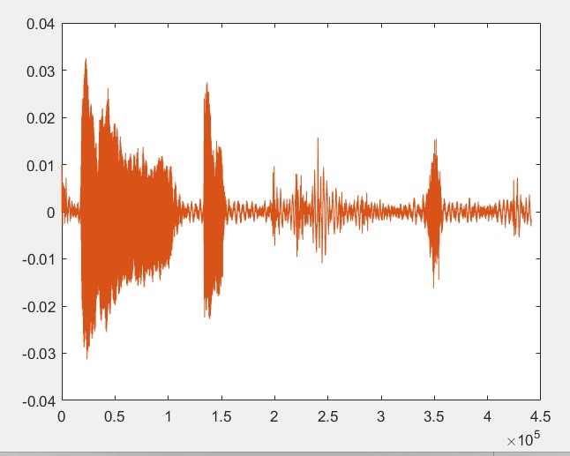

Figure 2: Generated signal.

1. **Simple Echo**

In this section, we needed to create a function that will create echoes.

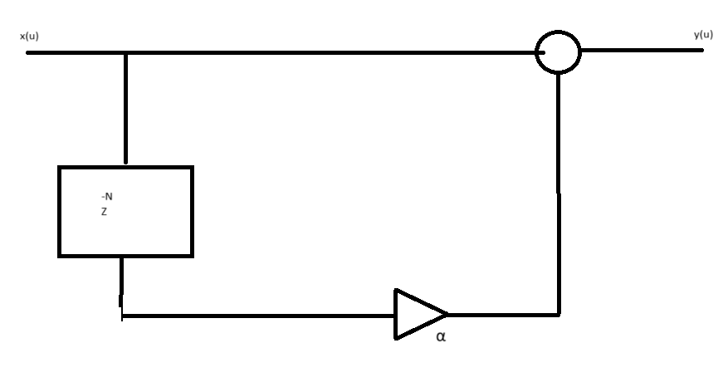

Figure 3: System's programming diagram.

This simple function will be used to create a simple echo, where x(n) is our voice, α is the amplitude and N is the delay that we will insert.

$$y\left(n\right)= x\left(n\right)+ αx(n-N)$$

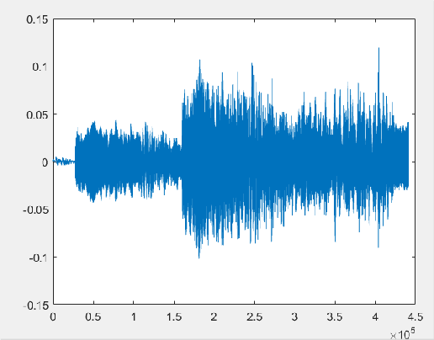

Figure 4: Signal and echo generated by the function.

1. **Multiple Echoes**

This simple equation allowed us to generate multiple echoes, where x(n) is our voice, α is the amplitude of echoes and N is the delay.

$$y\left(n\right)=x\left(n\right)+ αy(n-N)$$

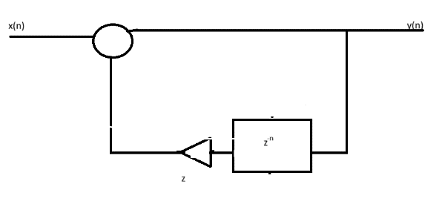

Figure 5: Programming diagram for the system.

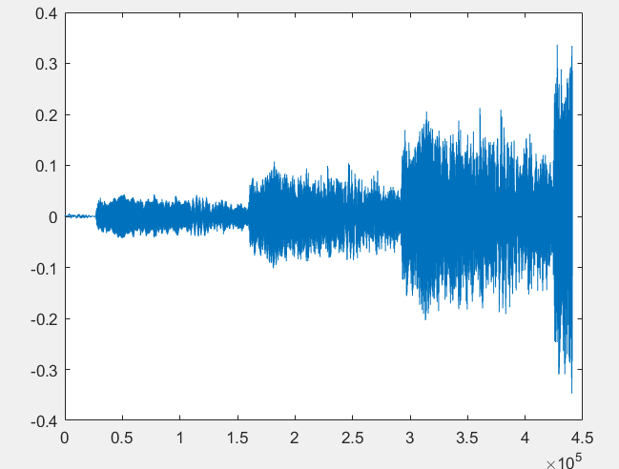

Figure 6: New signal with multiple echoes.

1. **Simple Echo Equalizer**

In this section, we need to create a function that allows us to remove all the echo generated before (Simple Echo).

This equation will remove all the simple echo, where y(n) is our voice signal, α is the amplitude of echo, and N is the delay implemented.

$$z\left(n\right)=y\left(n\right)- αz(n-N)$$

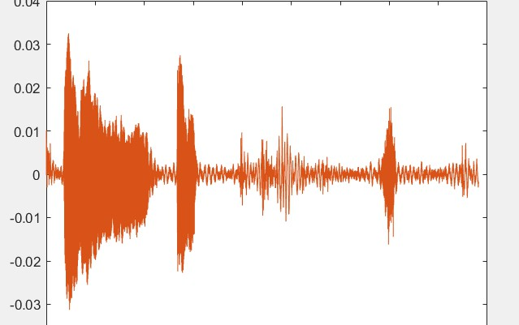

Figure 7: Signal without single echo.

1. **Multiple Echoes Equalizer**

In this last section, we needed to create a function that removed all the echoes generated in section Multiple Echoes.

This equation will remove all of them, where y(n) is our voice, α is the amplitude and N is the delay.

$$z\left(n\right)=y\left(n\right)-αy\left(n-N\right)$$

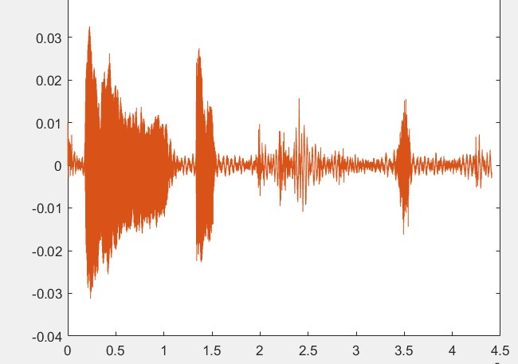

Figure 8: Signal without all the echoes.

**COMMON MISTAKES**

Some of the mistakes that we had were during the creation of the distinct functions, as we were creating new voices and not using the ones made before.

Also, we could have created better noises with using different word so it will be easier to differentiate between the original and the echo.

**UNITS**

We used these units to make the variables:

- t in seconds

- fs in Hz

- N (delay) in seconds

**CONCLUSION**  
In summary, this exercise allowed me to explore the generation and visualization of voice signals using the MATLAB platform. Additionally, I gained valuable insights into the processes of creating and eliminating echoes.  
I believe that firsthand practice with tools like these is essential for deepening understanding and effectively applying concepts in this field.

**REFERENCES**

1: Video explicatiu Pràctica 1 https://drive.google.com/file/d/1HNU1EMUKwhV4DQgnsdZWzyr_FZp3fWn/view

2: Introduction to Matlab https://atenea.upc.edu/pluginfile.php/3123187/mod_resource/content/3/Background_Study_Introduction_to_MATLAB.pdf