# 2015 REGION IV SOILS CONTEST GUIDELINES

**October 22-23, 2015**

# Stephenville, TX

**Hosted by:**

**Tarleton State University**

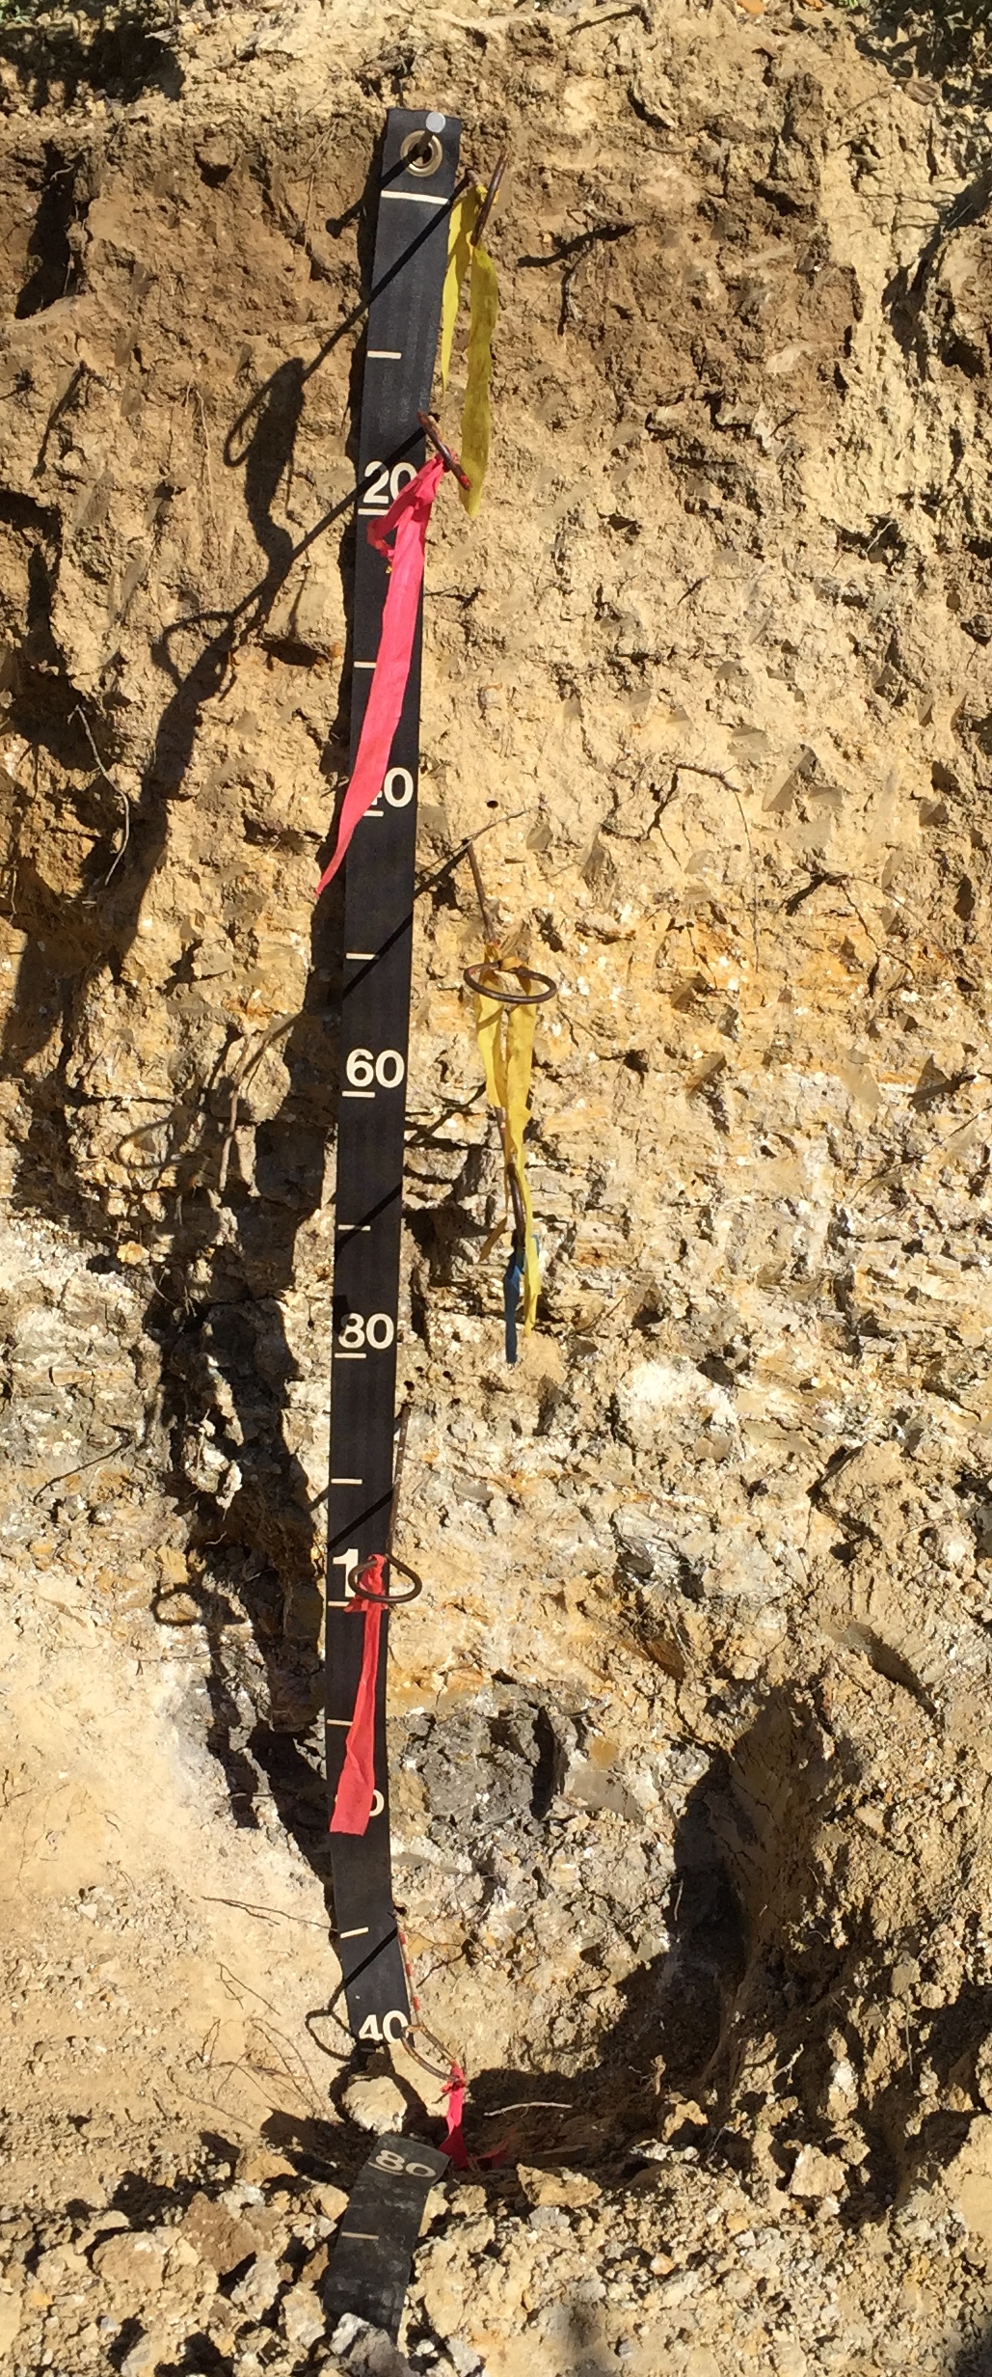

CONTEST RULES

Team Composition

A team is composed of three or four undergraduate students who are enrolled in a full-time, four-year curriculum in the institution they are representing. Each institution may enter only one team in the contest. Additionally, alternate competitors from each team are allowed to compete in the contest activities, but their individual-pit-judged scores will not count towards the sweepstakes (i.e., overall) total. However, alternate competitors are eligible for individual awards. All students must be eligible to represent their institution according to the rules and regulations governing eligibility at their institution. Team and alternate students should be designated by **9:00 pm Wednesday night prior to judging on Thursday morning.**

Contestant Field Equipment

Contestants should provide the following for their personal use:

* tape measure
* clinometer (or Abney level)
* water bottle or sprayer
* acid bottle and dropper
* knife
* pencils
* Munsell color charts
* hand towel
* hand lens
* containers for soil samples

Dedicated electronic calculators, 2-mm diameter sieves, and clipboards may also be used.

Computing, or communication devices other than dedicated electronic calculators are NOT permitted.

Contestant Professionalism

Talking between contestants is NOT permitted during the judging. Pit monitors will be instructed to collect scorecards from contestants and they will receive a zero for that pit for rule violations, especially talking to other contestants.

Contestants will respect each other, and avoid creating distractions during the competition.

Contest Format

The contest is "open book."

It is strongly advised that the contestants minimize documents and transfer notes to the contest guidelines packet for use during the contest.

Students must correctly enter their contestant ID code on their scorecard. Scorecard entries must be made according to the instructions for each specific feature to be judged (see following sections of this guidelines packet). Only one response should be entered in each blank, unless specifically instructed otherwise.

The contest will consist of three parts: a) four, individually judged pits (Thursday), b) one, team-judged pit (Friday), and c) the sweepstakes (overall) score, a combination of both team and individual results. The sweepstakes ranking will be used to select which teams advance to the National Collegiate Soil Judging Contest the following Spring.

The team scores from the individually judged pits will be the sum of the top three individual scores for each pit. Therefore, the sum of 13 scorecards (3 individuals times 4 individual pits plus 1 team-judged pit) will determine the overall sweepstakes score per team. All alternate students from an institution may participate in the one team-judged pit. Students from institutions having less than three team members may compete, but they are only eligible for individual awards.

**Tie Breaking:** The clay content of the third horizon will be used to break ties in both the individual and team competitions. In order to break a tie in the overall sweepstakes scores, the mean whole-profile clay content for individually judged Pit 1 is calculated from the estimates provided by all members of a given team. The team with the mean estimate closest to the actual value will receive the higher placing. If this does not break the tie, the next pit in order (i.e., Pit 2) will be used in the same manner. For individual score ties, the clay content of the third horizon at Pits 1, 2, and so on, if necessary, will be compared to that estimated by the individual in order to break a tie between individuals. For the team-judged pit, the team estimate of the clay content of the third horizon will be compared to the actual value. The team with the estimate closest to the actual value will receive the higher placing. If this does not break the tie, the next deepest horizon will be used.

**Results** will be announced Friday afternoon and will be final. Awards will be given to the top three overall sweepstakes teams, the top team in the team-judged-pit portion of the contest, and the top five individuals in the individual-pit-judged portion of the contest.

**Restricted Area:** each excavations “restricted area” will be clearly outlined and bounded vertically placed colored ribbon on one of the pit walls for the measurement of horizon depth and determination of boundary distinctness. A nail will be placed somewhere in the third horizon. A tape measure will also be attached to the restricted area. THE RESTRICTED AREA IS TO BE UNDISTURBED! Picking, taking samples, or other disturbances within the restricted area disqualifies contestant and/or team.

**Provided Characterization Data:** Constants can expect posting of the pit ID #, number of horizons to describe, depth to be considered, pH, and percent organic carbon (%OC) for each horizon. Other relevant information may be displayed on a sign at each pit.

An example of “other relevant information” might be: percent base saturation (%BS) when the pH is less than 7.5†, sodium adsorption ration (SAR), and others might be listed. Team coaches or Faculty Mentors will be apprised of other possible listed characterizations.

Contestants should expect to evaluate between three and eight horizons and layers per pit. Slope stakes will be placed along the grade for determination of slope and to facilitate the determination of the landform and hill slope profile.

**Judging Time Intervals:** Fifty (50) minutes will be allowed for the judging of each contest pit. The morning of the individually judged pit portion of the contest, each contestant will be provided an assigned number-letter combination corresponding to team-group designations. This will uniquely identify each contestant and be used to facilitate rotations at the pit according to the schedule provided in Table 1.

Table 1. Contestant rotations at individually judged pits.

|  |  |  |  |  |
| --- | --- | --- | --- | --- |
| Time | Individual Pits 1 and 3 | | Individual Pits 2 and 4 | |
| Odd team no. | Even team no. | Odd team no. | Even team no. |
| First 5 min. | In* | Out | Out | In |
| Next 5 min. | Out | In | In | Out |
| Next 10 min. | In | Out | In | Out |
| Next 10 min. | Out | In | In | Out |
| Next 20 min. | Free** | Free | Free | Free |

*In and Out refer to contestants being allowed in the pit or outside of the pit, respectively.

**During free time, contestants may remain in or out of the pit.

Team-pit Judging

Two teams will be at the team-judged pit at the same time, but start times for each team will be staggered so that only one team has access in the pit at a time. Each team will have two 10-minute intervals in the pit and two 10-minute intervals out of the pit (i.e., 10 minutes in, 10 minutes out, 10 minutes in, 10 minutes out) with the last 10 minutes of the 50-minute total time as free time to be in or out of the pit if desired.

Scoring and Abbreviations

Grading will be conducted by individuals competent in soil morphology and classification. Each grader will grade only one pit and each scorecard will be re-graded and scores tallied by a second individual for confirmation of accuracy. Point allocations vary among cells and are listed on the scorecard in parentheses.

Where an answer is not needed or is inappropriate, a dash (-) may be used, or the cell can be left blank.

Contestants may use the official abbreviations (preferred, see Attachment 1) or write out answers. Use of abbreviations other than official abbreviations is strongly discouraged, but graders shall give credit if, in their opinion, the meaning of an unofficial abbreviation is obvious.

For the individually judged portion of the contest, a team is composed of three or four undergraduate students. The team score will be the sum of the top three individual scores at each pit (see example in Table 2). This method maximizes the opportunity for all four team members to contribute to the final team score.

Table 2. Score tabulation example for the individual contest. Shaded scores represent those that are the low score for a pit among the team’s contestants and are not included in the team’s total score for that pit or overall.

|  |  |  |  |  |  |
| --- | --- | --- | --- | --- | --- |
| Contestant | Pit 1 | Pit 2 | Pit 3 | Pit 4 | Total |
| A | 132 | 130 | 110 | 144 | 516 |
| B | 146 | 116 | 141 | 138 | 541 |
| C | 130 | 112 | 160 | 158 | 560 |
| D | 125 | 114 | 129 | 145 | 513 |
| Total score: | 408 | 360 | 430 | 447 | 1645 |

The score from the team-judged pit will be added to the individual scores for the overall sweepstakes team totals and final rankings.

SCORECARD INSTRUCTIONS

The scorecard consists of five parts: I. Soil Morphology; II. Soil Profile Characteristics; III. Site Characteristics; IV. Soil Classification; and V. Interpretations (refer to the attached scorecard example at the back of this guidelines packet). The Soil Survey Manual (Chapter 3, 1993), Field Book for Describing and Sampling Soils, version 3.0 (Schoeneberger et al., 2012), and Keys to Soil Taxonomy (12th Edition, 2014) should be used as guides during practice. These publications are available at: <http://www.nrcs.usda.gov/wps/portal/nrcs/main/soils/ref/>.

Part I: Soil Morphology

A. Designations for Horizons and Layers – (Chpt. 18, Keys to Soil Taxonomy Twelfth Edition, 2014)

Horizon designations will follow standard procedures, including a master, transitional or combination horizon symbol to be recorded in the “Master” column, and when needed, a lower case symbol in the suffix/subordinate distinction column labeled “Sub”, and an Arabic numeral in the “No.” column. Arabic numerals should be used in the “Prefix” column preceding the “Master” column to indicate lithologic discontinuities. Prime symbols to distinguish otherwise identical designations should be placed in the “Master” column. All B horizons must have a suffix/subordinate distinction. If no designation is necessary for a cell, contestants may leave the cell blank or record a dash (-) to indicate no designation. Only mineral horizons will be described for the contest, and students should be especially familiar with the **master horizons** A, E, B, C, and R **layer** designations, and the appropriate application of **transitional and combination** horizons. Contestants are expected to be familiar with **suffix symbols**, **vertical subdivisions** and **discontinuities**. Special clarification will be communicated to your coach/instructor concerning special guidance when appropriate, or will be added as an addendum if necessary.

B. Lower Depth

The depth of the lower boundary as measured from the soil surface should be recorded in centimeters (cm). Alternately, the depth of both the upper and lower boundary may be given, but only the **depth to the lower boundary will be graded**. For example, a Bt1 horizon occurring from 30-45 cm may be recorded as “45 cm” (preferred) or “30-45 cm”.

Depth measurements should be made between the tapes in the restricted area on the pit wall using the mounted tape measure provided. A range for the lower depth considered correct will be based on the boundary’s distinctness according to Table 3. Where one horizon grades into another, the location of the boundary will be specified at the bottom of the transition zone.

The transition will be part of the overlying horizon for this judging.

No horizon less than 8 cm thick will be described. If a horizon less than 8 cm thick occurs, it should be combined with the adjacent horizon that is most similar for the depth measurement purposes. When two horizons combine to a total thickness of 8 cm or more, the properties of the thicker horizon should be described. If lamellae are encountered that are thinner than 8 cm, then the convention is to describe the eluvial and illuvial horizons as a unit (i.e., E&Bt) and the thickest horizon’s morphology would be described.

**Unconsolidated horizons and layers depths and interpretations:** should the excavation not extend to a depth of 150 cm the last horizon, or unconsolidated layer (interpret this as all non-root restrictive layers or horizons) should be extrapolated to 150 cm for interpretations. The last horizon depth should be the specified judging depth with a “+” added.

Thus, if the pit sign states “Describe 5 horizons to a depth of 140 cm”, the fifth lower depth designation should be “140+”.

**Lithic contact:** the upper contact should be considered in evaluating hydraulic conductivity, effective soil depth, and water retention difference. When a lithic contact is encountered the “+” is dropped from the depth.

**Paralithic contact:** occurs within the specified depth, the contact should be considered as one of the horizons to be included in the description, and the appropriate horizon nomenclature should be applied (i.e., Cr). When a paralithic contact is encountered the “+” is dropped from the depth.

C. Boundary Distinctness (Chpt. 3, Boundaries of Horizons and Layers, Soil Survey Manual; 1993)

“A boundary is a surface or transitional layer between two adjoining horizons or layers. Most boundaries are zones of transition rather than sharp lines of division. Boundaries vary in distinctness and in topography.

“Distinctness refers to the thickness of the zone within which the horizon boundary can be located. The distinctness of a boundary depends partly on the degree of contrast between the adjacent horizons and partly on the thickness of the transitional zone between them.

Table 3. Boundary distinctness with ranges of allowable grading tolerances. Acceptable abbreviations are in parenthesis after the distinctness class name.

Distinctness class name Distinctness class Range for grading

Abrupt (A) < 2 cm thick ± 1 cm

Clear (C) 2-5 cm thick ± 3 cm

Gradual (G) 5-15 cm thick ± 8 cm

Diffuse (D) > 15 cm thick ± 15 cm

The boundary distinctness of the deepest horizon will not be described and should be left blank or with a dash (-) recorded in the cell.

Boundary topography will not be described for this contest. Be sure to use horizon and layer depths measured at the restricted area of the pit wall since wavy and irregular boundaries may exist. Where wavy or irregular boundaries exist in restricted area the median of the maximum and minimum is the official depth.

D. Clay Percentage, Coarse Fragments, and Texture (Chpt. 3, Soil Survey Manual)

**Clay content:** as a weight percentage of the soil fines should be recorded in the “Clay%” column. A scaled range for correct answers compared to values estimated by the judges will be used according to the following:

Table 4. Allowed range deviation for contest judging.

Actual % Allowed Deviation %

< 20 +/- 2

20 to 40 +/- 3

> 40 +/- 4

The textural class and % clay for each horizon will be determined by the judges and supported by laboratory data. Soil textural classes as defined in the Soil Survey Manual Chapter 3 (1993) and their official abbreviations (supplied to contestants as part of Attachments 1 and 2) are to be used. Deviation from standard nomenclature will be incorrect (i.e., sandy silt or silty loam).

Credit for sand, loamy sand, and sandy loam textures will NOT be given if sand modifiers are required and not provided (i.e. very fine, fine, coarse, or very coarse).

**Textural class:** record in the “Class” column.

**Coarse fragments:** use the appropriate coarse fragment modifiers according to Table 5 when adequate volumes are observed. Abbreviations provided in Attachment 1 are acceptable substitutes for the proper modifier. Misspelled modifiers are not awarded points.

Table 5. The course fragment modifiers are applied using the following volumes. These are volumes of course fraction in the volume of soil.

Coarse fraction Modifier

< 15% none needed

15-34% modifier

35-60% very modifier

> 60% extremely modifier

For this purpose, the terms “gravel” and “cobble” are defined as below:

“Gravel” – a fragment 2-75 mm diameter; any lithology and shape; as a modifier – gravelly.

“Cobble” – a fragment 75 to 250 mm diameter; any lithology and shape; as a modifier – cobbly.

“Stone” – a fragment 250 to 600 mm diameter; any lithology and shape; as a modifier – stony.

If gravels and cobbles occur in the same horizon, the largest coarse fragment modifier is used unless the smaller size fragment exceeds 2 times the volume of the larger.

Coarse fragment modifiers should be recorded in the column labeled “CF Mod.”

Recording in the “Class” column for the soil textural class is incorrect and if not recorded in “CF Mod” will result in loss of points for both “Class” and “CF Mod.”

E. Color (Chpt. 3, pp. 146 – 157, Soil Survey Manual)

The Munsell color notation (hue, value, and chroma) will be recorded to describe the **moist soil color** of each horizon. For surface horizons, the moist color will be determined on briefly rubbed samples. See [Chapter 3 under the heading Soil Color in the Soil Survey Manual](http://www.nrcs.usda.gov/Internet/FSE_DOCUMENTS/nrcs142p2_050993.pdf) (1993).

For all other horizons, the color recorded should be the dominant moist color of the matrix (i.e., the color that occupies the greatest volume of the horizon). Ped surface color likely will not constitute sufficient volume to be designated as the dominant color.

F. Structure (Chpt. 3, pp. 157 – 163, Soil Survey Manual)

Both grade (i.e., structureless, weak, moderate, or strong) and shape of structure should be recorded. Acceptable types of structure are restricted to the following: granular, platy, subangular blocky, angular blocky, wedge, prismatic, and columnar. If two structure types are present in a given horizon, describe the structure with the stronger grade. If the two structures are of equal grade, describe the one with the larger physical size. If there is no structure, indicate “structureless” (SL) in the grade column and either “massive” (MA) or “single-grained” (SG) in the shape column. Structure size is not recorded.

G. Effervescence

Table 6. Effervescence Class, acceptable Class codes, and criteria.

Effervescence Class Code Criteria

Noneffervescent NE No bubbles form.

Very Slightly Effervescent VS Few bubbles form.

Slightly Effervescent SL Numerous bubbles form

Strongly Effervescent ST Bubbles form a low foam.

Violently Effervescent VE Bubbles rapidly form a thick foam.

Not populating this category (blank), using a tick (-), using N, or NO will be marked as incorrect since an established criteria (NE) exists for this condition.

Effervescence Class should be determined with 10% HCl when observing effervescence of carbonates.

H. Redoximorphic Features (Chpt. 1, pp. 24-25, Keys to Soil Taxonomy, 2010).

**Background:** Redoximorphic features (RMFs) are soil morphological features caused by alternating reduction/oxidation (redox) processes. The reduction/oxidation of iron (Fe), and to a lesser extent manganese (Mn), minerals result in most RMF features. Iron is a major pigment that influences soil color. The loss, accrual, and valence/mineral state of Fe are major determinates of color patterns within or across soil horizons. Iron or Mn reduction occurs when free oxygen is limited or excluded from a soil volume or horizon by water saturation for extended time. Reduced iron (Fe2+) is comparatively much more soluble and mobile than oxidized iron (Fe3+), and moves with water flow and by diffusion gradients. When soil is reduced, Fe and Mn in local zones can be removed, leaving uncoated mineral grains (depletions) of lighter color. Reduced Fe is oxidized and precipitates when water drains from soil (reentry of free oxygen), or where oxygen is present in, or along, soil pores, including root channels, or along roots. The re-oxidized Fe or Mn may form crystals, soft masses, or hard concretions or nodules (concentrations). Oxidized Fe will generally have a redder or yellower color than adjacent soil particles, while Mn often will have a darker color than adjacent soil particles.

Redox *concentrations* (**Con**) are defined as zones of Fe-Mn accumulation from:

1. Nodules and concentrations - Concentrations have internal rings and nodules do not.

2. Masses - Masses are non-cemented concentrations.

3. Pore linings - may be either coatings on pore surfaces or impregnations from the matrix adjacent to pores.

Redox *depletions* (**Dep**) are defined as zones with chromas less than, or values higher than those in the matrix where either Fe, or Mn, or both Fe, and Mn, have been removed through reduction and transport processes.

The presence of redox concentrations and/or depletions should be recorded in the column labeled “Con/Dep”. If only concentrations exist, record only “Con”. If only depletions exist, record only “Dep”. If both concentrations and depletions occur, record both “Con” and “Dep”. Record the abundance of RMFs in the column labeled “Abund” according to Table

Table 7. Redoximorphic Features Abundance.

Class Code Criteria: percent of surface area covered

Few F < 2

Common C 2 to < 20

Many M ≥ 20

Part II: Soil Profile Characteristics

A. Hydraulic Conductivity

The saturated hydraulic conductivity of the surface horizon (Surface) and the most-limiting horizon (Limiting Layer) within the depth specified for judging will be estimated. Should a lithic, paralithic, or densic contact occur at or above the specified judging depth, it should be considered in evaluating hydraulic conductivity.

The three general categories for hydraulic conductivity to be used in this contest are the following:

High - Greater than 3.6 cm/hr. This class includes sands and loamy sands and some highly structured sandy loams. Horizons containing large quantities of coarse fragments with insufficient fines to fill many voids between the fragments are also included in this class.

Moderate - Between 0.036 and 3.6 cm/hr. This class includes materials excluded from the “Low” and “High” classes.

Low - Less than 0.036 cm/hr. Low hydraulic conductivity should be indicated based on the following criteria:

* + - 1. Clays, silty clays, or sandy clays that are structureless or have a structure grade of weak or moderate
      2. Silty clay loams and clay loams that are structureless or have a structure grade of weak
      3. Dense layers (i.e., that use “d” as a horizon suffix)
      4. Bedrock layers (i.e., Cr or R horizons) where the horizon directly above contains redoximorphic depletions or a depleted matrix (i.e., color value ≥ 4 with chroma ≤ 2) due to prolonged wetness and indicative of restricted water flow

B. Effective Soil Depth

Effective soil depth classes are defined as the depth from the soil surface to the upper boundary of a root-restricting layer. Root-restricting layers include lithic and paralithic contacts, cemented layers, fragipans, and dense horizons. A sand and/or gravel layer with insufficient fines to fill the voids is also restrictive. If the lower depth of judging is less than 150 cm, and there is no restricting layer within or at the judging depth, the horizon encountered at the bottom of the judged profile may be assumed to continue to at least 150 cm unless the excavations information card indicates otherwise.

Table 8. Effective soil depth classes and associated depths.

Very Shallow…………root-restricting layer within 25 cm of soil surface

Shallow……………….root-restricting layer from 25 to 49 cm

Moderately deep……...root-restricting layer from 50 to 99 cm

Deep…………………..root-restricting layer from 100 to 149 cm

Very deep……………..root-restricting layer at 150 cm or deeper

If the information card, for example, indicates the depth of the top of an ‘R’ layer the lower depth of judging is the top of the ‘R’ layer even if soil from previous judgers have hidden it at the bottom of the excavation.

C. Water Retention Difference

The amount of water that a soil can hold between -33 kPa (-1/3 bar) and -1500 kPa (-15 bars) soil-water tension within the zone accessible to roots is the water retention difference of the soil. The water retention difference of the whole soil is calculated by estimating the amount of water each horizon can hold, determining which horizons are sufficiently accessible to plant roots to be significant sources of water, and summing the water retention differences of the accessible layers. Water retention difference is commonly expressed in cm water/cm soil. Classes are based on the amount of water retention difference in the upper 1.5 m of soil, or above a root-limiting layer, such as a lithic or paralithic contact. A number of factors are used to determine the water retention difference of individual horizons. These include texture, clay mineralogy, soil structure, volume of coarse fragments, organic matter content, and bulk density. For the contest, only texture and volume of coarse fragments will be used to estimate the water retention differences of individual horizons above 1.5 m. Estimated water retention in relation to texture is provided in Table 10. If the instructions for a pit require judging a profile that is less than 1.5 m deep, then assume the last horizon extends to a depth of 1.5 m unless it is directly underlain by or contains a lithic or paralithic contact. Contestants are to assume that plant roots are sufficiently restricted by these contacts that no water is available below the contact. Coarse fragments are considered to have negligible (assume zero) moisture retention so estimates must reflect the coarse fragment content (i.e., subtract the percentage of coarse fragment volume from the whole-soil volume). Table 11 is a sample calculation of water retention difference.

Table 9. The five classes for water retention difference

Water Retention Class Water retention

Very Low: < 7.50 cm

Low: 7.50-14.99 cm

Medium: 15.00-22.49 cm

High: 22.50-29.99 cm

Very High: > 30 cm

Table 10. Estimated relationships among water retention difference coefficients and soil textural class.

|  |  |
| --- | --- |
| Texture Class of Soil Horizon | cm H2O/cm soil |
| silt, silt loam, silty clay loam, loam, clay loam, and very fine sandy loam | 0.20 |
| sandy loam, fine sandy loam, sandy clay loam, sandy clay, clay, and silty clay | 0.15 |
| coarse sandy loam, loamy fine sand,  loamy very fine sand, and loamy sand | 0.10 |
| loamy coarse sand and all sands | 0.05 |

Table 11. Example calculation for water retention difference.

Horizon Depth Textural Class Coarse Fragments (%) Water Retention (cm)

Ap 0-12 ls 0 (12cm)(0.10) = 1.2

Bt1 12-28 sc 0 (16cm)(0.15) = 2.4

Bt2 28-54 scl 0 (26cm)(0.15) = 3.9

2Bt3 54-105 l 5 (51cm)(0.20)(0.95) = 9.69

2Bt4 105-132 grl 20 (27cm)(0.20)(0.80) = 4.32

2R 132+ - 0 0.00

Total water retention difference = 21.51

= MEDIUM

D. Soil Wetness Class

Soil wetness class is determined by the depth to specific redoximorphic features (RMF) in the soil indicative of prolonged wetness, specifically depletions with a color chroma of 2 or less and a color value of 4 or more (i.e., gray depletions of at least common abundance as defined by the NRCS). Redox concentrations alone shall not be sufficient evidence for a state of wetness.

Table 12. The wetness classes to be used for this contest.

Very Shallow: < 25 cm

Shallow: 25 to 49 cm

Moderately Deep: 50 to 99 cm

Deep: 100 to 149 cm

Very Deep: >150 cm

If no evidence of wetness exists within the specified depth for characterization and that depth is less than 150 cm, assume the wetness class is “Very deep”. These classes indicate free water and reduction occurs, but do not indicate the duration of occurrence of free water.

Part III: Site Characteristics

A. Parent Material

Parent material refers to unconsolidated organic and mineral material in which soils form. As parent material cannot be observed in its original state, inference from the properties of the soil and from other evidence must be used. Mode of deposition and/or weathering may be implied or implicit.

The following parent materials will be used in this contest:

Eolian – or Aeolian materials were deposited by wind.

Alluvium – unconsolidated sediments were deposited by running water of streams and rivers, including cobbles, gravels, sand, silt, clay, and various mixtures of these. Alluvium may occur on terraces well above present streams, or present flood plains or deltas, or as a fan at the base of a slope.

Colluvium – unconsolidated, unsorted sediments detached from the hillslopes and deposited at a footslope by gravity and water.

Residuum – unconsolidated, weathered, or partly weathered mineral material that accumulates by disintegration of bedrock in place.

Sometimes two parent materials may be evident in a pedon, for example alluvium over residuum. If evident, indicate the transition with an Arabic numeral in the “Prefix” column beginning with the number 2 for the first transition. It is implied that the overlying parent material is number 1. For example, the following sequence may be found in a profile with two parent materials: A – E – Bt1 – 2Bt2 – 2Bt3 etc.

B. Landform

The landform on which the soil pit is located should be identified.

**Uplands** - Areas dominated by residual and colluvial parent materials and usually occur above floodplains and stream terraces. The bulk of soil material in uplands is produced by physical and chemical weathering of parent material in place and mass wasting, such as soil creep, debris and mud flows, slump, landslides, etc.

**Depression** - positions on the landscape where water and/or sediment accumulate. They have no free surface water drainage outlet.

**Floodplain** - The lowest geomorphic surface which is adjacent to the stream channel and which floods first when the stream goes into flood stage. It is formed by the deposition of alluvium. Each stream has only one floodplain.

**Stream Terrace** - geomorphic surfaces formed by the deposition of alluvium and are higher in elevation than the flood plain. A stream may have one or more terraces. For the purpose of this contest, a landform will not be designated as a stream terrace unless its’ association with a present-day stream is reasonably apparent.

C. Slope Gradient

Slope classes to be used in the contest are listed on the scorecard. If a site falls on the boundary of two slope classes, mark the steeper class. The slope is to be determined between two stakes at each site designated for this purpose. The student is responsible for checking the heights of the stakes.

D. Site Position

If the landform is a stream terrace use **riser** or **tread** for the site position. A terrace consists of a flat or gently sloping geomorphic surface, called a tread that is typically bounded on one side by a steeper ascending slope, which is called a "riser."

Uplands shall be described according the Ruhe hilslope model (Figure 1), and the following:

**Summit** (SU) - The topographically highest position of a hill slope profile with a nearly level (planar or only slightly convex) surface. Ridge tops are included under summit since they are topographic highs and are usually planar in one direction.

**Shoulder** (SH) - The hill slope profile position that forms the convex, erosional surface near the top of a hill slope. It comprises the transition zone from summit to backslope.

**Backslope** (BS) - This position includes all landscape positions between the shoulder and footslope.

**Footslope** (FS) - The position that forms the concave surface at the base of a hill slope. In some landscapes, the footslope may gradually transition into a toeslope.

**Toeslope** (TS) - The lowest component that extends away from the base of the hill slope. Toeslopes are typically linear in shape. The toeslope may gently transition to a floodplain or depression. If the pit located in a closed depression center that is linear in shape, toeslope should be marked.

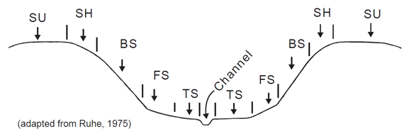

Figure 1. The diagram of the hillslope model adapted from Ruhe (1975).

E. Surface Runoff

Surface runoff refers to water that flows away from the soil over the land surface. Surface runoff is controlled by a number of factors including soil properties, climate, and plant cover. Runoff can be significantly altered by management (i.e., natural cover, cultivation, minimum tillage operations, etc.). For the purpose of this contest, only the runoff classes in Table 13 will be used.

Table 13. Surface runoff classes.

_______________________________________________________________________

Hydraulic Conductivity of the Surface Horizon

% Slope High Moderate Low

------------ surface runoff class ----------------

* 1. Very Slow Very slow Very slow

1-3 Very slow Slow Slow

3-5 Slow Medium Medium

5-8 Medium Medium Rapid

8-12 Medium Rapid Very rapid

12-20 Rapid Very rapid Very rapid

> 20 Very rapid Very rapid Very rapid

If a slope falls exactly on a break between slope classes, select the steeper slope category. Should a site be forested or in pasture, the surface runoff may be significantly decreased due to vegetative or residue cover. When surface cover is dense (i.e., less than 10% bare soil), the surface runoff class should be assigned one lower rate class to a minimum of “Very slow.” “Ponded” shall be used to describe surface runoff in depressional areas only.

F. Erosion Potential

Soil erosion potential refers to the likelihood of soil erosion by water. The potential for future erosion losses is influenced mainly by the texture of the surface soil and the amount of surface runoff at a site. For the purpose of this contest, only the erosion potential classes in Table 14 will be used. It is assumed that granular structure or structureless - single grained exists for the surface horizon and that the soil is bare, although in this contest there is no adjustment if that is not the case. A soil profile occurring not in a pit but in a natural cliff-like exposure will be classified with “very high” erosion potential.

Table 14. Erosion potential classes.

|  |  |  |  |  |
| --- | --- | --- | --- | --- |
|  | Surface Horizon Texture | | | |
| Surface Runoff | S, LS | SCL, SC | SL, CL, C, SiC | L, Si, SiL, SiCL |
| Ponded | Very low | Very low | Very low | Very low |
| Very slow | Very low | Very low | Low | Medium |
| Slow | Very low | Low | Medium | Medium |
| Medium | Very low | Low | Medium | High |
| Rapid | Low | Medium | High | Very high |
| Very Rapid | Medium | High | Very high | Very high |

Part IV: Soil Classification

Keys to Soil Taxonomy, 12th Edition (2014) should be used for details on soil classification. Some pertinent data may be displayed on the pit sign (i.e., percent base saturation, calcium carbonate equivalence, and/or organic carbon).

**Particle-Size Control Section:** The upper and lower limits of the family control section should be identified as defined in Keys to Soil Taxonomy, 12th Edition (2014).

**Family Particle Size Class:** Based on the determination of family control section, calculate the weighted percentage sand, silt, clay (and if needed, coarse fragment content in the control section), and determine the family particle size class. Students will need to know when to use the three broad particle size classes and when to use the seven more specific particle size classes. If two or more strongly contrasting particle size classes are present within the control section, both family particle-size classes should be identified. For example, check both coarse-silty and clayey if the family is coarse-silty over clayey.

Part V: Interpretations

Soil interpretations involve the determination of the degree of limitation for each soil at a site for a specified use. The most restrictive soil property determines the limitation rating. In cases where the base of the pit does not extend to the depth indicated in the following tables (e.g., 150 cm), one should assume that the lowest horizon in the pit extends to the depth of interest, unless a lithic or paralithic contact occurs within the depth to be judged. The following soil use interpretation tables are partially extracted and modified from the National Soil Survey Handbook (NSSH, Part 620; 1993).

The depth to a seasonally high water table is based on the shallowest observed depth of redoximorphic depletions of color value ≥ 4 with chroma ≤ 2 or a depleted matrix.

The hydraulic conductivity criteria for the septic tank absorption field interpretation excludes the upper 50 cm of the soil profile, thus only the soil between the depths of 50 and 150 cm should be considered.

In addition to indicating the suitability rating for each soil use, contestants will record the number corresponding to the reason in the table used for the suitability rating selected on the scorecard. If all the evaluations are “slight”, then record “none” as the reason on the scorecard.

RESOURCES

Schoeneberger, P.J., D.A. Wysocki, E.C. Benham, and Soil Survey Staff. 2012. Field book for describing and sampling soils, version 3.0. NRCS, NSSC, Lincoln, NE. [<http://www.nrcs.usda.gov/wps/portal/nrcs/detail/soils/research/guide/?cid=nrcs142p2_054184>]

Soil Survey Staff. 2014. Keys to Soil Taxonomy, 12th ed. USDA-Natural Resources Conservation Service, Washington, DC. [<http://www.nrcs.usda.gov/wps/portal/nrcs/detail/soils/survey/class/?cid=nrcs142p2_053580>]

Soil Survey Staff. 1993. Soil survey manual. Agric. Handbk. 18. U.S. Gov. Print. Office, Washington, DC. [<http://www.nrcs.usda.gov/wps/portal/nrcs/detail/soils/ref/?cid=nrcs142p2_054262>]

Soil Survey Staff. 1999. Soil Taxonomy: A basic system of soil classification for making and interpreting soil surveys. Agric. Handbk. 463. 2nd ed. U.S. Gov. Print. Office, Washington, DC. [<http://www.nrcs.usda.gov/wps/portal/nrcs/main/soils/survey/class/taxonomy/>]

Soil Survey Staff. 1993. National Soil Survey Handbook. Part 620; Legacy Soil Interpretation Rating Guides. [Link at bottom of page <http://www.nrcs.usda.gov/wps/portal/nrcs/detail/soils/ref/?cid=nrcs142p2_054241>]

Soil Use Interpretations Tables

**Dwellings with Basement**

|  |  |  |  |
| --- | --- | --- | --- |
|  | Degree of Limitation | | |
| Factors Affecting Use | Slight | Moderate | Severe |
| 1. Flooding or ponding frequency | None | Not a choice | Rare to Frequent |
| 2. Slope (%) | < 6 | 6 - 15 | > 15 |
| 3. Depth to seasonally high water table (cm) | > 100 | 50 - 100 | < 50 |
| 4. Depth to soft rock (Cr) (cm) | > 100 | 50 - 100 | < 50 |
| 5. Depth to hard rock (R) (cm) | > 150 | 100 - 150 | < 100 |

**Septic Tank Absorption Field**

|  |  |  |  |
| --- | --- | --- | --- |
|  | Degree of Limitation | | |
| Factors Affecting Use | Slight | Moderate | Severe |
| 1. Flooding or ponding frequency | None | Not a choice | Rare to Frequent |
| 2. Slope (%) | < 6 | 6 - 15 | > 15 |
| 3. Depth to seasonally high water table (cm) | > 150 | 100 - 150 | < 100 |
| 4. Depth to High or Low hydraulic conductivity* | > 150 | 100- 150 | < 100 |
| 5. Depth to rock (R or Cr) (cm) | > 150 | 100 - 150 | < 100 |

* Excluding the upper 50 cm of the soil profile. Only evaluate soil horizons between 50 and 150 cm.

**Local Roads and Streets**

|  |  |  |  |
| --- | --- | --- | --- |
|  | Degree of Limitation | | |
| Factors Affecting Use | Slight | Moderate | Severe |
| 1. Flooding or ponding frequency | None | Not a choice | Rare to Frequent |
| 2. Slope (%) | < 6 | 6 - 15 | > 15 |
| 3. Depth to seasonally high water table (cm) | > 50 | 25 - 50 | < 25 |
| 4. Depth to soft rock (Cr) (cm) | > 100 | 50 - 100 | < 50 |
| 5. Depth to hard rock (R) (cm) | > 150 | 100 - 150 | < 100 |

ATTACHMENT 1

**Official Abbreviations**

Boundary Distinctness

Abrupt - A Clear - C Gradual - G Diffuse - D

# Coarse Fragments

Gravelly - GR Cobbly - CB

Very Gravelly - VGR Very Cobbly - VCB

Extremely Gravelly - XGR Extremely Cobbly - XCB

# Texture

Coarse sand - COS Fine sandy loam - FSL

Sand - S Very fine sandy loam -VFSL

Fine sand - FS Loam - L

Very fine sandy - VFS Clay loam - CL

Loamy coarse sand - LCOS Silt - SI

Loamy sand - LS Silt loam - SIL

Loamy fine sand - LFS Silty clay loam - SICL

Loamy very fine sand - LVFS Silty clay - SIC

Coarse sandy loam - COSL Sandy clay loam - SCL

Sandy loam - SL Sandy clay - SC

Clay - C

# Structure, Grade

Weak – 1 Moderate – 2 Strong – 3 Structureless – 0

# Structure, Shape

Granular - GR Angular blocky - ABK

Platy - PL Subangular blocky - SBK

Prismatic - PR Single-grained - SG

Columnar - CO Massive - MA

Wedge - W

# Effervescence

Noneffervescent - NE Strong - ST

Very slight - VSL Violently - VE

Slight - SL

# Redox Features, Type and Abundance

RMF Type: Concentration – CON Depletion – DEP

Abundance: Few - F Common – C Many – M

ATTACHMENT 2

USDA Soil Textural Triangle

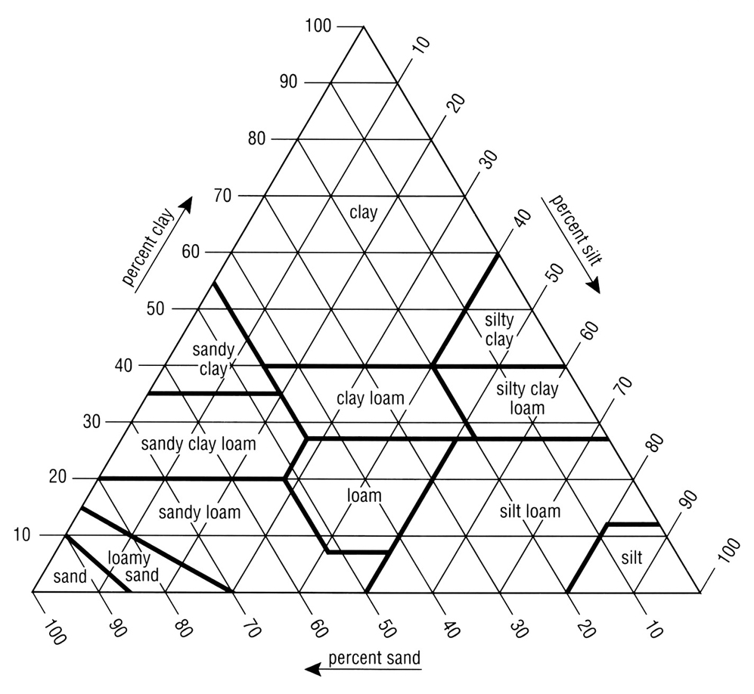

ATTACHMENT 3

USDA Taxonomic Particle-Size Classes for Families

