**Overview**

The internet is not like other forms of media. Interactivity is built into the process of using it in a way that sets it apart from film and books. The internet participatory and dynamic. It asks a question and you personally respond to it. For our project we wanted to create something that takes this essential dynamic nature and allows users to create something unique of their own creation. Rather than focus on the visual experience we like most sites, we decided to go with something that embraced sound. We came up with the idea of creating a digital instrument that could harness the dynamic nature of the internet to play notes. Each note would play a unique sound assigned to a particular IP address quartet, and through this association users could create their own opus using internet domains as their piano keys.

The interface that this instrument would be played through is the web browser, specifically an HTML form consisting of text area inputs, play buttons, toggles, and sliders. The simplest way of interacting with the site would be to enter in a domain name into the text area, and then click the play button to hear the sound it makes. Utilizing the toggle switch would allow the user to create more complex music. The toggle will play the note automatically. These notes are played at intervals defined by the slider. Moving the slider left or right will increase the frequency of the played intervals. By combining several different domain names from different server IP addresses with the toggle switch and the sliders, users would be able to create more complicated musical compositions.

We haven’t settled on a final name for the instrument yet. We’ve been mulling around with names and so far have ‘servichord’ (a functionally descriptive name), noteworthy (catchy, but kind of cheesy), and clarinternet (funny, but really cheesy). We plan to keep brainstorming on the final name, and as the project starts coming together and the audience/tone becomes more visually apparent we will decide which name is best suited.

**Requirements**

This project is perfect for adapting to mobile since the core essential pieces will be taking up such a small amount of screen real estate. It’s exactly the kind of thing you would want to pull out your phone and show someone, so we will be keeping with the mobile first strategy of site design. Beyond the UI for the instrument itself, the site will be fairly sparse consisting of a quick introduction/about page describing the project (and perhaps introducing ourselves) and a source page that includes links back to the relevant APIs we’ve used. Again, since the goal is for people to be using the instrument, not reading about it, we will want to make sure to stay away from large blocks of text and keep explanations as simple (but helpful) as we can. We are planning on utilizing the jquery mobile framework. This will help keep the design well suited to a mobile responsive platform while keeping a clear and readable code organization.

**Technology**

These are the API/Frameworks that we have been researching. We may not end up using all of them.

WHOIS APIs for retrieving IP address and geo-location information for domains:

<https://www.arin.net/resources/whoisrws/whois_api.html>

<https://www.robowhois.com/docs/api/v1/whois/>

Music/Audio Manipulation APIs for creating the notes and loop intervals:

<http://labs.echonest.com/Uploader/index.html>

<http://goldfirestudios.com/blog/104/howler.js-Modern-Web-Audio-Javascript-Library>

Responsive Framework:

<http://jquerymobile.com/>

Stretch Goal: Data Visualization is not one of the primary functions of the project, but it would be interesting to include a visual component, possibly one that takes into account the physical location of the server..

<http://d3js.org/>

Stretch Goal: Saving ‘songs’, is not an immediate goal for the project, but if time and scope allow it would be a good feature to add in .

**User Stories:**

**David The Web Designer**

David is a web designer who comes across the site after speaking about it with a friend. He wants to hear what kind of music he can create with the websites he has designed for clients. When he arrives at the home page he briefly glances over the introduction, but then immediately clicks the link to go to the instrument page. Immediately recognizing the familiar html elements he enters in the domain names of his most recent client and then clicks the play button. Then he clicks the button again, and a whole bunch more times. He decides to fiddle with the toggle at under the text input to see what it does. Moving the slider left and right makes it’s purpose clear. He then adds the domain names of 4 other recent projects he worked on and toggles the interval player for them all. He goes through all the site’s he’s had a hand in creating testing each out to see what kind of a note they play. After spending about 20 minutes on the site and feeling satisfied with the experience David closes out the browser.

**Jeff the Teenager**

Jeff is a teenager that sees a link to the project on Facebook. He is a particularly tech savvy and does not completely understand the significance of how the project works, but he grasps enough to understand that different websites make different sounds. He quickly scans over the instructions and then moves on to the main page. He enters some of his favorite websites into each of the boxes and after spending a minute clicking the play button for each of them starts messing with the sliders to create notes at different intervals. After spending a couple minutes tweaking the controls he has had his fill and moves on to another page.

**Nina the Software Developer**

Nina is a software developer for a simulation company and is introduced to the sight by her son. She carefully reads through the instructions on the main page and even reads over the more detailed explanations on the additional pages. She enters in the first website that comes to mind and presses the play button. After testing out a few other sights she wants to test the project out and specifically oklooks for 2 different domains hosted on the same server. Satisfied when the notes match up she plays around with the interval toggles creating a detailed composition. After 15 minutes of tweaking the song she bookmarks the page and closes out the browser.

**Mock-up**

This is just to give an idea of how the main page layout would look, the final version would be situated in a more familiar website with familiar navigation, home, about page, etc.

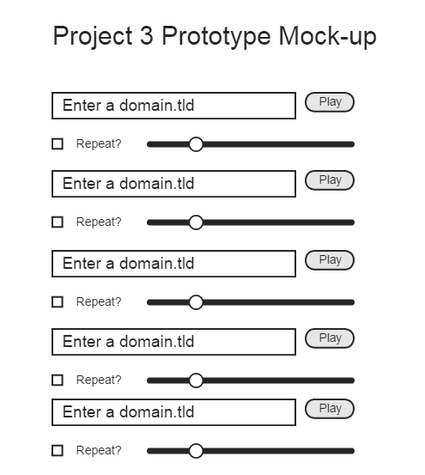

**Rubric**

A Work

All functions outlined in the design document work properly. Concept combines unique qualities of the web medium in an artistic way. The site, and especially the instrument UI utilize familiar web iconography and practices to create an intuitive interface design that focuses strongly on usability. Code is easily read and clearly organized in an efficient manner and emphasizes best practices with regard to semantic and hierarchy design. Site’s home page properly introduces the project and offers up simple instructions on the use and purpose of the site. Further details available through additional sections (about/references) provide additional details. Site maintains a consistent aesthetic throughout different pages that is appropriate for its tone and usage.

B Work

Majority of functions outlined in the design document work properly, though little errors present. Concept includes some novel ideas. The site’s interface design focuses on usability, but is not always clear. Code could be organized in a more efficient manner h regard to semantic and hierarchy design. Site’s home page properly introduces the project and offers up simple instructions on the use and purpose of the site. Further details available through additional sections (about/references) provide additional details. Site maintains a consistent aesthetic but needs improvement. .

C Work

Missing some essential functionality described in design document. Concept not fully realized. Usage of site not immediately recognizable. Code is organized in a chaotic and non-intuitive way. Aesthetics are inconsistent or look unfinished.

D Work:

Project does not function as outlined. Concept not realized. Confusing site organization. Code is unreadable. Aesthetics not consistent.

F Work:

Missing nearly all qualities outlined in rubric.

Project Planning, Scheduling, and Roles:

**PHASE 1 (Significant progress by 10/30, completion by 11/6)**

Creating the site

Wireframed site plan

Coding the HTML

Site Design/Aesthetics/Typography/Graphic Design/CSS

Special attention given to UI for the instrument

Working with API/Frameworks

Sound

Creation of a proof of concept prototype that accepts a numerical value 0-255 and returns a unique tone upon form submit.

WHOIS/IP Query

Creation of a proof of concept prototype that accepts a website domain.tld input and returns the IP address upon form submit.

**PHASE 2 (Completion by 11/13)**

Integration of prototypes into live site.

Refinement of site/UI design.

Extensive testing to identify bugs.

**PHASE 3 (Project completion by 11/20, remaining time left for stretch goals)**

Refinement of code/removal of bugs.

Refinement of site/UI design.

Analysis of remaining time and feasibility of stretch goals. Save function having the highest priority.

Project Delivery.