Differentiate between images of very Similar Products Using Deep Local Features
Diganta Das-- AI0057

1. ABSTRACT:

The newly discovered Deep Learning methods are helping for Keypoint detection of the interest points in various objects and also helps in matching between two disimilar object.The newly built deep learning technology is giving very good accuracy for detecting two different objects.So with the help of those deep learning algorithms we applied to detect between similar products.For example different flavours of chocolate present in the photo here: https://images-na.ssl-images-amazon.com/images/I/71h5seeZa6L._SL1280_.jpg .
So, it finds really hard to differentiate between similar products.Our paper presents to use some feature detection algorithm to differentiate closely related products.By experimenting with those feature detection algorithms we found that latest discovered Self-Supervised Interest point Detection and description(known as Superpoint) is giving better result than other feature detection techniques.

2.INTRODUCTION:

The application of such system is in retail,in CPG industries, in supply chain (for automatic product sorting and packing), manufacturing and robotics.The importance of Similar object detection is to extract the features and match across the images.This Self supervised framework for training interest point detectors and descriptors suitable for a large number of multiple view geometry problems in computer vision.The first step in geometric computer vision tasks such as Simultaneous Localization and Mapping (SLAM),Structure-from-Motion (SfM), camera calibration, and image matching is to extract interest points from images. Interest points are 2D locations in an image which are stable
and repeatable from different lighting conditions and viewpoints.However, the inputs to most real-world computer vision systems are raw images, not idealized point locations.

3.Design Diagram:

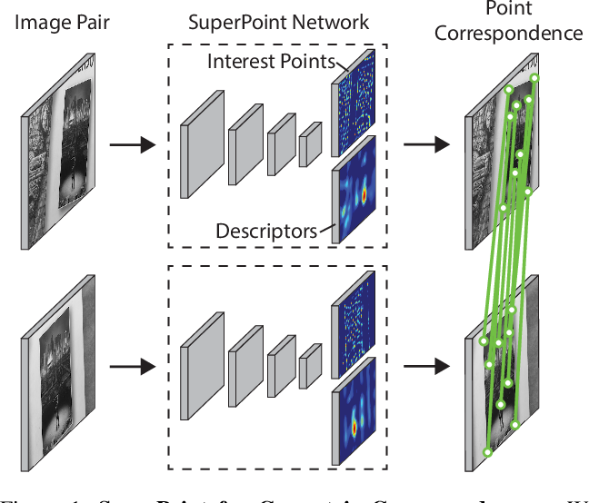

As shown in the picture, an image pair is taken with different geometric position and it is passed through a self supervised framework known as Superpoint Network, where it is detecting 2D interest keypoints and descriptors in a sinfle forward pass and runs on 320*240 images, after that it is matching with similar point correspondance.
Superpoint Architecture:
A fully-convolutional neural network architecture called SuperPoint is designed which operates on a full sized image and produces interest point detections accompanied by fixed length descriptors.
The model has
- A single encoder: It process and reduce the input image dimensionality.It uses a VGG style encoderto reduce dimensionality.It consists three max-pooling layers,letting it define H c = H/8 and W c = W/8 for an image sized H × W .It refer to the pixels in the lower dimensional output as “cells,” where three 2 × 2 non-overlapping max pooling operations in the encoder result in 8 × 8 pixel cells
After encoder, the architecture splits into two decoder, one for interest point detection and the other for interest point description.
- Interest Point Decoder: The interest point detector head computes X ∈R H c ×W c ×65 and outputs a tensor sized R H×W . The 65 channels correspond to local, non-overlapping 8 × 8 grid regions of pixels plus an extra “no interest point” dustbin.After a channel-wise softmax, the dustbin dimension is removed and a R H c ×W c ×64 ⇒ R H×W reshape is performed.
- Descriptor Decoder: The descriptor head computes D ∈ R H c ×W c ×D and outputs a tensor sized R H×W ×D . To output a dense map of L2-normalized fixed length descriptors, we use a model similar to UCN [3] to first output a semi-dense grid of descrip-ors (e.g., one every 8 pixels). Learning descriptors semi-densely rather than densely reduces training memory and keeps the run-time tractable. The decoder then performs bi-cubic interpolation of the descriptor and then L2-normalizes he activations to be unit length.
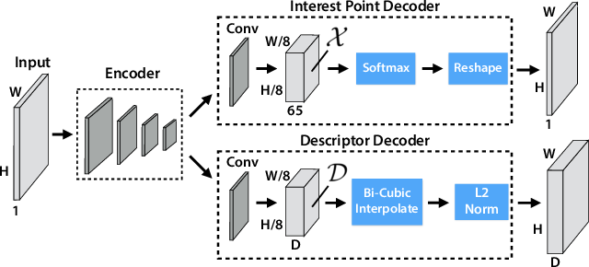

4.IMPLEMENTATION:
- Grozi Dataset: It is a multimedia Database of 120 grocery products.The objects belonging to it contains various sizes,shapes,dimension,color images.We took images of various products and applied traditional local features like ORB, CENSURE,RANSAC and measured the accuracy between similar-similar images and similar-disimilar images.
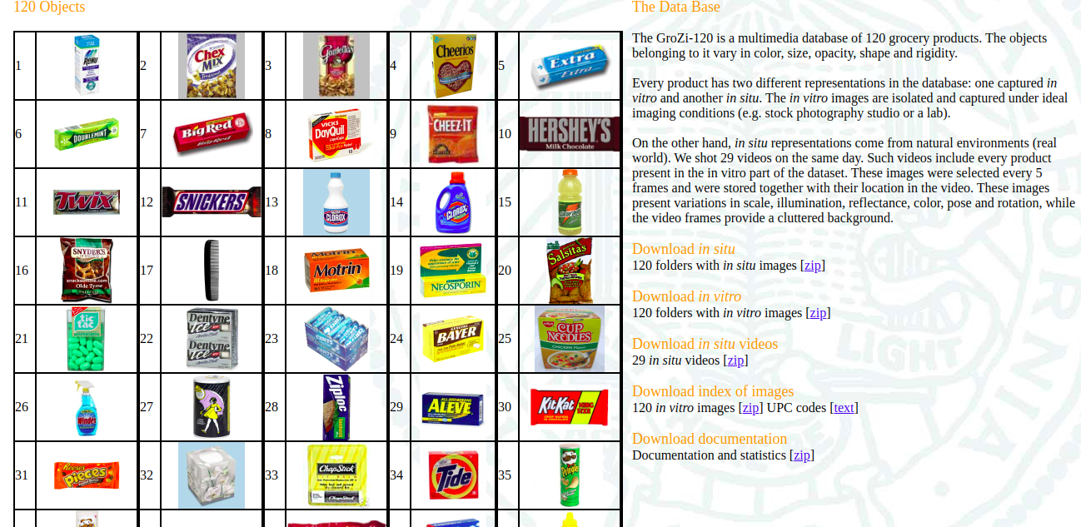

- Own created Dataset- It is a multimedia Database contains 20 folders with each folder containing 3 images, with 2 similar images of various shape,size,dimension and one disimilar images.Run self-supervised framework Superpoint algorithm and counted total no.of interest points.
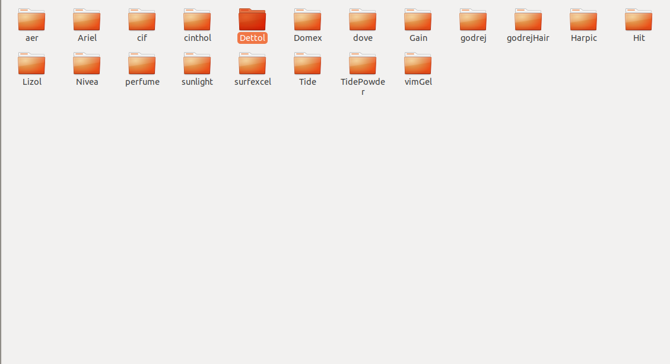
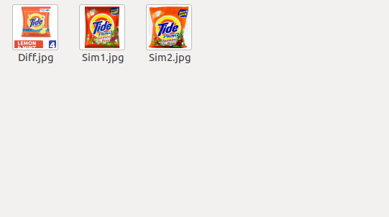

5. Project Approach:
1. Tried some simple hacks like edge detection
Canny Filter: The canny filter is a multistage edge detector.It uses a filter based on the derivative of a Guassian in order to compute the intensity of the gradients.The Gaussian reduces the effect of noise present in the image.
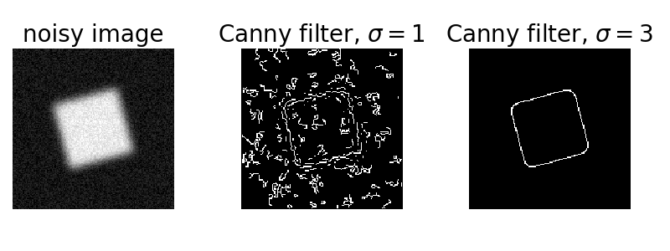
Canny filters on bottles:
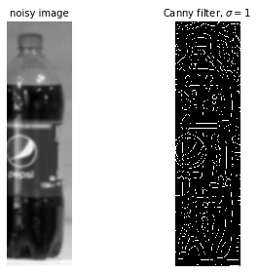

Rescale,Resize and downscale images:
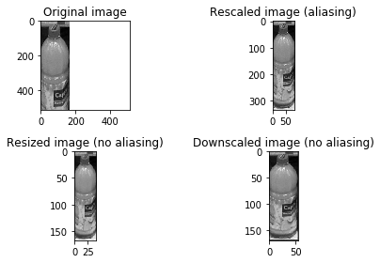

Harris Corner Detection:
Harris Corner Detector is a corner detector operator that is commonly used in computer vision algorithms to extract corners and infer features of an image.
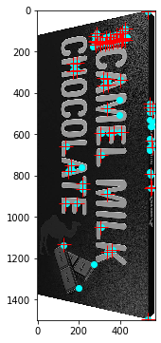
i> It determines which window produce very large variation in intensity when moved in both X and Y gradients
ii>With each such window found, a score R is computed
iii>After applying a thresold to this score important corners are selected and marked

Histogram Equilization on bottles:

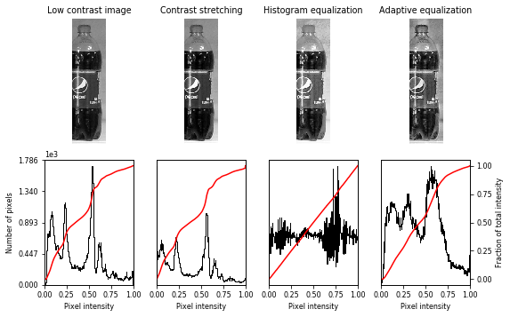

Plotting different keypoints on images using LoG,DoG in BLOB DETECTION
Blobs are bright on dark or dark on bright in an image
LoG- Only bright blobs on dark backgrounds are detected. Detecting larger blobs is especially slower because of larger kernel sizes during convolution.
DoG- This method suffers from the same disadvantage as LoG approach for detecting larger blobs. Blobs are again assumed to be bright on dark.
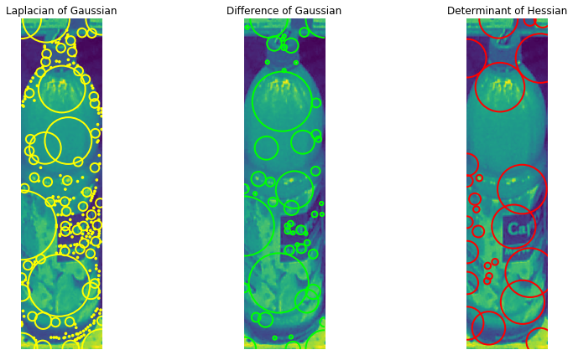
HoG- This is the fastest approach.Bright on dark as well as dark on bright blobs are detected.Small blobs are not detected accurately

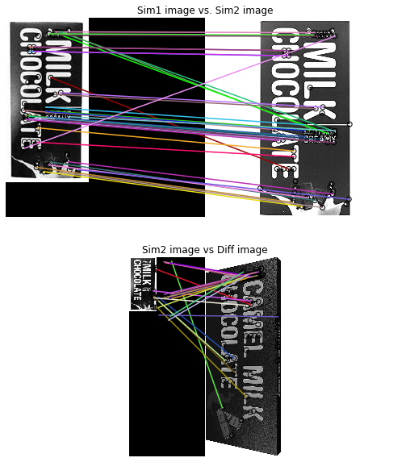
Image Matching using BRIEFHere we found the total matches between Similar1-similar2 image and Similar2-different image.we found the total no.of interest point detecting between the Sim1-sim2 images is more than the Sim2-Diff images.The accuracy rate of sim1-sim2 is more than sim2-diff image.
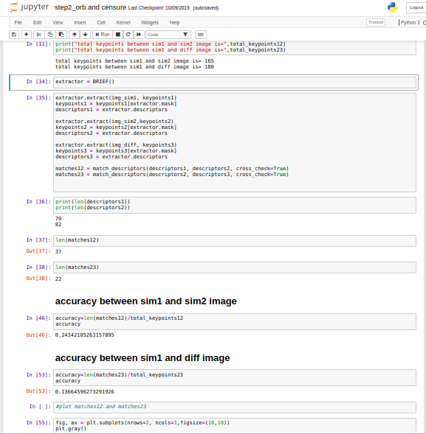
Image Matching using ORB:
ORB uses both FAST keypoint detector and BRIEF descriptor to creature feture vectors.Under rotational invariance it is giving more better performance in nearest neighbour applications.
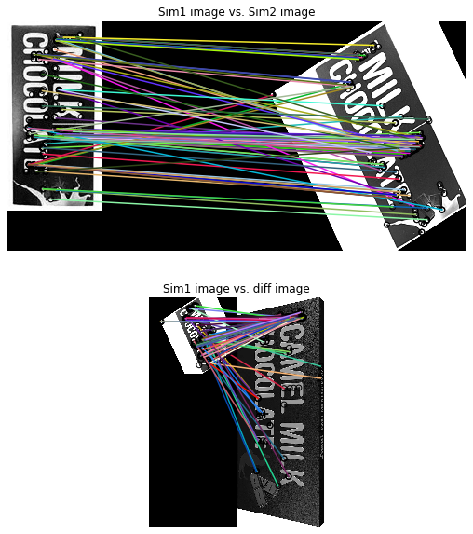

Image marching using CENSURE
Censure feature detector is a scale invariant center surround detector.It computes all features at all scales and select the extrema across across scale and location.It claims to outperform other detectors and is capable of real tme application.
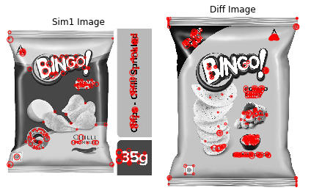
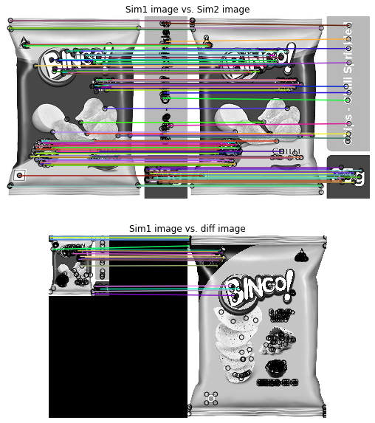

Image matching using RANSAC:
In image matching using Ransac we both used inliers(correct matches between sim1 and sim2 images) asnd outliers(incorrect matches between sim2 and diff images) and visualize the correct correspondance vs faulty correspondance between sim1-sim2 images and sim2-diff images.

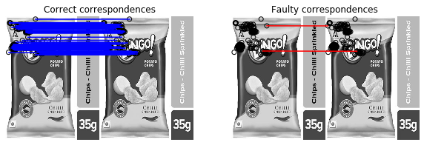
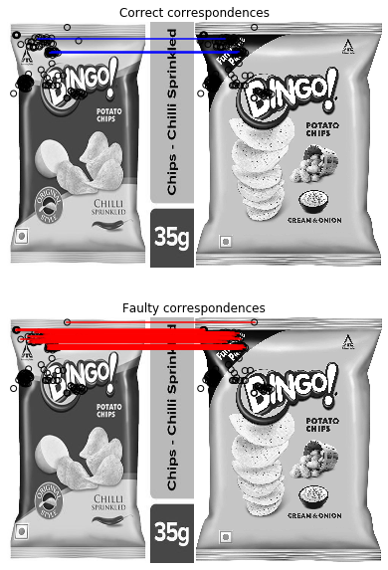

Introduction to Superpoint:
Here we pretrain an initial interest point detector on synthetic data(which contains different geometrical shapes), which we called as Magicpoint(trained detector).We use Homographic Adaptation(designed to enable self-supervised training of interest point detectors)in conjunction with the MagicPoint detector to boost the performance of the detector and generate the pseudo-ground truth interest points.The resulting detections are more repeatable,thus the resulting detector is SUPERPOINT.

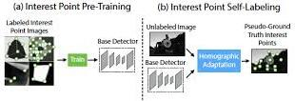

We applied SUPERPOINT in our own dataset and counted the no.of interest points it is detecting in real daily life use product images.
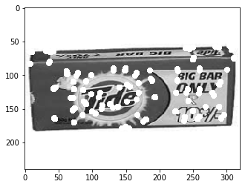
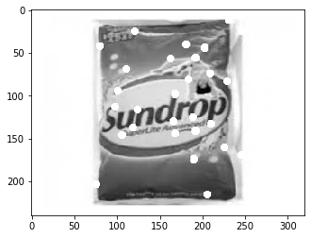
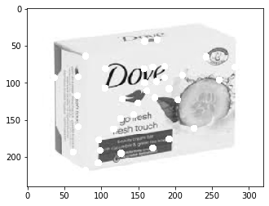

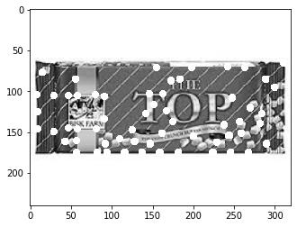
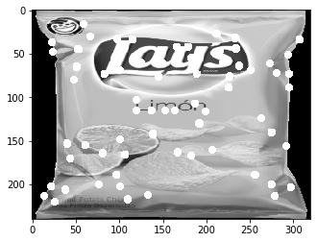
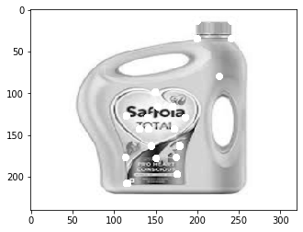

6. RESULTS:
We present quantitative results of the method presented in the paper.Evaluation of interest point and descriptors.
We measure the runtime of the superpoint architecture .A single forward pass ofthe model runs in approximately 11.15 ms with inputs sized 480 × 640, which produces the point detection locations and a semi-dense descriptor map.
We compare superpoint model with other traditional feature detection and image matching model like BRIEF,ORB,CENSURE,RANSAC all implemented usi skiImage.Repeatability is computed at 240 × 320 resolution with 300 points detected in each image. We also vary the Non-MaximumSuppression (NMS) applied to the detections.

Matching keypoints between SIM1-SIM2 and SIM2-DIFF image by varying nms_dist in Superpoint
nms_dist | conf_thres | nn_thers | sim1-sim2 | sim2-diff
1 | 0.2 | 0.2 | 43 | 34
5 | 0.2 | 0.2 | 40 | 29
10 | 0.2 | 0.2 | 35 | 25

Here we see by increasing nms_dist the matching points between similar-similar and similar-different is decreasing as applying larger amounts of NMS helps ensure that the points are evenly distributed in the image.
Matching keypoints between SIM1-SIM2 and SIM2-DIFF image by varying conf_thres in Superpoint
nms_dist | conf_thres | nn_thers | sim1-sim2 | sim2-diff
10/5/1 | 0.45 | 0.2 | 2 | 4
10/5/1 | 0.65 | 0.2 | 0 | 0
10/5/1 | 0.85 | 0.2 | 0 | 0

Here we see by making nms_constant as 10.5 or 1 and increasing the conf_thres we are not able to find the matching points.

Matching keypoints between SIM1-SIM2 and SIM2-DIFF image by varying nn_thres in Superpoint
nms_dist | conf_thres | nn_thers | sim1-sim2 | sim2-diff
10 | 0.2 | 0.45 | 35 | 25
10 | 0.2 | 0.65 | 35 | 25
10 | 0.2 | 0.85 | 35 | 25

Matching keypoints between SIM1-SIM2 and SIM2-DIFF image by varying nn_thres in Superpoint
nms_dist | conf_thres | nn_thers | sim1-sim2 | sim2-diff
5 | 0.2 | 0.45 | 43 | 34
5 | 0.2 | 0.65 | 43 | 34
5 | 0.2 | 0.85 | 43 | 34

Here we find we are getting same sim1-sim2 and sim2-diff matching points by varying nn_thresold(L2 descriptor distance for good match) and changing nms_dist.
Table of Accuracy of matching images between sim1-sim2 and sim2-diff images in Traditional Image matching algorithms .
Image Matching Algorithms name | Matching points between sim1-sim2 | Matching points between sim2-Diff | Accuracy(sim1-sim2) in Percent | Accuracy(sim2-Diff) in Percent
BRIEF | 37 | 22 | 24 | 13
ORB | 87 | 71 | 43 | 35
CENSURE | 140 | 19 | 37 | .04
RANSAC | 120 | 3 | 33 | .06

REFERENCES:
1. https://arxiv.org/abs/1712.07629
2. https://medium.com/software-incubator/introduction-to-orb-oriented-fast-and-rotated-brief-4220e8ec40cf
3. https://scikit-image.org/docs/dev/auto_examples/transform/plot_matching.html
4. https://medium.com/ml2vec/intro-to-pytorch-with-image-classification-on-a-fashion-clothes-dataset-e589682df0c5

