Teacher AI Literacy and Classroom Use in Sri Lanka:
Short-Form Scale Development and Initial Psychometric Evaluation
Dinesh Sanjeewa Deckker
School of Computing, Engineering and Technology
Wrexham University
Wrexham, United Kingdom
S23014222 | dinesh.deckker@example.ac.uk

Abstract: Artificial intelligence (AI) increasingly shapes everyday teaching, yet schools lack a brief, psychometrically evaluated way to gauge teachers’ readiness and link it to reported classroom behaviours. This study develops a short-form Teacher AI Literacy (TAIL-SF) scale and presents an initial psychometric evaluation alongside a composite-score path analysis of classroom AI use and ethical routines among Sri Lankan K-12 teachers (N = 362 after cleaning). Internal consistency was strong (Cronbach’s α = .76 to .93), though convergent validity was uneven across facets. A split-sample design used exploratory factor analysis on a calibration subsample (N_A = 181) and confirmatory factor analysis on a holdout subsample (N_B = 181). On the holdout, a five-correlated-factors model showed acceptable relative fit (CFI = .968, RMSEA = .046) and clearly outperformed a unidimensional model (CFI = .895, RMSEA = .079); a bifactor decomposition (ECV = 17.2%) pointed to a multidimensional structure in which the Ethics facet emerged as the clearest empirically distinct sub-domain, while Understanding, Prompting, Evaluation, and Pedagogy were not individually well-identified at this sample size. AI literacy was positively associated with perceived usefulness (β = .73), attitude (β = .48), and self-efficacy (β = .56). Self-efficacy showed the strongest direct association with classroom use (β = .24, p < .001); infrastructure also contributed (β = .17). A significant negative AI Literacy × Infrastructure interaction (β = -.15, p = .003) contradicts the original amplification hypothesis and is more consistent with a substitution pattern. Findings should be interpreted as preliminary given the cross-sectional self-report design and a digitally engaged convenience sample, and replication on more representative samples is required before strong validity claims can be made.
Keywords: AI literacy, teacher education, scale development, composite-score path analysis, confirmatory factor analysis, K-12, Sri Lanka, generative AI, self-efficacy
I. Introduction
Generative artificial intelligence (AI) has moved from research laboratories into the daily routines of teachers within a remarkably short period. Tools such as ChatGPT, Gemini, and Claude now assist with lesson planning, feedback drafting, language support, programming examples, and adaptive practice [1]. International policy guidance increasingly stresses human-centred adoption: investing in teacher capacity, embedding privacy and assessment safeguards, and avoiding blunt prohibitions that undermine equity and innovation [2].
Despite this momentum, schools lack a concise and psychometrically supported way to gauge teachers’ readiness and connect it to reported classroom behaviours. A recent systematic review of AI-literacy instruments found that most existing scales are long, heterogeneous in constructs, and rarely tailored to K-12 teachers, calling instead for short, context-aware measures with sound psychometric evidence [3]. The Sri Lankan context, in which infrastructure varies considerably across provinces and explicit institutional AI policies remain rare, magnifies this gap [8].
This paper responds in two ways. First, it develops a short-form Teacher AI Literacy scale (TAIL-SF) anchored in established competency frameworks [1] and policy guidance [2] and provides an initial psychometric evaluation. Second, it estimates a composite-score path model in which literacy is examined in association with perceived usefulness, attitude, and self-efficacy, and ultimately with classroom AI use, with policy clarity and infrastructure modelled as contextual moderators. Outputs include an instrument intended for open release, a scoring guide, and a preliminary path model with bootstrapped indirect statistical associations.
Three contributions follow. The instrument provides school leaders with a rapid diagnostic for professional development planning, conditional on larger independent-sample validation. The composite-score path model clarifies which levers, capability, perception, or context, most strongly relate to self-reported classroom integration in this sample. Finally, the deliverables, intended for open release, will enable replication and cross-country comparison, addressing calls to extend AI-in-education research beyond Global-North samples [16], [17].
The remainder of the paper is structured as follows. Section II reviews the literature on AI literacy frameworks, existing instruments, theoretical anchors for technology adoption, and the Sri Lankan educational context. Section III describes the methodology, including instrument development, sampling, and analysis plan. Section IV reports the empirical findings. Section V discusses theoretical and practical implications, limitations, and directions for future work. Section VI concludes.
II. Literature Review
A. Defining AI Literacy
Long and Magerko’s foundational paper defines AI literacy as the set of competencies enabling people to critically evaluate AI technologies, communicate and collaborate effectively with AI, and use AI as a tool online, at home, and in the workplace [1]. Their framework articulates seventeen competencies organised around recognising what counts as AI, understanding what AI can and cannot do, distinguishing between strong and weak AI, interpreting how machine learning operates, evaluating data representations, anticipating ethical implications, and imagining future possibilities. While this framework was developed before the public availability of large language models, its emphasis on critical evaluation, data awareness, and ethical judgment translates directly to the generative-AI era.
UNESCO’s guidance for generative AI in education and research extends these competencies into operational policy [2]. The guidance (2023, with a 2025 edition) sets out key steps for governments and institutions to regulate generative AI and addresses concerns directly relevant to teachers, including ensuring inclusion and equity in AI access, protecting human agency in teaching and learning, preserving academic integrity, building teacher and student AI capacity, and embedding privacy and data-protection safeguards. UNESCO explicitly cautions against blanket prohibitions, arguing that they tend to widen rather than narrow educational inequalities, and calls for context-sensitive professional development that empowers teachers as discriminating users rather than passive adopters or refusers.
Subsequent work has built on these foundations. Ng and colleagues operationalise AI literacy in education through affective, behavioural, cognitive, and ethical dimensions, with the cognitive dimension itself spanning knowing and understanding AI, applying it, and evaluating it [4]. Their model highlights the interdependence of cognitive understanding, behavioural skill, and ethical judgment, a teacher who understands AI but cannot apply it, or who applies it without ethical awareness, is not fully literate. This multidimensional view informs the present study’s five-facet design.
B. Existing Measurement Instruments
The systematic review by Lintner catalogued sixteen AI-literacy scales developed between 2020 and 2024 [3]. Their analysis found construct heterogeneity, scales variously emphasised technical knowledge, ethical reasoning, behavioural use, attitudes, or some mixture , with little convergence on a common operational definition. They also documented uneven psychometric reporting: many instruments lacked basic validity evidence, used unrepresentative samples, or had not been replicated. Most importantly, they noted that few instruments were tailored to specific user groups, and almost none had been validated in non-Western, non-English speaking contexts. Their explicit recommendation for short, context-aware forms with strong psychometric evidence directly motivates the present work.
Several recent instruments illustrate progress in particular subdomains. Ng and colleagues developed and validated the AI Literacy Questionnaire for secondary students, demonstrating sound factor structure and acceptable reliability across the four-factor model [4]. Hornberger and colleagues developed a short AI literacy test (AILIT-S) for university students, emphasising efficient assessment with strong psychometric properties [5]. Dong and colleagues applied Rasch modelling to refine a multidimensional AI literacy scale, demonstrating that careful item reduction can preserve measurement quality while easing respondent burden [6]. None of these instruments, however, targets in-service K-12 teachers as a distinct user group, and none has been validated in a South Asian context.
Teacher-focused instruments do exist but have limitations. Generic teacher technology integration scales such as the TPACK survey [13] capture broad technological-pedagogical content knowledge but predate the generative-AI era and lack items specific to AI capabilities, limitations, or ethical concerns. Celik’s Intelligent-TPACK extension [14] adds an explicit ethical-knowledge dimension to the classical TPACK framework and provides validation evidence on a teacher sample, but it targets the broader construct of AI-integrated pedagogical knowledge rather than a focused, short-form measure of teacher AI literacy as such, and its validation has been concentrated in particular national contexts. Teacher AI readiness instruments such as the recent Readiness for Artificial Intelligence Applications Scale (RAIS) by Ramazanoğlu and Akın [15] show promising psychometric properties but have not been examined for measurement invariance across linguistic or infrastructural contexts.
C. Theoretical Anchors for Adoption
Adoption of educational technology rarely follows from skills alone. The Technology Acceptance Model (TAM) established that perceived usefulness (PU) and perceived ease of use jointly determine attitude, behavioural intention, and ultimately actual use [10]. The Unified Theory of Acceptance and Use of Technology (UTAUT) extended TAM by adding social influence and facilitating conditions, and introduced moderators such as gender, age, experience, and voluntariness of use [11]. Both frameworks have been applied extensively to teacher technology adoption, with consistent findings that PU is the strongest direct predictor of intention and that facilitating conditions, access to devices, technical support, training time, matter independently of individual capability.
Recent empirical work specific to teachers’ generative-AI intentions confirms these predictors and adds risk perception as a salient factor [7]. Kong and colleagues found that teachers who perceived higher risks, concerning student over-reliance, academic dishonesty, factual inaccuracy, and privacy, reported lower behavioural intention to use generative AI, even after controlling for usefulness and ease perceptions. This pattern implies that promoting adoption requires not only emphasising benefits but also addressing reasonable concerns through transparent policy and skilled judgment.
Teacher self-efficacy, drawing on Bandura’s social-cognitive theory and operationalised by Tschannen-Moran and Woolfolk Hoy [12], further mediates the path from competence to classroom action. Self-efficacy is the belief that one can organise and execute the actions needed to produce given outcomes, distinct from possessing the skills themselves. In AI integration, a teacher may understand a tool conceptually but lack confidence to deploy it in front of students; conversely, high self-efficacy is statistically associated with greater self-reported integration even where formal training has been minimal. The present model treats self-efficacy as a parallel mediator alongside PU and attitude.
D. AI in K-12 Education: Recent Empirical Evidence
A systematic review by Alfarwan synthesises evidence on generative AI use in K-12 settings, identifying both documented benefits and persistent risks [8]. Reported benefits include personalised feedback, language and translation support, lesson-planning efficiency, and improved differentiation. Risks centre on factual inaccuracy (hallucination), cultural bias in outputs, plagiarism and academic-integrity erosion, privacy violations through inadvertent disclosure of student information, and potential deskilling of teachers and students alike. The review concludes that systemic teacher development is the principal lever for translating benefits into practice while containing risks.
Empirical studies of teacher AI use show patterns relevant to the present model. Research on teachers’ generative-AI adoption indicates that perceived usefulness and self-efficacy are salient correlates of intended and self-reported use [7], consistent with the view that informal, experiential learning may be at least as important as structured professional development. A broader meta-systematic review of AI in education has called for increased attention to ethics, collaboration, and methodological rigour, including the extension of evidence beyond Global-North samples [17]. Ethical practice patterns vary widely, and clear norms for disclosing or attributing AI assistance in shared materials remain at an early and emerging stage rather than being consistently established [16]. Policy clarity at the school and ministry levels emerges as a recurring correlate of responsible-use behaviours, even where it is not significantly associated with overall frequency of use.
E. The Sri Lankan Educational Context
Sri Lanka’s K-12 education system serves approximately 4.0 million students across more than 10,000 government schools, with additional private, international, and Pirivena schools [18]. Government schools are categorised as Type 1AB (offering Advanced Level science streams), 1C (Advanced Level arts and commerce), Type 2 (Ordinary Level only), and Type 3 (primary only), with substantial variation in resource availability across categories. Pirivenas, traditional Buddhist monastic schools, form a small but distinctive subsector. Internet penetration has improved markedly at the household level, but school-premises connectivity remains uneven across districts, with rural and estate-sector schools historically lagging urban national schools [18], [21], reflecting a long-standing rural and estate digital divide documented in the 2018 Computer Literacy Statistics of the Department of Census and Statistics [21] and surfaced again in pandemic-era distance-learning evaluations [22].
National policy on AI in education is at an early stage. As of writing, Sri Lanka’s overarching National Strategy on AI (“AI Sri Lanka 2028”) remains in public consultation [23], and there is no binding national regulation specifically governing classroom use of generative AI by teachers. Ministry-level activity in 2024 has included a Memorandum of Understanding between the Ministry of Education and Microsoft to pilot AI and machine-learning content in the national school curriculum from grade 8 upwards [24], and a national “AI Clubs in Schools” initiative led by the Ministry of Digital Economy in partnership with the Ministry of Education [25]. School-level policies on day-to-day teacher and student AI use, where they exist, are largely informal and developed by individual principals or ICT coordinators; teacher associations such as the Sri Lanka ICT Teachers Association have begun convening informal communities of practice. The combination of widespread availability of free generative-AI tools alongside an unsettled, top-down policy environment makes Sri Lanka a particularly informative context for studying teacher AI literacy and its classroom consequences. The descriptions of school-level practice reported here should, however, be read as contextual observations grounded in publicly available policy documents and our respondents’ self-reports, rather than as findings from a separate audit of school AI policy.
F. Synthesis and Hypothesised Model
Synthesising these threads, we frame AI literacy a priori as a teacher capability with five conceptually distinguishable facets (Understanding, Prompting, Evaluation, Ethics, Pedagogy), expressed through perceived usefulness, attitude, and self-efficacy, and ultimately enacted as classroom AI use. Whether these five facets behave as separable dimensions in practice or collapse into a smaller number of factors is an empirical question, and we therefore test this directly with a split-sample CFA that compares unidimensional, five-correlated-factors, and bifactor specifications (the latter following the now-common approach in psychometric work on broad self-report literacies). Reported ethical routines (such as disclosure, attribution, and student briefing) are modelled as a parallel behavioural outcome that triangulates the use measure: where self-reported “use” may overstate intensity, ethical routines tap into whether classroom AI integration is being conducted in a deliberate and accountable way. Policy clarity and infrastructure operate as contextual conditions that may moderate the literacy-use relationship. Three core hypotheses follow: (H1) AI literacy is positively associated with perceived usefulness, attitude, and self-efficacy; (H2) these mediators are positively associated with classroom AI use, with self-efficacy expected to carry the largest effect given the practice-based nature of classroom integration; and (H3) policy clarity and infrastructure moderate the literacy-use relationship, with literacy’s effect expected to be amplified where contextual conditions are favourable. Fig. 1 displays the a priori model.
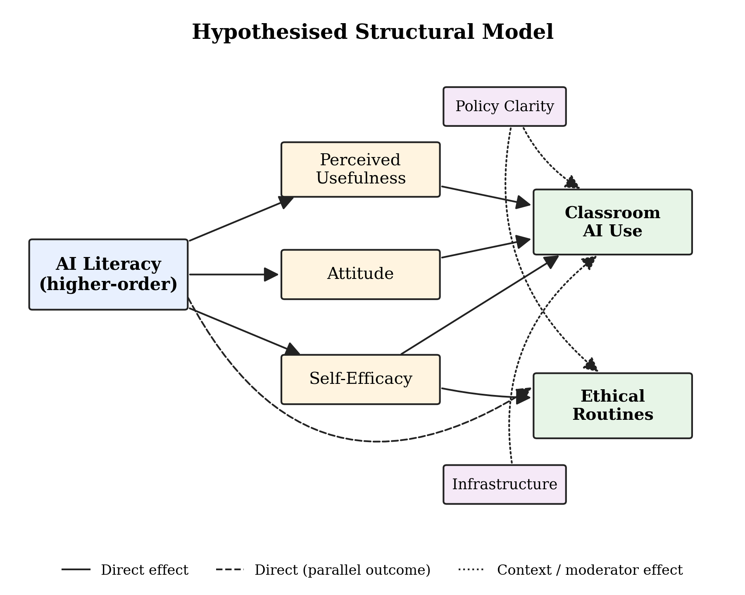
Fig. 1. A priori hypothesised structural model. AI Literacy is initially specified as a higher-order construct with five conceptually distinguishable facets (this specification is tested empirically by the split-sample CFA in Section IV.B); PU, Attitude, and Self-Efficacy operate as parallel mediators; Policy Clarity and Infrastructure are tested as moderators of the literacy-use path.
III. Methodology
A. Design and Participants
A cross-sectional online survey targeted in-service teachers in Sri Lankan K-12 schools (Grades 1 to 13). Recruitment proceeded through teacher WhatsApp groups, the Sri Lanka ICT Teachers Association, provincial education department contacts, and snowball sampling. Data collection ran from 28 October to 17 November 2025 via Google Forms. Of 403 raw submissions, 41 were excluded after data cleaning (3 near-duplicates identified by demographic profile and submission timing; 24 speeders below the 180-second completion threshold; 5 straightliners with zero variance across literacy items; 9 cases with more than 30% item-level missingness), yielding an analytic sample of N = 362.
Respondents were predominantly female (67.5%), with a mean age of 37.4 years (SD = 8.8) and 12.2 years of teaching experience (SD = 8.6). The Western Province contributed 29.0% of the sample, with all nine provinces represented. School types spanned Government 1AB (30.7%), Government 1C (24.3%), Type 2 (11.3%), Type 3 (10.5%), Private (14.4%), International (7.5%), and Pirivena (1.4%). Grade bands were represented as Primary (31.8%), Junior Secondary (31.8%), Senior Secondary (21.8%), and Collegiate (14.6%). ChatGPT was the most-used tool (80.1%), followed by Gemini (43.1%), Claude (25.4%), Copilot (18.8%), and Perplexity (18.2%). Fig. 2 summarises the sample composition.
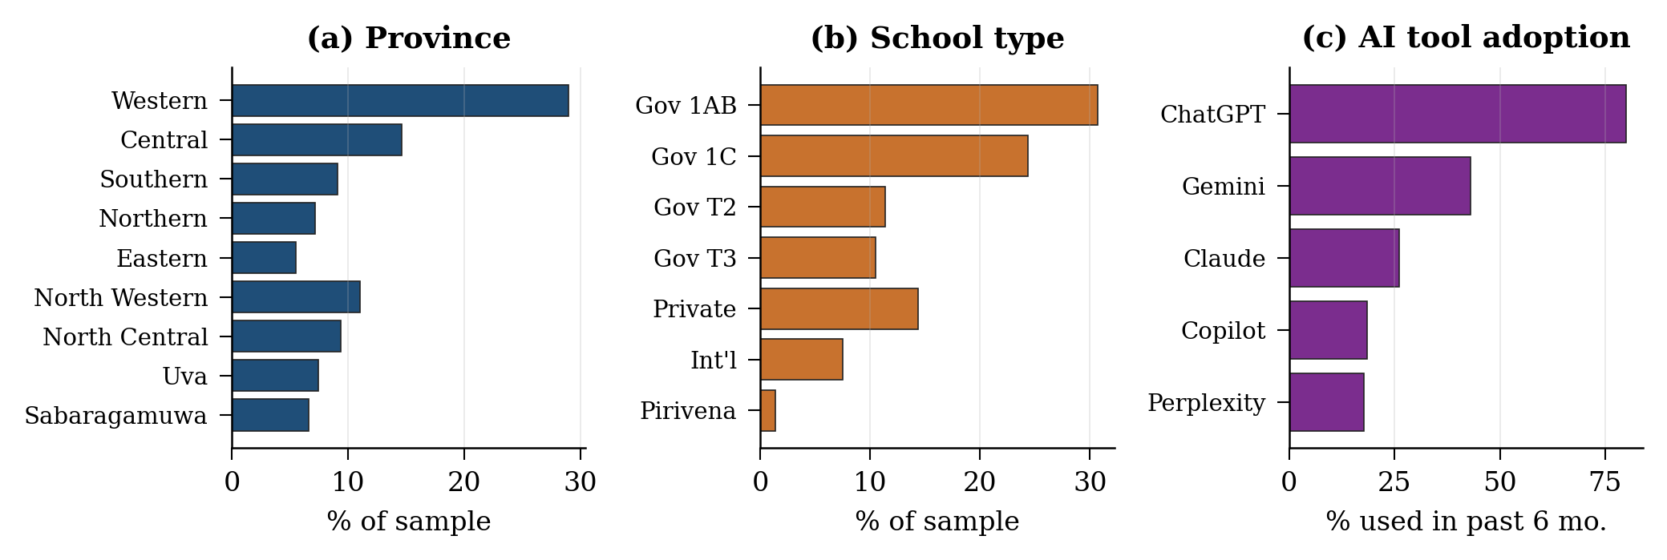
Fig. 2. Sample composition (N = 362). Panels show province distribution, school type, and AI tool adoption in the past six months.
B. Instrument Development
Items were drafted from competency frameworks [1] and policy guidance [2], covering five literacy facets: understanding (4 items), prompting (3 items), evaluation and bias checking (4 items, including one reverse-coded), privacy and ethics (4 items), and pedagogical judgment (3 items). Five subject-matter experts, two AI-in-education researchers, two experienced ICT coordinators from Sri Lankan schools, and one psychometrics specialist, reviewed the initial item pool for relevance and clarity, scoring each item on a 4-point relevance scale. Items with content validity index (CVI) below .78 were revised or dropped.
Cognitive interviews with 12 teachers, sampled to represent primary, secondary, and Advanced Level grade bands across three provinces, refined wording. Particular attention was paid to terms that might translate poorly in respondents’ mental Sinhala or Tamil framings (e.g., “hallucinations,” “prompts,” “bias”). A pilot study (n = 72) informed item retention through inter-item correlations, exploratory factor analysis, and item-total correlation analysis. The final TAIL-SF used in the main study comprises 18 items.
Covariate scales drew on validated short forms: perceived usefulness (4 items) and attitude (3 items, one reverse-coded) adapted from TAM [10]; self-efficacy (4 items) adapted from Tschannen-Moran and Woolfolk Hoy [12]; policy clarity (3 items) and infrastructure (3 items) developed for this study; ethical routines (4 items) capturing attribution, student briefing, and rule-setting; and a six-item classroom-use frequency block covering lesson planning, feedback, language support, coding help, assessment creation, and differentiation. All scale items used a five-point response format from 1 (Strongly Disagree / Never) to 5 (Strongly Agree / Daily).
C. Analysis Plan
Analyses proceeded in six stages. First, reliability was assessed via Cronbach’s α and item-total correlations, with .70 and .30 as the respective conventional thresholds. Second, the analytic sample was randomly partitioned 50/50 into a calibration subsample (N_A = 181) and a holdout subsample (N_B = 181). Exploratory factor analysis of the 18 literacy items on the calibration subsample used the Kaiser-Meyer-Olkin (KMO) measure of sampling adequacy, Bartlett’s test of sphericity, and parallel analysis with 100 random comparison datasets to determine the number of factors. Third, three competing measurement models were evaluated by confirmatory factor analysis (CFA) on the holdout subsample: (i) a unidimensional model with all 18 items loading on a single factor; (ii) a five-correlated-factors model corresponding to the a priori Understanding, Prompting, Evaluation, Ethics, and Pedagogy facets; and (iii) a bifactor model with one general factor and five orthogonal facet-specific factors. CFAs were estimated by maximum likelihood (ML) on the sample covariance matrix using semopy 2.3, with the 5-point Likert items treated as continuous; this is a common simplification for ordinal data with five or more response categories, although WLSMV-style estimators that explicitly model the categorical nature of the responses would be preferable for rigorous psychometric work and this choice is flagged as a limitation. Model fit was evaluated against conventional thresholds: CFI and TLI ≥ .95, RMSEA ≤ .06, SRMR ≤ .08 [26], with explained common variance (ECV) computed for the bifactor model to assess whether facets carried meaningful unique variance beyond the general factor. Fourth, convergent validity was evaluated using average variance extracted (AVE), and discriminant validity using the heterotrait-monotrait ratio (HTMT) with a .85 threshold [9]. Fifth, the structural model was estimated via composite-score path analysis on standardised aggregate scores using the full N = 362 sample, following the procedure described by Hair et al. [19] for variance-based structural modelling with composite indicators; this is not equivalent to a latent-variable structural equation model and does not include global model fit indices or correction for measurement error. Indirect (mediated) statistical associations were tested with 5,000 bootstrap resamples and percentile 95% confidence intervals. Moderation was tested by adding product terms (literacy × policy and literacy × infrastructure) to the model of classroom use. Sixth, because all measures were self-reported in a single questionnaire, two common-method-bias diagnostics were computed: Harman’s single-factor test (with a > 50% threshold for concern) and a full-collinearity variance inflation factor (VIF) check on the construct composites following Kock’s [20] procedure (with VIF > 3.3 as the threshold for concern).
D. Ethical Considerations
The study received ethical approval from the Wrexham University Research Ethics Committee (approval reference: WU-REC-2025-COM738-S23014222). Participation was voluntary and anonymous; no names, email addresses, school identifiers, or IP information were collected. Informed consent was obtained at the start of the questionnaire, and respondents could withdraw before submission. No student data was collected. The anonymised dataset, analysis code, and full TAIL-SF instrument will be deposited on the Open Science Framework (OSF) and Zenodo prior to camera-ready publication, with persistent DOIs inserted in this section at that stage; in the interim they are available from the corresponding author on reasonable request to support replication.
IV. Results
A. Reliability and Descriptive Statistics
Cronbach’s α exceeded the conventional .70 threshold for every construct. Internal consistency ranged from α = .76 (Pedagogy) to .91 (Classroom Use), with the literacy facets averaging α = .79. All item-total correlations were ≥ .30. Table I summarises the reliability statistics and composite-score descriptives. Fig. 3 displays construct means with 95% confidence intervals, showing that all literacy facets and mediators cluster near the scale midpoint, while context constructs (policy clarity, infrastructure) and outcomes (classroom use, ethical routines) cluster slightly below. The pattern is consistent with a population in mid-adoption: capability and motivation are present but context and behaviour have yet to fully follow.
TABLE I
Reliability and Descriptive Statistics for Composite Scores
Construct (k items) | α | M | SD | N
Understanding (4) | 0.82 | 3.07 | 0.73 | 362
Prompting (3) | 0.76 | 2.92 | 0.72 | 360
Evaluation (4) | 0.81 | 3.06 | 0.71 | 362
Ethics (4) | 0.81 | 3.01 | 0.71 | 362
Pedagogy (3) | 0.76 | 2.89 | 0.72 | 359
AI Literacy (overall, 18) | 0.93 | 2.99 | 0.60 | 362
Perceived Usefulness (4) | 0.78 | 3.14 | 0.67 | 361
Attitude (3) | 0.78 | 3.10 | 0.75 | 361
Self-Efficacy (4) | 0.81 | 2.93 | 0.76 | 362
Policy Clarity (3) | 0.84 | 2.65 | 0.90 | 360
Infrastructure (3) | 0.80 | 2.85 | 0.82 | 360
Ethical Routines (4) | 0.78 | 2.71 | 0.64 | 358
Classroom Use (6) | 0.91 | 2.55 | 0.79 | 355

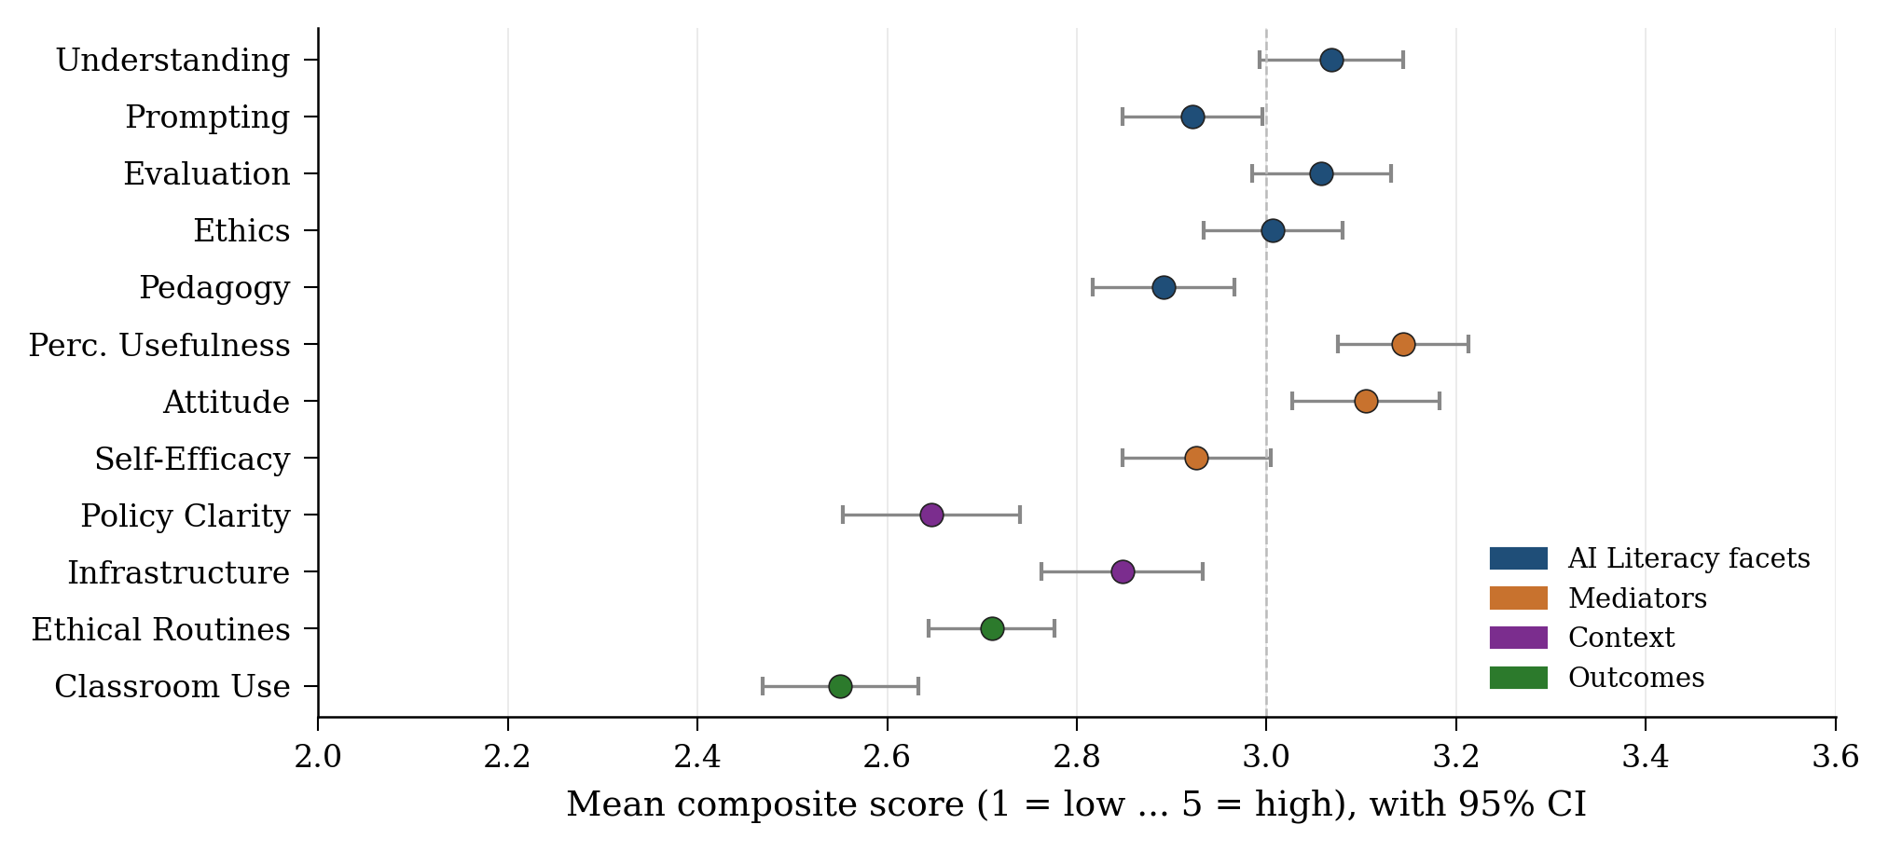
Fig. 3. Composite-score means with 95% confidence intervals (N = 362). Vertical dashed line marks the scale midpoint (3.0). Constructs are coloured by family.
B. Factor Structure of TAIL-SF
EFA on the calibration subsample (N_A = 181). The Kaiser-Meyer-Olkin measure was .945, classified as “marvelous,” and Bartlett’s test of sphericity was significant, χ²(153) = 1468.0, p < .001, supporting factorability. The eigenvalues of the inter-item correlation matrix on this subsample showed one dominant factor (λ₁ = 8.14, explaining 45.2% of variance) well above subsequent eigenvalues (λ₂ = 1.21, λ₃ = 0.92), and parallel analysis with 100 random comparison datasets matched to N_A confirmed retention of one factor at the EFA stage (the second observed eigenvalue fell below the parallel-analysis threshold of 1.60). Fig. 4 displays the corresponding scree pattern with parallel-analysis comparison computed on the calibration subsample. All 18 items loaded substantively on this general factor (calibration-subsample one-factor loadings ranging from .48 to .72); Fig. 5 displays the loading pattern coloured by intended facet.
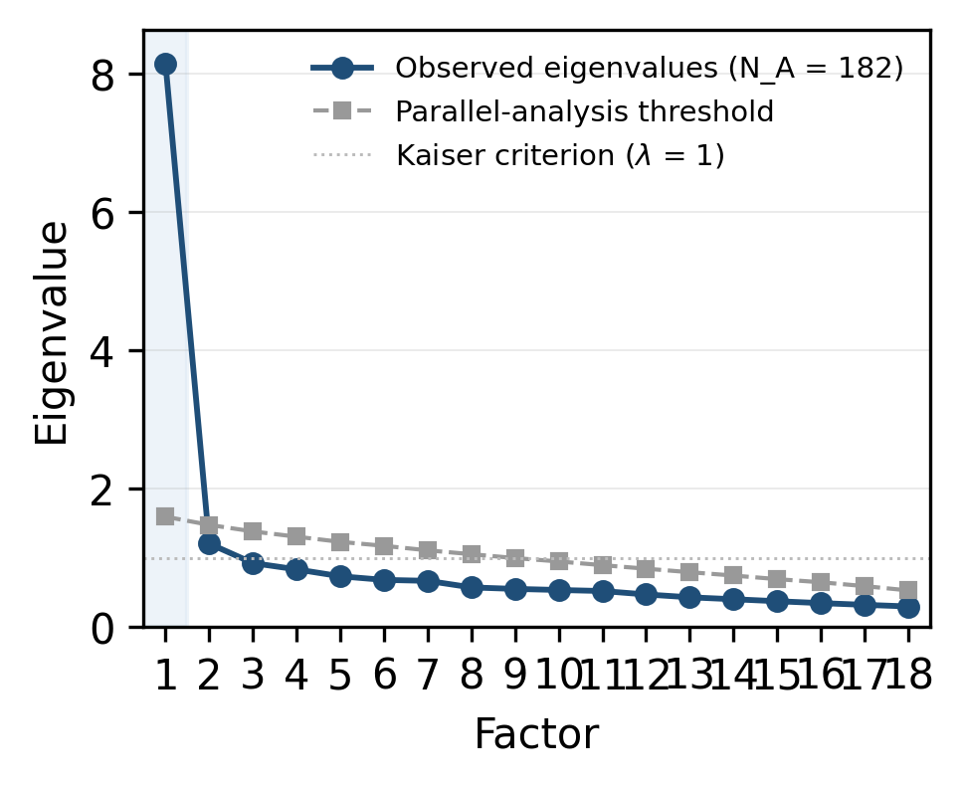
Fig. 4. Scree plot of the 18 AI-literacy items on the calibration subsample (N_A = 181) with parallel-analysis comparison. Only the first eigenvalue exceeds the random-data threshold. Shaded region marks the retained factor.
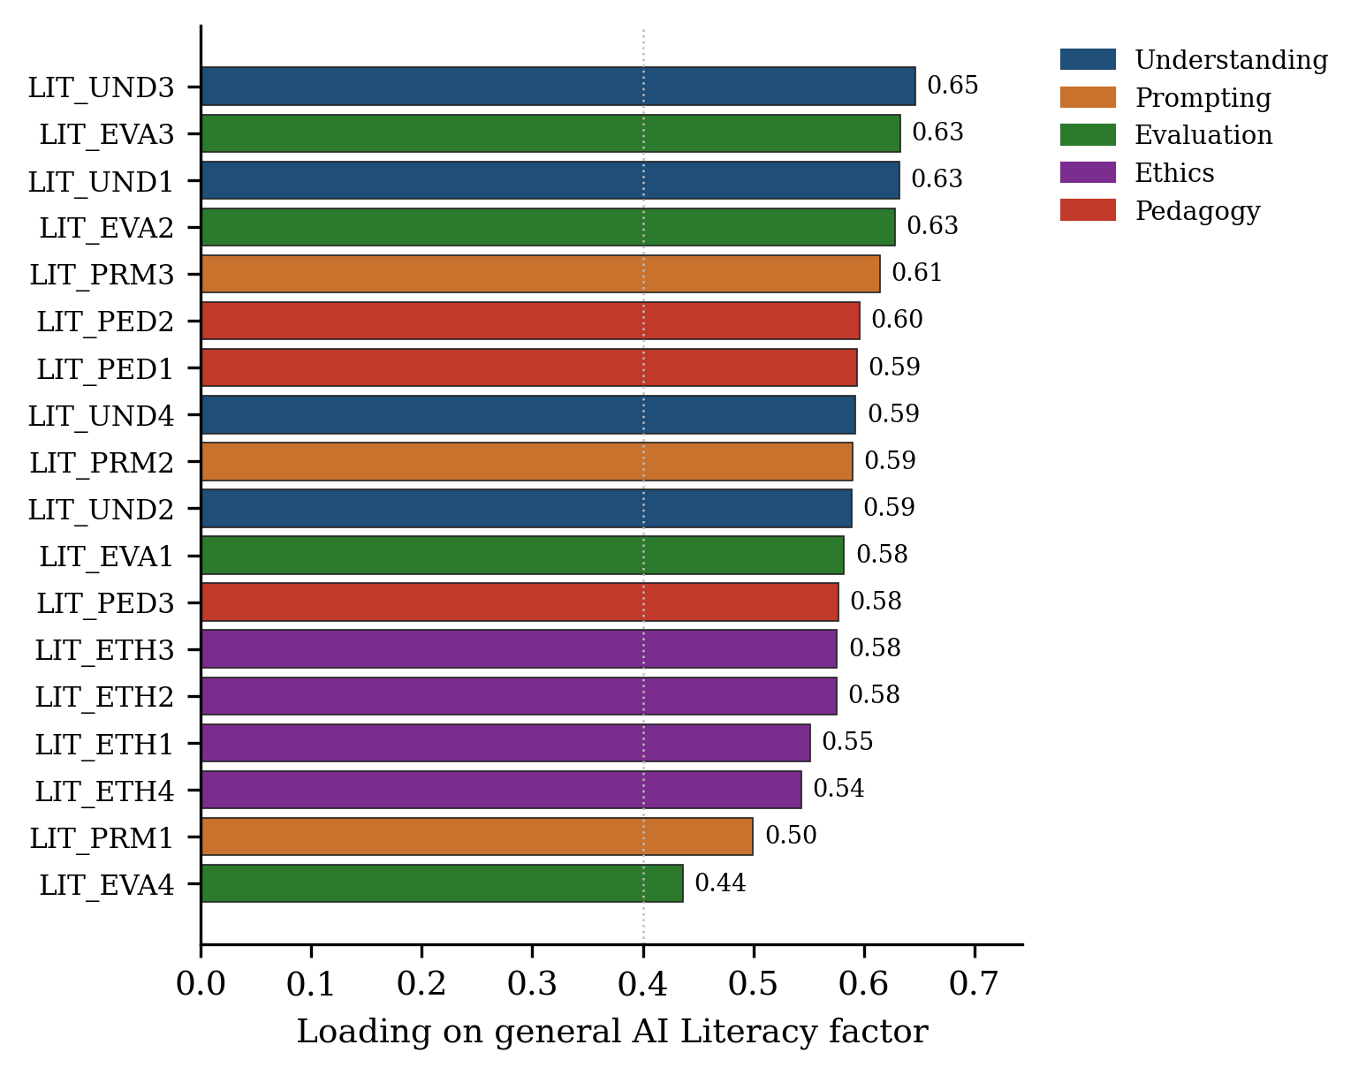
Fig. 5. Standardised loadings on the general AI Literacy factor, sorted high-to-low. Bars are coloured by intended facet. Vertical dotted line marks the .40 retention threshold; all items exceed this threshold.
CFA on the holdout subsample (N_B = 181). To test whether the five a priori facets carry meaningful unique variance beyond a single dominant factor, three competing measurement models were estimated by CFA on the holdout subsample using maximum-likelihood estimation on the sample covariance matrix (the items are 5-point Likert scales treated here as continuous; the implications of this choice are addressed below). Table II reports fit indices for the three models. Fit was clearly differentiated by the main indices: the unidimensional model fell below conventional acceptable thresholds (CFI = .895, RMSEA = .079), while the five-correlated-factors model showed acceptable relative fit (CFI = .968, RMSEA = .046) and the bifactor model showed comparable relative fit (CFI = .965, RMSEA = .049). SRMR values across all three models exceeded the conventional .08 threshold (.108 to .112), suggesting that absolute residual covariance fit is weaker than the relative fit indices alone would imply, so the five-factor and bifactor models should be characterised as showing acceptable relative fit rather than fully acceptable overall fit. This pattern is not unusual at small sample sizes. In the bifactor decomposition, the explained common variance (ECV) attributable to the general factor was 17.2%; on its own, this number is low and would conventionally be read as evidence against essential unidimensionality and in favour of a multidimensional structure.

TABLE II
CFA Fit Indices for the Three Competing Measurement Models on the Holdout Subsample (N_B = 181).
Model | χ² | df | p | CFI | TLI | RMSEA | SRMR
Unidimensional | 288.81 | 135 | <.001 | .895 | .882 | .079 | .110
Five correlated factors | 172.50 | 125 | .003 | .968 | .960 | .046 | .112
Bifactor | 168.81 | 117 | .001 | .965 | .954 | .049 | .108

However, inspection of the individual bifactor loadings tells a more specific story. Only the Ethics facet produced clearly significant facet-specific loadings beyond the general factor (LIT_ETH2, LIT_ETH3, LIT_ETH4 all p < .001), while the Understanding, Evaluation, and Pedagogy facet-specific loadings were mostly non-significant once the general factor was partialled out. The low ECV is therefore not evenly distributed across the five facets: it is largely concentrated in the Ethics dimension, with the other facet-specific factors absorbing variance that is not statistically distinguishable from noise on this holdout sample. Three interpretive points follow. First, the EFA-suggested unidimensionality is too strong a claim for this data: the holdout CFA prefers multi-factor structures, and the bifactor ECV of 17.2% does not support essential unidimensionality. Second, the scale is best described as multidimensional, with the Ethics facet emerging as the clearest empirically distinct sub-domain; the overall TAIL-SF score therefore serves as a practical diagnostic composite rather than as an indicator of a strongly general construct, and at this sample size the Understanding, Prompting, Evaluation, and Pedagogy facet-specific factors are not individually well-identified. Third, larger independent samples are needed to establish whether those four facets gain stronger empirical separation or whether they continue to behave as overlapping aspects of a common literacy capability. Subsequent structural analyses therefore use the overall TAIL-SF composite as the primary practical literacy variable while retaining the Ethics facet score as a separate predictor where theoretically warranted.
C. Convergent and Discriminant Validity
Average variance extracted ranged from .33 (Pedagogy) to .55 (Classroom Use). The Pedagogy AVE in particular is well below the conventional .50 threshold and indicates that, on average, less than half the variance in the three Pedagogy items is explained by the construct they are intended to measure: this is a substantive limitation, not merely a caveat, and suggests that the Pedagogy facet as currently operationalised does not achieve adequate convergent validity in this sample. Several other constructs also fall short of the .50 threshold, reflecting the high-shared-variance pattern documented in the factor analyses and the modest item loadings observed in the full-sample one-factor solution used to compute AVE (loadings .43 to .67 across the 18 literacy items). Composite reliability (approximated via Cronbach’s α) exceeded .70 for all constructs, suggesting that internal consistency is acceptable even where AVE is not. HTMT values were below the .85 threshold for most construct pairs (e.g., Understanding-Prompting = .84; PU-Attitude = .78; Policy-Infrastructure = .07; Use-Ethical Routines = .14); however, the Understanding-Evaluation pair (HTMT = .87) exceeded the threshold, indicating that these two facets are essentially measuring overlapping constructs in the present sample. Convergent and discriminant validity are therefore only preliminarily supported, with the Pedagogy AVE and the Understanding-Evaluation HTMT identifying the most pressing measurement issues for future revisions.
Two diagnostics for common-method bias were also computed. Harman’s single-factor test indicated that the first unrotated component of all self-report items explained 29.0% of variance, well below the conventional 50% threshold for concern; Harman’s test is widely used but is a weak diagnostic, so this result should be read as a screen rather than a definitive ruling-out. The full-collinearity VIF check across the eight construct composites yielded a maximum VIF of 3.33 (AI Literacy), with all other composites at or below 2.33. This maximum is marginally above the conservative 3.3 threshold suggested by Kock [20], indicating a borderline rather than severe common-method concern, and the elevated VIF for AI Literacy is consistent with the strong theoretical association between this construct and the three mediators rather than with substantive collinearity across unrelated constructs. Taken together, no strong evidence of severe common-method bias was detected, but neither diagnostic is as informative as a marker-variable or unmeasured-latent-method-factor approach would be; bias from a shared self-report channel cannot be ruled out, and longitudinal or multi-source designs, ideally incorporating a theoretically unrelated marker variable, remain desirable in future replications.
D. Structural Model
Composite-score path analysis supported all hypothesised direct associations between AI literacy and the mediators. AI literacy was strongly associated with perceived usefulness (β = .73, t = 20.34, p < .001, R² = .54), attitude (β = .48, t = 8.71, p < .001, controlling for PU; total model R² = .49), and self-efficacy (β = .56, t = 10.52, p < .001, controlling for PU; R² = .53). H1 is therefore preliminarily supported.
In the model of classroom AI use, self-efficacy showed the strongest direct association (β = .24, p < .001), followed by infrastructure (β = .17, p < .001), perceived usefulness (β = .14, p = .033), and attitude (β = .14, p = .030). Policy clarity was not significantly associated with use (β = .04, p = .43). The combined model explained 24.3% of variance in classroom use, leaving roughly three-quarters of the variance unexplained: this is modest by usual structural-modelling standards and suggests that other determinants not captured here, such as school culture, leadership support, peer norms, and curricular or time-pressure factors, are likely to play substantial additional roles. For ethical routines, the literacy ethics facet (β = .28, p < .001), policy clarity (β = .21, p < .001), and self-efficacy (β = .18, p < .001) were each significantly associated with the outcome (R² = .24), with similarly modest variance explained. Fig. 6 visualises the estimated model and Table III reports all standardised path coefficients.

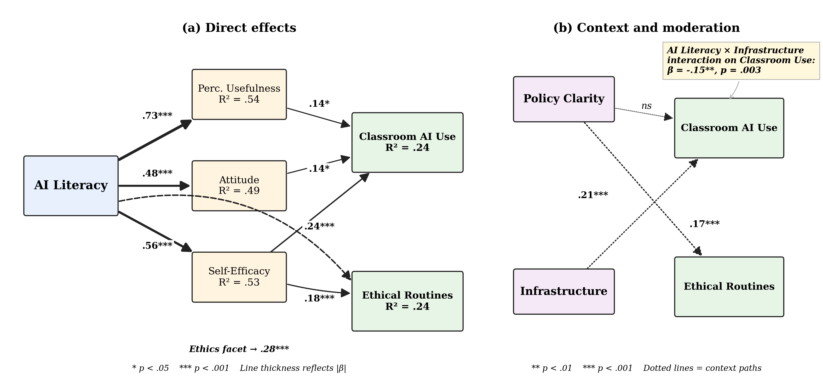
Fig. 6. Estimated structural model with standardised path coefficients. (a) Direct effects from AI Literacy through mediators (PU, Attitude, Self-Efficacy) to Classroom Use, plus the Ethics-facet → Ethical Routines parallel path. (b) Context paths from Policy Clarity and Infrastructure, with the AI Literacy × Infrastructure interaction on Classroom Use. Line thickness reflects |β|. * p < .05, ** p < .01, *** p < .001.

TABLE III
Standardised Path Coefficients in the Structural Model
Path | β | t | p
AI Literacy → Perceived Usefulness | .73 | 20.34 | <.001
AI Literacy → Attitude | .48 | 8.71 | <.001
AI Literacy → Self-Efficacy | .56 | 10.52 | <.001
PU → Classroom Use | .14 | 2.14 | .033
Attitude → Classroom Use | .14 | 2.19 | .030
Self-Efficacy → Classroom Use | .24 | 3.69 | <.001
Infrastructure → Classroom Use | .17 | 3.62 | <.001
Policy Clarity → Classroom Use | .04 | 0.79 | .43
Ethics facet → Ethical Routines | .28 | 5.25 | <.001
Policy Clarity → Ethical Routines | .21 | 4.51 | <.001
Self-Efficacy → Ethical Routines | .18 | 3.41 | <.001

E. Mediation
Bootstrap mediation with 5,000 resamples indicated three significant indirect statistical paths from AI literacy to classroom use: through perceived usefulness (a·b = .130, 95% CI [.029, .232]), through attitude (a·b = .112, 95% CI [.022, .199]), and through self-efficacy (a·b = .155, 95% CI [.058, .245]). The literacy → self-efficacy → ethical-routines indirect path approached but did not exceed the conventional threshold (a·b = .083, 95% CI [-.013, .180]). The self-efficacy mediator carried the largest indirect statistical association, consistent with the interpretation that capability beliefs may operate as the principal statistical channel linking literacy to classroom enactment in this sample, although causal direction cannot be established from cross-sectional data. H2 is therefore preliminarily supported, with the expected primacy of self-efficacy observed.
F. Moderation
Two interaction terms were tested. Policy clarity did not significantly moderate the literacy-use relationship (interaction β = -.05, p = .34). Infrastructure, however, did: the interaction term was significant and negative (β = -.15, t = -2.97, p = .003). The association between literacy and classroom use is stronger in lower-infrastructure contexts and weaker where infrastructure is more abundant. Fig. 7 displays simple slopes at −1 SD, mean, and +1 SD of infrastructure. This direction is the opposite of H3, which expected infrastructure to amplify the effect of literacy: the data instead indicate a substitution pattern, in which abundant infrastructure appears to dampen the marginal contribution of teacher literacy and scarce infrastructure appears to make literacy more decisive. H3 as originally specified is therefore not supported, and the observed interaction is more consistent with a compensatory than an amplification model. As with the other findings, the cross-sectional self-report design does not permit causal inference about substitution, and this result is treated as a generative finding to test in future work rather than as a confirmed effect.
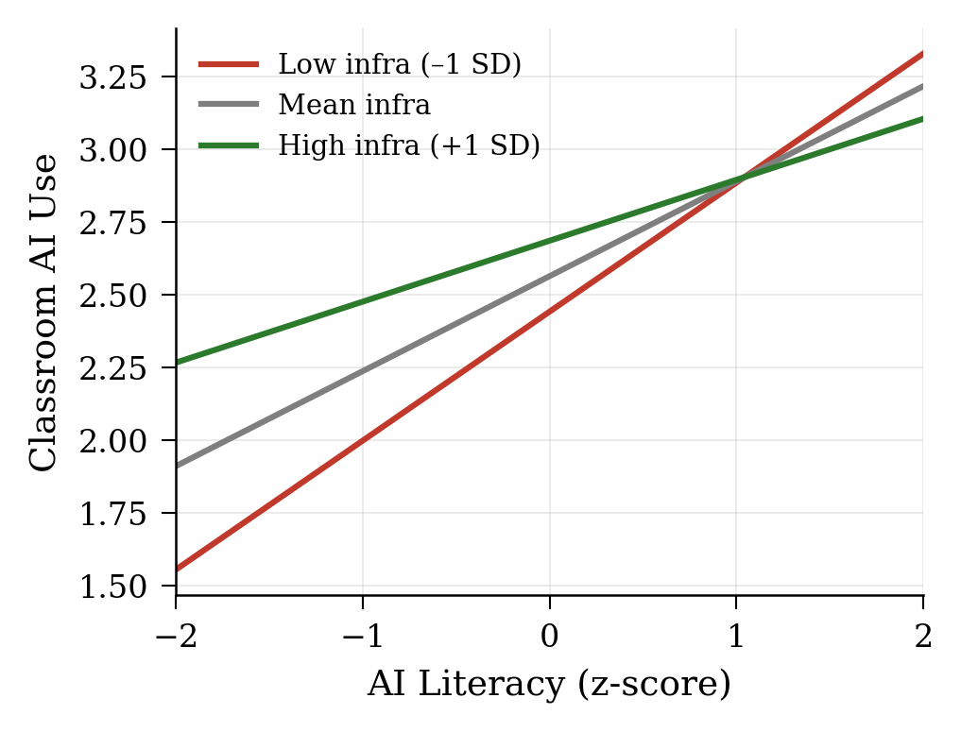
Fig. 7. Simple slopes for the AI Literacy × Infrastructure interaction associated with Classroom Use. The slope of literacy on use is steepest at low infrastructure (red) and shallowest at high infrastructure (green), consistent with a compensatory or substitution pattern.
V. Discussion
A. Theoretical Implications
The findings have four theoretical implications. First, the factor-analytic results challenge the assumption that AI literacy operates as a set of fully discrete competencies in practising teachers, but they also caution against the opposite extreme. Although exploratory factor analysis on the calibration subsample favoured a single dominant factor, confirmatory factor analysis on the holdout subsample showed that the five-correlated-factors model fits the data substantially better than a unidimensional model, and the bifactor decomposition indicated that the Ethics facet in particular carries meaningful unique variance beyond a general literacy factor (with ECV = 17.2% pointing to a multidimensional rather than essentially unidimensional structure). The picture that emerges is of a multi-faceted literacy capability with one empirically distinct sub-domain (ethical AI use), rather than either of the two extreme positions: neither a single indistinguishable construct nor five fully separable facets. While conceptually distinguishable [1], [4], the Understanding, Prompting, Evaluation, and Pedagogy facets share enough variance that the overall TAIL-SF score functions usefully as a practical composite for diagnostic and professional-development applications, consistent with [3]’s call for parsimonious instruments, even though their individual facet-specific variance is not statistically well-identified at this sample size.
Second, self-efficacy emerged as the strongest direct correlate of reported classroom use, extending Tschannen-Moran and Woolfolk Hoy’s [12] efficacy work into the AI domain. The mediation evidence is consistent with social cognitive theory: capability beliefs, not knowledge transfer alone, mediate between literacy and reported action.
Third, the negative literacy × infrastructure interaction is the study’s most theoretically interesting finding precisely because it contradicts the original hypothesis. The standard UTAUT-style expectation [11] is that facilitating conditions amplify the effect of individual capability: well-resourced contexts should let capable teachers do more, not equalise outcomes. The data instead suggest a substitutive, rather than amplifying, relationship between teacher literacy and infrastructure: where infrastructure is robust, even less-literate teachers find ways to integrate AI, while where infrastructure is weak, teacher literacy becomes more decisive. If this pattern holds in more representative samples, it has direct implications for resource-allocation decisions in low- and middle-income systems: investment in capability and investment in infrastructure may not be straightforwardly complementary but may instead substitute at the margin. This is a finding worth interrogating directly with experimental or longitudinal designs rather than treating as a settled effect.
Fourth, comparing the two behavioural outcomes pays off the triangulation framing introduced in Section II.F. The strongest predictor of self-reported classroom use is general self-efficacy, with broadly similar contributions from PU, attitude, and infrastructure. The strongest predictor of reported ethical routines, by contrast, is the Ethics facet of literacy itself, followed by policy clarity, with self-efficacy contributing more modestly. Two divergences are informative. The Ethics facet outperforms the overall literacy composite for routines, which is consistent with the bifactor finding that Ethics is the one empirically distinct facet rather than a redundant manifestation of general literacy. And policy clarity predicts routines but not overall use, suggesting that institutional rules shape how AI is used (with attribution, disclosure, and rule-setting) without necessarily shaping whether or how often it is used. The two outcomes therefore behave as theoretically distinguishable rather than redundant indicators of a single integration construct, which strengthens the case for treating ethical routines as a substantive outcome in its own right rather than as a stand-in for use.
B. Practical Implications
For school leaders and policymakers, three actionable conclusions follow. First, professional development should explicitly target self-efficacy, not just knowledge transfer, hands-on practice with classroom-relevant tasks, peer modelling, and incremental success experiences are likely to be more effective than one-off workshops or technical briefings. The pattern of findings suggests that teachers who can perform AI-supported tasks confidently in classroom settings may report higher integration than those whose knowledge is more abstract.
Second, policy clarity matters specifically for ethical routines, suggesting that explicit school AI policies pay dividends in responsible-use behaviours, attribution, student briefing, rule-setting, even when they are not significantly associated with overall use frequency. School leaders concerned about ethical practice should focus on making policy explicit and well-communicated rather than on encouraging or discouraging use per se.
Third, infrastructure investment in low-resource schools may yield the largest returns on AI-integration outcomes precisely because literacy alone may not fully compensate for absent enablers in those contexts. The compensatory interaction implies that in resource-constrained schools, system-level investment in connectivity and devices may be associated with integration outcomes that no amount of teacher training alone, on the basis of these data, may fully account for. Conversely, in well-resourced schools, capability-building investments are likely to deliver diminishing returns on use frequency, though they remain important for the depth and quality of integration.
C. Limitations
Several limitations qualify these findings, grouped under five headings. First, the cross-sectional, self-report design limits causal inference and introduces susceptibility to common-method bias; longitudinal and observational follow-up is needed. Second, the sampling strategy (recruitment via WhatsApp groups, ICT teacher associations, provincial contacts, and snowball sampling) likely produced a more digitally engaged sample than the Sri Lankan teacher population at large. The high reported ChatGPT use (80.1%) confirms this: the sample is best understood as Sri Lankan teachers who participate in ICT communities of practice, not Sri Lankan teachers in general. This skew is particularly consequential for the moderation finding. The negative literacy × infrastructure interaction implies that literacy matters most precisely in low-infrastructure contexts, and yet teachers in those very contexts are the ones most likely to be missing from an online, ICT-network-recruited sample. The substitution pattern observed here may therefore be conservative; it could be stronger, weaker, or shaped differently in a more representative sample, and replication with offline or stratified recruitment is a priority. Third, the study models reported behaviour rather than observed classroom practice or student outcomes; the mapping from self-report to enacted behaviour is imperfect.
Fourth, the rapid evolution of AI tools means that specific item content (e.g., references to “hallucinations,” specific tool names) may need periodic refresh, although the underlying competency targets are durable. Fifth, several aspects of the measurement evidence remain preliminary. AVE values below .50 for several constructs (most notably Pedagogy at .33) caution against strong claims of convergent validity, and the borderline Understanding-Evaluation HTMT (.87, exceeding the .85 threshold) indicates that the empirical separation of those facets is incomplete. The split-sample CFA used N_A = N_B = 181 per subsample, which is at the lower end of what is typically considered adequate for a five-factor 18-item model; small-sample CFA can produce somewhat inflated fit indices and parameter estimates can be unstable, and the SRMR values for all three CFA models in this study (.108 to .112) exceeded the conventional .08 threshold, suggesting that absolute residual covariance fit is somewhat weaker than the relative fit indices alone would imply. The CFA also treated 5-point Likert items as continuous and used ML estimation rather than a categorical-data estimator such as WLSMV; categorical estimation would be preferable for rigorous psychometric work and may shift fit indices and parameter estimates somewhat. The factor-structure conclusions reported here should therefore be replicated on larger independent samples (ideally N ≥ 300 per CFA) using categorical-appropriate estimation before they are taken as settled. Together, these issues mean that convergent validity (especially for Pedagogy), holdout-CFA stability, the treatment of ordinal items, and the Understanding-Evaluation distinction are the most pressing measurement questions for future revisions of the instrument.
D. Future Research
Three directions follow naturally. Cross-country replication using TAIL-SF would test the generalisability of the factor structure and the substitution moderation pattern, particularly across systems with different infrastructure baselines. Observational studies linking literacy scores to classroom video or learning-analytics data could validate the self-report-to-practice translation and extend the outcome variable from frequency to quality and impact. Longitudinal designs tracking teachers through professional development could examine whether literacy gains causally precede classroom-use changes, and at what time scale.
Beyond replication, the substitution finding warrants direct experimental investigation. A factorial design crossing infrastructure improvements (connectivity, devices) with literacy interventions (workshops, peer coaching) could clarify whether the observed compensation pattern is robust to manipulation and whether combined investments yield super- or sub-additive returns.
VI. Conclusion
This study set out to address two related gaps: the absence of a short, context-aware instrument for measuring K-12 teacher AI literacy, and the absence of empirical evidence on how that literacy connects to classroom behaviour in a South Asian, resource-asymmetric setting. The 18-item TAIL-SF, evaluated on a sample of 362 Sri Lankan teachers using a split-sample design, showed strong internal consistency, with the holdout CFA favouring multi-factor structures over a unidimensional model and the bifactor decomposition (ECV = 17.2%) pointing to a multidimensional structure in which the Ethics facet emerges as the clearest empirically distinct sub-domain; the overall TAIL-SF score therefore serves as a practical diagnostic composite rather than as an indicator of essential unidimensionality. Convergent validity is more uneven: AVE values for several constructs (notably Pedagogy at .33) fall below conventional thresholds, and the Understanding-Evaluation HTMT exceeds .85, indicating that some of the intended facets are not yet cleanly separated and will need item-level revision before stronger psychometric claims can be made. Within those limits, preliminary path-analytic evidence linked the overall literacy score, and the Ethics facet specifically, to perceived usefulness, attitude, self-efficacy, classroom AI use, and ethical routines.
The clearest practical message is that capability and confidence operate together, not interchangeably. Self-efficacy was the strongest direct correlate of reported classroom use, and the negative literacy × infrastructure interaction suggests that teacher capability matters most precisely where institutional conditions are weakest. Professional development that builds confidence through hands-on practice, and investment that closes the most acute infrastructure gaps, are likely to be complementary rather than competing levers in similar systems.
These findings should be read as a starting point rather than a conclusion. Confirmatory factor analysis on independent samples, longitudinal designs that can speak to causal direction, and observational or learning-analytics outcomes that go beyond self-report are the natural next steps. As AI tools and the policy environment in Sri Lanka and comparable systems continue to evolve, a brief instrument intended for open release, such as TAIL-SF, should make it easier for schools, ministries, and researchers to track teacher readiness and target support where it will have the most effect.

Appendix: TAIL-SF Item Pool and Scoring Guide
All items use a five-point response format from 1 (Strongly Disagree) to 5 (Strongly Agree), with item LIT_EVA4 reverse-coded. Subscale scores are computed as the mean of constituent items after recoding the reverse item. The overall TAIL-SF score is the mean of all 18 items.
TABLE IV
TAIL-SF: 18-Item Short Form for Teacher AI Literacy
Code | Facet | Item wording
LIT_UND1 | Understanding | I can explain in simple terms what a large language model does.
LIT_UND2 | Understanding | I understand the difference between AI that learns from data and AI that follows fixed rules.
LIT_UND3 | Understanding | I can describe at least two strengths and two limitations of generative AI tools.
LIT_UND4 | Understanding | I know what an AI hallucination is and can give an example.
LIT_PRM1 | Prompting | I can write clear, specific prompts that produce useful AI outputs for my teaching.
LIT_PRM2 | Prompting | I refine my prompts iteratively when the first AI response is not what I need.
LIT_PRM3 | Prompting | I include relevant context (grade level, subject, learner needs) in prompts to improve AI outputs.
LIT_EVA1 | Evaluation | I check AI-generated facts against trusted sources before using them with students.
LIT_EVA2 | Evaluation | I notice when an AI output is biased, stereotyped, or culturally inappropriate.
LIT_EVA3 | Evaluation | I can judge whether an AI-generated explanation is accurate for the topic I am teaching.
LIT_EVA4 | Evaluation (R) | I generally trust AI outputs and rarely feel the need to verify them. (reverse-coded)
LIT_ETH1 | Ethics | I am aware of student data privacy risks when using AI tools in lessons.
LIT_ETH2 | Ethics | I disclose to students when teaching materials were created or supported by AI.
LIT_ETH3 | Ethics | I avoid entering identifiable student information into public AI tools.
LIT_ETH4 | Ethics | I can explain to students what counts as appropriate and inappropriate use of AI in their work.
LIT_PED1 | Pedagogy | I can decide when AI is, and is not, the right tool for a given learning task.
LIT_PED2 | Pedagogy | I design AI-supported activities that still require students to think for themselves.
LIT_PED3 | Pedagogy | I adapt AI tools to fit my own teaching context (subject, grade, language).

Scoring: For each respondent, recode LIT_EVA4 as 6 minus the raw response. Compute facet means as the mean of the four (Understanding, Evaluation, Ethics) or three (Prompting, Pedagogy) constituent items. Compute the overall TAIL-SF score as the mean of all 18 items after recoding. Higher scores indicate greater self-reported AI literacy. Based on the split-sample CFA findings reported in Section IV.B, the overall score together with the Ethics facet score are the two indicators with the clearest empirical support in the present sample, and are recommended for diagnostic applications. The Understanding, Prompting, Evaluation, and Pedagogy facet scores may still be useful for finer-grained professional-development targeting, but users should treat differences across these four facets cautiously until stronger discriminant evidence is established in independent samples.

Acknowledgments
The author thanks the participating teachers and the expert reviewers who contributed to instrument development. Any errors remain the author’s own.
References
[1] D. Long and B. Magerko, “What is AI literacy? Competencies and design considerations,” in Proc. CHI Conf. Human Factors in Computing Systems, 2020, pp. 1-16, doi: 10.1145/3313831.3376727.
[2] F. Miao and W. Holmes, Guidance for Generative AI in Education and Research. Paris, France: UNESCO, 2023.
[3] T. Lintner, “A systematic review of AI literacy scales,” npj Science of Learning, vol. 9, art. 50, 2024, doi: 10.1038/s41539-024-00264-4.
[4] D. T. K. Ng, W. Wu, J. K. L. Leung, T. K. F. Chiu, and S. K. W. Chu, “Design and validation of the AI literacy questionnaire: The affective, behavioural, cognitive and ethical approach,” British Journal of Educational Technology, vol. 55, no. 3, pp. 1082-1104, 2024, doi: 10.1111/bjet.13411.
[5] M. Hornberger, A. Bewersdorff, D. S. Schiff, and C. Nerdel, “Development and validation of a short AI literacy test (AILIT-S) for university students,” Computers in Human Behavior: Artificial Humans, vol. 5, art. 100176, 2025, doi: 10.1016/j.chbah.2025.100176.
[6] Y. Dong, W. Xu, J. Huang, et al., “Validating and refining a multi-dimensional scale for measuring AI literacy in education using the Rasch Model,” Humanities and Social Sciences Communications, vol. 12, art. 1317, 2025, doi: 10.1057/s41599-025-05670-6.
[7] S. C. Kong, Y. Yang, and C. Hou, “Examining teachers’ behavioural intention of using generative artificial intelligence tools for teaching and learning based on the extended technology acceptance model,” Computers and Education: Artificial Intelligence, vol. 7, art. 100328, 2024, doi: 10.1016/j.caeai.2024.100328.
[8] A. Alfarwan, “Generative AI use in K-12 education: a systematic review,” Frontiers in Education, vol. 10, art. 1647573, 2025, doi: 10.3389/feduc.2025.1647573.
[9] J. Henseler, C. M. Ringle, and M. Sarstedt, “A new criterion for assessing discriminant validity in variance-based structural equation modeling,” Journal of the Academy of Marketing Science, vol. 43, pp. 115-135, 2015, doi: 10.1007/s11747-014-0403-8.
[10] F. D. Davis, “Perceived usefulness, perceived ease of use, and user acceptance of information technology,” MIS Quarterly, vol. 13, no. 3, pp. 319-340, 1989, doi: 10.2307/249008.
[11] V. Venkatesh, M. G. Morris, G. B. Davis, and F. D. Davis, “User acceptance of information technology: Toward a unified view,” MIS Quarterly, vol. 27, no. 3, pp. 425-478, 2003, doi: 10.2307/30036540.
[12] M. Tschannen-Moran and A. Woolfolk Hoy, “Teacher efficacy: Capturing an elusive construct,” Teaching and Teacher Education, vol. 17, no. 7, pp. 783-805, 2001, doi: 10.1016/S0742-051X(01)00036-1.
[13] P. Mishra and M. J. Koehler, “Technological pedagogical content knowledge: A framework for teacher knowledge,” Teachers College Record, vol. 108, no. 6, pp. 1017-1054, 2006, doi: 10.1111/j.1467-9620.2006.00684.x.
[14] I. Celik, “Towards Intelligent-TPACK: An empirical study on teachers’ professional knowledge to ethically integrate artificial intelligence (AI)-based tools into education,” Computers in Human Behavior, vol. 138, art. 107468, 2023, doi: 10.1016/j.chb.2022.107468.
[15] M. Ramazanoğlu and T. Akın, “AI readiness scale for teachers: Development and validation,” Education and Information Technologies, 2024, doi: 10.1007/s10639-024-13087-y.
[16] OECD, OECD Digital Education Outlook 2023: Towards an Effective Digital Education Ecosystem. Paris, France: OECD Publishing, 2023, doi: 10.1787/c74f03de-en.
[17] M. Bond, H. Khosravi, M. De Laat, N. Bergdahl, V. Negrea, E. Oxley, P. Pham, S. W. Chong, and G. Siemens, “A meta systematic review of artificial intelligence in higher education: a call for increased ethics, collaboration, and rigour,” International Journal of Educational Technology in Higher Education, vol. 21, art. 4, 2024, doi: 10.1186/s41239-023-00436-z.
[18] Ministry of Education of Sri Lanka, Annual School Census of Sri Lanka: Summary Report 2023. Colombo, Sri Lanka: Statistics Branch, MoE, 2024.
[19] J. F. Hair Jr., G. T. M. Hult, C. M. Ringle, and M. Sarstedt, A Primer on Partial Least Squares Structural Equation Modeling (PLS-SEM), 3rd ed. Thousand Oaks, CA, USA: SAGE, 2022.
[20] N. Kock, “Common method bias in PLS-SEM: A full collinearity assessment approach,” International Journal of e-Collaboration, vol. 11, no. 4, pp. 1-10, 2015, doi: 10.4018/ijec.2015100101.
[21] Department of Census and Statistics, Computer Literacy Statistics, Sri Lanka 2018. Colombo, Sri Lanka: Ministry of Finance, 2019.
[22] T. R. Liyanagunawardena and S. A. Williams, “Emergency remote education: experience from Sri Lanka during Covid-19,” Asian Journal of Distance Education, vol. 16, no. 1, pp. 207-229, 2021.
[23] Ministry of Digital Economy, Sri Lanka, AI Sri Lanka 2028: Sri Lanka’s National Strategy on AI (Draft for Public Consultation). Colombo, Sri Lanka: Ministry of Digital Economy, 2025. [Online]. Available: https://mode.gov.lk (accessed 2025).
[24] Ministry of Education, Sri Lanka and Microsoft, “Memorandum of Understanding on integrating AI and Machine Learning into the National School Curriculum,” Press release, 20 March 2024. [Online]. Available: https://news.microsoft.com (accessed 2025).
[25] Ministry of Digital Economy, Sri Lanka, “AI Clubs in Sri Lanka Schools,” Notice, 2024. [Online]. Available: https://mode.gov.lk (accessed 2025).
[26] L. Hu and P. M. Bentler, “Cutoff criteria for fit indexes in covariance structure analysis: Conventional criteria versus new alternatives,” Structural Equation Modeling, vol. 6, no. 1, pp. 1-55, 1999, doi: 10.1080/10705519909540118.

