Phatic-Only Slang and the Limits of Meaning-Based Lexical Theory: A Sociolinguistic Review of the “6-7” Meme
[Author Name] ¹*
¹ [Department / Faculty, Institution, City, Country] * Corresponding author: [email]
Abstract
Background. In October 2025 Dictionary.com named “67” (rendered 6-7, pronounced six-seven) its Word of the Year while conceding that the term is “impossible to define.” A non-sequitur interjection that spread among Generation Alpha through TikTok, basketball highlight edits, and a Philadelphia drill song, 6-7 appears to carry no referential content yet remains demonstrably meaningful to those who use it. Objective. This narrative review asks what such a phatic-only slang term reveals about the limits of meaning-based—referential and truth-conditional—lexical theory, and which frameworks best account for it. Methods. A structured narrative review synthesised conceptual, empirical, and lexicographic literature across five thematic search angles; extracted claims were rendered falsifiable and subjected to an adversarial verification pass that actively sought to refute them. Findings. Linguists and lexicographers converge on a single reading: 6-7 is semantically near-void but socially potent, operating as an in-group shibboleth through semantic bleaching, expressive (use-conditional) meaning, and sociolinguistic indexicality. It instantiates Malinowski’s (1923) phatic communion and Jakobson’s (1960) phatic function. Conclusions. 6-7 does not refute referential semantics so much as map its boundary; a complete theory of the lexicon requires use-based, expressive, and indexical supplementation. The paradox of a dictionary defining the indefinable is best read not as an embarrassment but as a diagnostic signal about what lexical meaning can be.
Keywords: phatic communion; phatic function; lexical semantics; expressive meaning; sociolinguistic indexicality; slang; internet linguistics; brainrot; Generation Alpha
1. Introduction
The lexicographer’s traditional task—pairing a word-form with a definition—presupposes that words have meanings of the kind a definition can capture. Most do. But a recurring challenge to meaning-based lexical theory comes from expressions that resist this pairing: interjections, expletives, discourse particles, greetings, and the formulaic small talk that linguists since Malinowski (1923) have grouped under the heading of phatic language. These items perform real communicative work, yet they are difficult or impossible to define in referential terms.
The viral slang term 6-7 is a near-perfect specimen of this class, and its 2025 elevation to Word of the Year by a dictionary—an institution whose entire enterprise is definition—sharpens the theoretical problem into something approaching paradox. When Dictionary.com’s Director of Lexicography, Steve Johnson, says the term is “part inside joke, part social signal and part performance” and that “when people say it, they’re not just repeating a meme; they’re shouting a feeling” (Smithsonian Magazine, 2025), he is describing an item whose value lies almost entirely outside the denotational dimension that meaning-based theory privileges.
This review pursues four aims. First, it documents the empirical phenomenon: the origins, spread, and reception of 6-7 (Section 3). Second, it situates the term within the theory of phatic communication (Section 4). Third, it lays out the commitments of meaning-based lexical theory—referential, truth-conditional, and lexical-semantic approaches (Section 5). Fourth, it argues that phatic-only slang like 6-7 tests the limits of those approaches, and that the most adequate accounts come from use-based, expressivist, and indexical frameworks (Sections 6–7). The synthesis is interdisciplinary, treating the meme not as a curiosity but as naturally occurring evidence about the architecture of lexical meaning.
2. Methods
2.1 Review design and search strategy
This study adopts a structured narrative—rather than systematic—review design, appropriate because the object spans a fast-moving cultural phenomenon and several mature but separate theoretical literatures that no single systematic protocol indexes well. Five thematic search angles were defined a priori: (i) the trajectory of the 6-7 meme; (ii) phatic communication and the phatic function; (iii) meaning-based versus use-based theories of lexical meaning; (iv) slang formation, internet linguistics, and memetics; and (v) the theoretical nexus joining phatic-only expression to lexical theory. Each angle was pursued through an independent fan-out of web searches across encyclopaedic, scholarly, lexicographic, and journalistic sources in June 2026 (Figure 1).
The review is organised around three research questions. RQ1: What are the documented origins, spread, and use of 6-7, and what do users and experts take it to mean? RQ2: How do meaning-based theories of the lexicon handle—or fail to handle—an item with no referential content? RQ3: Which theoretical frameworks best account for a phatic-only slang term, and what does the case imply for lexical theory more broadly?
2.2 Source selection
Sources were retained on the basis of relevance and authority. Three tiers were distinguished: (a) primary theoretical texts (e.g., Malinowski, 1923; Jakobson, 1960; Wittgenstein, 1953; Potts, 2005, 2007; Eckert, 2008); (b) peer-reviewed or scholarly secondary sources and reference works; and (c) reputable journalism and lexicographic statements, used chiefly for the contemporary phenomenon and always preferring pieces that quote named linguists (e.g., Taylor Jones, Valerie Fridland, Adam Aleksic, Cynthia Gordon). Popular sources were not used to support theoretical claims.
2.3 Adversarial verification protocol
To mitigate the risk of citing fabricated, misremembered, or misattributed findings, each substantive claim was rendered as a falsifiable statement and assigned a provisional confidence level. High-stakes claims and all medium- or low-confidence claims were then subjected to an adversarial verification pass in which independent counter-searches actively sought to refute them; a claim survived only under corroboration from multiple independent sources, and was otherwise corrected or struck. No claim was struck. Two citation corrections were applied: Firth’s “company it keeps” dictum was re-sourced to “A Synopsis of Linguistic Theory, 1930–1955” (Firth, 1957) rather than to Papers in Linguistics, and the term “indexical field” was credited to Eckert (2008) rather than to her 2018 book. Verbatim quotations from primary texts (Malinowski, Jakobson, Wittgenstein §43, Kaplan, Potts) were confirmed across multiple sources; the Wittgenstein §43 quotation follows the Anscombe translation.
2.4 Limitations of the method
As a narrative review, this synthesis is interpretive and non-exhaustive. The phenomenon is recent, so the contemporary evidence base leans on lexicographic statements and journalism quoting linguists rather than on peer-reviewed studies of 6-7 itself. The phatic-only items under study are characteristically ephemeral, and one origin claim—the 10-67 police-code etymology—remains unverified speculation. These constraints bound the strength, though not the direction, of the conclusions.
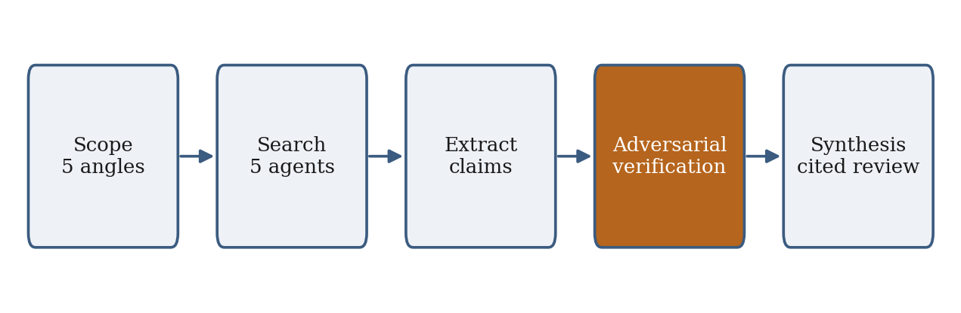
Figure 1. Structured narrative-review and adversarial-verification workflow.
3. The “6-7” Phenomenon: Origins, Spread, and Reception
3.1 Origins
The proximate origin of 6-7 is “Doot Doot (6 7),” a Philadelphia drill song by the rapper Skrilla (produced by 1Ellis). The track leaked to streaming platforms in December 2024 and was officially released via Priority Records on 7 February 2025, later appearing on the deluxe edition of Skrilla’s Zombie Love Kensington Paradise (Wikipedia contributors, n.d.-b). Crucially, the phrase was born semantically underdetermined: Skrilla has declined to fix its meaning, reportedly saying “I never put an actual meaning on it, and I still would not want to,” and elsewhere describing it as representing “what comes up in my head” (Complex, 2025; WHYY, 2025). Proposed sources—a Philadelphia or Chicago street, or, per linguist Taylor Jones, the police ten-code 10-67 used to report a death—remain speculative (CNN, 2025). The indeterminacy is not a gap in our knowledge; it is constitutive of the term.
3.2 Spread
The phrase migrated from music to mass meme through basketball. Highlight edits paired the lyric with footage of players listed at six-foot-seven, most prominently LaMelo Ball (2.01 m), exploiting the literal height coincidence (Bleacher Report, n.d.). On 31 March 2025 a YouTube AAU-basketball video by Cam Wilder featured a young boy—later dubbed the “67 Kid”—shouting “six seven” with a palms-up, alternating up-and-down hand gesture; the clip became a primary vector of virality (Wikipedia contributors, n.d.-a). By autumn 2025 the term saturated NBA and WNBA media, NFL celebrations, and celebrity content—Shaquille O’Neal reportedly joined in while admitting he did not understand it, a telling detail for a term whose use is detached from comprehension. Dictionary.com (2025) reported that 67 appeared in digital media roughly six times more frequently in October 2025 than across all of 2024, with searches up more than sixfold since June 2025 (Figure 2).
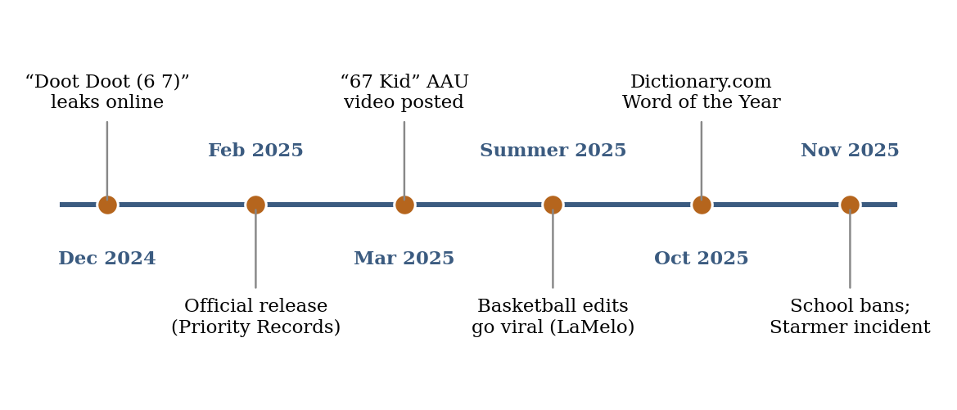
Figure 2. Timeline of the “6-7” meme, December 2024–November 2025.
3.3 Reception
In use, 6-7 functions as an interjection or non-sequitur—shouted on hearing either number, deployed as a punchline, or chanted communally—rather than as a contentful predicate. It is loosely glossed as “so-so” or “maybe this, maybe that,” mirrored by the see-sawing gesture, but the gloss is post-hoc and unstable (Dictionary.com, 2025). Reception data reinforce an in-group/out-group dynamic: teachers have banned the phrase and tallied its frequency (one Sioux Falls science teacher, Gabe Dannenbring, reported hearing it roughly 75 times in a single day), and on 24 November 2025 UK Prime Minister Keir Starmer was publicly corrected by a head teacher after leading schoolchildren in the gesture during a school visit (CNN, 2025; IBTimes UK, 2025). The comedy of these episodes turns on who is and is not “in on the joke”—a sociolinguistic fact, not a semantic one.
4. The Phatic Frame: Communion, Contact, and Contentless Talk
4.1 Malinowski’s phatic communion
The vocabulary for analysing contentless-but-functional language originates with the anthropologist Bronisław Malinowski, whose 1923 essay “The Problem of Meaning in Primitive Languages” appeared as a supplement to Ogden and Richards’s The Meaning of Meaning. There Malinowski coined the term—“actuated by the demon of terminological invention”—for “a type of speech in which ties of union are created by a mere exchange of words” (Malinowski, 1923). Phatic communion is the language of “free, aimless, social intercourse,” in which words “fulfil a social function, and that is their principal aim,” being “neither the result of intellectual reflection, nor do they necessarily arouse reflection in the listener.” Language is here “a mode of action, rather than as a countersign of thought”; it bonds rather than informs. This is, almost verbatim, what lexicographers now say about 6-7.
4.2 Jakobson’s phatic function
Roman Jakobson formalised the idea within his six-function model of communication (Jakobson, 1960). The phatic function corresponds to the contact factor, comprising “messages primarily serving to establish, to prolong, or to discontinue communication, to check whether the channel works”—exemplified by “Hello, do you hear me?” and “Are you listening?” Jakobson credited Malinowski for the term and observed that the phatic function is “the first verbal function acquired by infants,” who communicate before they can exchange information. That developmental priority resonates with Fridland’s (2026) analysis of 6-7 as the developmentally normal creation of socially meaningful language by adolescents—“not brain rot” but “linguistically normal.” The phatic function is not a degenerate use of language; it is foundational.
4.3 Phatic culture online
The frame extends to digital communication. Miller (2008) argues that network sociality has produced an online culture “dominated by non-dialogic, non-informational” exchange, in which “the connection, not the content, is what matters.” Practices such as Snapchat “streaks”—daily exchanges whose entire point is maintaining a connection counter—are paradigmatically phatic (see Miller, 2008, and subsequent phatic-media research). A meme that spreads as a shouted gesture, propagating connection rather than proposition, is the lexical-item-scale instance of exactly this phenomenon.
5. Meaning-Based Lexical Theory and Its Commitments
5.1 Referential and truth-conditional semantics
The dominant strand of formal semantics ties meaning to the world. Frege’s (1892/1948) distinction between sense (Sinn) and reference (Bedeutung) keeps reference central: “the morning star” and “the evening star” differ in sense yet share a referent, Venus. Truth-conditional semantics, developed by Davidson (1967) on Tarski’s theory of truth, holds that to give the meaning of a sentence is to give its truth conditions, so that a word’s meaning is its contribution to those conditions. The difficulty is immediate: 6-7 has no plausible truth-conditional contribution. It is not a predicate, names nothing, and a sentence is no more or less true for containing it—by the lights of strict truth-conditional semantics, not so much false as not truth-apt.
5.2 Lexical semantics
Lexical semantics studies word meaning and the sense relations—synonymy, hyponymy, antonymy, polysemy—that structure the lexicon (Jurafsky & Martin, 2023). Identifying lexical meaning purely with reference makes it hard to account for synonymy and analytic entailment, and the field accordingly distinguishes an inferential aspect of lexical competence (relations among senses) from a referential aspect (naming and application) (Stanford Encyclopedia of Philosophy, n.d.). 6-7 enters into neither set of relations robustly: it has no synonyms, no hypernym, no entailments. There is no sense for the inferential machinery to operate on—which is why a dictionary can simultaneously crown it and confess it cannot define it.
5.3 Use-based alternatives
The principal rival tradition makes use, not reference, primary. Wittgenstein’s (1953) Philosophical Investigations furnishes the slogan: “the meaning of a word is its use in the language” (§43, Anscombe translation). Meaning resides in language-games and is organised by family resemblance rather than shared essence; notably, Wittgenstein hedged—“not for all” cases—and 6-7 falls squarely in the use-governed, non-ostensive class he had in mind. Three further frameworks bear on slang: Firth’s (1957) distributional dictum (“you shall know a word by the company it keeps”); usage-based linguistics, which models grammar as a network of constructions learned from use; and construction grammar (Goldberg, 1995), which treats lexical and syntactic units alike as form–meaning pairings. Each permits “meaning” to be a conventionalised pairing of a form with a function—including a purely social function—rather than with a referent (Table 2).
5.4 Non-referential items as a standing problem
6-7 is not sui generis; it joins a class formal semantics has long handled at its margins. Discourse markers are traditionally analysed as non-truth-conditional—removing “so” or “you know” does not change a sentence’s truth value—and Relevance Theory treats such connectives as encoding procedural rather than conceptual meaning (Blakemore, 2002). Interjections are likewise characterised as content that is not truth-conditional in any way. The existence of this margin is the wedge: meaning-based theory has always needed a supplementary account for items whose meaning is not denotational. 6-7 simply pushes that supplement to the centre.
Table 2. Theories of lexical meaning and their fit for a phatic-only item.
Tradition | Key figures | Locus of meaning | Account of “6-7”
Referential / truth-conditional | Frege; Davidson | Reference; contribution to truth conditions | No content; not truth-apt
Lexical semantics | Cruse; Jurafsky & Martin | Sense and sense-relations | No sense; enters no relations
Use theory | Wittgenstein | Use within language-games | Meaning is its use
Usage-based / construction grammar | Firth; Bybee; Goldberg | Conventionalised form–function pairing | Form paired with a social function
Expressive / use-conditional | Kaplan; Potts; Gutzmann | Speaker attitude / affect | Expressive interjection
Indexical / third-wave | Silverstein; Eckert | Social indexing of identity/stance | Indexes in-group membership

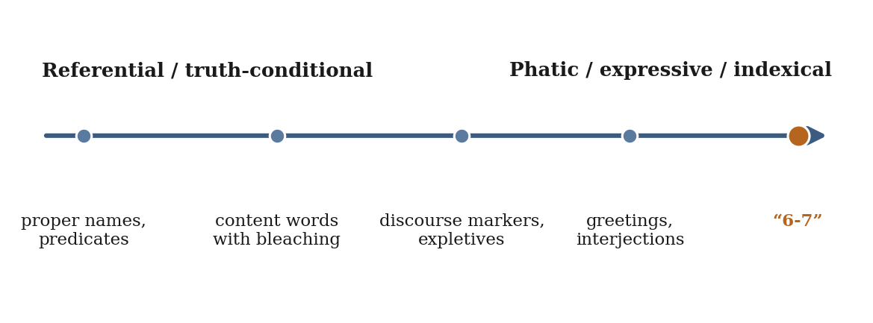
Figure 3. A cline of lexical meaning from referential to phatic, locating “6-7.”
6. Phatic-Only Slang Against Meaning-Based Theory
6.1 The convergent expert verdict
Independent commentators have reached the same conclusion using overlapping vocabulary (Table 1). The agreement is notable: every analyst relocates the term’s value from denotation to social contact, identity, and affect—that is, to the phatic and expressive dimensions.
Table 1. Convergent expert characterizations of “6-7.”
Commentator (affiliation) | Characterization of the term | Source
Taylor Jones (Univ. of Pennsylvania) | “Semantically … almost void”; a “shibboleth” marking in-group membership; product of “semantic bleaching” | CNN (2025)
Valerie Fridland (Univ. of Nevada, Reno) | “Void of any semantic meaning”; “makes sense” through social, not referential, meaning | Fridland (2026)
Adam Aleksic (“Etymology Nerd”) | “Six-seven doesn’t need to have a meaning. What matters is that it lands and provokes a reaction” | Today (2024)
Cynthia Gordon (Georgetown Univ.) | Trend “oriented to humor and play”; “only humorous … if a group of people are ‘insiders’” | Georgetown University (2025)
Steve Johnson (Dictionary.com) | An interjection; “a burst of energy that spreads and connects people long before anyone agrees on what it actually means” | Smithsonian Magazine (2025)

6.2 Semantic bleaching at internet speed
Semantic bleaching—the loss of denotational content while form and function persist—is a well-attested diachronic process. What 6-7 illustrates is bleaching compressed from centuries into months: the term arguably entered circulation already bleached, its tenuous link to a song lyric and a height statistic severed almost immediately (CNN, 2025). A comparable, slightly earlier case is “yeet,” which University of Colorado Boulder (2021) linguists analysed as undergoing “indexical bleaching” as it spread from African American English and attached primarily to gesture and stance. Internet circulation thus functions as a high-speed laboratory for processes historical linguistics usually observes only in slow motion.
6.3 Expressive meaning and descriptive ineffability
The most precise formal home for 6-7 is the expressivist strand of semantics. Kaplan’s (1999) “The Meaning of ‘Ouch’ and ‘Oops’” treats interjections as evidence for a semantics of meaning as use, distinguishing expressive content (which displays a speaker’s attitude) from descriptive, truth-apt content. Potts (2005, 2007) develops this into a systematic account of expressives as contributing non-truth-conditional, speaker-oriented meaning—what Kaplan (1999) and Gutzmann (2015) call use-conditional meaning—independent of at-issue content. Potts’s diagnostic properties map onto 6-7 with uncanny precision (Table 3); descriptive ineffability—speakers cannot paraphrase an expressive and instead resort to examples of use—is exactly the behaviour of teenagers and lexicographers confronted with 6-7. That a dictionary’s best account is “impossible to define … but meaningful to the people who use it” is the textbook signature of expressive (use-conditional) meaning.
Table 3. Potts’s (2007) diagnostic properties of expressives mapped onto “6-7.”
Property | Definition (Potts, 2007) | Manifestation in “6-7”
Independence | Expressive content is separate from at-issue/descriptive content | Adds no proposition to any sentence it punctuates
Nondisplaceability | Predicates something of the here-and-now of utterance | Performs the present moment; cannot report a past “6-7”
Perspective dependence | Tied to a perspective, usually the speaker’s | Signals the speaker’s stance/affiliation, not a fact
Descriptive ineffability | Speakers cannot paraphrase it; they give examples of use | Defined by when it is said, not what it denotes
Immediacy | Performs an act rather than describing one | Saying it is the social act
Repeatability | Repetition strengthens rather than becoming redundant | Chanted, echoic deployment in classrooms and arenas

6.4 Indexicality and third-wave sociolinguistics
If 6-7 is not denotational, what is its meaning? Sociolinguistics answers: indexical. Silverstein’s (2003) indexical order holds that forms acquire social meaning by indexing macro-social categories in micro-level interaction. Eckert (2008, 2018) argues that the meanings of linguistic variables are not fixed denotations but an indexical field—a constellation of ideologically related meanings activated in situated use to construct identity and signal stance. On this view the “meaning” of 6-7 just is its indexing of Generation Alpha in-group membership, playful stance, and shared participation: real, learnable, and socially consequential, yet categorically different from reference.
6.5 Slang as solidarity, and the anti-language
The sociology of slang independently predicts items like 6-7. Eble (1996) identifies the central purposes of slang as “cementing group identity and opposing authority,” with slang “deliberately chosen … to mark … inclusion in … a social group.” Halliday’s (1976) anti-language describes how oppositional groups generate vocabulary that “serves to create and maintain social structure through conversation,” often via overlexicalization. 6-7, as a shibboleth that bonds adolescents and irritates authority figures, performs this prototypical solidarity-and-opposition function with denotational content reduced essentially to zero.
6.6 Memetics and internet linguistics
Finally, the mechanism of 6-7’s spread is memetic rather than semantic. Dawkins (1976) coined “meme” as “a unit of cultural transmission, or a unit of imitation” propagating by copying—by replication, not by conveying fixed content. McCulloch (2019) shows that the “artfully disarrayed” form of animal-meme language made it “more likely to spread,” attributing virality to sound, form, and play rather than semantic payload. 6-7 spreads as Dawkinsian imitation: a catchy form plus a gesture, replicating because it is “just funny to say.” The broader “brainrot” lexicon—skibidi (a “pseudo word,” per Aleksic), Ohio, gyat—populates the same category, and Oxford’s selection of “brain rot” as its 2024 Word of the Year marks the cultural recognition of deliberately contentless online language (Oxford University Press, 2024; Today, 2024). Figure 4 summarises the disciplinary convergence.
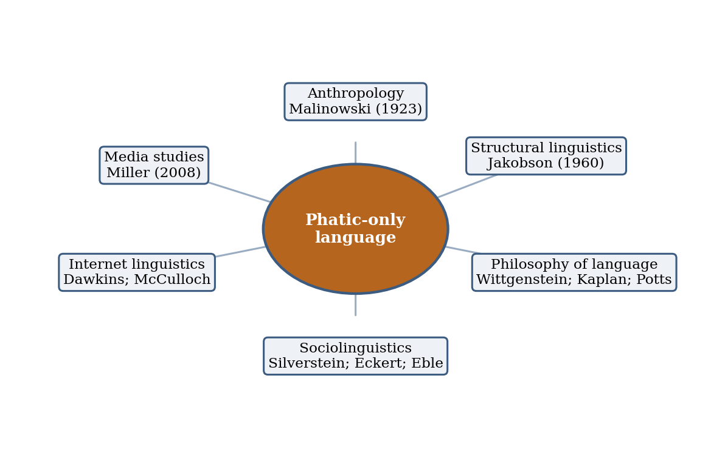
Figure 4. Disciplinary convergence on phatic-only language as social rather than denotational.
7. Discussion
7.1 The lexicographic paradox as a category signal
The headline irony—a dictionary crowning a word it cannot define—dissolves once the term is correctly categorised. Dictionary.com’s gloss (“meaningless, ubiquitous, and nonsensical … still … meaningful to the people who use it because of the connection it fosters”) is a near-paraphrase of Malinowski’s phatic communion and Potts’s expressive meaning. Merriam-Webster’s slang entry is equally telling: it defines six seven as “a nonsensical expression connected to a song and a basketball player” (Merriam-Webster, n.d.)—that is, by what it attaches to rather than by what it denotes, exactly the behaviour descriptive ineffability predicts. The institution of definition meets its limit not because 6-7 is sub-linguistic, but because the meaning-based, definitional model of the lexicon is the wrong model for this class of item.
7.2 Not a refutation but a scoping
It would overreach to say 6-7 “refutes” referential or truth-conditional semantics. Those theories were designed for the truth-apt, denotational core of the lexicon and remain powerful there. What 6-7 does is make vivid the boundary the tradition itself acknowledges through its marginal treatment of interjections and discourse markers. Meaning-based lexical theory is thus locally adequate but globally incomplete: it requires supplementation by a use-based conception of meaning (Wittgenstein; construction grammar), an expressive dimension (Kaplan; Potts), and a social-indexical dimension (Silverstein; Eckert). 6-7 is valuable precisely because it is phatic-only—a near-pure specimen that isolates these dimensions from any confounding denotational content, as a controlled experiment isolates a variable.
7.3 Limitations and open questions
Several caveats temper these conclusions. The phenomenon is recent and the academic literature on 6-7 specifically is thin, so the analysis leans on expert commentary and the application of established theory. “Meaninglessness” is, moreover, a matter of degree: 6-7 retains a faint indexical sense (so-so, ambivalence) and a robust social meaning, so claims that it means “nothing” should be read as “nothing denotational.” Phatic-only terms are characteristically ephemeral; whether 6-7 lexicalises a stable sense, fades, or leaves a constructional residue is an open empirical question well suited to longitudinal corpus study.
8. Conclusion
The “6-7” meme is a phatic-only slang term: an interjection whose communicative value is constituted almost entirely by social contact, in-group indexing, and affective performance, with denotational content bleached to near zero. Reviewed against meaning-based lexical theory, it does not collapse the referential and truth-conditional tradition so much as map that tradition’s edge—the same edge marked by interjections, expletives, and discourse particles. The most adequate accounts come from use-based, expressivist, and social-indexical frameworks, all of which permit “meaning” to be a conventionalised form–function pairing rather than a form–referent pairing. That a dictionary could name “impossible to define” as the defining feature of its Word of the Year is, read correctly, not a paradox but a precise empirical signal: the lexicon contains words whose meaning is their use, their stance, and their power to bond—and any theory that equates lexical meaning with reference will, at that boundary, run out of things to say exactly where 6-7 begins.
Declarations
Funding: The author(s) received no specific funding for this work.
Conflicts of interest: The author(s) declare no competing interests.
Data availability: This review analyses publicly available published and web sources; no new datasets were generated or analysed.
Methodology and AI use: Source discovery and a structured adversarial verification pass were conducted with AI-assisted web search; all claims were checked against cited sources, and the author(s) take responsibility for the final content.
References
Bleacher Report. (n.d.). How NBA star LaMelo Ball accidentally sparked the TikTok “6-7” meme. https://bleacherreport.com/articles/25240758-how-nba-star-lamelo-ball-accidentally-sparked-tiktok-6-7-meme
Blakemore, D. (2002). Relevance and linguistic meaning: The semantics and pragmatics of discourse markers. Cambridge University Press.
CNN. (2025, October 18). The “6-7” meme can be annoying. Kids are shouting it for a reason. https://www.cnn.com/2025/10/18/us/6-7-meme-slang-explained-cec
Complex. (2025). Skrilla’s “6-7” meme, explained. https://www.complex.com/music/a/khal/skrilla-6-7-meme-explained
Davidson, D. (1967). Truth and meaning. Synthese, 17(3), 304–323. https://doi.org/10.1007/BF00485035
Dawkins, R. (1976). The selfish gene. Oxford University Press.
Dictionary.com. (2025, October 28). Dictionary.com’s 2025 word of the year is “67.” https://www.dictionary.com/articles/word-of-the-year-2025
Eble, C. (1996). Slang and sociability: In-group language among college students. University of North Carolina Press.
Eckert, P. (2008). Variation and the indexical field. Journal of Sociolinguistics, 12(4), 453–476. https://doi.org/10.1111/j.1467-9841.2008.00374.x
Eckert, P. (2018). Meaning and linguistic variation: The third wave in sociolinguistics. Cambridge University Press.
Firth, J. R. (1957). A synopsis of linguistic theory, 1930–1955. In Studies in linguistic analysis (pp. 1–32). Blackwell.
Frege, G. (1948). Sense and reference (M. Black, Trans.). The Philosophical Review, 57(3), 209–230. https://doi.org/10.2307/2181485 (Original work published 1892)
Fridland, V. (2026, April 15). Slanguage: How “6-7” makes sense even though it means nothing. The Conversation. https://theconversation.com/slanguage-how-6-7-makes-sense-even-though-it-means-nothing-270006
Georgetown University. (2025). Linguistics professor explains the “six-seven” meme. https://www.georgetown.edu/news/six-seven-meme-linguistics/
Goldberg, A. E. (1995). Constructions: A construction grammar approach to argument structure. University of Chicago Press.
Gutzmann, D. (2015). Use-conditional meaning: Studies in multidimensional semantics. Oxford University Press.
Halliday, M. A. K. (1976). Anti-languages. American Anthropologist, 78(3), 570–584. https://doi.org/10.1525/aa.1976.78.3.02a00050
IBTimes UK. (2025, November 25). Keir Starmer apologises after being told off by teacher for doing “6-7” meme during school visit. https://www.ibtimes.co.uk/keir-starmer-apologises-after-being-told-off-teacher-doing-6-7-meme-during-school-visit-1757929
Jakobson, R. (1960). Linguistics and poetics. In T. A. Sebeok (Ed.), Style in language (pp. 350–377). MIT Press.
Jurafsky, D., & Martin, J. H. (2023). Lexical semantics. In Speech and language processing (3rd ed. draft, Chapter 19). https://web.stanford.edu/class/linguist1/Rdgs/JM19.pdf
Kaplan, D. (1999). The meaning of “ouch” and “oops”: Explorations in the theory of meaning as use [Unpublished manuscript]. University of California, Los Angeles.
Malinowski, B. (1923). The problem of meaning in primitive languages. In C. K. Ogden & I. A. Richards, The meaning of meaning (pp. 296–336). Kegan Paul.
McCulloch, G. (2019). Because internet: Understanding the new rules of language. Riverhead Books.
Merriam-Webster. (n.d.). Six seven. In Merriam-Webster slang dictionary. Retrieved June 4, 2026, from https://www.merriam-webster.com/slang/six-seven
Miller, V. (2008). New media, networking and phatic culture. Convergence, 14(4), 387–400. https://doi.org/10.1177/1354856508094659
Oxford University Press. (2024). “Brain rot” named Oxford word of the year 2024. https://corp.oup.com/news/brain-rot-named-oxford-word-of-the-year-2024/
Potts, C. (2005). The logic of conventional implicatures. Oxford University Press.
Potts, C. (2007). The expressive dimension. Theoretical Linguistics, 33(2), 165–198. https://doi.org/10.1515/TL.2007.011
Silverstein, M. (2003). Indexical order and the dialectics of sociolinguistic life. Language & Communication, 23(3–4), 193–229. https://doi.org/10.1016/S0271-5309(03)00013-2
Smithsonian Magazine. (2025, October 30). The term “67” is impossible to define. It just became Dictionary.com’s word of the year for 2025. https://www.smithsonianmag.com/smart-news/the-term-67-is-impossible-to-define-it-just-became-dictionary-coms-word-of-the-year-for-2025-180987650/
Stanford Encyclopedia of Philosophy. (n.d.). Word meaning. https://plato.stanford.edu/entries/word-meaning/
Today. (2024, June 27). What does “skibidi” mean? https://www.today.com/parents/teens/skibidi-slang-meaning-rcna153557
University of Colorado Boulder. (2021, May 3). To “yeet” or not to “yeet”: African American slang beyond Vine. https://www.colorado.edu/linguistics/2021/05/03/yeet-or-not-yeet-african-american-slang-beyond-vine
WHYY. (2025). The meaning of “6-7” and its Philadelphia roots. https://whyy.org/articles/meaning-6-7-skrilla-philadelphia/
Wikipedia contributors. (n.d.-a). 6-7 (meme). In Wikipedia. Retrieved June 4, 2026, from https://en.wikipedia.org/wiki/6-7_(meme)
Wikipedia contributors. (n.d.-b). Doot doot (6 7). In Wikipedia. Retrieved June 4, 2026, from https://en.wikipedia.org/wiki/Doot_Doot_(6_7)
Wittgenstein, L. (1953). Philosophical investigations (G. E. M. Anscombe, Trans.). Blackwell.

