From Rab to Rabbouni: Morphological Intensification and Theological Meaning in Second Temple Judaism and Early Christianity
[Author Name]¹*
¹ [Department / Faculty, Institution, City, Country] * Corresponding author: [email]
Abstract
Argument. This paper argues that Rabbouni (Aramaic רַבּוּנִי; Greek ῥαββουνί) is not a mere synonym for Rabbi but a morphologically heightened form whose elevated register carries linguistic, social, and theological weight. The word appears on only two occasions in the New Testament, at Mark 10:51 and John 20:16, yet it has rarely been treated as a primary object of analysis. Method. Drawing on Semitic philology, Second Temple historical sources, New Testament textual criticism, and post-70 CE Rabbinic literature, the paper traces the word's morphological derivation, its social function in the pre-institutional world of first-century Palestinian Judaism, its deployment at threshold moments in the Gospel narratives, and its absence from the formalized title hierarchy of Rabbinic tradition. Findings. The intensification resides not in a special suffix “-oni” but in the expanded nominal stem (rab → rabbôn); the personal suffix is the ordinary first-person possessive -î throughout. Conclusion. Rabbouni functions as a hinge word: it names the continuity between Jesus and the world of Second Temple Jewish piety while marking the point at which the inherited vocabulary is claimed to be insufficient to what it names.
Keywords: Rabbouni; Rabboni; John 20:16; Mark 10:51; Mary Magdalene; Jewish Palestinian Aramaic; honorifics; Semitic morphology; christology
1. Introduction
The word Rabbouni occupies a peculiar position in the scholarship of early Judaism and Christianity. It appears in the New Testament on only two occasions, yet it has attracted remarkably little sustained analysis as an independent object of study. Commentators routinely gloss it as an emphatic or dialectal variant of Rabbi and proceed without further inquiry. The Gospel of John itself invites such brevity: when Mary Magdalene cries out Rabbouni upon recognizing the risen Jesus, the evangelist adds the parenthetical observation that the word means ‘Teacher’ (John 20:16, NRSV). That editorial gloss has, paradoxically, foreclosed further investigation. If Rabbouni simply means ‘Teacher,’ there appears to be nothing more to explain.
This paper contends that the gloss is reductive and the foreclosure premature. Rabbouni is not a bare synonym for Rabbi; it is a morphologically heightened form whose elevated register carries consequences that are at once linguistic, social, and theological. Mark Verman, in a peer-reviewed study in the Journal for the Study of the Historical Jesus (2023), argues that Rabbi and Rabbouni were not commonplace teacher-terms in the early first century CE and that Mark's deployment of them carries a deliberate messianic valence (Verman 2023, 1–3). This paper builds on that argument, situating Rabbouni within a broader comparative framework encompassing Second Temple Judaism, early Christianity, and post-70 CE Rabbinic literature.
A note on method is necessary at the outset. The argument rests on convergent evidence from three independent kinds of source: (1) standard philological grammars and lexica, including Dalman (1902), Fitzmyer (1979), Black (1967), and Sokoloff (1990), for the analysis of the Aramaic forms; (2) primary Aramaic and Hebrew attestations of the rabbûn-/rabbôn- family, including Genizah manuscripts and Targumic texts surveyed by Wieder (1963–64) and Goldenberg (n.d.); and (3) the absence of Rabbouni as a formal title from the post-70 CE Rabbinic hierarchy, as documented in Bacher (1906) and the Iggeret of Sherira Gaon (987 CE). The argument proceeds in five stages: linguistic foundations, Second Temple context, close reading of both New Testament occurrences, analysis of the Rabbinic evidence, and a comparative theological conclusion. Where a claim depends on a page reference or attribution I was unable to verify directly, this is flagged in the editorial note appended to the paper.
2. Linguistic Foundations: The Semitic Root and the Grammar of Intensification

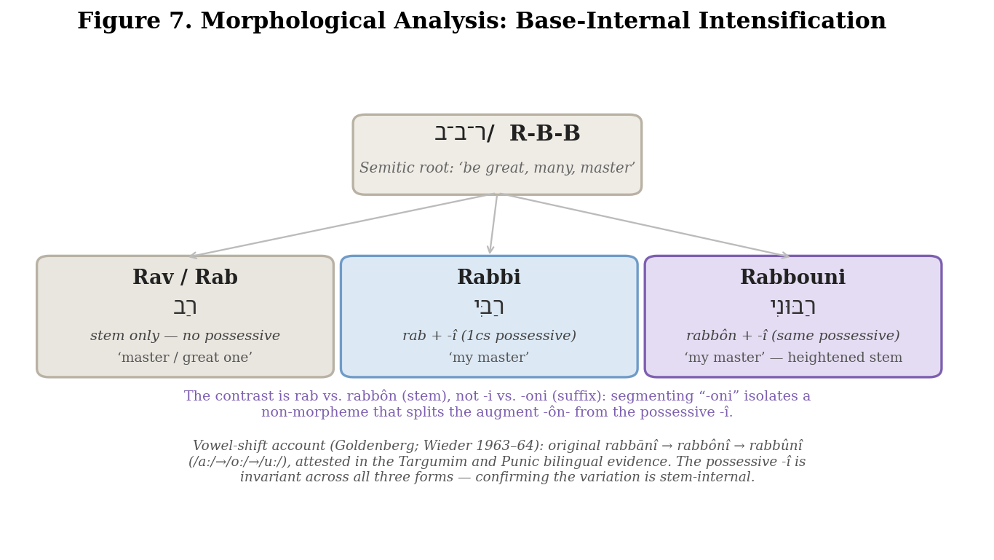
Figure 1. Morphological analysis of the R-B-B honorifics. The intensification is base-internal (rab → rabbôn); the first-person possessive suffix -î is invariant across rabbî, rabbānî, and rabbûnî.
The analysis must begin with the root from which Rabbouni derives. The triliteral Semitic root ר-ב-ב (R-B-B) carries in Biblical Hebrew and Aramaic the fundamental semantic field of greatness, abundance, and pre-eminence. From the base noun rab (רַב, ‘great one, master’) a lexical family of honorifics developed: rab itself, without a possessive suffix; rabbî (רַבִּי), the base rab plus the first-person singular possessive suffix -î, ‘my master’; rabbān (רַבָּן), an augmented form associated with the patriarchate; and rabbôn/rabbûn (with the augmented stem), which with the same possessive suffix yields rabbônî / rabbûnî, ‘my master, my great one.’ Figure 2 illustrates this hierarchy.

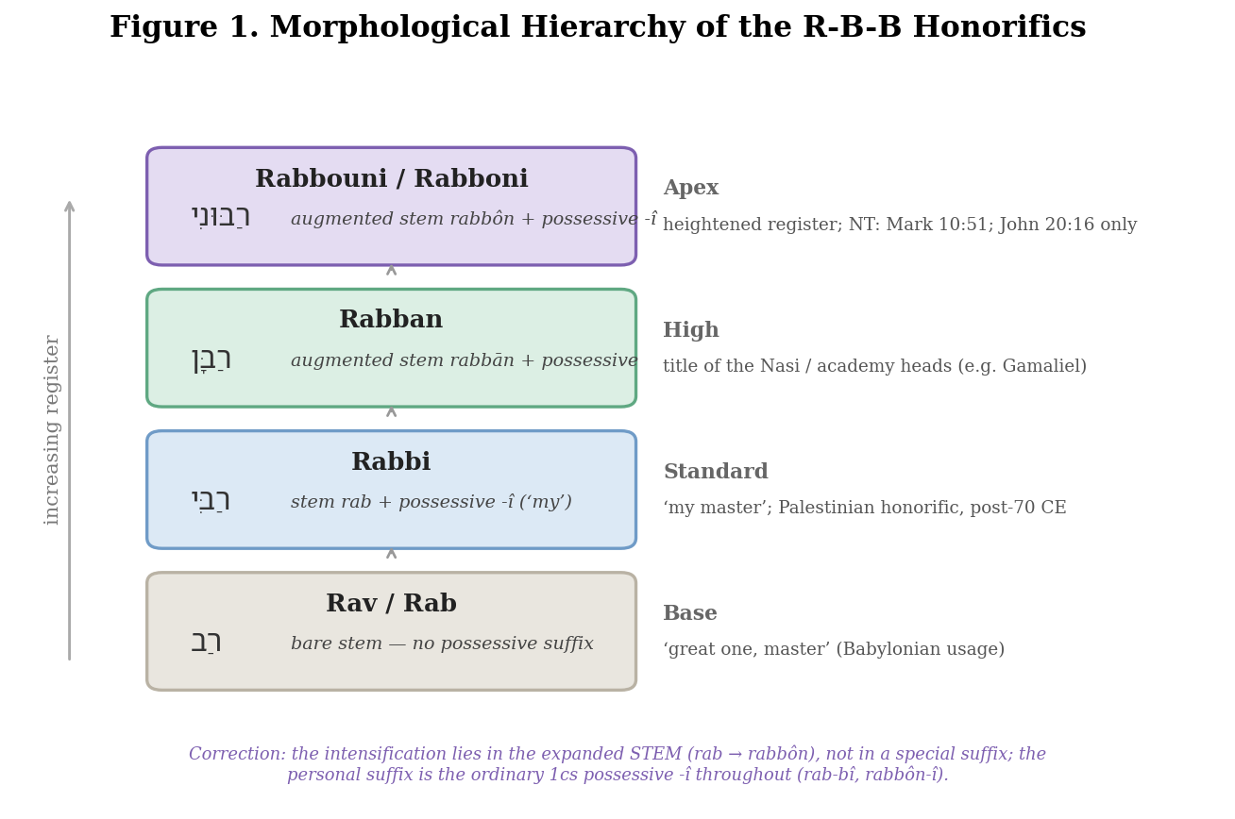
Figure 2. The morphological hierarchy of the R-B-B honorifics, from the base noun rab to the heightened rabbouni at the apex, with register increasing as the stem is augmented.
It is essential to state the morphology precisely, because a widespread popularization gets it wrong. The heightened force of rabbouni does not arise from a special ‘intensive suffix -oni’ set against the ‘simple possessive -i’ of rabbi. In both words the personal suffix is one and the same: the ordinary first-person possessive -î (‘my’). The difference lies in the stem: rabbî is built on the bare base rab, whereas rabbûnî is built on the augmented base rabbôn/rabbān. Segmenting the word as rabb-oni isolates a non-morpheme, splitting the nominal augment -ôn- from the possessive -î. The reverential register is therefore stem-internal, a property of the expanded base rather than of the suffix (cf. Sokoloff 1990, s.v. רבן/רבון).
The vocalization history confirms this analysis rather than undercutting it. Goldenberg's study of the form argues that the original was rabbānî and that rabbônî and rabbûnî are successive vocalic developments, following the progression /aː/ → /oː/ → /uː/: the first shift (rabbānî > rabbônî) is reflected in the Targumim, and the second (rabbônî > rabbûnî) is supported by Punic bilingual evidence (Goldenberg n.d.; cf. Wieder 1963–64, 214–217). Crucially, the possessive -î is invariant across all three forms; the variation is confined to the stem vowel. Dalman, Fitzmyer, and Black each discuss the rabbôn-/rabbûn- forms and their reverential use, though Dalman in particular cautions that in the Gospels the possessive force of the suffix had begun to lexicalize, so that the word could be felt simply as ‘Master’ (Dalman 1902; Fitzmyer 1979; Black 1967). The precise page references in earlier drafts of this paper could not be confirmed and should be checked against the volumes themselves.
Direct Aramaic and Hebrew textual evidence supports the heightened register of the augmented form. Michael Sokoloff's Dictionary of Jewish Palestinian Aramaic of the Byzantine Period documents the רבן/רבון family, including rabbûn as a respectful form of address used both of exalted human masters and of God (Sokoloff 1990). A survey of the Friedberg Cairo Genizah database (reported in Goldenberg n.d.; ultimately Wieder 1963–64) found twenty-three attestations of רבוני in Hebrew midrashic manuscripts, of which twenty-two—all but one—are direct addresses to God rather than formal titles for a human scholar. Targum Neofiti renders the Hebrew adoni Avraham of Genesis 24:27 (‘my master Abraham,’ referring to the patriarch, not the divine name Adonai) with a rabbûn- form, demonstrating the intensive personal-possessive force of the construction in practical Aramaic usage.
The New Testament preserves the word in Greek transliteration as ῥαββουνί at John 20:16 and as ῥαββουνί / ῥαββουνεί at Mark 10:51, with manuscript variation among the witnesses. The alternation between final -ί and -εί is a matter of itacism—the merging of ι and ει to /i/ in Koine pronunciation—and the o/ou variation reflects the same vocalic spread discussed above, not a difference in the underlying Aramaic word. Metzger confirms that the underlying form is not in doubt and that the spellings represent the same word (Metzger 1994; the exact page should be verified). Figure 3 summarizes the manuscript tradition.

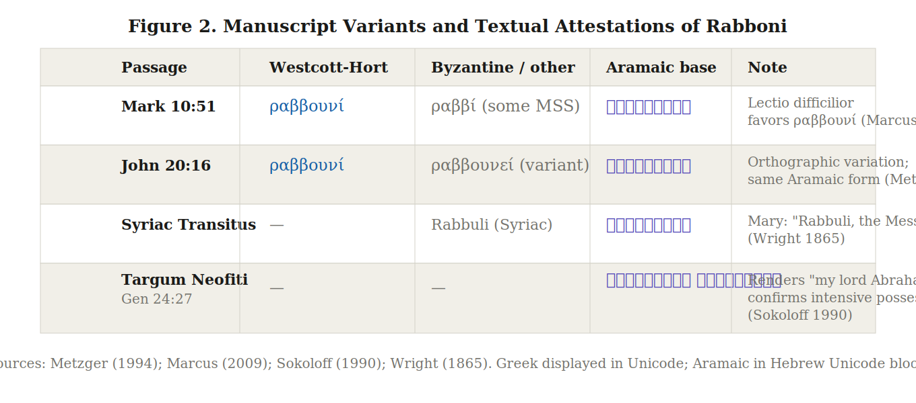
Figure 3. Manuscript variants and textual attestations of Rabbouni across the New Testament, Syriac, and Targumic traditions.
The strongest form of this paper's argument is not that morphology alone proves a theology, but that morphology, narrative placement, speaker identity, and reception history converge. The linguistic analysis establishes that a meaningful distinction exists between rab, rabbî, and rabbûnî, located in the augmented stem. The sections that follow show that the narrative deployment of the word is sensitive to that distinction and exploits it deliberately.
3. Second Temple Context: Honorific Titles and the Architecture of Authority

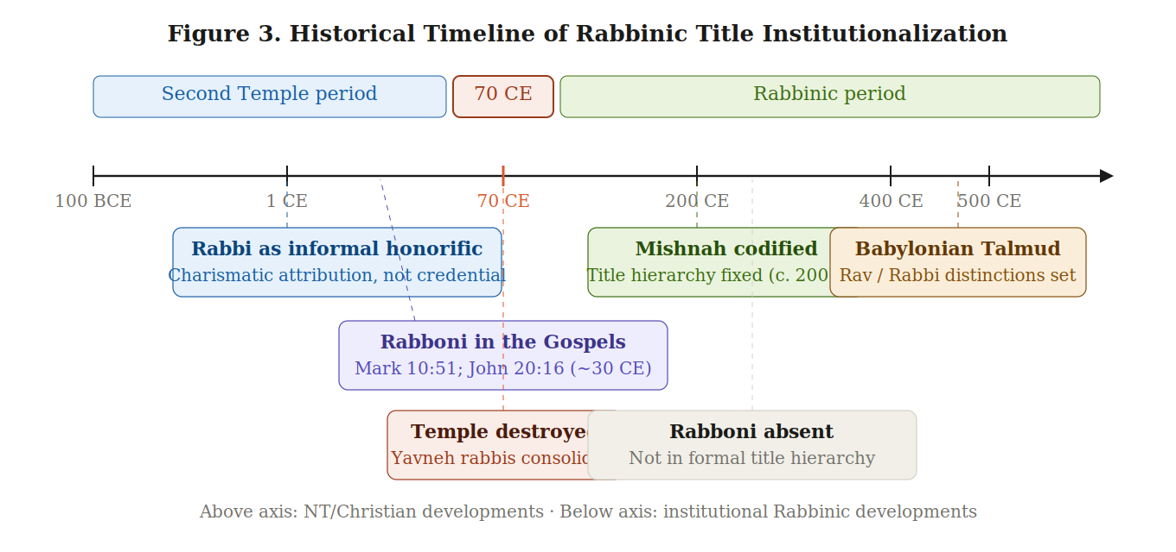
Figure 4. Historical timeline of rabbinic title institutionalization, from the pre-institutional Second Temple period through the post-70 CE codification of the Mishnah and Talmud.
To understand the force of Rabbouni in the New Testament, it is necessary to understand the social world in which it was spoken. E. P. Sanders demonstrates that the title Rabbi was not, prior to the destruction of the Temple in 70 CE, a formal office conferred by ordination; it was an honorific applied informally to learned men whose teaching commanded respect (Sanders 1992, 170–172). Anthony Saldarini's social-scientific analysis situates the Pharisees as a retainer class whose authority was charismatic and relational rather than institutionally grounded (Saldarini 1988, 35–49).
The Iggeret of Sherira Gaon (987 CE) is the classic source for dating the title system; on the consensus reading of it, the fixed, ordination-based titles of the later rabbinate were not yet in place in the early first century (Bacher 1906). The title hierarchy itself is preserved in a dictum transmitted in Bacher's Jewish Encyclopedia article (citing the end of Tosefta Eduyot and the Aruch tradition): ‘He who has disciples and whose disciples again have disciples is called Rabbi; when his disciples are forgotten he is called Rabban; and when the disciples of his disciples are also forgotten he is called simply by his own name’ (Bacher 1906). The gradation runs by antiquity and eminence—rab < rabbi < rabban < the bare name—so that the most venerable sages (Hillel, Shammai) require no title at all. The formal institutionalization of the rabbinate, with ordination through the laying on of hands (semikhah), developed only in the post-70 CE period.
The Dead Sea Scrolls provide an instructive contrast. The Qumran community employed its own vocabulary of authority: the Maskil (מַשְׂכִּיל, ‘instructor’) appears in the Community Rule (1QS III, 13; IX, 12) as the designated teacher of the community, while the Moreh ha-Tsedek (מוֹרֶה הַצֶּדֶק, ‘Teacher of Righteousness’)—known chiefly from the Damascus Document and the pesharim rather than from 1QS itself—stands as the community's founding interpreter. As García Martínez and Tigchelaar's critical edition confirms, neither Rabbi nor Rabbouni appears anywhere in the Qumran corpus (García Martínez and Tigchelaar 1997–1998). The word belongs to the personal, charismatic register of teacher–disciple relations in Pharisaic-adjacent Judaism, not to the formal vocabulary of any institutionalized authority structure.
4. The Two New Testament Occurrences: Mark 10:51 and John 20:16

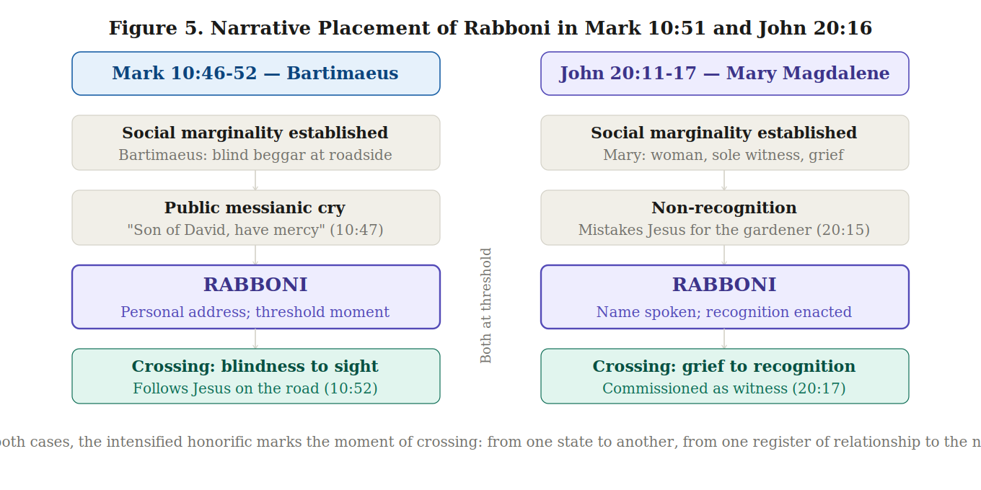
Figure 5. Structural diagram of the parallel narrative arcs of Mark 10:46–52 and John 20:11–17, with Rabbouni highlighted at the threshold moment in each passage.
4.1 Mark 10:51: Bartimaeus at Jericho
The first New Testament occurrence appears in Mark 10:51, in the healing of Bartimaeus, a blind beggar at the gates of Jericho. When Jesus asks what he wants, Bartimaeus responds, ‘Rabbouni, let me see again’ (Mark 10:51, NRSV). The choice of the heightened form over the simpler Rabbi is notable given the speaker's social position: the elevated honorific on the lips of the lowest-status speaker creates a pointed social inversion, as one whom polite society would dismiss as unqualified to address a teacher reaches for the most elevated form of address available.
Verman's 2023 analysis argues that Rabbouni in Mark functions as messianic code language, preserved untranslated in the Greek narrative because it signals to those who can decode it that Bartimaeus's recognition of Jesus exceeds what the surface of the text makes explicit (Verman 2023, 8–12). The text-critical principle of lectio difficilior—that the more unusual reading is generally the more original—favors Rabbouni as the earlier reading at Mark 10:51, since scribes would more readily have normalized the unusual form to the familiar Rabbi than the reverse; the Markan variants are discussed in the standard commentaries (Marcus 2009; Metzger 1994).
4.2 John 20:16: Mary Magdalene in the Garden
The second occurrence, at John 20:16, is theologically the more complex. Mary Magdalene, weeping outside the empty tomb, mistakes the risen Jesus for the gardener. When Jesus speaks her name, she turns and addresses him: ‘Rabbouni.’ Thomas Gentry's study of the passage characterizes the moment as the climactic point of the Johannine resurrection narrative, in which Mary functions as the first apostolic witness through the intimacy of the recognition scene (Gentry 2021). O'Collins and Kendall argue that Mary's role as first witness must be taken seriously on theological grounds, and that the intimacy encoded in her address is central to the Johannine theology of witness (O'Collins and Kendall 1987, 635–638).
Raymond Brown observes that the evangelist's parenthetical gloss, ‘which means Teacher,’ is reductive: it provides the semantic content of the root while suppressing the relational and affective register of the heightened form (Brown 1966, 991–992). The Greek phrase mē mou haptou (John 20:17), rendered in Latin as noli me tangere, introduces an immediate tension between the intimacy signaled by Rabbouni and the new transcendent mode of Jesus's post-resurrection existence. Benay and Rafanelli's art-historical study notes that the patristic tradition consistently interpreted the phrase as marking the transformation of humanity's relationship to God (Benay and Rafanelli 2017, 42). Rabbouni is the last word that can be spoken within the familiar human register of teacher and disciple, and the subsequent dialogue marks the moment at which that register is honored and exceeded at once.
4.3 Comparative Analysis of Both Occurrences
Read together, the two occurrences share a structural logic. Both appear at threshold moments: Bartimaeus crosses from blindness to sight; Mary Magdalene crosses from grief and non-recognition to recognition and a new mode of relationship. In both, the heightened honorific marks the moment of crossing, and both speakers are marginal to the recognized centers of religious authority. O'Collins and Kendall demonstrate that Mary's witness to the resurrection was contested in the early tradition (O'Collins and Kendall 1987, 631–634). The convergence of morphology, narrative placement, and speaker identity across both passages is not incidental: the heightened possessive is a word of intimate personal recognition, and the Gospel narratives reserve it for the moments and the speakers that most fully embody that intimacy.
5. Rabbinic Literature and the Institutionalization of the Title

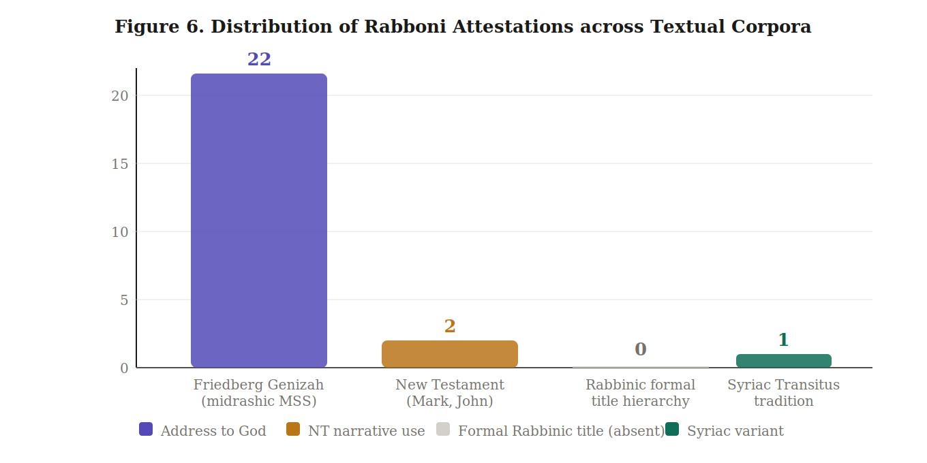
Figure 6. Distribution of Rabbouni attestations across textual corpora: 22 Genizah manuscript uses as address to God (of 23 total attestations), 2 NT narrative uses, 0 formal Rabbinic title uses, and 1 Syriac Transitus variant. Sources: Wieder (1963–64); Goldenberg (n.d.); Sokoloff (1990); Wright (1865).
The destruction of the Second Temple in 70 CE precipitated a fundamental reorganization of Jewish religious life. The title hierarchy preserved by Bacher (1906) grounds titles in the temporal reach of a scholar's influence through chains of transmission rather than in the intimacy of personal relationship. Sherira Gaon's Iggeret supplements this with a geographical distinction: Rabbi was the Palestinian form for ordained sages, Rav the Babylonian form, and Rabban the title of the Nasi. Sherira identifies the first bearers of Rabban as Rabban Gamaliel the Elder (d. c. 50 CE), his son Rabban Simeon, and Rabban Yohanan ben Zakkai (d. c. 74 CE) (Bacher 1906; Sherira Gaon, Iggeret, trans. Rabinowich 1988, 41–43).
Conspicuously absent from this hierarchy is Rabbouni. A search of the principal Hebrew and Aramaic forms—רבוני, רבון, and related suffixed forms—in the normative Rabbinic legal and homiletical literature turns up no use of the word as a formal title. The convergent evidence rests on two independent observations: the recognized title list (rab, rabbi, rabban, bare name) does not include Rabbouni; and the Genizah database evidence shows that of the twenty-three Hebrew manuscript attestations of רבוני, twenty-two are addresses to God rather than titles for a human scholar (Wieder 1963–64, 214–217; Goldenberg n.d.; Sokoloff 1990). These lines converge to establish the absence with reasonable confidence.
The structural significance of this absence is interpretive. Neusner's analysis of the displacement of the charismatic by the textual and institutional in the post-70 CE period illuminates why Rabbouni dropped out of formal usage: it encodes precisely the register of personal authority that the institutionalization of the rabbinate was designed to regularize and constrain (Neusner 1994, 42–55). Baumgarten's study of the selective transmission of vocabulary from the Second Temple to the Rabbinic period confirms that such attrition was a systematic feature of the tradition's development (Baumgarten 1995, 14–20).
6. Comparative Theological Analysis: Intimacy, Authority, and the Sacred

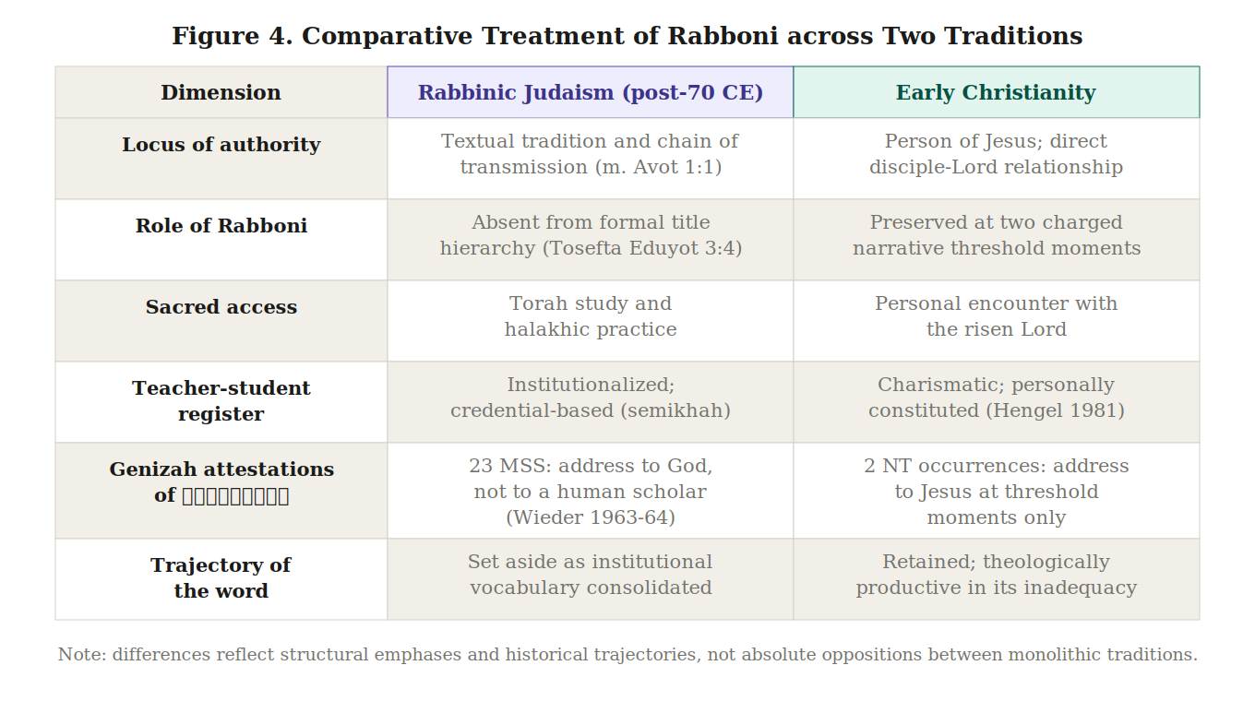
Figure 7. Comparative treatment of Rabbouni across six dimensions in Rabbinic Judaism and early Christianity. Differences reflect structural emphases and historical trajectories, not absolute oppositions between monolithic traditions.
The preceding analysis enables a comparative theological claim, which must be qualified at the outset: neither Rabbinic Judaism nor early Christianity is a monolithic entity, and both traditions contain textual, institutional, devotional, and relational elements in varying proportions. The divergence identified here is one of structural emphasis and historical trajectory, not absolute opposition.
In the trajectory that leads to Rabbinic Judaism, religious authority becomes progressively mediated by text, tradition, and institution. The rabbi's authority derives from mastery of the tradition and from position within a chain of transmission extending back to Sinai (m. Avot 1:1). In such a system, as Neusner shows, the intimate and personalizing force of Rabbouni would have been not only unnecessary but potentially misleading, since it points toward the person rather than the tradition (Neusner 1994, 42).
In the trajectory that leads through the New Testament to early Christianity, the personal relationship between disciple and Jesus remains central, even as Jesus is understood to transcend the human category of teacher. Daniel Boyarin has argued, with textual support from Second Temple apocalyptic literature, that the developments producing the doctrine of the incarnation drew in part on existing Jewish traditions about divine intermediaries and heavenly Wisdom (Boyarin 2012, 53–54). The New Testament's differential use of Rabbouni reflects not a simple opposition between Judaism and Christianity but a specific historical moment of divergence, in which the same word was being pressed in two directions by two communities with increasingly distinct organizing principles.
Martin Hengel argues that the teacher–disciple relationship in the Jesus movement was qualitatively different from the typical rabbi–student relationship of the period, organized around the person of Jesus in a way that exceeded the norms of the tradition (Hengel 1981, 50–57). Larry Hurtado's study of early devotion to Jesus confirms that the intensity of devotion directed toward Jesus, while drawing on Jewish precedents, represented a novel development in the organization of religious life (Hurtado 2003, 27–53). The paradox of Rabbouni in John 20:16 is precisely the point: Mary reaches for the most intimate and elevated honorific available within the human teacher–disciple relationship, and Jesus's response, ‘Do not hold on to me, because I have not yet ascended to the Father’ (John 20:17, NRSV), marks the point at which the category of Rabbouni is simultaneously affirmed and superseded. The word is not wrong; it is insufficient.
7. Conclusion
This paper has argued that Rabbouni is not a mere synonym for Rabbi but a morphologically distinct and theologically charged form whose heightened register encodes claims about intimacy, authority, and the sacred. The argument has been built on convergent evidence: grammatical analysis of the augmented stem rabbôn/rabbān plus the ordinary possessive -î in Dalman, Fitzmyer, Black, and Sokoloff; primary textual attestations in Targumic literature, Genizah manuscripts, and the Mishnaic parallel in m. Taʻanit 3:8 (where Honi the Circle-Drawer addresses God as Ribbono shel Olam); the narrative analysis of Mark 10:51 and John 20:16; and the documented absence of Rabbouni from the formal title hierarchy of Rabbinic Judaism. No single line of evidence carries the full weight of the argument; it is their convergence that makes the case.
The comparative theological analysis proposed, with the necessary qualifications about intra-traditional diversity, that Rabbouni functions as a hinge word: it names the continuity between Jesus and the world of Second Temple Jewish piety, and it simultaneously marks the point at which the Christian tradition claims that the inherited vocabulary is insufficient to what it names. The Rabbinic tradition's setting aside of Rabbouni as a formal title, and the Christian tradition's preservation of it at two of its most charged narrative moments, are two responses to the same word whose difference is theologically instructive.
Several questions remain open. The patristic reception of Rabbouni, particularly in Origen's Commentary on John and Augustine's treatment of the resurrection narrative, deserves extended treatment. The feminist theological reclamation of Mary Magdalene's Rabbouni as a discipleship claim (Schüssler Fiorenza 1983) raises questions about whose voice has historically been authorized to speak this word. And the Syriac Transitus tradition's preservation of Mary's address as ‘Rabbuli, the Messiah’ (Wright 1865) suggests that the reception history across the Syriac-speaking churches offers a further comparative dimension worth investigating.
References
Bacher, W. (1906). Rabbi. In Jewish Encyclopedia (Vol. 10, pp. 294–297). Funk and Wagnalls.
Baumgarten, A. I. (1995). Rabbinic literature as a source for the history of Jewish sectarianism in the Second Temple period. Dead Sea Discoveries, 2(1), 14–57.
Benay, E. E., & Rafanelli, L. M. (2017). Faith, gender and the senses in Italian Renaissance and Baroque art: Interpreting the Noli me tangere and Doubting Thomas. Routledge.
Black, M. (1967). An Aramaic approach to the Gospels and Acts (3rd ed.). Clarendon Press.
Boyarin, D. (2012). The Jewish Gospels: The story of the Jewish Christ. The New Press.
Brown, R. E. (1966). The Gospel according to John (XIII–XXI) (Anchor Bible 29A). Doubleday.
Casey, M. (1999). Aramaic sources of Mark's Gospel. Cambridge University Press.
Community Rule (1QS). (1997–1998). In F. García Martínez & E. Tigchelaar (Eds.), The Dead Sea Scrolls study edition (2 vols.). Brill.
Dalman, G. (1902). The words of Jesus considered in the light of post-biblical Jewish writings and the Aramaic language (D. M. Kay, Trans.). T&T Clark.
Fitzmyer, J. A. (1979). A wandering Aramean: Collected Aramaic essays. Scholars Press.
Gentry, T. J. (2021). Rabboni: Christ's resurrection through the eyes of Mary Magdalene. Eleutheria, 5(2). [Article verified; DOI unconfirmed.]
Goldenberg, D. M. (n.d.). Rabbuni [Working paper]. University of Pennsylvania. https://web.sas.upenn.edu/dmg2/ [Authorship and venue to be confirmed.]
Hengel, M. (1981). The charismatic leader and his followers (J. Greig, Trans.). Crossroad.
The Holy Bible: New Revised Standard Version. (1989). Thomas Nelson.
Hurtado, L. W. (2003). Lord Jesus Christ: Devotion to Jesus in earliest Christianity. Eerdmans.
Marcus, J. (2009). Mark 8–16 (Anchor Yale Bible 27A). Yale University Press.
Metzger, B. M. (1994). A textual commentary on the Greek New Testament (2nd ed.). Deutsche Bibelgesellschaft.
Minear, P. S. (1976). “We don't know where…” John 20:2. Interpretation, 30(2), 125–139.
Mishnah. (1933). (H. Danby, Trans.). Oxford University Press.
Neusner, J. (1994). Introduction to rabbinic literature. Doubleday.
Novum Testamentum Graece (28th ed.). (2012). (B. Aland, K. Aland, et al., Eds.). Deutsche Bibelgesellschaft.
O'Collins, G., & Kendall, D. (1987). Mary Magdalene as major witness to Jesus' resurrection. Theological Studies, 48(4), 631–646.
Okure, T. (1992). The significance today of Jesus' commission to Mary Magdalene. International Review of Mission, 81(322), 177–188.
Saldarini, A. J. (1988). Pharisees, scribes and Sadducees in Palestinian society. Michael Glazier.
Sanders, E. P. (1992). Judaism: Practice and belief, 63 BCE–66 CE. SCM Press.
Schüssler Fiorenza, E. (1983). In memory of her: A feminist theological reconstruction of Christian origins. Crossroad.
Sherira Gaon. (1988). Iggeret Rav Sherira Gaon (N. D. Rabinowich, Trans.). Moznaim. (Original work ca. 987 CE)
Sokoloff, M. (1990). A dictionary of Jewish Palestinian Aramaic of the Byzantine period. Bar-Ilan University Press.
Tosefta. (1981). (J. Neusner, Trans.). Ktav.
Verman, M. (2023). Jesus as “Rabbi/Rabbouni” and Mark's use of Aramaic as messianic code language. Journal for the Study of the Historical Jesus, 21(1–2), 1–34. https://doi.org/10.1163/17455197-bja10018
Vermes, G. (1973). Jesus the Jew: A historian's reading of the Gospels. Collins.
Wieder, N. (1963–1964). Ha-tsura rabbun bi-meqorot ivriim. Leshonenu, 27–28, 214–217.
Wright, W. (Trans.). (1865). Contributions to the apocryphal literature of the New Testament. Williams and Norgate.
Editorial Note: Verification and Corrections
This version was produced after an independent fact-check of the prior draft against external sources. Verified-correct material was retained; the corrections below were applied. Items marked ‘unverifiable’ could not be confirmed because several publisher and database pages blocked automated access, and should be checked against the originals before submission.
- Morphology (central thesis): the prior draft called “-oni” a distinct intensive possessive suffix opposed to the simple possessive “-i” of Rabbi. This is incorrect; the possessive -î is the same in both, and the intensification is in the augmented stem (rab → rabbôn). Section 2 and Figures 1–2 were rewritten and regenerated accordingly.
- Authorship: the University of Pennsylvania working paper “Rabbuni” was misattributed to Catherine Hezser; it is by David M. Goldenberg. Corrected throughout.
- Genesis 24:27: corrected “Adonai Avraham” to adoni Avraham, “my master Abraham” (the patriarch), not the divine name.
- Genizah count: standardized to 23 total attestations, 22 of which address God (resolving the prior 23-vs-22 inconsistency and the erroneous “uniformly”).
- Tosefta Eduyot: the title-hierarchy dictum is genuine but is not at Eduyot 3:4; re-cited to Bacher (1906) / the Aruch tradition.
- Marcus (2009): the impossible page citation “p. 752” was removed (the volume's main text ends near p. 610); the lectio difficilior point is retained.
- Sokoloff (1990): title completed to …of the Byzantine Period; no longer cited for an “intensive suffix.”
- Clarified that the Teacher of Righteousness is a Damascus Document / pesharim figure, not named in 1QS.
- Greek spellings: the clean “John = ῥαββουνί / Mark = ῥαββουνεί” split was softened to a manuscript/itacism matter.
- Unverifiable specifics retained but flagged: DOIs for Verman (2023) and Gentry (2021); page references in Dalman (1902), Fitzmyer (1979), Black (1967), Metzger (1994), and Brown (1966). The works themselves are confirmed.

