**Sensor Enclosure Cut Files**

Shuttle LIDAR Sensor | AXIS Communications case

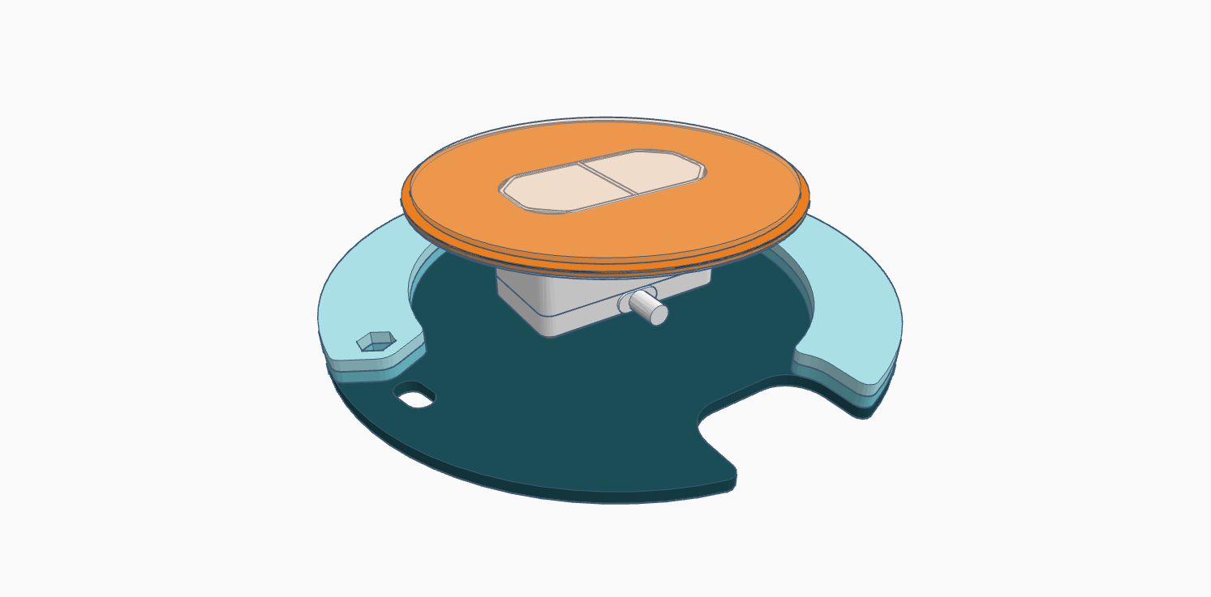

**TO CUT:**

**Wood Base (Blue)**

**Material:** ⅛ inch wood

**Power Settings:** Dependent on cutter

**Files:**

shuttleSensorBase.svg

shuttleSensorSpacers.svg

**Acrylic Covers (Orange)**

**Material:** 2mm Clear Acrylic

**Power Settings:** Dependent on cutter

**Files:**

shuttleSensorInnerCover.svg

shuttleSensorOuterCover.svg

**Note:**

Be sure to cover your acrylic with masking tape or use pre-masked acrylic sheeting to avoid scorch marks and heat patterns on the finished product.

**TO ASSEMBLE:**

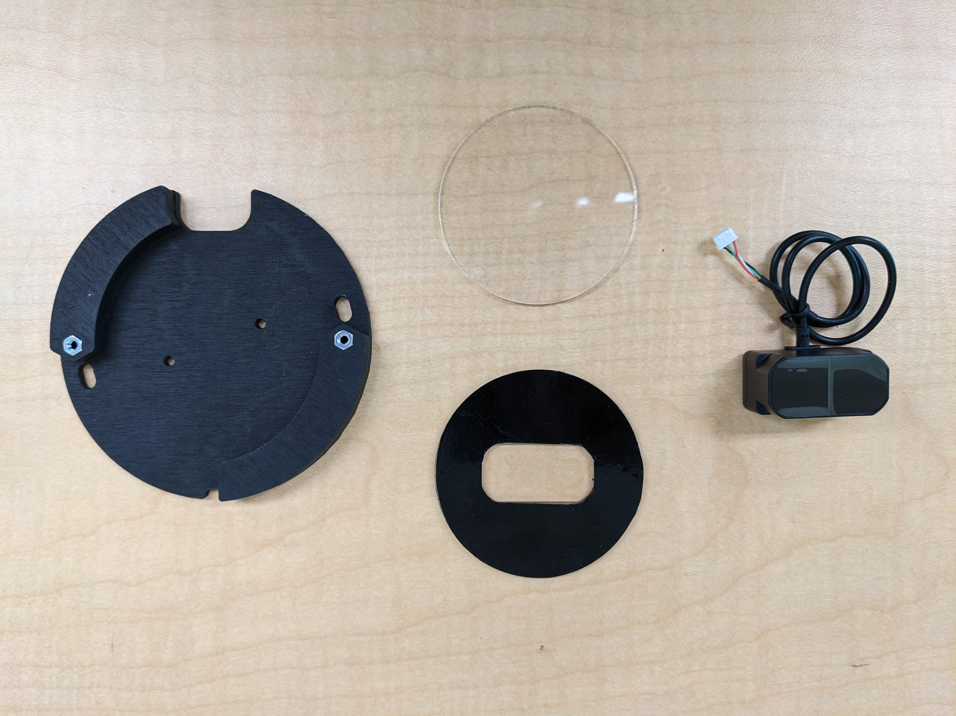

**Materials:**

Loctite or wood glue

M3-.50 Hex Nuts (2)

Black Vinyl Sticker

TF-Mini Plus LIDAR Sensor

Double Sided Sticky Tape

**Instructions:**

Cut black vinyl to fit inner acrylic piece and attach (shuttleSensorInnverCover.svg)

**DO NOT LASER CUT VINYL.**

Glue wood spacers together and attach to the wood base, lining up the perimeters as shown above.

Paint wood black if desired and insert hex nuts. Use tabletop or another solid surface to push them in until they are flush with the wood.

Insert clear acrylic cover into the top of the AXIS camera case and snap in black acrylic piece behind it to secure it.

Place the TF-mini plus sensor inside the indentation and screw the wooden base into place.

**Note:**

Use double sided sticky tape or other low-profile adhesive to keep the sensor in place if additional security is needed. Screwing into place is not necessary.

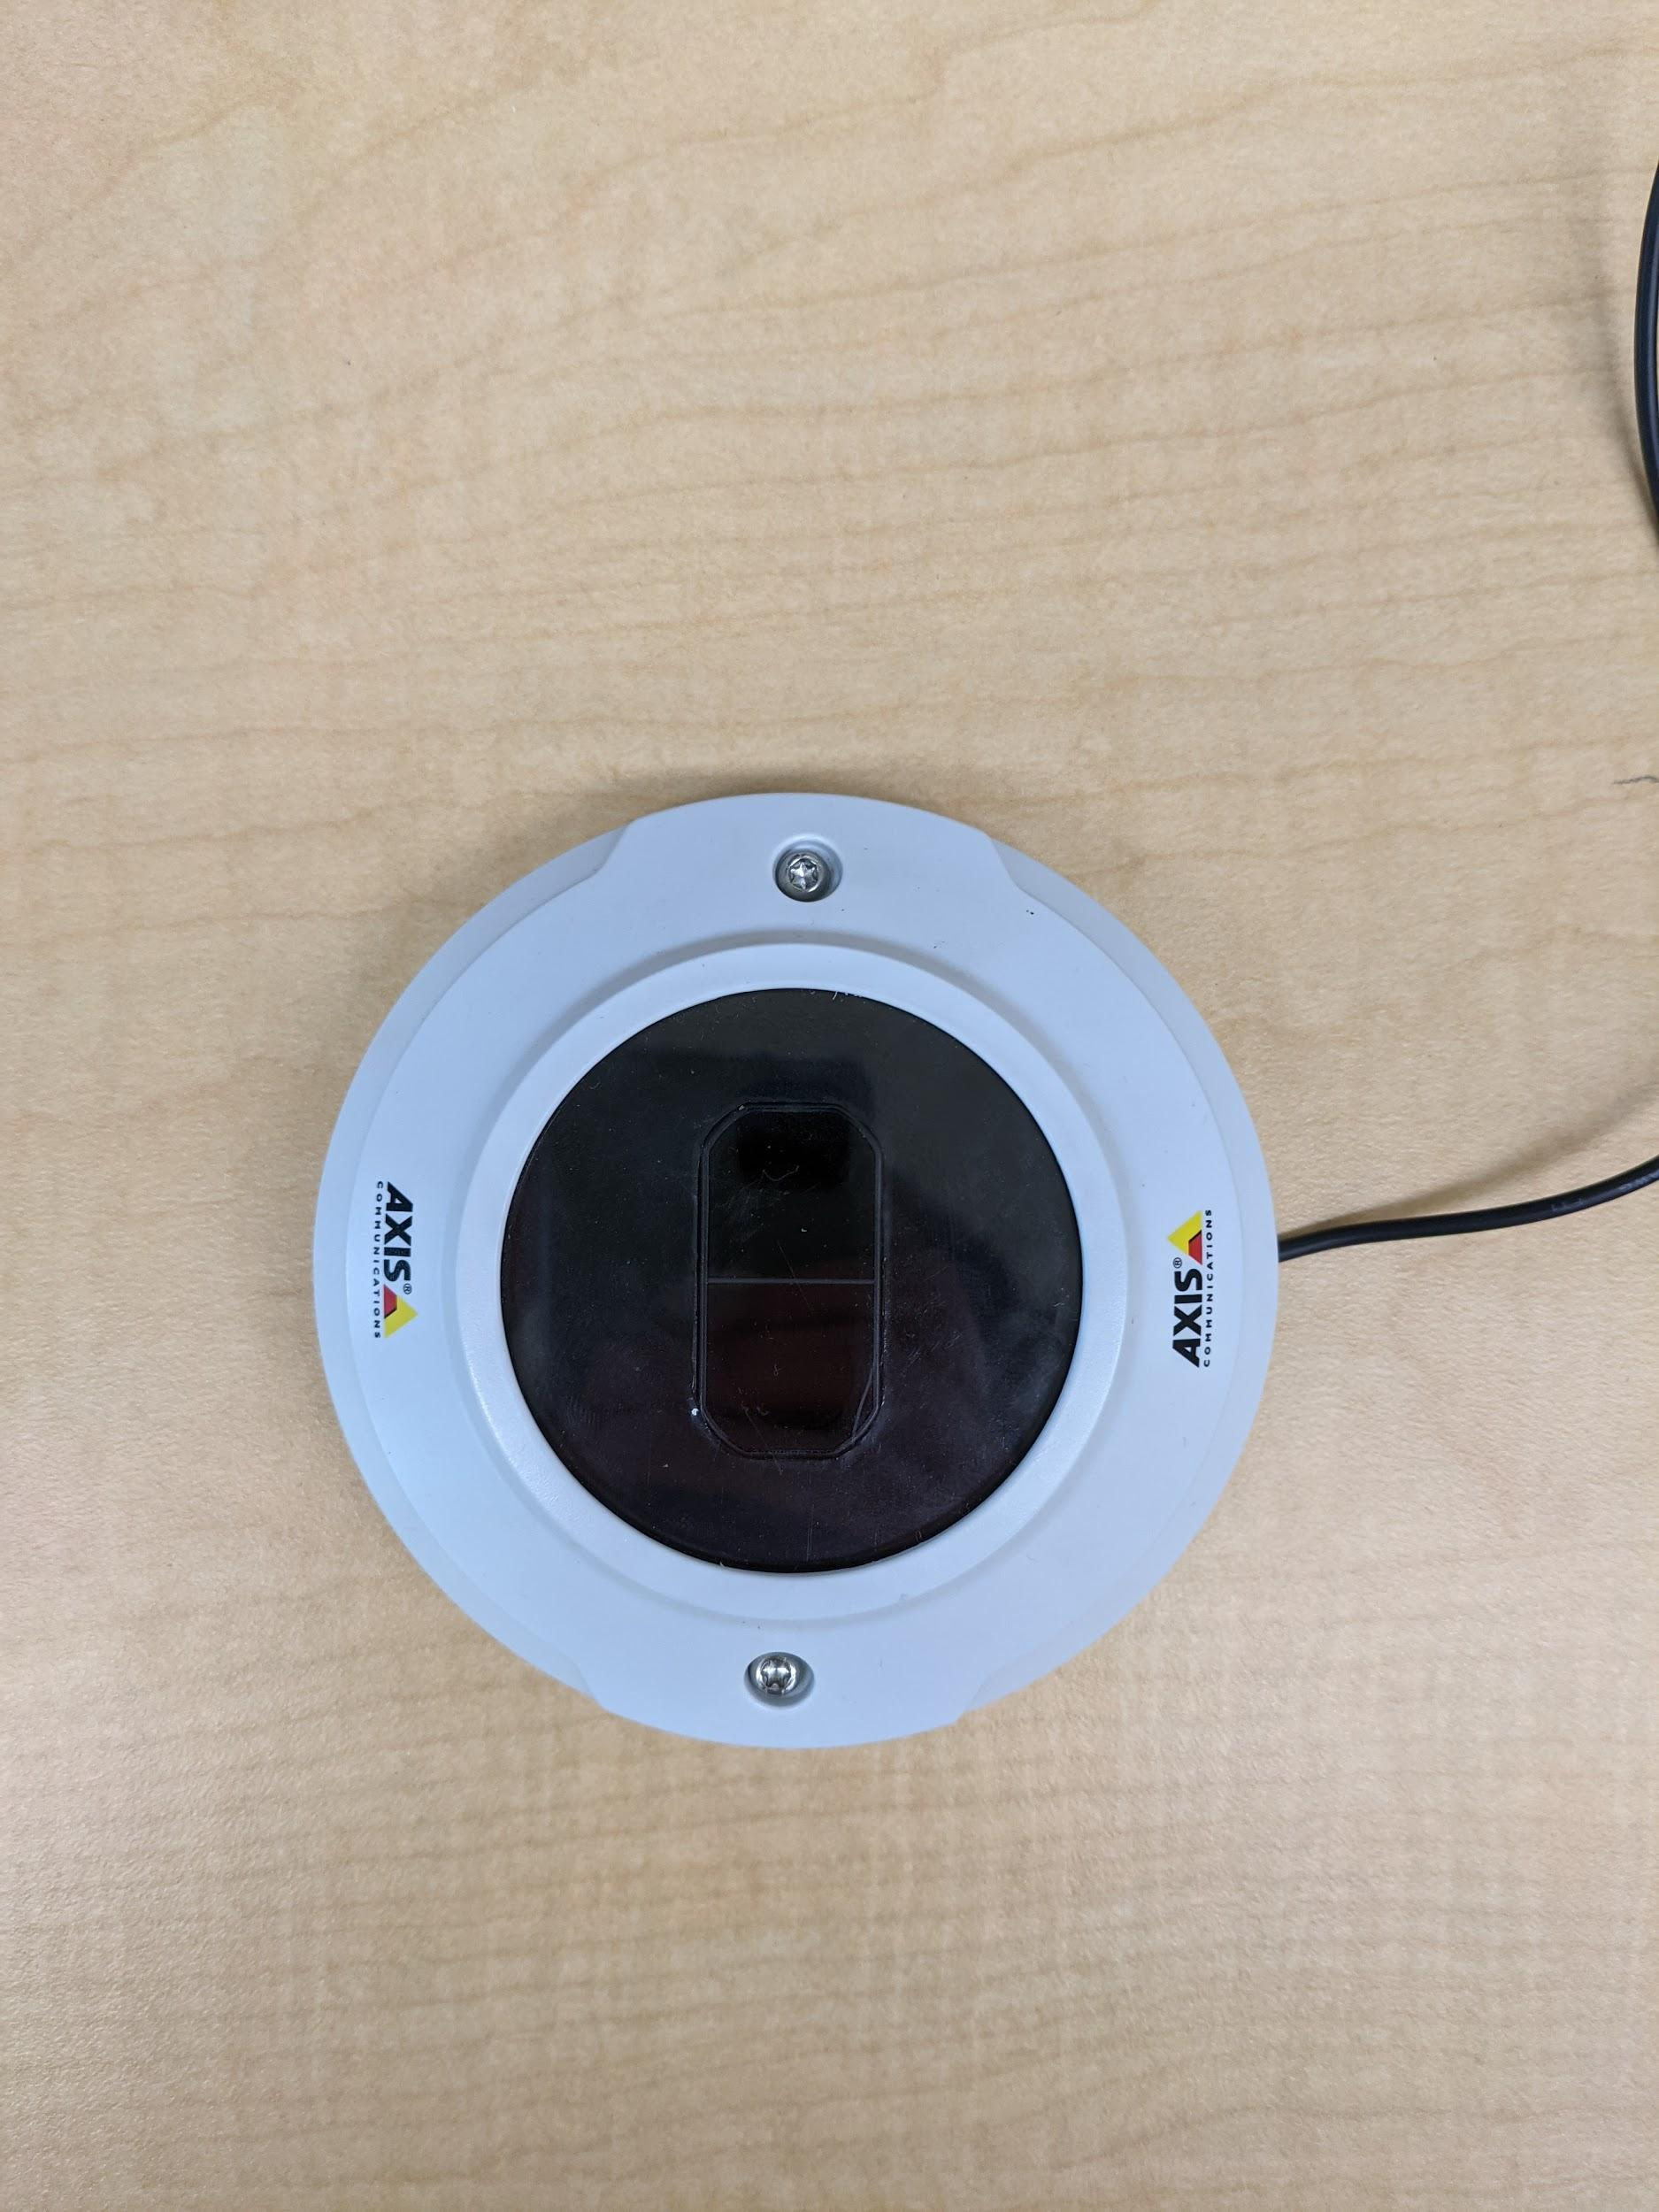

***Finished product***