# CSE 535 Group 28 Project Demo Submission

## Project Members

1. Deepika Krishna Kumar (1209489772)
2. Digant Jagtap(1209373513)
3. Purushotham Kaushik (1208626480)
4. Mihir Bhatt (1209422146)

## Project Idea

Smart Shopper is a context aware application that notifies the user about stores, based on his location, shopping preferences and stored memos. Users can login using their Google credentials. The application allows users to set Shopping Memos where they can list down categories to purchase. Depending on user’s current location context, he’ll be notified about nearby stores to purchase those products. He can then choose to store his shopping preference for that category. Based on the geospatial context and his store preference, he’ll be notified about the nearby stores when he wants to purchase the product again (Smart Search & Memo). Group Memos for a product(category) can also be set where each member of the group will receive the shared Memo. Any member of the group can update the memo and all Group Members will receive the update notification. The user will also be able to recommend their shopping preferences to friends. Users can snooze his notifications for a select duration.

## Project relevance to class

The project is an Android application that will incorporate several important concepts taught in class such as adaptation, context-awareness, background services and context storage and retrieval models. The app will use GPS to track the user’s current location (context acquisition), check his preferences/memo (delivery and reception) and suggest places(action). We will use storage mechanisms such as MongoDB to store user preferences.

## Demo Progress Status

|  |  |  |  |  |
| --- | --- | --- | --- | --- |
| [**S.No**](http://S.No) | **Task** | **Status** | **Description of Completed tasks** | **Description of In Progress tasks** |
| 1 | UI and Architecture Design | Done | Designed both Architecture and UI as shown in next section |  |
| 2 | Server Setup - REST API | Done | Setup Python-Flask free Server on RH Cloud with URL being https://smartshop-raredev.rhcloud.com. Server Details : Python V2.7, Flask V.1.10.1. Also, setup secured RESTful web services for communication between server/mobile host. |  |
| 3 | Database Setup Server Side | Done | Setup MongoDB V2.4.9 on Server with Users, Memos, GroupMemos, Participants collections to handle Smart Shopper data. Also, setup local SQLite DB on mobile client. |  |
| 4 | User Management and Authentication | Done | Setup Google SignIn for secured OAuth authentication used to login and logout from application. |  |
| 5 | Memo creation | Done | On HomeActivity screen, we provided a ListView to display all the created/existed lists. Also, made a floating button which upon clicking opens Individual Memo Creation screen with Category, Memo Content and Submit button link. After filling in the values and hitting submit button, the Memo is created and stored in database. |  |
| 6 | Location using GPS | Done | Identified user’s current location using GPS and sent to Google’s Location and GeoFence API to create a fence around the user. |  |
| 7 | Place Identification | Done | Integrated application with Google’s Places API to return the user’s location in terms of place name and other useful attributes like place category instead of the geo coordinates. |  |
| 8 | Geo spatial context awareness | Done | Google’s Fence API is used to determine the user’s proximity to his shopping preferences |  |
| 9 | Memo Reminder | Done | Using the user’s shopping preferences and geo spatial context (as mentioned in the previous task), he is sent a reminder notification about the nearby place and if he wants to buy something.. |  |
| 10 | Context - Location Aware Notification | Done | Based on his current location, the user receives a notification asking if he has shopped at a particular  place. For example, he receives a notification stating “Have you shopped at Safeway?” This data is  accordingly stored in his shopping preferences. |  |
| 11 | Storing User’s shopping preferences | Done | When the user clicks on the notification asking if he has shopped at a place (as mentioned in the previous task), that place gets stored in his shopping preferences along with the category. |  |
| 12 | Sharing Shopping Preference (Recommendations) | Done | User can select a category and a store to recommend which sends a push notification to the receiver |  |
| 13 | Push Notification Setup | Done | Set up a GCM client to receiver push notifications and display on the device. Set up a service on the server to communicate with GCM for pushing the notification to the client device. |  |
| 14 | Accepting a recommendation | Done | When the user accepts a recommendation by clicking on the push notification, it is added to his shopping preferences. |  |
| 15 | Snooze and Do Not Disturb to stop notifications | Done | User can choose to turn off his notifications for receiving recommendations from friend, group memo updates and memo reminders. Notifications are sent based on the flag set for snooze. |  |
| 16 | Group Memo | Done | If the user creates a group memo, the list is added to all the group members’ memos and reminders are sent to anyone  who is near the location to purchase a product. |  |
| 17 | Group Memo Update notification | Done | Based on any member of the group updating the memo, all the group members receive a notification regarding the  same. |  |
| 18 | Background Services | Done | Background services are used for creating Geo Fence, getting user's current context, nearby stores, group memo updates from server and GCM communication. |  |
| 19 | Smart Search | InProgress |  | Modify the existing service to return places based on what is saved in preferences. Implemented it separately, only integration with main app is pending. |
| 20 | Cold Start | InProgress |  | Create an activity for search so that when users search for category (Grocery,Pharmacy,Garments etc), it returns the list of shops nearby. Background service for the same is already done. Implemented it separately, not integrated with main application. |

**Task 1: Architecture**

martShopper.png

**Task 1 Contd.) UI Screenshots**

SignIn/SignOut Screen Navigation Drawer/ Side Menu

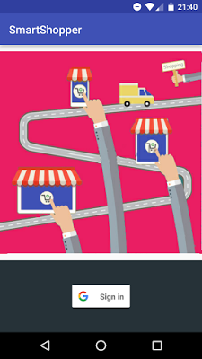

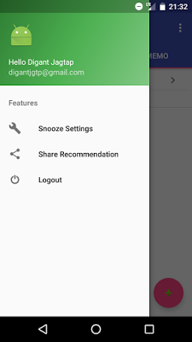

Home Screen Memo Creation Screen Recommend Screen

