# Week2_SL4J_HandsOn

## Exercise 1: Logging Error Messages and Warning Levels

Code:

import org.slf4j.Logger;  
import org.slf4j.LoggerFactory;  
  
public class LoggingExample {  
 private static final Logger logger = LoggerFactory.getLogger(LoggingExample.class);  
  
 public static void main(String[] args) {  
 logger.error("This is an error message");  
 logger.warn("This is a warning message");  
 }  
}

Output Screenshot:

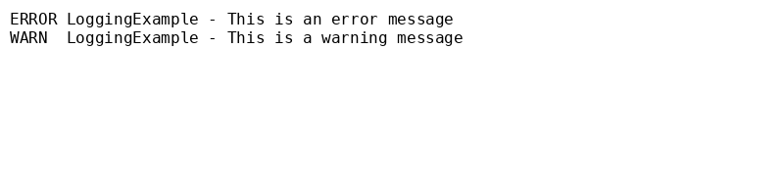

## Exercise 2: Parameterized Logging

Code:

import org.slf4j.Logger;  
import org.slf4j.LoggerFactory;  
  
public class ParameterizedLogging {  
 private static final Logger logger = LoggerFactory.getLogger(ParameterizedLogging.class);  
  
 public static void main(String[] args) {  
 String user = "Alice";  
 int attempts = 3;  
 logger.info("User {} has attempted to login {} times", user, attempts);  
 }  
}

Output Screenshot:

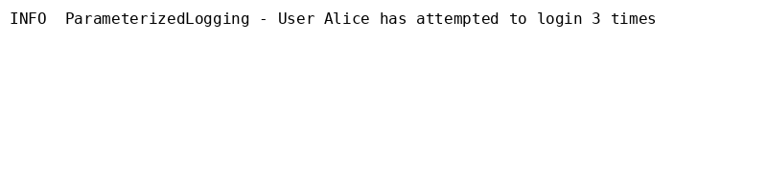

## Exercise 3: Using Different Appenders

Code:

import org.slf4j.Logger;  
import org.slf4j.LoggerFactory;  
  
public class MultiAppenderLogging {  
 private static final Logger logger = LoggerFactory.getLogger(MultiAppenderLogging.class);  
  
 public static void main(String[] args) {  
 logger.debug("Debug message for console and file");  
 logger.info("Info message for console and file");  
 }  
}

Output Screenshot:

